SentinelCrew: Technical Design Document
Table of Contents
1. Project overview 1
2. System architecture 3
3. AI models and algorithms 6
4. LLM integration 9
5. Code explanations 9
6. Testing and reliability 11
7. Setup and deployment 12
8. Assumptions and limitations 14
9. Future work 14
Appendix A: Demo scenarios 15

Project | SentinelCrew, an autonomous multi-agent SOC team
Track | AI / Cybersecurity (Multi-Agent Systems). Replace with the exact track name from the brief
Version | 1.0.0
Author | Vinay Gandhi
Date | 11 October 2026
Repository | https://github.com/vinaygandhigit/sentinelcrew
Demo video | https://youtu.be/-eZUFSH03KU

1. Project overview

1.1 The problem
A Security Operations Center (SOC) receives thousands of alerts a day. Industry surveys put the false-positive share at well over half, and every alert costs an analyst the same repetitive routine: pull the logs, look up the IPs, check whether IT was doing maintenance, decide, contain, and write it up. Real incidents wait in the same queue as noise, and the time lost there is time an attacker has inside the network.

1.2 The solution
SentinelCrew is a team of specialised AI agents that works each alert end to end, the way a disciplined human shift would. A Triage agent scores the alert with a machine-learning model and expert rules. An Investigator and a Threat-Intel agent then work in parallel to build the evidence. A Case-Memory agent recalls how similar incidents ended. The Orchestrator fuses all of this into one confidence score. The next stage is what most automated triage leaves out: a Critic agent argues against the verdict before anyone acts on it. After the debate, a Responder contains the threat under a risk policy that keeps a human in charge of anything disruptive, and a Reporter writes the incident report.

1.3 What is new
Idea | Why it matters
Debate before escalation | The Critic raises benign explanations and settles each one against real data: the asset inventory, the change calendar, the allowlist, threat intel, and past cases. Upheld challenges lower confidence and refuted ones raise it. In the benchmark, this alone takes accuracy from 60% to 100% and halves the analyst queue.
LLM proposes, tools verify | The LLM picks hypotheses, chooses challenges, and writes narrative. Every number, verdict, and action comes from deterministic, tested code. LLM output must pass a JSON schema with enum-restricted fields, so it cannot invent a check, a target, or an attack stage.
Graceful degradation | Without an API key, or during an LLM outage, every agent falls back to deterministic reasoning and the verdicts stay the same. This is verified by tests.
Hybrid AI | An unsupervised Isolation Forest (written from scratch in NumPy, explainable, and saved as JSON), expert rules, noisy-OR evidence fusion, a TF-IDF case memory, and LLM reasoning.
Measurable value | A built-in benchmark compares runs with and without the Critic. The console shows the auto-close rate, mean time to verdict, and pending approvals.
Human-in-the-loop | Low-risk actions run automatically. Medium-risk actions run only at high confidence. High-risk actions always wait for an analyst, and protected assets can never be actioned.

1.4 Scope of the MVP
The MVP covers the full alert lifecycle across five scripted, realistic scenarios: two real attacks, two convincing false positives, and one piece of plain noise. It includes ingestion of JSON, JSONL, CSV, and syslog alerts and logs; both LLM providers; a REST API; a live analyst console; a CLI; persistence; and a test suite of 178 tests. Response actions are simulated by design.

2. System architecture

2.1 High-level architecture
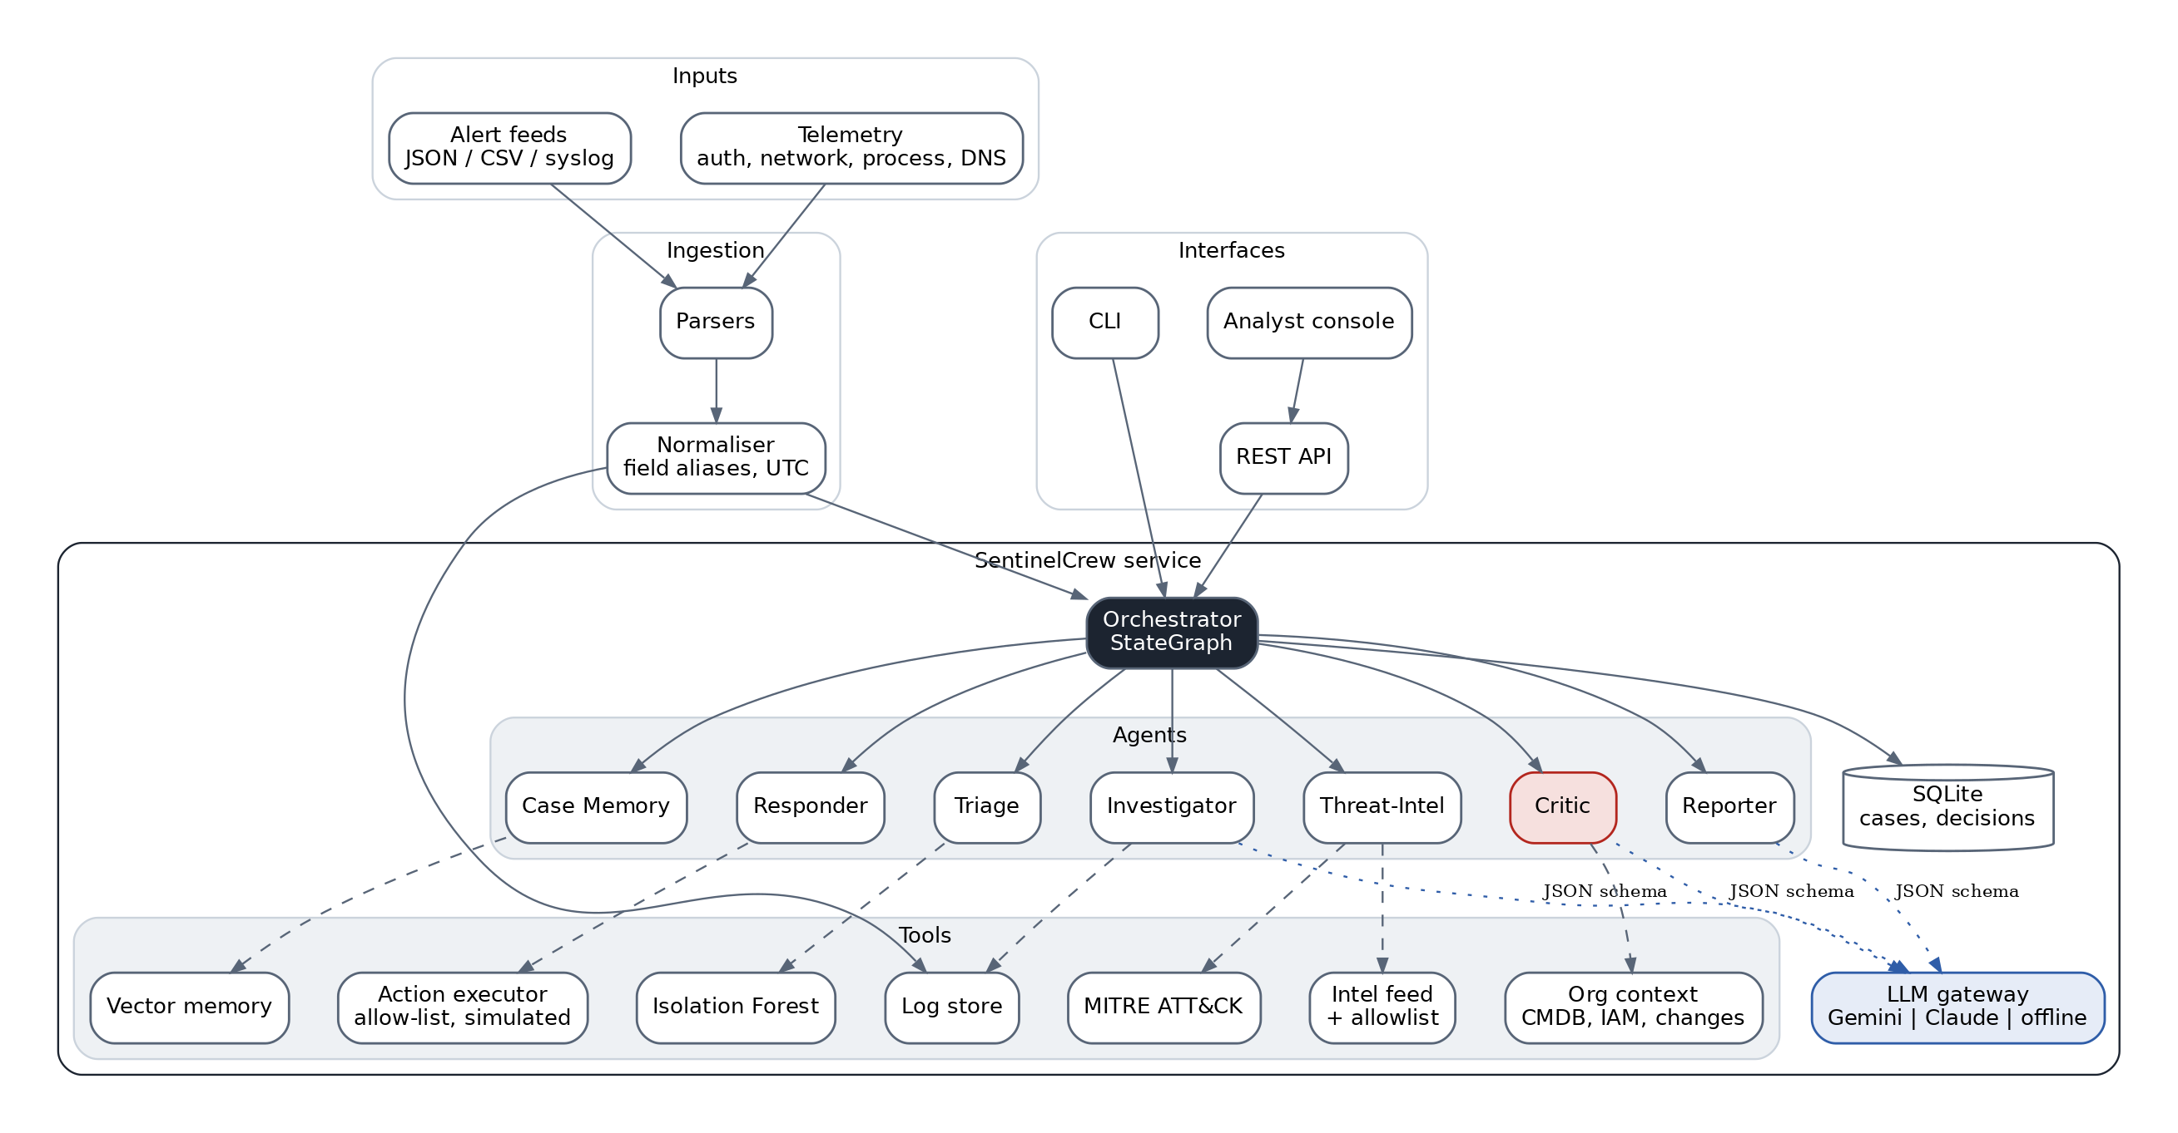
The system is one Python package arranged in layers. Interfaces (CLI, API, console) call a single SentinelService. The service owns the toolkit and the workflow. Agents receive the toolkit through dependency injection, so every agent can be tested in isolation with fakes.

2.2 Agent workflow (orchestration graph)
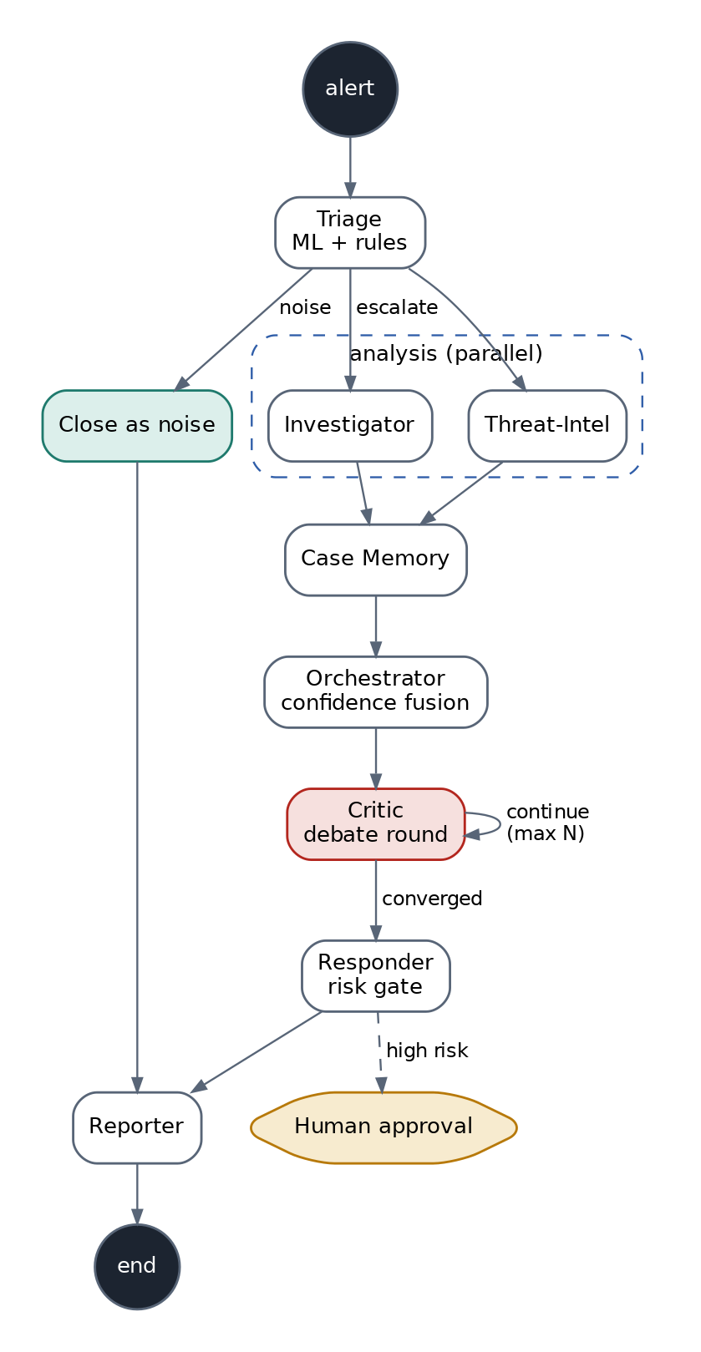
The graph runs on a small engine modelled on LangGraph (orchestration/graph.py). It supports sequential edges, conditional routing (which is how the debate loop and the noise short-cut are built), and parallel fan-out on a thread pool. Two safety properties are enforced by the engine itself:
- Termination. There is a hard max_steps budget (10 + DEBATE_MAX_ROUNDS), so a faulty router can never loop forever.
- Failure isolation. If a node raises, the Orchestrator records the error, posts it to the agent conversation, and continues with whatever data exists. A crashed Threat-Intel agent still produces a verdict and a report.

2.3 Sequence of a case
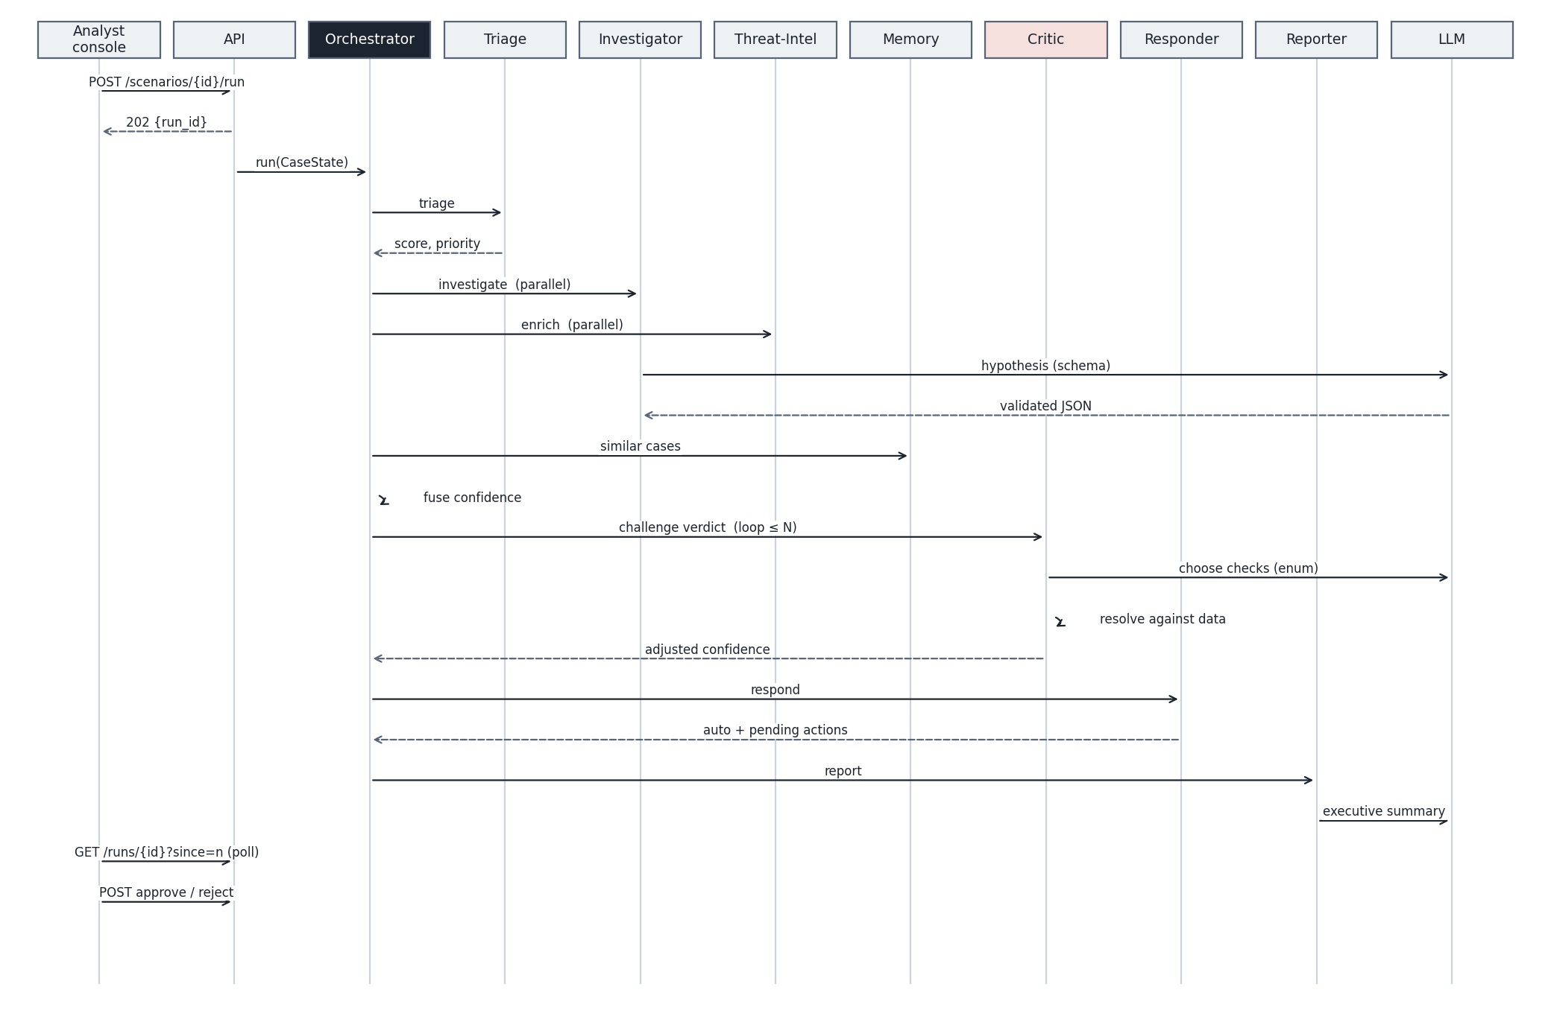

2.4 Data flow
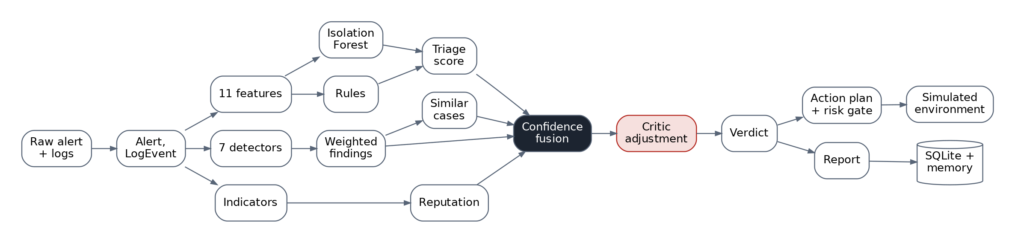

3. AI models and algorithms

3.1 Triage: hybrid anomaly detection
Features. For every alert, the Triage agent pulls the telemetry within ±180 minutes that touches any of the alert’s entities and computes 11 behavioural features: failed-auth count, distinct users targeted from the source, success after five or more failures, off-hours, external source, MB sent outbound, distinct destination ports, beacon regularity, suspicious process, severity hint, and asset criticality from the CMDB.
Beacon regularity is the classic command-and-control heuristic. For connections to the same destination, the agent computes the coefficient of variation of the inter-arrival times and scores 1 − CV. A perfectly periodic beacon scores close to 1. Large transfers (over 100 kB) are left out so that exfiltration doesn’t hide the beacon.
Isolation Forest. The model is a from-scratch implementation of Liu, Ting and Zhou (2008) in NumPy. It is trained unsupervised on normal behaviour, with 150 trees and a sub-sample of 256. The anomaly score is s(x) = 2^(−E[h(x)] / c(n)), where c(n) is the average unsuccessful-search path length of a binary search tree. Writing it ourselves rather than importing scikit-learn has three benefits. The model is explainable: each tree credits the feature whose split isolated the point, weighted by 1/depth, and the top drivers appear in the triage reasoning. It serialises to plain JSON, so loading a model file can never execute code the way pickle can. And it keeps the dependency footprint to NumPy alone.
Hybrid score. triage = 0.4 × anomaly + 0.6 × rules. The raw anomaly score is mapped from [0.45, 0.70] to [0, 1]. The rules score is the noisy-OR of the rules that fired (for example, 10 or more failed logons, or a beacon regularity of at least 0.8). An alert is closed as noise only when its score is below NOISE_THRESHOLD and no rule fired, so the ML model on its own can never silence an alert that matches a known-bad pattern.

3.2 Investigator: correlation detectors
The Investigator does a two-hop pivot. First it gathers events for the alert’s entities. Then it adds events for every host on which those entities logged on successfully, which is how a VPN brute force is connected to the workstation the attacker reached next. Seven detectors produce weighted findings tied to MITRE techniques:
Detector | Signal | Technique | Weight
Brute force | 10 or more failures from one source | T1110 | 0.50–0.60
Password spraying | 5 or more accounts from one source | T1110.003 | 0.45
Success after failures | Logon after 5 or more failures (external source raises the weight) | T1078 | 0.50–0.65
Suspicious process | Encoded PowerShell, LOLBins such as rundll32 and certutil, credential tools | T1059.001, T1218.011, T1059 | 0.55
C2 beaconing | 6 or more small connections with regularity of at least 0.8 | T1071.001 | 0.60
Exfiltration | 50 MB or more to one external destination | T1041 | 0.40–0.55
Port scan | 20 or more distinct ports from one source | T1046 | 0.45
When an LLM is configured, it receives the findings and a timeline excerpt. It returns a hypothesis, the most advanced attack stage (restricted by enum to ATT&CK tactics), and up to five open questions for the Critic.

3.3 Threat-Intel
Indicators are taken from structured fields and extracted with regular expressions from free text. Domains are restricted to known TLDs, so usernames such as j.mehta and files such as x.dll aren’t mistaken for domains. Internal RFC 1918 addresses are excluded. Each indicator is then looked up across the configured sources. The MVP ships a curated local feed with an organisation allowlist, and the ThreatIntelSource protocol makes MISP, OTX, or VirusTotal a drop-in addition. Matches on parent domains (a.b.evil.com matches evil.com) and merging across sources (taking the highest reputation and the union of tags) are supported.

3.4 Case memory
A TF-IDF vector store with L2-normalised sparse vectors and cosine similarity holds a fingerprint of every non-noise case: the rule, techniques, rule reasons, and finding titles. It is seeded with eight historical cases. The memory prior is the similarity-weighted share of malicious precedents, pulled back toward neutral (0.5) when similarity is weak. The Embedder protocol lets neural embeddings replace TF-IDF without changing any agent.

3.5 Confidence fusion
evidence = 1 − Π(1 − wᵢ) noisy-OR over findings
base = Σ wₖ · componentₖ / Σ wₖ k ∈ {triage 0.25, evidence 0.40, intel 0.25, memory 0.10}
final = clamp(base + critic_adjustment, 0.01, 0.99)
verdict = TP if final ≥ 0.70, FP if final < 0.40, otherwise NEEDS_REVIEW
Noisy-OR is used because independent pieces of evidence should reinforce each other without ever exceeding certainty. When a case has no external indicators, the intel term is removed and the remaining weights are re-normalised, so the absence of intel isn’t counted as evidence of innocence.

3.6 The Critic and the debate protocol
The Critic holds a catalogue of eight verifiable challenges. Each one has an applicability test and an evaluator that resolves it against data:
Check | Resolved against | Upheld impact | Refuted impact
Authorised scanner? | Asset inventory tag authorized-scanner | −0.30 | +0.02
Approved change window? | Change calendar, by time and asset | −0.15 | 0
Sanctioned destinations? | Allowlist versus known-bad intel | −0.20 | +0.03
Single uncorroborated signal? | Strong findings across ATT&CK tactics | −0.06 | +0.03
User mistyped a password? | Count and origin of failures | −0.15 | +0.02
Similar past case was benign? | Case memory | −0.10 | +0.02
Expected service-account automation? | IAM tags, plus no execution or exfiltration techniques | −0.10 | +0.02
Independent intel corroboration? | Maximum reputation | −0.04 | +0.03
Each round, the Critic raises up to three challenges that haven’t been raised yet. With an LLM, the model picks them. The JSON schema limits selected_checks to an enum of the applicable check IDs, so a hallucinated check is rejected and the heuristic order takes over. The model also writes the critical commentary. Each challenge resolves to upheld, refuted, or unverifiable. The adjustment accumulates within [−0.55, +0.10], so the Critic has more power to clear a case than to escalate one, which is deliberate. The debate stops when no applicable checks remain, when confidence moves by less than 0.005, or at DEBATE_MAX_ROUNDS (default 3).

3.7 Responder and risk policy
Action | Risk | Policy
add_to_watchlist, create_ticket, block_ip, block_domain | Low | Automatic
reset_sessions | Medium | Automatic only if confidence ≥ 0.85, otherwise waits for approval
disable_account, isolate_host | High | Always waits for analyst approval
Guardrails are enforced in code: only actions in the allow-list exist; targets come only from the case’s own entities and malicious indicators, so the LLM cannot introduce a target; protected assets (domain controllers, built-in admin and krbtgt, public DNS resolvers) are rejected even with approval; and every execution is written to an audit log. All actions change an in-memory SimulatedEnvironment.

3.8 Reporter
The report’s factual sections (entities, triage reasoning, evidence table, timeline, intel, similar cases, debate table, and actions) are rendered from case data, so they cannot drift from the evidence. The LLM contributes only the executive summary, the impact statement, and recommendations, and those are schema-validated too.

4. LLM integration

4.1 Providers
Provider | Use | Endpoint | Auth
Google Gemini | Testing and demo | generativelanguage.googleapis.com/v1beta/models/{model}:generateContent | x-goog-api-key
Anthropic Claude | Production | api.anthropic.com/v1/messages (version 2023-06-01) | x-api-key
Offline | CI, air-gapped | none | none
The provider is chosen through configuration (LLM_PROVIDER). With auto, APP_ENV=production selects Claude and anything else selects Gemini, so the same build moves from demo to production by changing one environment variable. Both clients call the public REST APIs through a small standard-library transport. That keeps the dependencies minimal and lets tests inject a fake transport.

4.2 Structured output guardrail
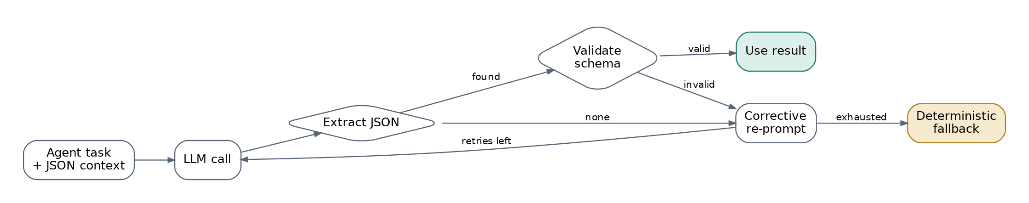
complete_json adds the schema to the prompt and turns on Gemini’s JSON MIME mode. It extracts JSON robustly, from fenced blocks, embedded in prose, or with braces inside strings. It then validates the result with a dependency-free JSON-schema validator (type, required, enum, bounds, item limits, and additionalProperties). If validation fails, the model is re-prompted with the exact error. Transport errors are retried with exponential back-off on 408, 429, 5xx, and 529. Usage (calls, failures, latency) is tracked and reported in /api/metrics.

5. Code explanations

5.1 Module map
Module | Responsibility
models.py | Dataclass domain model (Alert, LogEvent, Finding, Case, …) and JSON serialisation
config.py | Immutable Settings loaded from the environment or .env; provider resolution
validation.py | JSON-schema subset validator used as the LLM guardrail
ingestion/ | Parsers for JSON, JSONL, CSV, and RFC 3164/5424 syslog; field-alias normaliser; UTC timestamps; severity scales
llm/ | LLMClient base (retry, JSON extraction, usage), Gemini and Anthropic clients, factory, ScriptedLLM fake
ml/ | Isolation Forest, feature extraction, synthetic baseline and training CLI
tools/ | Indexed LogStore, ThreatIntelService, MitreMapper, OrgContext, ActionExecutor
memory/ | CaseStore (SQLite, thread-safe, upserts, metrics) and VectorStore
agents/ | The seven agents; base.py holds the Toolkit and the ask_json helper with fallback
orchestration/ | StateGraph engine, thread-safe CaseState, SOCWorkflow wiring
scoring.py | Noisy-OR, memory prior, fusion, verdict thresholds
service.py | Bootstrapping, scenario loading, case lifecycle, memorisation, human decisions
api/server.py | Framework-free router (SentinelAPI.dispatch), background run manager, HTTP handler
api/static/index.html | Analyst console: live agent stream, confidence trace, approvals
evaluation.py | Benchmark comparing runs with and without the Critic
cli.py | serve, scenarios, run, analyze, evaluate, train, check-llm

5.2 Key design decisions
A custom graph engine instead of a LangGraph dependency. The workflow needs exactly three primitives: edges, conditional edges, and parallel fan-out. A 200-line engine with full test coverage is easier to audit than a framework, has no version drift, and installs anywhere. Its API mirrors LangGraph’s (add_node, add_conditional_edges, set_entry_point, END), so porting is mechanical if that’s wanted later.
Shared mutable state with locks. CaseState is one object that every agent writes to, with an RLock around message emission. The parallel nodes write disjoint fields (investigation and intel), so they don’t contend.
Determinism. Model training, the synthetic data, and the Critic’s heuristic ordering are all seeded or ordered. Running the same scenario twice gives the same verdict, which the tests rely on.
A framework-free API. SentinelAPI.dispatch(method, path, query, body) is a pure function of its inputs, so every route is unit-tested without sockets. The HTTP handler is a thin adapter on top. Cases run on background threads under a single execution lock, which keeps the shared log store consistent while the UI polls /api/runs/{id} for new messages.
Persistence. The full case is stored as a JSON payload alongside indexed summary columns. Metrics are computed in SQL plus Python. Analyst decisions go into a separate decisions table, which serves as the audit trail.

5.3 REST API
Method and path | Purpose
GET /api/health | Liveness, version, active LLM
GET /api/scenarios | Demo scenarios
POST /api/scenarios/{id}/run | Start a scenario, returns run_id
POST /api/alerts | {"alert": {...}} or {"alerts": [...]} with optional "events"; returns run_ids
GET /api/runs/{run_id}?since=n | Incremental agent messages, done, case_id
GET /api/cases, GET /api/cases/{id} | Case list and full case
GET /api/cases/{id}/report | Markdown report
POST /api/cases/{id}/actions/{action_id} | {"approve": true, "analyst": "...", "comment": "..."}
GET /api/metrics | Auto-close rate, mean time to verdict, debate shift, pending approvals, simulated environment, LLM usage
GET /api/graph | The workflow as Mermaid
Errors return JSON with suitable status codes: 400 for malformed input, 404 for unknown resources, 405 for the wrong method, 409 for an action that isn’t pending, 413 for a body over 2 MB, and 422 for alerts that can’t be normalised.

6. Testing and reliability

6.1 Strategy
The suite has 178 tests, about 99% line coverage of src/, and runs in under 10 seconds with no network and no API keys. They are written with unittest, so they run under both pytest and python -m unittest.
Area | What is tested
Ingestion (23) | Every timestamp form, severity scales, field aliases and nesting, CSV/JSON/JSONL/syslog, format detection, rejection of bad rows
LLM layer (26) | Payload shape and headers per provider, response parsing, blocked or empty responses, corrective retry, retry and back-off policy, factory selection, auto mode, missing key, scripted fake
Resilience (6) | Real HTTP transport against a local server (success, retryable and non-retryable status codes, invalid JSON, connection refused); a crashing agent doesn’t kill the case
Tools (22) | Log indexing and OR-queries, intel allowlist, parent-domain and multi-source merge, ATT&CK mapping, change windows, every action, protected targets
ML (16) | c(n), outlier ranking, determinism, explanations, JSON round trip, constant data, beacon regularity, feature extraction
Core (29) | Fusion maths, memory prior, vector search, SQLite upsert, rollback and metrics, config and .env, graph engine (loops, max_steps, true concurrency, error routing, validation)
Agents (33) | Each agent with and without a scripted LLM. The LLM cannot invent checks or stages, a benign explanation lowers confidence, a real attack survives the debate, the adjustment stays bounded, risk gating works, guardrails block protected targets, report sections are present
Integration (23) | All five scenarios reach the expected verdict; trace order; memorisation; approve and reject flow; full pipeline with a scripted LLM; identical verdicts during an LLM outage; every API route and error; a real HTTP round trip; every CLI command; the benchmark

6.2 Edge cases covered
These are covered explicitly: malformed and empty logs, a record with no timestamp, an LLM returning prose instead of JSON, an LLM returning JSON that breaks the schema, an LLM outage, network timeouts, HTTP 429 and 503, a debate that never converges (stopped by max_steps and the round limit), a router returning an unknown label, a crashing agent inside a parallel branch, a broken UI listener, attempts to run an action not on the allow-list or against a protected target, a double approval, path traversal in a scenario ID, and oversized request bodies.

6.3 Running
pytest --cov=src/sentinelcrew --cov-report=term-missing
python -m unittest discover -s tests -t .
GitHub Actions (.github/workflows/ci.yml) runs the suite on Python 3.10, 3.11, and 3.12 with an 85% coverage gate.

7. Setup and deployment

7.1 Requirements
Python 3.10 or newer and NumPy. Nothing else is needed at runtime. Development adds pytest, pytest-cov, and ruff.

7.2 Local setup
git clone https://github.com/vinaygandhigit/sentinelcrew
Set-Location sentinelcrew
py -m venv .venv
.\.venv\Scripts\Activate.ps1
python -m pip install -r requirements-dev.txt
python -m pip install -e .

Copy-Item .env.example .env # then add your key(s), see "Choosing the LLM"
sentinelcrew check-llm # confirms the key works
sentinelcrew serve # open http://127.0.0.1:8000

The synthetic data is committed. To regenerate it, run python scripts/generate_data.py. The triage model is trained and cached in var/models/ on first start. To retrain it, run sentinelcrew train.

7.3 Configuration reference
Variable | Default | Meaning
APP_ENV | development | production makes auto choose Claude
LLM_PROVIDER | auto | auto, gemini, anthropic, or offline
GEMINI_API_KEY / GEMINI_MODEL | none / gemini-2.5-flash | Gemini credentials and model (GOOGLE_API_KEY also accepted)
ANTHROPIC_API_KEY / ANTHROPIC_MODEL | none / claude-sonnet-4-5 | Claude credentials and model
LLM_TEMPERATURE, LLM_TIMEOUT_S, LLM_MAX_RETRIES, LLM_MAX_TOKENS | 0.1, 60, 2, 4096 | LLM behaviour
DEBATE_MAX_ROUNDS | 3 | Critic round limit
NOISE_THRESHOLD, TP_THRESHOLD, FP_THRESHOLD | 0.20, 0.70, 0.40 | Decision thresholds
AUTO_MEDIUM_RISK_CONFIDENCE | 0.85 | Confidence needed to auto-run medium-risk actions
LOG_WINDOW_MINUTES | 180 | Investigation window (±)
SENTINEL_DATA_DIR, SENTINEL_VAR_DIR | ./data, ./var | Reference data and runtime state

7.4 Production deployment
Your DevOps team owns the packaging, so no container files are included. The service is a single process with a standard Python entry point:
python -m pip install . # or: python -m pip install -r requirements.txt
$env:APP_ENV = "production"
$env:LLM_PROVIDER = "anthropic"
$env:ANTHROPIC_API_KEY = "your-api-key"
sentinelcrew serve --host 0.0.0.0 --port 8000 # health check: GET /api/health
Concern | Guidance
Health check | GET /api/health returns 200 with the active provider
State | Only SENTINEL_VAR_DIR (SQLite, model, reports); put it on persistent storage
Secrets | Supply API keys as environment variables from your vault; .env is git-ignored
TLS and auth | Terminate TLS and add authentication (SSO or an API gateway) at your reverse proxy; the MVP has no built-in user authentication
Scaling | One process handles cases one at a time. Scale out by sharding alert sources across instances; for shared state, move CaseStore to PostgreSQL (one class)
Egress | Allow outbound HTTPS to generativelanguage.googleapis.com and/or api.anthropic.com only
Logs | Access logs go to stderr; case-level audit lives in the decisions table

8. Assumptions and limitations
Assumption or limitation | Detail
Simulated response | Every action changes an in-memory SimulatedEnvironment. Real EDR, firewall, or IdP connectors would implement the same ActionExecutor handlers.
Synthetic data | Telemetry, the intel feed, the ATT&CK subset (17 techniques), the CMDB, IAM, the change calendar, and historical cases are synthetic and reproducible (scripts/generate_data.py). No real customer data is used.
Triage baseline | The Isolation Forest is trained on a synthetic baseline of normal activity. In production you would retrain it on your own known-good telemetry, for example 30 days.
Time | All timestamps are normalised to UTC; “off-hours” means outside 07:00–20:00 UTC or a weekend.
LLM role | The LLM never decides a verdict or an action on its own. Its output is schema-validated and restricted to enums. Verdicts are deterministic given the data.
Small benchmark | The 100% accuracy is measured on five purpose-built scenarios that demonstrate behaviour. It is not a statistical claim about real-world precision.
Single tenant, no auth | The API has no built-in authentication. Deploy it behind your SSO or API gateway.
Concurrency | Cases are processed one at a time per instance to keep the shared log store consistent.

9. Future work
Future work includes connectors for SIEM ingestion (Splunk, Sentinel, Elastic), real EDR and IdP actions behind the same allow-list, neural embeddings for case memory, analyst feedback that tunes the Critic’s impacts (learning from approve and reject decisions), the full ATT&CK catalogue, and multi-tenant authentication.

Appendix A: Demo scenarios
Scenario | Story | Expected result
01_bruteforce_compromise | 46 off-hours VPN failures from a Tor exit node, then success, then RDP to a finance workstation | True positive. IP blocked and sessions reset automatically; account disable waits for approval
02_scanner_false_positive | 140-port scan of a DMZ server | False positive. The source is the authorised scanner under change CHG-2041; confidence goes from 0.58 to 0.03
03_beacon_exfiltration | Word launches encoded PowerShell, a 60-second beacon to a C2 domain, rundll32, then 260 MB out | True positive. Domain and IP blocked; host isolation waits for approval
04_low_value_noise | One mistyped password | Noise. Closed at triage without running the other agents
05_backup_false_positive | 380 MB uploaded off-hours by svc-backup | False positive. The destination is allowlisted and it’s the nightly backup

