Assignment JAVA

**Simple**

1.       Implement a JAVA program to print “Hello SOIS” on the console.

2.       Define a two variables a and b, and using assertion check whether they are same or not.

3.       Implement a JAVA program to find the square of the number.

4.       Implement a JAVA program for finding x.

5.       Implement a JAVA program to find a centroid of a triangle.

6.       Implement a JAVA program to find the distance of two points (x1,y1) and (x2,y2).

7.       Implement a JAVA program to find area of a) triangle b) circle [ use case statement]

8.       Implement a JAVA program to find a factorial of a number.

**Arrays**

1.       Implement a JAVA program to find the minimum and maximum value of an array.

2.       Implement a JAVA program to add two matrix A and B. (simple 2x2 matrix)

3.       Extend the above problem for generic m x n matrix.

4.       Implement a JAVA program to find the transpose of 3x3 matrix.

5.       Implement a JAVA program to find the mean of an “n” size array.

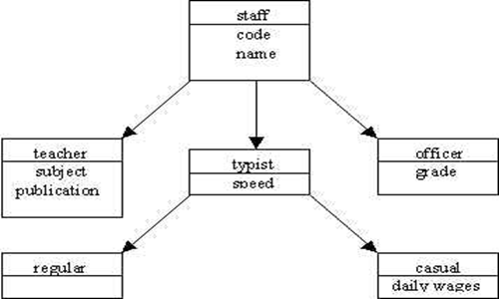6.       Implement a JAVA program to find a) mean b) average c) standard deviation d) variance of a given array of numbers.  
  
Intermediate Programs

1.   Write a program that prints 3 arguments taken from command line.

2.   Write a program that prints the sum of 3 numeric arguments taken from command line.

3.   Allow the user to enter a string and display the string in alphabetic order and find the length of string.

4.   Check whether entered string is a palindrome or not.

5.   Write a program to convert the given temperature in fahrenheit to celsius using the following conversion formula C=(F-32)/1.8

6.   Write a Program to sort an array of Numbers

7.   Write a program to display the reverse of an input string

8.   Write a program to find the number of and sum of all integers greater than 100 and less than 200 that are divisible by 7

9.   Shown below is a Floyd's triangle.  
1  
2 3  
4 5 6  
7 8 9 10  
11 ... ... ... 15  
.  
.  
79 .. .. .. .. .. .. .. .. 91

a.   Write a program to print this triangle

b.   Modify the program to produce the following form of Floyd's triangle  
1  
0 1  
1 0 1  
0 1 0 1  
1 0 1 0 1

10.                Given a number,write a program using while loop reverse the digits of the number  
For example, the number  
        12345  
should be written as  
        54321  
  
(Hint: Use modulus operator to extract the last digit and the integer division by 10 to get the n-1 digit number from the n digit number)

11.                Display a question to user allow the user to answer the question. Allow 3 chances to user. If correct answer display "Good" else display correct answer after 3 attempts.

12.                Develop a quiz application. Display the marks scored by user.

13.                Allow the user to enter 10 numbers. Find max, min and sort the input.

14.                Generate 10 randam numbers and display them.

15.                Develop Stack with following operations  
i) createNew( )        ii) push( )      iii)   pop( )      iv) display( )    v) empty( )

16.                Develop Queue with following operations  
i) createNew( )        ii) add( )      iii)   remove( )      iv) display( )    v) empty( )

17.                Define a class to represent a bank account. Include the following data members

o    Name of the depositor

o    Account number

o    Type of account

o    Balance amount in the account

Member Functions

o    To assign initial values

o    To deposit an amount

o    To withdraw an amount after checking the balance

o    To display name and balance

Write a main program to test the program

18. An educational institution wishes to maintain a database of its employees. The database is divided into a number of classes whose hierarchical relationships are shown in the following figure.



 The figure also shows the minimum information required for each class. Specify all the classes and define functions to create the database and retrieve individual information as and when required.

19. Assume that the test results of a batch of students are stored in three different classes. Class **Student**stores the rollNumber, class **Test** stores the marks obtained in two different subjects and class **Result** contains the total marks obtained in the test. The class **Result**  can inherit the details of the marks obtained in the test and the rollNumber of students through multilevel inheritance. Write a Java Program to implement this.

20. Modify the program in exercise 20 to include the following requirement. Assume that we have to give weightage for sports before finalising the results. The weightage for sports is stored in a separate class called **Sports**. Now write a Java program to have this.( Hint: Use interface).

21. Modify the program in exercise 20 such that classes Student and Test are kept in one package; interface Sports is kept in another package and the class Result is kept in other third package. Test the program to get the similar results.