**Machine Learning Approach For Employee Performance Prediction With IBM**

1. **INTRODUCTION:**
2. Overview:-

In this project we are going to analyze and predict the performance of employees in an organization on the basis of various factors, including, but not limited to, individual and domain specific characteristics, nature and level of schooling, socioeconomic status and different psychological factors.

1. Purpose:-

The purpose of this project is to predict the performance of employees.

1. Objective:

→Know fundamental concepts and techniques used for machine learning.

→Gain a broad understanding about data.

→Have knowledge on pre-processing the data/transformation techniques and some visualization concepts.

1. **LITERATURE SURVEY:**
2. Existing problem:

On previous system employee performance is calculated using paper works by evaluating the performance of the employee by hand

1. Proposed solution:

As an alternative to the existing problem this project is made to automate the performance of the employee.

1. **THEORETICAL ANALYSIS:**
2. Block Diagram:

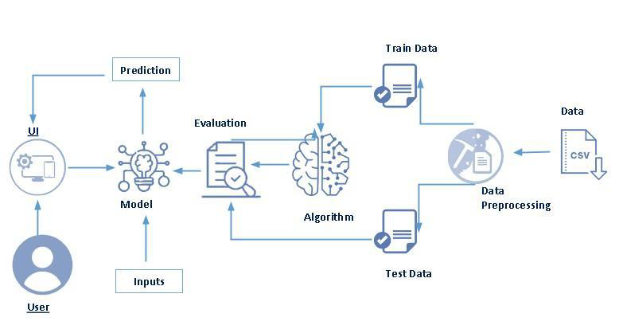

1. Hardware Minimum Requirement:

⦁ CPU : PENTIUM III Processor

⦁ Memory : 128 MB

⦁ Cache : 512KB

⦁ Floppy Disk : 1.44MB

⦁ Hard Disk : 4.3GB

⦁ Display : 15” Monitor

⦁ Key Board : Standard 108 keys Enhanced Keyboard

⦁ Mouse : MS Serial Mouse

1. Software Minimum Requirement:

⦁ Operating System : Windows XP, 7, 8 or above

⦁ Front Tool : PHP

⦁ Back End Tool :HTML

1. **EXPERIMENTAL INVESTIGATIONS:**

Based on my analysis since the project is used with Supervised learning techniques namely Support Vector Machines, Random Forest, Naive Bayes, Neural Networks and Logistic Regression. The performance of the employee is analyzed based on the number of days the employee works ,target productivity acquired, over time they worked, how many team members etc and the most accurate result is found out.

1. **FLOWCHART:**
2. *User interacts with the UI to enter the input.*
3. *Entered input is analyzed by the model which is integrated.*
4. *Once model analyzes the input the prediction is showcased on the UI*

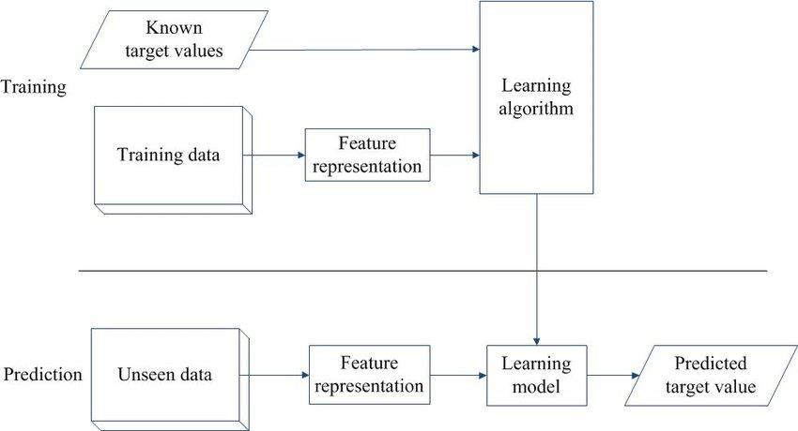

1. **RESULT:**

OUTPUT:

HOMEPAGE: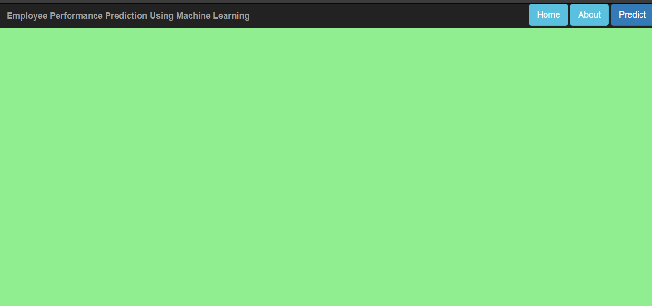

INPUT:

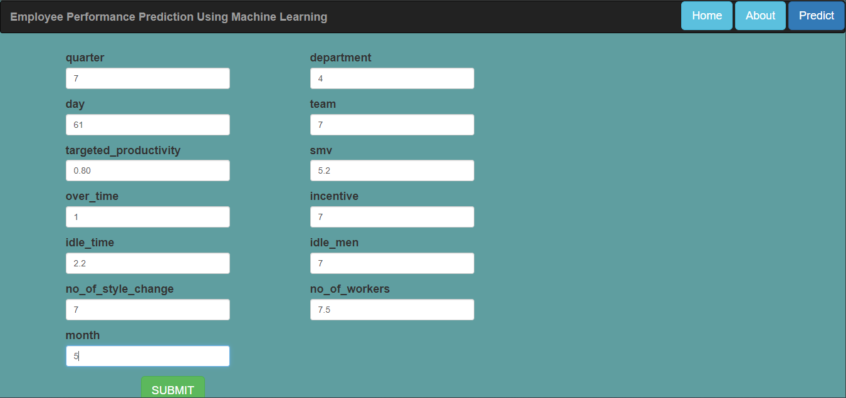

OUTPUT:

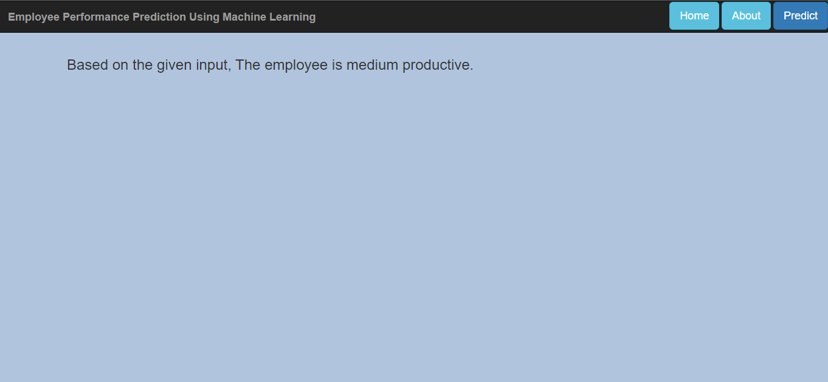

Medium Productive

1. **ADVANTAGES:**

1. Provides clarity

2. Enhances efficiency

3. Promotes job satisfaction

4. Increases motivation

5. Enables objective decision-making

6. Helps plan for training needs

1. **DISADVANTAGES;**

1. The absence of goal setting and defined milestones

2. Using performance management solely as a measurement tool

3. Establishing trust

4. Untrained managers

5. It’s an annual activity

1. **APPLICATIONS:**

1. Attendance

2. Time management

3. Training

4. Initiative & innovation

1. **CONCLUSION:**

This project analyzes and predicts the performance of employees in an organization on the basis of various factors, including, but not limited to, individual and domain specific characteristics, nature and level of schooling, socioeconomic status and different psychological factors. The performance is evaluated successfully.

**APPENDIX**

1. **app.py**

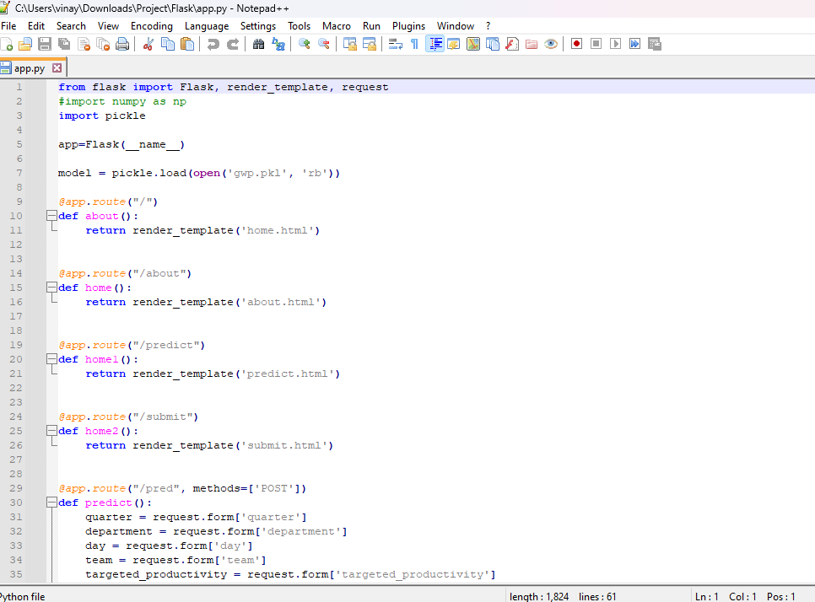

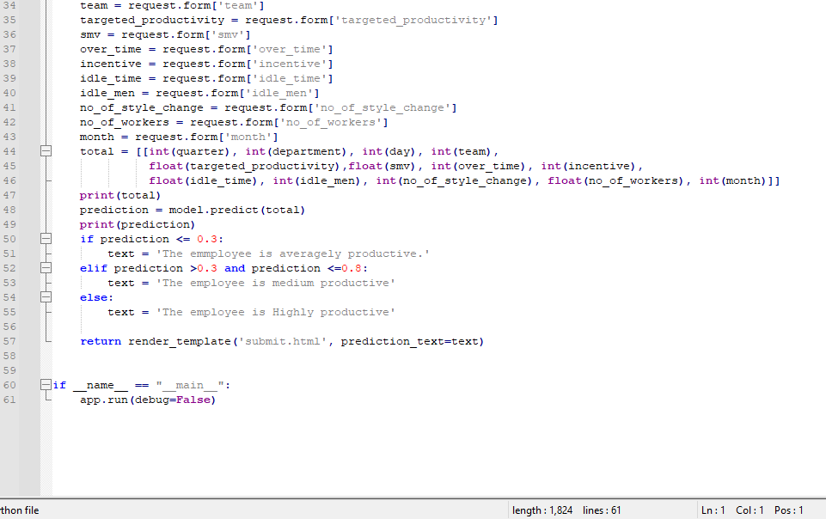

1. **home.html**

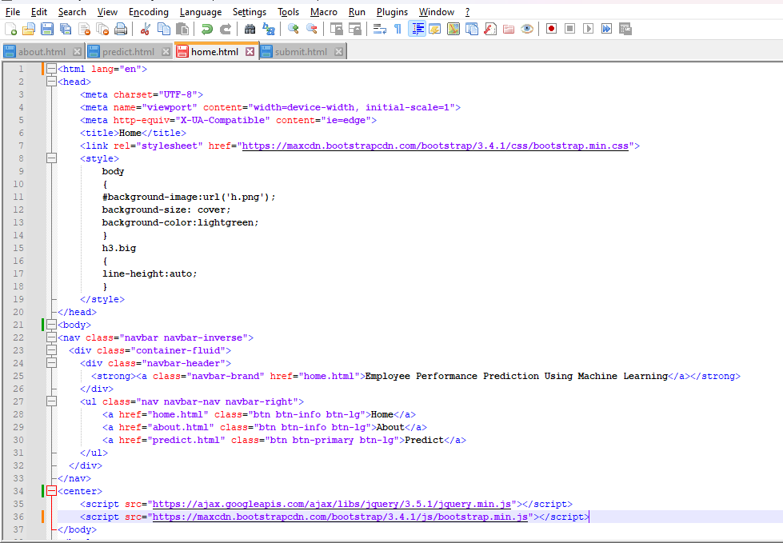

1. **about.html**

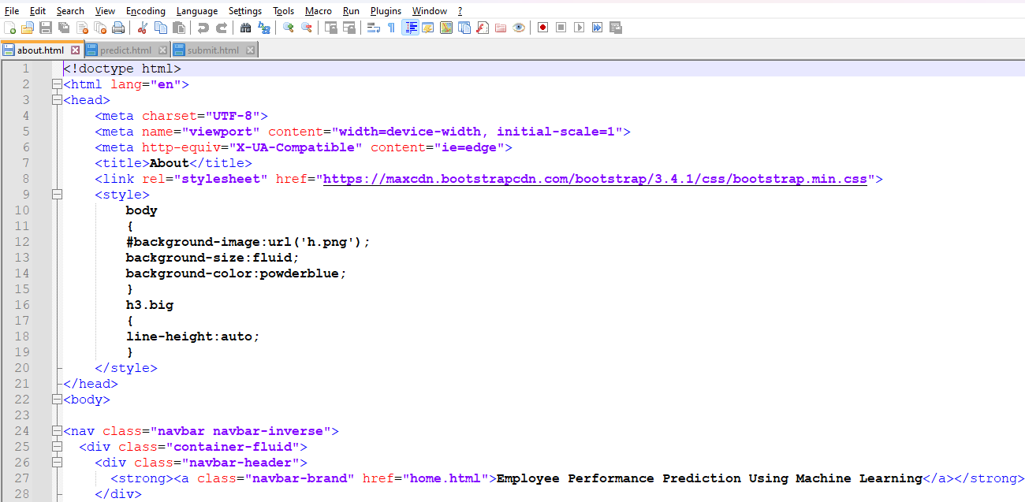

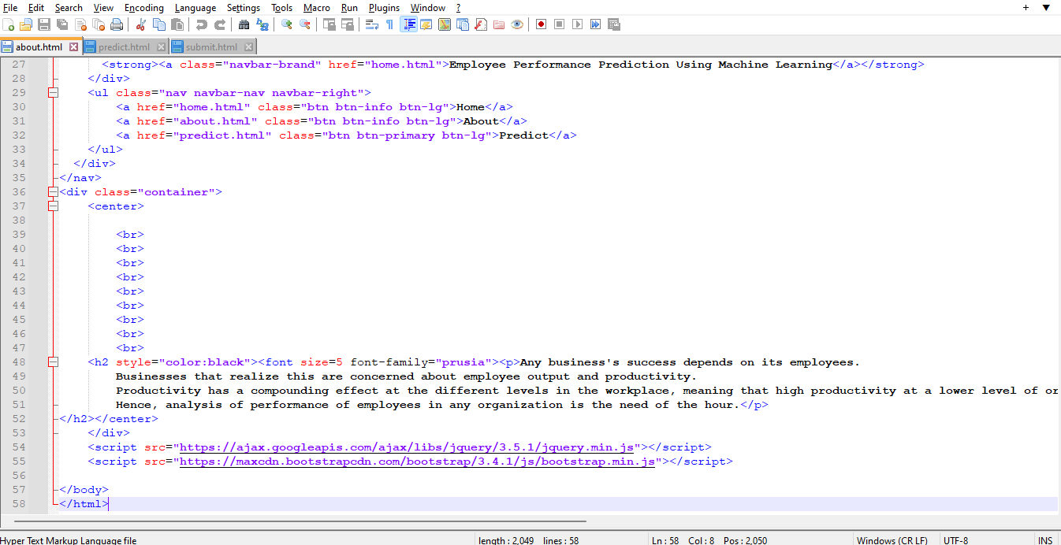

**4.submit.html**

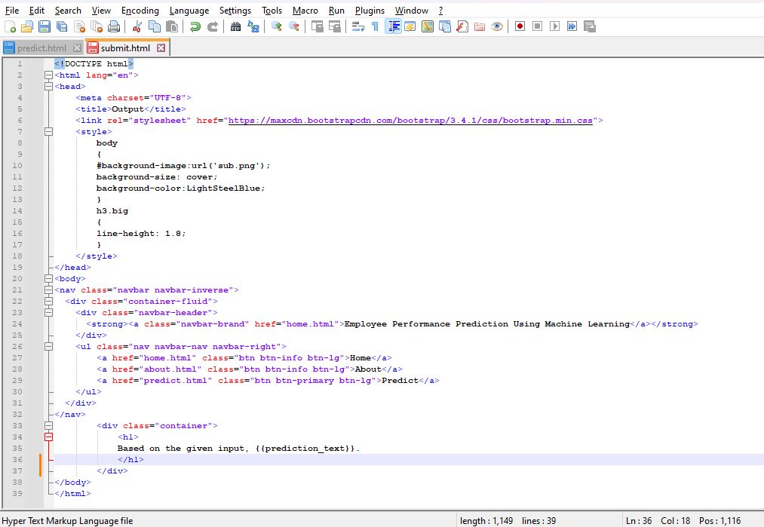

**5.predict.html**

