Postman

Postman is a API testing tool which used most popularly to test the REST endpoints and other services. Its integrated with a browser and easy UI which is very user friendly to test your endpoints, it also maintains the history of endpoints tests which was made by us which becomes hassle free for API testing.

Download Postman from below link

<https://www.postman.com/downloads/>

Follow simple installation process and the home looks like below.

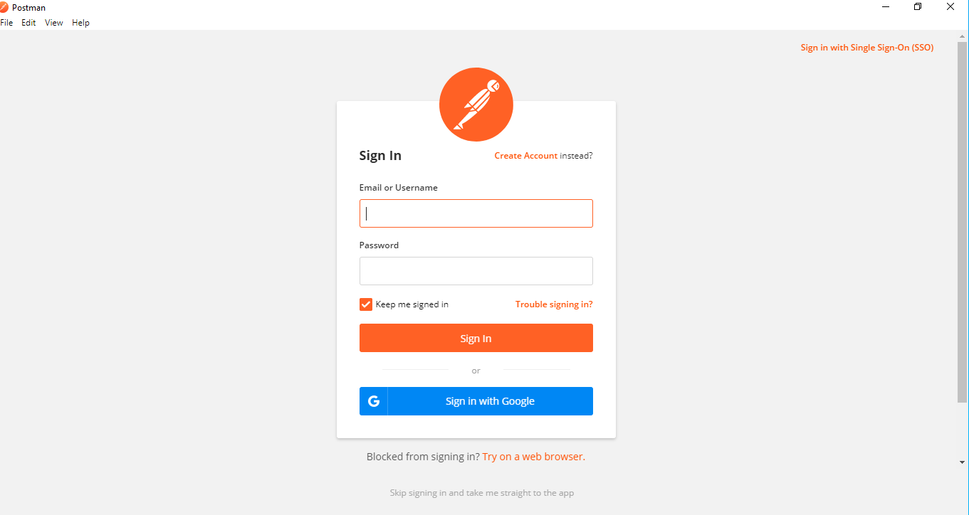

If you wish to keep track of all your works in a workspace then create a account else skip it which you can see in bottom of the screen.

Then you will arrive at the below screen.

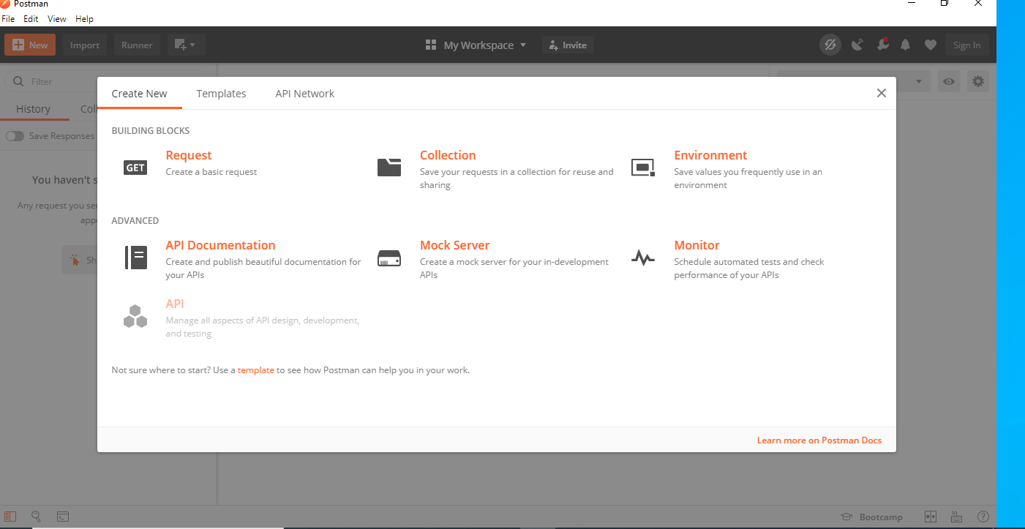

Close it and you will arrive at below screen.

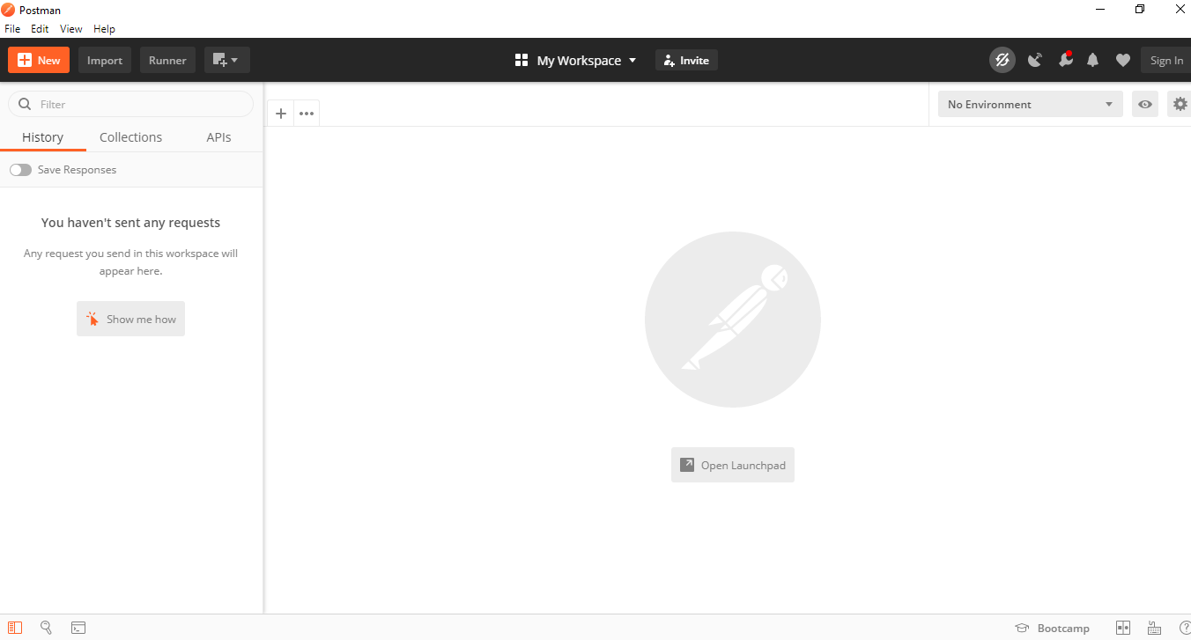

Here you can use + symbol which will open a new request and you can enter any endpoint and test it.

For this demonstration lets use the below public endpoint which works on JSON.

<https://jsonplaceholder.typicode.com/users>

Once you click on “+” you will arrive at below screen.

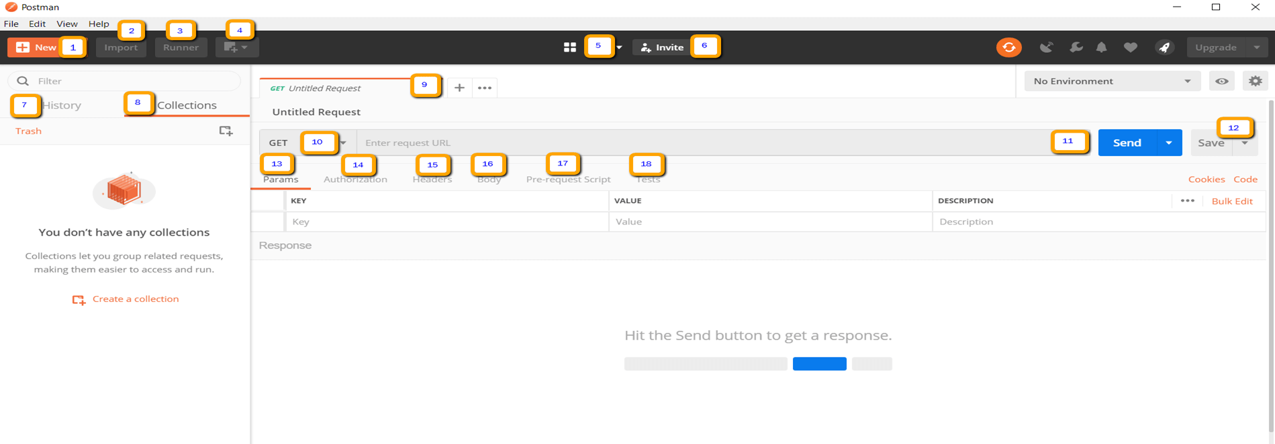

1. New - Used for creating New requests for your endpoints.
2. Import – Any prewritten collections can be imported using this button.
3. Runner – You can run automation tests using this.
4. Open New – Can open a new tab using this.
5. My Workspace – Have a workspace configured for yourself and the team too.
6. Invite – Invitation to collaborate for others.
7. History – Keeps track of all the endpoints tests which you made, click and add those to test them frequently.
8. Collections -Group your test suites at one place using this.
9. Request tab – Shows the tab of the request you are currently working on.
10. HTTP Request – Select any of HTTP Methods from this dropdown
11. Request URL -Put the endpoint to be tested.
12. Save – saves the request.
13. Params – any parameters we wish to pass with the request we can pass it using this.
14. Authorization – Some APIs may require authorization; you can use this to add authorization given by the client.
15. Headers – Any meta information which you wish to pass you can via headers
16. Body – For POST and PUT requests this will be handy to send the data using body
17. Pre-request Script – Any script which you wish to execute before the request is sent, we can add that script here.
18. Tests – You can have these automated test scripts which can check if the request was executed successfully or not.

**Working with GET Requests**

In the workspace

1. Make the HTTP method as GET.
2. Pass the endpoint <https://jsonplaceholder.typicode.com/users>
3. Click on the Send
4. Check out for 200 Status OK
5. We should see 10 users at this point in the body.

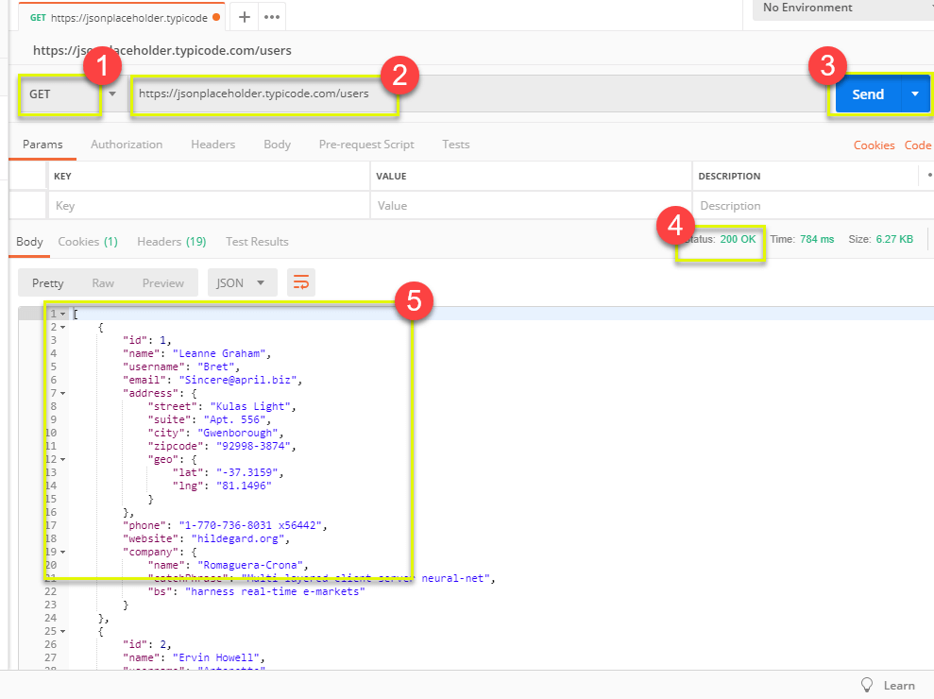

**Working with POST Requests**

For POST requests you need to send the data in the body to accomplish it.

**Step 1)** Open a New tab

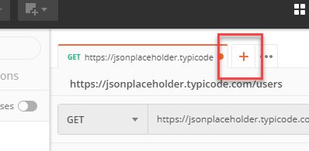

**Step 2)** In the new tab

1. Change the request HTTP method to POST.
2. Paste the same endpoint as the previous GET request https://jsonplaceholder.typicode.com/users
3. Click on body tab menu.

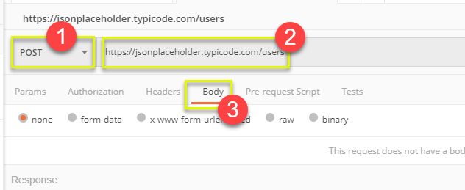

**Step 3)** Within the Body tab now select the radio **raw** and then you will get option as below   
 now choose **JSON (application/json)** from the dropdown

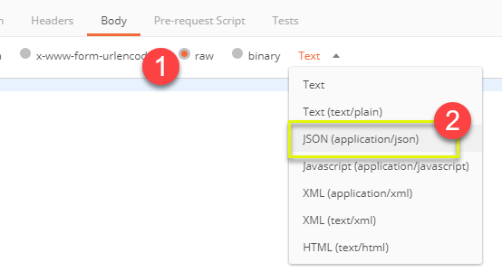

**Step 4)** Go ahead copy paste the below JSON object in the body

[

{

"id": 11,

"name": "Sreedhar Raja",

"username": "Sree",

"email": "[Sree@gmail.com](mailto:Sree@gmail.com)

",

"address": {

"street": "swamy uppar street",

"suite": "suite no 550",

"city": "Mumbai",

"zipcode": "91234-1234",

"geo": {

"lat": "-37.3159",

"lng": "81.1496"

}

},

"phone": "1-770-736-8031 x56442",

"website": "test.org",

"company": {

"name": "Romaguera-Crona",

"catchPhrase": "Multi-layered client-server neural-net",

"bs": "harness real-time e-markets"

}

}

]

*Note: Please keep your mind the JSON format should be strictly correct, and all syntax to be followed up, to be on safer side you can pick the JSON object from the GET results which you received previously and then do modification to it and then send it the respective request. For more you can use tools like <https://jsonformatter.curiousconcept.com/>

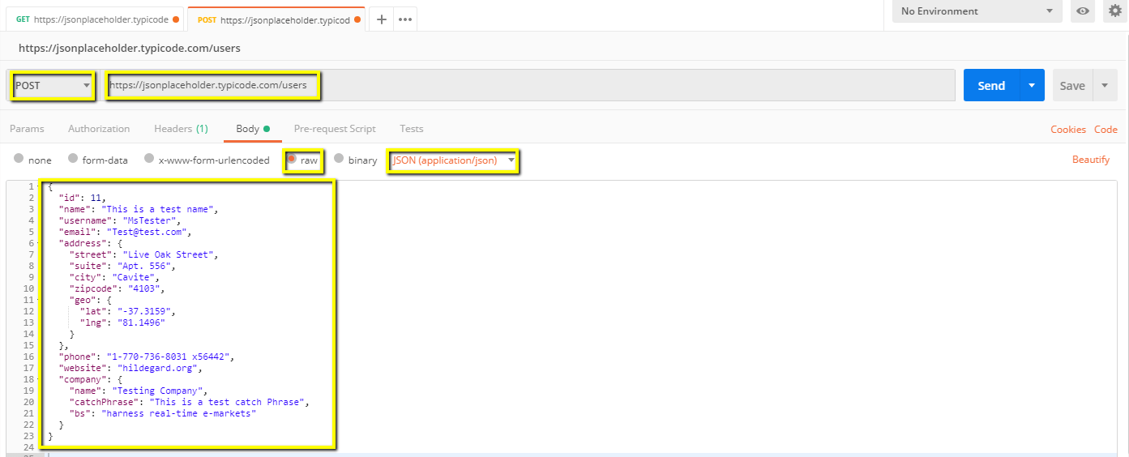

**Step 5)** Next,

1. Once done on all above now click on SEND to send the POST request.
2. 201 status should be shown for creation for POST request.
3. Scroll down to see the POSTed data as response back from the endpoint.

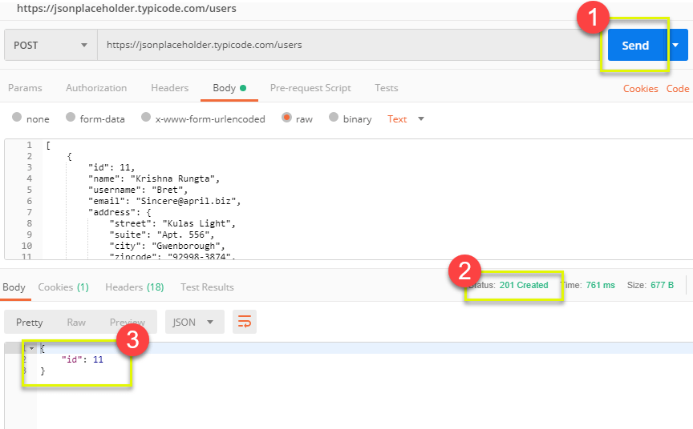

**Assignment.**

Now go ahead try the similar get and post request with below endpoint.

<https://jsonplaceholder.typicode.com/posts>