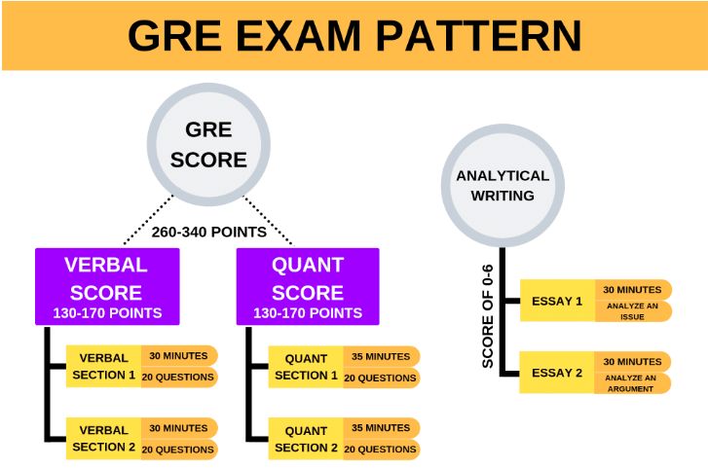
- Verbal Reasoning assesses reading comprehension, critical reasoning, and vocabulary usage in two sections.
- Quantitative Reasoning assesses basic high school level mathematical knowledge and reasoning skills in two sections.
- Analytical Writing is intended to test how well you can work with your words. The section consists of two tasks each of essay writing.

GRE General Test:
Gor the computer-based general test, verbal and quantitative section will be section-level adaptive. This means the computer will choose the second section depending upon a candidate’s performance in the first section. Questions asked in all the section will contribute to the final raw score calculation. The raw score will be converted into a scaled score.
- The Verbal Reasoning and Quantitative Reasoning sections are scored on a range of 130-170, in 1 point increments.
- Analytical Reasoning is scored in a range of 0–6, in half-point increments.
- If a candidate does not answer any questions of any/all measures, then a No Score (NS) is stated for that measure.

Computer – Delivered Test Pattern
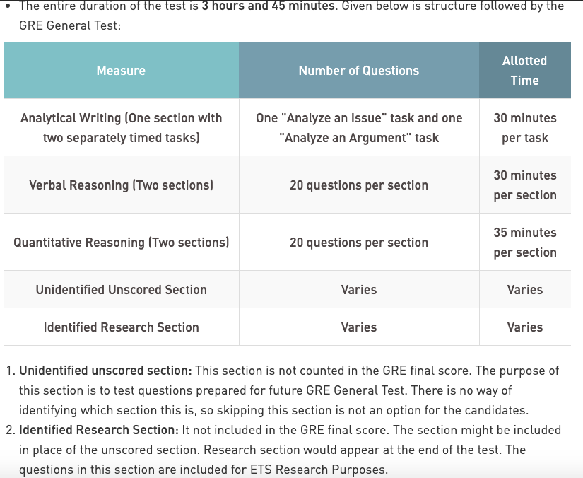
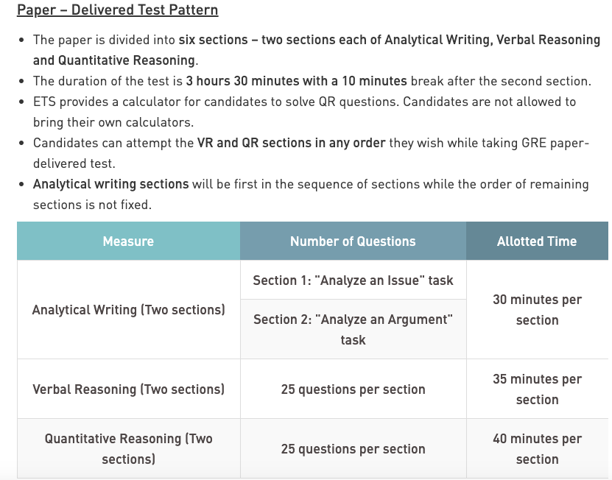

Verbal Reasoning
This section requires a candidate to:
- analyze and draw conclusions from discourse; reason from incomplete data; identify author's assumptions and/or perspective; understand multiple levels of meaning, such as literal, figurative and author's intent
- select important points; distinguish major from minor or relevant points; summarize text; understand the structure of a text
- understand the meanings of words, sentences and entire texts; understand relationships among words and among concepts
Three types of questions are asked in this section and they are:
- Reading Comprehension
- Text Completion
- Sentence Equivalence
Books for Verbal Reasoning
Best books that can help in the verbal reasoning section of GRE exam is given below.
- ETS Official GRE Verbal Reasoning Practice Questions
- GRE Verbal Grail – Aristotle Prep (Good for Reading Comprehension)
- Kaplan GRE Verbal Workbook
- Manhattan 5LB Book of Practice Problems (Questions harder than the actual GRE)
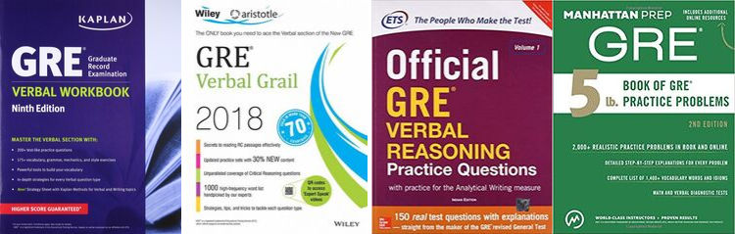

Quantitative Reasoning
It intends to test if a candidate can:
- understand, interpret and analyze quantitative problems
- solve problems using mathematical formulae and techniques
- apply elementary concepts and basic skills of arithmetic, algebra, geometry and data analysis
List of the topics that are asked in the quant section is:
Ratio and proportion | Profit and loss
Simple and compound interest | Speed, distance and time
Permutation & combination | Linear equations
Quadratic equations | Sets Theory
Statistics | Powers and roots
Probability | Pipes, cisterns, work, time
Lines and angles | Triangles
Polygon | Quadrilateral
Circles | Coordinate geometry
Order of operations | Volume and surface area
Percentage | Number properties
Books for Quantitative Reasoning
Candidates can follow the books given below to ace quantitative reasoning section of GRE exam:
- Manhattan 5LB Book of Practice Problems
- ETS Official GRE Quantitative Reasoning Practice Questions
- GRE Math Prep Course (Nova’s GRE Prep Course)
- Kaplan GRE Math Workbook
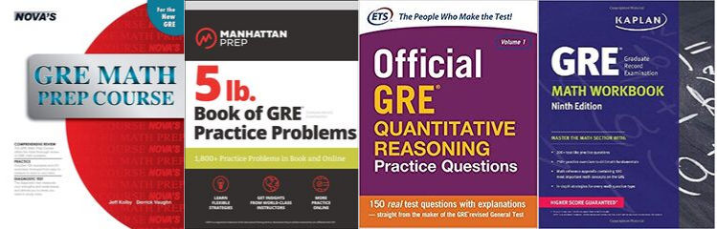

Analytical Writing
The sections aim at assessing the following abilities in a candidate:
- articulate complex ideas effectively and with clarity
- support ideas with appropriate reasons and examples
- examine claims and accompanying evidence
- sustain a well-focused, coherent discussion
- control the elements of standard written English
Books for Analytical Writing
- Vibrant Publishers GRE Analytical Writing – Solutions to Real Essay Topics ( Books 1 and 2)
- ETS Official Guide to the GRE Revised General Test


GRE® Revised General Test: Analytical Writing Question Types

The Analytical Writing section of the GRE revised General Test consists of two separately timed analytical writing tasks:

- An Analyze an Issue task
- An Analyze an Argument task

Analyze An Issue Task

The Analyze an Issue task assesses your ability to think critically about a topic of general interest and to clearly express your thoughts about it in writing. Each issue statement makes a claim that you can discuss from various perspectives and apply to many different situations or conditions. The issue statement is followed by a set of specific instructions. The specific instructions could be one of the following:

- Write a response in which you discuss the extent to which you agree or disagree with the statement and explain your reasoning for the position you take. In developing and supporting your position, you should consider ways in which the statement might or might not hold true and explain how these considerations shape your position.

- Write a response in which you discuss the extent to which you agree or disagree with the recommendation and explain your reasoning for the position you take. In developing and supporting your position, describe specific circumstances in which adopting the recommendation would or would not be advantageous and explain how these examples shape your position.

- Write a response in which you discuss the extent to which you agree or disagree with the claim. In developing and supporting your position, be sure to address the most compelling reasons or examples that could be used to challenge your position.

- Write a response in which you discuss which view more closely aligns with your own position and explain your reasoning for the position you take. In developing and supporting your position, you should address both of the views presented above.

- Write a response in which you discuss the extent to which you agree or disagree with the claim AND the reason on which that claim is based.

- Write a response in which you discuss your views on the policy above and explain your reasoning for the position you take. In developing and supporting your position, you should consider the possible consequences of implementing the policy and explain how these consequences shape your position.

Sample Analyze an Issue Tasks

1. As people rely more and more on technology to solve problems, the ability of humans to think for themselves will surely deteriorate.

Write a response in which you discuss the extent to which you agree or disagree with the statement and explain your reasoning for the position you take. In developing and supporting your position, you should consider ways in which the statement might or might not hold true and explain how these considerations shape your position.

2. A nation should require all of its students to study the same national curriculum until they enter college.

Write a response in which you discuss the extent to which you agree or disagree with the recommendation and explain your reasoning for the position you take. In developing and supporting your position, describe specific circumstances in which adopting the recommendation would or would not be advantageous and explain how these examples shape your position.

Analyze An Argument Task

The Analyze an Argument task assesses your ability to understand, analyze, and evaluate arguments and to clearly convey your evaluation in writing. You are presented with a brief passage in which the author makes a case for some course of action or interpretation of events by presenting claims backed by reasons and evidence. Your task is to discuss the logical soundness of the author's case according to the specific instructions by critically examining the line of reasoning and the use of evidence. The specific instructions could be one of the following:

- Write a response in which you discuss what specific evidence is needed to evaluate the argument and explain how the evidence would weaken or strengthen the argument.

- Write a response in which you examine the stated and/or unstated assumptions of the argument. Be sure to explain how the argument depends on these assumptions and what the implications are if the assumptions prove unwarranted.

- Write a response in which you discuss what questions would need to be answered in order to decide whether the recommendation and the argument on which it is based are reasonable. Be sure to explain how the answers to these questions would help to evaluate the recommendation.

- Write a response in which you discuss what questions would need to be answered in order to decide whether the advice and the argument on which it is based are reasonable. Be sure to explain how the answers to these questions would help to evaluate the advice.

- Write a response in which you discuss what questions would need to be answered to decide whether the recommendation is likely to have the predicted result. Be sure to explain how the answers to these questions would help to evaluate the recommendation.

- Write a response in which you discuss what questions would need to be answered in order to decide whether the prediction and the argument on which it is based are reasonable. Be sure to explain how the answers to these questions would help to evaluate the prediction.

- Write a response in which you discuss one or more alternative explanations that could rival the proposed explanation and explain how your explanation or explanations can plausibly account for the facts presented in the argument.

Sample Analyze an Argument Tasks

1. In surveys Mason City residents rank water sports (swimming, boating, and fishing) among their favorite recreational activities. The Mason River flowing through the city is rarely used for these pursuits, however, and the city park department devotes little of its budget to maintaining riverside recreational facilities. For years there have been complaints from residents about the quality of the river’s water and the river’s smell. In response, the state has recently announced plans to clean up Mason River. Use of the river for water sports is, therefore, sure to increase. The city government should for that reason devote more money in this year’s budget to riverside recreational facilities.

Write a response in which you examine the stated and/or unstated assumptions of the argument. Be sure to explain how the argument depends on the assumptions and what the implications are if the assumptions prove unwarranted.

2. The following is a memorandum from the business manager of a television station.

“Over the past year, our late-night news program has devoted increased time to national news and less time to weather and local news. During this time period, most of the complaints received from viewers were concerned with our station’s coverage of weather and local news. In addition, local businesses that used to advertise during our late-night news program have just canceled their advertising contracts with us. Therefore, in order to attract more viewers to the program and to avoid losing any further advertising revenues, we should restore the time devoted to weather and local news to its former level.”

Write a response in which you discuss what specific evidence is needed to evaluate the argument and explain how the evidence would weaken or strengthen the argument.

GRE® Revised General Test: Verbal Reasoning Question Types

The GRE Verbal Reasoning section of the GRE revised General Test contains three types of questions:

- Reading Comprehension
- Text Completion
- Sentence Equivalence

Reading Comprehension questions appear in sets; Text Completion and Sentence Equivalence questions are independent.

Reading Comprehension Questions
There are three types of Reading Comprehension questions:

Multiple-choice Questions—Select One Answer Choice: These are the traditional multiple-choice questions with five answer choices of which you must select one.

Multiple-choice Questions—Select One or More Answer Choices: These provide three answer choices and ask you to select all that are correct; one, two, or all three of the answer choices may be correct. To gain credit for these questions, you must select all the correct answers, and only those; there is no credit for partially correct answers.

Select-in-Passage: The question asks you to click on the sentence in the passage that meets a certain description. To answer the question, you choose one of the sentences and click on it; clicking anywhere on a sentence will highlight it.

Reading comprehension passages are drawn from the physical sciences, the biological sciences, the social sciences, the arts and humanities, and everyday topics, and are based on material found in books and periodicals, both academic and nonacademic. The passages range in length from one paragraph to four or five paragraphs.

Sample questions 1 to 3 below are based on this passage:

Policymakers must confront the dilemma that fossil fuels continue to be an indispensable source of energy even though burning them produces atmospheric accumulations of carbon dioxide that increase the likelihood of potentially disastrous global climate change. Currently, technology that would capture carbon dioxide emitted by power plants and sequester it harmlessly underground or undersea instead of releasing it into the atmosphere might double the cost of generating electricity. But because sequestration does not affect the cost of electricity transmission and distribution, delivered prices will rise less, by no more than 50 percent. Research into better technologies for capturing carbon dioxide will undoubtedly lead to lowered costs.

Sample Multiple-choice Question—Select One Answer Choice

1. The passage implies which of the following about the current cost of generating electricity?

A. It is higher than it would be if better technologies for capturing carbon dioxide were available.
B. It is somewhat less than the cost of electricity transmission and distribution.
C. It constitutes at most half of the delivered price of electricity.
D. It is dwelt on by policymakers to the exclusion of other costs associated with electricity delivery.
E. It is not fully recovered by the prices charged directly to electricity consumers.

Answer: C. It constitutes at most half of the delivered price of electricity.

Sample Multiple-choice Question—Select One or More Answer Choices

Consider each of the three choices separately and select all that apply.
2. The passage suggests that extensive use of sequestration would, over time, have which of the following consequences?

A. The burning of fossil fuels would eventually cease to produce atmospheric accumulations of carbon dioxide.
B. The proportion of the delivered price of electricity due to generation would rise and then decline.
C. Power plants would consume progressively lower quantities of fossil fuels.

Answer: B. The proportion of the delivered price of electricity due to generation would rise and then decline.

Sample Select-in-Passage Question

3. Select the sentence that explains why an outcome of sequestration that might have been expected would not occur.

Answer: “But because sequestration does not affect the cost of electricity transmission and distribution, delivered prices will rise less, by no more than 50 percent.”

Sample questions 4 to 6 below are based on this passage:

Reviving the practice of using elements of popular music in classical composition, an approach that had been in hibernation in the United States during the 1960’s, composer Philip Glass (born 1937) embraced the ethos of popular music without imitating it. Glass based two symphonies on music by rock musicians David Bowie and Brian Eno, but the symphonies’ sound is distinctively his. Popular elements do not appear out of place in Glass’s classical music, which from its early days has shared certain harmonies and rhythms with rock music. Yet this use of popular elements has not made Glass a composer of popular music. His music is not a version of popular music packaged to attract classical listeners; it is high art for listeners steeped in rock rather than the classics.

Sample Multiple-choice Question—Select One Answer Choice

4. The passage addresses which of the following issues related to Glass’s use of popular elements in his classical compositions?

A. How it is regarded by listeners who prefer rock to the classics
B. How it has affected the commercial success of Glass’s music
C. Whether it has contributed to a revival of interest among other composers in using popular elements in their compositions
D. Whether it has had a detrimental effect on Glass’s reputation as a composer of classical music
E. Whether it has caused certain of Glass’s works to be derivative in quality

Answer: E. Whether it has caused certain of Glass’s works to be derivative in quality

Sample Multiple-Choice Question—Select One or More Answer Choices

Consider each of the three choices separately and select all that apply.
5. The passage suggests that Glass’s work displays which of the following qualities?

A. A return to the use of popular music in classical compositions
B. An attempt to elevate rock music to an artistic status more closely approximating that of classical music
C. A long-standing tendency to incorporate elements from two apparently disparate musical styles

Answer: A (A return to the use of popular music in classical compositions) and C (A long-standing tendency to incorporate elements from two apparently disparate musical styles)

Sample Select-in-Passage Question

6. Select the sentence that distinguishes two ways of integrating rock and classical music.

Answer: “His music is not a version of popular music packaged to attract classical listeners; it is high art for listeners steeped in rock rather than the classics.”

Text Completion Questions

Text Completion questions include a passage composed of one to five sentences with one to three blanks. There are three answer choices per blank, or five answer choices if there is a single blank. There is a single correct answer, consisting of one choice for each blank. The examinee receives no credit for partially correct answers.

Sample Text Completion Questions

Directions: For each blank select one entry from the corresponding column of choices. Fill all blanks in the way that best completes the text.

Text Completion Question 1.
It is refreshing to read a book about our planet by an author who does not allow facts to be BLANK by politics: well aware of the political disputes about the effects of human activities on climate and biodiversity, this author does not permit them to BLANK his comprehensive description of what we know about our biosphere. He emphasizes the enormous gaps in our knowledge, the sparseness of our observations, and the BLANK, calling attention to the many aspects of planetary evolution that must be better understood before we can accurately diagnose the condition of our planet.

Answer choices for question 1.

Blank 1 | Blank 2 | Blank 3
overshadowed | enhance | plausibility of our hypotheses
invalidated | obscure | certainty of our entitlement
illuminated | underscore | superficiality of our theories

Answer: overshadowed, obscure, and superficiality of our theories

Answer to Question 1 in Context:
It is refreshing to read a book about our planet by an author who does not allow facts to be overshadowed by politics: well aware of the political disputes about the effects of human activities on climate and biodiversity, this author does not permit them to obscure his comprehensive description of what we know about our biosphere. He emphasizes the enormous gaps in our knowledge, the sparseness of our observations, and the superficiality of our theories, calling attention to the many aspects of planetary evolution that must be better understood before we can accurately diagnose the condition of our planet.

Text Completion Question 2.
Vain and prone to violence, Caravaggio could not handle success: the more his BLANK as an artist increased, the more BLANK his life became.

Answer choices for question 2.

Blank 1 | Blank 2
temperance | tumultuous
notoriety | providential
eminence | dispassionate

Answer: eminence and tumultuous

Answer to Question 2 in Context:

Vain and prone to violence, Caravaggio could not handle success: the more his eminence as an artist increased, the more tumultuous his life became.

Text Completion Question 3.

The author’s BLANK style renders a fascinating subject, the role played by luck in everyday life, extraordinarily BLANK.

Answer choices for question 3.

Blank 1 | Blank 2
soporific | pedantic
lucid | tedious
colloquial | opaque

Answer: soporific and tedious

Answer to Question 3 in Context:
The author’s soporific style renders a fascinating subject, the role played by luck in everyday life, extraordinarily tedious.

Text Completion Question 4.

From the outset, the concept of freedom of the seas from the proprietary claims of nations was challenged by a contrary notion—that of the BLANK of the oceans for reasons of national security and profit.

A. promotion
B. exploration
C. surveying
D. conservation
E. appropriation

Answer: E. appropriation

Answer to Question 4 in Context:

From the outset, the concept of freedom of the seas from the proprietary claims of nations was challenged by a contrary notion—that of the appropriation of the oceans for reasons of national security and profit.

Sentence Equivalence Questions
Sentence Equivalence questions consist of a single sentence, one blank, and six answer choices. These questions require the examinee to select two of the answer choices. The examinee receives no credit for partially correct answers.

Sample Sentence Equivalence Questions
Directions: Select the two answer choices that, when used to complete the sentence, fit the meaning of the sentence as a whole and produce completed sentences that are alike in meaning.

1. Although it does contain some pioneering ideas, one would hardly characterize the work as BLANK.

A. orthodox
B. eccentric
C. original
D. trifling
E. conventional
F. innovative

Answer: C (original) and F (innovative)

2. The corporation expects only BLANK increases in sales next year despite a yearlong effort to revive its retailing business.

A. dynamic
B. predictable
C. expanding
D. modest
E. slight
F. volatile

Answer: D (modest) and E (slight)

GRE® Revised General Test: Quantitative Reasoning Question Types

Figures
This document includes figures, which appear on screen. Following each figure on screen is text describing that figure. Readers using visual presentations of the figures may choose to skip parts of the text describing the figure that begin with “Begin skippable figure description” and end with “End skippable figure description.”

Mathematical Equations and Expressions
This document includes mathematical equations and expressions. Some of the mathematical equations and expressions are presented as graphics. In cases where a mathematical equation or expression is presented as a graphic, a verbal presentation is also given and the verbal presentation comes directly after the graphic presentation. The verbal presentation is in green font to assist readers in telling the two presentation-modes apart. Readers using audio alone can safely ignore the graphical presentations, and readers using visual presentations may ignore the verbal presentations.

Introduction

The revised Quantitative Reasoning section contains four types of questions:

Multiple-choice Questions — Select One Answer Choice
Multiple-choice Questions — Select One or More Answer Choices
Numeric Entry Questions
Quantitative Comparison Questions

Each question appears either independently as a discrete question or as part of a set of questions called a Data Interpretation set. All of the questions in a Data Interpretation set are based on the same data presented in tables, graphs, or other displays of data. Below are descriptions, directions, and samples of each type of question.

Multiple-Choice Questions — Select One Answer Choice

These questions are multiple-choice questions that ask you to select only one answer choice from a list of five choices.

Sample Questions

Directions: Select a single answer choice.

Sample question 1 below is based on figure 1.
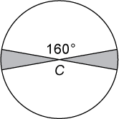
Figure 1

Begin skippable figure description.
Figure 1 is a circle with center C. Two diameters of the circle are drawn, dividing the circle into 4 sectors. Two nonadjacent sectors are shaded, and the central angle of one of the unshaded sectors measures 160 degrees.

End skippable figure description.

1. Figure 1 above shows a circle with center C and radius 6. What is the sum of the areas of the two shaded regions?
A. 7.5 pi
B. 6 pi
C. 4.5 pi
D. 4 pi
E. 3 pi

Answer: D (4 pi)

Sample question 2 below is based on figure 2.
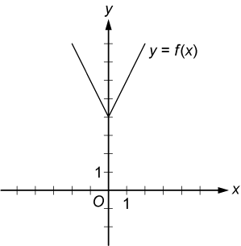
Figure 2

Begin skippable figure description.
Figure 2 shows the graph in the x y plane of the function f of x = the absolute value of 2x, end absolute value, + 4. There are equally spaced tick marks along the x axis and along the y axis. The first tick mark to the right of the origin, and the first tick mark above the origin, are both labeled 1.
The graph of the function f is in the shape of the letter V. It is above the x axis and is symmetric with respect to the y axis.
The lowest point on the graph of f is the point 0 comma 4 on the y axis.
Going leftward from the point 0 comma 4 the graph of f is a line that slants upward, passing through the point negative 2 comma 8.
Going rightward from the point 0 comma 4 the graph of f is a line that slants upward, passing through the point 2 comma 8.

End skippable figure description.

2. Figure 2 above shows the graph of a function f, defined by f of x = the absolute value of 2x, end absolute value, + 4 for all numbers x. For which of the following functions g defined for all numbers x does the graph of g intersect the graph of f ?
A. g of x = x minus 2
B. g of x = x + 3
C. g of x = 2x minus 2
D. g of x = 2x + 3
E. g of x = 3x minus 2

Answer: E (g of x = 3x minus 2)

Multiple-Choice Questions — Select One or More Answer Choices

These questions are multiple-choice questions that ask you to select one or more answer choices from a list of choices. A question may or may not specify the number of choices to select.

Sample Questions

Directions: Select one or more answer choices according to the specific question directions.

If the question does not specify how many answer choices to select, select all that apply.

The correct answer may be just one of the choices or may be as many as all of the choices, depending on the question.

No credit is given unless you select all of the correct choices and no others.

If the question specifies how many answer choices to select, select exactly that number of choices.

1. Each employee of a certain company is in either Department X or Department Y, and there are more than twice as many employees in Department X as in Department Y. The average (arithmetic mean) salary is $25,000 for the employees in Department X and is $35,000 for the employees in Department Y. Which of the following amounts could be the average salary for all of the employees in the company?

Indicate all such amounts.

A. $26,000
B. $28,000
C. $29,000
D. $30,000
E. $31,000
F. $32,000
G. $34,000

Answer: A ($26,000) and B ($28,000)

2. If f, g, and h are positive integers, f is a factor of g, and g is a factor of h, which of the following statements must be true?

Indicate all such statements.

A. f is a factor of g squared.
B. f is a factor of gh.
C. f is a factor of h minus g.

Answer: A (f is a factor of g squared), B (f is a factor of gh.), and C (f is a factor of h minus g)

Numeric Entry Questions

Questions of this type ask you either to enter the answer as an integer or a decimal in a single answer box or to enter it as a fraction in two separate boxes — one for the numerator and one for the denominator. In the computer-administered test, the computer mouse and keyboard are used to enter the answer.

Sample Questions

Directions: Enter your answer in the answer box(es) below the question.

Equivalent forms of the correct answer, such as 2.5 and 2.50, are all correct. Fractions do not need to be reduced to lowest terms.

Enter the exact answer unless the question asks you to round your answer.

1. If x = 10 to the power negative 1, what is the value of 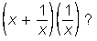 open parenthesis, x + the fraction 1 over x, close parenthesis, times, open parenthesis, 1 over x, close parenthesis?

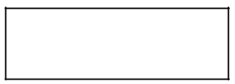Answer Box

Answer: 101

2. A university admitted 100 students who transferred from other institutions. Of these students, 34 transferred from two-year community colleges, 25 transferred from private four-year institutions, and the rest transferred from public four-year institutions. If two different students are to be selected at random from the 100 students, what is the probability that both students selected will be students who transferred from two-year community colleges?

Give your answer as a fraction.

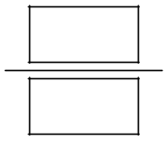Fraction answer boxes

Answer: 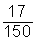17 over 150 (or any equivalent fraction).

Quantitative Comparison Questions

Questions of this type ask the examinee to compare two quantities — Quantity A and Quantity B — and then determine which of four statements describes the comparison.

Sample Questions

Directions: Compare Quantity A and Quantity B, using the additional information given, if any. Select one of the following four answer choices.

A. Quantity A is greater.

B. Quantity B is greater.

C. The two quantities are equal.

D. The relationship cannot be determined from the information given.

A symbol that appears more than once in a question has the same meaning throughout the question.

1.
Quantity A: x squared + 1
Quantity B: 2x, minus 1

A. Quantity A is greater.
B. Quantity B is greater.
C. The two quantities are equal.
D. The relationship cannot be determined from the information given.

Answer: A (Quantity A is greater.)

Sample question 2 below is based on figure 3.
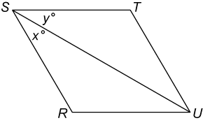
Figure 3

Begin skippable figure description.
Figure 3 shows parallelogram RSTU. Sides R U and S T are horizontal, with S T above, and slightly to the left of side R U. Diagonal S U, which extends from vertex S at the upper left of the parallelogram to vertex U at the lower right of the parallelogram, divides the parallelogram into two triangles, R S U and U S T; and the angle at vertex S into 2 adjacent angles R S U and U S T. The measure of angle R S U is x degrees, and the measure of angle U S T is y degrees.

End skippable figure description.

2.
It is given that RSTU is a parallelogram.
Quantity A: x
Quantity B: y

A. Quantity A is greater.
B. Quantity B is greater.
C. The two quantities are equal.
D. The relationship cannot be determined from the information given.

Answer: D (The relationship cannot be determined from the information given.)

Data Interpretation Sets

Data Interpretation questions are grouped together and refer to the same table, graph, or other data presentation. These questions ask you to interpret or analyze the given data. The types of questions may be Multiple-choice (both types) or Numeric Entry.

Sample Questions

Directions: Questions 1 to 3 are based on the data in the following table.

The table shows the percent change in monthly value of inventory at six businesses from April to June.
Business | Percent Change from April to May | Percent Change from May to June
G | +6 | +8
K | +5 | minus 5
M | +2 | +12
R | +8 | minus 5
V | +14 | 0
Z | +2 | minus 10

Note: Inventory values are determined at the end of each month.

1. If the value of inventory at Business K was $30,000 for April, what was the value of inventory at Business K for June?

A. $22,500
B. $29,925
C. $30,000
D. $33,000
E. $33,075

Answer: B ($29,925)

2. At Business M, the value of inventory for May was what percent of the value of inventory for June?

Give your answer to the nearest 0.1 percent.

% Answer box followed by percent sign
Answer: 89.3

3. For which of the six businesses shown was the percent change in value of inventory from April to June greatest?

A. G
B. K
C. M
D. R
E. V

Answer: A (Business G)

Directions: Questions 4 to 6 are based on the data shown in figure 4.

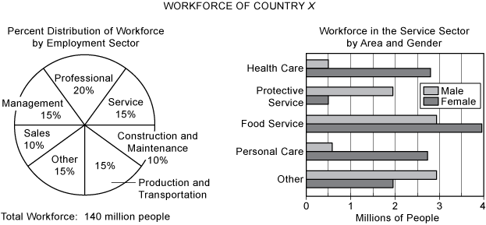
Figure 4

Begin skippable figure description.
The title of the data in figure 4 is “Workforce of Country X.” The data consists of a pie chart and a bar graph. The title of the pie chart is “Percent Distribution of Workforce by Employment Sector” and the title of the bar graph is “Workforce in the Service Sector by Area and Gender.”
The percent distribution of the workforce by employment sector in the pie chart is as follows:
Professional Sector 20%.
Service Sector 15%
Construction and Maintenance Sector 10%
Production and Transportation Sector 15%
Other Sector 15%
Sales Sector 10%
Management Sector 15%
The bar graph shows the number of males and females in each of the five service sectors. The bar graph has horizontal bars. The graph has a horizontal axis labeled Millions of People, with vertical gridlines in multiples of 0.5 million, from 0.5 million to 4 million. Five Service Sector areas are listed along the vertical axis. The data in the bar graph is as follows:
Health Care Sector, 0.5 million males and 2.75 females
Protective Service Sector, a little under 2 million males and 0.5 million females
Food Service Sector, a little under 3 million males and a little under 4 million females
Personal Care Sector, a little over 0.5 million males and about 2.75 million females
Other Sector, a little under 3 milllion males and a little under 2 million females

End skippable figure description.

4. Approximately how many people are in the production and transportation sector of the workforce?

A. 9 million
B. 12 million
C. 15 million
D. 18 million
E. 21 million

Answer: E (21 million)

5. Approximately what fraction of the workforce in the food service area of the service sector is male?

A. 1 fourth
B. 1 third
C. 3 sevenths
D. 4 sevenths
E. 7 tenths

Answer: C (3 sevenths)

6. In the workforce, the ratio of the number of males to the number of females is the same for the sales sector as it is for the protective service area of the service sector. Which of the following is closest to the number of females in the sales sector?

A. 2.9 million
B. 3.6 million
C. 10.4 million
D. 11.1 million
E. 14.0 million

Answer: A (2.9 million)

References-

Exam pattern-
https://collegedunia.com/exams/gre/exam-pattern

Sample test-
https://www.ets.org/gre/revised_general/prepare/?WT.ac=gre_prepare_170731

Test dates-
https://ereg.ets.org/ereg/public/workflowmanager/workflow?workflowItemId=tcAvailability

MBA Gre Universities-
https://www.ets.org/gre/revised_general/about/mba/programs/

Attached Sample GRE Quant,Verbal papers

