1. OBJECTIVE

This project is to use Model Predictive Control (MPC) to drive a car in the Udacity simulator. The simulator provides reference waypoints and we use MPC to compute steering and throttle commands to drive the car. The solution must be robust to 100ms latency to simulate real-world user and actuator delays. In this project, the MPC optimize the actuators (steering and throttle), simulate the vehicle trajactory, and minimize the cost like cross-track error. A max speed of 80 MPH is achieved in this project.

2. MODEL

2.1 KINEMATIC MODEL
A kinematic model is implemented to control the vehicle around the track. Kinematic models are simplifications of dynamic models that ignore tire forces, gravity, and mass. This simplification reduces the accuracy of the models, but it also makes them more tractable. The kinematic model includes the vehicle's x and y coordinates, orientation angle (psi), and velocity, as well as the cross-track error and psi error (epsi). Actuator outputs are acceleration and delta (steering angle). The model combines the state and actuations from the previous timestep to calculate the state for the current timestep.

States:
x: cars x position
y: cars y position
ψ (psi): vehicle's angle in radians from the x-direction (radians)
ν: vehicle's velocity
cte: cross track error
eψ : orientation error

Actuator values
δ (delta): steering angle
a : acceleration (including throttle and break)

The kinematic model can predict the state on the next time step by taking into account the current state and actuators as follows:
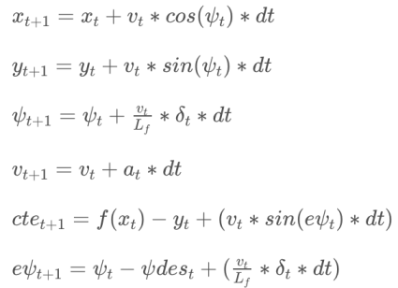

2.2 Timestep Length and Elapsed Duration (N & dt)
N = 10
dt = 0.10 s // tested with 0.3, 0.12, 0.1, 0.08s
The prediction horizon T is the duration over which future predictions are made. T is the product of N and dt, T = N * dt. T is usually a few seconds, at most. Beyond that horizon, the environment will change enough that it won't make sense to predict any further into the future. N and dt are parameters to be tuned for each model predictive controller. However, there are some general guidelines: T should be as large as possible, while dt should be as small as possible. These guidelines create tradeoffs.
These following dt has been tested 0.3, 0.12, 0.1, 0.08, and I found that the dt should be closer to the latency in order to make the MPC work. So, dt = 0.10 was selected.
The goal of Model Predictive Control is to optimize the control inputs: [δ,a]. An optimizer will tune these inputs until a low cost vector of control inputs is found.

2.3 Polynomial Fitting and MPC Preprocessing
Since the reference waypoints are given in the map global coordinates, they were converted into the car's coordinate and then a 3rd order polynomial is fitted to waypoints. Actual state of the vehicle was "shifted" into the future by 100 ms latency. It helps to reduce negative effects of the latency and increase stability of the controller. The cost function parameters were tuned by try-and-error method.

2.4 Model Predictive Control with Latency

The latency was introduced to simulate real delay of a human driver or physical actuators in case of a self driving car. The original kinematic equations depend upon the actuations from the previous timestep, but with a delay of 100ms (which happens to be the timestep interval) the actuations are applied another timestep later, so the equations have been altered to account for this.

