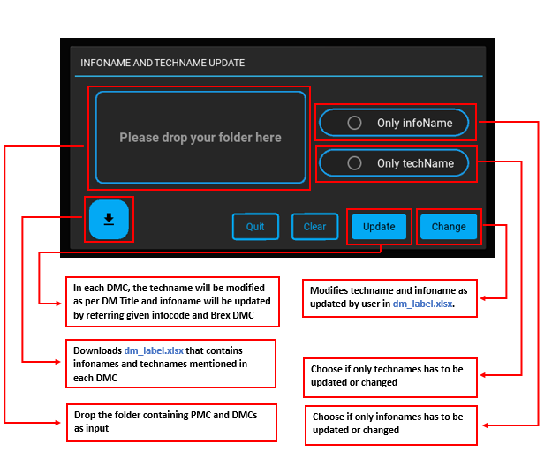

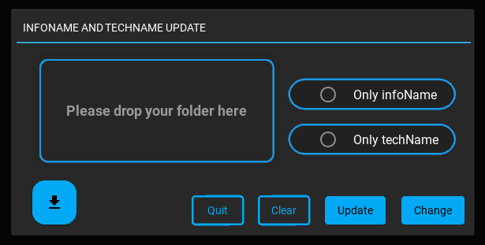

**Modifies techname and infoname as updated by user in dm_label.xlsx.**

**Choose if only infonames has to be updated or changed**

**Choose if only technames has to be updated or changed**

**In each DMC, the techname will be modified as per DM Title and infoname will be updated by referring given infocode and Brex DMC**

**Drop the folder containing PMC and DMCs as input**

**Downloads dm_label.xlsx that contains infonames and technames mentioned in each DMC**