**Software Requirements Specification**

**For**

**Guarantee/Warranty card & Bill saving System**

**Version 1.0 approved**

**Prepared by Vinay Kantilal Chavan**

**VJTI**

**22-09-2017**

**Table of Contents**

**Table of Contents 2**

**1. Introduction 3**

1.1 Purpose 3

1.2 Document Conventions 3

1.3 Intended Audience and Reading Suggestions 3

1.4 Product Scope 4

1.5 References 4

1.6 Overview of Document 4

**2. Overall Description 6**

2.1 Product Perspective 6

2.2 Product Functions 6

2.3 User Classes and Characteristics 6

2.4 Operating Environment 7

2.5 Design and Implementation Constraints 7

2.6 User Documentation 7

**3. External Interface Requirements**  **8**

3.1 User Interfaces 8

3.2 Hardware Interfaces 9

3.3 Software Interfaces 10

3.4 Communications Interfaces 10

**4. System Features** 11

4.1 System Feature 1 11

**5. Other Nonfunctional Requirements** 22

5.1 Performance Requirements 22

5.2 Safety Requirements 22

5.3 Security Requirements 22

5.4 Software Quality Attributes 22

5.5 Business Rules 22

# Introduction

## Purpose

The purpose of this Software Requirements Specification (SRS) document is to provide a detailed description of the functionalities of the Guarantee/Warranty card & Bill system. This document will cover each of the system’s intended features, as well as offer a preliminary glimpse of the software application’s User Interface (UI). The document will also cover hardware, software, and various other technical dependencies.

In Today’s life people has to keep the Guarantee/Warranty card And Bill for each electronic product manually to get benefits when product get damage/Nonfunctional under valid period of time, if user fail to keep those card and bill then user will not get any benefit though the product is under the valid period and user has to pay money for repairing of product. Usually one person has many electronics things in house so it’s very difficult to maintain Guarantee/Warranty card And Bill for each electronic product manually to avoid this we are creating a system where all Guarantee/Warranty cards And Bills will save digitally and user will not to worry to maintain the cards.

## Document Conventions

The document focuses on the high priority requirements which will be implemented for the final deliverable

## Intended Audience and Reading Suggestions

This document is for all stack-holders who are participating and/or supervising the Guarantee/Warranty card And Bill Saving System project. This has been implemented under the guidance of college professors. This project is useful for the sellers and as well as to the customers. It will illustrate the purpose and complete declaration for the development of system. It will also explain system constraints, interface and interactions with other external applications. This document is primarily intended to be proposed to a customer for its approval and a reference for developing the first version of the system for the development team. If readers interested in a brief overview of the product should focus on the rest of Chapter 1 (Introduction), as well as Chapter 2 of the document (Overall Description), which provide a brief overview of each aspect of the system as a whole. The all information about the system is provided in this document. All project technical details are provided in this document.

Readers who wish to add the features of Guarantee/Warranty card & Bill in more detail should read on to Chapter 4 (System Features), which expands upon the information laid out in the main overview. Chapter 3 (External Interface Requirements) offers further technical details, including information on the user interface as well as the hardware and software platforms on which the application will run.

Readers interested in the non-technical aspects of the project should read Part 5, which covers performance, safety, security, and various other attributes that will be important to users. Readers who have not found the information they are looking for should check Part 8 (Other Requirements), which includes any additional information which does not fit logically into the other sections.

## Product Scope

The Guarantee/Warranty card And Bill saving system is client/server architecture where customers and sellers will create account. Client side will be on web portal/Android App and server side will provide the features to the clients (customer and seller).The overall system includes saving Guarantee/Warranty card and also Bills of that product. The customer also asks for extension of Guarantee/Warranty card.

## References

1. IEEE Software Engineering Standards Committee, “IEEE STD 830-1998, IEEE Recommended Practice for Software Requirements Specifications”, October 20, 1998
2. <http://www.cse.chalmers.se/~feldt/courses/reqeng/examples/srs_example_2010_group2.pdf>
3. <https://krazytech.com/projects>

**1.6 Overview of the Document**

The next chapter, the Overall Description section, of this document gives an overview of the functionality of the product. It describes the informal requirements and is used to establish a context for the technical requirements specification in the next chapter.

The third chapter, Requirements Specification section, of this document is written primarily for the developers and describes in technical terms the details of the functionality of the product.

Both sections of the document describe the same software product in its entirety, but are intended for different audiences and thus use different language.

# Overall Description

## Product Perspective

This system contains only one part i.e. web portal/Android app. In web portal/Android app the customer and seller can view the data where the customer also can request for extension of guarantee/warranty card. Seller can create/update the card for the customer. The customer has to go to the seller’s store and buy the item and if the item consist guarantee /warranty then the seller will create card for the customer and assign it to the customer id on web portal/Android app.

## Product Functions

With the help of web portal/Android app the user can search the data and the customer also can see the guarantee/Warranty card validity. On the other side the seller also can see the particular user’s card validity and also can update it.

The customer will get notification when his/her guarantee/Warranty card is about to expire before month. If the user will click on that notification it will redirected to site and site will provide the many options about extension of Guarantee/Warranty card if user chooses the period of extension then the seller will be notified the same and the seller and then the system will ask seller for confirmation if seller confirmed it then customer get notification about that sellers confirmed it and then the customer has to pay money according to the period and rules and after the payment the card will automatically extended and user will notify the same. If a seller denies to extend the warranty then the customer gets notification that the seller’s denied the request.

## User Classes and Characteristics

There are three types of users that interact with the system: Customer, Seller and the administrator each of these have the different use of the system so each of them has different requirements.

## Operating Environment

The customer and the seller both must have Internet connection to access the data on web portal/Android app. The device could be PC, Mobile and Laptop which support the browsing.

1. Any Browser i.e. Google Chrome, Fire-Fox, Internet Explorer.
2. Cell phones with android version greater than 2.0 to debug and run the app.
3. Android Studio or Net beans or Eclipse IDE.

## User Documentation

The components which will be delivered to user as follows:

1. User Manual.

2. SRS Document

3. Tutorial Video.

There will also help option available for user on web portal/Android app in which all information about the system will be given with some FAQs.

# External Interface Requirements

## User Interfaces

1. Customer Side

The project will have following screens:

1. Login screen/Register screen.
2. Home will contain product advertisement uploaded by seller user can also block particular or all advertisements.
3. If user clicks on particular products advertisement and click on interest button then notification will sent to seller with all user details.
4. Dashboard will contain tabs like Bill, Cards, Request, Help and Contact Us
5. On Clicking on Bill tab it will open new screen which will contain all products bills list on clicking on each it will again create new screen with all deep details about the bill such as date, product id, QR code, name of the customer, paid money.
6. On Clicking on Cards tab it will open new screen which will contain all products cards (It will show whether it is Guarantee card or Warranty card besides the title) list on clicking on each it will again create new screen with all deep details about the card such as start-date, end-date, Valid period, product id, QR code, name of the customer, paid money.
7. On clicking on Request tab it will create new screen which will show the cards list which are going to expire after some period if user clicks on particular card it will create new screen which will include various extension options such as for 6 months , 1 year on selecting on each option there will be Cost label beside it will show the price for that extension as per extension period and product details .If user clicks on request button afterwards the notification will be sent to seller if seller accepts it user has to pay the money through payment gateway(online).
8. On Clicking on Help tab it will create new screen which will contain all information about the app and which will also include some FAQs and feedback forms.
9. On Clicking on Contact Us tab it will create new screen which will provide the developers contact information such as email id and contact no.
10. Seller Side

The project will have following screens:

1. Login screen/Register screen.
2. Home will contain all interested user for particular advertisement with all their details and then seller will mail them with all specific details about the product.
3. Dashboard will contain tabs like Upload product advertise, Request, Help and Contact Us
4. On clicking on Upload product advertise it will create new screen where seller has to fill all required information and upload product images after clicking on upload button it will be uploaded to all customers which are related to the sellers account. In first when seller do not have any previous customer then seller has to pay money to advertise the product to the system developer the payment will depend on period to be product to be advertise.
5. On clicking on Request tab it will create new screen which will show all customers request for extension on clicking on one it will create new screen which will provide all deep details such as customer name, product id, product name, purchase date, extension period ,money etc. and it will provide two buttons accept and reject and also mode of payment if customer clicks on accept it will notified to user and then user has to pay and after successful payment the money will transfer to account if seller ask for online payment otherwise user has to pay to seller by cash and if seller has choose cash payment there will be generate new button name extend warranty and if seller clicks on it card guarantee/Warranty will be extended whether in online payment case it will be extended automatically and if seller click on reject button the customer will again notify the same.
6. On Clicking on Help tab it will create new screen which will contain all information about the app and which will also include some FAQs and feedback forms
7. On Clicking on Contact Us tab it will create new screen which will provide the developers contact information such as email id and contact no.

## Hardware Interfaces

Guarantee/Warranty card And Bill saving system is intended as a mobile application or web portal for the Android platform and hence is solely supported on Android-powered devices. Messages, updates, and data exchanged between Android devices are transmitted to and handled by the system server. Guarantee/Warranty card And Bill saving system is being developed specifically for Android and web portal. The Android and web portal platform supports push messages that will be used to synchronize data between the local application and the main application server. Information will be sent using TCP/IP and the HTTP protocol. The Android and web portal platform provides abstractions for all network communication interfaces and thus the hardware as well.

Software Interfaces

1. Android app

System will implement in Android Studio with backend Java development Kit (JDK).

1. Web Portal

Web portal will be implemented with the following things:

1. Database:SQL
2. Front-end: HTML, CSS, Boot-Strap
3. Back-end: PHP, Java, Python

The communication between the database and the web portal consists of operation concerning both reading and modifying the data, while the communication between the database and the mobile application consists of only reading operations.

## Communications Interfaces

The communication between the different parts of the system is important since they depend on each other. However, in what way the communication is achieved is not important for the system and is therefore handled by the underlying operating systems for both the mobile application and the web portal.

# System Features

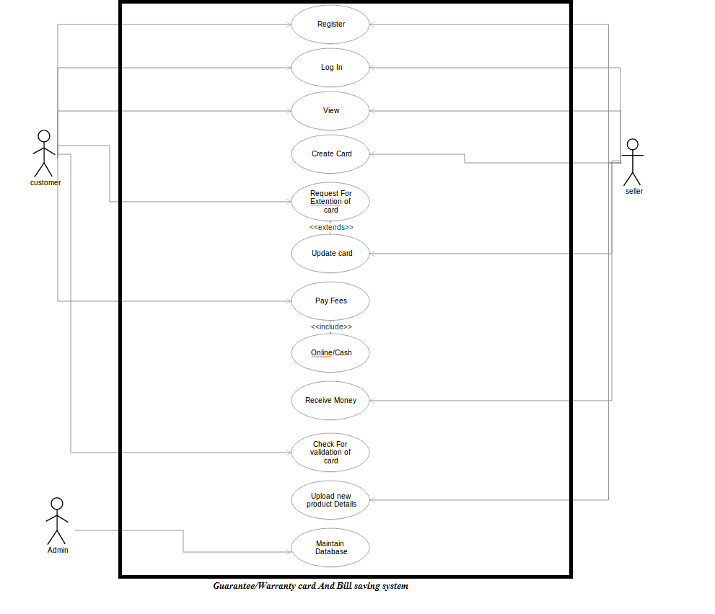

## System Feature 1

# Use case No.1

**Use case Name: Create Account**

**Use case Description:** This use case will allow both customers and sellers to register themselves with the system for using it.

**Actors involved:** customers, sellers

**Frequency usage:** Low

**Pre-condition:** This is the first task that would be performed by people interacting with this system. Therefore, it does not require any pre-condition.

# Basic flow & events

|  |  |
| --- | --- |
| Actor | System |
| 1)Actor hits register button | 2)Display registration form to be filled out |
| 3) Actor has to fill this form. | 4) System saves entered information into database and prompt “your information has been saved successfully." |

**Alternet flow & events**

3.1) System shows error when entered information is not in proper format. 3.2) System will resume at 2.0 in main flow.

4.1) if database connectivity failure occurs then system will show “Database Connectivity error” and will resume at 2.0.

**Post condition:** After successful registration system will bring to login Page.

**Special condition:** the response from database after insertion of

Information must fast enough.

# Use case No.2

**Use case Name: Login**

**Use case Description:** This use case will allow both customers and sellers to Log into the system.

**Actors involved:** Customers, sellers

# Frequency usage: high

**Pre-condition:** Customers and sellers must be registered before using this use Case.

# Basic flow & events

|  |  |
| --- | --- |
| Actor | System |
| 1)Actor hits login button | 2)System asks for log in credentials |
|  | 3) System verifies entered credentials with the database. After verification Actor logged into the system. |

**Alternet flow & events**

2.1) System shows error when entered information is not in proper format. 3.1) System shows error “invalid credential”, when verification fails and Resumes at 2.0.

3.2) if database connectivity failure occurs then system will show “Database Connectivity error” and will resume at 2.0.

**Post condition:** After successful login to system.it will bring to

Next page depends upon type of actor.

**Special condition:** the response from database after verification of

Credential must fast enough.

# Use case No.3

**Use case Name:** Create Card

**Use case Description:** This use case will allow sellers to create a Guarantee/Warranty card for particular product and customer.

**Actors involved:** seller

**Frequency usage:** Medium

**Pre-condition:** Seller must be Loged-in.

# Basic flow & events

|  |  |
| --- | --- |
| Actor | System |
| 1)Actor hits Create card button | 2)Display card form to be filled out |
| 3) Actor has to fill this form. | 4) System saves entered information into database and prompt “your information has been saved successfully." |

**Alternet flow & events**

3.1) System shows error when entered information is not in proper format. 3.2) System will resume at 2.0 in main flow.

4.1) if database connectivity failure occurs then system will show “Database Connectivity error” and will resume at 2.0.

**Post condition:** After successful creation card display message i.e. successful created a card.

**Special condition:** the response from database after insertion of

Information must fast enough.

# Use case No.4

**Use case Name:** Update Card

**Use case Description:** This use case will allow sellers to update card which already exist.

**Actors involved:** seller

**Frequency usage:** Low

**Pre-condition:** Seller must be Logged-in & and card must be exist for that product and customer.

**Basic flow & events**

|  |  |
| --- | --- |
| Actor | System |
| 1)Actor hits update card button | 2) System saves entered information into database and prompt “your information has been saved successfully." |

**Alternet flow & events**

4.1) if database connectivity failure occurs then system will show “Database Connectivity error” and will resume at 2.0.

**Post condition:** After successful updation of card

**Special condition:** the response from database after insertion of

Information must fast enough.

# Use case No.5

**Use case Name:** View

**Use case Description:** This use case will allow both sellers and customers

to view the system and the data associate with their accounts

**Actors involved:** seller, customers

**Frequency usage:** High

**Pre-condition:** Seller & customer must be Loged-in.

**Basic flow & events**

None

**AlterNet flow & events**

None

**Post condition:** After successful Login. Seller and customer can view the data.

**Special condition:** the response from database after insertion of Information must fast enough.

# Use case No.6

**Use case Name:** Request for extension

**Use case Description:** This use case will allow customers to request for the extension of guarantee/warranty card for particular product.

**Actors involved:** customers

**Frequency usage:** Medium

**Pre-condition:** customer must be Loged-in and have guarantee card.

**Basic flow & events**

|  |  |
| --- | --- |
| Actor | System |
| 1)Actor hits Request button | 2)Display form to be filled out |
| 3) Actor has to fill this form. | 4) System saves entered information into database and prompt “your information has been saved successfully." |
|  | 5)Send Notification to seller and ask for confirmation |

**Alternet flow & events**

4.1) if database connectivity failure occurs then system will show “Database Connectivity error” and will resume at 2.0.

**Post condition:** After successful request it will show message that successfully placed request.

**Special condition:** the response from database after insertion of Information must fast enough.

# Use case No.7

# Use case Name: Pay Money

**Use case Description:** This use case will allow customers to Pay Money.

**Actors involved:** customers

**Frequency usage:** Medium

**Pre-condition:** customer must be Loged-in and have guarantee card and must request for extension of card.

**Basic flow & events**

|  |  |
| --- | --- |
| Actor | System |
| 1) Display Notification status if seller confirmed then customer has to pay the fees. Customer clicks on pay button. | 2) Display payment options. (online payment gateway) |
| 3) Customer chooses the payment gateway. | 4) Display required details. |
| 5) Customer fills details i.e. credit/debit card no. | 6) Check validation of card if exist or not. if exist then asked for verification such as OTP or ATM PIN. |
| 7) Fill required details. | 8) Authenticate customer if valid then transaction successful and display message |
|  | 9)Add balance to sellers account and notify him same through message or email. |

**Alternet flow & events**

3.1) System shows error when entered information is not in proper format.

3.2) System will resume at 2.0 in main flow.

4.1) if database connectivity failure occurs then system will show “Database Connectivity error” and will resume at 2.0.

**Post condition:** After successful transaction it will show message that successfully placed request

**Special condition:** the response from database after insertion of

Information must fast enough.

# Use case No.8

**Use case Name:** Check user request

**Use case Description:** This use case will allow sellers to check for user request for extension of Guarantee/Warranty card

**Actors involved:** sellers

**Frequency usage:** Medium

**Pre-condition:** customer must be requested for extension of card.

**Basic flow & events**

|  |  |
| --- | --- |
| Actor | System |
| 1)Actor hits Check button | 2) Display users list who has applied for extension of card and also product details. |
| 3) Actor will click on particular user form. | 4) Display customers all information who has applied for extension of card. |
| 5) Actor click on accept or reject button. | 6) System saves entered information into database  and Notify the customer same. |

**Alternet flow & events**

4.1) if database connectivity failure occurs then system will show “Database Connectivity error” and will resume at 2.0.

**Post condition:** After successful updation it will show message that successfully card extended.

**Special condition:** the response from database after insertion of Information must fast enough.

# Use case No.9

**Use case Name:** Upload new product details

**Use case Description:** This use case will allow sellers to upload new product details which will advertise on site.

**Actors involved:** sellers

**Frequency usage:** Medium

**Pre-condition:** Seller must be authorized.

**Basic flow & events**

|  |  |
| --- | --- |
| Actor | System |
| 1)Actor hits Upload button | 2)Display registration form to be filled out |
| 3) Actor has to fill this form. | 4) System saves entered information into database and prompt “your information has been saved successfully." |
|  | 5) Displays the product details on the site and notify seller if some customer wants it. |

**Alternet flow & events**

4.1) if database connectivity failure occurs then system will show “Database Connectivity error” and will resume at 2.0.

**Post condition:** product successfully uploaded

**Special condition:** the response from database after insertion of Information must fast enough.

# Use case No.10

**Use case Name:** Maintain Database

**Use case Description:** This use case will allow admin to maintain the database.

**Actors involved:** admin

**Frequency usage:** Medium

**Pre-condition:** Nothing

**Basic flow & events:** Nothing.

**AlterNet flow & events**

4.1) if database connectivity failure occurs then system will show “Database Connectivity error” and will resume at 2.0.

**Special condition:** the response from database after insertion of Information must fast enough.

# Other Nonfunctional Requirements

## Performance Requirements

The performance of the software must be high while payment and while user requesting the extension for the card.

## Safety Requirements

The Payment Gateway option is available in the system so it must be safe payment methods through which money will transfers safely.

## Security Requirements

The system must be secured it must be check for all authenticate user accurately and prevent system’s confidentiality, integrity and availability.

## Software Quality Attributes

The system should provide quality in the ways like availability, correctness, flexibility, interoperability, maintainability, portability, reliability, reusability, robustness, testability, and usability.

## Business Rules

Seller can upload the advertisements of the product for extension we will add same services to customer where customer can upload second hand product and sell it with the help of the system like OLX.