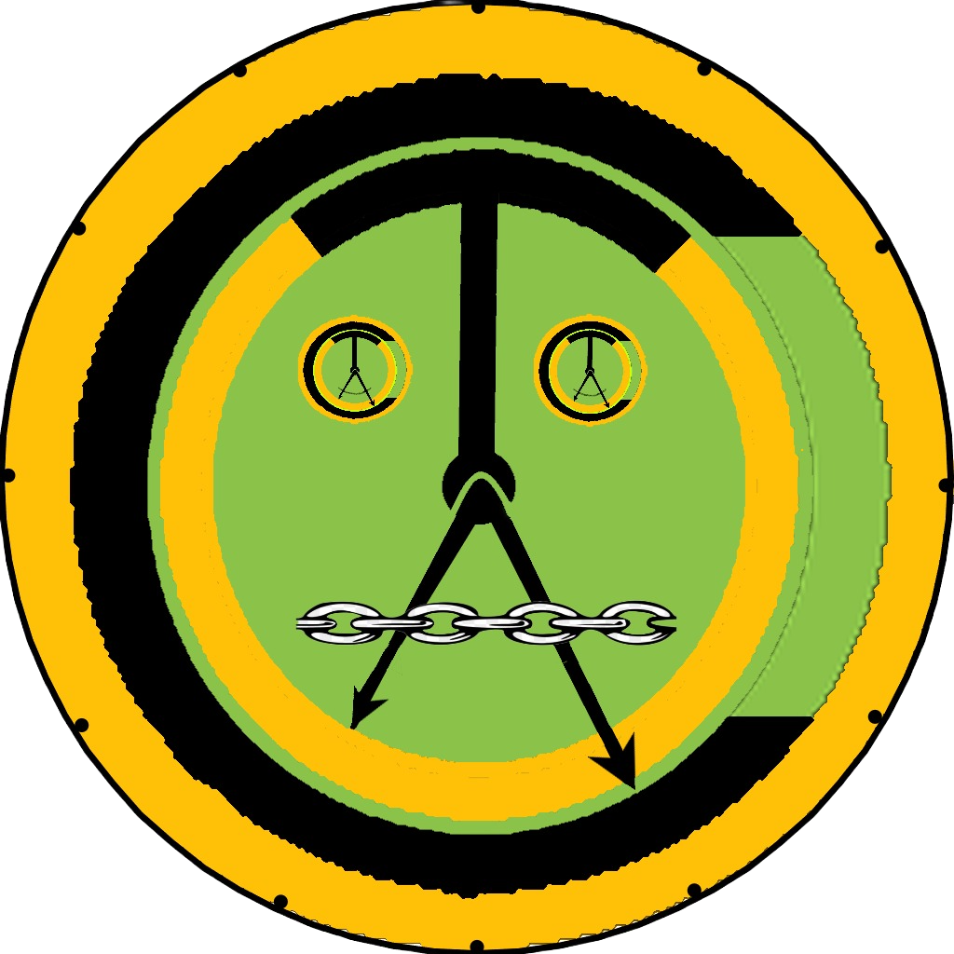

Chain Alarms & Timers
What is It & How It works?

Introduction
CAT Stands for Chain Alarms & Timers.
CAT is a clock App that allows us to create the Interactive Chain of Timers/Alarms.

Home Screen
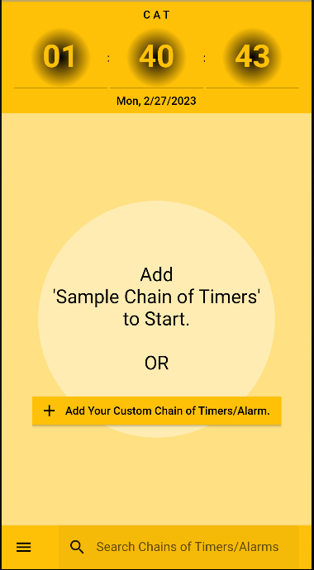
- A Digital Clock in 24-hour format.
- On your first usage of the app, users get the option to add a Sample Chain of Timers, or Add your own custom Chain of Timers/Alarm.
- Theme of this app is to keep all required controls at the bottom of the screen, which can help user to work single handedly on large screen phones.
- Home screen has a Bottom App Bar with:
- List of Chain of Timers/Alarms
with a button to Add One for you.
- Search Bar
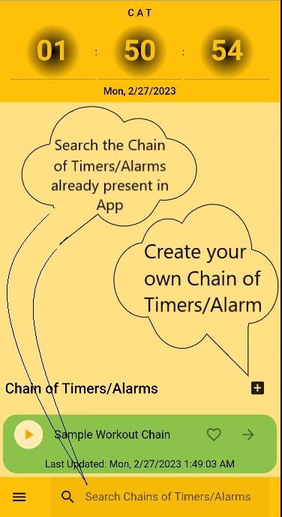

Search of Chain of Timers/Alarm
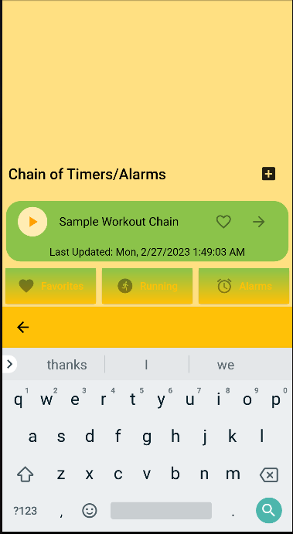

Tile of Individual “Chain” item on Home Screen
- Tile of Individual Chain Item from List of Chain on Home (Chains) Screen has controls to:
  - Play the Chain (of Timers in it).
- Mark the chain as Favorite.
- See the execution summary of Chains.
- Pressing the Body of Chain (i.e. Tile of Individual “Chain” item on Home Screen, itself) will navigate the App to “1.5. Add/Edit Chain Activity Screen”.
- Pressing the button will navigate the App to “1.7. Chain execution summary Screen”, and modify Chain of Timers.
- Pressing the Play button will Execute the chain and take us to "1.9 Play Chain Screen"
- Newly Created chain or Completed will look on Home Screen (Chains) as under:
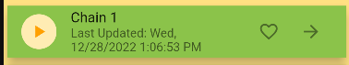

- Chain will execute on Pressing  and Tile of this Running Chain will look as:
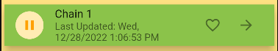
- Chain can be marked as favorite on pressing and tile of Chain will look as:


App Drawer
- Bottom App Bar on every Screen of this app has an App Drawer that looks like a Burger Icon as .
- App Drawer pops up on pressing this icon as:
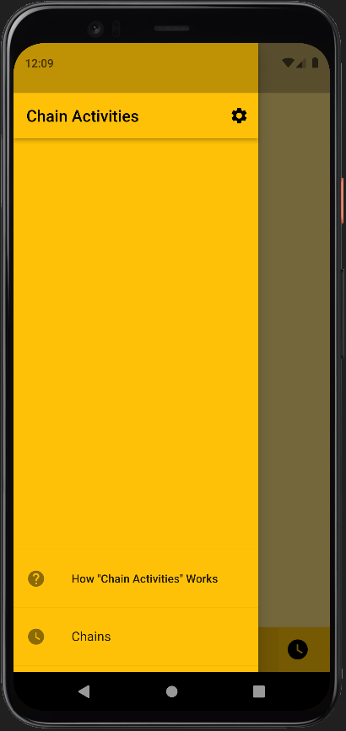
- App Drawer has three main Menu Items as under:
  - Chains, which is the Home Screen of this App.
  - How “Chain Timers” Works, which opens this PDF file to help us with App usage.
  - Gear Icon  for App Settings.
- Summary of all these Menu items is available in their respective sections later.

Settings Screen
- Settings Screen allows us to control the following aspects of this App:
  - Restore App to Factory Settings:
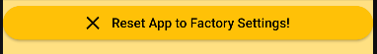
  - App Configuration:
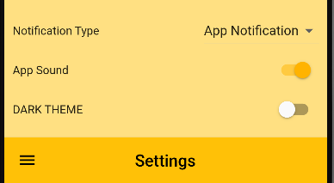
    - Dark Theme:
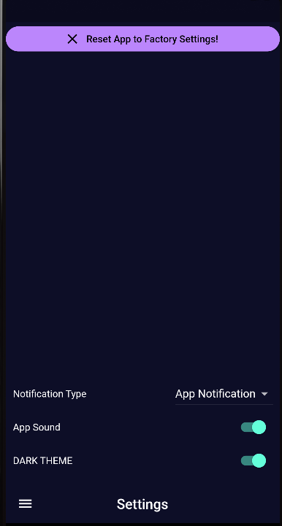
    - App Sound, This just turns on or off the sound on Completion of Activity in any Chain.
    - App Notifications: Sound of App Notification depends on Platform (Android, IOS) Settings.

Add/Edit Chain Activity Screen
- This is screen for adding a new chain of Timers or editing it.
- We can reach up to this screen by clicking on following buttons:
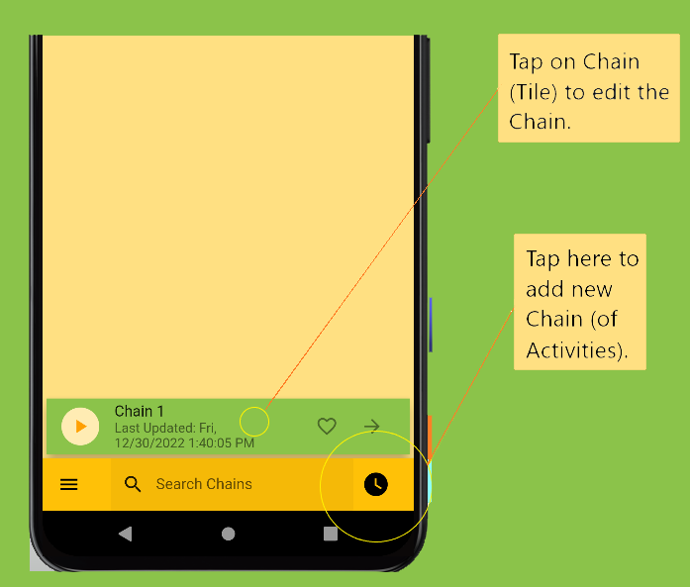
- Add Chain Screen:
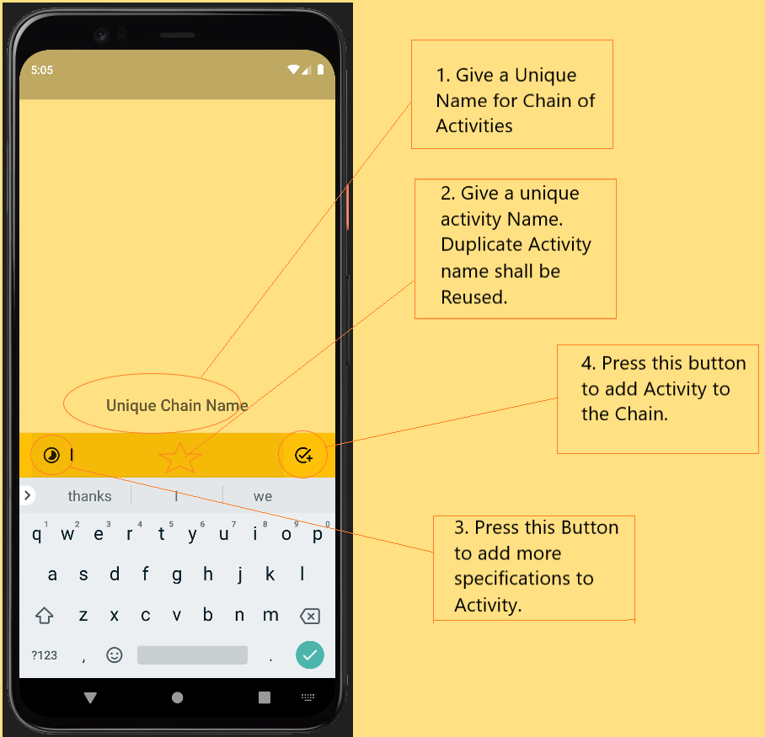

- Addition of Chain title is mandatory. We can search Chains from Home Screen by Chain Title.
- Use bottom Text Input Bar to add Activity in Chain.
- Bottom Text Input bar has an button to add more details to activity.
- Activity specification allows us to:
  - Add/Update Duration to activity
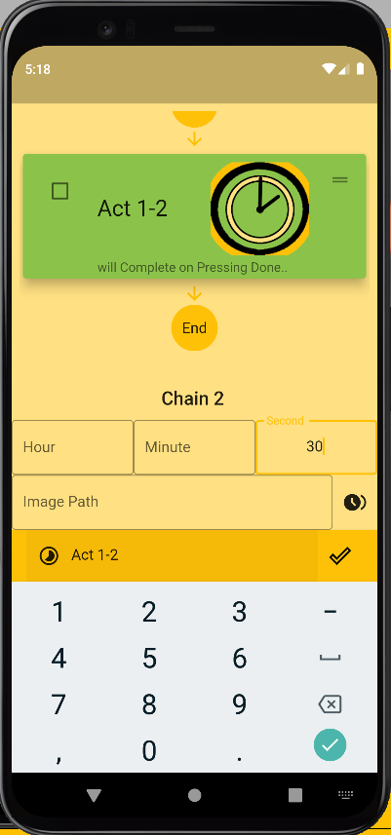 | 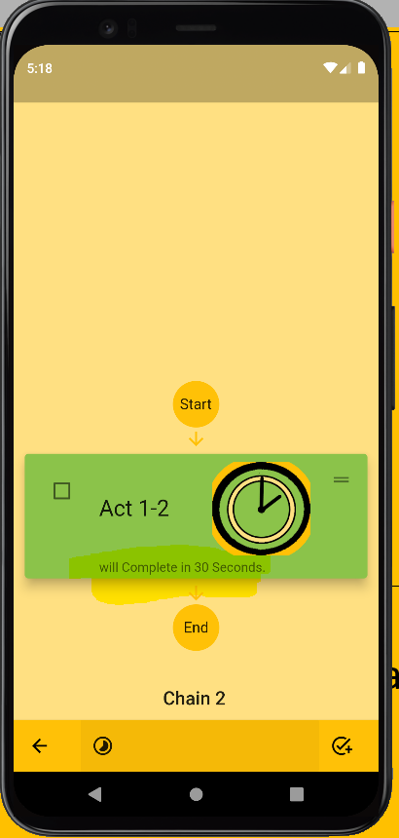

  - Add image to activity from local storage.
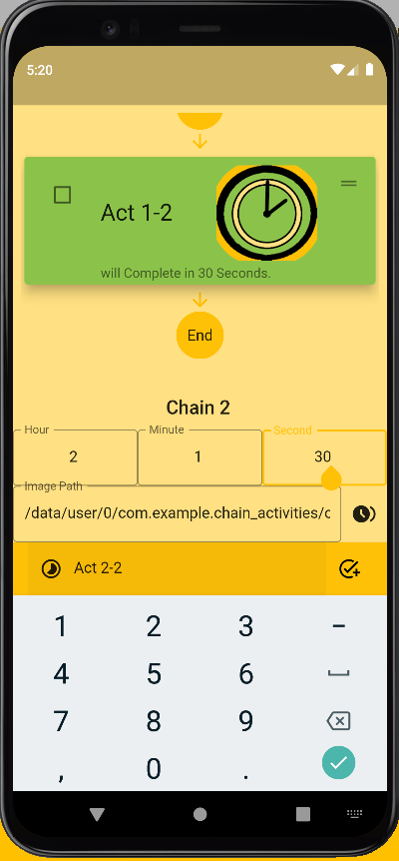 | 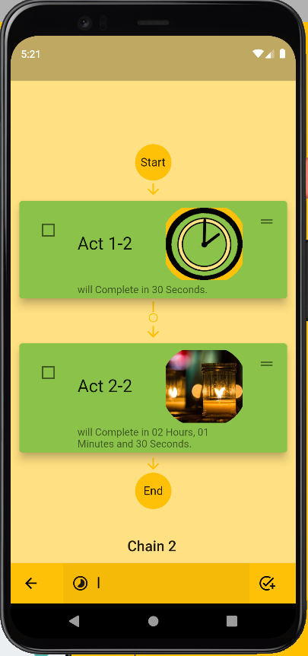
  - Add duration between two Timers:
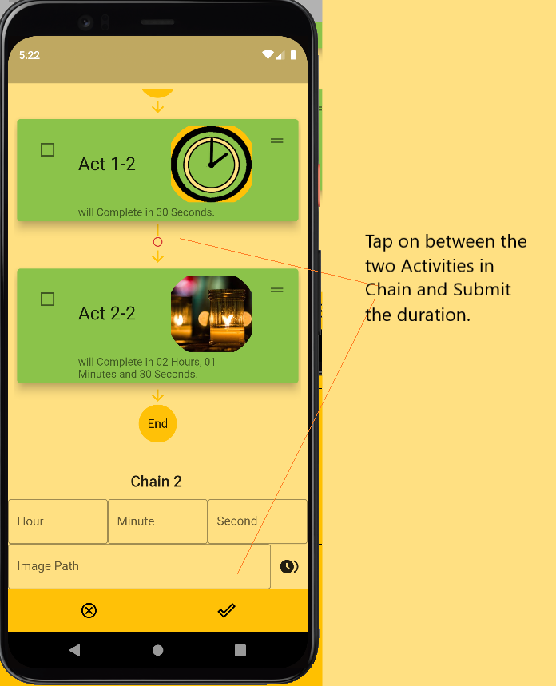
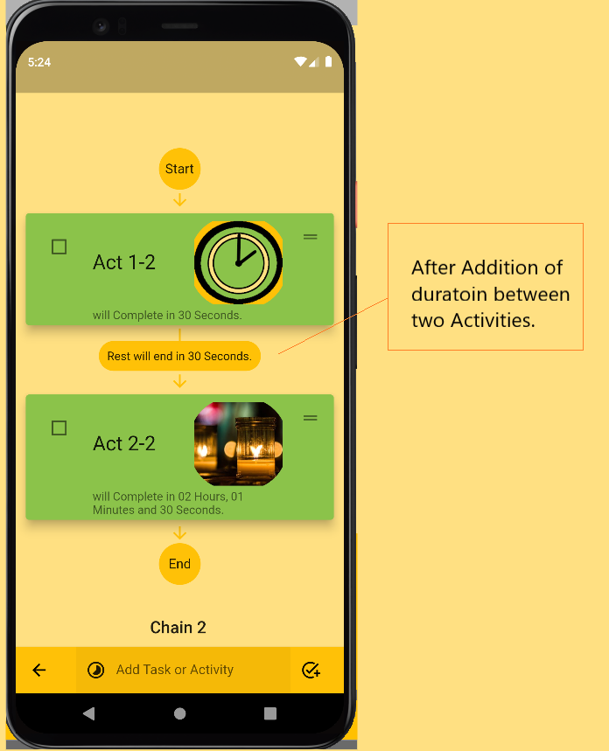

- Schedule Chain to execute in future by clicking on Start button:
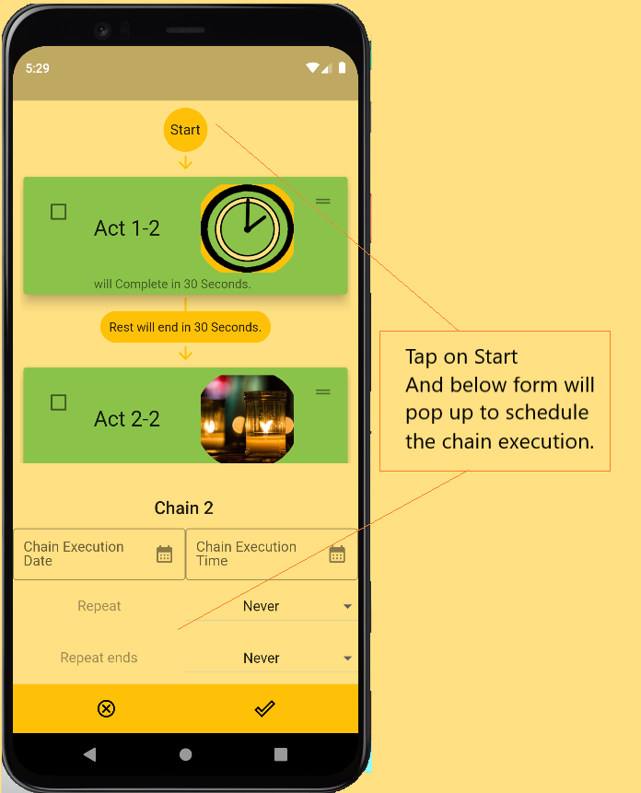
- Press back button Save this chain.

Search Chains Screen.
- On Home Screen with List of Chains, we have the option to filter or search chains vis Search Bar as under:
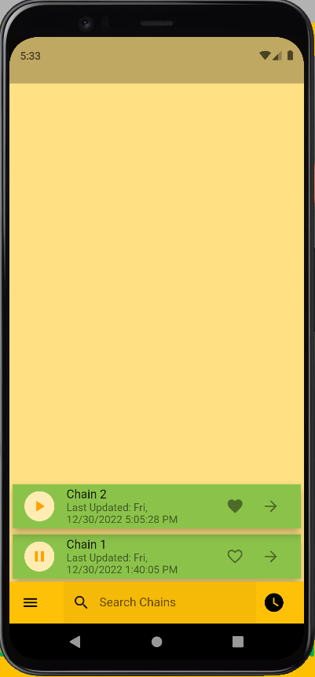 | 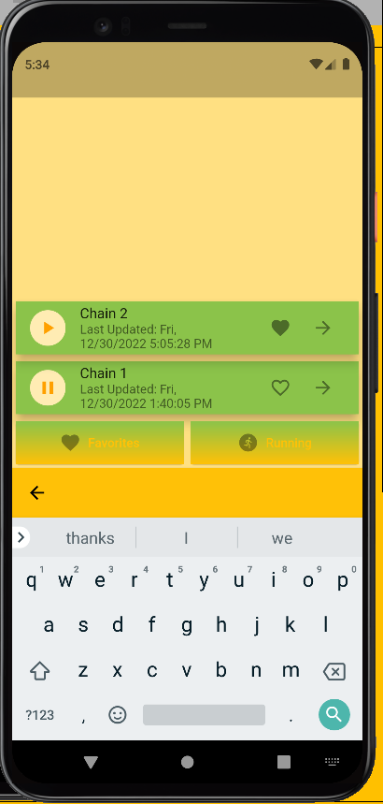
- We can filter chains via Predefined buttons for Running or Favorite Chains.
 | 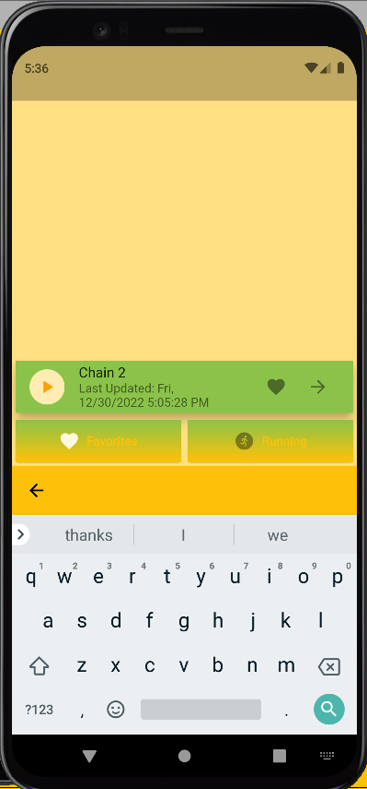
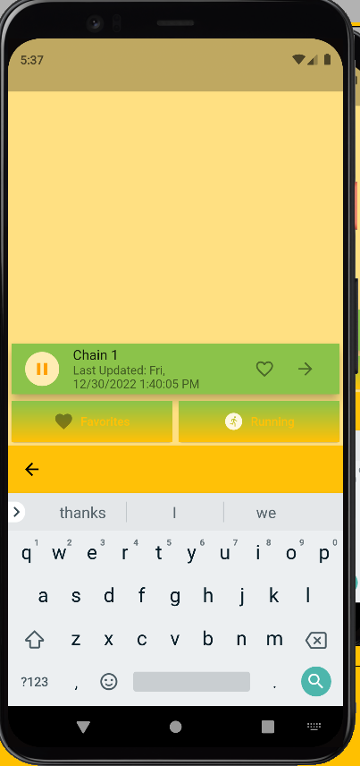 | 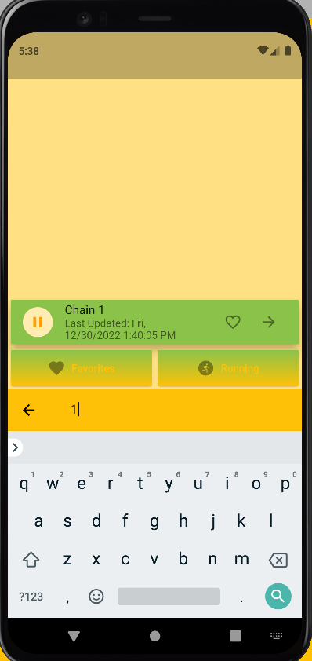

Chain execution summary Screen.
- We can see the Chain Execution Summary by Clicking on Forward Arrow Icon on Chain Tile:
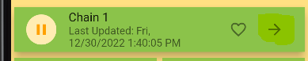 | 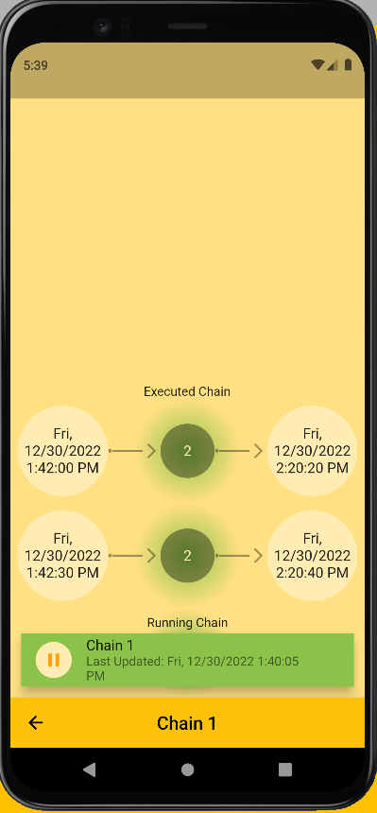
- Executed Chain looks as under:
This comes on pressing the executed chain -> | 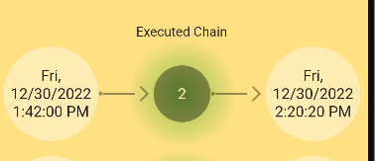
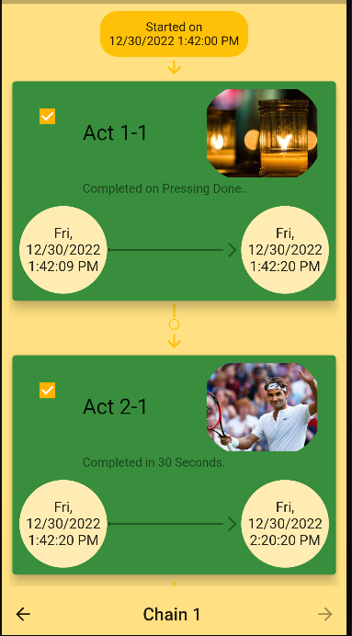 | 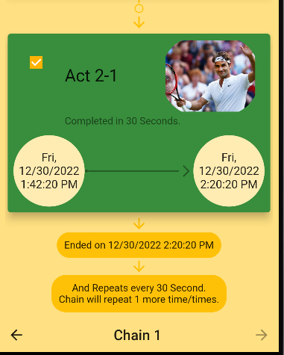  Scrolled down to showcase here.

- Executing Chain
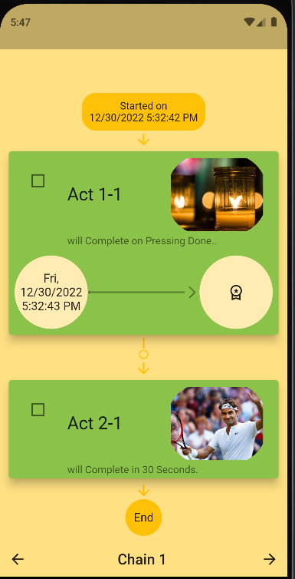

Loading Screen
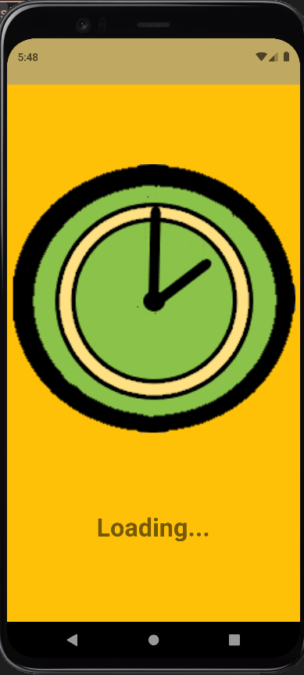

Play Chain Screen
- Playing chain takes you the screen of first incomplete Activity:
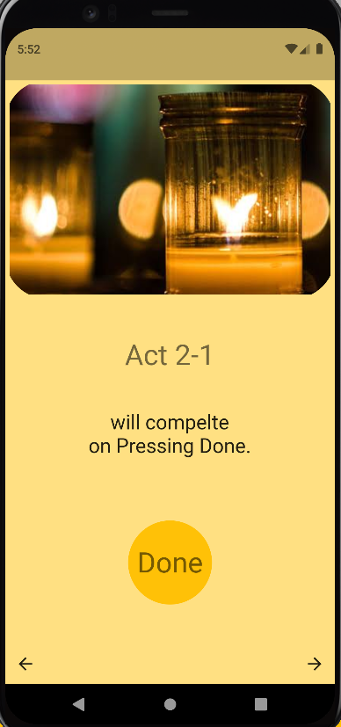
- Back Button will take the control to Page showing Chain of Timers, and forward will complete the Activity.
- We can complete the activity by pressing ‘Done’ as instructed on Screen.
- This screenshot is for Manual Activity with which User has not configured the Duration and task/activity has to complete manually by User.
- Other possible screen is Time Activity where Duration is configured with Activity while Adding/Updating Chain (Section 1.5).

- Timer Activity:
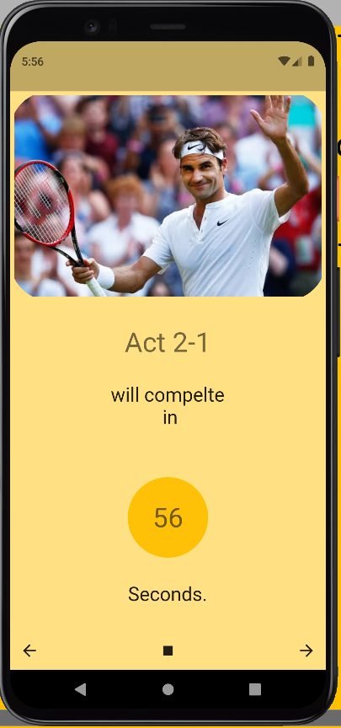

- We can pause the timer and leave the page. Chain will start executing from the same state later:
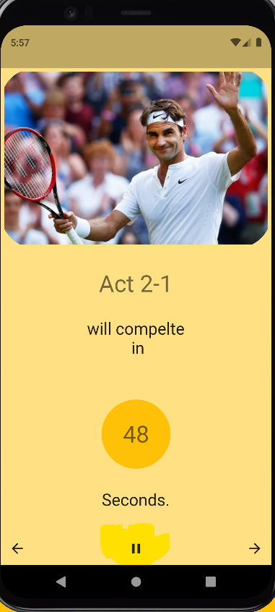
- We can leave the app after resuming the timer too. In this Case, App send notification for completion of Activity, as under:
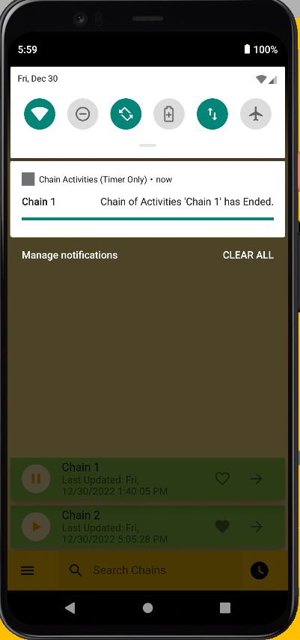

Conclusion
This document can give you the idea to use this app.
Please play with it and try to make use of this app, and let me know how you have made use of this App in your work or life.
You can reach out to me on vinaykhare123@gmail.com for your suggestions or if you need the enhanced version of this app for your personal usage.
Happy to help.

