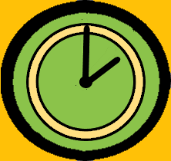

Chain Activities
What is It & How It works?

Description of Screens

Home Screen
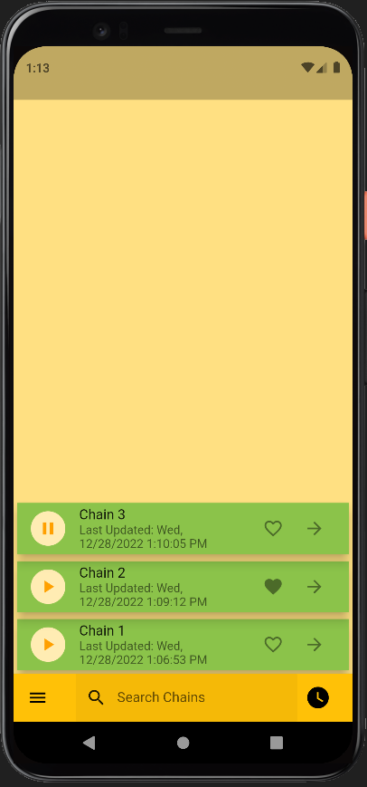
- Theme of this app is to keep all required controls at the bottom of the screen, which can help user to work single handedly on large screen phones.
- Home screen has a Bottom App Bar with:
- List of Chains that contains the Chain of Activities, as under:
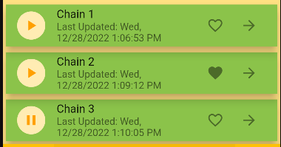
- Search Bar to filter Chains listed on Home screen, showed in later section.
- Add Chain Button that will take us to “Add or Edit Chain Activity Screen” showed in later section.
This button looks as: 

Tile of Individual “Chain” item on Home Screen
- Tile of Individual Chain Item from List of Chain on Home (Chains) Screen has controls to:
  - Play the Chain (of Activities in it).
- Mark the chain as Favorite.
- See the execution summary of Chains.

- Pressing the Body of Chain (i.e. Tile of Individual “Chain” item on Home Screen, itself) will navigate the App to “1.5. Add/Edit Chain Activity Screen”.
- Pressing the button will navigate the App to “1.7. Chain execution summary Screen”, and modify Chain of Activities.
- Pressing the Play button will Execute the chain and take us to "1.9 Play Chain Screen"
- Newly Created chain or Completed will look on Home Screen (Chains) as under:


- Chain will execute on Pressing  and Tile of this Running Chain will look as:

- Chain can be marked as favorite on pressing and tile of Chain will look as:


App Drawer
- Bottom App Bar on every Screen of this app has an App Drawer that looks like a Burger Icon as .
- App Drawer pops up on pressing this icon as:
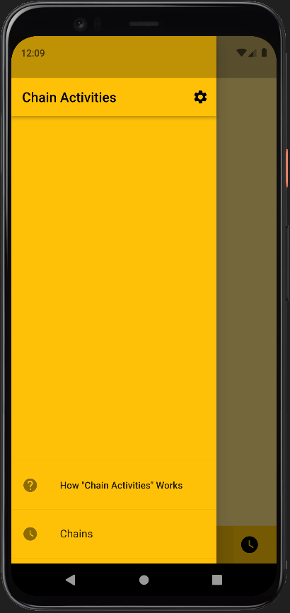
- App Drawer has three main Menu Items as under:
  - Chains, which is the Home Screen of this App.
  - How “Chain Activities” Works, which opens this PDF file to help you with App usage.
  - Gear Icon  for App Settings.
- Summary of all these Menu items is available in their respective sections later.

Settings Screen
- Settings Screen allows you to control the following aspects of this App:
  - Restore App to Factory Settings:

  - App Configuration:
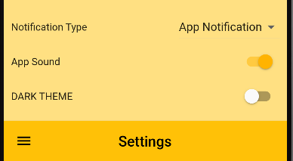
    - Dark Theme:
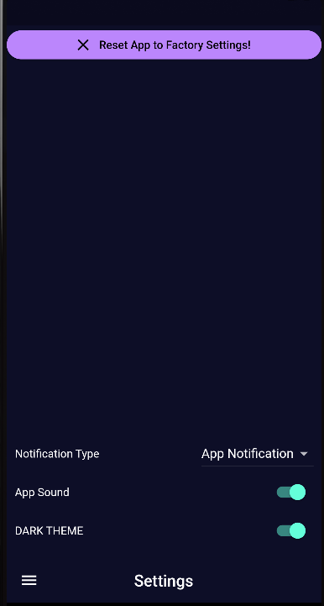
    - App Sound, This just turns on or off the sound on Completion of Activity in any Chain.
    - App Notifications: Sound of App Notification depends on Platform (Android, IOS) Settings.

Add/Edit Chain Activity Screen

Search Chains Screen.

Chain execution summary Screen.

Loading Screen

Play Chain Screen

Timer Activity Screen

Manual Activity Screen

Create Chain of Activities

Chain of Manual Activities

Chain of Timer Activities

Chain of Audio Activities

Execute the Chain (of Activities)

Schedule the Execution of Chain (of Activities)

Use Cases

