Log-Book:
Week-1

Output:-
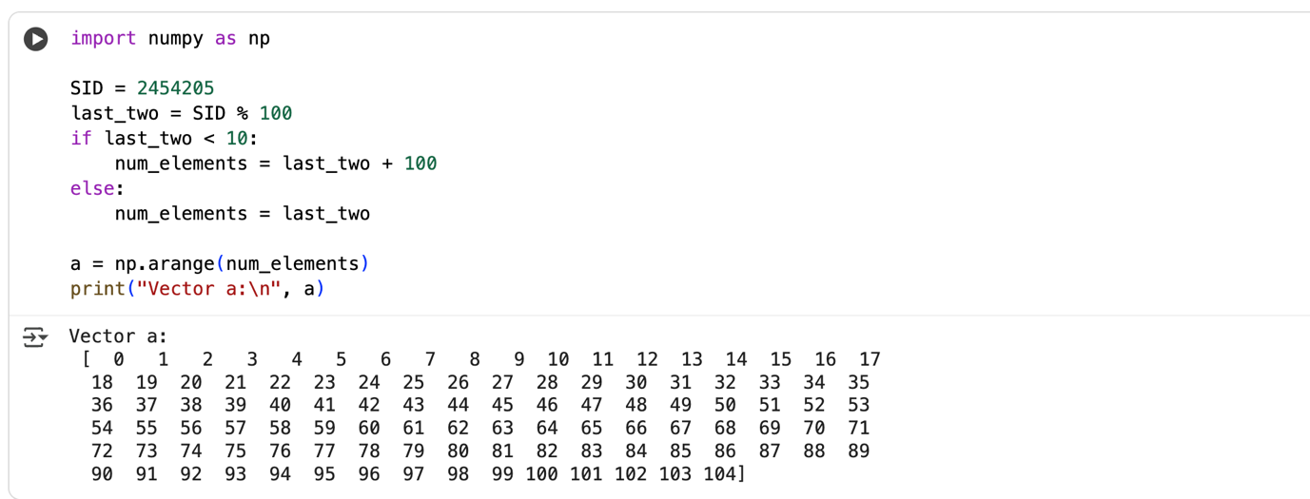

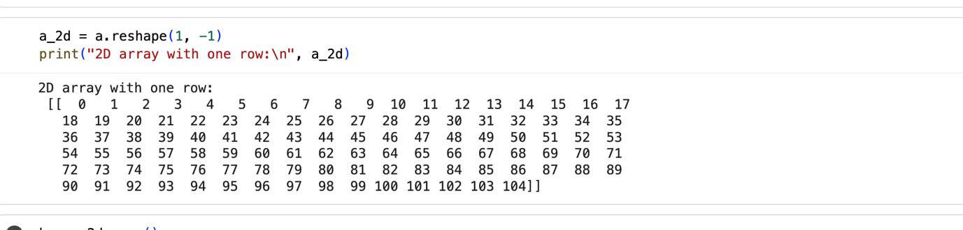
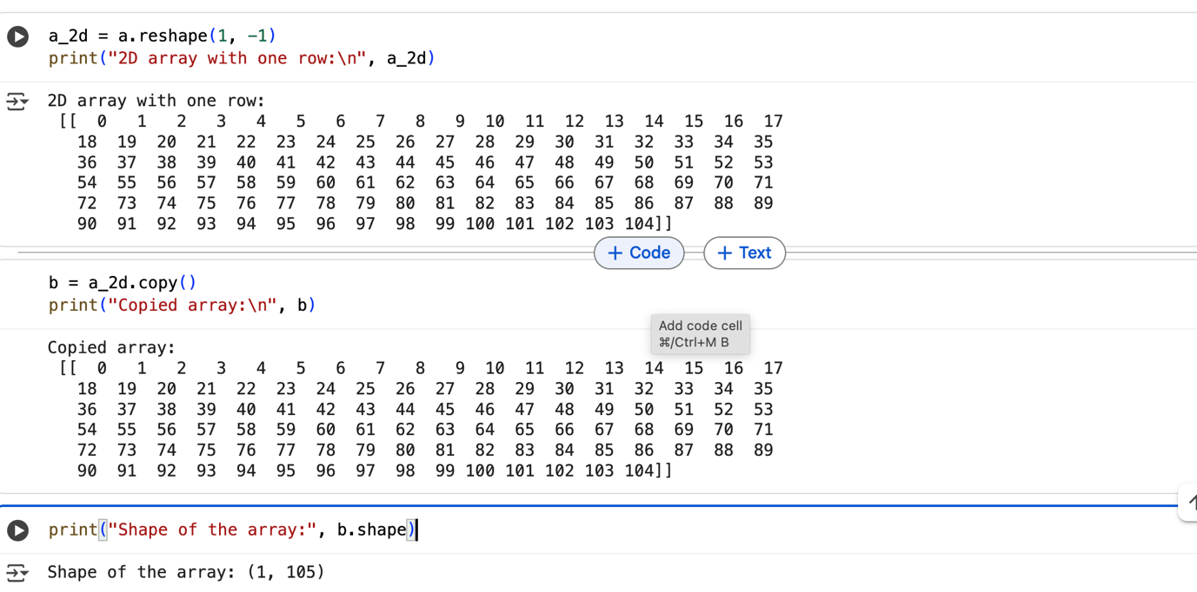
Code:-
import numpy as np

SID = 2454205
last_two = SID % 100
if last_two < 10:
num_elements = last_two + 100
else:
num_elements = last_two

a = np.arange(num_elements)
print("Vector a:\n", a)
a_2d = a.reshape(1, -1)
print("2D array with one row:\n", a_2d)
b = a_2d.copy()
print("Copied array:\n", b)
print("Shape of the array:", b.shape)

