Andrew Lin, Jeffrey Tao, Vinay Senthil

Period 3

Warowac User Manual

Warowac is a program that assists in implementing the alternative vote voting system. The user first sets up an election and asks the voters to enter their ballots into the program. Then, the program processes these ballots and gives the winner of the election, as well as some interesting statistics about voter preferences.

To start, visit tinyurl.com/warowac and click Create. Next, enter the name of the election and the number of candidates, followed by the names of the Candidates. Candidate names cannot be numbers, but can be strings of letters. Then, instruct your voters to go to tinyurl.com/warowac and click vote to submit their ballots. Once all of the votes have been inputted, run the Results.java program and enter the name of the election. Then, click the Eliminate Candidate button until the desired number of winners is reached. To get statistics for this election, click the Get Statistics button. This will give a pop-up table of comparative preference.

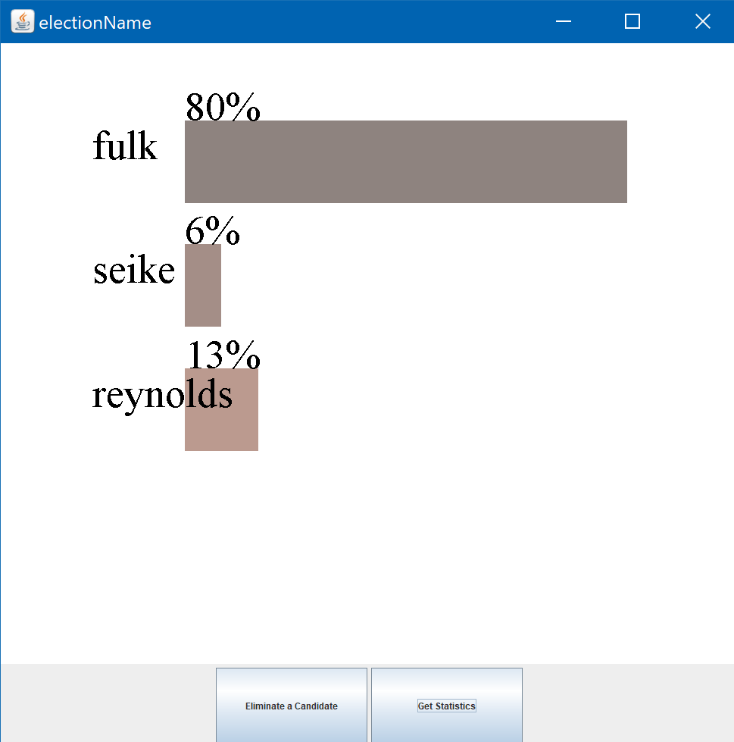

In order to run the result.java class to retrieve the final statistics the following drivers are required:

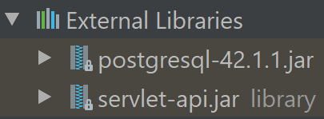

These can be downloaded from the internet. We’ve also zipped these .jar files to the project’s folder for your convenience.