CHAPTER - 8

Introduction to Double Stacked Container (DSC) service on Indian Railways

Intermodal transport is gaining increasing popularity now a days. This mode is used specially on high volume, low weight, high value traffic. In order to bring down cost of transportation, container traffic has been started in double stacked mode which increases throughput by a quantum with least cost inputs. Currently such double-stacked container trains are being run on North American Continent covering USA, Canada and Mexico.
On March 24,2006, Indian Railway joined the select club of double stacked container operation by running its first train from Jaipur to Pipvav Port. Unique feature of IR operation is carrying double-stacked containers on flat wagons, which increases throughput per rake by 100% as against 40% increase in throughput for well wagon design as is the practice in US Rail roads. This has been possible by exploiting the wider track gauge of 1676 mm on IR compared to 1435 mm in US Railroads. Double stack container operation will cut down the cost of transportation per unit (TEU) to half contributing to competitiveness of our exports as well as increase our market share in container movement vis. a vis. road sector.
The initial DSC operation was started with two 8’6” on existing BLC wagons(20.32t A/L), however from Dec. 07 Railway Board permitted operation with 9’6” high containers(On specified route).

To increase throughput of container traffic, Broad Gauge low platform Bogie container flat wagons type BLCAM & BLCBM wagon having maximum axle load of 22.0t were being introduced. BLCAM and BLCBM, loaded with double stack are same as existing 20.32t axle load double stacked BLCA & double stacked BLCB wagons except suspension.

Two additional inner springs in suspension are provided. Suspension consists of 14 Outer, 14 inner and 4 snubber springs along with friction wedges to drg. no. SK-03206 (Specification No. CONTR-02-Misc-2007) and Constant Contact Side Bearer as per drawing No. 40704 of Miner-Sujan made to AAR M 948 specifications (RDSO’s SpecificationNo. CONTR-01-Misc-2007) fitted on LCCF bogie.

For BLCM wagons write marking particulars as per drawing NO.CONTR-09002-S/01 with latest alteration for Car ‘A’ and CONTR-09002-S/02 with latest alteration for Car ‘B’

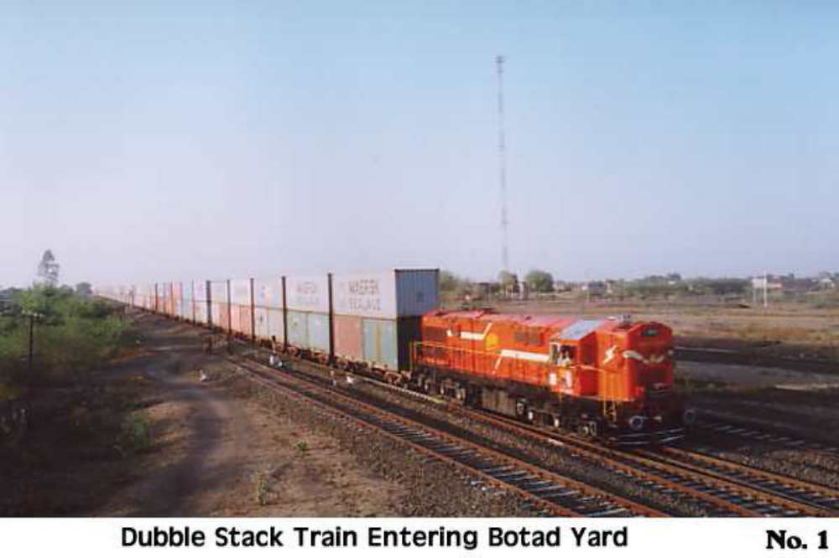
Loading Instruction for placement of containers in Double Stack on BLCA/BLCB Wagons(20.32t A/L)

Double stacking of 8’- 6” (2591mm) and/or 9’- 6”(2896 mm) high ISO containers on existing BLC wagon should be strictly done as per table given below:-

SERIES | CONTAINERS POSITION |  | LOADING CONDITION
SERIES | LOWER | UPPER | LOWER | UPPER
I | 40’ | 40’ | EMPTY | EMPTY
II | 40’ | 40’ | LOADED | EMPTY
III | 40’ | 40’ | LOADED | LOADED
IV | 2 x 20’ | 40’ | EMPTY | EMPTY
V | 2 x 20’ | 40’ | LOADED | EMPTY
VI | 2 x 20’ | 40’ | LOADED | LOADED

NOTE:

- While loading, care should be taken to place loaded containers evenly on wagons as far as possible.

2. In no case, load of top container should be more than the load of bottom container for Series III and combined load of bottom containers for series VI.

- Payload of 61t for container wagon implies tare weight of containers + weight of goods in containers. This should be strictly followed to prevent overloading of wagon.

Loading Instruction for placement of containers in Double Stack on BLCAM/BLCBM Wagons(22.0t A/L)

Double stacking of 20’ and 40’ high ISO containers on BLCAM/BLCBM wagon should be strictly done as per table given below:-

(i) While loading, care should be taken that gross load of bottom containers(20’) should be equal to each other to the maximum possible extent.
(ii) Gross weight of wagon should not exceed 88.0 tonnes in any case.
(iii) In no case, load of top container should be more than the load of bottom container/containers for all Series.
(iv) Payload for container wagon implies tare weight of containers + weight of goods in containers. This should be strictly followed to
prevent overloading of wagon.

SERIES | CONTAINERS POSITION |  | LOADING CONDITION |  | Loading Limits ( in tonnes)
SERIES | LOWER | UPPER | LOWER | UPPER | LOWER | UPPER
I | 2 x 20’ | 1 x 40’ | EMPTY | EMPTY | -- | --
II | 2 x 20’ | 1 x 40’ | LOADED | EMPTY | 61 (max.) | -
III(a) | 2 x 20’ | 1 x 40’ | LOADED | LOADED | 45.0 to 61.0 tonne | Difference of Pay load capacity of wagon and combined load of lower containers
III(b) | 2 x 20’ | 1 x 40’ | LOADED | LOADED | <45 to >35 | <=22
III(c) | 2 x 20’ | 1 x 40’ | LOADED | LOADED | <=35 to >25 | <=20
III(d) | 2 x 20’ | 1 x 40’ | LOADED | LOADED | <=25 to >20 | <=17
III(e) | 2 x 20’ | 1 x 40’ | LOADED | LOADED | Empty to 20.0 tonne | Load in top container should not be more than gross load in lower containers and maximum limit of load is 17.0 tonne.
IV(a) | 1 x 40’ | 1 x 40’ | EMPTY | EMPTY | -- | --
IV(b) | 1 x 40’ | 1 x 40’ | LOADED | EMPTY | 30.0 (max.)-- | --
IV(c) | 1 x 40’ | 1 x 40’ | LOADED | LOADED | <=30 to >15 | 15 (max.)
IV(d) | 1 x 40’ | 1 x 40’ | LOADED | LOADED | Empty to 15.0 tonne | Load in top container should not be more than gross load in lower containers and maximum limit of load is 15.0 tonne.

