**NAME : VINAYKUMAR**

**USN : 1BM24CS327**

**show databases;**

**create database bank;**

**use bank;**

**create table branch(**

**b_name varchar(40) primary key,**

**b_city varchar(40),**

**assets int);**

**desc branch;**

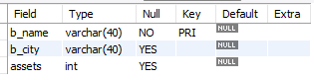

**create table Bankaccount (**

**accno int primary key,**

**b_name varchar(45),**

**balance int,**

**foreign key (b_name) references Branch (b_name));**

**desc bankaccount;**

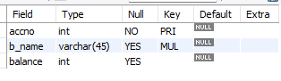

**create table BankCustomer (**

**cus_name varchar(45) primary key,**

**cus_street varchar(45),**

**city varchar(45));**

**desc BankCustomer;**

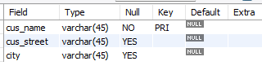

**create table depositor (**

**cus_name varchar(45),**

**accno int ,**

**primary key(cus_name,accno),**

**foreign key (accno) references BankAccount (accno),**

**foreign key(cus_name) references bankcustomer(cus_name));**

**DESC depositor;**

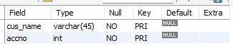

**create table loan(**

**loan_no int primary key,**

**b_name varchar(45),**

**amt int,**

**foreign key (b_name) references branch (b_name));**

**desc loan;**

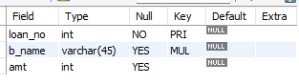

**INSERT INTO Branch VALUES**

**('SBI_Chamrajpet', 'Blr', 500000),**

**('SBI_ResidencyRoad', 'Blr', 100000),**

**('SBI_ShivajiRoad', 'Bombay', 200000),**

**('SBI_ParlimentRoad', 'Delhi', 100000),**

**('SBI_Jantarmantar', 'Delhi', 200000);**

**select * from branch;**

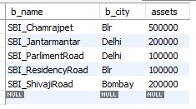

**INSERT INTO BankCustomer VALUES**

**('Avinash', 'Bull_Temple_Road', 'Bangalore'),**

**('Dinesh', 'Bannerghatta_Road', 'Bangalore'),**

**('Mohan', 'NationalCollege_Road', 'Bangalore'),**

**('Nikil', 'Akbar_Road', 'Delhi'),**

**('Ravi', 'Prithviraj_Road', 'Delhi');**

**select * from bankcustomer;**

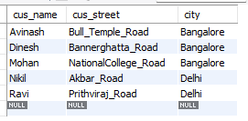

**INSERT INTO BankAccount VALUES**

**(1, 'SBI_Chamrajpet', 2000),**

**(2, 'SBI_ResidencyRoad', 5000),**

**(3, 'SBI_ShivajiRoad', 6000),**

**(4, 'SBI_ParlimentRoad', 9000),**

**(5, 'SBI_Jantarmantar', 8000),**

**(6, 'SBI_ShivajiRoad', 4000),**

**(8, 'SBI_ResidencyRoad', 4000),**

**(9, 'SBI_ParlimentRoad', 3000),**

**(10, 'SBI_ResidencyRoad', 5000),**

**(11, 'SBI_Jantarmantar', 2000);**

**select * from bankaccount;**

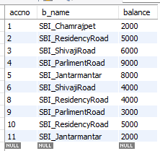

**INSERT INTO depositor VALUES**

**('Avinash', 1),('Dinesh', 2),('Nikil', 4),**

**('Ravi', 5),('Avinash', 8),**

**('Nikil', 9),('Dinesh', 10),('Nikil', 11);**

**select * from depositor;**

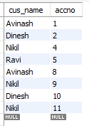

**INSERT INTO loan VALUES**

**(1, 'SBI_Chamrajpet', 1000),**

**(2, 'SBI_ResidencyRoad', 2000),**

**(3, 'SBI_ShivajiRoad', 3000),**

**(4, 'SBI_ParlimentRoad', 3000),**

**(5, 'SBI_Jantarmantar', 5000);**

**select * from loan;**

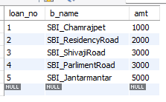

**select b_name as 'Branch_Name',assets/100000.0 as 'assets_in_lakhs' from branch;**

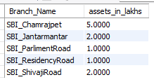

**select d.cus_name,b.b_name,count(*) as num_accounts**

**from depositor d, bankaccount b**

**where d.accno = b.accno**

**group by d.cus_name,b.b_name**

**having count(*)>=2;**

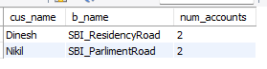

**CREATE VIEW Summary AS**

**SELECT b_name,SUM(amt) AS total_loan_amount**

**FROM loan**

**GROUP BY b_name;**

**select * from summary;**

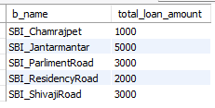

**select d.cus_name**

**from depositor d,bankaccount b**

**where d.accno=b.accno and b_name in (select b_name from branch where b_city='Delhi')**

**group by d.cus_name;**



**SELECT DISTINCT d.cus_name**

**FROM depositor d,bankaccount b,loan l**

**where d.accno = b.accno and b.b_name = l.b_name**

**and b.b_name IN (**

**SELECT b_name FROM branch WHERE b_city = 'Blr'**

**);**

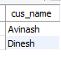

**SELECT b_name**

**FROM branch**

**WHERE assets > ALL (**

**SELECT assets**

**FROM branch**

**WHERE b_city = 'Blr'**

**);**



**DELETE FROM bankaccount**

**WHERE b_name IN (**

**SELECT b_name**

**FROM branch**

**WHERE b_city = 'Bombay'**

**);**

**SELECT * FROM BANKACCOUNT;**

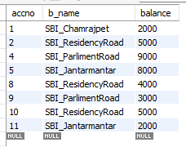

**UPDATE bankaccount**

**SET balance = balance +(balance * 0.05);**