NAME=VINAYKUMAR

USN=1BM24CS327

create database empk;use empk;

CREATE TABLE DEPT (

DEPTNO INT PRIMARY KEY,

DNAME VARCHAR(20),

DLOC VARCHAR(20)

);

CREATE TABLE EMPLOYEE (

EMPNO INT PRIMARY KEY,

ENAME VARCHAR(20),

MGR_NO INT,

HIREDATE DATE,

SAL int,

DEPTNO INT,

FOREIGN KEY (DEPTNO) REFERENCES DEPT(DEPTNO)

);

CREATE TABLE PROJECT (

PNO INT PRIMARY KEY,

PLOC VARCHAR(50),

PNAME VARCHAR(50)

);

CREATE TABLE ASSIGNED_TO (

EMPNO INT,

PNO INT,

JOB_ROLE VARCHAR(50),

FOREIGN KEY (EMPNO) REFERENCES EMPLOYEE(EMPNO),

FOREIGN KEY (PNO) REFERENCES PROJECT(PNO)

);

CREATE TABLE INCENTIVES (

EMPNO INT,

INCENDATE DATE,

INCENAMT DECIMAL(10,2),

FOREIGN KEY (EMPNO) REFERENCES EMPLOYEE(EMPNO)

);

INSERT INTO DEPT VALUES

(1, 'HR', 'Delhi'),

(2, 'IT', 'Blr'),

(3, 'Fin', 'Hyd'),

(4, 'Market', 'Mumbai'),

(5, 'ORG', 'Chennai'),

(6, 'Admin', 'Pune');

SELECT * FROM DEPT;

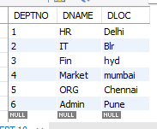

INSERT INTO EMPLOYEE VALUES

(101, 'bro', 0, '2020-01-15', 50000, 1),

(102, 'meow', 101, '2021-03-12', 60000, 2),

(103, 'kiwi', 101, '2021-06-25', 55000, 3),

(104, 'bankai', 102, '2022-01-09', 45000, 2),

(105, 'mum', 103, '2022-11-18', 40000, 4),

(106, 'biggie', 101, '2023-02-10', 48000, 5);

SELECT * FROM EMPLOYEE;

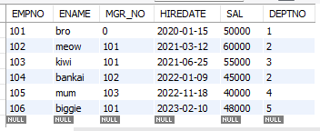

INSERT INTO PROJECT VALUES

(10, 'Blr', 'kannobiraki'),

(20, 'Mumbai', 'kamishini'),

(30, 'Delhi', 'ashogizizo'),

(40, 'Hyd', 'zanka no tachi'),

(50, 'Chennai', 'nozarashi'),

(60, 'Pune', 'zangetsu');

SELECT * FROM PROJECT;

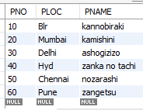

INSERT INTO ASSIGNED_TO VALUES

(101, 10, 'Leader'),

(102, 10, 'Developer'),

(103, 20, 'Analyst'),

(104, 30, 'Tester'),

(105, 40, 'Designer'),

(106, 50, 'Co-ordinator'),

(103, 60, 'Engineer');

SELECT * FROM ASSIGNED_TO;

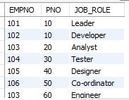

INSERT INTO INCENTIVES VALUES

(101, '2023-12-31', 5000),

(102, '2024-01-10', 3000),

(104, '2024-05-20', 2000),

(105, '2024-07-30', 2500),

(106, '2024-09-10', 3500);

SELECT * FROM INCENTIVES;

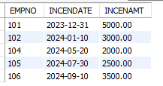

SELECT DISTINCT A.EMPNO

FROM ASSIGNED_TO A,PROJECT P

WHERE A.PNO = P.PNO AND P.PLOC IN ('Blr', 'Hyd', 'Mysuru');

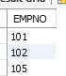

SELECT EMPNO

FROM EMPLOYEE

WHERE EMPNO NOT IN (SELECT EMPNO

FROM INCENTIVES);

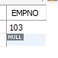

SELECT E.ENAME,E.EMPNO,D.DNAME,D.DLOC,A.JOB_ROLE ,P.PLOC

FROM EMPLOYEE E,DEPT D,ASSIGNED_TO A,PROJECT P

WHERE E.DEPTNO = D.DEPTNO AND E.EMPNO = A.EMPNO AND A.PNO = P.PNO AND D.DLOC = P.PLOC;

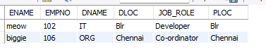

SELECT M.ENAME AS Manager_Name,M.SAL

FROM EMPLOYEE M, EMPLOYEE E

WHERE M.EMPNO = E.MGR_NO

GROUP BY M.ENAME,M.SAL

HAVING M.SAL > AVG(E.SAL);

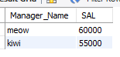

SELECT E.ENAME AS Second_Level_Manager, D.DNAME

FROM EMPLOYEE E, DEPT D

WHERE E.DEPTNO = D.DEPTNO

AND E.MGR_NO IN (SELECT EMPNO FROM EMPLOYEE WHERE MGR_NO = 0);

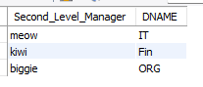

SELECT E.ENAME, E.EMPNO, I.INCENAMT

FROM EMPLOYEE E, INCENTIVES I

WHERE E.EMPNO = I.EMPNO

AND I.INCENDATE BETWEEN '2019-01-01' AND '2019-01-31';

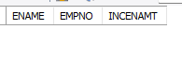

SELECT E.ENAME AS Employee_Name, M.ENAME AS Manager_Name, D.DNAME AS Department

FROM EMPLOYEE E, EMPLOYEE M, DEPT D

WHERE E.MGR_NO = M.EMPNO

AND E.DEPTNO = D.DEPTNO

AND E.DEPTNO = M.DEPTNO;

