**React.js Component Creation**

**Name:-** p. Vinay

**Email.com:**vinaykumarchowdary96@gmail.com

**Phone:-**9182090016

**Roll No:-** 209F1A0596 (cse)

**College Name:-**Sri Venkateswara institute of Technology, Anantapur

**SOURCE CODE: Screen shot**

**BUTTON COMPONENT:**

import React from 'react';

export default function ButtonComponet({img,title,description}) {

  return (

    <div className='main'>

        <div className='container'>

            <img src={img} alt="placeholder" className='img'></img>

            <h1 className='text-x1 '>{title}</h1>

            <p className='loknath'>{description}</p>

            <a href='"vinay' className='vinay'>clickme</a>

    </div>

        </div>

  )

}

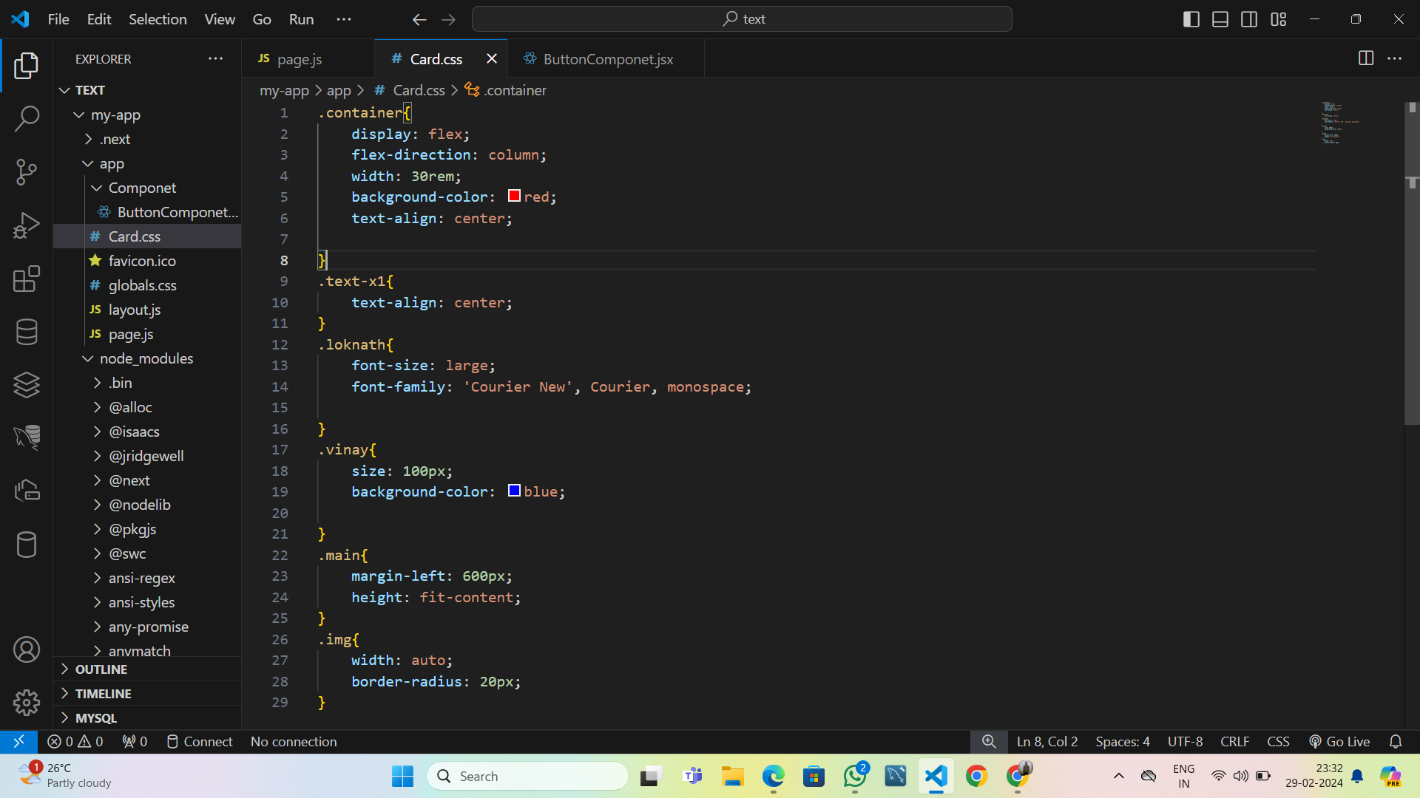**CARD COMPONENT: screen shot**

**Card.css code:**

.container{

    display: flex;

    flex-direction: column;

    width: 30rem;

    background-color: red;

    text-align: center;

}

.text-x1{

    text-align: center;

}

.loknath{

    font-size: large;

    font-family: 'Courier New', Courier, monospace;

}

.vinay{

    size: 100px;

    background-color: blue;

}

.main{

    margin-left: 600px;

    height: fit-content;

}

.img{

    width: auto;

    border-radius: 20px;

}

**Page.js: Screen shot**

**PAGE .JS CODE:**

"use client"

import ButtonComponet from './Componet/ButtonComponet';

import{useState} from "react";

import "./Card.css";

export default function Home(){

  const[label,setlabel]=useState("continue")

  const  clickme =()=>{

    alert("hello");

};

return(

  <div>

    <ButtonComponet

    img ="https://images.tv9hindi.com/wp-content/uploads/2021/10/KTM-RC-200-price-in-india.jpg"

    title="hello"

    description="hello this is a Ktm bike."

    />

        <ButtonComponet

    img ="https://bikeindia.in/wp-content/uploads/2023/07/HD-X440-003.jpg"

    title="hello"

    description=" This is Harley-Davidson

    The Harley-Davidson X440 is the first product to come out of the joint venture between Hero MotoCorp and Harley-Davidson.."

    />

        <ButtonComponet

    img ="https://encrypted-tbn0.gstatic.com/images?q=tbn:ANd9GcTXueInFor-oBlOnTR3Qb1rMHJsC2u3FOn2VA&usqp=CAU.jpg"

    title="hello"

    description="hello this is a splender,it is good millage bike in india"

    />    <ButtonComponet

    img ="https://encrypted-tbn0.gstatic.com/images?q=tbn:ANd9GcQQZzzav_36ZbMSrfR8hvFTpiEso2J5Kms3EA&usqp=CAU.jpg"

    title="hello"

    description="hello this is a passion  pro,it is a one of the best bike"

    />

    </div>

  )

}

**OUTPUT:**