* Name space 🡺 Process ID (PID), Network (net), File system/mount (mnt), Inter-proc comms (ipc), UTS, Users.
* Control Group 🡺 CPU, RAM, Disk

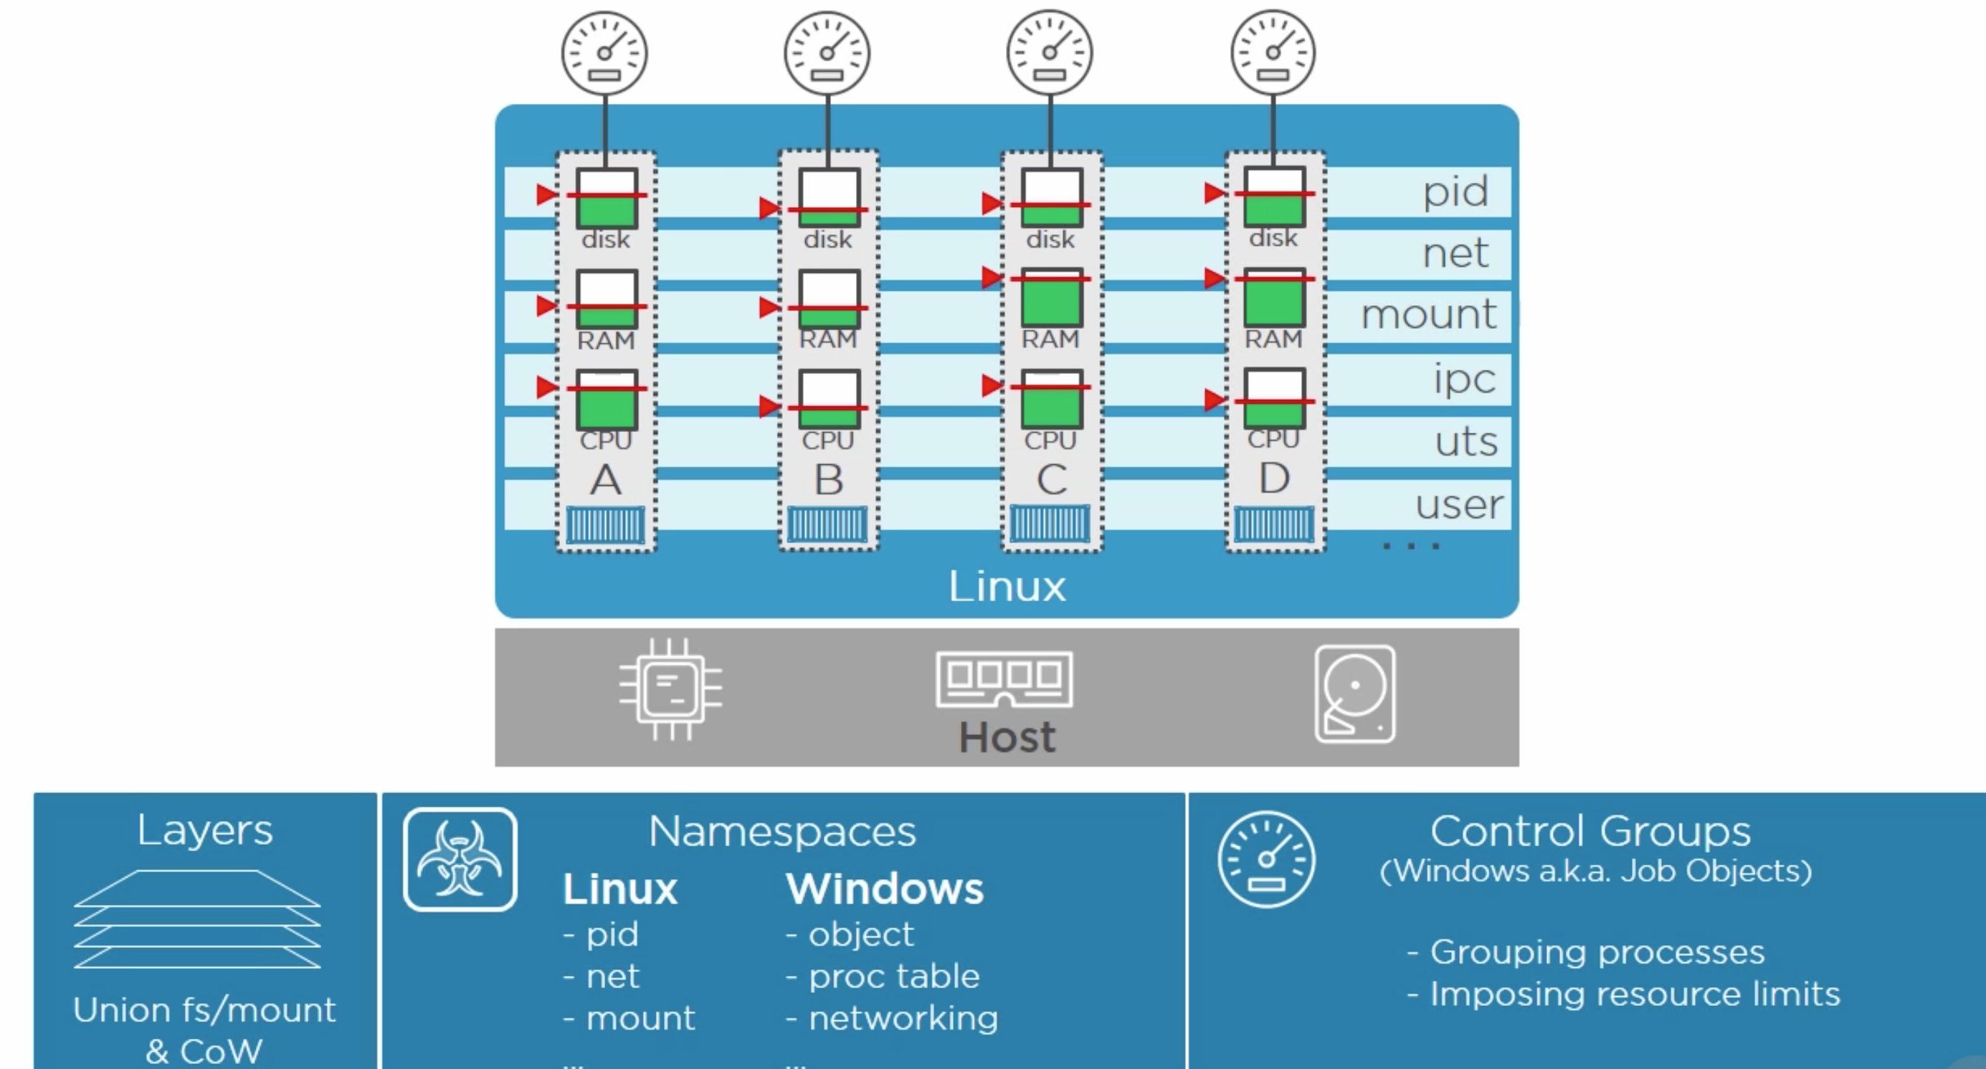

**Docker Engine Architecture:**

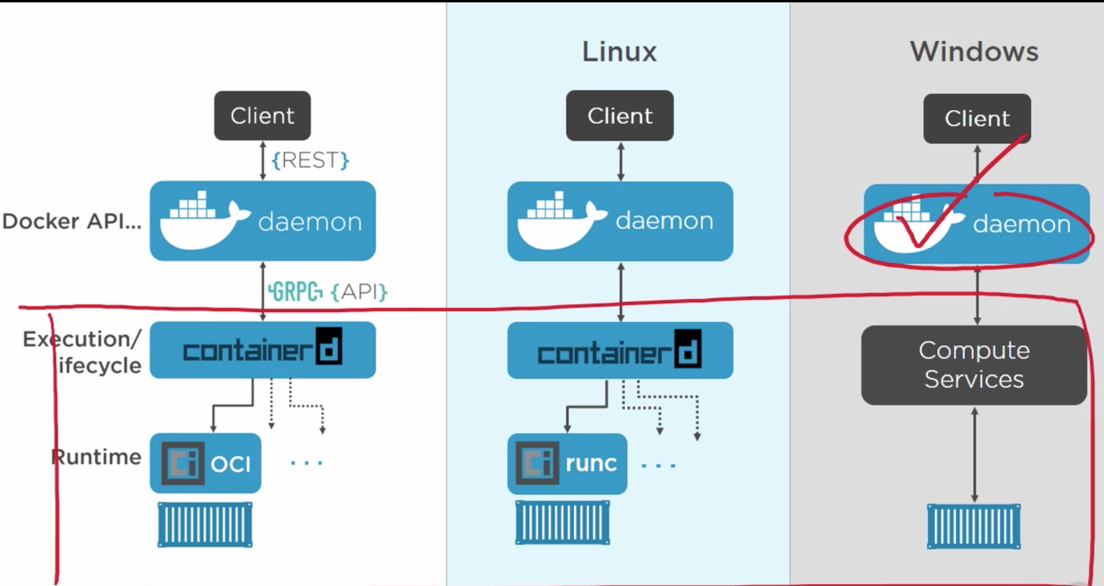

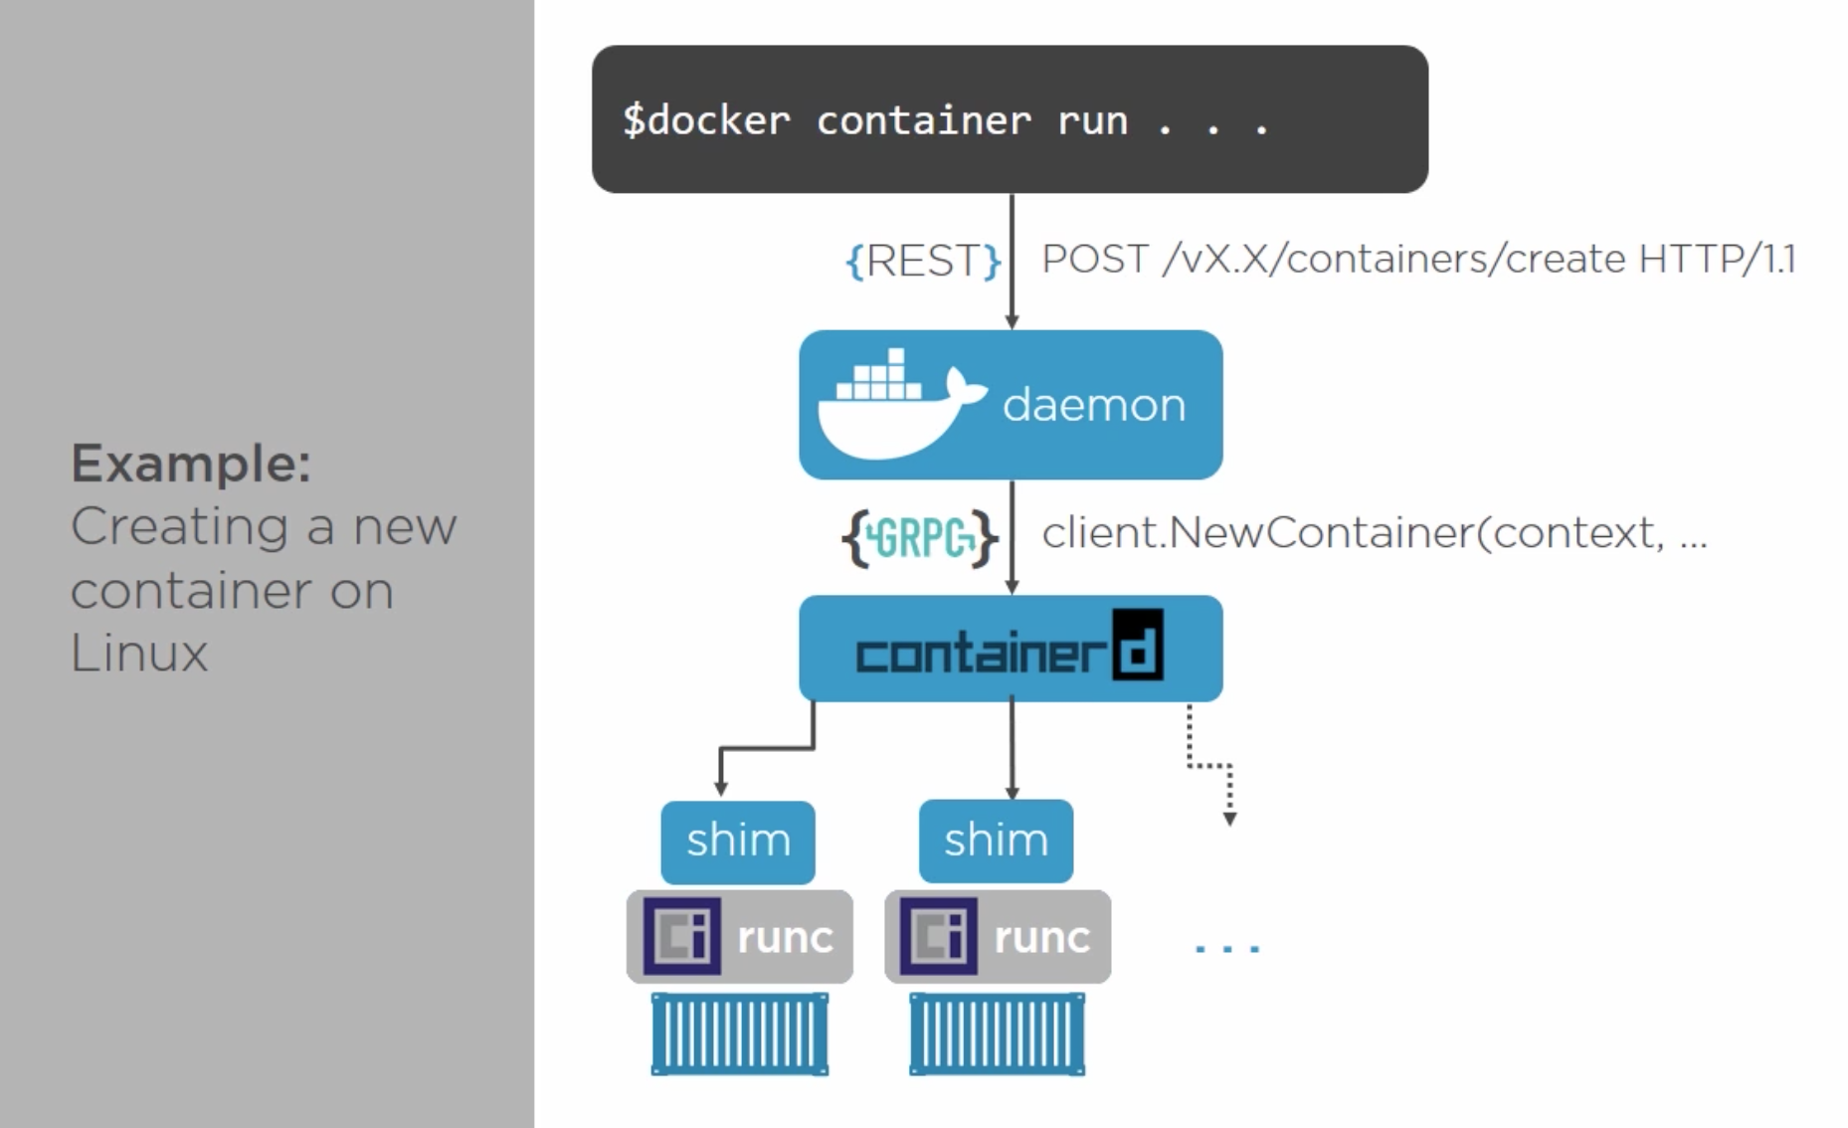

Docker Commands: <https://docs.docker.com/engine/reference/run/>

Official Repo – alpine

|  |  |  |
| --- | --- | --- |
| **Description** | **Command line** | **Note** |
| Pull Image | *docker image pull [image]:[version]* | If version is not specified then defaulted to **latest** |
| Image History | *docker history [image]* |  |
| Inspect image | *docker image inspect [image]* |  |
| Image list | *docker image ls --digest* |  |
| Containers list | *docker container ls docker container ls --all docker container ls -aq* | running  all  all in quiet mode |
| Build | *docker build -f Dockerfile -t [dockerURL]/[image]:[tag] .* |  |
| Run image | *docker run -p 4000:80 [image]*  *docker run -d -p 8443:8443 -it [CONTAINERID]/bin/bash* | Run "friendlyname" mapping port 4000 to 80  Detach mode |
| Push Image | *docker push [dockerURL]/[image]:[tag]* | Push image to repository |
| Stop or kill container | *docker container stop [hash]*  *docker container kill [hash]* | Gracefully stop the specified container  Force shutdown of the specified container |
| Remove Image/ Container | *docker container rm [hash]*  *docker container rm $(docker container ls -a -q)*  *docker image rm [image id]*  *docker image rm $(docker image ls -a -q)* | Remove specified container from this machine  Remove all containers  Remove specified image from this machine  Remove all images from this machine |
| Login | *docker login --username=[UID] --password=[PASS] [DOCKYARDURL]* |  |
| Copy files from docker | *docker cp [containerId]:/file/path/within/container /host/path/target* |  |
| Connect to Container | *docker exec -it [container id] bash* |  |
| Persistence Data | *docker volume create [OPTIONS] [VOLUME]* |  |

Docker File:

FROM = base image

RUN = execute command and create layer

COPY = copy code into image as new layer

WORKDIR

EXPOSE = specify port

ENTRYPOINT = default app from image/container

Difference between CMD and ENTRYPOINT

* CMD: Runtime argument overrides CMD instruction
* ENTRYPOINT: Runtime arguments are appended to ENTRYPOINT

-------------------------------------------------------------------------------------------------------------------------------

Swarm Clustering

Node1> docker swarm init

Node1> docker swarm join

Node2> docker swarm join --token <<Node1>>