Product Adoption Document – CRM

February, 2017

Balasubramaniam Ravi
Program Manager - Intellect Wealth
Intellect Design Arena Limited, India
E-mail: balasubramaniam.ravi@intellectdesign.com

COPYRIGHT NOTICE
Copyright © 2017 Intellect Design Arena Limited
All rights reserved. These materials are confidential and proprietary to Polaris and no part of these materials should be reproduced, published in any form by any means, electronic or mechanical including photocopy or any information storage or retrieval system nor should the materials be disclosed to third parties without the express written authorization of Intellect Design Arena Limited.
Revision History
Version No. | Change Reference No. | Author | Reviewer | Published Date | Section Changed | Description Of change
1.0 |  | Swati Raman | Vinay K | 12/03/2107 |  | Base Version
2.0 |  | Faye Babasa
3.0 |  | Swati Raman |  |  |  | Incorporated the discussion comments
FInalVer1.0 |  | Swati Raman | Vinay K | 28/06/2017 |  | Final Version after discussions

List of CBC Reviewers and Approvers
Ver No. | CBC Reviewer1 |  | CBC Reviewer 2 |  | Published Date |  | CBC Approver1 | CBC Approver 2 | Description Of change
1.0 |  |  |  |  |  |  |  |  | Base Version

Distribution List
Name | Team | Email ID
Faye Theresa S. Babasa | CBC | ftsbabasa@chinabank.ph  ftsbabasa@chinabank.ph
Gemma B. Deladia | CBC | GBDELADIA@chinabank.ph
Jonathan S. Mayor | CBC | JSMAYOR@chinabank.ph
Marie Claire B. Young | CBC | mcbyoung@chinabank.ph
Vinay Kumar | Intellect | Vinay.k@intellectdesign.com
Haja Mohideen | Intellect | Haja.Mohideen@intellectdesign.com
Ravikumar T | Intellect | ravikumar.t@intellectdesign.com
Venkat Gudapati | Intellect | Venkat.gudapati@intellectdesign.com
Atul Shukla | Intellect | Atul.Shukla@intellectdesign.com
Balasubramaniam Ravi | Intellect | balasubramaniam.ravi@intellectdesign.com
Swati Raman | Intellect | Swati.Raman@intellectdesign.com
Debasish Swain | Intellect | Debasish.Swain@intellectdesign.com
Sarvanan Sa | Intellect | Sarvanan.Sa@intellectdesign.com
Eniyan G | Intellect | Eniyan.G@intellectdesign.com
Shekar P | Intellect | Shekar.P@intellectdesign.com

Contents
User Journey_1.2 – Manage Prospect 4
User Journey_1.3 – On-boarding a Customer 18
User Journey_1.5 – Manage Customer Relationship 43
User Journey_1.6 – Handover and Assignment 60
User Journey_1.7 – Manage Campaign 65
User Journey_1.11 – Manage Hierarchy and Groups 73
User Journey_1.12 – Product Definition 86
Plan 88
User Journey_1.4 – Risk Profiling and Asset Allocation 89
User Journey_8.1 – Manage Financial Information 94
User Journey_8.5 – Generate Proposal 100
User Journey_1.8 – Manage Service Request 102
User Journey_1.9 – Manage Calendar 108
User Journey_1.9b – Task List 113
User Journey_1.10 – Manage Call Report 116
Appendix 122

Note – For input data details in each process, the various types in which user can input data is given below.
- Drop Down: List of predefined values will be displayed for user to select
- Manual / Free Text: User can input data or select from a set of displayed values
- System Generated: The reference is auto generated by the system
- Display: The data is not editable which may include display of a stored value or calculated value

User Journey_1.2 – Manage Prospect

- Process Objective –
This user journey details the journey traversed by the user to manage a prospect with the objective of converting the prospect to customer. The application has provisions to enable Relationship Managers/ entitled users to update prospect information, drop prospect, re-activate prospect and recommend prospect to become a customer.

- Customer to wealth Process flow Map

Process Area | Process | Sub Process | Intellect Module | Intellect Process Name
Client Acquisition | Prospect Creation |  | CRM | Relationship - Prospect – Add

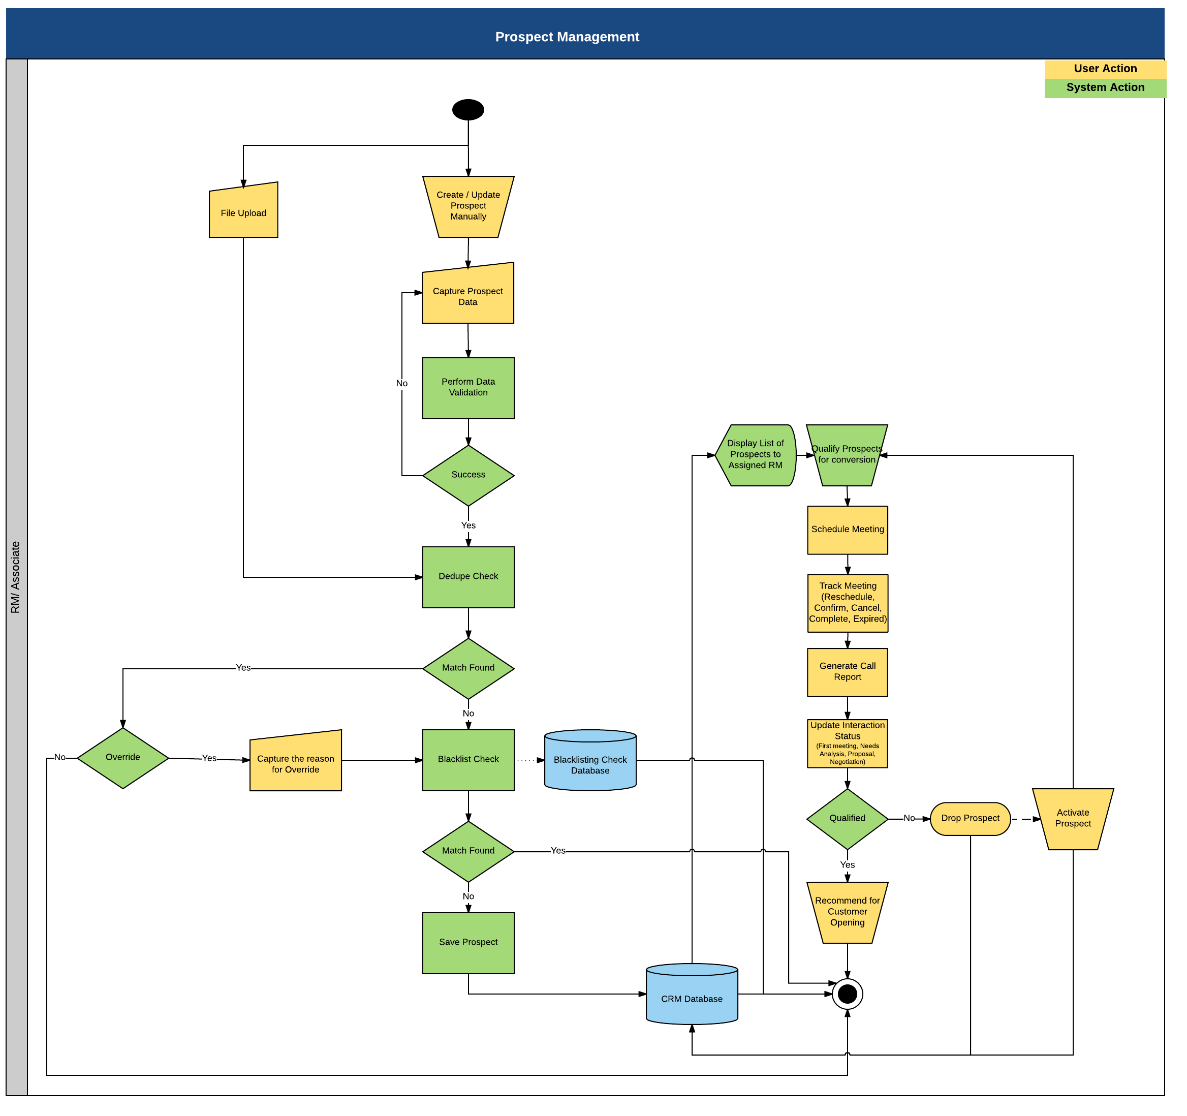

- Description of process steps –
- Prospect data can be uploaded or entered manually.
- Captured data would be subject to business validations
- De Duplication Check:
    - System will perform de duplication check against the existing data of lead/ prospect/ client
    - De-Duplication check is performed against the below mentioned field combinations
- Individual - First Name, Last Name and Email ID/Mobile Number. This is a soft stop combination, where system will allow users to override in case a combination available, along with reason for overriding.
- Non Individual – Entity Name and Email ID/Mobile Number. This is a soft stop combination, where system will allow users to override in case a combination available, along with reason for overriding.
- Negative/Blacklist Check:
    - If the match is not found in de duplication then system will perform check against Negative list which is pre uploaded into the system.
    - The combination for performing Negative check is same as above mentioned in de duplication. This would be a hard stop.
- If there is no hard stop prospect can be saved with captured details.
- System will display list of all prospects to the assigned RM. Prospect can be mapped to an RM while creating a manual prospect in the wealth system by the RM. It can also be mapped when a file upload is being used to upload prospects for an RM. Another way to map RM is through the process of assignment and handover.
- Assigned RM can filter prospect based on various attributes such as Entity Type (Prospect, CIF), Company Name, RM ID, Customer Category (Individual, Non-Individual), Total Assets, Total Liabilities, Total Business, Revenue, Risk Score, TRV and Risk Profile.
- For all the filtered prospects the assigned RM would be able to perform below actions
  - Modify Details – Once information about the prospects is populated in the application, the Relationship Manager can make changes to the information to keep them updated.
  - Handover/Assignment of Prospect to another RM –Prospects can be assigned or handed over to an RM by the supervisor. The prospects would be mapped to the branch manager automatically if no RM is mapped while uploading a file. RM to whom the prospect is mapped would be able to drop and activate a dropped prospect
  - Tagging prospects from one Relationship Manager to another facilitates:
    - Relationship Managers to concentrate on prospects of similar nature, thus enabling them to frame strategies on better servicing the leads
    - Providing attention to prospects of special importance
    - Ensuring that all prospects are serviced continuously, even in the absence of an existing Relationship Manager
    - Re-balancing workload of Relationship Managers, through prospect distribution
  - Drop Prospect –
    - RM would be able to drop the prospect based on his/ her perception and follow ups
    - While dropping a prospect RM would be able to capture the reason for dropping for future reference.
    - Once a prospect is dropped the status of the prospect would be flagged as Dropped and will not be available for client recommendation
  - Activate Prospect – Service to prospects, who have been put on-hold (Drop Prospect), can be resumed.
  - Recommend for client creation

Below are the fields to be captured for prospect.
Can we include a field for the CIF in case the prospect is an existing client of the bank and if the data is available? In the prospect grid system would display the Ageing in days. Date of creation of prospect would be available in Conversion History.
Can we also include the Customer Type – Field called Prospect Type is there in the table. - As requested in the Daily Document, kindly include a field to capture the Product that will be offered to the Prospect or what the potential client is interested in. - Field called Product Type is there in the table.

Can we also include fields to track the status of the Prospect? - In the prospect grid system would display the Ageing in days. Date of creation and Date of conversion of prospect would be available in Conversion History. Next Action Date (when the client/prospect needs to be contacted can be recorded in the Call Report.
S.No. | Field Name | Data Type | Mandatory | Field Description | Entry Type
Personal Information
1 | Salutation | String | Yes | This will be a static data field with the following values:  Dr, Mr, Mrs, Ms, Atty., Engr. | Dropdown
2 | Prospect Type | String | Yes | This field will auto-populate the value of the Prospect type based on the user selection. | Fetched
3 | First Name | String | Yes | This field will auto-populate the value entered by the user at the time of Primary Data Validation.  This will be a free text field allowing the user to enter the first name of the customer. | Input
4 | Short Name | String | No | This will be a free text field allowing the user to enter the Middle name of the customer. It is like Alias. | Input
5 | Middle Name | String | No | This will be a free text field allowing the user to enter the Middle name of the customer. | Input
6 | Last Name | String | Yes | This field will auto-populate the value entered by the user at the time of Primary Data Validation.  This will be a free text field allowing the user to enter the last name of the customer. | Input
7 | Date of Birth | Date | No | This field will auto-populate the value entered by the user at the time of Primary Data Validation.  The date of birth of the individual / the date of incorporation of the company or the trust.  De dupe would be done on this field also. | Input
8 | RO Name-RO ID | String | Yes | This will be a drop-down field which populates all the Relationship Officer who are maintained in the application.  These users will be created and mapped under the Maintenance -> User section in the application.  Value would be defaulted to the User but has the option to change. If RM logs into the system he/she becomes the default RM but when Ops logs-in then the user has the option to select an RM. | Dropdown
9 | Branch | String | Yes | This field will be a drop-down field which will populate all the branches that are defined in the application.  The branches will be created in the application under the Maintenance -> Branch section in the application. | Dropdown
10 | Referral Type | String | No | This field will be a drop-down field which will have the following values:  Own Prospect  Branch Referral  Business Center Referral  IBG Referral  Subsidiary Referral  WMG Referral  CBS Referral  Others | Dropdown
11 | Politically Exposed | String | No | Involved in Politics - Yes/No | Dropdown
12 | Referral ID | String | No | This will be a drop-down list.  This will populate value based on the selection made under the Referral Type field. For eg:  Existing Prospect - This will populate all the prospects maintained in the application. | Dropdown
13 | Gender | String | No | This will be a drop-down list.  This will have the following values stored in the database:  Male, Female | Dropdown
14 | Nationality | String | No | This field will be a drop-down field which will list all the countries that are stored in the database. | Dropdown
15 | Marital Status | String | No | Single, Married, Separated, Divorced, Widowed | Dropdown
16 | Risk Profile | String | No | This field will auto-populate based on the risk profiling done for the underlying customer.  The risk profiling for the customer will take place under the Maintenance -> Risk Profiling section in the application.  The following will be the static values that will be available for categorizing the risk profile of the prospect:  Conservative, Moderate, Balanced, Aggressive | Fetched
17 | Status | String | No | This field will show the current status of the underlying prospect. This needs to be changed manually. The values that will get displayed are as follows:  Active, Inactive, closed | Dropdown
18 | Risk Profile Comments | String | No | This will allow the user to define the risk profile of the Prospect. | Input
19 | Country of Residence | String | No | This field will be a drop-down field which will list all the countries that are stored in the database. | Dropdown
20 | Industry | String | No | This will list all the -industry that will be stored in the database in the backend. | Dropdown
21 | Occupation | String | No | This field will allow the user to enter the occupation of the underlying customer. | Input
22 | Classification | String | No | This will be a drop-down list, which will have values that are stored in the database.  This will have the following values:  Bronze  Gold  Platinum  Silver  Titanium | Dropdown
23 | Gross Monthly Income | Numeric | No | This field will allow the user to select values in listed below  Values to be displayed are as ff  Below PHP10,000  PHP10,000 – 19,999  PHP20,000 – 49,999  PHP50,000 – 99,999  PHP100,000 and above | Dropdown
24 | TRV Currency | String | No | TRV stands for Total Relationship Value. This field allows the user to select the currency for this amount.  This will be a drop-down field.  This field will have all the currencies as drop-down values, stored in the database. Default should be PHP | Dropdown
25 | TRV | Numeric | No | This field will allow the user to define the TRV. | Input
New | Place of Birth | String | No | This would be an input field to capture the place of birth. | Input
New | CIF No | String | No | User can input or upload the CIF if available. | Input
Family Member Details
26 | Relationship | String | Conditional Mandatory  (Conditional mandatory fields are those where if selected then only values needs to be provided) | This field will be a drop-down field which will list the following values:  Brother  Daughter  Father-in-law  Father  Guardian  Mother-in-law  Mother  Other  Sister  Son  Spouse  These will be stored in the database. | Dropdown
27 | Existing CIF ID | String | No | This will be a drop-down field, which will fetch all the CIF's of customers present in the applications database.  User would be able to dynamically search using the remote filters. | Dropdown
28 | Salutation | String | Conditional Mandatory | To capture the family member details. This will be a static data field with the following values:  Dr, Mr, Mrs, Ms, Engr., Atty. | Dropdown
29 | First Name | String | Conditional Mandatory | This will be a free text field allowing the user to enter the first name of the family member | Input
30 | Middle Name | String | No | This will be a free text field allowing the user to enter the Middle name of the family member | Input
31 | Last Name | String | No | This will be a free text field allowing the user to enter the last name of the family member | Input
32 | Date of Birth | Date | No | DOB of the family members | Input
33 | Wedding Anniversary | Date | No | This field will allow the user to select the Wedding Anniversary of the underlying family member. | Input
34 | Dependent | String | No | This captures whether the family member is dependent on the primary customer or not. This will be a drop-down field with the following values:  Yes  No | Dropdown
Address Details
35 | Address Type | String | No | The following will be the drop-down values:  Present Address, Permanent Address, Business Address | Dropdown
36 | Address 1 | String | No | This field will allow the user to enter the first line of the customers address | Input
37 | Address 2 | String | No | This field will allow the user to enter the second line of the customers address | Input
38 | Address 3 | String | No | This field will allow the user to enter the third line of the address | Input
39 | Region | String | No | This will allow the user to enter the Region-region of the underlying customer on boarded. | Input
40 | Country | String | No | This field will be a drop-down field which will list all the countries that are stored in the database. | Dropdown
41 | Province | String | No | This field will be a drop-down field which will list all the states that are mapped to the underlying country selected. This mapping is stored in the database. | Dropdown
42 | City/Municipality | String | No | This field will be a drop-down field which will list all the cities based on the combination of Country and State mapping. | Dropdown
43 | Zip Code | Numeric | No | This field will allow the user to input the ZIP code of the underlying contact. | Input
44 | Preferred Communication Address | String | No | All the advices and reports would pick up this address. Against each address mentioned there would be an option to mark it as primary or not. This will be a drop-down field with the following values:  Yes  No | Dropdown
45 | Contact Type | String | Yes | This will be a drop-down field.  This field will have the following values, stored in the application database:  Spouse Contact  Email 1  Office Telephone  Residence Telephone  Others Telephone  Mobile 1  Mobile 2  Fax  Email 2 | Dropdown
46 | Value | String | Yes | This will allow the user to enter the contact details. | Input
Identification Details
47 | Document Type | String | No | This will be a drop-down field.  This will have the following values as static, and stored in the database:  Passport  License  National Permit Card  National Resident Identification Card  Others  passport  Resident Card  Visa | Dropdown
48 | Document Number | String | No | The document number can be placed here. | Input
49 | Document Name | String | No | Passport, Driving License etc. | Dropdown
50 | Place of Issue | String | No | The place where the document was issued. | Input
51 | Document Issued Date | Date | No | Date of the issue of the document provided | Input
52 | Document Expiry Date | Date | No | The expiry date of the document provided | Input
Life Style Information
53 | Hobbies | String | No | This will be a drop-down field. Some of the static values that will be stored and displayed as part of this field are:  Driving  Gardening  Golf Playing  Music Hearing  Others  Reading  Watching Movies  This field should allow the user to input free text as well. | Dropdown
54 | Product Type | String | Yes | This will be a drop-down field. Some of the static values that will be stored and displayed as part of this field are:  UITF  IMA  PMT  Escrow  Others | Dropdown
55 | Investment Outlets | String | No | This will be a drop-down field. Some of the static values that will be stored and displayed as part of this field are:  Corporate Bonds  Government Securities  Equities  UITF  Mutual Funds  Deposit  VUL | Dropdown
56 | Other Banks | String | No | This will be a drop-down field. | Dropdown
57 | Other Bank Products | String | No | This will be a drop-down field. Some of the static values that will be stored and displayed as part of this field are:  Savings Account  Time Deposit  Credit Card  Insurance  Auto Loan  Home Loan | Dropdown
Document Details (To capture the details of documents apart from the ones used for identification)
59 | Document Name | String | No | Address Proof, Identity Proof etc.  The general Items are:  Identity Proof  Mutual Fund KYC Confirmation C18  PAN Card  Proof of Address  Prospect Photo  Prospect Specimen Signature | Dropdown
60 | Status | String | No | This is the status of the document. This will be a drop-down field, with the following values stored in the database:  Submitted, Pending, Not Applicable. | Dropdown
61 | Submission/Later Submission Date | Date | No | Status of the document | Input
62 | Expiry Date | Date | No | Expiry date of the document that is uploaded. | Input
63 | Remarks | String | No | Additional comments | Input
64 | Upload Document

- Input details – File upload or Manual. Data Fields as shown above.

- Validations
  - Mandatory Field Verification
    - System will validate whether the mandatory or conditional mandatory fields (marked with * or with ** respectively) are filled in by user. If not then system would display an on screen error message - “Please capture mandatory fields” listing all the fields which are not filled in by user.
  - Field length and type Verification
    - System will validate whether the user has input a value which is longer/ bigger than expected and would display an on screen error message “Field Length should not be more than (expected) value”.
  - Data Validation
    - System would perform the data validation for specific set of fields like provided email id is in the correct format or not ( should contain an @ symbol and at least a dot)
    - System would validate whether there are any special Strings entered which are not allowed like ^, {,}

- Business Rules
  - Existing Prospect/ Client cannot be on boarded again.
  - In case a match is found in soft stop scenario the system would allow override.
  - Only Active prospects shall be allowed for Recommendation
  - Only Dropped prospects shall be allowed for re activation
  - System shall only display the Prospect assigned to the logged in RM

- Actor / Entitlements
  - Relationship Officer
  - Associates

- Trigger
  - Manual / File upload

- Output Details
  - None

- Alert/ Notification
  - None

- Next Process
  - User Journey_1.3 – On-boarding a Customer

- Process Gaps – to be taken up as modification
  - Last Name should be able to accommodate special characters such as dash (-), Ñ / ñ
  - A new field “Suffix” should be added to capture “Junior, Senior, III, IV, V, etc.”
  - Product Type and Branch to be added in the grid as column.
  - Field to be added “Account Type”. Drop down values – Sole/Joint/Corporate.
  - Prospect Number Generation – Format – PXXXXXXXX where X represents the 8 digit unique number generated by the system.
  - Prospect Creation for Corporates: Adding contact details of 2 people.
  - Add a new tab for Group Company Details for Corporates.
  - Maker checker is not required for prospect creation. When the prospect is modified then there should be a maker checker.

User Journey_1.3 – On-boarding a Customer

- Process Objective – The objective of this process is to create/ get the clients’ data from Finacle to Intellect system.

- Customer to wealth Process flow Map

Process Area | Process | Sub Process | Intellect Module | Intellect Process Name
Client Acquisition | On-boarding a Customer |  | CRM | Relationship – On-boarding a Customer

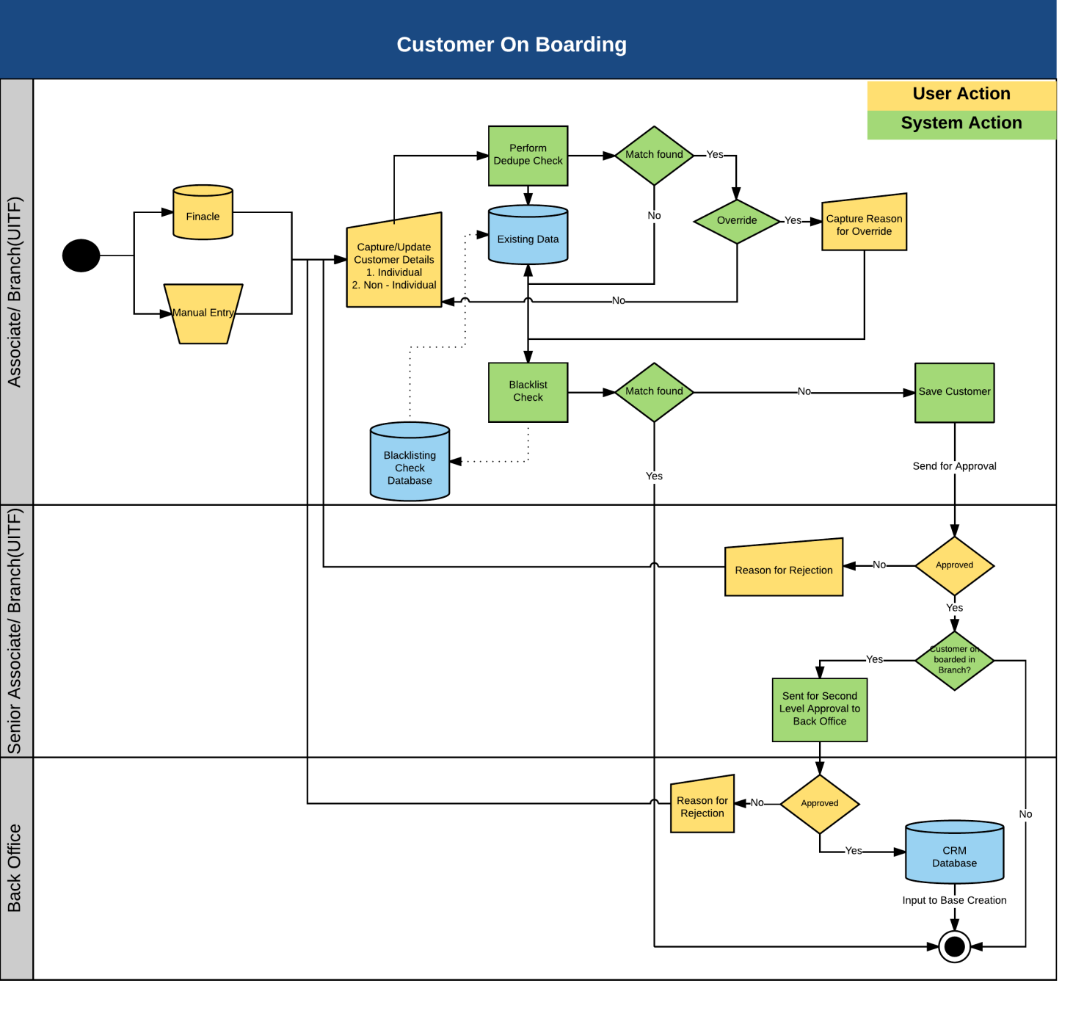
- Description of process steps –
- Client data can be fetched through an interface from Finacle or entered manually.
- When fetching through interface from Finacle:
  - Associate/Branch User would enter the Cust ID of Finacle in the Trust System.
  - System would check if the Cust ID exists in Trust system. If it exists system would show an error - customer id already exists. If it does not exist in Trust System then it should check availability in Finacle. System would check if it exists in Finacle. If the Cust ID exists in Finacle then it would fetch all the details related to it (as elaborated in the interface document). When the customer is converted from Prospect, system will fetch all the relative data and place them in the respective fields. There would be an option for the user to link prospect ID with a CIF. Upon linking all the data entered in prospect would be copied to the CIF but if there is any data which is already present in CIF, the prospect data would not override the same.
  - Negative/Blacklist Check:
    - System will perform check against Negative list which is pre uploaded into the system.
    - The combination for performing Negative check is same as in prospecting stage. This would be a hard stop.
  - If there is no hard stop client can be saved with captured details.

- When manually creating:
  - This would be done occasionally when the Finacle interface is down. Associate user would enter the details in the System.
  - Captured data would be subject to business validations
  - De Duplication Check:
    - System will perform de duplication check against the existing data of lead/ prospect/ client
    - De-Duplication check is performed against the below mentioned field combinations
- Individual - First Name, Last Name and Email ID/Mobile Number. This is a soft stop combination, where system will allow users to override in case a combination is available, along with reason for overriding. Date of Birth can also be included as a parameter to de dupe. All the various combinations are listed below.
- Non Individual – Entity Name and Email ID/Mobile Number. This is a soft stop combination, where system will allow users to override in case a combination is available, along with reason for overriding.

De-Dupe Combination for Individual
# | Attributes | Soft Stop Combination | Hard Stop Combination
1 | First Name + Last Name | Yes | No
2 | First Name + Last Name + Email ID | No | Yes
3 | First Name + Last Name + Mobile Number | No | Yes
4 | First Name + Last Name + DOB | No | Yes
5 | First Name + Mobile Number | No | Yes
6 | Last Name + Mobile Number | No | Yes
7 | First Name + DOB | Yes | No
8 | Last Name + DOB | Yes | No
9 | First Name + Email ID | Yes | No
10 | Last Name + Email ID | Yes | No

De-Dupe Combination for Corporate
# | Attributes | Soft Stop Combination | Hard Stop Combination
1 | Entity Name | Yes | No
2 | Entity Name + Date of Incorporation | No | Yes
3 | Entity Name + Mobile Number | Yes | No
4 | Entity Name + Email ID | Yes | No
5 | Entity Name + TIN Number | No | Yes

  - Negative/Blacklist Check:
- If the match is not found in de duplication or an override is provided, system will perform check against Negative list which is pre uploaded into the system.
- The combination for performing Negative check is same as above mentioned in de duplication. This would be a hard stop.
  - If there is no hard stop client can be saved with captured details.
- In both the above cases, system would generate a customer number internal to trust system. In case of customer creation using interface both the Cust ID (Finacle) and customer no (Trust) would be available. In case of manual creation customer no (Trust) would be generated and the Cust ID (Finacle) could be entered later.
- Client Creation
  - While creating the client system would perform data validations.
  - If errors are found system will send the record to exception queue for manual verification by users.
  - If no errors are found system would save the client in maker stage. It would be sent for approval.
- Modification would not be allowed for the data which is fetched from Finacle. Modification of CIF data fetched from Finacle would be done at EOD through a feed file from Finacle.
- In Trust system modification would be allowed only for the data which is not fetched from Finacle. Once modified it would go for authorization.
- On boarding would be a maker checker process. If the on boarding is done by Associate then it would be one level checker where senior associate would be the authorizer. In case on boarding is done in Branch then it would go through 2 levels of approval. First level would happen in branch and second would happen by associate.
- Welcome letter should be generated -whenever a customer subscribes to a new product except UITF.

CIF Modification:
- Modification would be allowed for the data which is fetched from Finacle. All the modifications done would be available as a report and would have to be done manually in the trust system.
- In Trust system modification would be allowed only for the data which is not fetched from Finacle. Once modified it would go for authorization.
- CIF can be modified by the user to enhance the data information of the customer
- The information can be enhanced by selecting a customer and clicking on modify
- Once the data is modified the same would go for authorization to checker
- Once the record is authorized the enhanced data would be saved

Below are the fields to be captured for On-boarding a Customer.

Will there be a field reflecting the date the Customer is created? It would be available in Conversion History.

S.No. | Field Name | Data Type | Mandatory | Field Description | Entry Type
Personal Information
1 | Salutation | String | Yes | This will be a static data field with the following values:  Dr, Mr, Mrs, Ms, Atty., Engr. | Dropdown
2 | First Name | String | Yes | This field will auto-populate the value entered by the user at the time of Primary Data Validation.  This will be a free text field allowing the user to enter the first name of the customer. | Input
3 | Middle Name | String | No | This will be a free text field allowing the user to enter the Middle name of the customer. | Input
4 | Last Name | String | Yes | This field will auto-populate the value entered by the user at the time of Primary Data Validation.  This will be a free text field allowing the user to enter the last name of the customer. | Input
5 | Short Name | String | No | This will be a free text field allowing the user to enter the Short name of the customer. | Input
6 | Date of Birth | Date | Yes | This field will auto-populate the value entered by the user at the time of Primary Data Validation.  The date of birth of the individual / the date of incorporation of the company or the trust. | Input
7 | Cust ID | String | Yes | The user will be able to enter a unique customer ID of an external system (Finacle) which also holds customer data | Input
8 | Prospect ID | String | No | If a record is converted from a Prospect to a customer, then this field will have the prospect number.  The user will be able to enter a Prospect ID, if it exists. | Input
9 | RO Name-RO ID | String | Yes | This will be a drop-down field which populates all the Relationship Officer who are maintained in the application. It should be defaulted to User.  These users will be created and mapped under the Maintenance -> User section in the application. BM’s should be able to see the accounts that they open and Relationship Officer should be able to see the entire relationship. | Dropdown
10 | TRA ID | String | No | This field will be a drop-down field which will populate all Trust Relationship Associate defined in the application.  The TRA ID will be mapped to users under the Maintenance -> Users section in the application. | Dropdown
11 | Referral Type | String | No | This field will be a drop-down field which will have the following values:  Own Prospect  Branch Referral  Business Center Referral  IBG Referral  Subsidiary Referral  WMG Referral  CBS Referral  Others  If the record is converted from a Prospect, this field should auto-populated with the referral type previously maintained. | Dropdown
12 | Referral ID | String | No | This will be a drop-down list.  This will populate value based on the selection made under the Referral Type field.  Employee- Users maintained under the Maintenance -> Users section  Existing Prospect - This will populate all the prospects maintained in the application | Dropdown
13 | Advisor ID | String | No | This will be a drop-down list.  This field will populate all the Advisors ID's maintained under the Maintenance section of the application. | Dropdown
14 | Gender | String | Yes | This will be a drop-down list.  This will have the following values stored in the database:  Male, Female | Dropdown
15 | Nationality | String | Yes | This field will be a drop-down field which will list all the countries that are stored in the database. | Dropdown
16 | Marital Status | String | Yes | Single, Married, Separated, Divorced, Widowed | Dropdown
17 | Client Type | String | Yes | This will be a drop-down list, provided by the bank. Indicative list can have the following values:  Individual  Corporate | Dropdown
18 | Risk Profile | String | No | This field will auto-populate based on the risk profiling done for the underlying customer. | Fetched
19 | Client Status | String | No | This field will be a drop-down field. The indicative values that will get displayed are as follows:  Valid Values:  HNI, Salary Account, Private Banking Group, Trust group, Premiere. | Dropdown
20 | Country of Residence | String | Yes | This field will be a drop-down field which will list all the countries that are stored in the database. | Dropdown
21 | Resident Status | String | Yes | Resident, Non-Resident | Dropdown
22 | Occupation | String | No | This will list all the occupations that will be stored in the database | Dropdown
23 | Client Reference Currency | String | Yes | This is base currency which would be shown in FABX Portfolio View by default. This field will be a drop-down field which will list all the currencies that are stored in the database. Default should be PHP. | Dropdown
25 | Gross Monthly Income | Numeric | No | This field will allow the user to select values from the application.  Values to be displayed are as ff  Below PHP10,000  PHP10,000 – 19,999  PHP20,000 – 49,999  PHP50,000 – 99,999  PHP100,000 and above | Dropdown
26 | CIF Status | String | Yes | This field will auto-populate based on the current status of the customer. This will have the following static values:  Active, Inactive, closed | Fetched
27 | Last Review Date | Date | No | This will allow the user to select a date of last review of customer profile. | Input
28 | Politically Exposed | String | Yes | Involved in Politics - Yes/No | Dropdown
New | Place of Birth | String | Yes | This will allow user to indicate the city and country of birth of the client. | Input
New | Mother’s Maiden Name | String | Yes | This will allow the user to input the client’s mother’s maiden name. This is a mandatory field. | Input
New | US Person | String | Yes | This field will be a dropdown field which will list the following values:  Yes  No  No with US Indicia | Dropdown
New | Employment Type | String | Yes | This field will be a dropdown field which will list the following values:  Employed  Self-Employed  Retired  Not Applicable  CBC Employee | Dropdown
New | Relation with CBC and its employees | String | No | This field will be a dropdown field which will list the following values:  - Not Applicable  - Director/stockholder/employee is relative  - Applicant is a director/stockholder/employee  - Applicant is a Trust Personnel | Dropdown
New | Name and Unit of Director/Stockholder/Employee | String | No | - User will be allowed to input the name and unit of the director/stockholder/employee  - Free text | Input
New | Relationship to Director/Stockholder/Employee | String | No | User will be allowed to input the relationship with Director/Stockholder/Employee | Input
New | Source of Funds | String | Yes | This will be a dropdown field with the following values.  Salary  Remittance  Business  Commission  Interest  Pension  Others | Dropdown
New | Employer Name | String | Yes | This will be a free text field allowing the user to enter the employer or business name of the client. | Input
New | Risk Rating | String | Yes | ECRAF – also to show who are the high risk customers. To be available in the grid also. This will be a dropdown field with the following values:  1-Low Risk  2-Normal Risk  3-High Risk | Dropdown
Family Member Details
29 | Existing CIF ID | String | No | This will be a drop-down field, which will fetch all the CIF's of customers present in the applications database. | Dropdown
30 | Salutation | String | Conditional Mandatory | This will be a static data field with the following values:  Dr, Mr, Mrs, Ms, Atty., Engr. | Dropdown
31 | First Name | String | Conditional Mandatory | This will be a free text field allowing the user to enter the first name of the family member | Input
32 | Middle Name | String | No | This will be a free text field allowing the user to enter the Middle name of the family member | Input
33 | Last Name | String | Conditional Mandatory | This will be a free text field allowing the user to enter the last name of the family member. | Input
35 | Relationship | String | Conditional Mandatory | This field will be a drop-down field which can have the following values:  Brother  Daughter  Father-in-law  Father  Guardian  Mother-in-law  Mother  Other  Sister  Son  Spouse  Grandchild  Niece  Nephew | Dropdown
36 | Date of Birth | Date | Conditional Mandatory | This field allows the user to define the Birth date of the family member.  The guardian cannot be a minor. | Input
37 | Date of Appointment | Date | No | Guardian appointment date for Minor account | Input
38 | Appointment Expiry Date | Date | No | Guardian appointment cancellation date for Minor account | Input
39 | Reference Number | String | No | This will allow the user to enter any reference number pertaining to the Guardian | Input
40 | Document Number | String | No | Document number | Input
41 | Date of Issue | Date | No | This field will allow the user to select the Issue date of the Passport used by the Nominee as a reference. | Input
42 | Date of Expiry | Date | No | This field will allow the user to select the Expiry date of the Passport used by the Nominee as a reference. | Input
New | No. of Dependents |  | No | The field will allow the user to input the number of client’s dependents. System would have a provision to mark whether the relationship is dependant or not. | Input
New | Employer/Business Name of Spouse | String | No | The field will allow the user to input the employer / business name of the Spouse | Input
New | Work Address of Spouse | String | No | The field will allow the user to input the work address of the Spouse. This would be available in contact details tab. | Input
New | Contact No. of Spouse | String | No | The field will allow the user to input the contact no. of the Spouse. This would be available in contact details tab. | Input
Address Details
43 | Address Type | String | Yes | The following will be the drop-down values:  Present Address, Permanent Address, Work Address | Dropdown
44 | Address 1 | String | Yes | This field will allow the user to enter the first line of the customers address | Input
45 | Address 2 | String | Yes | This field will allow the user to enter the second line of the customers address | Input
46 | Address 3 | String | No | This field will allow the user to enter the third line of the address | Input
47 | Region | String | No | This will allow the user to enter the Region of the underlying customer on boarded. | Input
48 | Country | String | Yes | This field will be a drop-down field which will list all the countries that are stored in the database. | Dropdown
49 | Province | String | No | This field will be a drop-down field which will list all the states that are mapped to the underlying country selected. This mapping is stored in the database. | Dropdown
50 | City | String | No | This field will be a drop-down field which will list all the cities based on the combination of Country and State mapping | Dropdown
51 | Zip Code | String | No | This field will allow the user to input the ZIP code of the underlying contact. | Input
52 | Preferred Communication Address | String | Yes | This will be a drop-down field with the following values:  Yes  No | Dropdown
53 | Contact Type | String | Yes | This will be a drop-down field.  This field will have the following values, stored in the application database:  Spouse Contact  Email 1  Office Telephone  Residence Telephone  Others Telephone  Mobile 1, Mobile 2  Fax  Email 2 | Dropdown
54 | Value | String | Yes | This will allow the user to enter the contact details. | Input
Identification Details
55 | Document Type | String | No | This will be a drop-down field.  This will have the following values as static, and stored in the database:  Passport  Driver’s License  PRC IDNBI Clearance  Police Clearance  Postal ID  Voter’s ID  Barangay Certification  GSIS e-Card  SSS ID  UMID  Philhealth Card  Senior Citizen Card  OWWA ID  OFW ID  Seaman’s Book  Alien Certificate of Registration  Immigrant Certificate of Immigration  Government Office ID  Certification NCWDP  DSWD Certification  Philippine Retirement Authority Special Resident Retiree Visa  Company ID  School ID | Dropdown
56 | Document Number | String | No | The document number can be placed here. | Input
57 | Document Name | String | No | This is different from document type. Document type could be Identification and under that there could be 2 documents National ID and Passport. Eg: Pan Card, Driving License etc. | Input
58 | Place of Issue | String | No | The place where the document was issued. | Input
59 | Document Issue Date | Date | No | The date of issue of the document provided | Input
60 | Document Expiry Date | Date | No | The expiry date of the document provided | Input
Lifestyle Details
61 | Hobbies | String | No | This will be a drop-down field. Some of the static values that will be stored and displayed as part of this field are:  Driving  Gardening  Golf Playing  Music Hearing  Others  Reading  Watching Movies | Dropdown
62 | Product Type | String | Yes | This will be a drop-down field. Some of the static values that will be stored and displayed as part of this field are:  UITF  IMA  PMT  Escrow  This list would include all the products mentioned in product hierarchy excel sheet. | Dropdown
63 | Investment Outlets | String | No | This will be a drop-down field. Some of the static values that will be stored and displayed as part of this field are:  Corporate Bonds  Government Securities  Equities  UITF  Mutual Funds  Deposit  VUL | Dropdown
64 | Other Banks | String | No | This will be a drop-down field. | Dropdown
65 | Other Bank Products | String | No | Savings Account  Time Deposit  Credit Card  Insurance  Auto Loan  Home Loan | Dropdown
Document Details
67 | Document Name | String | Yes | Various documents related to a customer can be uploaded for easy access in the future.  IDs  Client Information File  Signature Card  ECRAF  FATCA | Dropdown
68 | Status | String | Yes | This will be a drop-down field, with the following values stored in the database:  Submitted, Pending, Not applicable, | Dropdown
69 | Submission/Later Submission Date | Date | No | Status of the document. The status would show whether the document has been submitted or not. If not then what would be the submission date. | Input
70 | Expiry Date | Date | No | Expiry date of the document submitted | Input
71 | Remarks | String | No | Additional comments | Input
72 | Upload Document | String | No | This field will allow the user to select the documents to be uploaded. | Input
Corporate Customer
Client Information
1 | Name of Entity | String | Yes | This should populate the name of the customer entered as part of the Primary Data validation.  This field should be non-editable. | Fetched
2 | Prospect ID | String | No | This field would allow the user to map all the details entered at Prospect level to Customer level once the customer is on-boarded | Fetched
3 | Date of Incorporation | Date | Yes | This field will allow the user to select the date of incorporation of the underlying customer's entity. | Input
4 | Cust ID | String | Yes | This would be the unique identifier for a customer. This can be mapped to an external ID or internal system generated ID | Fetched
5 | Referral Type | String | No | This field will be a drop-down field which will have the following values:  Own Prospect  Branch Referral  WMG Referral  IBG Referral  Business Center Referral  Subsidiary Referral  Counterparty  CBS Referral  Others | Dropdown
6 | RO Name-RO ID | String | Yes | This will be a drop-down field which populates all the Trust Relationship Managers who are maintained in the application. It should be defaulted to User.  These users will be created and mapped under the Maintenance -> User section in the application. BM’s should be able to see the accounts that they open and RO should be able to see the entire relationship. | Dropdown
7 | TRA ID | String | No | This will be a drop-down field.  This field will have all the CSM ID's that are created and maintained under the Maintenance -> Users section of the application. | Dropdown
8 | Referral ID | String | No | This will be a drop-down list.  This will populate value based on the selection made under the Referral Type field.  Employee- Users maintained under the Maintenance -> Users section  Existing Client - This will populate all the customers present in the application database.  Existing Prospect - This will populate all the prospects maintained in the application | Dropdown
9 | Advisor ID | String | No | This will be a drop-down field.  This field will list all the Advisors present in the application. | Dropdown
Corporate Information
10 | Country of Incorporation | Date | No | This will be a drop-down field.  This field will have all the countries maintained in the application. | Dropdown
11 | Nature of Business | String | Yes | This will be a drop-down field, with values stored in the database.  The following lists the standard static values that will be available:  Agriculture/Fishing/ Mining  Building and Construction  Cash Intensive Business (restaurant / Convenience Store)  Casino and Gaming  Charity  Financial Institution  General Commerce (Export/Import/Trading)  Jewellery Dealer  Manufacturing  Money Changer / Remitter  Others  Professional Services  Real Estate Agent / Broker  Transportation / Communication  Foundation  NGO  Remittance | Dropdown
12 | Risk Profile | String | No | This field will auto-populate based on the risk profiling carried out for the underlying customer. | Fetched
13 | Client Reference Currency | String | Yes | This field will be a drop-down field which will list all the currencies that are stored in the database. It would be defaulted to PHP but with option to change. | Dropdown
14 | CIF Status | String | Yes | Active, Inactive, Closed | Fetched
15 | US Person | String | No | This field will be a drop-down field which will list the following values:  Yes  No  No with Indicia | Dropdown
16 | Resident Status | String | Yes | This field will be a drop-down field.  - Resident  - Non-Resident | Dropdown
17 | Accredited Investor | String | No | Investor who has knowledge about investments. This field will be a drop-down field which will list the following values:  Yes  No | Dropdown
18 | Parent Company Name | String | No | This field will allow the user to enter the Name of the Parent Company, if applicable. | Input
19 | Other Business Details | String | No | This field will allow the user to enter the details of other business corresponding to the underlying entity, if applicable. | Input
20 | Occupation | String | No | This field will allow the user to enter the occupation engaged by the entity, if applicable | Input
21 | Type of Company | String | No | This field will allow the user to define the type of company. | Input
22 | Country of Parent Company | String | No | This field will be a drop-down field which will list all the countries stored in the application. | Dropdown
New | Source of Funds | String | Yes | This field will be a drop-down field which will have the following values:  Business  Interest  Commission  Gifts/Donations  Dividends  Others | Dropdown
New | Relation with CBC and its employees | String | No | This field will be a dropdown field which will list the following values:  Not Applicable  Director/stockholder/employee is relative  Applicant is a director/stockholder/employee | Dropdown
New | Name and Unit of Director/Stockholder/Employee | String | No | User will be allowed to input the name and unit of the director/stockholder/employee  Free text | Input
New | Relationship to Director/Stockholder/Employee | String | No | User will be allowed to input the relationship with Director/Stockholder/Employee | Input
Contact Person Information
23 | Salutation | String | Yes | This will be a static data field with the following values:  Dr, Mr, Mrs, Ms, Atty, Engr. | Dropdown
24 | First Name | String | Yes | This will be a free text field allowing the user to enter the first name | Input
25 | Middle Name | String | No | This will be a free text field allowing the user to enter the Middle name | Input
26 | Last Name | String | Yes | This will be a free text field allowing the user to enter the last name | Input
27 | Date of Birth | Date | No | This field will allow the user to input the Date of Birth of the POC. | Input
28 | Short Name | String | No | This will be a free text field allowing the user to enter the Short name of the customer. | Input
Address Details
29 | Address Type | String | Yes | The following will be the drop-down values:  Principal Office Address  Branch/Regional Office Address | Dropdown
30 | Address 1 | String | Yes | This field will allow the user to define the first line of the address | Input
31 | Address 2 | String | Yes | This field will allow the user to define the second line of the address | Input
32 | Address 3 | String | No | This field will allow the user to define the third line of the address | Input
33 | Region | String | No | This field will allow the user to enter the Region | Input
34 | Country | String | Yes | This field will be a drop-down field which will list all the countries that are stored in the database. | Dropdown
35 | Province | String | No | This field will be a drop-down field which will list all the states that are mapped to the underlying country selected. This mapping is stored in the database. | Dropdown
36 | City | String | No | This field will be a drop-down field which will list all the cities based on the combination of Country and State mapping | Dropdown
37 | Zip Code | Numeric | No | This field will allow the user to enter the ZIP code of the contact | Input
38 | Preferred Communication Address | String | Yes | This will be a drop-down field with the following values:  Yes  No | Dropdown
39 | Contact Type | String | Yes | This will be a drop-down field.  This field will have the following values, stored in the application database:  Email 1  Office Telephone  Others Telephone  Mobile  Fax  Email 2 | Dropdown
40 | Value | String | Yes | This field will allow the user to enter the contact details | Input
Identification Details
41 | Document Type | String | No | This will be a drop-down field.  This will have the following values as static, and stored in the database:  Certificate of Incorporation  Others  Registration Certificate  Registration No.  Trade Licence  VAT No. | Dropdown
42 | Document Name | String | No | This will be a free-text field | Input
43 | Document Registration Number | String | No | The registration number of the document provided | Input
44 | Place of Issue | String | No | Place of Issue of the document provided | Input
45 | Document Issued Date | Date | No | Date of issue of the document provided | Input
46 | Document Expiry Date | Date | No | Date of expiry of the document provided | Input
Document Details
47 | Document Name | String | Yes | Address Proof, Identity Proof etc.  The General items are:  Address Proof  Auditor Certificate  Certificate of Incorporation  Document evidencing Incorporation  Extract of the register of the Regulator  Fax Indemnity - Call and Invest  Identity Proof  Identity Proof Director / Authorized Signature  KYC Document (CDD)  Other Letter on Company Letter Head  Others  Partnership deed  Registration Certificate  Relationship Opening Forms  Trust Resolution  Verified List Directors Shareholders / Beneficial Owners | Dropdown
48 | Status | String | Yes | This will be a drop-down field, with the following values stored in the database:  Submitted, Pending, not applicable, | Dropdown
49 | Submission/Later Submission Date | Date | No | Status of the document. The status would show whether the document has been submitted or not. If not then what would be the submission date. | Input
50 | Expiry Date | Date | No | Expiry date of the document | Input
51 | Remarks | String | No | Additional comments | Input
Related Party
52 | Salutation | String | Yes | This will be a static data field with the following values:  Dr, Mr, Mrs, Ms, Atty., Engr | Dropdown
53 | First Name | String | Yes | This will be a free text field allowing the user to enter the first name | Input
54 | Middle Name | String | No | This will be a free text field allowing the user to enter the Middle name | Input
55 | Last Name | String | Yes | This will be a free text field allowing the user to enter the last name | Input
56 | Date of Birth | Date | No | This field will allow the user to input the Date of Birth of the POC. | Input
57 | 20% Ownership | String | No | This will be a free text field allowing the user to enter the other details | Input
58 | Designation | String | No | This will be a drop-down field, which will fetch all the designation present in the applications database. | Dropdown
59 | Existing CIF ID | String | No | This will be a drop-down field, which will fetch all the CIF's of customers present in the applications database. | Dropdown

- Input details – Interface or Manual. Data Fields as shown above.

- Validations
  - Mandatory Field Verification
    - System will validate whether the mandatory or conditional mandatory fields (marked with * or with ** respectively) are filled in by user. If not then system would display an on screen error message - “Please capture mandatory fields” listing all the fields which are not filled in by user.
  - Field length and type Verification
    - System will validate whether the user has input a value which is longer/ bigger than expected and would display an on screen error message “Field Length should not be more than (expected) value”.
  - Data Validation
    - System would perform the data validation for specific set of fields like provided email id is in the correct format or not ( should contain an @ symbol and at least a dot)
    - System would validate whether there are any special Strings entered which are not allowed like ^, {,}

- Business Rules
  - Existing Clients cannot be on boarded again.
  - In case a match is found in soft stop scenario the system should allow override.
  - Customers should not appear in SDN/ Negative list/Black List.

- Actor / Entitlements
  - Associate
  - Senior Associate
  - Branch User
  - Back Office

- Trigger
  - Manual / Interface

- Output Details
  - None

- Alert/Notification
  - None

- Next Process – NA

- Process Gaps – to be taken up as modification
  - Field to show ECRAF (Enhanced Customer Risk Assessment Form) rating. Alert to be generated based on this rating for re profiling the customer. If rating is High, re profiling every year. If rating is medium, re profiling is every 2 years. And if rating is Low, re profiling is every 3 years.
  - User should be alerted if the CIF is “US Person”. Override should be allowed.
  - CIF Number Generation – Format – XXXXXXXX where X represents the 8 digit unique number generated by the system.
  - Fields related to AMLA to be shown.
  - Beneficiary/Related Parties Tab – Not required. This would be available at the portfolio level.
  - When the CIF ID is entered system should fetch the corresponding details like first name, date of birth etc.
  - System should have a provision to store the TAPS Header No.

User Journey_1.5 – Manage Customer Relationship
- Process Objective –
Once customers are on boarded into the application, the next step will be to manage them so that the required services and products can be provided. The following processes allow the user to manage relationship with the customers:
- Base Creation
- Account Creation
- Assignment to New RM

- Customer to wealth Process flow Map

Process Area | Process | Sub Process | Intellect Module | Intellect Process Name
Manage Relationship for Customer | Manage Relationship for Customer |  | CRM | Manage Relationship for Customer

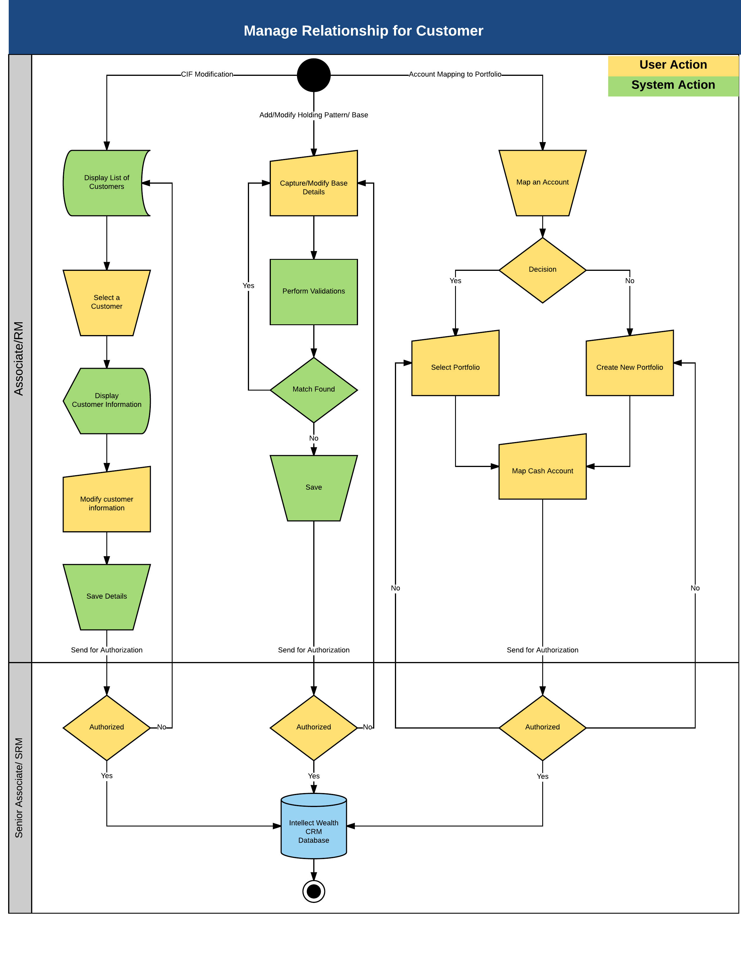

- Description of process steps –
Add/Modify Holding pattern:
- Bases can be created and modified to take care of holding pattern of a portfolio. A customer can have any number of bases tagged to him with different holding pattern. User can amend the CIFs for multiple holding patterns. E.g. If I created a base for CIF 1 and CIF 2, I be allowed to change CIF 2 with CIF 3. Also from multiple to single or vice versa.
- The application will allow customers to have either:
  - A single Holding pattern or
  - A multiple Holding pattern (upto 6 CIF’s). In case a base is defined with multiple holders, one of the CIF needs to be marked as Primary Holder. It is possible to amend from multiple holding patterns to single holding pattern.Once the user has entered the base details, the application will perform duplicate check on the information provided. If a duplicate base pattern exists then the application will ask the user to use the existing base or create a new unique base. Bases with same criteria are not allowed. Eg. CIF1 +CIF2 = Base 1. Now with the same pattern another base cannot be created.
- Once all the validations are carried out successfully, the application will create the base and store the details in the database.

Portfolio and Account Creation:
- Multiple portfolios can be created under base.
- User can define following attributes for a given portfolio like
  - Portfolio Name
  - Portfolio Number – System generated
  - Base – System would show all the bases under the CIF.
  - Risk profile - to be inherited from base and can be modified for the portfolio.
  - Mandate - Directed or Managed
  - Model portfolio
  - Status – Holdout/free
  - Review Date
- User would be able to link the portfolio to a product such as IMA, PMT, Retirement Fund etc.
- User would be able to upload the documents required. List of documents required would be shown based on combination of Product, Mandate and Customer type.
- Would also be able to define the fees structure in the fees and charges module.
- User would be able to capture details of related parties such as Beneficiaries, PoA and signatories.
- Account set up would be linked to each portfolio. Separate accounts would be created for each unique combination of branch and tax status of investments.
- One TSA (account opened in Finacle) would be linked to a Portfolio for each currency like PHP, USD.
- CASA Accounts would also be opened in Finacle and it would be linked to portfolio/account (user would be able to select a default CSA) based in the below mentioned ways:
  - Create - Where the user clicks on the create button and the system would fetch details from Finacle and show on the screen. Then user selects the account and clicks on "Link CSA".
  - Enter and validate - Where the system would allow user to enter the account no on the screen and once this is verified in Finacle, details of the same would be populated on the screen. Then user clicks on "Link CSA" to link it.
- If 2 CSA’s are defined in the same currency then system should have a flag to set the default account. Default account would appear in OMS and Corporate actions. System would have a provision to delink a CSA. User would be able to change the account status manually for both linked and unlinked accounts. System would not allow linking inactive or closed accounts. Linking and delinking of TSA should also be allowed. There would always be only one active TSA per currency.

- Can we add the mailing instruction with the option for (a) via email; (b) collect – branch; (d) hold-head office; (e) mail (i.e. to client’s preferred communication address). This should be at base level.
- Preferred Communication Address should be defined at the Base (if we need to send out consolidated reports) and at the Portfolio (since Financial Statements are now being sent out on a per product / agreement).
- At the Account creation; system would have a field or provision for user to define the disposition of coupon / dividends/ maturity/ redemption. They can choose (1) Pay-out - CSA; (2) Pay-out check; (3) Reinvest; (4) Retain-TSA. Presently Instruction is received from the customer upon every buy of bond/equity about the disposition method. We would have it at account level. It would be defaulted from account level for corporate actions with provision to change. If the disposition selected is Pay-out CSA then system would allow the user to select the default CSA (this would be defaulted in Corporate Actions).
- Regulatory Report (Accounts Opened and Terminated) for AMLA purposes would be generated by the system with the fields as following-– Account no, Account name, Date of opening/closure, Product, Amount of initial contribution/final withdrawal amount.

Documents:
- Documents would be maintained for each product-mandate-customer type combination. Currently attaching the document list shared by Faye. This section would be updated once the details for all the products are received.

Below are the mandatory fields to be captured for managing Relationship for Customer:
Base:
S.No. | Field Name | Data Type | Mandatory | Field Description | Entry Type
1 | Holding Pattern | String | Yes | This is a drop-down field.  This field will have the following values:  Single  Multiple | Dropdown
2 | Primary Holder Details | String | Yes | This is a drop-down field.  This field will populate all the customers who are available in the application.  The user can select any customer who will act as the Primary base holder. | Dropdown
3 | Signing Condition | String | Yes | This field will be enabled only when the user selects the Holding Pattern as "Multiple".  If the Holding Pattern is selected as "Single" then this field will be inactive.  This will be a drop-down field.  This field will have the following values:  Single  Multiple (Any one) – to be defaulted for Individuals  Multiple (Any two)  Multiple (Any three)  All  Custom – To be defaulted for Corporates | Dropdown
4 | Base Name | String | Yes | This field will allow the user to define a name for the underlying base created. | Input
5 | Household Number | Numeric | No | This will be a drop-down field.  This field will populate all the Households that have been created in the application. | Dropdown
6 | RO Name-RO ID | String | Yes | This is a drop-down field.  This field will populate values of RM's present in the application. This will populate data from the Maintenance -> User section in the application. | Dropdown
7 | Branch Code | String | Yes | This is a drop-down field.  This field will populate values as per the mapping done for RM under the Maintenance -> Branch section in the application. | Dropdown
8 | Segment / Service Unit | String | Yes | This is a drop-down field.  This field will populate values as per the mapping done for RM under the Maintenance -> Service Unit section in the application. | Dropdown
9 | Resident Status | String | No | To be fetched from primary holder’s details. This is a drop-down field.  This field will have the following values stored in the application database:  Resident  Non-Resident | Dropdown
10 | Client Status | String | No | This is a drop-down field.  This field will have the following values stored in the application database:  High Value Client - AUM > Rs. 50 lacs  Platinum - AUM Rs. 20-50 lacs  Gold - AUM Rs. 5 - 20 lacs  Silver - AUM Rs. 2 - 5 lacs  Bronze - AUM < Rs. 2 lacs  Not Applicable | Dropdown
11 | Reference Currency | String | Yes | This field will auto-populate based on the primary holder details.  The reference currency that is tagged to the Primary Holder will appear in this field. | Fetched
12 | Base Status | String | Yes | This field will be user input based on the underlying status of the base. | -Input
13 | Remarks | String | No | Additional comments | Input
14 | Phone / Fax Indemnity | String | No | This will be a drop-down field.  This field will have the following values:  Phone  Fax  Phone/Fax  No Indemnity | Dropdown
15 | Risk Rating | String | No | This field will populate the risk mapping pertaining to the underlying base.  This field will be non-editable.  The values that will appear in this field from the model portfolio are:  Very High Risk  High Risk  Medium Risk  Low Risk  Very Low Risk | Fetched
16 | Country of Residence | String | Yes | This will be a drop-down field.  This field will populate all the countries that are stored in the application database. To be fetched from primary holder’s details. | Dropdown
17 | Address Type | String | Yes | Residential, Permanent, Office etc.  This field will auto-populate the value based on the "Primary Holder Details" field selection under the "Basic Information" tab. | Fetched
18 | Address 1 | String | Yes | This field will auto-populate the value based on the "Primary Holder Details" field selection under the "Basic Information" tab. | Fetched
19 | Address 2 | String | Yes | This field will auto-populate the value based on the "Primary Holder Details" field selection under the "Basic Information" tab. | Fetched
20 | Address 3 | String | No | This field will auto-populate the value based on the "Primary Holder Details" field selection under the "Basic Information" tab. | Fetched
21 | Region | String | No | This field will auto-populate the value based on the "Primary Holder Details" field selection under the "Basic Information" tab. | Fetched
22 | Country | String | Yes | This field will auto-populate the value based on the "Primary Holder Details" field selection under the "Basic Information" tab. | Fetched
23 | Province | String | No | This field will auto-populate the value based on the "Primary Holder Details" field selection under the "Basic Information" tab. | Fetched
24 | City | String | No | This field will auto-populate the value based on the "Primary Holder Details" field selection under the "Basic Information" tab. | Fetched
25 | Zip Code | String | No | This field will auto-populate the value based on the "Primary Holder Details" field selection under the "Basic Information" tab. | Fetched
26 | Contact Type | String | Yes | This field will auto-populate the value based on the "Primary Holder Details" field selection under the "Basic Information" tab. | Fetched
27 | Value | String | Yes | The contact information can be placed here. | Fetched
28 | Leverage | String | No | This will be a drop-down field with the following values stored in the application database:  Cash & Equivalent  Equities  Fixed Income  Mutual Funds  Alternative Investments | Dropdown
29 | Advisory | String | No | This will be a drop-down field with the following values stored in the application database:  Cash & Equivalent  Equities  Fixed Income  Mutual Funds  Alternative Investments | Dropdown
30 | Portfolio Management | String | No | This will be a drop-down field with the following values stored in the application database:  Cash & Equivalent  Equities  Fixed Income  Mutual Funds  Alternative Investments | Dropdown
33 | Document Name | String | Yes | Address Proof, Identity Proof etc. | Input
34 | Status | String | Yes | This will be a drop-down field, with the following values stored in the database:  Submitted, Pending, Not Applicable | Dropdown
35 | Submission/Later Submission Date | Date | No | Status of the document | Input
36 | Expiry Date | Date | No | Expiry date of the document provided | Input
37 | Remarks | String | No | Additional comments | Input
38 | Applicable | String | Yes | This will be a drop-down field, allowing the user to mention if KYC is applicable.  This field will have the following values:  - Yes  - No | Dropdown
39 | Reference Number | String | Yes | This field will allow the user to provide the reference number of the document. | Input
40 | Approval Date | Date | Yes | This is approval date for KYC. This field will allow the user to select the date when approval was provided. | Input
41 | Next Review Date | Date | Yes | This date should be greater than the Approval Date. Based on the ECRAF rating there would be an alert generated for review. | Input
42 | Reason | String | Yes | This field will allow the user to provide remarks as required. | Input

Product Subscription:
At the time of subscription user would be able to capture the product details, document details and related party details.
S.No. | Field Name | Data Type | Mandatory | Field Description | Entry Type
1 | Base Name | String | Yes | This is a drop-down field.  This field will populate all Base's maintained in the application. | Dropdown
2 | Product | String | Yes | This field will populate the products like IMA managed, IMA directed, MTI, Employee Benefit, Escrow etc. | Dropdown
3 | Purpose | String | No | This is a free text field where the user would be able to capture the purpose for subscription to the product. | Input
4 | Subscription Name | String | Yes | This field will enable the user to capture the name of the subscription | Input
5 | Inception Date | Date | Yes | This field will auto populate the business date | Display
6 | Relationship Officer | String | No | This field will populate the trust RM derived from the primary CIF of the base. | Fetched
7 | Payment Type | String | No | This field would capture the payment mode like cheque, direct debit etc. | Dropdown
8 | Referring Unit | String | No | This will be derived from base level. Values are Head Office Units, Treasury and Private Banking. | Display
9 | Referring Unit RM | String | No | This field will display the RM of the referring unit captured at base level | Display
10 | Review Date | Date | Yes | This field will allow the user to enter next review date | Input
11 | Dispositive Provision | String | No | This will allow the user to capture the dispositive provision. This is required only for PMT and Escrow | Input
12 | Document Upload |  | No | This will allow the user to capture any number of documents. | Input
13 | Related Party Type | String | Yes | This will display the list related partied like Beneficiary, Nominee, POA, Signatory, Guardian. | Dropdown
14 | Related Party Name | String | Yes | This will allow the user to capture the related party name. | Dropdown
15 | Relationship | String | Yes | This will allow the user to capture the related party relationship. | Dropdown
16 | % share | Number | No | This will allow the user to capture the related party benefit % | Input
17 | Present and Permanent Address | String | No | This would allow to capture the address | Input
18 | Date of Birth | Date | No | This would allow to capture the date of birth of the related party | Input
19 | Place of Birth | String | No | This would allow to capture the place of birth of the related party | Input
20 | Nature of Work and Name of Employer | String | No | This would allow to capture the Nature of Work and Name of Employer | Input
21 | Contact Details | String | No | This would allow to capture the contact details | Input
22 | Source of funds | String | No | This would allow to capture the source of funds | Dropdown
23 | Nationality | String | No | This would allow to capture the nationality | Dropdown
24 | Identification Documents | String | No | TIN/SS/GSIS | Dropdown

Product Activation:
User would be able to activate the subscription and also create/link the accounts.
S.No. | Field Name | Data Type | Mandatory | Field Description | Entry Type
Portfolio Details
1 | Base Name | String | Yes | This is a drop-down field.  This field will populate all base's maintained in the application. | Dropdown
2 | Product | String | Yes | This field will populate the products based on the category of primary CIF (Individual/ Corporate) | Dropdown
3 | Subscription No | String | Yes | This would populate all the subscription pending for activation | Dropdown
4 | Portfolio Name | String | Yes | This field will enable the user to capture the name of the portfolio. It should be defaulted with the Base Name – Product Name – Portfolio No.(system generated). | Input
5 | Portfolio Number | String | Yes | This field will auto populate the product code + base no + system generated sequence no | Fetched
6 | Description | String | No | This field will allow the user to capture the description of the portfolio | Input
7 | Risk Profile | String | Yes | This field will be defaulted based the risk profile of the primary CIF with an option to change. | Fetched
8 | Model Portfolio | String | No | This will be a drop-down field. This will populate values based on the risk profile of the base. It would populate same or lower risk profile model portfolio’s | Dropdown
9 | Fund Manager | String | No | This would be defaulted based on the model portfolio selected. | Fetched
10 | Garnishment | String | No | This would enable the user to capture the garnishment status as full, partial, none. | Dropdown
11 | Garnishment Amount | Number | No | This would be the available only when the garnishment is selected as partial. User would be able to capture the amount | Input
12 | Next Review Date | Date | Yes | This would enable the user to capture the review date for the account. | Input
Account Details
13 | Source Type | String | Yes | This field will allow the user to define if the account is an account maintained within the bank or outside. The drop-down values that will be available are:  Internal  External | Dropdown
14 | Account Type | String | Yes | This will be a drop-down field.  This will populate values based on the Source Type selected by the user. The following provides the default list of values stored in the application database and their mapping to the Source Type:  Internal  Investment Account  External  TSA  CSA  There would a validation that the TSA should be unique per Portfolio | Dropdown
15 | Account Number | String | Yes | This field will allow the user to mention the account number of the account maintained externally.  This field will be non-editable if the user has mentioned the Source Type as "Internal". | Input
16 | Account Name | String | No | This field will allow the user to enter the name of the account.  Investment Acc Name - It should be defaulted with the Base Name – Product Name – Account No. (System generated).  Cash Acc Name – (to be defaulted from the value coming from Finacle). | Input
17 | Account Currency | String | Yes | This will auto-populate the currency tagged to the user's base, if the Source Type is selected as "Internal".  This field will allow the user to select the Account currency from the drop-down list.  This list will populate all the currencies that are maintained in the application. | Dropdown
18 | Account Status | String | No | This field will auto populate the status of the account. | Fetched
19 | RM | String | Yes | This will allow the user to capture RM of the Branch. | Dropdown
20 | Tax Status | String | Yes | Whether the account is taxable or tax exempt | Dropdown
21 | Branch | String | Yes | User would be able to capture the branch in which the account is maintained | Dropdown
22 | Nominee Details | String | No | This will be an icon which will allow the user to define a nominee for the underlying account that is created.  Once the user clicks on this icon, a form asking the user to input the nominee details will appear. | Input
23 | Document Upload |  | No | This will allow the user to capture the documents | Input

- Input details – Manual. Data Fields as shown above.

- Validations
  - Mandatory Field Verification
    - System will validate whether the mandatory or conditional mandatory fields (marked with * or with ** respectively) are filled in by user. If not then system would display an on screen error message - “Please capture mandatory fields” listing all the fields which are not filled in by user.
  - Field length and type Verification
    - System will validate whether the user has input a value which is longer/ bigger than expected and would display an on screen error message “Field Length should not be more than (expected) value”.
  - Data Validation
    - System would perform the data validation for specific set of fields like provided email id is in the correct format or not ( should contain an @ symbol and at least a dot)
    - System would validate whether there are any special Strings entered which are not allowed like ^, {,}

- Business Rules
  - All bases must have unique Holding patterns for a customer
  - Two portfolios cannot be in the system with the same name

- Actor / Entitlements
  - Relationship Manager
  - Senior RM
  - Associate
  - Senior Associate

- Trigger
  - Manual

- Output Details
  - None

- Alert/Notification
  - None

- Next Process - NA

- Process Gaps – to be taken up as modification
  - Base Creation: If the Holding Pattern is Single - Primary Holder Details should be populated by the system.
  - In the services availed – system should show the products.
  - Provision to capture Beneficiary Owner Details. Below are the Beneficiary Details (for PMT)
- Name
- Relationship to Client
- % share
- Present and Permanent Address
- Date and Place of Birth
- Nature of Work and Name of Employer
- Contact Details
- Source of Funds
- Nationality
- TIN, SSS or GSIS
  - Base Number Generation – Format – XXXXXXXX where X represents the 8 digit unique number generated by the system.
  - System should have a provision to store the TAPS Base No.
  - Portfolio No – [3-digit Alpha Numeric Product Code]-[Base No.]
  - Account No – [Portfolio No]-[4 Numeric Branch Code]
  - Holdout status to be maintained. It should be maintained at security level. Garnishment should be maintained at portfolio level. User should be able to define the garnishment amount.
  - Risk Disclosure Form to be uploaded at portfolio level. For UITF, it should be uploaded for all the funds individually. RDS is applicable for IMA, PMT and Retirement Funds
  - Escrow (Buy and Sell) – List of Signatories to be added. Authorized Signatories will also be added for corporate accounts at the portfolio level. We need to capture the following AMLA information:
- -Name
- -Present and Permanent Address
- -Date and Place of Birth
- -Nature of work
- -Contact Details
- -Source of Funds
- -TIN, SSS or GSIS
- Mother’s Maiden Name
  - Trust RM should be available at Base Level.
  - Unit/Group, Referring Branch, and Referring RM should be available at account level.
  - For multiemployer funds system should be able to record employee and employer contribution of each employer separately.
  - Provision to capture the numbered account at the base level. If the CIF has multiple bases and if one of the bases is a numbered account, when a report is generated at CIF level, the numbered account would be shown in the reports.
  - A field for capturing the FS quarter cut-off date on which the system would trigger the generation of the FS at EOD.

User Journey_1.6 – Handover and Assignment
- Process Objective –
The objective of this process is to enable the user to Handover or assign single or multiple Leads, Prospects and Clients from one Relationship Manager to another Relationship Manager. Once a CIF is assigned, all the bases where he is the primary holder would be assigned to the new RM. Bases where he is secondary holder would have to be assigned/handed over separately.

- Customer to wealth Process flow Map

Process Area | Process | Sub Process | Intellect Module | Intellect Process Name
Handover and Assignment | Handover and Assignment |  | CRM | Handover and Assignment

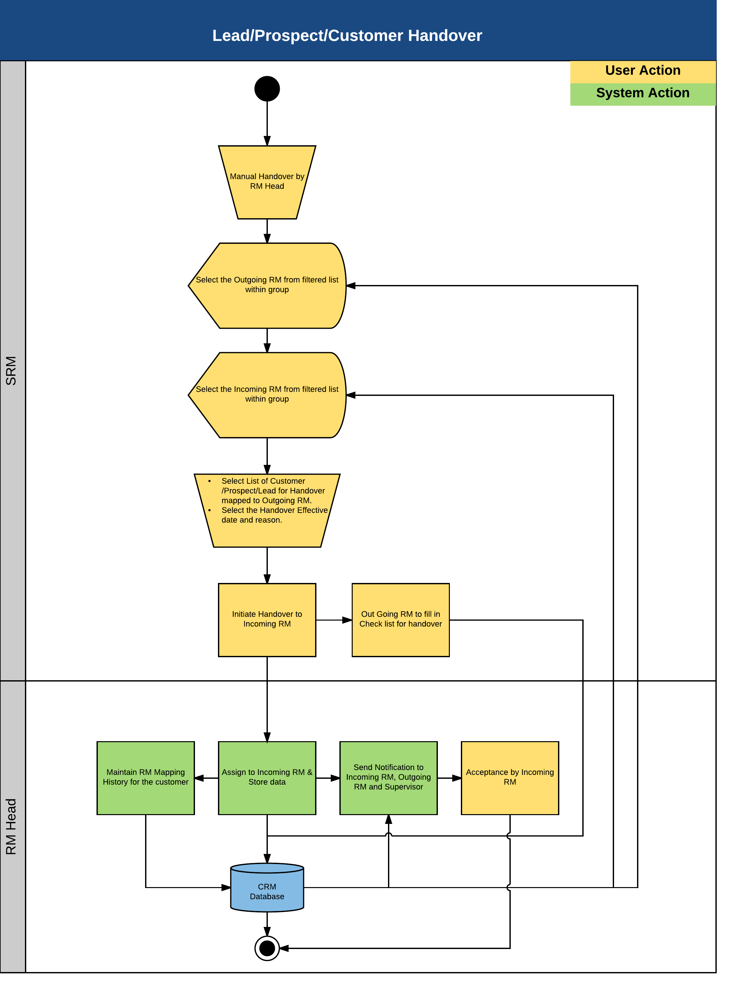

- Description of process steps –
HANDOVER: This defines the permanent assignment of customers to another RM
  - The Senior RM would be able to select the outgoing Relationship Manager from a list.
  - The Senior RM will be able to see all the clients mapped to the outgoing Relationship Manager.
  - The Senior RM would be able to select an Incoming Relationship Manager from the filtered list populated from the database. This list will comprise of RMs under the Senior RM.
  - The Senior RM would be able to select one or many of customers for the handover and define an effective date.
  - The Senior RM would be able to save the Handover details.
  - This may include:
    - Pending Issues of Client
    - Pending Call Reports related to client meeting(s)
    - Any other related information pertaining to the client
  - System would maintain the Relationship Manager History at client level.
  - System would send a notification to Incoming Relationship Manager and outgoing Relationship Manager on Handover of clients.
  - The new Incoming RM would be able to access the handed over clients from the effective date.
  - This would be a maker checker process where maker would be senior RM and checker would be RM Head.

ASSIGNMENT: This is defined as a temporary handover to another RM.
  - The RM or Supervisor would be able to initiate assignment.to another RM
  - The RM or Supervisor will be able to see all the clients mapped to the outgoing Relationship Manager.
  - The RM or Supervisor would be able to select the start and end date. At the end date the visibility to the new RM would end
  - The Incoming and outgoing RM would receive all the notifications simultaneously till the end period has not expired
  - The RM or Supervisor would be able to save the Assignment details.
  - System would maintain the Relationship Manager History at client level.
  - System would send a notification to Incoming Relationship Manager and outgoing Relationship Manager on Assignment of clients.
  - The new Incoming RM would be able to access the handed over clients from the effective date.
  - This would be a maker checker process where maker would be senior RM and checker would be RM Head.

Below are the mandatory fields to be captured for Handover and Assignment
S.No. | Field Name | Data Type | Mandatory | Field Description | Entry Type
1 | Incoming RM | String | Yes | This will be a drop-down list.  This field will populate all the RM details present in the application. | Dropdown
2 | Incoming SRM | String | Yes | This will be a drop-down list.  This field will populate all the SRM details present in the application. | Dropdown
3 | Incoming CSM | String | Yes | This will be a drop-down list.  This field will populate all the CSM details present in the application. | Dropdown
4 | Incoming Advisor | String | No | This will be a drop-down list.  This field will populate all the Advisors details present in the application. | Dropdown
5 | Existing Clients.  This will have the following column names:  CIF No  Client Name  Cust ID  RM ID - RM Name  Advisor ID - Advisor Name  Branch | String | No | This table will populate all the Clients who are tagged under the Outgoing RM, as per the columns defined. | Fetched
6 | Selected Clients  This will have the following column names:  CIF No  Client Name  Cust ID  RM ID - RM Name  Advisor ID - Advisor Name | String | No | This table will populate all the Clients who are tagged under the Outgoing RM, as per the columns defined.  This table will be populated by dragging and dropping individual customers from the "Existing Clients" table. | Fetched
7 | Validation | String | No | This field will have the checklist questionnaire, which needs to be addressed. | Input
8 | Status | String | Yes | This will be a drop-down list field.  This field will have the following values stored in the application database:  Completed  Not Applicable  Pending  Work In Progress | Dropdown
9 | Remarks | String | No | This field will allow the user to input the remarks corresponding to the validation checklist questionnaire. | Input
10 | Handover Reason | String | Yes | When the user clicks on this button, a window will appear asking the user to mention the reason for handover. | Input

- Input details – Manual. Data Fields as shown above.

- Validations -
  - Mandatory Field Verification
    - System will validate whether the mandatory or conditional mandatory fields (marked with * or with ** respectively) are filled in by user. If not then system would display an on screen error message - “Please capture mandatory fields” listing all the fields which are not filled in by user.

- Business Rules
  - Effective date can be any date in future or past or current business date.
  - System shall only display the list of RMs who report to the Senior RM or to his group for handover or assignment.
  - Incoming and outgoing RM cannot be the same person.

- Actor / Entitlements
  - Senior Relationship Manager/ Relationship Manager
  - RM Head

- Trigger
  - Manual

- Output Details
  - None

- Alert/Notification
  - System shall send a notification to the newly assigned RM
  - System shall send a notification to the Outgoing RM

- Next Process – NA

- Process Gaps –
  - None

User Journey_1.7 – Manage Campaign
- Process Objective –
Campaigns are used as a source to generate leads, prospects and customers. These campaigns can be used to promote the products and services offered to the intended audience. The application allows the user to create and manage campaigns, create and manage list of intended recipients of the campaign and record responses pertaining to the underlying campaign.

- Customer to wealth Process flow Map

Process Area | Process | Sub Process | Intellect Module | Intellect Process Name
Manage Campaign | Manage Campaign |  | CRM | Manage Campaign

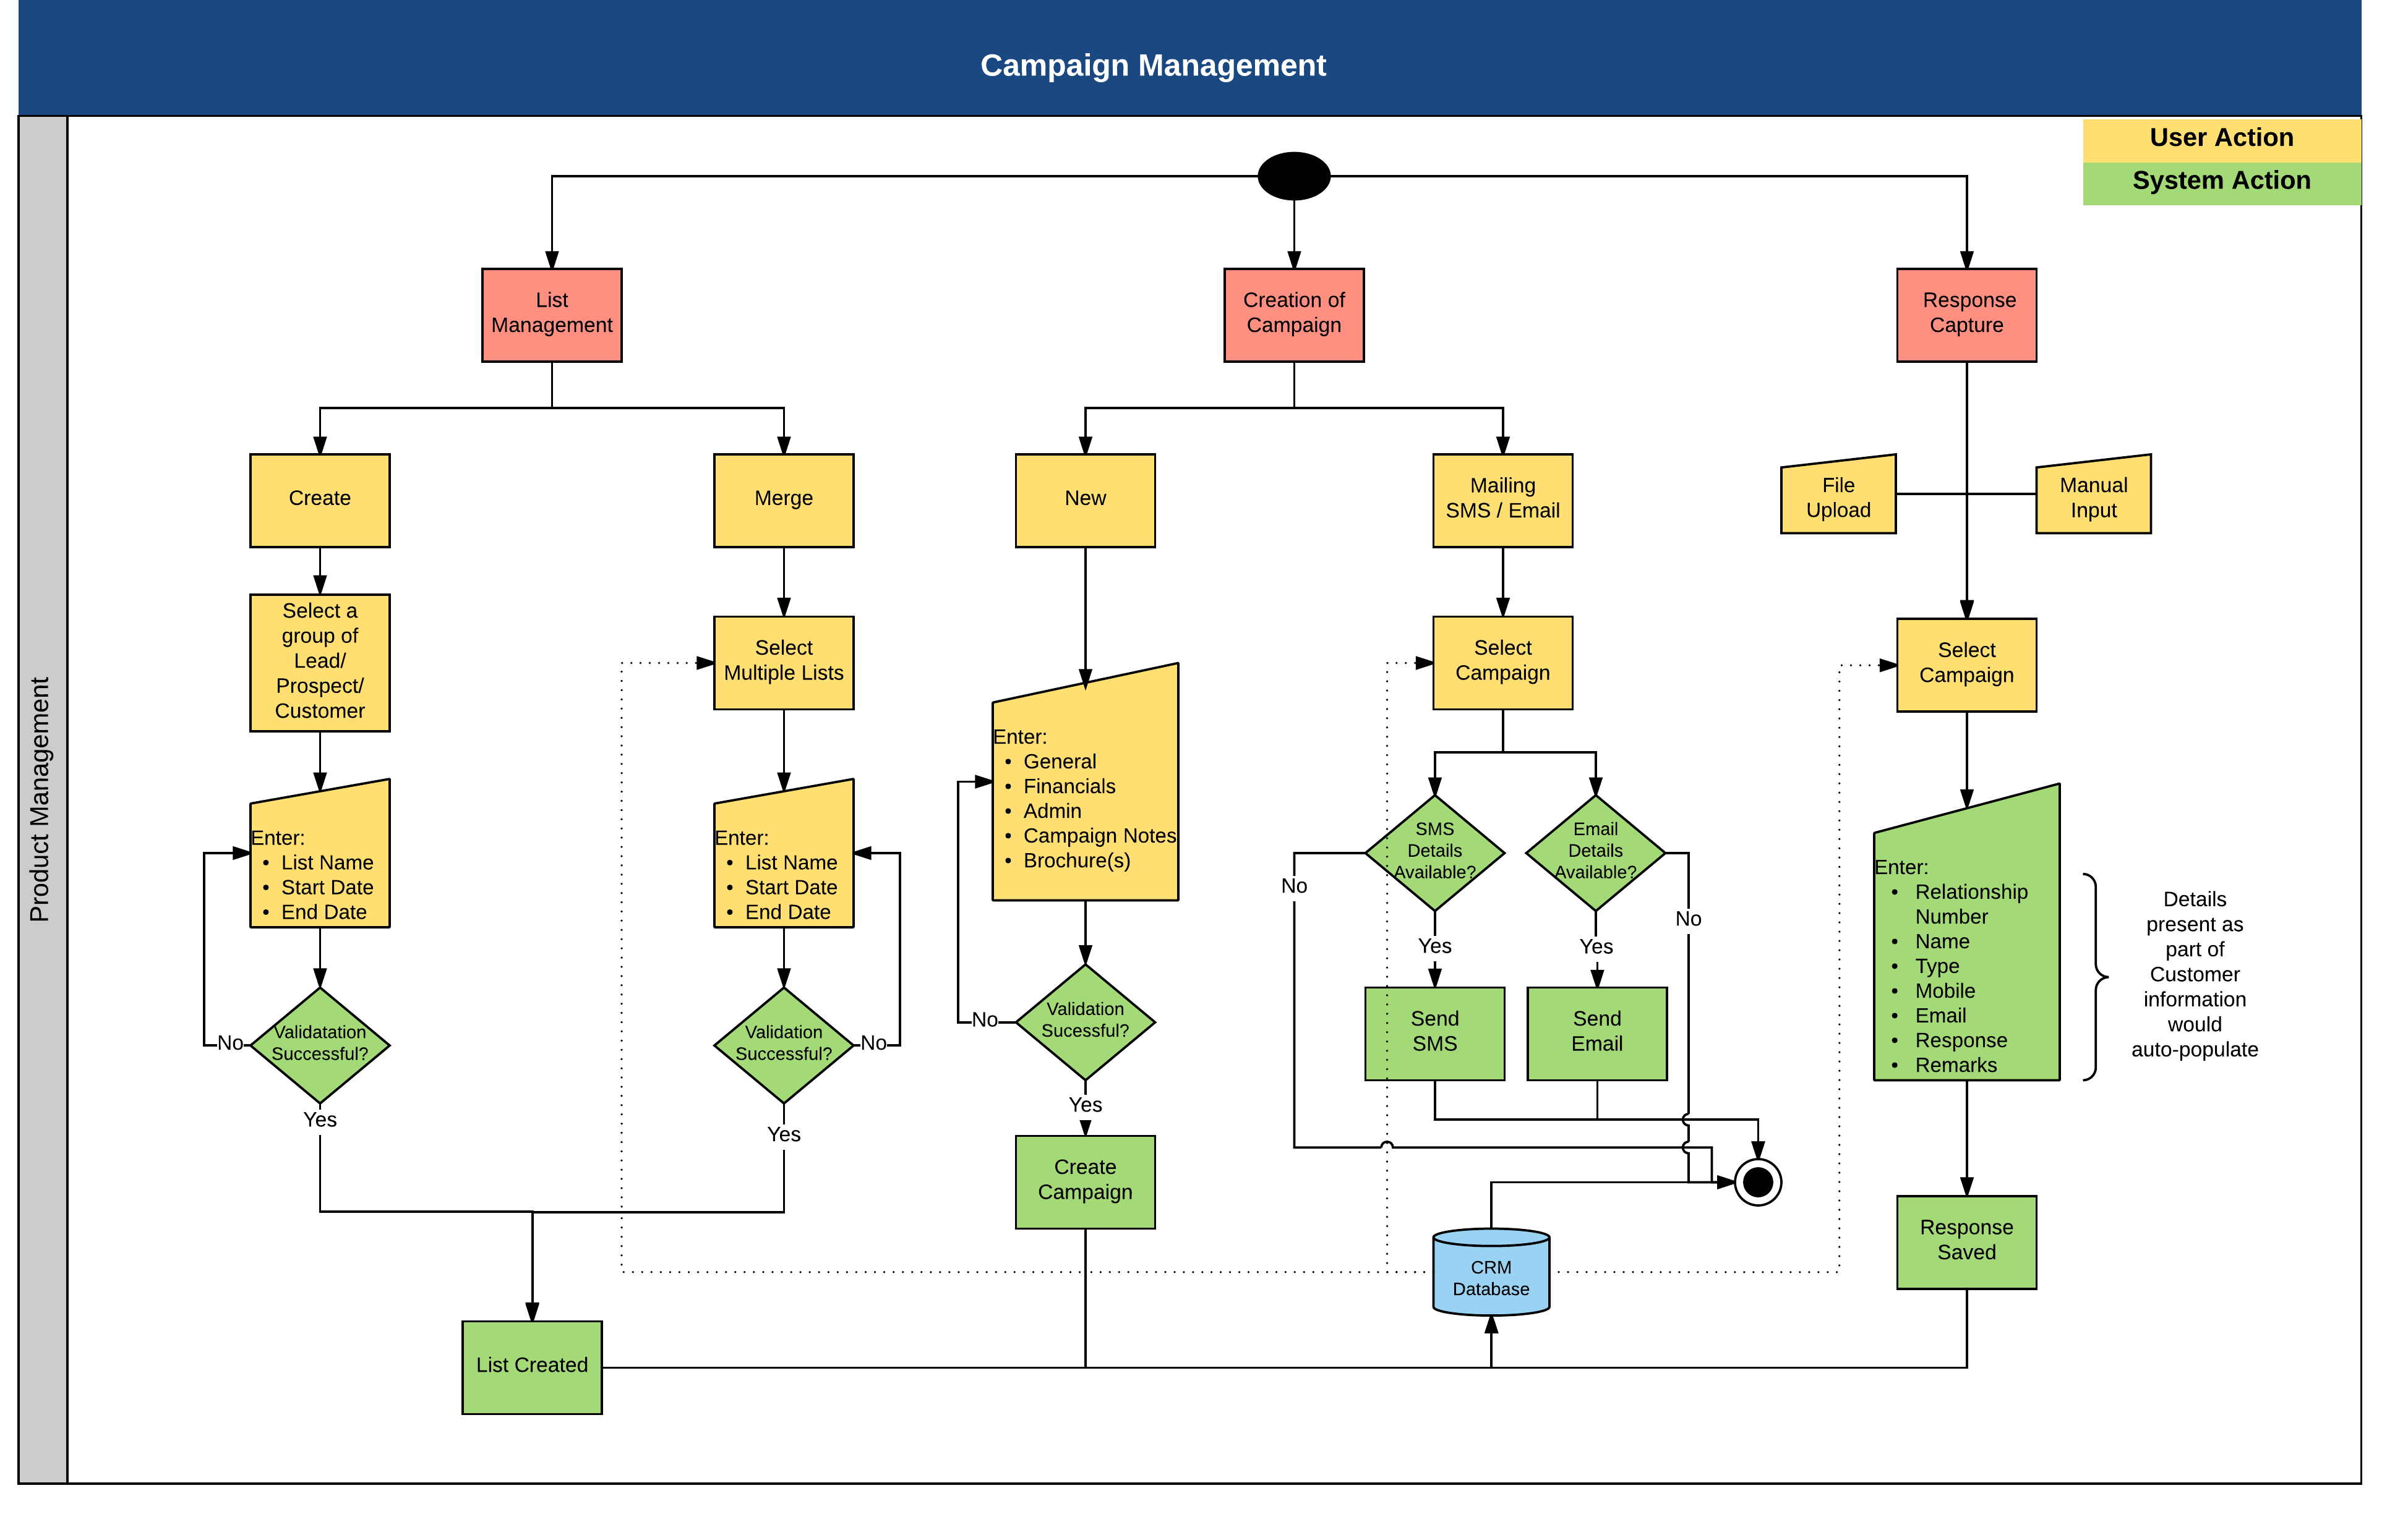

- Description of process steps –
List Management
- Create List
- The first step towards the management of a campaign is to create a list, at which the campaign would be targeted.
- System will list all the CIF’s and Prospects present in application and user shall be able to filter the list based on defined criteria.
- The filtered data can be saved as a new list.

- Modify List
- To modify a list, the user needs to select a list to be modified.
- Names from the list can be removed if needed.
- Modified list can be saved.

- Merge List
- The application provides the option for merging 2 or more lists
- After the lists are merged, the new list can be used as any other list in the application.

Creation of Campaign
- Campaign can be created with or without the list creation. Once the list is created in the application the user will be able to create a new campaign. Campaign can also be created independently but user would not be able to attach list of target audience since it is not maintained yet.
- Each campaign needs to have a unique code for identification.
- The user will be able to use the list created (target audience) under List Management to send campaign communication to the intended audience.
- The application will allow the user to capture the following details pertaining to the campaign:
        - General Campaign Information
        - Financial Information
        - Administration Information
        - Brochures
- Once the campaign is created, the notification will be sent across to the intended recipients.

Response Capture
- The final stage in campaign Management is to capture the responses received from the intended audiences to whom mail and sms was sent.
- The user has the option to manually capture the responses that would be received from the participants of the campaign.
- These responses can be modified as the discussions progress with the prospective customers.

Below are the fields captured for Campaign Management
S.No. | Field Name | Data Type | Mandatory | Field Description | Entry Type
1 | Name | String | Yes | This field will allow the user to enter the name of the campaign. | Input
2 | Status | String | Yes | This will be a drop-down field.  This field will have the following values stored in the application database, to depict the status of the campaign:  Proposed  New | Dropdown
3 | Campaign Code | String | Yes | This field will allow the user to enter the Campaign Code.  This Campaign Code should be unique. | Input
4 | Campaign Type | String | Yes | This will be a drop-down field.  The type of campaign values stored in the application are:  Cross-Sell  External List  New Product | Dropdown
5 | Expected Response | String | No | This field will allow the user to enter/select the number of responses expected from this campaign. | Dropdown
6 | Primary Channel | String | Yes | This will be a drop-down field.  The type of Primary Channel stored in the application are:  SMS  Telephone  Email  Website | Dropdown
7 | Mode of Communication | String | Yes | This will be a drop-down field.  The Mode of Communication values stored in the application are:  SMS  Telephone  Email  Face to Face | Dropdown
8 | Channel | String | Yes | This will be a drop-down field.  The Channel drop-down values will be populated based on the mapping with the Primary Channel field stored in the application. | Dropdown
9 | Objective | String | Yes | This field will allow the user to define the purpose of this campaign. | Input
10 | Proposed Start Date | Date | No | This will allow the user to enter the expected date of starting this campaign. | Input
11 | Proposed End Date | Date | No | This will allow the user to enter the expected date of completing this campaign. | Input
12 | Campaign Effective End Date | Date | No | This will allow the user to enter the Holistic completion of this campaign. | Input
13 | Actual Start Date | Date | No | This will allow the user to enter the Actual date of starting this campaign. | Input
14 | Actual End Date | Date | No | This will allow the user to enter the Actual date of completing this campaign. | Input
15 | Remarks | String | No | This field will allow the user to enter comments pertaining to the campaign for reference. | Input
16 | Cost Type | String | No | This will be a drop-down field.  The drop-down values will be as follows:  Advertisement Cost  Campaign Cost | Dropdown
17 | Budget | String | No | This will be a drop-down field.  The drop-down values will allow the user to enter/select the budget allocated for the underlying campaign. | Dropdown
18 | Actual Cost | String | No | This will be a drop-down field.  The drop-down values will allow the user to enter/select the actual cost for the underlying campaign. | Dropdown
19 | Currency | String | No | This will be a drop-down field.  This field will populate all the currencies that are stored in the application database. Default should be PHP. | Dropdown
20 | Name | String | Yes | This will be a drop-down field.  This field will populate all the names of admins who are available in the application. | Input
21 | Contact No. | String | No | This will allow the user to enter the contact details pertaining to the Admin personal assigned to this campaign. | Input
22 | Contact Email | String | No | This field will allow the user to enter the email address of the admin. | Input
23 | List Name | String | No | This will be a drop-down field.  This field will populate all the Campaign Lists created in the application. The campaign lists are maintained under Campaign -> List Management section of the application. | Dropdown
24 | Start Date | Date | No | This field will auto-populate the value based on the underlying list selected. | Fetched
25 | End Date | Date | No | This field will auto-populate the value based on the underlying list selected. | Fetched
26 | View | String | No | This will show an icon which has an underlying | Input
27 | Mail Notes | String | No | This is the name of the column.  This will be a rich text box, allowing the user to format the contents that needs to be sent via email. | Input
28 | SMS Notes | String | No | This is the name of the column.  This field will allow the user to enter the SMS note which needs to be sent to the customer. | Input
29 | Name | String | No | This is the name of the column.  This field will auto-populate the name of the file selected by the user. | Fetched
30 | Size | String | No | This is the name of the column.  This field will auto-populate the size of the file selected by the user. | Fetched
31 | Status | String | No | This is the name of the column.  This will display the status of the file that has been selected to be uploaded. | Fetched
32 | List Name |  | Yes | The user will be able to enter the List Name in this field. | Input
33 | Start Date | Date | Yes | The user will be able to define the effective date from when this list will be valid. | Input
34 | End Date | Date | Yes | The user will be able to define the effective date when the underlying list will expire. | Input
35 | Merged List Name | String | Yes | The user will be able to enter the List Name in this field. | Input
36 | Start Date | Date | Yes | The user will be able to define the effective date from when this list will be valid. | Input
37 | End Date | Date | Yes | The user will be able to define the effective date when the underlying list will expire. | Input
38 | Campaign | String | No | This is a drop-down field.  This field will populate all the Campaigns that are maintained in the application. | Dropdown
39 | Relationship Number | String | No | The value would be fetched from the stored data | Fetched
40 | Name | String | No | The name of the customer would be fetched from the stored data | Fetched
41 | Type | String | No | The type of customer would be fetched from the stored data maintained against the customer | Fetched
42 | Mobile | Numeric | No | The value would be fetched from the stored data (If available) | Fetched
43 | Email | String | No | The value would be fetched from the stored data (if available) | Fetched
44 | Response | String | No | This field will allow the user to capture the exact response provided. | Input
45 | Remarks | String | No | Additional comments | Input

- Input details – Manual. Data Fields as shown above.

- Validations
  - Mandatory Field Verification
    - System will validate whether the mandatory or conditional mandatory fields (marked with * or with ** respectively) are filled in by user. If not then system would display an on screen error message - “Please capture mandatory fields” listing all the fields which are not filled in by user.
  - Field length and type Verification
    - System will validate whether the user has input a value which is longer/ bigger than expected and would display an on screen error message “Field Length should not be more than (expected) value”.
  - Data Validation
    - System would perform the data validation for specific set of fields like provided email id is in the correct format or not ( should contain an @ symbol and at least a dot)
    - System would validate whether there are any special Strings entered which are not allowed like ^, {,}

- Business Rules
  - The list created should have a unique name.
  - The Campaign Code should be unique.

- Actor / Entitlements
  - Relationship Manager
  - Product Management

- Trigger
  - Manual / File upload

- Output Details
  - None

- Alert/Notification
  - None

- Next Process – NA

- Process Gaps – to be taken up as modification
  - In Response Capture Screen – Response column to have an additional value “Converted”. Other existing values are Interested, Not Interested, Need more Information and Others. Also add a new column to show the RM Name and ID corresponding to every CIF/Prospect/Lead in the response capture grid.
  - Campaign Management and List Management would be done by the Product Management Team and RM’s would be responsible for the response capture.

User Journey_1.11 – Manage Hierarchy and Groups
- Process Objective –
The objective of this process is to enable the Back Office team to setup the pre-requisites required to use the application and map the organizational hierarchy. The Maintenance menu of CRM provides a complete support to back-office in maintaining various entities such as Legal Entity, Service Groups and Units, Users and Roles Using this module user can create, modify necessary details, authorize – wherever applicable, delete – depending on applicability of the entities maintained in Maintenance module.

- Customer to wealth Process flow Map

Process Area | Process | Sub Process | Intellect Module | Intellect Process Name
Maintenance | Hierarchy Setup |  | CRM | Maintenance - Add

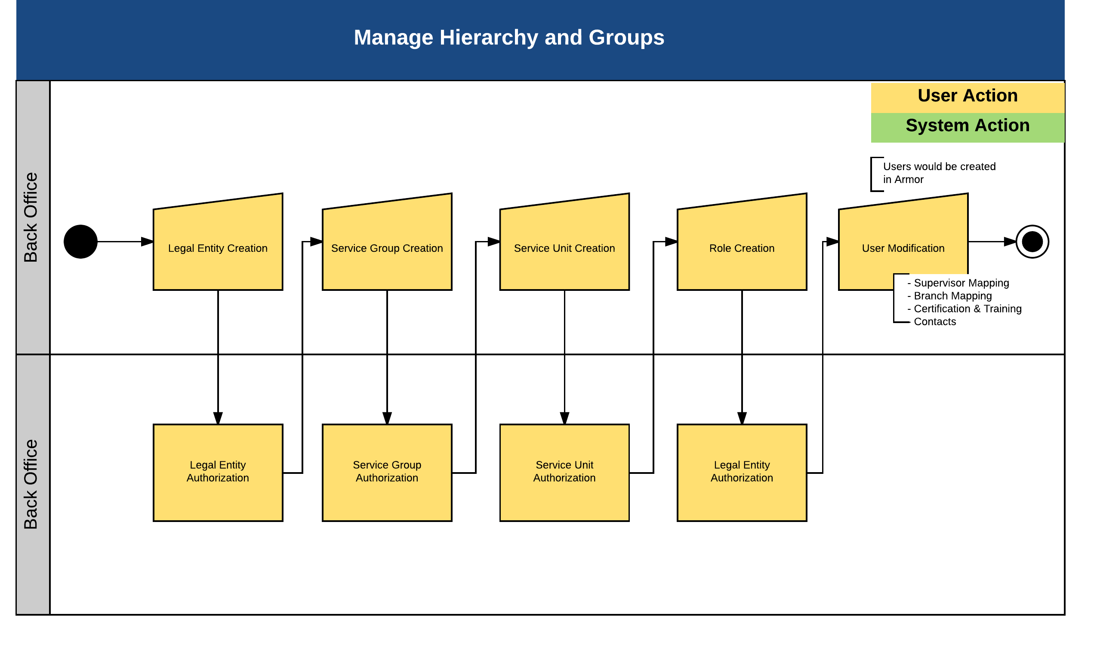

- Description of process steps –

  - Manual Creation of Legal Entity
Legal Entity is the name of the entity in whose name business is carried out.

Manual Creation of Service Group
Service Group is a provision in CRM to create different user groups and based on this grouping entitlements can be defined. Service Group creation or modification is a maker-checker process. A user id must have been created and mapped to a Legal Entity in ARX before a user can be mapped to a service group.
Pre Requisites:
- Legal Entity must have been created
- User should have been created
- Entitlements must have been mapped to the service group

  - Manual Creation of Service Unit
After a Service Group is created, a Service Unit is created to provide an additional layer in the segregation of users in CRM. Service Unit creation or modification is a maker-checker process
Pre Requisites:
- Legal Entity must have been created
- User should have been created
- Entitlements must have been mapped to the service group

  - Manual Creation of Roles
This screen allows user to define multiple roles. The usual set of roles is Relationship Managers, Advisers, Region/Business Heads, Operation Managers, Administrators, and so on. CRM provides the functionality to define Roles specific to banks and maintain a user hierarchy. Role creation process is subject to maker checker process.
Pre Requisites:
- Legal Entity must have been created
- User should have been created
- Entitlements must have been mapped to the service group

  - Manual Modification of Users
After defining Roles, users are mapped to a role. According to the access right and mapping, a user can perform certain actions. In CRM, you can only view and modify a user; users are added only in ARX. User modification process is subject to maker-checker.

Below are the fields captured for defining the above entities:
Branch:
S.No. | Field Name | Data Type | Mandatory | Field Description | Entry Type
1 | Branch Code | String | Yes | This field will allow the user to define the Branch Code to identify the Branch to be created. | Input
2 | Branch Name | String | Yes | This field will allow the user to define the Branch. | Input
3 | Short Name | String | No | Short Name for the branch can be provided in this field. | Input
4 | Address | String | Yes | The Branch address can be provided here. | Input
5 | Email | String | No | The email address corresponding to the branch created can be placed here. | Input
6 | Telephone 1 | String | Yes | The primary telephone number can be provided here. | Input
7 | Telephone 2 | String | No | The secondary telephone number can be provided here. | Input
8 | Fax | String | No | The fax details can be defined here. | Input
9 | Active | String | No | This field will allow the user to mention if the branch is Active or Inactive.  This will be a drop-down field.  This will have the following values:  Yes  No | Dropdown
10 | Weekly Off | String | No | This field will allow the user to define the weekly holiday.  This will be a drop-down list having the following values:  Monday  Tuesday  Wednesday  Thursday  Friday  Saturday  Sunday | Dropdown
Role Definition:
S.No. | Field Name | Data Type | Mandatory | Field Description | Entry Type
1 | Service Unit | String | Yes | This will be a drop-down field.  This field will list all the Service Units that are created in the application. | Dropdown
2 | Escalation | String | Yes | This will be a drop-down field, with the following values stored in the database:  Yes  No | Dropdown
3 | Role Code | String | Yes | This field will allow the user to define a code to tag the underlying role. | Input
4 | Role Description | String | Yes | This field will allow the user to define the underlying role being created. | Input
5 | Level | String | Yes | This field will allow the user to define the hierarchy of the role being created. | Input
Service Group Definition:
S.No. | Field Name | Data Type | Mandatory | Field Description | Entry Type
1 | Service Group Description | String | Yes | This field will allow the user to define a name for the Service Group | Input
2 | Legal Entity | String | Yes | This field will populate all the Legal Entities that are there in the application.  The user will be able to remove the redundant Legal Entities. | Fetched
3 | Relationship Service Group | String | Yes | This will be a drop-down field, with the following values stored in the database:  Yes  No | LOV
Service Unit Definition:
S.No. | Field Name | Data Type | Mandatory | Field Description | Entry Type
1 | Service Group Code | String | Yes | This will be a drop-down field.  This field will populate all the Service Group codes created in the application. | Dropdown
2 | Legal Entity | String | Yes | This field will populate all the Legal Entities that are there in the application.  The user will be able to remove the redundant Legal Entities. | Fetched
3 | Service Unit Code | String | Yes | This field will allow the user to enter a service unit code of 6-characters long. | Input
4 | RM Unit | String | No | This will be a drop-down field, with the following values stored in the database:  Yes  No | Dropdown
5 | Service Unit Description | String | Yes | This field will allow the user to provide a note on the Service Unit created. | Input
User Set-up:
S.No. | Field Name | Data Type | Mandatory | Field Description | Entry Type
1 | Service Unit | String | No | This will be a drop-down field.  This field will list all the Service Units that are created in the application. | Dropdown
2 | Role | String | No | This will be a drop-down field.  This field will list all the Roles that have been tagged to the selected "Service Unit" | Dropdown
3 | Supervisor | String | No | This will be a drop-down field.  This field will list all the Supervisors who have been tagged to the selected "Service Unit" and "Role". | Dropdown
4 | Service Unit | String | No | This will be a drop-down field.  This field will list all the Service Units that are created in the application. | Dropdown
5 | Role | String | No | This will be a drop-down field.  This field will list all the Roles that have been tagged to the selected "Service Unit" | Dropdown
6 | Primary | String | No | This field will allow the user to define if the underlying role is the primary role for the user under consideration.  This will be a drop-down field.  This field will list the following values:  Yes  No | Dropdown
7 | User Type | String | No | This will allow the user to select the type of underlying user.  This will be a drop-down list.  This field will have the following values as drop-down:  Backup  Facilitator | Dropdown
8 | Service Unit | String | No | This will be a drop-down field.  This field will list all the Service Units that are created in the application. | Dropdown
9 | Role | String | No | This will be a drop-down field.  This field will list all the Roles that have been tagged to the selected "Service Unit" | Dropdown
10 | User | String | No | This will be a drop-down field.  This field will list all the Supervisors who have been tagged to the selected "Service Unit" and "Role". | Dropdown
11 | Start Date | Date | No | This will allow the user to specify the date from which this mapping needs to be effective from. | Input
12 | End Date | Date | No | This will allow the user to specify the date till which this mapping needs to be effective. | Input
13 | Certification | String | No | This will allow the user to select the certification.  This will be a drop-down list having the following values:  AMFI  CFA  CFP  IRDA | Dropdown
14 | Date Completed | Date | No | This will allow the user to specify the date when the certification was completed successfully. | Input
15 | Valid Till | Date | No | This will allow the user to specify the date when the certification will expire. | Input
16 | Training | String | No | This will allow the user to select the certification.  This will be a drop-down list having the following values:  AMFI  CFA  CFP  IRDA | Dropdown
17 | Date Completed | Date | No | This will allow the user to specify the date when the training was completed successfully. | Input
18 | Valid Till | Date | No | This will allow the user to specify the date till when the training will be effective. | Input
19 | Branch Code - Branch Name | String | No | This will be a drop-down field.  This field will list all the Branches that are available in the application. | Dropdown
20 | Start Date | Date | No | This will allow the user to specify the date from which this mapping needs to be effective from. | Input
21 | End Date | Date | No | This will allow the user to specify the date till which this mapping needs to be effective. | Input
22 | Primary | String | No | This field will allow the user to define if the underlying branch is the primary branch for the user under consideration.  This will be a drop-down field.  This field will list the following values:  Yes  No | Dropdown
23 | Code Type | String | No | Field to capture the code that is related to a user. This will be a drop-down field.  This field will have the following values stored in the database:  CAFOS  DSA ID  Sub Broker | Dropdown
24 | Code | String |  | This field will allow the user to enter a code for the type of identifier selected. | Input
25 | Date of Allotment | Date | No | This will allow the user to specify the date from which this identity will be effective from. | Input
26 | Valid Till | Date | No | This will allow the user to specify the date till when the identity will be effective. | Input
27 | Branch Code - Branch Name | String | No | This will be a drop-down field.  This field will list all the Branches that are available in the application. | Dropdown
28 | Address Type | String | No | The following will be the drop-down values:  Current Residential, Permanent Residence, Office, Correspondence | Dropdown
29 | Address 1 | String | No | This field will allow the user to define the first line of the address | Input
30 | Address 2 | String | No | This field will allow the user to define the second line of the address | Input
31 | Address 3 | String | No | This field will allow the user to define the third line of the address | Input
32 | Region | String | No | This field will allow the user to enter the Region | Input
33 | Country | String | No | This field will be a drop-down field which will list all the countries that are stored in the database. | Dropdown
34 | State | String | No | This field will be a drop-down field which will list all the states that are mapped to the underlying country selected. This mapping is stored in the database. | Dropdown
35 | City | String | No | This field will be a drop-down field which will list all the cities based on the combination of Country and State mapping | Dropdown
36 | Zip Code | String | No | This field will allow the user to enter the ZIP code of the contact | Input
37 | Contact Type | String | No | This will be a drop-down field.  This field will have the following values, stored in the application database:  Spouse Contact  Email 1  Office Telephone  Residence Telephone  Others Telephone  Mobile  Fax  Email 2 | Dropdown
38 | Value | String | No | This will allow the user to enter the contact details. | Input
39 | Name | String | No | This field will display the name of the file uploaded | Fetched
40 | Size | String | No | This field will display the size of the file uploaded | Fetched
41 | Status | String | No | This field will display the status of the file uploaded | Fetched
42 | View | String | No | This field will allow the user to view the file that has been uploaded into the application. | Fetched
Legal Entity:
S.No. | Field Name | Data Type | Mandatory | Field Description | Entry Type
1 | Legal Entity Code | String | Yes | The code given to the geographical unit | Fetched
2 | Description | String | Yes | Name of the Entity | Input
3 | Short Description | String | Yes | Short (Name) Description of the Entity | Input
4 | Local Description | String | Yes | Local Name of the Entity | Input
5 | Business Date | Date | No | Start date of the entity | Fetched
6 | Processing Date | Date | No | Transaction Start date of the entity | Fetched
7 | Last Working Date | Date | No | Last date of work of the entity | Fetched
8 | Branch Currency | String | Yes | Currency in which transactions would be made | Dropdown
9 | Weekly Off | String | Yes | Weekly off for the entity | Dropdown
10 | Time Zone | Time | Yes | Time zone that is being followed | Dropdown
11 | Swift Address | String | Yes | Swift address of the entity | Input
12 | Address 1 | String | Yes | Address Line 1 of the entity | Input
13 | Address 2 | String | Yes | Address Line 2 of the entity | Input
14 | City | String | Yes | City where entity is located | Input
15 | Province | String | Yes | Province where entity is located | Input
16 | Country | String | Yes | Country where entity is located | Dropdown
17 | ZIP Code | Numeric | Yes | Zip Code of the place | Input
18 | Phone Number 1 | Numeric | Yes | Contact Number 1 of the entity | Input
19 | Phone Number 2 | Numeric | No | Contact number 2 of the entity | Input
20 | FAX 1 | Numeric | Yes | FAX Number 1 of the entity | Input
21 | FAX 2 | Numeric | No | FAX Number 2 of the entity | Input

- Input details – Manual. Data Fields as shown above.

- Validations
  - Mandatory Field Verification
    - System will validate whether the mandatory or conditional mandatory fields (marked with * or with ** respectively) are filled in by user. If not then system would display an on screen error message - “Please capture mandatory fields” listing all the fields which are not filled in by user.
  - Field length and type Verification
    - System will validate whether the user has input a value which is longer/ bigger than expected and would display an on screen error message “Field Length should not be more than (expected) value”.
  - Data Validation
    - System would perform the data validation for specific set of fields like provided email id is in the correct format or not ( should contain an @ symbol and at least a dot)
    - System would validate whether there are any special Strings entered which are not allowed like ^, {,}

- Business Rules
  - None

- Actor / Entitlements
  - Back Office

- Trigger
  - Manual

- Output Details
  - None

- Alert/Notification
  - None

- Next Process – NA

- Process Gap
  - None

User Journey_1.12 – Product Definition
- Process Objective –
The objective of this process is to define products that are offered by CBC.

- Customer to wealth Process flow Map

Process Area | Process | Sub Process | Intellect Module | Intellect Process Name
Product Definition | Product Definition |  | CRM | Product - Add

- Description of process steps –
- After portfolio creation, user would be able to link the portfolio to a product such as IMA, PMT, Retirement Fund etc.
- User would be able to select the product class (Agency, Trust, Other Fiduciary Services) and the product (Agency - Pre need, Trust – Pre need, Agency – Employee Benefit – Retirement Fund, Agency – Employee Benefit – PF Employee contribution only etc)

Fields for various products are attached in excel.
Mandatory fields
Optional fields
Subscription fields

- Input details – Manual. Data Fields as shown above.

- Validations
  - Mandatory Field Verification
    - System will validate whether the mandatory or conditional mandatory fields (marked with * or with ** respectively) are filled in by user. If not then system would display an on screen error message - “Please capture mandatory fields” listing all the fields which are not filled in by user.
  - Field length and type Verification
    - System will validate whether the user has input a value which is longer/ bigger than expected and would display an on screen error message “Field Length should not be more than (expected) value”.
  - Data Validation
    - System would perform the data validation for specific set of fields like provided email id is in the correct format or not ( should contain an @ symbol and at least a dot)
    - System would validate whether there are any special Strings entered which are not allowed like ^, {,}

- Business Rules
  - None

- Actor / Entitlements
  - Product Management

- Trigger
  - Manual

- Output Details
  - None

- Alert/Notification
  - None

- Next Process – NA

- Process Gaps – to be taken up as modification
  - Product definition and subscription related fields

Plan

User Journey_1.4 – Risk Profiling and Asset Allocation
- Process Objective –
Risk profiling can be done for all the prospects/customers who are on-boarded. Risk profiling defines customers’ attitude to uncertainty of return. This will be used as a base for identifying and suggesting products and services suitable to the needs of the customer.

- Customer to wealth Process flow Map

Process Area | Process | Sub Process | Intellect Module | Intellect Process Name
Risk Profiling and Asset Allocation | Risk Profiling and Asset Allocation |  | CRM | Risk Profiling and Asset Allocation

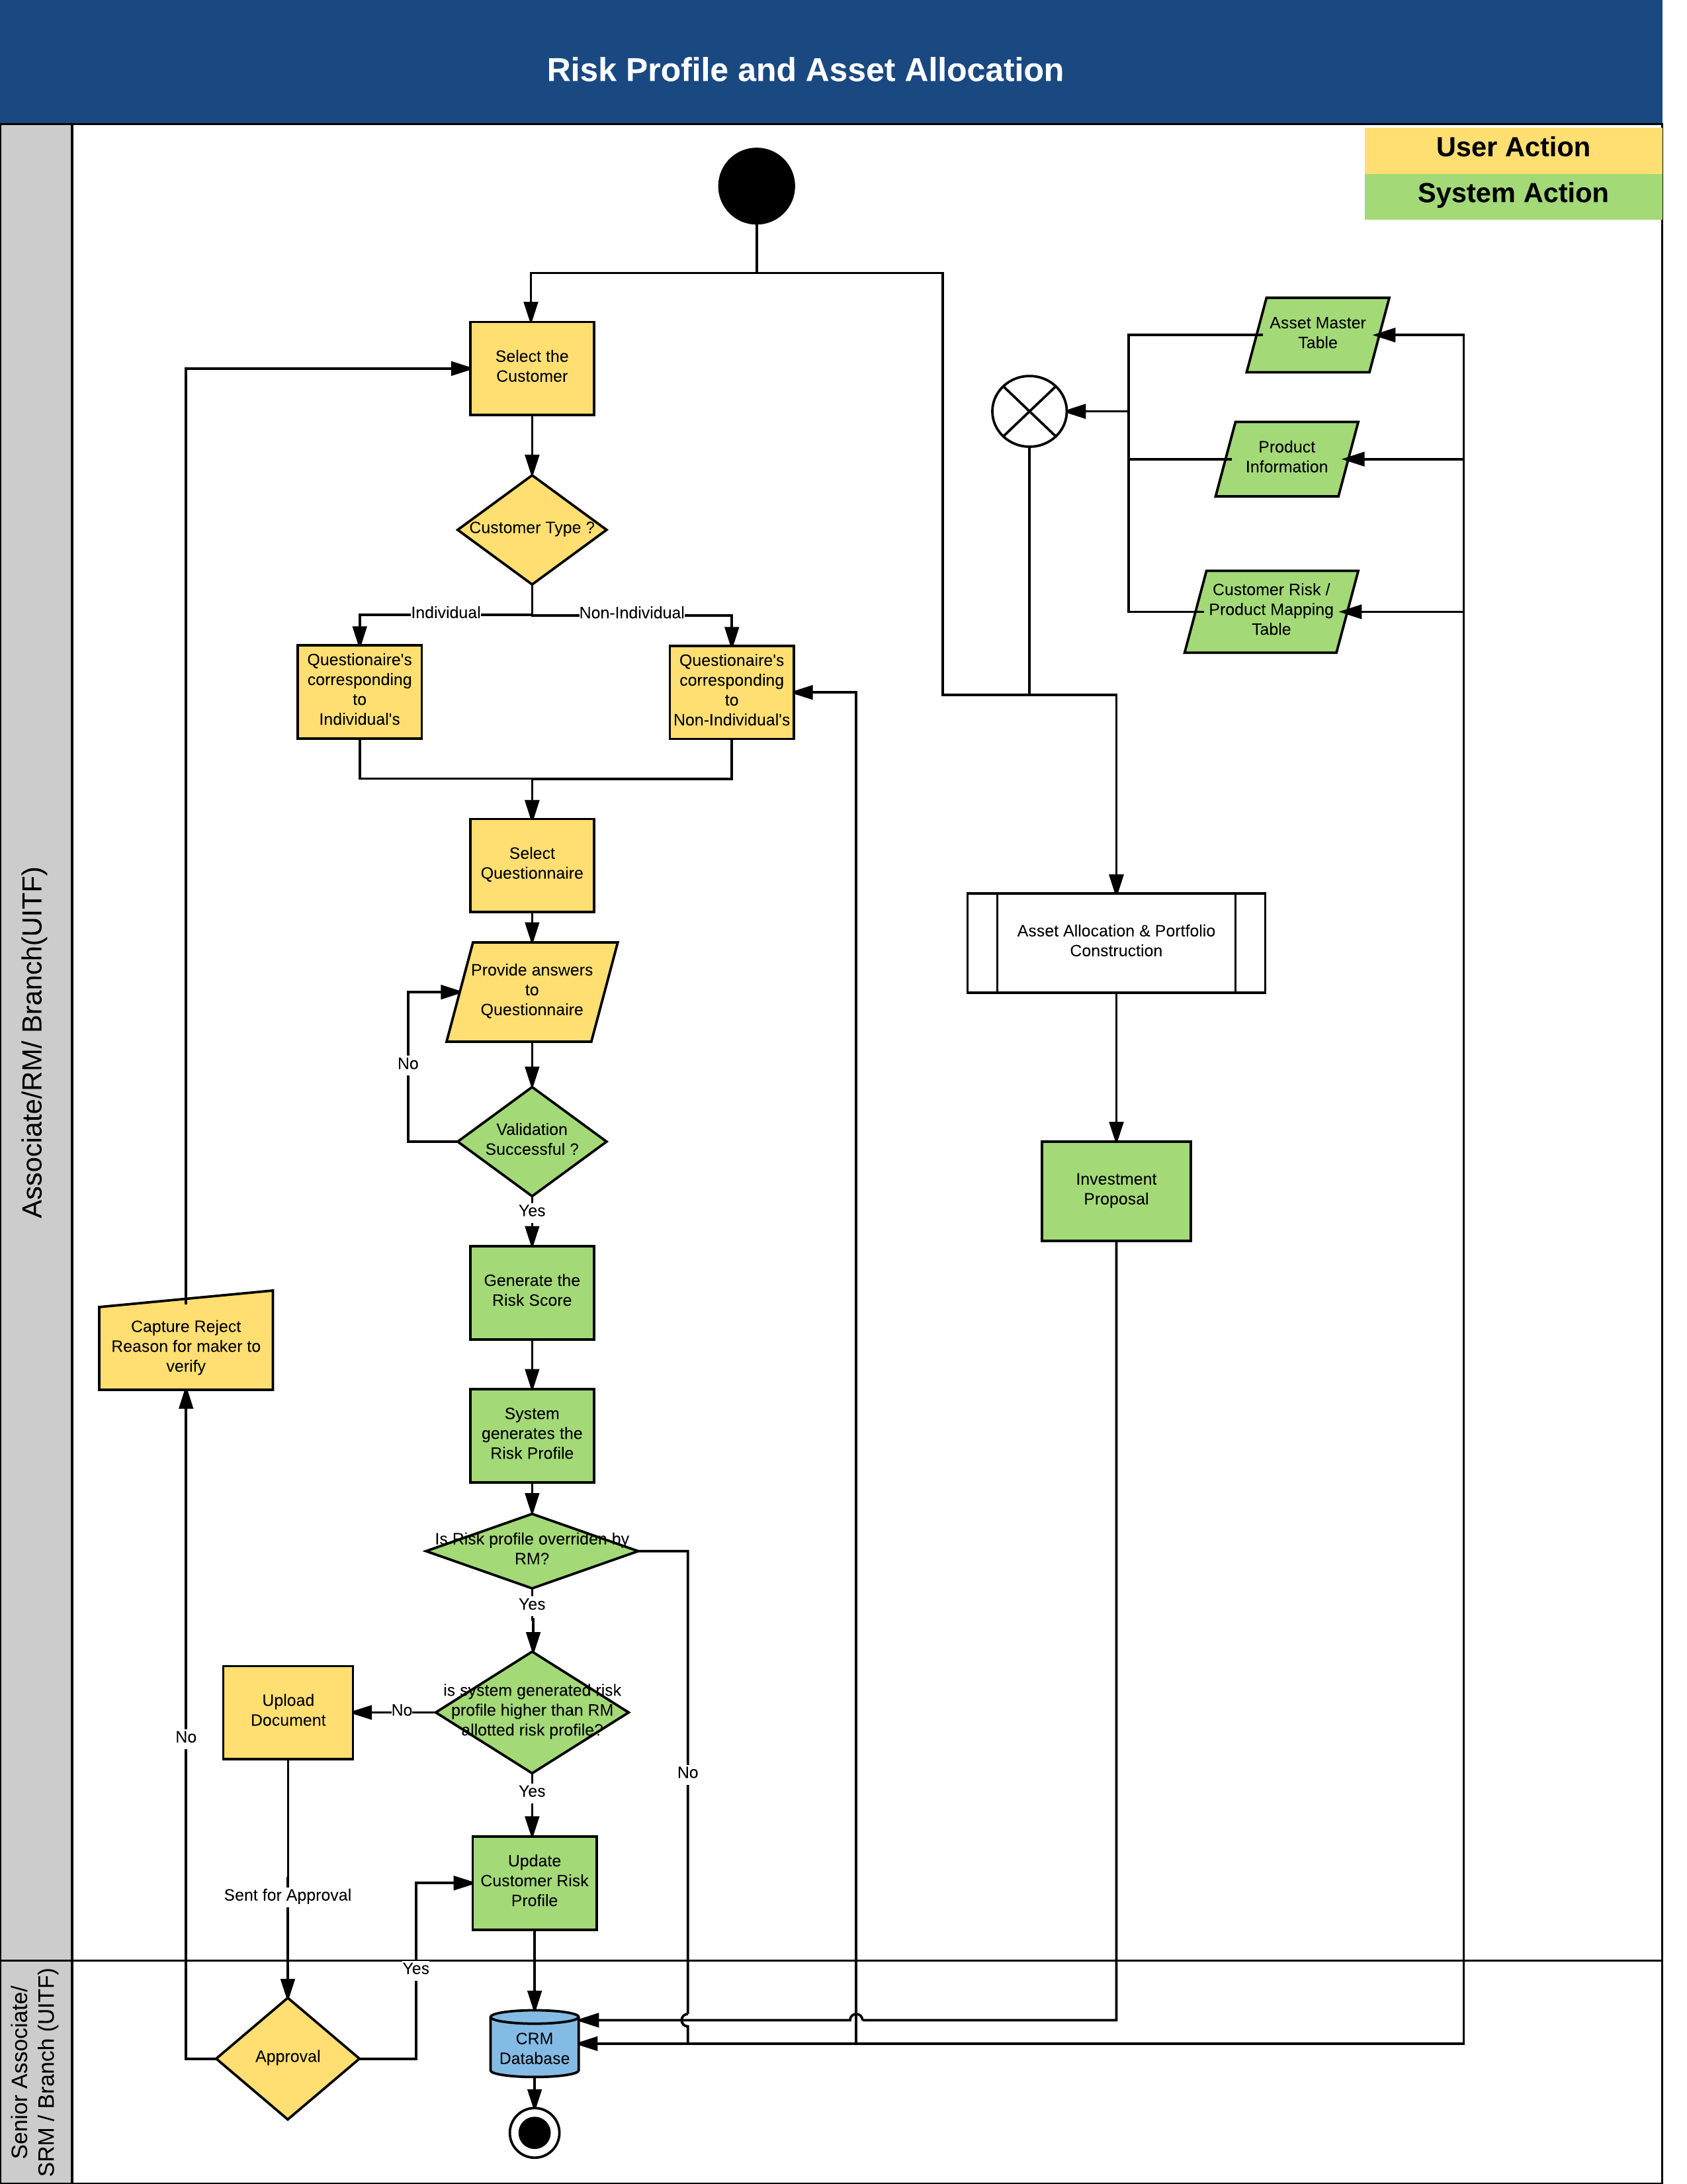

- Description of process steps –
- The first step is to select the customer/prospect for which the risk profiling needs to be carried out. All the customers/prospects that have been authorized will be available for Risk Profiling.
- Based on customer/prospect type (Individual or Non-Individual), the application will identify the Questionnaire, stored in the application, to be used for risk profiling.
- Based on the responses to the questions, the application will arrive at the aggregate score of the customer/prospect.
- This will be referred to the benchmark mapping set in the application to arrive at the risk profile.
- System would check if the RM/Associate has overridden the system generated profile. If yes then system checks if the change has been from lower to higher risk profile.
- If yes RM/Associate would have to upload an approval document and it would go for authorization to SRM/Senior Associate
- If no then risk profile would be updated in the system.
- On approval, system would record both the original and modified risk profile for future reference. This Risk Profiling score will be used across the application to reflect the risk appetite of the customer.
- Branch Users can do risk profiling only for customers (only for UITF) and not prospects.
- Risk profile questionnaire maintenance and modification would be done by back office.

Asset Allocation
- Each risk profile is linked to an asset allocation. Based on risk profile of the customer, the model asset allocation is displayed.
- Customer can choose to change the asset allocation if he wishes to follow a different investment strategy.
- Revised asset allocation would be sent for approval.
- On approval, system would record both the original and modified asset allocation for future reference.
- The suitable model portfolio comprising allocation to various assets is recommended to the customer based on risk score and time horizon of investment.

Below are the fields to be captured for Risk Profiling and Asset Allocation:
S.No. | Field Name | Data Type | Mandatory | Field Description | Entry Type
1 | Questionnaire Description | String | Yes | This field will allow the user to name the underlying Questionnaire. | Input
2 | Customer Category | String | Yes | This will be a drop-down field.  This field will populate the following values stored in the database:  Customer - Individual  Customer - Proprietary  Customer - Fund  Customer - Corporate | Dropdown
3 | Profile Type | String | Yes | These are types of risk profiling. The system is capable of maintaining multiple risk profiles. This would be maintained as Risk profile for individual and risk profile for corporate | Dropdown
4 | Question Description | String | Yes | This field will allow the user to define the Question, to be used as part of this Questionnaire. | Input
5 | Mandatory | String | No | This field will allow the user to mention if the underlying Question will be a mandatory or not to be answered.  Only if this box is checked will this field, will it be treated as a mandatory field.  If this field is left blank, then the underlying field will be left blank. | Input
6 | Answer Description | String | Yes | This will allow the user to provide the Answer options available for the underlying Question. | Input
7 | Weightage | Numeric | Yes | This will allow the user to provide the weightage that the underlying question carries. | Input
8 | Questionnaire Name | String | Yes | This field will allow the user to define the Name of the Questionnaire for easy reference. . | Dropdown
9 | Score From | Numeric | Yes | This field will allow the user to define the floor of the score. | Input
10 | Score To | Numeric | Yes | This field will allow the user to define the ceiling of the score. | Input
11 | Risk Profile | Character | Yes | This field will allow the user to define the categorization of the risk.  This field will be a drop-down list.  The drop down values will be stored in the application as follows:  Conservative  Moderate  Balanced  Aggressive | Dropdown

- Input details – Manual. Data Fields as shown above.

- Validations
  - Mandatory Field Verification
    - System will validate whether the mandatory or conditional mandatory fields (marked with * or with ** respectively) are filled in by user. If not then system would display an on screen error message - “Please capture mandatory fields” listing all the fields which are not filled in by user.
  - Field length and type Verification
    - System will validate whether the user has input a value which is longer/ bigger than expected and would display an on screen error message “Field Length should not be more than (expected) value”.
  - Data Validation
    - System would perform the data validation for specific set of fields like provided email id is in the correct format or not ( should contain an @ symbol and at least a dot)
    - System would validate whether there are any special Strings entered which are not allowed like ^, {,}

- Business Rules
  - ‘Score To’ should be greater than ‘Score From’ for a given Risk Profile

- Actor / Entitlements
  - Relationship Manager / Senior Relationship Manager
  - Associate/ Senior Associate
  - Branch User (UITF)
- Trigger
  - Manual

- Output Details
  - None

- Alert/Notification
  - The user would be able to see the risk profiling date and expiry date. On expiry the RM would receive the notification

- Next Process – NA

- Process Gaps – to be taken up as modification
  - User should be able to download the risk profile questionnaire and the asset allocation.

User Journey_8.1 – Manage Financial Information
- Process Objective –
Objective of this process is to capture data on various financial aspects of the customer like income, expenses, assets, liabilities etc.

- Customer to wealth Process flow Map

Process Area | Process | Sub Process | Intellect Module | Intellect Process Name
Financial Plan | Manage Financial Information |  | FNA | Manage Financial Information

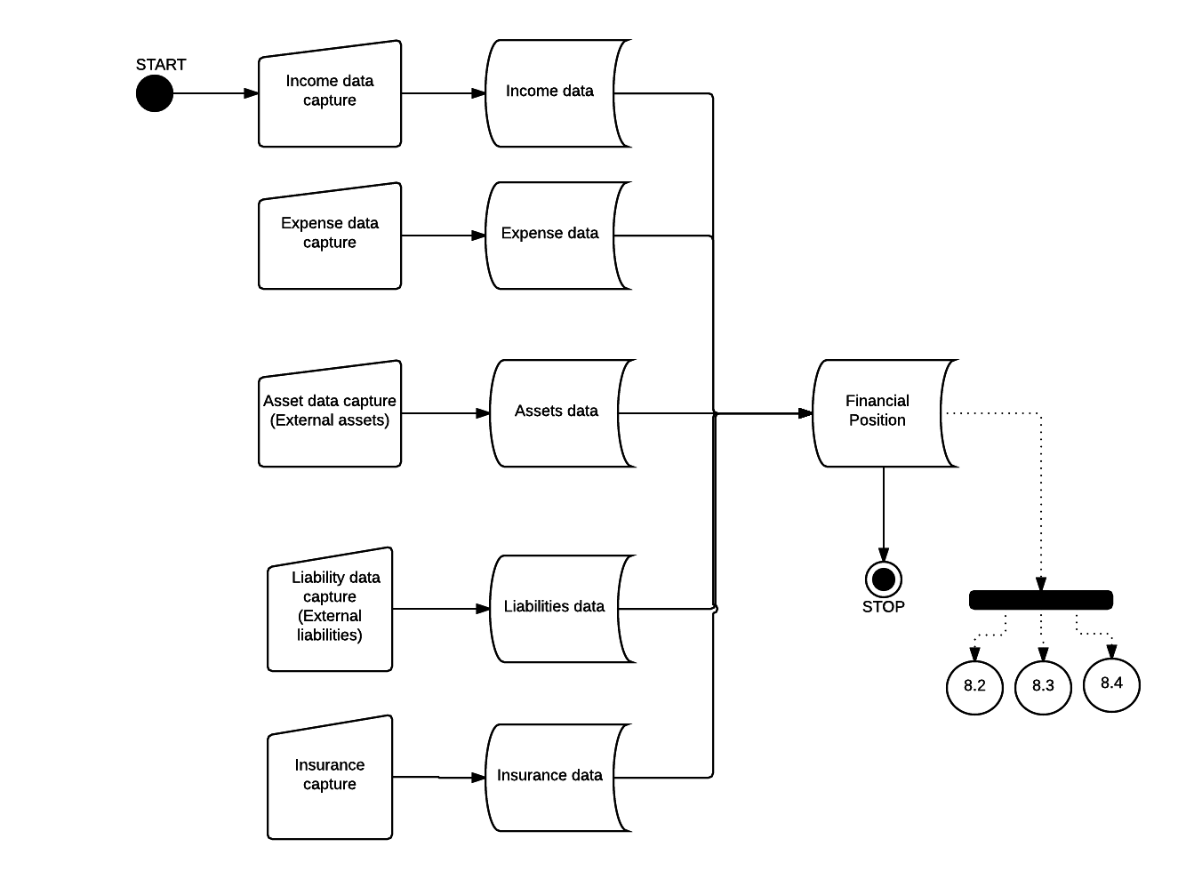

- Description of process steps –
  - Various income of the customer would be captured and saved in the system
  - Various expenses of the customer would be captured and saved in the system
  - Assets held with other banks/institutions would be captured and saved in the system and the assets held with CUSTOMER can be fetched from DB (Real time data can be fetched using online web service as shown in the diagram above)
  - Liabilities with other banks/institutions would be captured and saved in the system and the liabilities with CUSTOMER can be fetched from DB
  - Existing insurance would be captured and saved in the system

Below is the data field description:
  - Incomes
S.No. | Field Name | Data Type | Mandatory | Field Description | Entry Type
1 | Income Type | String | Yes | The income type of customer for which the information is to be captured. | Drop down
2 | Amount | Number | Yes | The amount of income | Input
3 | Description | String | Yes | A brief on the income | Input
4 | Frequency | Number | Yes | The periodicity of the income. | Drop down
5 | Currency | String | Yes | The underlying currency of the income. | Drop down
6 | Owner | String | Yes | The owner of the income. | Drop down
7 | Start Year | Number | Yes | The starting year of the income to be realized. | Input
8 | End Year | Number | Yes | The year till which the income is to be received. | Input
9 | Growth Rate | Number | Yes | The assumed growth rate of the income. | Input
10 | Retirement | Check box | No | Is this income tagged to Retirement allocation. | Input
11 | Insurance | Check box | No | Is this income tagged to Insurance allocation. | Input

  - Expenses
S.No. | Field Name | Data Type | Mandatory | Field Description | Entry Type
1 | Expense Type | String | Yes | The expense type of customer for which the information is to be captured. | Drop down
2 | Amount | Number | Yes | The amount of expense | Input
3 | Description | String | Yes | A brief on the Expense | Input
4 | Frequency | Number | Yes | The periodicity of the Expense. | Drop down
5 | Currency | String | Yes | The underlying currency of the Expense. | Drop down
6 | Owner | String | Yes | The owner of the Expense. | Drop down
7 | Start Year | Number | Yes | The starting year of the Expense to be realized. | Input
8 | End Year | Number | Yes | The year till which the Expense is to be received. | Input
9 | Growth Rate | Number | Yes | The growth rate of the Expense. | Input
10 | Retirement | Check box | No | Is this Expense tagged to Retirement allocation. | Input
11 | Insurance | Check box | No | Is this Expense tagged to Insurance allocation. | Input

  - Assets
S.No. | Field Name | Data Type | Mandatory | Field Description | Entry Type
1 | Asset Class | String | Yes | This will allow the user to select the Asset Class | Drop down
2 | Sub Asset Class | String | Yes | This field will populate the drop-down values based on the asset class selected. | Drop down
3 | Description | String | Yes | A brief on the underlying asset | Input
4 | Currency | String | Yes | The underlying currency of the Asset. | Drop down
5 | Quantity | Number | Yes | Quantity of the asset | Input
6 | Owner | String | Yes | The owner of the Asset. | Drop down
7 | Current Market Price | Number | Yes | The Current Market Price of the underlying asset. | Input
8 | Expected return | Number | Yes | The year till which the Expense is to be received. | Input
9 | Insurance flag | Check box | No | This field will allow the user to tag the underlying asset for insurance mapping. | Input
10 | Savings | Check box | No | This field will be marked with a tick if this asset pertains to Savings. | Input
11 | Saving / premium frequency | Number | Yes | The frequency in which the Saving will take place.  This field will be enabled if the user has tagged the underlying asset for Savings. | Drop down
12 | Saving / premium amount | Number | Yes | This field will allow the user to define the amount that will be saved. | Input
13 | End Year | Number | Yes | This field will allow the user to define the ending year for the saving. | Input
14 | Investment growth rate | Number | No | The rate of growth of the underlying investment. | Input
15 | Sum assured | Number | No | This field will auto-populate the sum assured at the time of maturity. | Fetch

  - Liabilities
S.No. | Field Name | Data Type | Mandatory | Field Description | Entry Type
1 | Liability Type | String | Yes | The type of Liability. | Drop down
2 | Description | String | Yes | Allows user to provide a brief description about the Liability. | Input
3 | Actual EMI | Number | Yes | The amount that needs to be paid in instalments. | Input
4 | Specified EMI | Number | Yes | The required instalment amount that needs to be paid. | Input
5 | Interest rate | Number | Yes | The rate of interest that is applicable for the underlying liability. | Input
6 | Currency | String | Yes | The currency in which the Liability is undertaken. | Drop down
7 | Outstanding Balance | Number | Yes | The current outstanding liability. | Input
8 | Owner | String | Yes | The owner of the Liability. | Drop down
9 | Start Year | Number | Yes | The year when the servicing of the liability will commence. | Input
10 | End Year | Number | Yes | The year when the liability will be completely serviced. | Input
11 | Years Left | Number | Yes | The duration till when the underlying liability will exist. | Fetch
12 | Insurance Flag | Check box | No | This field will be used to denote if the underlying liability will be subject to insurance. | Input

  - Future Cash flows:
S.No. | Field Name | Data Type | Mandatory | Field Description | Entry Type
1 | Inflow Type | String | Yes | The Cash flow type of customer for which the information is to be captured. | Drop down
2 | Description | String | Yes | A brief about the Cash flow can be placed here. . | Input
3 | Start Year | Number | Yes | The beginning date for the Cash flow to start | Input
4 | End Year | Number | Yes | The year when the cash flow will end. | Input
5 | Amount | Number | Yes | The amount of the Cash flow. | Input
6 | Frequency | Number | Yes | The periodicity of the Cash flow. | Input
7 | Growth Rate | Number | Yes | The growth rate of the Cash flow during the time duration. | Input
8 | Currency | String | Yes | The underlying currency of the cash flow. | Drop down
9 | Owner | String | Yes | The owner of the cash flow. | Drop down
10 | Insurance | Check box | No | Is this cash flow subject to Insurance allocation. | Input
11 | Future Value | Check box | No | Does the underlying cash flow depict a Future Value. | Input

- Input details – Manual. Data Fields as shown above.

- Validations
  - Mandatory Field Verification
    - System will validate whether the entire mandatory fields with * mark are filled in by user or not. If not then system would display an on screen error message “Please capture mandatory fields” listing all the fields which are not filled in by user.
  - Field Length Verification
    - System will validate whether the user have inputted the value more than expected and would display an on screen error message “Field Length should not be more than (expected) value”.
  - Data Validation
    - System would perform the data validation for specific set of fields like provided email id is in the correct format or not ( should contain an @ symbol and at least a dot)
    - System would validate whether there are any special characters entered which are not allowed like ^, {,}

- Business Rules
  - None

- Actor / Entitlements
  - Relationship Manager

- Trigger
  - Manual

- Output Details
  - None

- Alert/Notification
  - None

- Next Process – NA

- Process Gap
  - None

User Journey_8.5 – Generate Proposal
- Process Objective –
Purpose of this process is to generate a proposal for the customer based on his risk profile and suggested asset allocation.

- Customer to wealth Process flow Map

Process Area | Process | Sub Process | Intellect Module | Intellect Process Name
Financial Plan | Generate Proposal |  | CRM | Generate Proposal

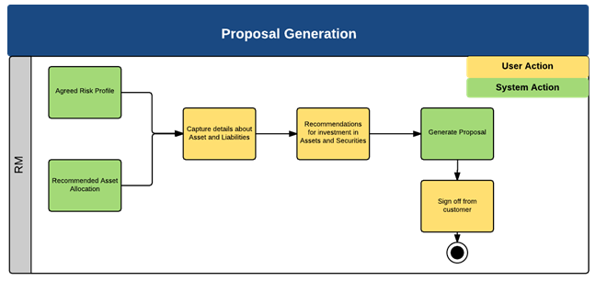

- Description of process steps –
  - An Investment proposal report would be generated as per the agreed format.

- Input details – Agreed Portfolio, Model Portfolio.

- Validations
  - None

- Business Rules
  - None

- Actor / Entitlements
  - Relationship Manager
  - Associates

- Trigger
  - Manual / File upload

- Output Details
  - None

- Alert/Notification
  - None

- Next Process - NA

- Process Gap
  - None

User Journey_1.8 – Manage Service Request
- Process Objective –
Service requests will be raised by users on behalf of customers. The users would assign a complaint ticket to the designated service unit.
This process flow details the complete lifecycle from defining a service request to the resolution of the raised ticket.

- Customer to wealth Process flow Map

Process Area | Process | Sub Process | Intellect Module | Intellect Process Name
Manage Service Request | Manage Service Request |  | CRM | Manage Service Request

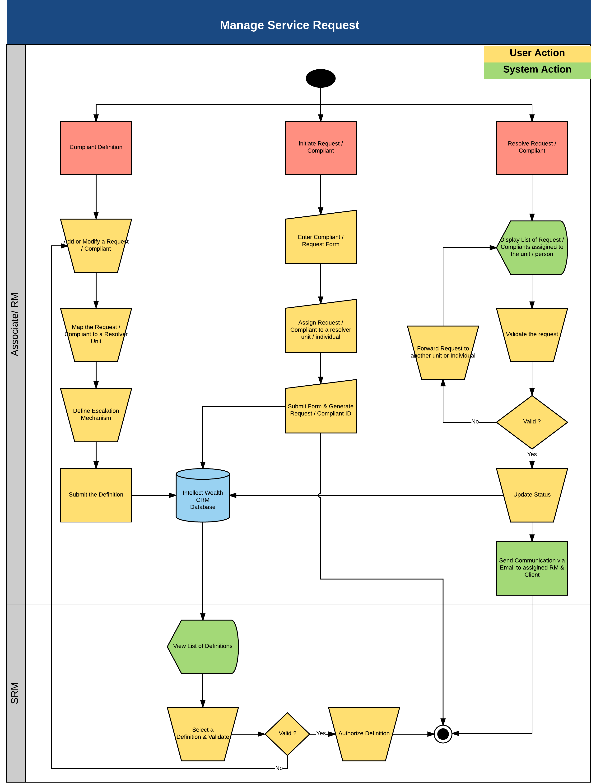
- Description of process steps –

Create / Modify Complaint:
- User can create or modify different definitions in system
- User needs to map the definition of a complaint type to an initiator Unit and resolver unit.
- User needs to define the escalation mechanism for system to identify in case of any delays in resolution for the defined priority and timeline
- User need to define the levels of escalation and map the users in the system to which the escalation need to be sent.
- Post providing the details, user need to submit the definition for authorization.
- Checker would be able to perform below actions at the time of approval
  - Approve: In case of correct definition, approve.
  - Reject: In case of discrepancy the checker would be able to reject the definition and capture the reason for rejection. This would be displayed to the maker for further corrections.
- If the approval is provided then the definition will be stored and will be available for capture of complaint/ service request.

- For all the rejected definitions the maker would be able to see the reject reason provided by the authorizer and can perform below actions.
  - Update Definition: Maker would be able to update/ modify the definition details and then resend for approval.
  - Delete Definition: Maker would be able to delete the created definition.

Initiate Request/Complaint:
- Request can be initiated by an RM or Customer Service executive on behalf of customer.
- The user needs to fill the request form and assign the request to a resolver unit or an individual.
- Post filling the request details, user needs to submit the form, which would be stored in and will be available in the resolver queue for resolution.

Resolve Request / Complaint:
- Resolution queue will display list of requests assigned to a particular user or to a group
- Users will be able to see all the request/complaints Assigned/escalated/forwarded in the resolvers queue
- Users will be able to select a request/complaint available or assigned from the queue
- User will be able to update the status of the request /complaint, post validation as resolved, closed, Interim Response etc.
- Users will be able to forward the request/complaint to another resolver unit or to a specific user, in case if the resolver has done a wrong assignment.
- Forwarded requests/complaints would be available for take further action

Below are the fields to be captured for Manage Service Request:
Complaint Definition
S.No. | Field Name | Data Type | Mandatory | Field Description | Entry Type
1 | Request Type | Drop Down | Yes | Defined List of values either a request or complaint type.  Issue Bank Certification  Issue Confirmation of Investment (COI)  Issue Escrow Certification for BIR  Apply TIN (Retirement Fund)  For Final Accounting  Issue Official Receipt (OR)  Issue UITF Redemption Advice  Issue UITF Subscription Advice  Open Trust Savings Account (TSA) | Input
2 | Initiator Service Unit | Drop Down | Yes | List of all Service Units defined in system.  - Associate  - Relationship Manager  - Senior RM  - Branch Manager | Input
3 | Resolver Service Unit | Drop Down | Yes | List of all Service Units defined in system  Account Servicing  Transaction Processing | Input
4 | Closure Date Change Allowed | Check box | Yes | Will define, whether to allow closure date manually for a request of this type | Input
5 | High | Dropdown | Yes | Will capture Day’s & Hours | Input
6 | Medium | Dropdown | Yes | Will capture Day’s & Hours | Input
7 | Low | Dropdown | Yes | Will capture Day’s & Hours | Input
8 | Escalation level | String | No | Will define the level of escalation | Input
9 | Service Unit | Dropdown | CM | If Escalation Level is defined then this field is mandatory. List of all Service Units defined in system.  Account Servicing/Head  Transaction Processing/Head | Input
10 | User ID | Dropdown | CM | If Escalation Level is defined then this field is mandatory. List of all users mapped to the selected Service unit above | Input
11 | Duration Day’s | String | CM | If Escalation Level is defined then this field is mandatory. Captures no of day’s for the escalation post initiation | Input
12 | Duration Hour’s | Dropdown | CM | If Escalation Level is defined then this field is mandatory. | Input
CM – Conditional Mandatory

Request/Complaint Registration:

S.No. | Field Name | Data Type | Mandatory | Field Description | Entry Type
1 | Request | String | Yes | Free Text | Input
2 | Request Type | String | Yes | List of all defined types of requests mapped to the logged in user service unit as defined in Request definition | Dropdown
3 | Priority | String | Yes | Priority of Request High/Medium/Low, used for SLA’s | Dropdown
4 | Source Type | String | Yes | Lead/Prospect/Customer | Dropdown
5 | Source | String | Yes | Client Number | Dropdown
6 | Reported Date/Time | Date | Yes | Date and time when the complaint was registered | Input
7 | Request Mode | String | No | Mode of Communication of Client | Dropdown
8 | Product | String | No | List of all product defined in system | Dropdown
9 | Closure Date/Time | Date | Yes | Defaulted based on Priority selected and SLA defined | Input
10 | Linked Reference Number | String | No | Any previous reference number if available | Input
11 | Transaction Reference Number | String | No | Any Transaction reference number if available | Input
12 | Action | String | Yes | Defaulted to Available | Dropdown
13 | Initiation Service Unit | String | Yes | List of initiator Service units mapped to request type | Dropdown
14 | User ID | String | No | List of all users mapped to Initiator service unit | Dropdown
15 | Remarks | String | No | Free Text | Input

Resolve Request/Complaint

S.No. | Field Name | Data Type | Mandatory | Field Description | Entry Type
1 | Request | String | No | Auto populates the values of the selected request | Fetched
2 | Request Type | String | No | Auto populates the values of the selected request | Fetched
3 | Priority | String | No | Auto populates the values of the selected request | Fetched
4 | Source Type | String | No | Auto populates the values of the selected request | Fetched
5 | Source | String | No | Auto populates the values of the selected request | Fetched
6 | Reported Date/Time | Date | No | Auto populates the values of the selected request | Fetched
7 | Request Mode | String | No | Auto populates the values of the selected request | Fetched
8 | Product | String | No | Auto populates the values of the selected request | Fetched
9 | Closure Date/Time | String | No | Auto populates the values of the selected request | Fetched
10 | Linked Reference Number | String | No | Any previous reference number if available | Input
11 | Transaction Reference Number | String | No | Any Transaction reference number if available | Input
12 | Action | String | Yes | Forward, Resolved, Closed, Interim Reply, Reopen | Input
13 | Initiation Service Unit | String | Yes | List of initiator Service units mapped to request type | Input
14 | User ID | String | No | List of all users mapped to Initiator service unit | Fetched
15 | Remarks | String | No | Free Text | Input
16 | Log | String | Yes | Will display the entire history of the request/complaint to the user | Fetched

- Input details – Manual. Data Fields as shown above.

- Validations
  - Mandatory Field Verification
    - System will validate whether the mandatory or conditional mandatory fields (marked with * or with ** respectively) are filled in by user. If not then system would display an on screen error message - “Please capture mandatory fields” listing all the fields which are not filled in by user.
  - Field length and type Verification
    - System will validate whether the user has input a value which is longer/ bigger than expected and would display an on screen error message “Field Length should not be more than (expected) value”.
  - Data Validation
    - System would perform the data validation for specific set of fields like provided email id is in the correct format or not ( should contain an @ symbol and at least a dot)
    - System would validate whether there are any special Strings entered which are not allowed like ^, {,}

- Business Rules
  - A Definition cannot be created with the same name if it exists already.
  - System shall only display the assigned customers list to the logged in User.
  - System shall display the customer list when an RM/Associate is logged in.

- Actor / Entitlements
  - Admin Maker
  - Admin Checker
  - Relationship Manager
  - Associate
  - Senior Relationship Manager

- Trigger
  - Manual

- Output Details
  - None

- Alert/Notification
  - Alert to the assigned resolver if the request/complaint is not resolved in defined SLA
  - Alert to the users defined in the escalation matrix based on the level, in case if the request/complaint is not resolved in specified SLA
  - Alert to the assigned RM, in case of breach in SLA resolution.

- Next Process – NA

- Process Gaps – to be taken up as modification
  - Request type to have additional value “New Portfolio Creation”.

User Journey_1.9 – Manage Calendar
- Process Objective –
The objective of this user journey is to enable the User to -
- Schedule Meeting
- Track Meeting
- Re-schedule/ Cancel Meetings

- Customer to wealth Process flow Map

Process Area | Process | Sub Process | Intellect Module | Intellect Process Name
Manage Calendar | Manage Calendar |  | CRM | Manage Calendar

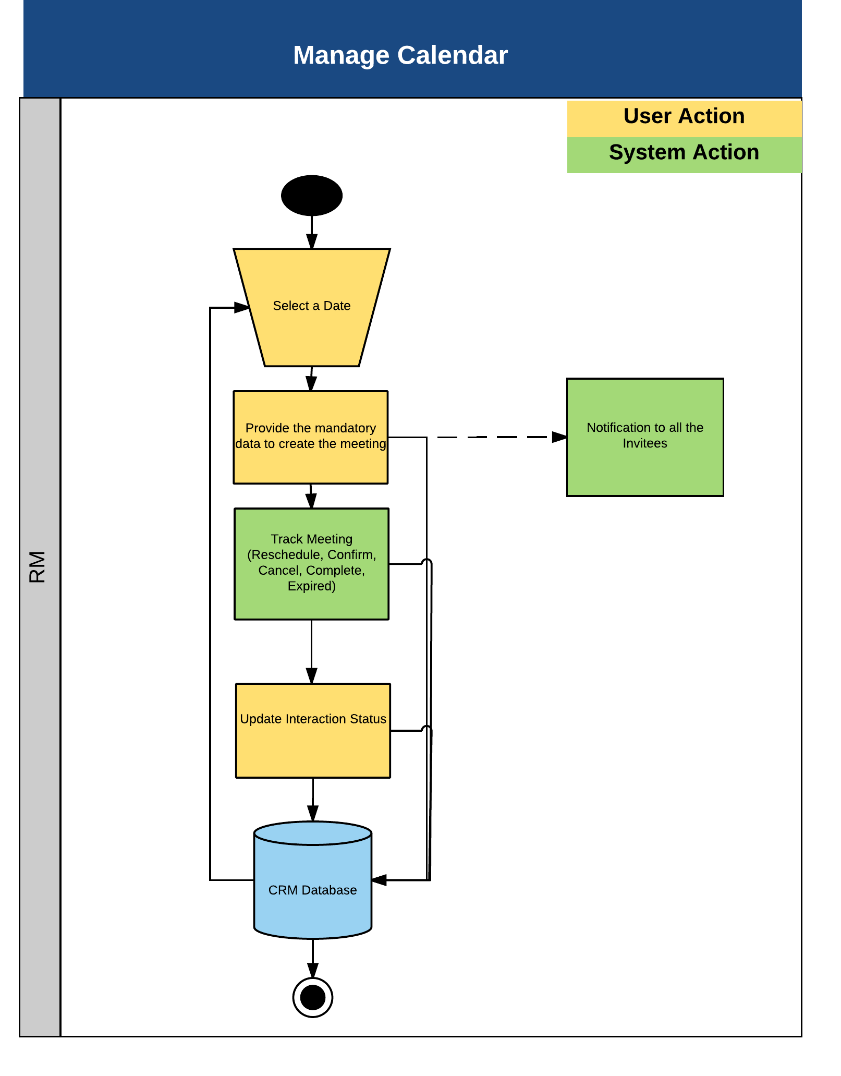

- Description of process steps –
  - The application will allow the RMs to select a date from the calendar to define an action.
  - Once the RM clicks on a date, the application will open a form.
  - This form will allow the RM to define and schedule a meeting for the selected date.
  - Once the meeting is scheduled, all the invitees would receive a meeting invite
  - RM can make a calendar entry about a meeting or modify an existing meeting. He would have a Day wise, Week wise and Month wise view.
  - System generates a reminder for upcoming meetings.

Below are the fields captured for managing the Calendar.
S.No. | Field Name | Data Type | Mandatory | Field Description | Entry Type
1 | Meeting Reason | String | Yes | This field will allow the user to select the categorization of the meeting.  This will be a drop-down field.  This will have the following fields as suggested by the bank  Client Call – New  Client Call - Existing  Branch Visit  Portfolio Review  Others | Dropdown
2 | Campaign Code | String | No | If the meeting is related to a follow-up with a campaign, then the user can mention that Campaign Code in this field.  The Start (Date) needs to be less than or equal to the To (Date) selected by the user.  Start (Date) <= To (date) | Input
3 | Subject | String | Yes | This field will allow the user to enter the purpose of the meeting of the meeting. | Input
4 | Starts (Date) | Date | Yes | This will allow the user to select the start date of the meeting. This will be facilitated by using the date-picker.  This field will populate based on the call report selected. | Input
5 | Starts (Time) | String | Yes | This will allow the user to select the start time of the meeting, pertaining to the Start Date selected.  This will allow the user to select time in multiplies of 15 minutes for the entire 24 hour period.  This field will populate based on the call report selected. | Dropdown
6 | To (Date) | Date | Yes | This will allow the user to select the Till date of the meeting.  This field will populate based on the call report selected. | Input
7 | To (Time) | String | Yes | This will allow the user to select the Till time of the meeting, pertaining to the Till Date selected.  This will allow the user to select time in multiplies of 15 minutes for the entire 24 hour period.  This field will populate based on the call report selected. | Dropdown
8 | All Day | String | No | This field will allow the user to define if the meeting would be for the entire day | Input
9 | Location | String | Yes | This field will allow the user to enter the venue where the meeting is to take place. | Input
10 | Meeting Type | String | Yes | With whom this meeting is to take place will be selected in this field.  This will be a drop-down field.  The drop-down values that will appear in this field is as follows:  CIF  Prospect  Others | Dropdown
11 | Mode of Meeting | String | Yes | This will be a drop-down field.  The drop-down values that will appear in this field would be defined by the bank  Face-to-Face  Telephone | Dropdown
12 | Relationship | String | Yes | This field will allow the user to select the user depending to the selection made under the Meeting Type: If the user selects:  CIF - This will be display all the customers created in the application.  Prospects - This will display all the prospects created in the application. | Dropdown
13 | Contact Details | String | Yes | This will allow the user to mention the contact details pertaining to the underlying meeting. | Input
14 | Remarks | String | No | Additional comments | Input
15 | Required | String | Yes | This will be a drop-down field.  This field will populate all the RM's who are there in the application.  This field indicates the RM's who are mandated for the meeting. | Dropdown
16 | Optional | String | No | This will be a drop-down field.  This field will populate all the RM's who are there in the application.  This field indicates the RM's who are optional to attend the meeting. | Dropdown

- Input details – Manual. Data Fields as shown above.

- Validations
  - Mandatory Field Verification
    - System will validate whether the mandatory or conditional mandatory fields (marked with * or with ** respectively) are filled in by user. If not then system would display an on screen error message - “Please capture mandatory fields” listing all the fields which are not filled in by user.
  - Field length and type Verification
    - System will validate whether the user has input a value which is longer/ bigger than expected and would display an on screen error message “Field Length should not be more than (expected) value”.
  - Data Validation
    - System would perform the data validation for specific set of fields like provided email id is in the correct format or not ( should contain an @ symbol and at least a dot)
    - System would validate whether there are any special Strings entered which are not allowed like ^, {,}

- Business Rules
  - The Start Date selected needs to be less than or equal to the "To (Date)" selected.
  - Meetings can be created for overlapping schedules.

- Actor / Entitlements
  - Relationship Manager
  - Senior Relationship Manager

- Trigger
  - Manual

- Output Details
  - None

- Alert/Notification
  - Notification about pending meetings

- Next Process – NA

- Process Gaps
  - None

User Journey_1.9b – Task List
- Process Objective –
The objective of this user journey is to manage tasks of an RM

- CLIENT to wealth Process flow Map -

Process Area | Process | Sub Process | Intellect Module | Intellect Process Name
Monitor | Task List |  | CRM | Scheduler

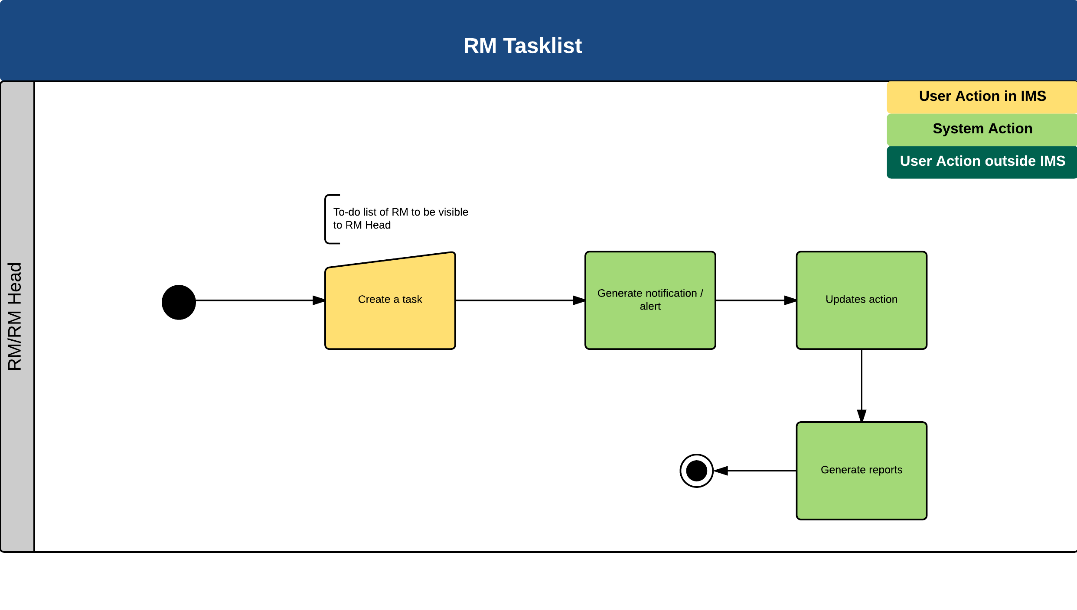
- Description of process steps –
- RM can create a task using to-do option.
- RM Head can assign a task to RM using to-do option.
- System sends a reminder to RM about the upcoming tasks.
- RM can update the status after completing the task.

S.No. | Field Name | Data Type | Mandatory | Field Description | Entry Type
1 | Subject | String | Yes | This field will allow the user to define the topic of the note. | Input
2 | To Do For | String | Yes | This is a drop-down field.  This field will have the following values:  Self  Team | LOV
3 | Starts (Date) | Date | Yes | This field will allow the user to select the date when the underlying activity needs to be carried out. | Input
4 | Start (Time) | Time | Yes | This field will allow the user to select the time when the underlying activity needs to be carried out. | LOV
5 | Who | String | Yes | This will be a drop-down field.  This field will populate the team members of the underlying RM. | LOV
6 | Priority | String | Yes | This will be a drop-down field.  This field will populate the following values stored in the database:  High  Medium  Low  None | LOV
7 | Category | String | No | This will allow the user to categorize the activity to be carried out. | Input
8 | Status | String | No | This will be a drop-down field with values -  To Be Started  Started  Completed | LOV

- Input details – Manual

- Validations:
  - Mandatory Field Verification
    - System will validate whether the mandatory or conditional mandatory fields (marked with * or with ** respectively) are filled in by user. If not then system would display an on screen error message - “Please capture mandatory fields” listing all the fields which are not filled in by user.
  - Field length and type Verification
    - System will validate whether the user has input a value which is longer/ bigger than expected and would display an on screen error message “Field Length should not be more than (expected) value”.
  - Data Validation
    - System would perform the data validation for specific set of fields like provided email id is in the correct format or not ( should contain an @ symbol and at least a dot)
    - System would validate whether there are any special Strings entered which are not allowed like ^, {,}

- Business Rules
  - None

- Actors/Entitlements
  - RM
  - Senior RM
  - Associates
  - Senior Associates

- Trigger
  - Manual

- Output Details
  - None

- Alert/Notification:
  - Notification when Senior RM assigns a task to RM
  - Notification about pending tasks

- Next Process - NA

- Process Gaps
  - None

User Journey_1.10 – Manage Call Report
- Process Objective –
Call Reports is a tool used by the Relationship Manager to keep track of all customer interactions. The Importance of call report management is as follows:
- Call Reports help Relationship Managers to make note of customer needs and address them accordingly in a timely manner.
- Call Reports play a very important role when customers are handed over to a new Relationship Manger. These act as a base for the incoming relationship Manager to understand the past history of interaction that the customer has had with the out-going relationship manager. Thus avoiding reaching out to the customer again for gathering information.
- Call Report assists team leads of Relationship Managers to evaluate their sub-ordinates.
- Notes present in the Call Reports can act as a source of data for understanding the customer needs, to formulate new products and services.

- Customer to wealth Process flow Map

Process Area | Process | Sub Process | Intellect Module | Intellect Process Name
Manage Call Report | Manage Call Report |  | CRM | Manage Call Report

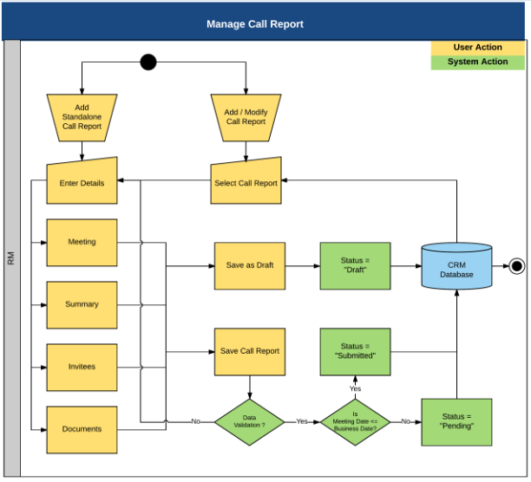

- Description of process steps –
- The call report will allow the Relationship Manager to capture information in the following categories:
  - Meeting Particulars – This section allows the Relationship Manager to capture information pertaining to the meeting with the customer. Some of the information that will be captured in this field is Meeting Reason, Subject, Start and End time and Location.
  - Meeting Information – The Summary and action items from the meeting can be placed here. Some of the parameters under this section are Meeting Type, Mode of Meeting, Summary of Discussion and Summary of Action Items.
  - Invitees – This allows the Relationship Manger to define the participants who are expected to be part of this meeting with the customer.
  - Documents – This allows the user to attach documents which have been referenced as part of the meeting with the customer.
- When a call report is created in the application, it can be stored in the application with one of the following status -
  - Draft – When a call report is created in the application, after providing the mandatory inputs the Relationship Manager will have the option to keep the call report as draft. Draft reports can be updated later.
  - Submitted – When a call report is created in the application, after providing the mandatory inputs the Relationship Manager will have the option to create the call report. Once the create call report option is selected, the application will check the meeting date. If it has passed, then the call report will be saved in the application with status as “Submitted”.
- The application will also allow the Relationship Manager to create a follow up call report. This will ensure that there is a continuation in the way how customer interaction is maintained.
- There is a report on Call reports filed by the RM’s.

Below are the fields captured for managing a Call Report:
S.No. | Field Name | Data Type | Mandatory | Field Description | Entry Type
1 | Meeting Reasons | String | Yes | This field will allow the user to select the categorization of the meeting.  This will be a drop-down field.  The list of values would be maintained as per the bank requirement | Input
2 | Subject | String | Yes | This field will allow the user to enter the purpose of the meeting of the meeting. | Input
3 | Starts (Date) | Date | Yes | This will allow the user to select the start date of the meeting. This will be facilitated by using the date-picker.  This field will populate based on the call report selected. | Input
4 | Starts (Time) | Time | Yes | This will allow the user to select the start time of the meeting, pertaining to the Start Date selected.  This will allow the user to select time in multiplies of 15 minutes for the entire 24 hour period.  This field will populate based on the call report selected. | Dropdown
5 | Ends (Date) | Date | Yes | This will allow the user to select the Till date of the meeting.  This field will populate based on the call report selected. | Input
6 | Ends (Time) | String | Yes | This will allow the user to select the Till time of the meeting, pertaining to the Till Date selected.  This will allow the user to select time in multiplies of 15 minutes for the entire 24 hour period.  This field will populate based on the call report selected. | Dropdown
7 | Location | String | Yes | This field will allow the user to enter the venue where the meeting is to take place. | Input
8 | Client Status | String | No | This will be a drop-down field.  The drop-down values that will appear in this field is as follows:  Conference Call  Client Abroad , Email Taken  Not Contactable  Not Interested In Bank Services | Dropdown
9 | Next Meeting (Date) | Date | No | When the next meeting is expected to be held.  This will allow the user to select the Till date of the meeting. | Dropdown
10 | State of Mind | String | No | This will be a drop-down field.  This field will have the following values:  Happy  Irate  Satisfied  Sensitive  Ultra-Sensitive | Dropdown
11 | Meeting Type | String | Yes | With whom this meeting is to take place will be selected in this field.  This will be a drop-down field.  The drop-down values that will appear in this field is as follows:  CIF  Prospect  Lead  Others | Dropdown
12 | Mode of Meeting | String | Yes | This will be a drop-down field.  The drop-down values that will appear in this field is as follows:  Others  Telephone  In-Person  Video Conference  Telephone Off Shore  In-Person Off Shore  Video Conference Off Shore | Input
13 | Relationship | String | Yes | This field will allow the user to select the user depending to the selection made under the Meeting Type: If the user selects:  CIF - This will be display all the customers created in the application.  Prospects - This will display all the prospects created in the application.  Lead - This will display all the leads created in the application. | Input
14 | Remarks | String | No | This field will allow the user to make note of any other related information. | Input
15 | Contact Details | String | Yes | This will allow the user to mention the contact details pertaining to the underlying meeting. | Input
16 | Summary of Action Items | String | No | This field will allow the user to enter notes that have been taken during interaction with the customer. | Input
17 | Summary of Discussions | String | Yes | This field will allow the user to enter the summary of the interaction that took place with the customer. | Input
18 | Required | String | Yes | This will be a drop-down field.  This field will populate all the RM's who are there in the application.  This field indicates the RM's who are mandated for the meeting. | Dropdown
19 | Optional | String | No | This will be a drop-down field.  This field will populate all the RM's who are there in the application.  This field indicates the RM's who are optional to attend the meeting. | Dropdown
20 | Documents | String | No | On clicking on this button the user will be able to select the documents corresponding to the underlying call report. | Input

- Input details – Manual. Data Fields as shown above.

- Validations
  - Mandatory Field Verification
    - System will validate whether the mandatory or conditional mandatory fields (marked with * or with ** respectively) are filled in by user. If not then system would display an on screen error message - “Please capture mandatory fields” listing all the fields which are not filled in by user.
  - Field length and type Verification
    - System will validate whether the user has input a value which is longer/ bigger than expected and would display an on screen error message “Field Length should not be more than (expected) value”.
  - Data Validation
    - System would perform the data validation for specific set of fields like provided email id is in the correct format or not ( should contain an @ symbol and at least a dot)
    - System would validate whether there are any special Strings entered which are not allowed like ^, {,}

- Business Rules
  - Call Reports can be created and tagged to customer Meetings which has taken place.
  - There should not be an overlapping of meeting timing when creating a call report.

- Actor / Entitlements
  - Relationship Manager
  - Senior Relationship Manager
  - Relationship Manager Head
  - Associates
  - Senior Associates

- Trigger
  - Manual

- Output Details
  - None

- Alert/Notification
  - None

- Next Process – NA

- Process Gaps – to be taken up as modification
  - Add a field to capture the “Product” that the lead/prospect/customer is interested in or which was discussed during the meeting.

Appendix

Abbreviations
- RM: Relationship Manager
- SRM: Senior Relationship Manager
- RM Head: Relationship Manager Head
- AUM: Asset Under Management
- CIF: Customer Identification Folio
- SDN: Special Designated Nationals
- Conditional Mandatory: (Conditional mandatory fields are those where if selected then only values needs to be provided)

