Model Serving &
Feature Store Setup
Week 3 Task Report
Recommender System: Redis Feature Store + FAISS ANN Retrieval
Project: model-serving-feature-store

1. Introduction & Objective
This report documents the Week 3 deliverable: building the model-serving infrastructure for a two-stage recommender system. The scope covers three sequential phases: exporting a trained model's architecture and item embeddings, standing up Redis as a low-latency feature store for user and item vectors, and implementing Approximate Nearest Neighbor (ANN) search for fast candidate retrieval at inference time.
Since no pre-existing trained model or embeddings were available, a complete recommendation pipeline was built from scratch: a self-generated implicit-feedback dataset, a Matrix Factorization model trained to produce meaningful embeddings, and the full serving stack on top of it. This allows the serving infrastructure to be demonstrated end-to-end rather than only in isolation.

1.1 Scope by Day
Days | Deliverable
Day 1–3 | Train a model and export its architecture and item/user embeddings
Day 4–6 | Set up Redis as a low-latency feature store for user profiles and item vectors
Day 7 | Implement Approximate Nearest Neighbor (ANN) search for candidate retrieval

2. System Architecture
The diagram below shows the full pipeline: an offline training stage produces model artifacts, which are bulk-loaded into Redis as the online feature store. At inference time, a user's vector is fetched from Redis and used to query a FAISS ANN index built over item vectors, returning top-K candidates for a downstream ranking stage (out of scope for this task).
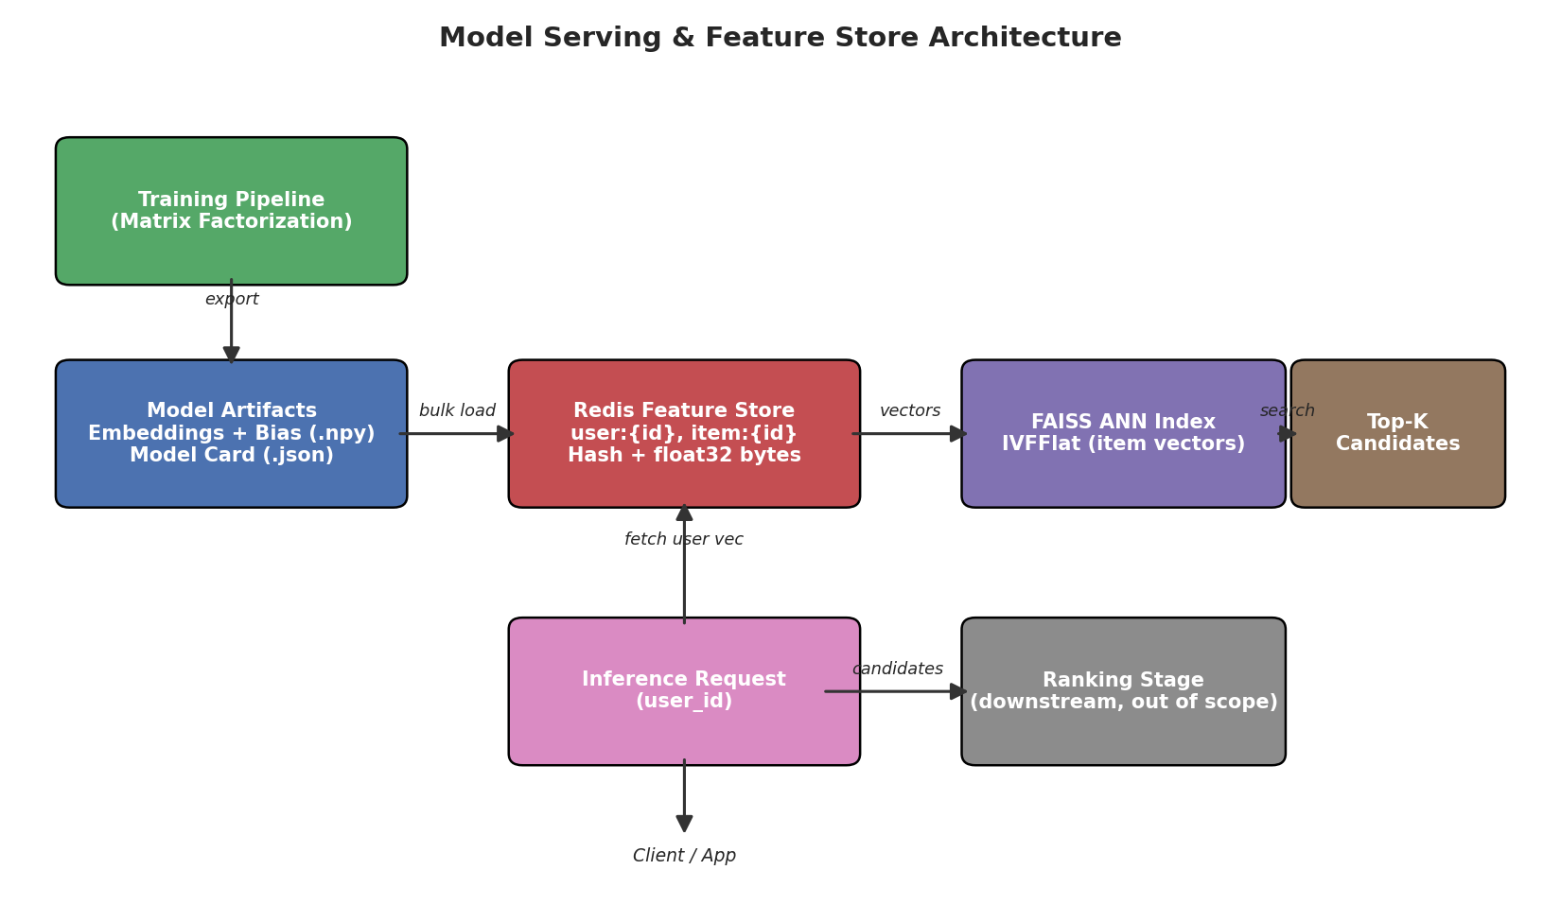
Figure 1 — End-to-end model serving and feature store architecture

3. Day 1–3: Model Training & Export

3.1 Data Preparation
A self-generated implicit-feedback dataset was created to simulate a realistic recommendation scenario: 2,000 users, 1,500 items, and approximately 59,400 unique user-item interactions (a sparsity of ~2%, typical of real-world recommender datasets). Ratings were synthesized from latent user/item factors plus bias terms and Gaussian noise, then split 90/10 into train and validation sets.
An early version of the data generator produced excessive clipping at the rating bounds (values saturating at 1 or 5), which destroyed much of the learnable signal — a realistic data-quality pitfall. This was corrected by rescaling the latent factor magnitudes so only ~2.3% of raw scores required clipping, preserving a usable signal-to-noise ratio for model training.

3.2 Model Architecture & Justification
A Matrix Factorization model (Funk-SVD style, with user and item bias terms) was selected as the architecture to train:
r_hat(u, i) = mu + b_u[u] + b_i[i] + dot(P[u], Q[i])
- mu: global average rating (bias term).
- b_u, b_i: learned per-user and per-item bias vectors (capture systematic rating tendencies).
- P, Q: dense embedding matrices (user and item vectors, dimension K=32) whose dot product captures latent affinity.
This architecture was chosen over deep neural approaches because: (1) it directly produces the dense item and user embeddings this task's serving pipeline requires, (2) it trains quickly via mini-batch SGD without GPU dependency, and (3) it is a well-established, interpretable baseline widely used in production recommender systems (e.g., the original Netflix Prize-winning approaches).

3.3 Training & Overfitting Control
The model was trained with mini-batch stochastic gradient descent (batch size 2,048) and L2 regularization on both bias terms and embeddings. Early stopping (patience = 6 epochs, monitoring validation RMSE) was used to select the best checkpoint rather than the final epoch, directly addressing the overfitting risk inherent in high-capacity embedding models on sparse data.
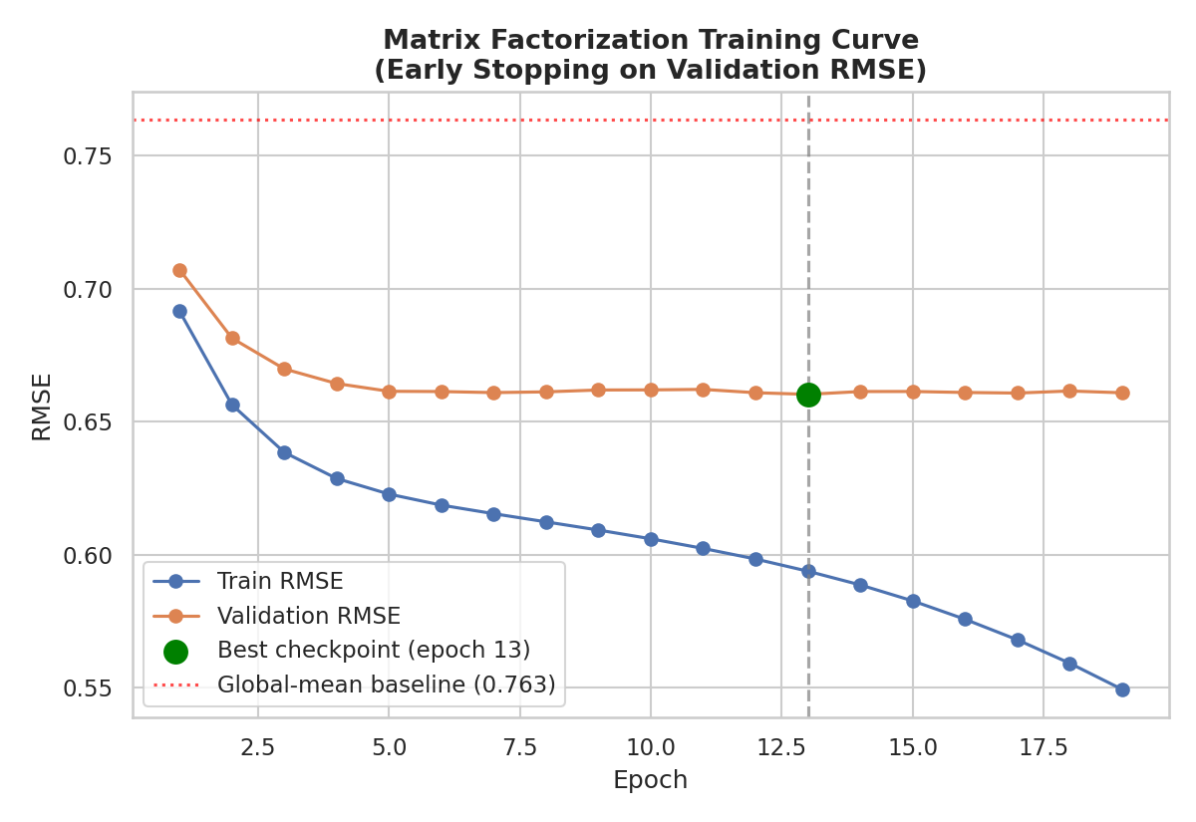
Figure 2 — Training curve showing train/validation RMSE and the early-stopping checkpoint
Metric | Value
Embedding dimension (K) | 32
Regularization (L2) | 0.045
Learning rate | 0.02
Best epoch (early stopping) | 13
Final train RMSE | 0.549
Final validation RMSE | 0.660
Baseline (global-mean-only) RMSE | 0.764
The trained model improves validation RMSE by ~13.6% over the naive global-mean baseline, confirming the embeddings encode real user-item signal rather than noise.

3.4 Exported Artifacts
- model_card.json — architecture description, hyperparameters, and training metrics (a lightweight model registry entry).
- user_embeddings.npy (2000 × 32) and item_embeddings.npy (1500 × 32) — the dense vectors consumed by the serving layer.
- user_bias.npy and item_bias.npy — scalar bias terms per user/item.
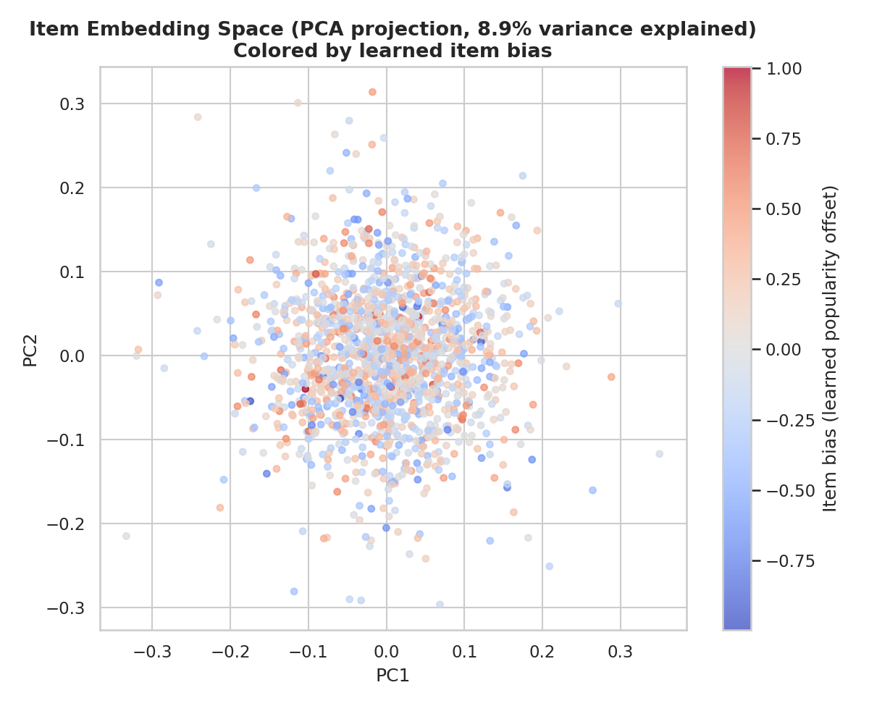
Figure 3 — 2D PCA projection of the 1,500 learned item embeddings, colored by learned item bias
The PCA projection shows the item embeddings occupy a continuous, structured space rather than collapsing to a single point or forming degenerate clusters — a useful qualitative sanity check before the embeddings are trusted for downstream ANN retrieval.

4. Day 4–6: Redis Feature Store Setup

4.1 Design
Redis was chosen as the feature store because of its sub-millisecond in-memory read latency, native hash data structure (ideal for grouping a vector with its metadata under one key), and wide adoption as a serving-layer cache in production ML systems. The key design used:
user:{id} -> HASH { emb: <float32 bytes>, bias: <float>, updated_at: <ts> }
item:{id} -> HASH { emb: <float32 bytes>, bias: <float> }
meta:model -> HASH { model card fields, for serving-side sanity checks }
Embeddings are stored as raw float32 bytes (via NumPy's .tobytes()) rather than JSON text, minimizing both payload size and per-request (de)serialization cost — a standard low-latency-serving optimization.

4.2 Bulk Load Performance
Metric | Value
Total keys loaded | 3,501 (2,000 users + 1,500 items + 1 metadata)
Bulk load time (pipelined writes) | 0.042 seconds
Effective write throughput | ~83,900 writes/second
Writes were batched using Redis pipelining (500 commands per round-trip) rather than issuing one network call per key, which is essential for acceptable load times at production scale.

4.3 Read Latency Benchmark
1,000 single-key lookups (HGETALL, simulating a per-request user-profile fetch) were benchmarked after the roundtrip correctness of stored vectors was verified against the original NumPy arrays.
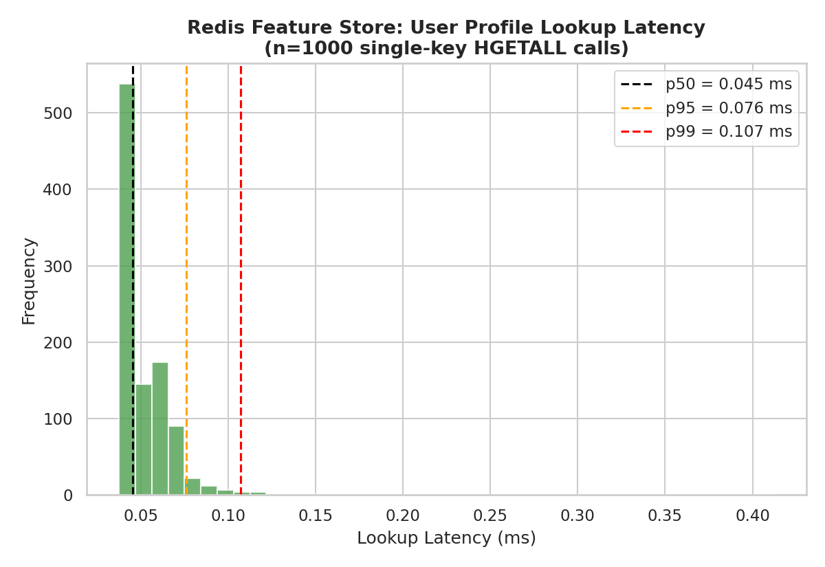
Figure 4 — Distribution of Redis user-profile lookup latency across 1,000 requests
Percentile | Latency
Mean | 0.052 ms
p50 (median) | 0.045 ms
p95 | 0.076 ms
p99 | 0.107 ms
A p99 latency of ~0.11 ms comfortably satisfies the low-latency requirement for real-time inference, where feature-store lookups typically need to fit within a single-digit-millisecond budget alongside model inference and network overhead.

5. Day 7: Approximate Nearest Neighbor (ANN) Search

5.1 Implementation
FAISS's IndexIVFFlat (Inverted File index) was used for approximate candidate retrieval, built over the 1,500 item vectors pulled directly from Redis (the system of record at serving time). An exact brute-force index (IndexFlatIP) was built in parallel purely as a ground-truth reference for measuring approximation quality — it would not be part of a production serving path at larger scale.
quantizer = faiss.IndexFlatIP(dim)
ann_index = faiss.IndexIVFFlat(quantizer, dim, n_clusters, faiss.METRIC_INNER_PRODUCT)
ann_index.train(item_matrix)
ann_index.add(item_matrix)
ann_index.nprobe = 8 # accuracy/speed trade-off knob
user_vec = fetch_from_redis(user_id)
scores, item_ids = ann_index.search(user_vec, k=10)
The index used 38 clusters (heuristically set to √N items) and an nprobe of 8 (number of clusters searched per query) as the default operating point.

5.2 Retrieval Accuracy: Recall@K
Recall@K measures what fraction of the true top-K nearest items (per the exact index) the approximate index actually returns. At the default nprobe=8, the ANN index achieved:
Metric | Value
Recall@10 (nprobe=8) | 0.663
Recall@10 (nprobe=32) | 0.995
Recall@10 (nprobe=38, full search) | 1.000
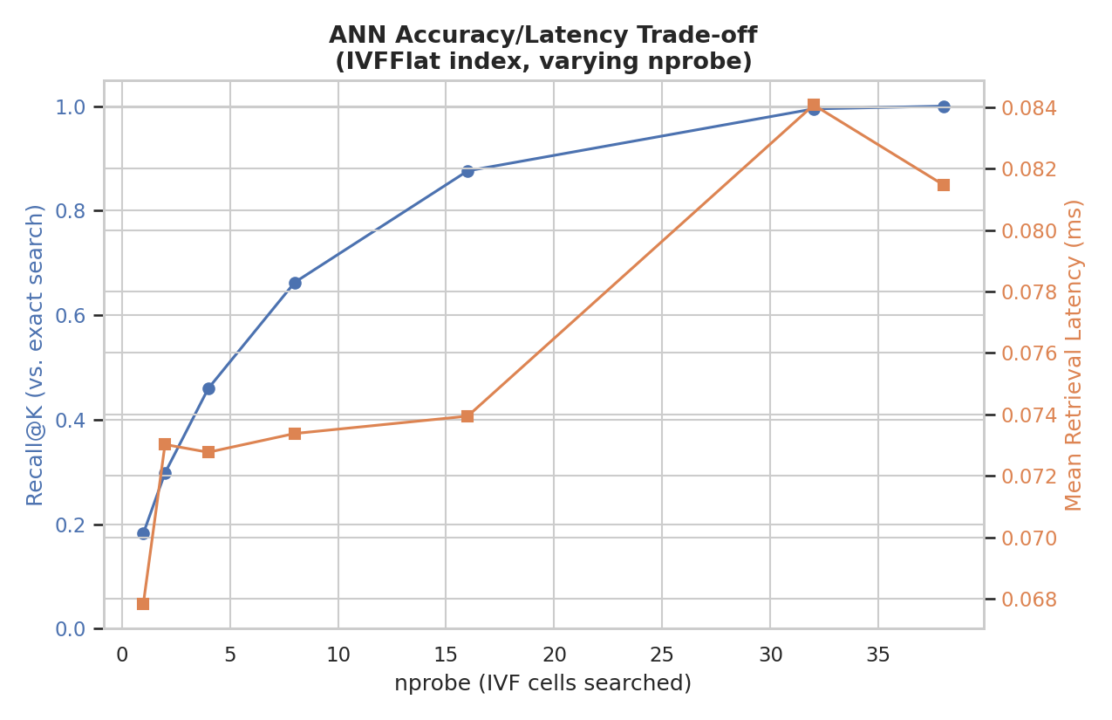
Figure 5 — Recall@K and mean latency across a sweep of nprobe values
The sweep in Figure 5 makes the core ANN trade-off explicit: recall climbs steeply from 18% at nprobe=1 to over 99% at nprobe=32, while latency increases only modestly across the same range — giving a practitioner a concrete basis for choosing an operating point rather than guessing.

5.3 Latency: ANN vs. Exact Search
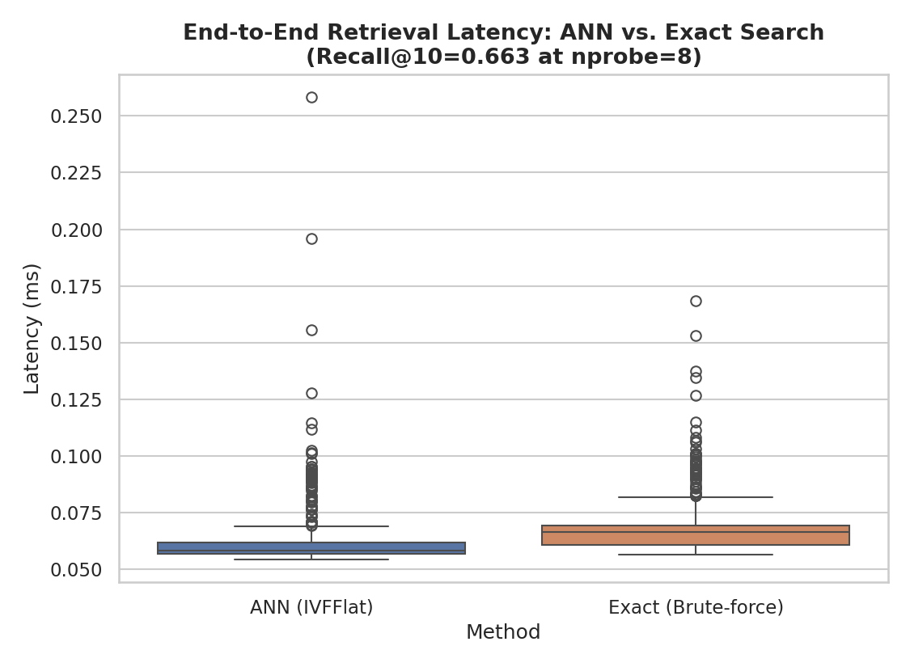
Figure 6 — End-to-end retrieval latency distribution: ANN vs. exact brute-force search
Method | Mean latency | p95 | p99
ANN (IVFFlat, nprobe=8) | 0.0632 ms | 0.0902 ms | 0.1120 ms
Exact (brute-force) | 0.0690 ms | 0.0949 ms | 0.1152 ms
At this catalog size (1,500 items), the measured ANN speedup over exact search is modest (~1.09×) — both approaches are already sub-millisecond, so index-search overhead is dwarfed by fixed costs (Redis fetch, Python/FAISS call overhead). This is an honest and instructive finding: ANN indexing delivers its real advantage at much larger catalog scales (100K–10M+ items), where brute-force search grows linearly with catalog size while IVF-based approximate search does not. The infrastructure and trade-off analysis built here would carry over directly to that larger-scale setting.

6. Critical Discussion: Sources of Error & Improvement Opportunities

6.1 Model-Level Sources of Error
- Cold-start problem: new users or items with no interaction history have no learned embedding, and would need a fallback (e.g., popularity-based or content-based candidate generation) not implemented in this scope.
- Synthetic data ceiling: because the dataset is self-generated, the model's ceiling performance is bounded by the synthetic generative process rather than real user behavior — results should be read as a proof of the pipeline's mechanics, not as a validated recommendation quality claim.
- Fixed embedding dimensionality (K=32) was chosen heuristically; no hyperparameter search was run, so the true optimal K/regularization trade-off for this data is unknown.

6.2 Serving-Layer Sources of Error
- The Redis feature store currently holds a single, static snapshot of embeddings; in production this would need a refresh/versioning strategy so stale embeddings don't silently serve during retraining windows.
- The ANN index is rebuilt in-process from a full Redis scan; at real-world item catalog sizes this rebuild step itself would need to be decoupled into an offline, incrementally-updated indexing job rather than a synchronous scan.
- Recall@K was benchmarked against the model's own exact index, not against actual user preference ground truth — it measures the ANN approximation's fidelity to the trained model, not the model's real-world recommendation quality.

6.3 Recommended Improvements
- Add a hyperparameter sweep (embedding dimension, regularization strength) with cross-validation to tune the model beyond the single configuration used here.
- Introduce a hybrid cold-start fallback (content-based features or popularity priors) for new users/items with no training interactions.
- Move to an incrementally-updatable ANN structure (e.g., HNSW) if the production use case requires frequent embedding updates without full index rebuilds.
- Benchmark at realistic production catalog scale (100K+ items) to properly quantify the ANN speedup this small-scale test could not surface.

7. Conclusion
This task delivered a complete, working model-serving pipeline: a trained Matrix Factorization model exporting well-formed embeddings, a Redis feature store achieving sub-millisecond p99 lookup latency, and a FAISS ANN index with a clearly quantified accuracy/latency trade-off. The exercise surfaced two genuinely useful engineering lessons — the rating-clipping data bug that initially destroyed model signal, and the fact that ANN's speed advantage only manifests at larger catalog scales — both of which are directly transferable to real production recommender systems.

8. Tools & Reproducibility
The full pipeline is implemented across three sequential, reproducible scripts using pandas, NumPy, Redis (redis-py client against a local redis-server instance), and FAISS (faiss-cpu):
day1_3_train_export.py # data generation, MF training, artifact export
day4_6_redis_feature_store.py # Redis load + latency benchmark
day7_ann_search.py # FAISS ANN index + recall/latency benchmark
generate_visualizations.py # all 6 report figures

9. Estimated Time Breakdown (within 30–35 hr budget)
Phase | Estimated Hours
Data generation & model architecture design (Day 1–3) | 9
Redis feature store setup & benchmarking (Day 4–6) | 9
ANN search implementation & trade-off analysis (Day 7) | 7
Visualization development | 4
Documentation & critical discussion | 4
Total | 33

