

Operator Defined Services : BE impact

HE 4.0 BE release

Design Specification v0.2

|  |  |
| --- | --- |
| Version | 0.2 |
| Author | Bhawani Singh Shekhawat |
| Contributors |  |

The document comprises 146 pages, all pages have version no 0.2

This issue was last saved on 03.12.2013 18:52.

This document was edited with MS WinWord version 11.0.

The filename of the main document file was DSpec_ Operator_Defined_Services_v02.doc.

Copyright © 2013 Accenture

All rights reserved.

Confidential and Proprietary.

The reproduction, transmission or use of this code/document or its contents is not permitted without prior express written consent of Accenture. Offenders will be liable for damages. All rights, including but not limited to rights created by patent grant or registration of a utility model or design, are reserved.

Accenture reserves the right to modify technical specifications and features. Technical specifications and features are binding only insofar as they are specifically and expressly agreed upon in a written contract.

0 General Information 7

0.1 History 7

0.2 References 7

0.3 Glossary and Abbreviations 7

0.4 List of Figures and Tables 8

1 Introduction 10

1.1 Document organization 10

1.2 Document Overview 10

2 Related FR 12

2.1 Operator Defined Services (ODSvcs) 12

2.1.1 Scope 12

2.1.2 Requirements Overview 12

2.2 Assumptions and Restrictions 12

2.2.1 Assumptions 12

2.2.2 Restrictions 12

3 Overview 13

3.1 Component Interaction 13

4 Object Model 14

4.1 Myrio TotalManage 14

4.1.1 Use Case Modeling 14

4.1.1.1 ODP type definition and ODP type parameters Configuration 14

4.1.1.1.1 Add ODP type definition 14

4.1.1.1.2 Edit ODP type definition 15

4.1.1.1.3 Delete ODP type definition 15

4.1.1.1.4 Add ODP type parameters 16

4.1.1.1.5 Edit ODP type parameters 17

4.1.1.1.6 Delete ODP type parameters 18

4.1.1.2 Operator Defined Products Configuration 19

4.1.1.2.1 Add/Edit Operator Defined Products Properties 19

4.1.1.2.2 Activate/Inactivate Operator Defined Products 20

4.1.1.2.3 Delete Operator Defined Products 21

4.1.1.2.4 Operator Defined Products Parameter Configuration 21

4.1.1.2.5 Operator Defined Products Package Assignment Configuration 22

4.1.1.3 Item Assignment Configuration 23

4.1.1.4 Reports Configuration 24

4.1.1.5 Security Profile Configuration 25

4.1.1.6 Operator Defined Server Configuration 26

4.1.1.6.1 Create/Edit Operator Defined Server Configuration 26

4.1.1.6.2 Delete Operator Defined Server Configuration 27

4.1.2 Class Modeling 28

4.1.2.1 ODP Types Class Diagram 28

4.1.2.2 Operator Defined Products Class Diagram 29

4.1.2.3 Operator Defined Server Class Diagram 30

5 Implementation 31

5.1 ODP Types Configuration 31

5.1.1 Flow Diagram 31

5.1.1.1 Add/Edit ODP Types 31

5.1.1.2 Delete ODP Types 32

5.1.1.3 Add/Edit ODP Type Parameter 33

5.1.1.4 Delete ODP Type Parameter 34

5.1.2 Sequence Diagram 35

5.1.2.1 Add ODP Type 35

5.1.2.2 Edit ODP Type 36

5.1.2.3 Delete ODP Type 37

5.1.2.4 Add ODP Type Parameter 37

5.1.2.5 Edit ODP Type Parameter 38

5.1.2.6 Delete ODP Type Parameter 39

5.1.3 Business Logic 39

5.1.3.1 ODP Type Definition Object 39

5.1.3.2 ODP Type Parameter Object 40

5.1.3.3 ODP Types Presentation Layer classes 41

5.1.3.4 ODP Type Servlet 53

5.1.3.5 ODP Type Configuration Application Layer 54

5.1.3.6 Objects to lock 56

5.1.3.7 Exceptions 56

5.1.3.8 Error messages 56

5.1.3.9 ODP Type Database Layer 57

5.1.3.10 Framework Layer 59

5.2 Operator Defined Product Configuration 60

5.2.1 Flow Diagram 60

5.2.1.1 Add/Edit Operator Defined Product Properties 60

5.2.1.2 Activate/Inactivate ODP 60

5.2.1.3 Delete ODP Item 62

5.2.1.4 Add/Edit ODP Parameters 63

5.2.1.5 ODP Package assignment/unassignment 64

5.2.2 Sequence Diagram 65

5.2.2.1 Add ODP Item 65

5.2.2.2 Edit ODP Item 66

5.2.2.3 Delete ODP Item 67

5.2.2.4 Activate ODP Item 68

5.2.2.5 Inactivate ODP Item 69

5.2.3 Business Logic 70

5.2.3.1 Operator Defined Product Objects 70

5.2.3.2 ODP Presentation Layer classes 71

5.2.3.3 ODP Servlet 83

5.2.3.4 ODP Application Layer classes 86

5.2.3.5 Objects to lock 88

5.2.3.6 Exceptions 89

5.2.3.7 Error messages 89

5.2.3.8 ODP Database Layer 89

5.2.3.9 Framework Layer 93

5.3 Package & Pricing Item Assignment Configuration 98

5.3.1 Flow Diagram 98

5.3.1.1 Package & Pricing Item assignment/ unassignment 98

5.3.2 Sequence Diagram 99

5.3.2.1 Package Assignment and Unassignment ODP Item 99

5.3.3 Business Logic 99

5.3.3.1 Package & Pricing Item Assignment Objects 99

5.3.3.2 Package & Pricing Item Assignment Presentation Layer classes 99

5.3.3.3 Package & Pricing Item Assignment Servlet 99

5.3.3.4 Package & Pricing Item Assignment Application Layer classes 100

5.3.3.5 Objects to lock 100

5.3.3.6 Exceptions 100

5.3.3.7 Error messages None 100

5.3.3.8 Package & Pricing Item Assignment Database Layer 100

5.4 Reports Configuration 101

5.4.1 Flow Diagram 101

5.4.1.1 Reports 101

5.4.2 Sequence Diagram 101

5.4.3 Business Logic 101

5.4.3.1 Reports Objects 101

5.4.3.2 Reports Presentation Layer classes 101

5.4.3.3 Reports Servlet 101

5.4.3.4 Reports Application Layer classes 102

5.4.3.5 Objects to lock 102

5.4.3.6 Exceptions 102

5.4.3.7 Error messages 102

5.4.3.8 Reports Database Layer 102

5.5 Security Profile Configuration 102

5.5.1 Flow Diagram 103

5.5.1.1 Security Profile 103

5.5.2 Sequence Diagram 103

5.5.3 Business Logic 103

5.5.3.1 Security Profile Objects 103

5.5.3.2 Security Profile Presentation Layer classes 104

5.5.3.3 Security Profile Servlet 104

5.5.3.4 Security Profile Application Layer classes 104

5.5.3.5 Objects to lock 104

5.5.3.6 Exceptions 105

5.5.3.7 Error messages 105

5.5.3.8 Security Profile Database Layer 105

5.5.3.9 Database changes 105

5.6 Operator Defined Server Configuration 105

5.6.1 Flow Diagram 106

5.6.1.1 Create/Edit Operator Defined Server 106

5.6.1.2 Delete Operator Defined Server 107

5.6.2 Sequence Diagram 108

5.6.2.1 Add Operator Defined Server 108

5.6.2.2 Edit Operator Defined Server 109

5.6.2.3 Delete Operator Defined Server 110

5.6.3 Business Logic 111

5.6.3.1 Operator Defined Server Objects 111

5.6.3.2 Operator Defined Server Presentation Layer classes 111

5.6.3.3 Operator Defined Server Servlet 116

5.6.3.4 Operator Defined Server Application Layer classes 116

5.6.3.5 Objects to lock 116

5.6.3.6 Exceptions 116

5.6.3.7 Error messages 116

5.6.3.8 Operator Defined Product Objects 117

5.6.3.9 Operator Defined Server Database Layer 119

6 Broker Documents 121

6.1 Open Client Interfaces 121

6.1.1 Global Broker Documents 121

6.1.1.1 GlobalInstall 121

6.1.1.2 Class Diagram 121

6.1.1.3 Flow Diagram 122

6.1.1.4 Sequence Diagram 122

6.1.1.5 Business Logic 123

6.1.1.5.1 Presentation Layer classes 123

6.1.1.5.2 Servlet 123

6.1.1.5.3 Application Layer classes 123

6.1.1.5.4 Objects to lock 125

6.1.1.5.5 Exceptions 125

6.1.1.5.6 GlobalInstall.xml 125

6.2 OPI: Open Portal Integration 127

6.2.1 GlobalInfo SOAP interface 127

6.2.1.1 Class Diagram 127

6.2.1.2 Flow Diagram 127

6.2.1.3 Sequence Diagram 127

6.2.1.4 Business Logic 127

6.2.1.4.1 Presentation Layer classes 127

6.2.1.4.2 Servlet 127

6.2.1.4.3 Application Layer classes 127

6.2.1.4.4 Objects to lock 128

6.2.1.4.5 Exceptions 128

6.2.1.4.6 Opa/ops/config/war/WEB-INF/xslt/getGlobalInfo.xsll 128

7 Exported Interfaces 131

7.1 ODP Type Definition TM GUI 131

7.2 ODP Type Parameters TM GUI 132

7.3 Operator Defined Products, Tab Properties TM GUI 133

7.4 Operator Defined Products, TAB Package Assignment TM GUI 134

7.5 Operator Defined Products, TAB Log TM GUI 135

7.6 Packages, TAB Item Assignment TM GUI 136

7.7 Reports 137

7.8 Security 🡪 User Groups, TAB Security Profiles (UPDATE) 137

7.9 Setup 🡪 Company, TAB Servers TM GUI 138

8 Configuration 139

9 Imported Interfaces 140

10 Database Migration/Upgrade 141

10.1 Database Patch 141

10.2 ODP 141

10.2.1 ODP Types 141

10.2.2 ODPTYPEPARAMETERS 141

10.2.3 ODPTYPEPARAMETERRULESMAPPING 142

10.2.4 ODPPARAMETERRULES 142

10.2.5 OPERATORDEFINEDPRODUCTS 142

10.2.6 ODPPARAMETERVALUE 143

10.2.7 ITEMTYPES inserts 143

10.2.8 COMPANYSERVERTYPES inserts 143

10.2.9 REGISTERS inserts 144

10.2.10 ODPPARAMETERRULES inserts 144

10.2.11 REPORTS inserts 144

10.2.12 REPORTCOLUMNFORMAT inserts 145

11 Design Specification Reviewers List & Template 146

# General Information

## History

|  |  |  |
| --- | --- | --- |
| **Version** | **Date** | **Reason for Changes** |
| 0.1 | 23-10-2013 | Initial Draft |
| 0.2 | 03-12-2013 | Review Comments |
|  |  |  |
|  |  |  |

Table : History

## References

|  |  |
| --- | --- |
| [1] | FSpec - FSpec Operator Defined Services IUS 1 1 |
| [2] | *RSpec -* RSPec - Operator Defined Services v 1.0 |
|  |  |

|  |  |
| --- | --- |
| **Type of documents** | |
| FR | Feature Request |
| FS | Functional Specification |
| DS | Design Specification |
| IS | Interface Specification |
| TS | Test Specification |
| UD | User Documentation |

## Glossary and Abbreviations

|  |  |
| --- | --- |
|  | **Description** |
| ODSvcs | Operator Defined Services |
| ODP | Operator Defined Product |
| ODPT | Operator Defined Product Type |
| ODS | Operator Defined Server |
| STB | Set Top Box |
| TM | Total Manage |
| UI | User Interface |
| GUI | Graphical User Interface |
| DB | Database |
| OCI | Open Client Interface |
| URH | Unicast Request Handler |
| OTT | Over The Top |
| OPI | Open Portal Interface |
| DAO | Data Access Object |
| MMDDF | Myrio Multicast Data Distribution Framework |

Table : Abbreviations

## List of Figures and Tables

Figure 1: Component Interaction Diagram 13

Figure 2: Add ODP Type Definition 14

Figure 3: Edit ODP type definition 15

Figure 4: Delete ODP type definition 16

Figure 5: Add ODP type parameters 16

Figure 6: Edit ODP type parameters 17

Figure 7: Delete ODP type parameters 18

Figure 8: Add/Edit Operator Defined Products Properties 19

Figure 9: Activate/Inactivate Operator Defined Products 20

Figure 10: Delete Operator Defined Products 21

Figure 11: Operator Defined Products Parameter 22

Figure 12: Operator Defined Products Package Assignment 23

Figure 13: Item Assignment 24

Figure 14: Reports 25

Figure 15: Security Profile 25

Figure 16: Create/Edit Operator Defined Server 26

Figure 17: ODP Types Class Diagram 28

Figure 18: Operator Defined Products Class Diagram 29

Figure 19: Operator Defined Server Class Diagram 30

Figure 20: Add/Edit ODP Types Flow Diagram 31

Figure 21: Delete ODP Types Flow Diagram 32

Figure 22: Add/Edit ODP Type Parameter 33

Figure 23: Delete ODP Type Parameter 34

Figure 24: Add ODP Type 35

Figure 25: Edit ODP Type 36

Figure 26: Delete ODP Type 37

Figure 27: Add ODP Type Parameter 37

Figure 28: Edit ODP Type Parameter 38

Figure 29: Delete ODP Type Parameter 39

Figure 30: Add/Edit Operator Defined Product Properties 60

Figure 31: Activate/Inactivate ODP 61

Figure 32: 5.2.1.4 Delete ODP Item 62

Figure 33: Add/Edit ODP Parameters 63

Figure 34: ODP Package assignment/unassignment 64

Figure 35: Add ODP Item 65

Figure 36: Edit ODP Item 66

Figure 37: Delete ODP Item 67

Figure 38: Activate ODP Item 68

Figure 39: Inactivate ODP Item 69

Figure 40: Package & Pricing Item assignment/ unassignment 98

Figure 41: Package Assignment and Unassignment ODP Item 99

Figure 42: Reports Flow Diagram 101

Figure 43: Security Profile 103

Figure 44: Create/Edit Operator Defined Server 106

Figure 45: Delete Operator Defined Server 107

Figure 46: Add Operator Defined Server 108

Figure 47: Edit Operator Defined Server 109

Figure 48: Delete Operator Defined Server 110

Figure 49: Global Install Class Diagram 121

Figure 50: GlobalInstall Sequence Diagram 122

Figure 51: GlobalInfo 127

Figure 52: ODP type Definition TM GUI 131

Figure 53: ODP Type Parameters TM GUI 132

Figure 54: Operator Defined Products, Tab Properties TM GUI 133

Figure 55: Operator Defined Products, TAB Package Assignment TM GUI 134

Figure 56: Operator Defined Products, TAB Log TM GUI 135

Figure 57: Packages, TAB Item Assignment TM GUI 136

Figure 58: Reports 137

Figure 59: Security : User Groups, TAB Security Profiles (UPDATE) 137

Figure 60: Setup : Company, TAB Servers TM GUI 138

Figure 61: ODPTYPES Schema 141

Figure 62: ODPTYPEPARAMETERS Schema 141

Figure 63: ODPTYPEPARAMETERRULESMAPPING Schema 142

Figure 64: ODPPARAMETERRULES Schema 142

Figure 65: OPERATORDEFINEDPRODUCTS Schema 142

Figure 66: ODPPARAMETERVALUE Schema 143

Figure 67: ITEMTYPES inserts 143

Figure 68: COMPANYSERVERTYPES inserts 143

Figure 69: REGISTERS inserts 144

Figure 70: ODPPARAMETERRULES inserts 144

Figure 71: REPORTS inserts 144

Figure 72: REPORTCOLUMNFORMAT inserts 145

Table 1: History 7

Table 2: Abbreviations 8

Table 3: Add ODP Type Definition 14

Table 4: Edit ODP type definition 14

Table 5: Delete ODP type definition 15

Table 6: Add ODP type parameters 16

Table 7: Edit ODP type parameters 17

Table 8: Delete ODP type parameters 18

Table 9: Add/Edit Operator Defined Products Properties 19

Table 10: Activate/Inactivate Operator Defined Products 19

Table 11: Delete Operator Defined Products 20

Table 12: Operator Defined Products Parameter 21

Table 13: Operator Defined Products Package Assignment 22

Table 14: Item Assignment 23

Table 15: Reports 23

Table 16: Security Profile 24

Table 17: Create/Edit/Delete Operator Defined Server 25

# Introduction

This document is the "System Design Specification" for project HE 4.0 and it joins all feature design contributions from “Operator Defined Services”.

See document chapters "History" and "Document Organization" for more information.

For this project the basis standard software for specific subsystems will be HE 4.0.

## Document organization

The feature requirements expected by the development will be restricted to include the project RS and FS (See References [1]).

Regarding the document contributions it is expected from development that the features to be realized be distributed considering the design phase:

- Analysis, consisting in the "Functional Specification Level 1 version IUS1.1" contributions, meaning chapters:  
 General Information  
 Introduction  
 Related FR  
 Object Model (excluding only the Use Cases subchapter Class Diagram)  
 Exported Interfaces  
 Imported Interfaces  
  
- Design , consisting in the remaining "Design Specification" contributions, meaning chapters:  
 Object Model (only the Use Cases subchapter Class Diagram)  
 Implementation  
 Configuration  
 Database Migration/Upgrade  
 Installation  
  
See document chapter "History" for more information.

## Document Overview

R SPec - Operator Defined Services v 1.0

Operator Defined Services (ODSvcs) requirements

Design Specification Level 0.1

Operator Defined Services: BE impact

Project Name: HE 4.0

FSpec Operator Defined Services IUS 1 1

Operator Defined Services: BE impact

# Related FR

## Operator Defined Services (ODSvcs)

### Scope

This document defines the Detailed Design for the requirements and use cases defined in the Functional Spec for “Operator Defined Services”.

### Requirements Overview

This process extends the introduction of a new product or a new server in TM. To handle this case a new generic and flexible functionality is proposed which would enable the provider to create customized products and servers bypassing the need of specific development for the same.

More Details: [References [1,2].]

## Assumptions and Restrictions

### Assumptions

* Solution Engineer will add ODS related XSDs in OCI documentations.
* Help related changes are part of customer documentations.
* The rules mentioned in FSpec have same functionality as in UDF.

### Restrictions

Not Applicable

# Overview

## Component Interaction

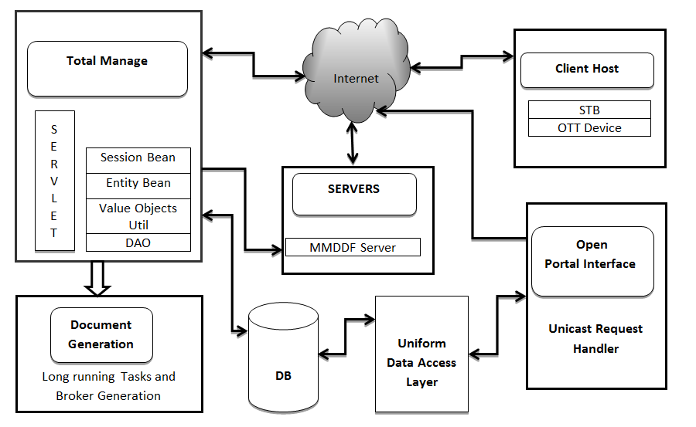

Figure : Component Interaction Diagram

# Object Model

## Myrio TotalManage

### Use Case Modeling

#### ODP type definition and ODP type parameters Configuration

TM admin can add/edit/delete ODP type definition and ODP type parameters via TM UI.

##### Add ODP type definition

TM admin can add ODP type definition via TM UI.



Figure : Add ODP Type Definition

|  |  |
| --- | --- |
| **Actor** | TM admin |
| **Information** | Addition of ODP type definition in TM |
| **Pre-condition** | TM admin has write access to the Setup module of Total Manage |
| **Flow of events** | 1.TM admin opens the module “Setup”  2.TM admin selects the tab “Company”  3.TM admin selects the tab “ODP Types”  4.TM admin selects the tab “ODP Type Definitions”  5.TM admin pushes the “Add” button  6.TM admin enters the name, external Id, description and accessibility in OCI and OPI and click on “Submit"  7.A new ODP type is added  8.TM prompts with successful execution |
| **Post condition** | The changes are saved in TM DB. |
| **Alternative flow of events** | TM Operator enters the name, external Id, description and accessibility in OCI and OPI and Cancels the changes; the changes are not saved / updated in TM DB. |
| **Exception** | ▪ Name and external ID (mandatory fields) weren’t filled; TM prompts an error message advertising that mandatory fields are empty.  ▪ Name/external id has non unique value; TM prompts an error message advertising that non unique values were inputted.  ▪ Name have values with special characters (except – and _); TM prompts an error message advertising that special characters were inputted.  ▪ Total number of ODP type definitions in system is greater than 50; TM prompts an error message advertising that max 50 ODP types are allowed in the system.  . |
| **Reference** | See References [1]. |

Table : Add ODP Type Definition

##### Edit ODP type definition

TM admin can edit ODP type definition via TM UI.



Figure : Edit ODP type definition

|  |  |
| --- | --- |
| **Actor** | TM admin |
| **Information** | Edition of ODP type definition in TM |
| **Pre-condition** | TM admin has write access to the Setup module of Total Manage |
| **Flow of events** | 1.TM admin opens the module “Setup”  2.TM admin selects the tab “Company”  3.TM admin selects the tab “ODP Types”  4.TM admin selects the tab “ODP Type Definitions”  5.TM admin double click on ODP types table  6.TM admin edit the name, external Id, description and accessibility in OCI and OPI and click on “Submit"  7.Selected ODP type is updated  8.TM prompts with successful execution |
| **Post condition** | The changes are saved in TM DB. |
| **Alternative flow of events** | TM Operator enters the name, external Id, description and accessibility in OCI and OPI and Cancels the changes; the changes are not saved/updated in TM DB. |
| **Exception** | ▪ Name and external ID (mandatory fields) weren’t filled; TM prompts an error message advertising that mandatory fields are empty.  ▪ Name/external id has non unique value; TM prompts an error message advertising that non unique values were inputted.  ▪ Name have values with special characters (except – and _); TM prompts an error message advertising that special characters were inputted.  ▪ It is not possible to modify ODP type definition if active ODP of selected ODP type exists. |
| **Reference** | See References [1]. |

Table : Edit ODP type definition

##### Delete ODP type definition

TM admin can delete ODP type definition via TM UI.



Figure : Delete ODP type definition

|  |  |
| --- | --- |
| **Actor** | TM admin |
| **Information** | Deletion of ODP type definition in TM |
| **Pre-condition** | ▪ TM admin has write access to the Setup module of Total Manage  ▪ An ODP type definition is available in TM |
| **Flow of events** | 1.TM admin opens the module “Setup”  2.TM admin selects the tab “Company”  3.TM admin selects the tab “ODP Types”  4.TM admin selects the tab “ODP Type Definitions”  5.TM admin selects row in ODP type definition table  6.TM admin pushes the “Delete” button  7.TM prompts a message asking about confirmation, click on 'Yes'  8.TM prompts with successful execution |
| **Post condition** | The changes are saved in TM DB. |
| **Alternative flow of events** | TM Operator click on ‘No’ option on confirmation message, the changes are not saved/updated in TM DB. |
| **Exception** | An ODP type cannot be deleted when there is still an ODP of this ODP type defined within the system. |
| **Reference** | See References [1]. |

Table : Delete ODP type definition

##### Add ODP type parameters

TM admin can add ODP type parameters via TM UI.



Figure : Add ODP type parameters

|  |  |
| --- | --- |
| **Actor** | TM admin |
| **Information** | Addition of ODP type parameters in TM |
| **Pre-condition** | TM admin has write access to the Setup module of Total Manage |
| **Flow of events** | 1.TM admin opens the module “Setup”  2.TM admin selects the tab “Company”  3.TM admin selects the tab “ODP types”  4.TM admin selects the tab “ODP Type Parameters”  5.TM admin pushes the “Add” button  6.TM admin enters the parameter name, display description, enum values, default value accessibility in OCI and OPI and define ODP type parameter value constraints and click on “Submit”  7.A new ODP type parameter is added  8.TM prompts with successful execution |
| **Post condition** | The changes are saved in TM DB. |
| **Alternative flow of events** | TM Operator enters the parameter name, display description, enum values, default value accessibility in OCI and OPI and define ODP type parameter value constraints and Cancels the changes; the changes are not saved/updated in TM DB. |
| **Exception** | ▪ Parameter name, display description (mandatory fields) weren’t filled; TM prompts an error message advertising that mandatory fields are empty.  ▪ Parameter name has non unique value; TM prompts an error message advertising that non unique value is inputted.  ▪ Display description has more than 200 characters; TM prompts an error message advertising that max of 200 characters is allowed.  ▪ Default value is not from enum value list; TM prompts an error message advertising that the default value must be one value from this list.  ▪ Total number of ODP type parameters for a ODP type is greater than 50; TM prompts an error message advertising that max 50 ODP type parameters are allowed in the system. |
| **Reference** | See References [1]. |

Table : Add ODP type parameters

##### Edit ODP type parameters

TM admin can edit ODP type parameters via TM UI.



Figure : Edit ODP type parameters

|  |  |
| --- | --- |
| **Actor** | TM admin |
| **Information** | Edition of ODP type parameters in TM |
| **Pre-condition** | TM admin has write access to the Setup module of Total Manage |
| **Flow of events** | 1.TM admin opens the module “Setup”  2.TM admin selects the tab “Company”  3.TM admin selects the tab “ODP types”  4.TM admin selects the tab “ODP Type Parameters”  5.TM admin double clicks on ODP type parameters  6.TM admin enters the parameter name, display description, enum values, default value accessibility in OCI and OPI and define ODP type parameter value constraints and click on “Submit”  7.A ODP type parameter is updated  8.TM prompts with successful execution |
| **Post condition** | The changes are saved in TM DB. |
| **Alternative flow of events** | TM Operator enters the parameter name, display description, enum values, default value accessibility in OCI and OPI and define ODP type parameter value constraints and Cancels the changes; the changes are not saved/updated in TM DB. |
| **Exception** | ▪ ODP type parameter will not updated if there is any active ODP is present which is associated with this ODP type. TM prompts an error message advertising that edition is not allowed if active ODP of the selected ODP type is present in the system.  ▪ Parameter name, display description (mandatory fields) weren’t filled; TM prompts an error message advertising that mandatory fields are empty.  ▪ Parameter name has non unique value; TM prompts an error message advertising that non unique value is inputted.  ▪ Display description has more than 200 characters; TM prompts an error message advertising that max of 200 characters is allowed.  ▪ Default value is not from enum value list; TM prompts an error message advertising that the default value must be one value from this list. |
| **Reference** | See References [1]. |

Table : Edit ODP type parameters

##### Delete ODP type parameters

TM admin can delete ODP type parameters via TM UI.



Figure : Delete ODP type parameters

|  |  |
| --- | --- |
| **Actor** | TM admin |
| **Information** | Deletion of ODP Types parameters in TM |
| **Pre-condition** | ▪ TM admin has write access to the Setup module of Total Manage  ▪ An ODP Types parameter is available in TM |
| **Flow of events** | 1.TM admin opens the module “Setup”  2.TM admin selects the tab “Company”  3.TM admin selects the tab “ODP types”  4.TM admin selects the tab “ODP type parameters”  5.TM admin selects row in ODP type parameters table  6.TM admin pushes the “Delete” button  7.TM prompts a message asking about confirmation, click on 'Yes'  8.TM prompts with successful execution |
| **Post condition** | The changes are saved in TM DB. |
| **Alternative flow of events** | TM Operator click on ‘No’ option on confirmation message, the changes are not saved/updated in TM DB. |
| **Exception** | An ODP type parameter cannot be deleted when there is still an ODP of this ODP type defined within the system. |
| **Reference** | See References [1]. |

Table : Delete ODP type parameters

#### Operator Defined Products Configuration

##### Add/Edit Operator Defined Products Properties

TM admin can add/edit operator defined products properties via TM UI.



Figure : Add/Edit Operator Defined Products Properties

|  |  |
| --- | --- |
| **Actor** | TM admin |
| **Information** | Addition/Edition of operator defined products in TM |
| **Pre-condition** | TM admin has write access to the Products module of Total Manage |
| **Flow of events** | 1.TM admin opens the module “Products”  2.TM admin selects the tab “Operator Defined Products”  3.TM admin selects the tab “ODP Properties”  4.TM admin selects add/edit button  5.TM admin enters the value for Item Name,Description ,External id and selects from Item SubType drop down  6.TM admin pushes the “Submit” button  7.A ODP is successfully created/edited  8.TM prompts with successful execution |
| **Post condition** | The changes are saved in TM DB. |
| **Alternative flow of events** | 1.TM Operator click on ‘Cancel’/‘No’ option on confirmation message, the changes are not saved/updated in TM DB  2.TM Operator click on ‘Refresh Icon’/‘No’ option on confirmation message, the changes are not saved/updated in TM DB |
| **Exception** | ▪ Item Name and External ID (mandatory fields) weren’t filled; TM prompts an error message advertising that Item Name fields are empty,and for empty External ID prompts a message for auto generation.  ▪ Item Name has non unique value; TM prompts an error message advertising that non unique values were inputted. |
| **Reference** | See References [1]. |

Table : Add/Edit Operator Defined Products Properties

##### Activate/Inactivate Operator Defined Products

TM admin can activate/inactivate operator defined product via TM UI.



Figure : Activate/Inactivate Operator Defined Products

|  |  |
| --- | --- |
| **Actor** | TM admin |
| **Information** | Activate/Inactivate of operator defined product in TM |
| **Pre-condition** | TM admin has write access to the Products module of Total Manage |
| **Flow of events** | 1.TM admin opens the module “Products”  2.TM admin selects the tab “Operator Defined Products”  3.TM admin selects the ODP Item from list in Top Panel  4.TM admin pushes the “Activate/Inactivate” Icon  5.A ODP will successfully activated/inactivated  6.TM prompts with successful execution |
| **Post condition** | The changes are saved in TM DB. |
| **Alternative flow of events** | TM Operator selects the ODP Item from list in Top Panel and then click on ‘Refresh Icon’/‘No’ option on confirmation message, the changes are not saved/updated in TM DB. |
| **Exception** | If any parameter constraint fails then on tm GUI will show a proper error message. |
| **Reference** | See References [1]. |

Table : Activate/Inactivate Operator Defined Products

##### Delete Operator Defined Products

TM admin can delete operator defined product Item via TM UI.



Figure : Delete Operator Defined Products

|  |  |
| --- | --- |
| **Actor** | TM admin |
| **Information** | Delete of operator defined product in TM |
| **Pre-condition** | TM admin has write access to the Products module of Total Manage |
| **Flow of events** | 1.TM admin opens the module “Products”  2.TM admin selects the tab “Operator Defined Products”  3.TM admin selects the Inactive ODP Item from list in Top Panel(for deletion of active ODP Item first make it inactive then delete it)  4.TM admin pushes the “Delete Icon” button  5.TM prompts a message asking about confirmation, click on 'Yes'  6.A ODP will successfully deleted  7.TM prompts with successful execution |
| **Post condition** | The changes are saved in TM DB. |
| **Alternative flow of events** | TM Operator selects the ODP Item from list in Top Panel and then click on ‘Refresh Icon’/‘No’ option on confirmation message, the changes are not deleted in TM DB. |
| **Exception** | If the ODP Item contains Assigned packages it prompts an Error message”Item still assigned to package so cannot be deleted”. |
| **Reference** | See References [1]. |

Table : Delete Operator Defined Products

##### Operator Defined Products Parameter Configuration

TM admin can add/edit operator defined product parameter values via TM UI.



Figure : Operator Defined Products Parameter

|  |  |
| --- | --- |
| **Actor** | TM admin |
| **Information** | Addition/Edition of operator defined product parameters in TM |
| **Pre-condition** | TM admin has write access to the Products module of Total Manage |
| **Flow of events** | 1.TM admin opens the module “Products”  2.TM admin selects the tab “Operator Defined Products”  3.TM admin selects the tab “ODP Parameters”  4.TM admin enter/edit the values for parameters or selecting a parameter of type enumerated, a drop-down menu listing the possible enum values  5.TM admin pushes the “Submit” button  6.A ODP parameter/s value is/are successfully saved  7.TM prompts with successful execution |
| **Post condition** | The changes are saved in TM DB. |
| **Alternative flow of events** | ▪ TM Operator click on ‘Cancel’ button, the changes are not saved/updated in TM DB.  ▪ TM Operator click on ‘Refresh Icon’/‘No’ option on confirmation message, the changes are not saved/updated in TM DB. |
| **Exception** | When an ODP parameter is provided a value that does not comply with a  configured value constraint, then the ODP parameter value assignment is  rejected with a proper error message. In case of errors in multiple  parameters, the error message would pop up one by one for each erroneous  parameter value. |
| **Reference** | See References [1]. |

Table : Operator Defined Products Parameter

##### Operator Defined Products Package Assignment Configuration

TM admin can assign/unassigned operator defined product package via TM UI.



Figure : Operator Defined Products Package Assignment

|  |  |
| --- | --- |
| **Actor** | TM admin |
| **Information** | Assignment/Unassigned of operator defined product packages in TM |
| **Pre-condition** | ▪ TM admin has write access to the Products module of Total Manage |
| **Flow of events** | 1.TM admin opens the module “Products”  2.TM admin selects the tab “Operator Defined Products”  3.TM admin selects the tab “ODP Package Assignment”  4.TM admin selects packages from “Available Package” table and push the assign button  5.TM admin selects packages from “Assigned Packages” table and push the unassigned button  6.TM admin pushes the “Submit” button  7.A ODP package/s is/are successfully assigned/unassigned to ODP Item  8.TM prompts with successful execution |
| **Post condition** | The changes are saved in TM DB. |
| **Alternative flow of events** | ▪ TM Operator click on ‘Cancel’ button, the changes are not saved in TM DB.  ▪ TM Operator click on ‘Refresh Icon’/‘No’ option on confirmation message, the changes are not saved/updated in TM DB. |
| **Exception** | None |
| **Reference** | See References [1]. |

Table : Operator Defined Products Package Assignment

#### Item Assignment Configuration

TM admin can assign/unassigned Item via TM UI.



Figure : Item Assignment

|  |  |
| --- | --- |
| **Actor** | TM admin |
| **Information** | Assignment/Unassignment of item in TM |
| **Pre-condition** | TM admin has write access to the Packages & Pricing module of Total Manage |
| **Flow of events** | 1.TM admin opens the module “Packages & Pricing”  2.TM admin selects the tab “Item Assignment”  3.TM admin selects packages from “Available Items” table and push the assign button  4.TM admin selects packages from “Assigned Items”” table and push the unassign button  5.TM admin pushes the “Submit” button  6.A ODP Item is/are successfully assigned/unassigned to the package  7.TM prompts with successful execution |
| **Post condition** | The changes are saved in TM DB. |
| **Alternative flow of events** | TM Operator click on ‘Cancel’ button, the changes are not saved in TM DB. |
| **Exception** | None |
| **Reference** | See References [1]. |

Table : Item Assignment

#### Reports Configuration

TM admin can generate report via TM UI.



Figure : Reports

|  |  |
| --- | --- |
| **Actor** | TM admin |
| **Information** | Generation of reports in TM |
| **Pre-condition** | TM admin has write access to the Report module of Total Manage |
| **Flow of events** | 1.TM admin opens the module “Reports”  2.TM admin selects “Reports type: Operator Defined Product List” from “Select Report” combo  3.TM admin pushes the “Go” button  4.ODP Report will be generated  5.TM admin clear the data by pushing “Refresh”/clear button  6.TM admin exports the data by pushing “Export” button |
| **Post condition** | None |
| **Alternative flow of events** | None |
| **Exception** | None |
| **Reference** | See References [1]. |

Table : Reports

#### Security Profile Configuration

TM admin can edit access level via TM UI.



Figure : Security Profile

|  |  |
| --- | --- |
| **Actor** | TM admin |
| **Information** | Edit access level in TM |
| **Pre-condition** | TM admin has write access to the Security module of Total Manage |
| **Flow of events** | 1.TM admin opens the module “Security”  2.TM admin selects the tab “User Groups”  3.TM admin selects the tab “Security Profiles of Operator Defined Products”  4.TM admin changes the access level of Operator Defined Products  5.TM admin pushes the “Assign” button  6.Access level is successfully assigned  7.TM prompts with successful execution |
| **Post condition** | The changes are saved in TM DB. |
| **Alternative flow of events** | TM Operator click on ‘Cancel’ button, the changes are not saved in TM DB. |
| **Exception** | None |
| **Reference** | See References [1]. |

Table : Security Profile

#### Operator Defined Server Configuration

##### Create/Edit Operator Defined Server Configuration

TM admin can Create/Edit Operator Defined Server via TM UI.



Figure : Create/Edit Operator Defined Server

|  |  |
| --- | --- |
| **Actor** | TM admin |
| **Information** | Create/Edit Operator Defined Server in TM |
| **Pre-condition** | TM admin has write access to the Setup module of Total Manage |
| **Flow of events** | 1.TM admin opens the module “Setup”  2.TM admin selects the tab “Servers”  3.TM admin pushes the “Create/Edit” button  4.TM admin changes the required details  5.TM admin push the “Submit” button  6.ODS date is successfully saved  7.TM prompts with successful execution |
| **Post condition** | The changes are saved in TM DB. |
| **Alternative flow of events** | TM Operator click on ‘Cancel’ button, the changes are not saved in TM DB. |
| **Exception** | ▪ Server name, server type, location (mandatory) weren’t filled; TM prompts an error message advertising that mandatory fields are empty.  ▪ Server name has non unique value; TM prompts an error message advertising that non unique value is inputted.  ▪ If total number of ODS is greater than 50; TM prompts an error message advertising that more than 50 ODS is not allowed.  ▪ If total number of ODS Parameters is greater than 50; TM prompts an error message advertising that more than 50 ODS Parameters is not allowed.  ▪ If ODS Parameters Name greater than 20 characters; and if Value is more than 200 characters it advertising a error message.  ▪ If ODS Parameters Name or Value is blank,or starts with space it advertising a error message |
| **Reference** | See References [1]. |

Table : Create/Edit/Delete Operator Defined Server

##### Delete Operator Defined Server Configuration

TM admin can Delete Operator Defined Server via TM UI.



|  |  |
| --- | --- |
| **Actor** | TM admin |
| **Information** | Delete Operator Defined Server in TM |
| **Pre-condition** | TM admin has write access to the Setup module of Total Manage |
| **Flow of events** | 1.TM admin opens the module “Setup”  2.TM admin selects the tab “Servers”  3.TM admin selects the servers in the left pane to delete(If the server is active it is first inactivated then deleted)  4.TM admin pushes the “Delete” button  5.ODS date is successfully saved  6.TM prompts with successful execution |
| **Post condition** | The changes are saved in TM DB. |
| **Alternative flow of events** | TM Operator click on ‘Cancel’ button, the changes are not saved in TM DB. |
| **Exception** | ▪ If Selected Server is active; TM prompts an error message advertising that  Server is active. |
| **Reference** | See References [1]. |

### Class Modeling

#### ODP Types Class Diagram



Figure : ODP Types Class Diagram

#### Operator Defined Products Class Diagram



Figure : Operator Defined Products Class Diagram

#### Operator Defined Server Class Diagram



Figure : Operator Defined Server Class Diagram

# Implementation

## ODP Types Configuration

Add operation is used for UI section only but Submit operation is used for inserting data into database.

### Flow Diagram

#### Add/Edit ODP Types

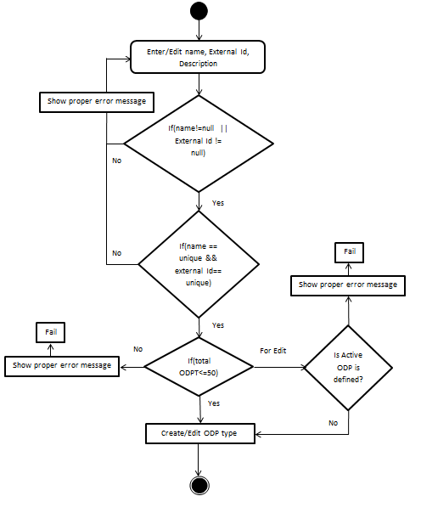

Figure : Add/Edit ODP Types Flow Diagram

#### Delete ODP Types

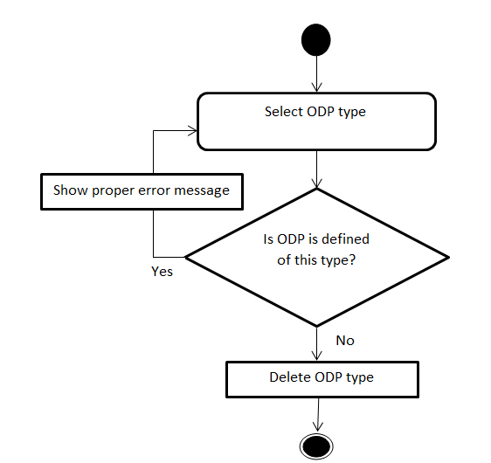

Figure : Delete ODP Types Flow Diagram

#### Add/Edit ODP Type Parameter

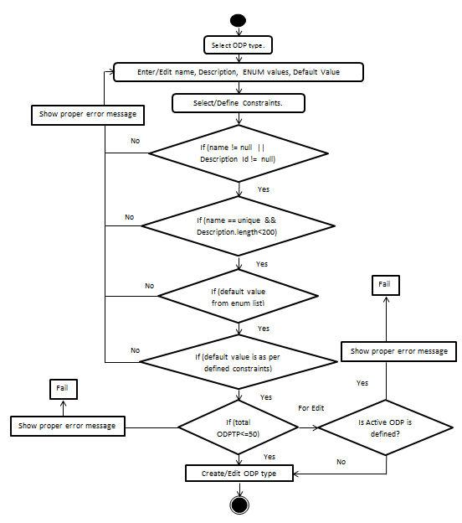

Figure : Add/Edit ODP Type Parameter

#### Delete ODP Type Parameter

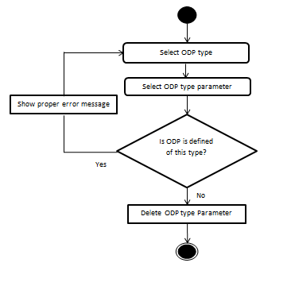

Figure : Delete ODP Type Parameter

### Sequence Diagram

#### Add ODP Type



Figure : Add ODP Type

#### Edit ODP Type



Figure : Edit ODP Type

#### Delete ODP Type



Figure : Delete ODP Type

#### Add ODP Type Parameter



Figure : Add ODP Type Parameter

#### Edit ODP Type Parameter



Figure : Edit ODP Type Parameter

#### Delete ODP Type Parameter



Figure : Delete ODP Type Parameter

### Business Logic

#### ODP Type Definition Object

A new class needs to be implemented to define the ODP type definition object which contains all ODP type properties.

* **com.myrio.tm.company.util.CCompanyODPTypeDefinitionFeature**

|  |  |  |  |  |
| --- | --- | --- | --- | --- |
| ***Creating Attributes*** | ***Attribute Type*** | ***Default Value*** | ***Mandatory Attribute*** | ***Description*** |
| id | Private int |  | Yes | ID is generated by system |
| name | Private String |  | Yes | Name value is defined by TM admin |
| externalId | Private String |  | Yes | externalId is defined by TM admin, if not provided than automatically calculated by TM |
| description | Private String |  | No | Description is defined by TM admin |
| accessinOciAndOpi | Private String |  | No | Access in OCP and OPI is selected by TM admin |
| lastUpdateTime | Private String |  | No | Automatically calculate by System |
| lastUpdateUserId | Private String |  | No | Automatically calculate by System |
| modeOfOperation | Private String |  | No |  |
| maxNoOfType | Private String |  | No | Defined in properties file |

|  |  |  |
| --- | --- | --- |
| ***Creating Method*** | ***Change Description*** | ***Exception*** |
| public getXXX() | Method to get the attribute values. Should be defined a method for each class attribute. e.g.: getName() | None |
| public setXXX(…) | Method to set the attribute values. Should be defined a method for each class attribute. e.g.: setName(String name) | None |

#### ODP Type Parameter Object

A new class needs to be implemented to define the ODP Type Parameters.

* **com.myrio.tm.company.util.CCompanyODPTypeParametersFeature**

|  |  |  |  |  |
| --- | --- | --- | --- | --- |
| ***Creating Attributes*** | ***Attribute Type*** | ***Default Value*** | ***Mandatory Attribute*** | ***Description*** |
| id | Private int |  | Yes | It is automatically calculated by TM |
| name | private String |  | Yes | Defined by TM admin |
| odpTypeId | private int |  | No | Defined by TM admin |
| description | private String |  | No | Defined by TM admin |
| enumValues | private String |  | No | Defined by TM admin |
| defaultValue | private String |  | No | Defined by TM admin |
| accessinOciAndOpi | private int |  | No | Defined by TM admin |
| lastUpdateTime | private String |  | No | Generated by TM |
| lastUpdateUserId | private String |  | No | Generated by TM |
| obj_ArrayListForConstraints | private ArrayList |  | No | Defined by TM admin |
| maxNoOfParameters | private int |  | No | Defined in properties file |

|  |  |  |
| --- | --- | --- |
| ***Creating Method*** | ***Change Description*** | ***Exception*** |
| public getXXX() | Method to get the attribute values. Should be defined a method for each class attribute. e.g.: getName() | None |
| public setXXX(…) | Method to set the attribute values. Should be defined a method for each class attribute. e.g.: setName(String name) | None |

* **com.myrio.tm.company.util.CCompanyODPTypeParameterConstraintsFeature**

|  |  |  |  |  |
| --- | --- | --- | --- | --- |
| ***Creating Attributes*** | ***Attribute Type*** | ***Default Value*** | ***Mandatory Attribute*** | ***Description*** |
| id | Private int |  | Yes | Unique Id |
| ruleName | private String |  | Yes | Rule Name |
| errorCode | private String |  | Yes | Error code |
| acceptParameter | private int |  | Yes | Flag for parameter (Rule will accept parameter or not(if 1 than yes 0 than no)) |
| javaClass | private String |  | Yes | This class is used to define the rule logic |
| odpConstraintParameterValue | private String |  | No | Constraint value |
| odpConstraintIsUse | private int | 0 | No | Flag used in code |

|  |  |  |
| --- | --- | --- |
| ***Creating Method*** | ***Change Description*** | ***Exception*** |
| public getXXX() | Method to get the attribute values. Should be defined a method for each class attribute. e.g.: getName() | None |
| public setXXX(…) | Method to set the attribute values. Should be defined a method for each class attribute. e.g.: setName(String name) | None |

#### ODP Types Presentation Layer classes

New classes need to be implemented to create the panels so that we can access and create the ODP types via TM GUI. This package is included not only for the new panels but also for data manager, who is responsible to connect the TM applet with the servlet and to interpret and treat the applet requests.

* **com.myrio.tm.company.pl.resources.Company.properties**

|  |  |
| --- | --- |
| ***Key*** | ***Value*** |
| odp_types | ODP Types |
| odp_types_diff_tab | ODP Type Definitions |
| odp_types_param_tab | ODP Type Parameters |
| odp_types_tip | ODP Types |
| odp_types_diff_tab_tip | ODP Type Definitions |
| odp_types_param_tab_tip | ODP Type Parameters |
| odp_type_def_table | ODP Types |
| odp_type_def_table_col1 | ID |
| odp_type_def_table_col2 | Name |
| odp_type_def_table_col3 | External ID |
| addODPType_Name | Add ODP Type Definition |
| deleteODPType_Name | Delete ODP Type Definition |
| addODPType_Icon | add16.gif |
| deleteODPType_Icon | rowdelete16.gif |
| addODPType_Desc | Add ODP Type Definition |
| deleteODPType_Desc | Delete ODP Type Definition |
| odp_type_id | ID: * |
| odp_type_name | Name: * |
| odp_type_externalid | External ID: * |
| odp_type_description | Description: |
| odp_type_accessibility | Accessibility in OCI and OPI: |
| odp_type_params | ODP Type Parameters |
| odp_type_param_table_col1 | Parameter Name |
| odp_type_param_table_col2 | Display Description |
| odp_type_param_table_col3 | Default Value |
| odp_type_param_table_col4 | Generate ODP Type Parameter Usage Fields |
| addODPType_param_Name | Add ODP Type Definition |
| deleteODPType_param_Name | Delete ODP Type Definition |
| addODPType_param_Desc | Add ODP Type Definition |
| deleteODPType_param_Desc | Delete ODP Type Definition |
| odp_type_param_name | Parameter Name: * |
| odp_type_param_display_desc | Display Description: * |
| odp_type_param_enum_val | Enum Values: |
| odp_type_param_default_val | Default Value: |
| odp_type_param_accessibility | Accessibility in OCI and OPI: |
| odp_type_parameter_value_constraints | ODP Type Parameter Value Constraints |
| odp_type_parameter_value_constraints_col1 | Rule Name |
| odp_type_parameter_value_constraints_col2 | Use Rule |
| odp_type_parameter_value_constraints_col3 | Validation Parameters |
| odp_type_name_required | Please provide name. |
| odp_type_externalid_autogenerate | The ExternalID field was not filled. Do you want an ID automatically generated? |
| odp_type_space_not_required | Please provide name which does not contain space. |
| odp_type_name_max_char | Please provide name of not more than 30 characters. |
| odp_type_special_char_not_required | Please provide name which does not contain any special charector except _ and -. |
| odp_type_externalid_required | Please provide external ID. |
| odp_type_externalid_max_char | Please provide external ID of not more than 50 characters. |
| odp_type_description_max_char | Please provide description of not more than 200 characters. |
| odp_type_delete_warning | Do you want to delete this ODP type ? |
| odp_type_delete_done | ODP type has been deleted. |
| odp_type_delete_not_done | Cannot delete this ODP type. |
| odp_type_edit_not_done | Cannot edit this ODP type, it is associated with active Operator Defined Product. |
| ODP_FORMAT | #,###,###,###.##*MM/DD/YYYY*DD/MM/YYYY*YYYY/MM/DD*MM/dd/yyyy HH:mm:ss*EMail*(###)###-####*###-###-####*###.###.#### |
| odp_type_param_delete_warning | Do you want to delete this ODP type parameter? |
| odp_type_param_delete_done | ODP type parameter has been deleted. |
| odp_type_param_delete_not_done | Cannot delete this ODP type parameter. |
| odp_type_param_name_required | Please provide parameter name. |
| odp_type_desc_required | Please provide display description. |
| odp_type_param_name_max_char | Please provide parameter name of not more than 30 characters. |
| odp_type_desc_name_max_char | Please provide display description of not more than 200 characters. |
| odp_type_enum_value_required | Please provide enum values. |
| odp_type_default_value_valid_char | Please provide valid default value from enum value list. |
| odp_type_max_no_of_type | 50 |
| odp_type_max_no_of_parameters | 50 |

* **com.myrio.tm.company.pl.CCompanyPanel**

|  |  |  |
| --- | --- | --- |
| ***Creating Attributes*** | ***Attribute Type*** | ***Description*** |
| iODPType | private static int | Tab index |
| odpTypePanel | private CCompanyOdpTypePanel | jPanel for ODP types Panel |

* **com.myrio.tm.company.pl.CCompanyOdpTypePanel**

|  |  |  |
| --- | --- | --- |
| ***Creating Attributes*** | ***Attribute Type*** | ***Description*** |
| resource | private CResourceBundle | Resources for Company |
| tabPane | private JTabbedPane | JTabbedPane for ODP type panel |
| obj_ArrayListContainer | private ArrayList | ArrayList for ODP type panel |
| odpTypeDefinitionPanel | CCompanyODPTypeDefinitionPanel | jPanel for ODP type definition |
| odpTypeParametesPanel | CCompanyODPTypeParametersPanel | jPanel for ODP type parameter |
| obj_CTrackChange | CTrackChange | Change tracker for panel |

|  |  |  |
| --- | --- | --- |
| ***Creating Method*** | ***Change Description*** | ***Exception*** |
| public CCompanyOdpTypePanel() | Constructor | None |
| public void initUI() | Initializes the user interface | None |
| private void refeshDefinitionPanel() | Refresh panel data for ODP type definition | None |
| protected void refereshParameterPanel() | Refresh panel data for ODP type parameterss | None |
| public void loadODPTypeData() | Load data for ODP type and parameter | None |
| public void disableButtonsAndTextField() | Disable controls for ODP type definition pannel | None |

* **com.myrio.tm.company.pl.CCompanyODPTypeDefinitionPanel**

|  |  |  |
| --- | --- | --- |
| ***Creating Attributes*** | ***Attribute Type*** | ***Description*** |
| resource | private CResourceBundle | Resources for Company |
| odpDefinitionsTable | private CCompanyOdpTypeTable | Table for ODP Type |
| odpDefinitionsPane | private JScrollPane | JScrollPane for ODP type panel |
| odpDefinitionsPanel | private JPanel | jPanel for ODP type definition |
| createEditToolBar | private JToolBar | Toll bar |
| odpTypeLabel | private JLabel | Label |
| str_odpTypeLabel | private String | Label |
| idLabel | private JLabel | Label |
| str_idLabel | private String | Label |
| idTextField | private JTextField | Text box |
| nameLabel | private JLabel | Label |
| str_nameLabel | private String | Label |
| nameTextField | private JTextField | Text box |
| externalidLabel | private JLabel | Label |
| str_externalidLabel | private String | Label |
| externalidTextField | private JTextField | Text box |
| descriptionLabel | private JLabel | Label |
| str_descriptionLabel | private String | Label |
| descriptionTextArea | private JTextArea | Text Area |
| odp_type_accessibilityLabel | private JLabel | Label |
| str_odp_type_accessibilityLabel | private String | Label |
| odp_type_accessibilityCheck | private JCheckBox | Check Box |
| optionButtonsPanel | private COptionButtonsPanel | Option button panel |
| submitBtn | private JButton | Submit button |
| permissions | private String | Permission String |
| featureTableRowSelected | private int | Integer |
| odpTypeIdSelected | private int | Integer |
| mainPanel | private JPanel | Main Panel |
| wmainp | int[] | Integer Array |
| hmainp | int[] | Integer Array |
| layoutmain | HIGLayout | HIGLayout Object |
| cMain | HIGConstraints | HIGConstraints Object |

|  |  |  |
| --- | --- | --- |
| ***Creating Method*** | ***Change Description*** | ***Exception*** |
| public CCompanyODPTypeDefinitionPanel() | Constructor | None |
| private void setTabOrderTraversal() | Tab order traversal | None |
| private void layoutComponents() | Layout of component | None |
| private void createToolBar() | Creating toolbar with add and delete button | None |
| private void createODPTypePanel() | Create ODP type panel | None |
| public void doCancel() | Cancel addition/edition | None |
| public void initializeComponents() | Initializes the user interface | None |
| protected CCompanyODPTypeDefinitionFeature checkExternalId(  CCompanyODPTypeDefinitionFeature odpTypeData) | Check externalId for null | CPLException |
| private String generateExtId() | Generate external Id | CPLException |
| protected CCompanyODPTypeDefinitionFeature getODPTypeData() | Gets user entered data from all components | None |
| public void loadODPTypeData() | Loads ODP type table with default values for other components | None |
| public CCompanyODPTypeDefinitionFeature getDefaultODPFeature() | Load default value for all components | None |
| public void makeDataVisible() | Load data from selected criteria | None |
| public void makeEditable(boolean bCheck) | Controls enable and disable action for all components | None |
| public void setCompanyODPsData(CCompanyODPTypeDefinitionFeature defaultODPFeature) | Set value for all components | None |
| public boolean validate(CCompanyODPTypeDefinitionFeature newOdpTypeFeature) | Validation of input values | CException |
| public void disableButtonsAndTextField() | Disable textboxes and buttons | None |

* **com.myrio.tm.company.pl.CCompanyODPTypeParametersPanel**

|  |  |  |
| --- | --- | --- |
| ***Creating Attributes*** | ***Attribute Type*** | ***Description*** |
| resource | private CResourceBundle | Resources for Company |
| permissions | private String | Permission string |
| odpTypeTableId | private int | Integer |
| odpTypeParameterTableId | private int | Integer |
| odpDefinitionsTable | private CCompanyOdpTypeTable | Table for ODP Type |
| odpDefinitionsPane | private JScrollPane | JScrollPane for ODP type panel |
| odpDefinitionsPanel | private JPanel | jPanel for ODP type definition |
| odpTypeLabel | private JLabel | Label |
| str_odpTypeLabel | private String | Label |
| odpTypeParameterLabel | private JLabel | Label |
| str_odpTypeParameterLabel | private String | Label |
| mainPanel | private JPanel | Main Panel |
| odpParameterTable | private CCompanyOdpTypeParameterTable | Table for ODP type parameter |
| odpParameterPane | private JScrollPane | JScrollPane for ODP type parameter |
| odpParameterPanel | private JPanel | JPanel for ODP type parameter |
| createEditToolBar | private JToolBar | Tool bar |
| paramNameLabel | private JLabel | Label |
| str_paramNameLabel | private String | Label |
| paramNameTextField | private JTextField | Text Field |
| displayDescLabel | private JLabel | Label |
| str_displayDescLabel | private String | Label |
| displayDescTextField | private JTextField | Text Field |
| enumValLabel | private JLabel | Label |
| str_enumValLabel | private String | Label |
| enumValTextField | private JTextField | Text Field |
| defaultValLabel | private JLabel | Label |
| str_defaultValLabel | private String | Label |
| defaultValTextField | private JTextField | Text Field |
| accessibilityLabel | private JLabel | Label |
| str_accessibilityLabel | private String | Label |
| accessibilityCheck | private JCheckBox | Check box |
| odpTypeParamValueConstraintsTable | private CCompanyODPTypeParamValueConstraintsTable | Table for ODP type parameter value constraints |
| odpTypeParamValueConstraintsPane | private JScrollPane | JScrollPane for ODP type parameter value constraints |
| odpTypeParamValueConstraintsPanel | private JPanel | JPanel for ODP type parameter value constraints |
| odpTypeParamValueConstraintsLabel; | private JLabel | Label |
| str_odpTypeParamValueConstraintsLabel | private String | Label |
| submitBtn | private JButton | Button |
| optionButtonsPanel | private COptionButtonsPanel | Option button for panel |
| odpParameterSelectedList | private List | Parameter List |
| odpTypeParameterIdSelected | private int | Parameter seclection id |
| wmainp | int[] | Int array |
| hmainp | int[] | Int array |
| layoutmain | HIGLayout | HIGLayout object |
| cMain | HIGConstraints | HIGConstraints object |

|  |  |  |
| --- | --- | --- |
| ***Creating Method*** | ***Change Description*** | ***Exception*** |
| CCompanyODPTypeParametersPanel () | Constructor | None |
| private void setTabOrderTraversal() | Tab order traversal | None |
| private void layoutComponents() | Layout of component | None |
| private void createToolBar() | Creating toolbar with add and delete button | None |
| private void createODPTypeParameterValueConstraintsPanel() | Create ODP type parameter constraints panel | None |
| private void createODPTypeParameterPanel() | Create ODP type parameter panel | None |
| public void initializeComponents() | Initializes the user interface | None |
| private void createODPTypePanel() | Create ODP type panel | CPLException |
| protected boolean validate(CCompanyODPTypeParametersFeature odpTypeParameterData) | Validate data | CException, UIRulesException |
| private boolean getIsLengthParaValid(String sParameter) | Check length for parameter | None |
| private boolean getIfRangeValid(String sParameter) | Check value for parameter | None |
| protected CCompanyODPTypeParametersFeature getODPTypeParameterData() | Get ODP type parameter data from all components | None |
| public void loadODPTypeData() | Load data from selected criteria | None |
| private void makeEditable(boolean bCheck) | Controls enable and disable action for all components | None |
| public void doCancel() | Set value for all components | None |
| public CCompanyODPTypeParametersFeature getDefaultODPParameterFeature() | Get default values for ODP type parameter | CException |
| public void makeOdpTypeParameterConstaintEditable(boolean b) | Enable/disable ODP type parameter constraint table | None |
| public void makeDataVisible() | Load data by selected criteria | None |
| private void loadParameterTable(int selectedRow) | Load ODP type parameter tabel | None |
| public void setCompanyODPsData( CCompanyODPTypeParametersFeature defaultODPParameterFeature) | Set data to components | None |
| public void disableButtonsAndTextField() | Disable button and text fields | None |

* **com.myrio.tm.company.pl.CCompanyOdpTypeTable**

|  |  |  |
| --- | --- | --- |
| ***Creating Attributes*** | ***Attribute Type*** | ***Description*** |
| COMPANY_RESOURCES | private CResourceBundle | Resources for Company |
| obj_TableModel | private TableModel | Object of TableModel class |

|  |  |  |
| --- | --- | --- |
| ***Creating Method*** | ***Change Description*** | ***Exception*** |
| public CCompanyOdpTypeTable() | Constructor | None |
| private void settings() | Initializes the user interface | None |
| public void loadODPTypeData() | Load values in ODP type table | None |
| public List getODPTypeTableData() | Returns a list for ODP type table | None |
| public void deleteRow() | Deletes a row from ODP type table | None |

|  |  |  |  |
| --- | --- | --- | --- |
| ***InnerClass Creating Attributes*** | | ***Attribute Type*** | ***Description*** |
| TableModel | colNames | String[] | Table Column name |
| TableModel | data | private ArrayList | Table Column date |

|  |  |  |  |
| --- | --- | --- | --- |
| ***InnerClass Creating Method*** | | ***Change Description*** | ***Exception*** |
| TableModel | public TableModel() | Constructor | None |
| TableModel | public void deleteRow(int selectedRow) | Selete selected row | None |
| TableModel | public void loadTableData() | Loads tabler data | None |
| TableModel | public String getColumnName(int col) | Returns column name | None |
| TableModel | public int getColumnCount() | Returns column count | None |
| TableModel | public int getRowCount() | Returns row count | None |
| TableModel | public Object getValueAt(int row, int col) | Returns value of a cell | None |
| TableModel | public Class getColumnClass(int col) | Returns column class | None |
| TableModel | public List getODPsList() | Return ODP data list | None |

* **com.myrio.tm.company.pl.CCompanyOdpTypeParameterTable**

|  |  |  |
| --- | --- | --- |
| ***Creating Attributes*** | ***Attribute Type*** | ***Description*** |
| COMPANY_RESOURCES | private CResourceBundle | Resources for Company |
| obj_TableModel | private TableModel | Object of TableModel class |

|  |  |  |
| --- | --- | --- |
| ***Creating Method*** | ***Change Description*** | ***Exception*** |
| public CCompanyOdpTypeParameterTable () | Constructor | None |
| private void settings() | Initializes the user interface | None |
| public void loadODPTypeData(int odpTypeId) | Load values in ODP type parameter table | None |
| public List getODPParameterTableData () | Returns a list for ODP type parameter table | None |
| public void deleteRow() | Deletes a row from ODP type parameter table | None |

|  |  |  |  |
| --- | --- | --- | --- |
| ***InnerClass Creating Attributes*** | | ***Attribute Type*** | ***Description*** |
| TableModel | colNames | String[] | Table Column name |
| TableModel | data | private ArrayList | Table Column date |

|  |  |  |  |
| --- | --- | --- | --- |
| ***InnerClass Creating Method*** | | ***Change Description*** | ***Exception*** |
| TableModel | public TableModel() | Constructor | None |
| TableModel | public void deleteRow(int selectedRow) | Delete selected row | None |
| TableModel | public void deleteRow() | Delete row | None |
| TableModel | public void loadTableData() | Loads tabler data | None |
| TableModel | public String getColumnName(int col) | Returns column name | None |
| TableModel | public int getColumnCount() | Returns column count | None |
| TableModel | public int getRowCount() | Returns row count | None |
| TableModel | public Object getValueAt(int row, int col) | Returns value of a cell | None |
| TableModel | public Class getColumnClass(int col) | Returns column class | None |
| TableModel | public List getODPParameterList() | Return ODP parameter data list | None |

* **com.myrio.tm.company.pl.CCompanyODPTypeParamValueConstraintsTable**

|  |  |  |
| --- | --- | --- |
| ***Creating Attributes*** | ***Attribute Type*** | ***Description*** |
| obj_CResourceBundle | private CResourceBundle | Resources for Company |
| obj_CCompanyTableModel | CCompanyTableModel | Object of CCompanyTableModel class |

|  |  |  |
| --- | --- | --- |
| ***Creating Method*** | ***Change Description*** | ***Exception*** |
| public CCompanyODPTypeParamValueConstraintsTable () | Constructor | None |
| private void settings() | Initializes the user interface | None |
| public void public RowEditorModel getRowEditorModel() | Returns object of RowEditorModel class | None |
| public void setRowEditorModel(RowEditorModel obj_IDERowEditorModel) | Set object of RowEditorModel class | None |
| private void fillFormatCombo() | Fill format combo box | None |
| public void setData(ArrayList lst) | Set data to constraint table | None |
| public ArrayList getData() | Get data from constraint table | None |
| public void clearData() | Clear data of constraint table | None |
| public void initData() | Initialize constraint table | None |
| public void setValueAt(Object o, int row, int col) | Set value at specified location in constraint table | None |
| public void loadODPTypeData() | Load data to constraint table | None |

|  |  |  |  |
| --- | --- | --- | --- |
| ***InnerClass Creating Attributes*** | | ***Attribute Type*** | ***Description*** |
| CCompanyTableModel | obj_CCompanyODPTypeParamValueConstraintsTable | CCompanyODPTypeParamValueConstraintsTable | Object of CCompanyODPTypeParamValueConstraintsTable class |
| CCompanyTableModel | obj_ArrayList | ArrayList | Table data list |
| CCompanyTableModel | colNames | String[] | Column list |

|  |  |  |  |
| --- | --- | --- | --- |
| ***InnerClass Creating Method*** | | ***Change Description*** | ***Exception*** |
| CCompanyTableModel | public CCompanyTableModel(CCompanyODPTypeParamValueConstraintsTable obj_JTable) | Construction | None |
| CCompanyTableModel | public void initData() | Init list | None |
| CCompanyTableModel | public int getRowCount() | Returns row count | None |
| CCompanyTableModel | public int getColumnCount() | Returns column count | None |
| CCompanyTableModel | public String getColumnName(int col) | Returns column name | None |
| CCompanyTableModel | public Class getColumnClass(int col) | Returns column class | None |
| CCompanyTableModel | public Object getValueAt(int row, int col) | Returns value of a cell | None |
| CCompanyTableModel | private void handleLengthField(boolean bCheck) | Handel length field | None |
| CCompanyTableModel | private void handleFormatCombo(boolean bCheck) | Handle format combo | None |
| CCompanyTableModel | public void setValueAt(Object o, int row, int col) | Set value to a cell | None |
| CCompanyTableModel | public void clearData() | Clear table | None |
| CCompanyTableModel | public ArrayList getData() | Returns table data | None |
| CCompanyTableModel | public void updateTable(ArrayList obj_ArrayListData) | Updates table | None |
| CCompanyTableModel | public boolean isCellEditable(int rowIndex, int columnIndex) | Returns sell editable status | None |

* **com.myrio.tm.company.pl.CPLCompanyDataManager**

|  |  |  |
| --- | --- | --- |
| ***Creating Method*** | ***Change Description*** | ***Exception*** |
| public ArrayList getAllOdpTypeFeature() | Returns all ODP type definitions | CPLException |
| public CCompanyODPTypeDefinitionFeature getDefaultODPFeature() | Returns default ODP type definition | CPLException |
| public CCompanyODPTypeDefinitionFeature createNewODPType(CCompanyODPTypeDefinitionFeature odpTypeData) | Creates new ODP type definition | CPLException |
| public int deleteCompanyODPType(int id) | Deletes ODP type | CPLException |
| public CCompanyODPTypeParametersFeature getDefaultODPTypeParameterFeature() | Returns default ODP type parameter | CPLException |
| public ArrayList getODPTypeParameters(int odpTypeId) | Returns ODP type parameter by typeId | CPLException |
| public CCompanyODPTypeDefinitionFeature updateODPType(int odpTypeIdSelected,  CCompanyODPTypeDefinitionFeature odpTypeDetail) | Updates ODP type definition | CPLException |
| public int deleteCompanyODPTypeParameter(CCompanyODPTypeParametersFeature cCompanyODPTypeParametersFeature) | Deletes ODP type paramete | CPLException |
| public boolean checkDataForODPTypeEditOption(int id) | Validates for ODP type edition | CPLException |
| public CCompanyODPTypeParametersFeature createNewODPTypeParameter(CCompanyODPTypeParametersFeature odpTypeParameterData) | Creates ODP type parameter | CPLException |
| public CCompanyODPTypeParametersFeature updateODPTypeParameter(int odpTypeParameterIdSelected, CCompanyODPTypeParametersFeature odpTypeParamDetail) | Updates ODP type parameter | CPLException |

#### ODP Type Servlet

• **com.myrio.tm.company.servlet.ICompanyOpcode**

|  |  |
| --- | --- |
| ***Creating Attributes*** | ***Change Description*** |
| GET_ALL_ODP_TYPES | Code to be used by the CCompanyServlet to return all ODP type definitions |
| GET_DEFAULT_ODP_DEFINITIONS | Code to be used by the CCompanyServlet to return default ODP type definitions |
| CREATE_NEW_ODP_TYPE | Code to be used by the CCompanyServlet to  create new ODP type |
| DELETE_ODP_TYPES | Code to be used by the CCompanyServlet to  delete a ODP type |
| GET_DEFAULT_ODP_PARAMETERS | Code to be used by the CCompanyServlet to  return default ODP type parameters |
| GET_ODP_TYPE_PARAMETERS_BY_TYPEID | Code to be used by the CCompanyServlet to return ODP type parameter by type id |
| UPDATE_ODP_TYPES | Code to be used by the CCompanyServlet to update ODP type definition |
| DELETE_ODP_TYPE_PARAMETERS | Code to be used by the CCompanyServlet to delete a ODP type parameter |
| CHECK_DATA_FOR_ODPTYPE_EDIT_OPTION | Code to be used by the CCompanyServlet to check data for ODP type edit option |
| CREATE_NEW_ODP_TYPE_PARAMETER | Code to be used by the CCompanyServlet to create new ODP type parameter |
| UPDATE_ODP_TYPE_PARAMETERS | Code to be used by the CCompanyServlet to update ODP type parameter |

1. **com.myrio.tm.company.servlet.CCompanyServlet**

|  |  |  |
| --- | --- | --- |
| ***Requests*** | ***Change Description*** | ***Exception*** |
| GET_ALL_ODP_TYPES | Returns all ODP type definition list | None |
| GET_DEFAULT_ODP_DEFINITIONS | Return default ODP type definition | None |
| CREATE_NEW_ODP_TYPE | Creates new ODP type definition | None |
| DELETE_ODP_TYPES | Deletes a ODP type definition | None |
| GET_DEFAULT_ODP_PARAMETERS | Return default ODP type parameter | None |
| GET_ODP_TYPE_PARAMETERS_BY_TYPEID | Return ODP type parameter by type id | None |
| UPDATE_ODP_TYPES | Update ODP type definition | None |
| DELETE_ODP_TYPE_PARAMETERS | Deletes a ODP type parameter | None |
| CHECK_DATA_FOR_ODPTYPE_EDIT_OPTION | Checks data for ODP type edit option | None |
| CREATE_NEW_ODP_TYPE_PARAMETER | Creates new ODP type parameter | None |
| UPDATE_ODP_TYPE_PARAMETERS | Update ODP type parameter | None |

#### ODP Type Configuration Application Layer

1. **classes.com.myrio.tm.company.al.ICompanyBusinessMethods**

|  |  |  |
| --- | --- | --- |
| ***Creating Method*** | ***Change Description*** | ***Exception*** |
| Collection getAllODPTypes() | Returns all ODP type definitions | RemoteException, CException |
| CCompanyODPTypeDefinitionFeature getDefaultODPDefinitions() | Returns default ODP type definition | RemoteException, CException |
| CCompanyODPTypeDefinitionFeature createNewODPTypes(CCompanyODPTypeDefinitionFeature newOdpTypeFeature) | Creates new ODP type definition | RemoteException, CException |
| int deleteODPType(Integer dataObj) | Deletes a ODP type definition | RemoteException, CException |
| public CCompanyODPTypeParametersFeature getDefaultODPParameter() | Return default ODP type parameter | RemoteException, CException |
| Collection getODPTypeParameters(int odpTypeId) | Returns ODP type parameter by type id | RemoteException, CException |
| CCompanyODPTypeDefinitionFeature updateODPTypes(Integer dataObj,s CCompanyODPTypeDefinitionFeature odpTpeFeature) | Updates ODP type definition | RemoteException, CException |
| int deleteODPTypeParameter(CCompanyODPTypeParametersFeature dataObj) | Deletes a ODP type parameter | RemoteException, CException |
| Boolean checkDataForODPTypeEditOption(Integer intValue) | Checks data for ODP type edit option | RemoteException, CException |
| CCompanyODPTypeParametersFeature createNewODPTypeParameters(CCompanyODPTypeParametersFeature newOdpTypeParamFeature) | Creates new ODP type parameter | RemoteException, CException |
| CCompanyODPTypeParametersFeature updateODPTypeParameters(Integer dataObj, CCompanyODPTypeParametersFeature odpTypeParamFeature) | Updates ODP type parameter | RemoteException, CException |

1. **com.myrio.tm.company.al.CCompanyBean**

|  |  |  |
| --- | --- | --- |
| ***Creating Method*** | ***Change Description*** | ***Exception*** |
| public Collection getAllODPTypes() | Returns all ODP type definitions | RemoteException, CException |
| public CCompanyODPTypeDefinitionFeature getDefaultODPDefinitions() | Returns default ODP type definition | RemoteException, CException |
| public CCompanyODPTypeDefinitionFeature createNewODPTypes(CCompanyODPTypeDefinitionFeature newOdpTypeFeature) | Creates new ODP type definition | RemoteException, CException |
| public int deleteODPType(Integer dataObj) | Deletes a ODP type definition | RemoteException, CException |
| public CCompanyODPTypeParametersFeature getDefaultODPParameter() | Return default ODP type parameter | RemoteException, CException |
| public Collection getODPTypeParameters(int odpTypeId) | Returns ODP type parameter by type id | RemoteException, CException |
| public CCompanyODPTypeDefinitionFeature updateODPTypes(Integer dataObj,s CCompanyODPTypeDefinitionFeature odpTpeFeature) | Updates ODP type definition | RemoteException, CException |
| public int deleteODPTypeParameter(CCompanyODPTypeParametersFeature dataObj) | Deletes a ODP type parameter | RemoteException, CException |
| public Boolean checkDataForODPTypeEditOption(Integer intValue) | Checks data for ODP type edit option | RemoteException, CException |
| public CCompanyODPTypeParametersFeature createNewODPTypeParameters(CCompanyODPTypeParametersFeature newOdpTypeParamFeature) | Creates new ODP type parameter | RemoteException, CException |
| public CCompanyODPTypeParametersFeature updateODPTypeParameters(Integer dataObj, CCompanyODPTypeParametersFeature odpTypeParamFeature) | Updates ODP type parameter | RemoteException, CException |

#### Objects to lock

None

#### Exceptions

None

#### Error messages

|  |  |
| --- | --- |
| ***No.*** | ***Error Message*** |
| 1 | Please provide name. |
| 2 | Please provide name which does not contain space. |
| 3 | Please provide name of not more than 30 characters. |
| 4 | Please provide name which does not contain any special character except _ and -. |
| 5 | Please provide external ID. |
| 6 | The ExternalID field was not filled. Do you want an ID automatically generated? |
| 7 | Please provide external ID of not more than 50 characters. |
| 8 | Please provide description of not more than 200 characters. |
| 9 | Cannot delete this ODP type. |
| 10 | Cannot edit this ODP type, it is associated with active Operator Defined Product. |
| 11 | Cannot delete this ODP type parameter. |
| 12 | Please provide parameter name. |
| 13 | Please provide display description. |
| 14 | Please provide parameter name of not more than 30 characters. |
| 15 | Please provide display description of not more than 200 characters. |
| 16 | Please provide enum values. |
| 17 | Please provide valid default value from enum value list. |
| 18 | Beside numeric only '<','>','=' and '-' characters are allowed. |
| 19 | Length cannot be more than 255 characters. |
| 20 | Any value in default field should not exceed 255 in length. |
| 21 | Please provide values in enum list of not more than 500 characters. |
| 22 | Please provide values in comma separated enum list. |
| 23 | Please provide unique name. |
| 24 | Please provide unique external ID. |
| 25 | You can't create more than 50 ODP types. |
| 26 | Please provide unique parameter name. |
| 27 | You can't create more than 50 parameters for a ODP type. |

#### ODP Type Database Layer

* **com.myrio.tm.company.dba.CCompanyODPDAO**

|  |  |  |
| --- | --- | --- |
| ***Creating Method*** | ***Change Description*** | ***Exception*** |
| public List getAllODPTypes() | Returns All ODP type definitions | CException |
| public boolean validateODPType (CCompanyODPTypeDefinitionFeature newOdpTypeFeature, int uniquenessCheckFlagForName, int uniquenessCheckFlagForExtId) | Validates user input for ODP type definition | CException |
| public CCompanyODPTypeDefinitionFeature createNewODPTypes(CCompanyODPTypeDefinitionFeature newOdpTypeFeature) | Creates new ODP types | CException |
| public int getUniqueODPTypeId() | Generates unique ODP type Id | CException |
| public boolean checkUniquenessForODPType(String name, String extId) | Check uniqueness for name and external id for ODP type definition | CException |
| public int countOdpType() | Counts total number of ODP type | CException |
| public int countOdpTypeParameters(int odptypeid) | Counts total number of ODP type parameter for specified typeid | CException |
| public int deleteODPType(int id) | Deletes ODP type | CException |
| private boolean checkDependency(int id) | For ODP dependency for odp type and parameter deletion | CException |
| public ArrayList getODPTypeParameterConstraintsList() | Return parameter constraints(rules) | CException |
| public List getODPTypeParameters(int odpTypeId) | Return parameter list by ODP type id | CException |
| private ArrayList getRuleAsPerParamMapping(int paramId, ArrayList obj_ArrayListBasic) | Returns rule mapping | CException |
| public CCompanyODPTypeDefinitionFeature updateODPType(int intValue, CCompanyODPTypeDefinitionFeature odpTpeFeature) | Updates ODP type definition | CException |
| public int deleteODPTypeParameter(CCompanyODPTypeParametersFeature dataObj) | Deletes ODP type parameter | CException |
| public Boolean checkDataForODPTypeEditOption(int id) | Checks data for ODP type edit option | CException |
| public boolean validateODPTypeParameter (sCCompanyODPTypeParametersFeature newOdpTypeParamFeature, int checkUniqunessness) | Validates data for ODP type Parameter | CException |
| private boolean validateValAsPerRule(String sEnumVal, ArrayList odpTypeParameterConstraints) | Validates rule | CException ,UIRulesException |
| public boolean checkUniquenessForODPTypeParameter(String name) | Check uniqueness for name field for ODP type parameter | CException |
| public int getUniqueODPTypeParameterId() | Generates unique parameter id | CException |
| public CCompanyODPTypeParametersFeature createNewODPTypeParameters(CCompanyODPTypeParametersFeature newOdpTypeParamFeature) | Creates new ODP type parameter | CException |
| public CCompanyODPTypeParametersFeature updateODPTypeParameters(int intValue, CCompanyODPTypeParametersFeature odpTypeParamFeature) | Updates ODP type parameter | CException |
| public int addOdpTypeParameterConstaint(int paramId, CCompanyODPTypeParameterConstraintsFeature paramConstaintFeature) | Add rules to Parameter | CException |
| public int deleteODPTypeParamConstaints(int paramId) | Deletes rules from parameter | CException |
| public CCompanyODPTypeDefinitionFeature getODPType(int odpTypeId) | Returns ODP type definition by typeid | CException |
| public CCompanyODPTypeParametersFeature getODPTypeParameterById(int paramaterId) | Return ODP type parameter by parameter id | CException |
| public boolean validateValueAsPerRule(String javaClass, int paramId, int ruleId, String value, String ruleParameterValue, int odpID) | Validate values as per rule defined | CException, UIRulesException |
| public boolean isValueunique(int paramId, int odpId, String value) | Checks uniqueness | CException |

#### Framework Layer

* **tm.build.xml**

|  |
| --- |
| ***Edit TAG*** |
| <target name="compile_tm_common" depends="init, mmddf_jar">  …………………………………….  <javac debuglevel  ………………………………….  com/myrio/common/uirules/*.java,  ………………………………….  </javac>  ………………………………………  </target>  ………………  ……………….  <target name"compile_tm_ejb" depends="init,mmddf_jar,compile_tm_common,compile_xsd">  …………………………………….  <javac fork………………  ………………………………….  com/myrio/common/uirules/*.java,  ………………………………….  </javac>  ………………………………………  </target> |

## Operator Defined Product Configuration

Add operation is used for UI section only but Submit operation is used for inserting data into database.

### Flow Diagram

#### Add/Edit Operator Defined Product Properties

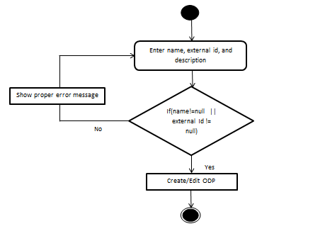

Figure : Add/Edit Operator Defined Product Properties

#### Activate/Inactivate ODP

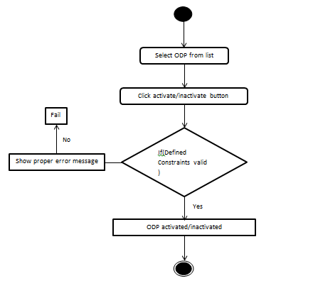

Figure : Activate/Inactivate ODP

#### Delete ODP Item

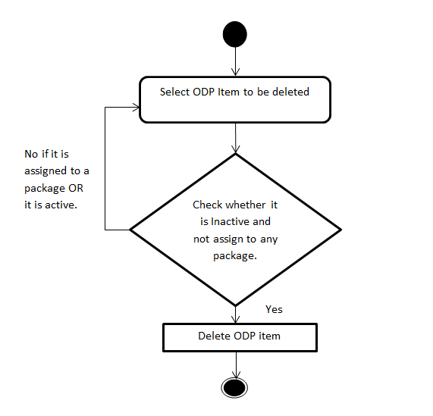

Figure : 5.2.1.4 Delete ODP Item

#### Add/Edit ODP Parameters

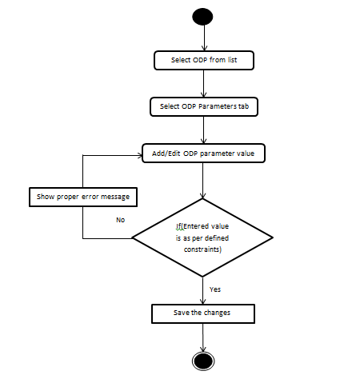

Figure : Add/Edit ODP Parameters

#### ODP Package assignment/unassignment

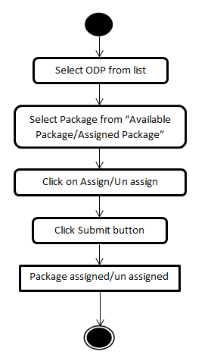

Figure : ODP Package assignment/unassignment

### Sequence Diagram

#### Add ODP Item



Figure : Add ODP Item

#### Edit ODP Item



Figure : Edit ODP Item

#### Delete ODP Item



Figure : Delete ODP Item

#### Activate ODP Item



Figure : Activate ODP Item

#### Inactivate ODP Item



Figure : Inactivate ODP Item

### Business Logic

#### Operator Defined Product Objects

* **com.myrio.tm.products.operatordefinedproducts.util.CODPItemDetailsFeature**

|  |  |  |
| --- | --- | --- |
| ***Creating Attributes*** | ***Attribute Type*** | ***Description*** |
| odptypeid | private CElementNumber | Odp type id |

|  |  |  |
| --- | --- | --- |
| ***Creating Method*** | ***Description*** | ***Exception*** |
| public CElementNumber getOdptypeid() | Returns Odptypeid. | None |
| public void setOdptypeid(CElementNumber odptypeid) | Sets Odptypeid | None |
| public CODPItemDetailsFeature() | Default Constructor | None |

* **com.myrio.tm.products.operatordefinedproducts.util.CCommonODPParametersFeature**

|  |  |  |
| --- | --- | --- |
| ***Creating Attributes*** | ***Attribute Type*** | ***Description*** |
| odpId | private int | It is automatically calculated by TM |
| odpTypeId | private int | It is automatically calculated by TM |
| odpTypeparameterId | private int | It is automatically calculated by TM |
| odpParameterName | private String | Defined by TM admin |
| odpParameterValue | private String | Defined by TM admin |
| obj_ArrayListEnum | private ArrayList | Defined by TM admin |
| odpEnumValue | private String | Defined by TM admin |
| odpDefaultValue | private String | Defined by TM admin |

|  |  |  |
| --- | --- | --- |
| ***Creating Method*** | ***Change Description*** | ***Exception*** |
| public getXXX() | Method to get the attribute values. Should be defined a method for each class attribute. e.g.: getName() | None |
| public setXXX(…) | Method to set the attribute values. Should be defined a method for each class attribute. e.g.: setName(String name) | None |

#### ODP Presentation Layer classes

* **com.myrio.tm.framework.pl.log.CLogHistoryDataManager**

|  |  |  |
| --- | --- | --- |
| ***Existing Method*** | ***Change Description*** | ***Exception*** |
| private Map createRequestData(int iModuleID, String type, String sWhereClause) | Returns all Log History Configuration values from specific resources(iModuleID) in form of Map. | None |

* **com.myrio.tm.framework.pl.resources.tmapplet.properties**

|  |  |
| --- | --- |
| ***Key*** | ***Value*** |
| odp_item_servlet_alias | operatordefinedproducts |

* **com.myrio.tm.products.pl.CProductsResources.java**

|  |  |  |
| --- | --- | --- |
| ***Creating Method*** | ***Change Description*** | ***Exception*** |
| public static CResourceBundle getODPItemResource() | To load resources ODPItem.properties | None |

* **com.myrio.tm.products.pl.resources.WebAccessItems.properties**

|  |  |
| --- | --- |
| ***Key*** | ***Value*** |
| ODP_Tab_Name | Operator Defined Products |

* **com.myrio.tm.products.operatordefinedproducts.pl.resources.ODPItem.properties**



* **com.myrio.tm.products.operatordefinedproducts.pl.CODPItemLogPanel**

|  |  |  |
| --- | --- | --- |
| ***Creating Attributes*** | ***Attribute Type*** | ***Description*** |
| RESOURCES | private CResourceBundle | Resource for ODP |
| componentPanel | private JPanel | componentPanel |
| buttonPanel | private JPanel | buttonPanel |
| createdByLbl | private JLabel | Label createdByLbl |
| lastUpdatedDateLbl | private JLabel | Label lastUpdatedDateLbl |
| lastUpdatedUserIDLbl | private JLabel | Label lastUpdatedDateLbl |
| createdByTxt | private JTextField | TextField createdByTxt |
| lastUpdatedDateTxt | private JTextField | TextField createdByTxt |
| lastUpdatedUserIDTxt | private JTextField | TextField lastUpdatedUserIDTxt |
| okButton | private JButton | okButton |
| cancelButton | private JButton | cancelButton |
| helpButton | private JButton | helpButton |
| cancelAction | private Action | cancelAction |

|  |  |  |
| --- | --- | --- |
| ***Creating Method*** | ***Change Description*** | ***Exception*** |
| public CODPItemLogPanel() | Creates a new CODPItemLogPanel object | None |
| public void display() | Displays Layout of Components | None |
| public Component getFirstComponent() | Returns cancelButton Component | None |
| public void setData(CProductLogFeature log) | Sets the ProductLogFeature | None |

* **com.myrio.tm.products.operatordefinedproducts.pl.CODPItemPropertiesPanel**

|  |  |  |
| --- | --- | --- |
| ***Creating Attributes*** | ***Attribute Type*** | ***Description*** |
| RESOURCES | private CResourceBundle | Resource for ODP |
| documentListener | private CDocumentListener | Document Listener |
| subtypeModifyListener | private CODPItemSubtypeModifiedListener | subtypeModifyListener |
| itemSubTypeButton | private CPLDescriptionCombo | itemSubTypeButton |
| itemTypeButton | private CPLDescriptionCombo | itemTypeButton |
| recordStatusCodeCmb | private CPLDescriptionCombo | recordStatusCodeCmb |
| externalidTxt | private CPLTextField | externalidTxt |
| descTxt | private CPLTextField | Description Text |
| recordStatusCodeLbl | private JLabel | recordStatusCodeLbl |
| externalid | private JLabel | externalid |
| itemSubType | private JLabel | itemSubType |
| itemType | private JLabel | itemType |
| description | private JLabel | description |

|  |  |  |
| --- | --- | --- |
| ***Creating Method*** | ***Change Description*** | ***Exception*** |
| public CODPItemPropertiesPanel() | Constructor | None |
| public Component getFirstComponent() | Returns descTxt Component | None |
| public void display() | Displays Layout of Components | None |
| public void setData(CODPItemDetailsFeature itemDetails,CRecordStatusCodeFeature recordStatusCode) | Sets the Data | None |
| public CODPItemDetailsFeature getData(CODPItemDetailsFeature itemDetails) | Sets the Data | None |
| public CRecordStatusCodeFeature getData(CRecordStatusCodeFeature recordStatusCode) | Returns CRecordStatusCodeFeature | None |
| public void setPermission(String per) | Sets the Permission | None |

|  |  |  |  |
| --- | --- | --- | --- |
| ***InnerClass Creating Method*** | | ***Change Description*** | ***Exception*** |
| CODPItemSubtypeModifiedListener | public void actionPerformed(ActionEvent e) | For every time 'itemSubtype' changes the GUI is refreshed. | None |

* **com.myrio.tm.products.operatordefinedproducts.pl.** **CODPItemsPackageAssignmentPanel**

|  |  |  |
| --- | --- | --- |
| ***Creating Attributes*** | ***Attribute Type*** | ***Description*** |
| RESOURCES | private CResourceBundle | Resource for ODP |
| DEBUG_SWITCH | private static boolean | Debug Switch |
| datamap | HashMap | datamap |
| id | int | Operator Defined Products Id |

|  |  |  |
| --- | --- | --- |
| ***Creating Method*** | ***Change Description*** | ***Exception*** |
| public CODPItemsPackageAssignmentPanel() | Constructor | None |
| public void initialize(int id) | Reset the Hashdatamap | None |
| protected void submitChanges() | Called when the Submit Button is hit | None |
| protected void cancelChanges() | Called when the Cancel Button is hit | None |
| private Iterator getItemIterator(HashMap itemmap) | Custom iterator of itemmap to implement custom sorting order | None |

* **com.myrio.tm.products.operatordefinedproducts.pl.CODPItemTopPanel**

|  |  |  |
| --- | --- | --- |
| ***Creating Attributes*** | ***Attribute Type*** | ***Description*** |
| debug | private static boolean | Resource for ODP |
| ADD_ACTION | public static final int | ADD_ACTION |
| EDIT_ACTION | public static final int | EDIT_ACTION |
| DELETE_ACTION | public static final int | DELETE_ACTION |
| NO_ACTION | public static final int | NO_ACTION |
| RESOURCES | private ResourceBundle | RESOURCES |
| toolBarPanel | private JPanel | ToolBarPanel |
| table | private CODPItemTable | CODPItemTable object |
| defaultItemModel | CEntityModel | DefaultItemModel |
| tpwt | private int[] | Top Panel width |
| tpht | private int[] | Top Panel height |
| toolwt | private int[] | Tool Bar width |
| toolht | private int[] | Tool Bar height |
| WAIT_CURSOR | private static final Cursor | The wait cursor |
| DEFAULT_CURSOR | private static final Cursor | The default cursor |
| addAction | private Action | Get the default content item model |
| deleteAction | private Action | Send a delete request to the server remove the row from the table |
| editAction | private Action | Sets data in the base panel gets the selected data sets name and id |
| activate | private Action | ACTIVATE Action gets the id for the selected line item |
| inactivate | private Action | INACTIVATE Action gets the id for the selected line item |
| showNextItems | private Action | Shows the next page of line items |
| showPrevItems | private Action | Shows the prev page of line items |
| logOff | private Action | Called when Log Off Button is hit |
| action | private int | NO_ACTION |
| refreshTable | private Action | Refreshes the table contents |
| noAction | private Action | Used as a dummy action when the base panel is visible |

|  |  |  |
| --- | --- | --- |
| ***Creating Method*** | ***Change Description*** | ***Exception*** |
| public CODPItemTopPanel() | Constructor | None |
| private void makeLayout() | Displays Layout of Components | None |
| public void jspTablelistener() | JSPTable Listener | None |
| public void refresh() | Called in refreshTable Action refreshes table contents | None |
| public void disableActions() | Disables actions related to a selected line item, viz, EDIT, DELETE, ACTIVATE and INACTIVATE | None |
| public void setPermission(String per) | Sets the Permission | None |
| public CEntityModel getDefaultEntityModel() | Returns DefaultEntityModel | None |
| public Action getNoAction() | Returns noAction | None |
| public int getAction() | Returns action | None |
| public void setAction(int action) | Sets the action | None |
| public JToolBar getToolBar() | Returns ToolBar | None |
| public CODPItemTable getTable() | Returns Table | None |
| public JScrollPane getjspTable() | Returns jspTable ScrollPane | None |
| public Action getAdd() | Returns addAction | None |
| public Action getEdit() | Returns editAction | None |
| public Action getDelete() | Returns deleteAction | None |
| public Action getActivate() | Returns activateAction | None |
| public Action getInactivate() | Returns InactivateAction | None |
| public JPopupMenu getPopup() | Returns PopupMenu | None |

|  |  |  |  |
| --- | --- | --- | --- |
| ***InnerClass Creating Method*** | | ***Change Description*** | ***Exception*** |
| ItemTableMouseListener | public void mousePressed(MouseEvent e) | Called When Mouse Button is Pressed | None |
| ItemTableMouseListener | public void mouseReleased(MouseEvent e) | Called When Mouse Button is Released | None |

* **com.myrio.tm.products.operatordefinedproducts.pl.CODPParametersPanel**

|  |  |  |
| --- | --- | --- |
| ***Creating Attributes*** | ***Attribute Type*** | ***Description*** |
| SUBSCRIBER_RESOURCES | private CResourceBundle | Resource for ODP |
| idComboModel | private DefaultComboBoxModel | ComboBoxModel |
| odpTable | private CCommonODPTable | CCommonODPTable object |
| odpparameterPanel | private JPanel | Odpparameter Panel |
| changeNeedsTracking | private boolean | Flag to specify whether dirty flag |
| odpparameterScrollPane | private JScrollPane | Store the current action. |
| action | private int | Store the current action. |
| permission | private String | permission string |
| w2 | private int[] | Width of component |
| h2 | private int[] | Height of component |
| prevRowSelected | private int | prevRowSelected |
| featureTableRowSelected | private int | featureTableRowSelected |

|  |  |  |
| --- | --- | --- |
| ***Creating Method*** | ***Change Description*** | ***Exception*** |
| public CODPParametersPanel() | Constructor | None |
| public JButton getOK() | Returns the OkButton. | None |
| public void setODPParametersData(CCommonODPParametersFeature odpdefinitionsFeature) | Sets the ODP Parameters Data | None |
| private void makeLayout() | Displays Layout of Components | None |
| public void setHelpId(String helpId) | Associate the helpID with the help action. | None |
| public void loadTableData() | Load ODP Parameters Table Data | None |
| public ArrayList getODPParametersData () | Returns ODP Parameters Data | None |
| public void loadTableData(int subscriberId) | Load ODP Parameters Table Data | None |
| public void setPermissions(String permission) | Disabling Components if the user has "read only" or "delete" permissions | None |

* **com.myrio.tm.products.operatordefinedproducts.pl.CODPItemModule**

|  |  |  |
| --- | --- | --- |
| ***Creating Attributes*** | ***Attribute Type*** | ***Description*** |
| debug | private static boolean | Debug |
| odpItemModule | private static CODPItemModule | Odp Item Module |
| RESOURCES | private CResourceBundle | Resource for ODP |
| modulePermission | private String | Module Permission |
| itemDataCopy | private CEntityModel | Item DataCopy |
| dataManager | private CODPItemDataManager | Data Manager |
| emptyPanel | private JPanel | Empty Panel |
| detailsPanel | private CODPItemPropertiesPanel | Details Panel |
| parameterPanel | private CODPParametersPanel | Parameter Panel |
| pkgPanel | private CODPItemsPackageAssignmentPanel | Pkg Panel |
| logPanel | private CODPItemLogPanel | Log Panel |
| buttonPanel | private JPanel | Button Panel |
| idNamePanel | private JPanel | Id Name Panel |
| bottomPanel | private JPanel | Bottom Panel |
| parameterbuttonPanel | private JPanel | Parameter buttonPanel |
| topPanel | private CODPItemTopPanel | Top Panel |
| h | private int[] | Hieght Dimension |
| w | private int[] | Width Dimension |
| idnw | private int[] | ID Panel Width |
| idnh | private int[] | ID Panel Hieght |
| bpw | private int[] | Buttom Panel width |
| bph | private int[] | Buttom Panel Height |
| itemDetailPanel | private JPanel | Item DetailPanel |
| itemParameterDetailPanel | private JPanel | Item Parameter DetailPanel |
| modifyListener | private CDocumentListener | Modify Listener |
| previousSelectedTab | private int | Previous Selected Tab |
| isBasePanelVisible | private boolean | Is BasePanelVisible |
| obj_CLogHistoryPanel | private CLogHistoryPanel | Object CLogHistoryPanel |
| obj_JPanelTemp | private JPanel | Obj JPanelTemp |
| keyStroke | private KeyStroke | Key Stroke |
| okAction | private Action | Called when submit is clicked |
| cancelAction | private Action | Called when cancel is pressed |

|  |  |  |
| --- | --- | --- |
| ***Creating Method*** | ***Change Description*** | ***Exception*** |
| private CODPItemModule() | Constructor | None |
| public static CODPItemModule getInstance() | Returns CODPItemModule Instance | None |
| public static CODPItemModule refreshInstance() | Returns Refresh Instance of CODPItemModule Instance | None |
| public void initBottomPanel() | Inits the base panel adds log panel only in the edit mode adds tab change listener to the tab pane in base panel | None |
| public void resetOldData() | Resets data in the base panel | None |
| private void addTabChangeListener() | Tab Change Listener Changes the tab | None |
| private void makeLayout() | Displays Layout of Components | None |
| public void makeBasePanelVisible(boolean visible) | Makes the base panel visible/invisible | None |
| public void setData(CEntityModel itemModel) | Sets the Data | None |
| public CEntityModel getData(CEntityModel defaultEntityModel) | Returns Data | None |
| public CEntityModel makeCopyOfEntityModel(CEntityModel oldModel) | Make a copy of the specified entity model. | None |
| public void doCancel() | Called when the Cancel Button is hit | None |
| private void performUpdate() | Called when the submit button is pressed and in EDIT mode | None |
| public void setIDNameLabel(String idStr, String nameStr) | Sets the ID,Name Field | None |
| public CODPItemTopPanel getTopPanel() | Returns CODPItemTopPanel | None |
| public void setPermissions(String permission) | Sets the Permissions | None |
| private void setHelpId(String helpId) | Sets the Help Id | None |
| private void setparameterHelpId(String helpId) | Sets the Parameter Help Id | None |
| public boolean getBasePanelVisibleFlag() | Returns isBasePanelVisible | None |
| private void showLogPanel() | Show Log History Panel | None |
| protected boolean validatexternalid(CEntityModel itemData) | Validates ExternalID | None |

* **com.myrio.tm.products.operatordefinedproducts.pl.CCommonODPTable**

|  |  |  |
| --- | --- | --- |
| ***Creating Attributes*** | ***Attribute Type*** | ***Description*** |
| SUBSCRIBER_RESOURCES | private ResourceBundle | ODP Resource |
| model | CCommonODPTableModel | Obj CCommonODPTableModel |
| obj_JPasswordFieldConceal | JPasswordField | Obj JPasswordFieldConceal |
| obj_IDERowEditorModel | RowEditorModel | Obj IDERowEditorModel |
| obj_RowRendererModel | RowRendererModel | Obj RowRendererModel |
| odpActionListener | private CODPActionListener | ODP ActionListener for dirty bit |
| odpDocumentListener | private CODPDocumentListener | ODP DocumentListener for dirty bit |

|  |  |  |
| --- | --- | --- |
| ***Creating Method*** | ***Change Description*** | ***Exception*** |
| public CCommonODPTable() | Constructor | None |
| private void settings() | Render Table Model | None |
| public CCommonODPParametersFeature getValueAtRow(int iRow) | Returns Value At Row | None |
| public String getToolTipText(MouseEvent me) | Returns Tool Tip Text | None |
| public void stopCellEditing() | Stop Cell Editing | None |
| public void setRowEditorModel(RowEditorModel obj_IDERowEditorModel) | Sets the Row Editor Model | None |
| public RowRendererModel getRowRendererModel() | For getting Row editormodel | None |
| public void setRowRendererModel(RowRendererModel obj_RowRendererModel) | Sets the Row Renderer Model | None |
| public RowEditorModel getRowEditorModel() | For getting Row editormodel | None |
| public TableCellEditor getCellEditor(int row, int col) | Returns Table Cell Editor | None |
| public TableCellRenderer getCellRenderer(int row, int col) | Returns Cell Renderer | None |
| public CCommonODPParametersFeature getRowData(int iRow) | Returns Row Data | None |
| public ArrayList getData() | Returns Data | None |
| public void setData(ArrayList obj_ArrayList) | Sets the Data | None |

|  |  |  |  |
| --- | --- | --- | --- |
| ***InnerClass Creating Attributes*** | | ***Attribute Type*** | ***Description*** |
| CCommonODPTableModel | data | private ArrayList | Data |
| CCommonODPTableModel | obj_CPLCommonODPTable | CCommonODPTable | Object CPLCommonODPTable |
| CCommonODPTableModel | colNames | String[] | Col Names |
| RowRendererModel | obj_Hashtable | private Hashtable | Object Hashtable |

|  |  |  |  |
| --- | --- | --- | --- |
| ***innerClass Creating Method*** | | ***Change Description*** | ***Exception*** |
| CCommonODPTableModel | public CCommonODPTableModel(CCommonODPTable obj_CPLCommonODPTable) | Constructor | None |
| CCommonODPTableModel | public int getRowCount() | Returns Row Count | None |
| CCommonODPTableModel | public int getColumnCount() | Returns Column Count | None |
| CCommonODPTableModel | public String getColumnName(int col) | Returns Column Name | None |
| CCommonODPTableModel | public CCommonODPParametersFeature getRowData(int iRow) | Returns Row Data | None |
| CCommonODPTableModel | public Object getValueAt(int row, int col) | Returns ValueAt | None |
| CCommonODPTableModel | public void setValueAt(Object o, int row, int col) | Sets the Value At | None |
| CCommonODPTableModel | public boolean isCellEditable(int row, int col) | Returns Is CellEditable | None |
| CCommonODPTableModel | public ArrayList getData() | Returns Data | None |
| CCommonODPTableModel | public void setData(ArrayList obj_ArrayList) | Sets the Data | None |
| RowRendererModel | public RowRendererModel() | Constructor | None |
| RowRendererModel | public void addRendererForRow(int iRow, TableCellRenderer obj_TableCellRenderer) | For Addition of Renderer to Row | None |
| RowRendererModel | public void removeRendererForRow(int iRow) | For Removing of Renderer to Row | None |
| RowRendererModel | public TableCellRenderer getRenderer(int iRow) | To get Editor | None |
| RowRendererModel | public void resetEditorHashTable() | To reset Editor | None |

* **com.myrio.tm.products.operatordefinedproducts.pl.CODPItemTable**

|  |  |  |
| --- | --- | --- |
| ***Creating Attributes*** | ***Attribute Type*** | ***Description*** |
| debug | private static boolean | debug |
| RESOURCES | private static ResourceBundle | ODP resource |
| lastSelectedRow | private int | lastSelectedRow |
| rowListener | private RowSelectionChangeListener | Row Listener |

|  |  |  |
| --- | --- | --- |
| ***Creating Method*** | ***Change Description*** | ***Exception*** |
| public CODPItemTable() | Constructor | None |
| public void settings() | Render Setting of ODP Item Model | None |
| public void feedData() | Called in refreshTable Action of Top Panel gets all the data from server and sdisplays in the table | None |
| public Object getSelectedItemData() | Returns a cached copy of CEntityModel of the selected item in a table | None |
| public void removeRow() | Deletes the selected row from the table and disables the relevant actions in the  top panel tool bar (add,edit,activate and inactivate) | None |
| public void addNewRow(CEntityModel data) | Adds a new row to table also disables the relevant actions in the top panel tool  bar (add,edit,activate and inactivate) | None |
| public void updateRow(CEntityModel data) | Updates the selected row in the table | None |
| public void updateRows() | Deselects all the rows in the table | None |
| public void setSelectedRow(int id) | Sets the row selection in table to the row corr to the given id | None |
| private CPLODPItemModel getODPItemModel() | Convenience method to return a properly typed reference to the data model. | None |
| private void setDataInBasePanel() | Sets data in the base panel gets the selected data sets name and id in the base  panel sets the mode to EDIT mode shows the base panel and finally sets the data in  base panel | None |

|  |  |  |  |
| --- | --- | --- | --- |
| ***InnerClass Creating Attributes*** | | ***Attribute Type*** | ***Description*** |
| CPLODPItemModel | colNames | String[] | Col Names |
| CPLODPItemModel | data | private List<CEntityModel> | Data |

|  |  |  |  |
| --- | --- | --- | --- |
| ***InnerClass Creating Method*** | | ***Change Description*** | ***Exception*** |
| TableMouseClickListener | public void mouseClicked(MouseEvent e) | Sets Data in the base Panel | None |
| RowSelectionChangeListener | public void valueChanged(ListSelectionEvent e) | The sequence of actions take place only when the table has focus | None |
| CPLODPItemModel | public CPLODPItemModel() | Constructor | None |
| CPLODPItemModel | public void feedData() | To Feed Data Table Model | None |
| CPLODPItemModel | public List<CEntityModel> getItemData() | Returns Item Data | None |
| CPLODPItemModel | public int getRowCount() | Returns Row Count | None |
| CPLODPItemModel | public int getColumnCount() | Returns Column Count | None |
| CPLODPItemModel | public String getColumnName(int col) | Returns Column Name | None |
| CPLODPItemModel | public Object getValueAt(int row, int col) | Returns Value At | None |
| CPLODPItemModel | public Class<?> getColumnClass(int col) | Returns Value At | None |
| CPLODPItemModel | public void setValueAt(Object o, int row, int col) | Sets the Value At | None |
| CPLODPItemModel | public boolean isCellEditable(int row, int col) | Returns Is Cell Editable | None |

* **com.myrio.tm.products.operatordefinedproducts.pl.CODPActionListener**

|  |  |  |
| --- | --- | --- |
| ***Creating Method*** | ***Change Description*** | ***Exception*** |
| public CODPActionListener() | Constructor | None |
| public void actionPerformed(ActionEvent e) | The callback method which would be called when ever the component to which this listener is attached has some action performed on it | None |

* **com.myrio.tm.products.operatordefinedproducts.pl.CODPDocumentListener**

|  |  |  |
| --- | --- | --- |
| ***Creating Method*** | ***Change Description*** | ***Exception*** |
| public CODPDocumentListener() | Constructor | None |
| public void changedUpdate(DocumentEvent e) | When contents change set dirty bit flag true | None |
| public void removeUpdate(DocumentEvent e) | When contents are removed set dirty bit flag true | None |
| public void insertUpdate(DocumentEvent e) | When contents are inserted set dirty bit flag true | None |

* **com.myrio.tm.products.operatordefinedproducts.pl.CODPItemDataManager**

|  |  |  |
| --- | --- | --- |
| ***Creating Attributes*** | ***Attribute Type*** | ***Description*** |
| dataManager | private static CODPItemDataManager | Data Manager |
| debug | private static boolean | debug |
| RESOURCES | private ResourceBundle | RESOURCES |
| recordStatusCode | private HashMap | Record StatusCode |
| itemSubType | private HashMap | Item SubType |

|  |  |  |
| --- | --- | --- |
| ***Creating Method*** | ***Change Description*** | ***Exception*** |
| public CODPItemDataManager() | Constructor | None |
| public static CODPItemDataManager getInstance() | Returns Instance of CODPItemDataManager | None |
| public HashMap getAllODPTypes() | Returns a cached copy of item subtypes | None |
| public HashMap getRecordData() | Returns a cached copy of record status codes | None |
| protected URLConnection getGetConnection(int opCode) | Returns an HTTP GET connection with the given OpCode | IOException |
| protected URLConnection getPostConnection(int opCode) | Returns an HTTP POST connection with the given OpCode | IOException |
| public List<CEntityModel> getAllODPItems() | Get a ODPItemsDefault values | CPLException |
| public CEntityModel getDefaultEntityModel() | Get a ODPItemsDefault values | CPLException |
| public CEntityModel insert(CEntityModel itemModel) | Insert ODP Items | CPLException |
| public CEntityModel update(CEntityModel itemModel) | Update ODPItems | CPLException |
| public CEntityModel get(int id) | Get a ODPItem | CPLException |
| public void delete(int id) | Delete ODP Item | CPLException |
| public HashMap loadODPTypes() | Load All ODP Types | CPLException |
| public HashMap loadRecordStatusCode() | Load Record Status of ODP Item | CPLException |
| public void activate(int id) | Activate an ODP Item | CPLException |
| public void inactivate(int id) | InActivate an ODP Item | CPLException |
| public HashMap getAssignedPackages(int id) | Get Assigned Packages of an Odp Item | CPLException |
| public HashMap getUnassignedPackages(int id) | Get Assigned Packages of an Odp Item | CPLException |
| public void updateAssignedPackages(int id, HashMap packageMap) | Update Assigned Packages of an Odp Item | CPLException |

#### ODP Servlet

* **com.myrio.tm.products.operatordefinedproducts.servlet.resources.odpitemservlet.properties**

|  |  |
| --- | --- |
| ***Key*** | ***Value*** |
| DB_LOAD_FAILED | Failed to Load data from Operator Defined Product Item Domain Tables |
| DB_CREATE_FAILED | Failed to Create Operator Defined Product Item |
| DB_FIND_FAILED | Failed to Find Operator Defined Product Item |
| DB_FIND_ALL_FAILED | Failed to Fetch all Operator Defined Product Items |
| DB_ALREADY_DELETED | The Operator Defined Product Item has already been deleted |
| DB_GET_FAILED | Failed to get Operator Defined Product Item |
| DB_CONCURRENT_UPDATE | Concurrent Update Exception: The Operator Defined Product Item has already been updated |
| DB_DELETE_FAILED_ITEM_ASSIGNED | Failed to delete the Operator Defined Product Item: item already assigned to package |
| Exception_Code_Length | 6 |
| AL_NAME_REQUIRED | Name is a mandatory field |
| AL_DESCRIPTION_REQUIRED | Description is a mandatory field |
| AL_ITEM_TYPE_REQUIRED | Item Type is a mandatory field |
| AL_ITEM_SUBTYPE_REQUIRED | Item Subtype is a mandatory field |
| AL_EXTERNAL_ID_REQUIRED | External ID is a mandatory field |
| AL_RECORD_STATUS_REQUIRED | Record Status a mandatory field |
| AL_INSERT_FAILED | Failed to create Operator Defined Product Item |
| AL_UPDATE_FAILED | Failed to update Operator Defined Product Item |
| AL_ALREADY_DELETED | The Operator Defined Product Item has already been deleted |
| AL_GET_FAILED | Failed to get Operator Defined Product Item |
| AL_DELETE_FAILED | Failed to delete Operator Defined Product Item |
| AL_CANNOT_DELETE_ACTIVE | The item is still active and cannot be deleted |
| AL_CANNOT_DELETE_ASSIGNED | The item is still assigned to packages and cannot be deleted |
| AL_FIND_ALL_FAILED | Failed to fetch all Operator Defined Product Items |
| AL_ACTIVATE_FAILED | Failed to activate Operator Defined Product Item |
| AL_ITEM_ALREADY_ACTIVE | The Item has already been activated |
| AL_DEACTIVATE_FAILED | Failed to inactivate Operator Defined Product Item |
| AL_ITEM_IS_ASSIGNED | The Item has already assigned to a package and cannot be inactivated |
| AL_ITEM_ALREADY_DEACTIVATED | The Item has already been inactivated |
| AL_FIND_ACTIVE_FAILED | Failed to fetch active Operator Defined Product Items |
| Operation_Failed | Operation Failed |

* **com.myrio.tm.products.operatordefinedproducts.servlet.IODPItemServletConstants**

|  |  |  |
| --- | --- | --- |
| ***Creating Attributes*** | ***Attribute Type*** | ***Value*** |
| ODP_SERVLET_RESOURCES | ResourceBundle |  |
| GET_ALL_OPERATOR_DEFINED_PRODUCTS_ITEMS_OPCODE | Int | 80 |
| GET_DEFAULT_OPERATOR_DEFINED_PRODUCTS_ITEM_OPCODE | Int | 81 |
| INSERT_OPERATOR_DEFINED_PRODUCTS_ITEM_OPCODE | Int | 82 |
| UPDATE_OPERATOR_DEFINED_PRODUCTS_ITEM_OPCODE | Int | 83 |
| DELETE_OPERATOR_DEFINED_PRODUCTS_ITEM_OPCODE | Int | 84 |
| GET_OPERATOR_DEFINED_PRODUCTS_ITEM_OPCODE | Int | 85 |
| LOAD_ITEM_TYPES_OPCODE | Int | 86 |
| LOAD_ITEM_SUB_TYPES_OPCODE | int | 87 |
| LOAD_RECORDSTATUS_CODES_OPCODE | int | 90 |
| ACTIVATE_OPERATOR_DEFINED_PRODUCTS_ITEM_OPCODE | Int | 93 |
| INACTIVATE_ODP_ITEM_OPCODE | Int | 94 |
| GET_OPERATOR_DEFINED_PRODUCTS_ITEMS_ASSIGNED_PACKAGES | Int | 96 |
| GET_OPERATOR_DEFINED_PRODUCTS_ITEMS_UNASSIGNED_PACKAGES | Int | 97 |
| UPDATED_ODP_ITEMS_ASSIGNED_PACKAGES | int | 98 |

* **com.myrio.tm.products.operatordefinedproducts.servlet.CODPItemServlet**

|  |  |  |
| --- | --- | --- |
| ***Creating Attributes*** | ***Attribute Type*** | ***Description*** |
| logger | private static Log | Object of Log class |
| RESOURCES | private static final ResourceBundle | ODP servlet resource |
| odpItemRemote | private IODPItemSessionRemote | CODPItemSessionBean interface |
| odpItemDescRemote | private IODPItemDescriptionRemote | CODPItemDescriptionSessionBean interface |
| systemDescRemote | private ISystemDescriptionRemote | CSystemDescriptionSessionBean interface |

|  |  |  |
| --- | --- | --- |
| ***Creating Method*** | ***Change Description*** | ***Exception*** |
| public void init(ServletConfig config) | Initialize the servlet | ServletException |
| public void service(HttpServletRequest request, HttpServletResponse response) | Service the HTTP request. | ServletException, IOException |

#### ODP Application Layer classes

* **com.myrio.tm.products.operatordefinedproducts.al.** **CODPItemDescriptionSessionBean**

|  |  |  |
| --- | --- | --- |
| ***Creating Attributes*** | ***Attribute Type*** | ***Description*** |
| logger | private static Log | Object of Log class |
| ctx | private SessionContext | Store the session context associated with the Session beanss |

|  |  |  |
| --- | --- | --- |
| ***Creating Method*** | ***Change Description*** | ***Exception*** |
| public void setSessionContext(SessionContext context) | Sets the SessionContext for the bean | None |
| public void ejbActivate() | Called by the container on bean activation | None |
| public void ejbPassivate() | Called by the container on bean passivation | None |
| public void ejbRemove() | Called by the container while removing the bean free the resources. | None |
| public void ejbCreate() | Called by the container. initializes the bean | CreateException |
| public CEntityModel getDefaultODPItemModel() | The DefaultODPItemModel is loaded from the CODPItemDAO | CException |
| public void validate(CEntityModel itemModel) | The DefaultODPItemModel is loaded from the CODPItemDAO | CMandatoryFieldNotFoundException, CException |

* **com.myrio.tm.products.operatordefinedproducts.al.CODPItemSessionBean**

|  |  |  |
| --- | --- | --- |
| ***Creating Attributes*** | ***Attribute Type*** | ***Description*** |
| logger | private static Log | Object of Log class |
| ctx | private SessionContext | Store the session context associated with the Session beanss |
| ITEM_UNIQUE_KEY_NAME | private static final String | ITEM UNIQUE KEY NAME |

|  |  |  |
| --- | --- | --- |
| ***Creating Method*** | ***Change Description*** | ***Exception*** |
| public void setSessionContext(SessionContext context) | Called by the container and sets the session context for the bean. | None |
| public void ejbActivate() | Called by the container while Activating the Session bean. | None |
| public void ejbPassivate() | Called by the container while passivating the bean | None |
| public void ejbRemove() | Called by the container while removing the bean | None |
| public void ejbCreate() | Called by the container when the bean is created | None |
| public CEntityModel insert(CEntityModel odpItemModel) | Inserts a new ODP item into persistent storage. | CException |
| public CEntityModel update(CEntityModel odpItemModel) | Updates a ODPItem | CException |
| public CEntityModel get(int id) | Gets the Operator Defined Product Item associated with the specified ID from the persistent storage | CException |
| public void delete(int id, String userId) | Delete of a Operator Defined Product Item. | CException |
| public List<CEntityModel> getAllODPItems() | Gets all the Operator Defined Product items from the Entity Bean and packs it as an ArrayList and sends it back to the client. | CException |
| public HashMap loadODPtypes() | HashMap of representing all the ODPItems types. | CException |
| public void activate(int id, String userId) | Activates a Operator Defined Product Item | CException |
| public void inactivate(int id, String userId) | Inactivates an ODPItem. | CException |
| public HashMap getAssignedPackages(int id) | Gets the list of packages that this ODP Item has been assigned | CException |
| public HashMap getUnassignedPackages(int id) | Gets the list of packages that this ODP Item is NOT assigned | CException |
| public void updateAssignedPackages(int id, HashMap updatePackageMap) | Update the packages that this ODP Item is assigned to. (including add or delete) | CException |
| private int getNextItemId() | Generate the unique item Id | SQLException |

* **com.myrio.tm.products.operatordefinedproducts.al.IODPItemDescriptionHome**

|  |  |  |
| --- | --- | --- |
| ***Creating Method*** | ***Change Description*** | ***Exception*** |
| IODPItemDescriptionRemote create() | Creates the Session Bean and returns a remote interface of the bean instance | CreateException, RemoteException |

* **com.myrio.tm.products.operatordefinedproducts.al.IODPItemDescriptionRemote**

|  |  |  |
| --- | --- | --- |
| ***Creating Method*** | ***Change Description*** | ***Exception*** |
| void validate(CEntityModel itemModel) | Validates entity data according to the configured mandatory fields. | CMandatoryFieldNotFoundException,  CException,  RemoteException |
| CEntityModel getDefaultODPItemModel() | Returns the Default CODPItem model | RemoteException, CException |

* **com.myrio.tm.products.operatordefinedproducts.al.IODPItemSessionHome**

|  |  |  |
| --- | --- | --- |
| ***Creating Method*** | ***Change Description*** | ***Exception*** |
| IODPItemSessionRemote create() | Creates an instance of the CODPItemSessionBean | CreateException, RemoteException |

* **com.myrio.tm.products.operatordefinedproducts.al.IODPItemSessionRemote**

|  |  |  |
| --- | --- | --- |
| ***Creating Method*** | ***Change Description*** | ***Exception*** |
| void activate(int id, String userId) | Activates an ODPItem. | RemoteException, CException |
| void inactivate(int id, String userId) | Deactivates an ODPItem. | RemoteException, CExceptions |
| List<CEntityModel> getAllODPItems() | Returns a list of all the ODPItems in the system. | RemoteException, CException |
| HashMap loadODPtypes() | Returns a list of Sub types in the system. | RemoteException, CException |
| void delete(int id, String userId) | Delete a ODP Item. | RemoteException, CException |
| CEntityModel get(int id) | Returns the ODPItems corresponding to the specified ID. | RemoteException, CException |
| CEntityModel update(CEntityModel itemModel) | Updates a ODPItems, after validating the specified update data. | RemoteException, CException |
| CEntityModel insert(CEntityModel itemModel) | Creates a new ODPItems, after validating the specified data. Any validation errors  are contained in an exception object. | RemoteException, CException |
| HashMap getAssignedPackages(int id) | Gets the list of assigned packages by Id | RemoteException, CException |
| HashMap getUnassignedPackages(int id) | Gets the list of unssassigned packages by Id | RemoteException, CException |
| void updateAssignedPackages(int id, HashMap updatePackageMap) | Update the packages that this ODP Item is assigned to. (including add or delete) | RemoteException, CException |

#### Objects to lock

None.

#### Exceptions

None.

#### Error messages

|  |  |
| --- | --- |
| ***No.*** | ***Error Message*** |
| 1 | Failed to Load data from Operator Defined Product Item Domain Tables |
| 2 | Failed to Create Operator Defined Product Item |
| 3 | Failed to Find Operator Defined Product Item |
| 4 | Failed to Fetch all Operator Defined Product Items |
| 5 | Concurrent Update Exception: The Operator Defined Product Item has already been updated |
| 6 | Failed to delete the Operator Defined Product Item: item already assigned to package |
| 7 | Cannot delete this ODP type. |
| 8 | Cannot edit this ODP type, it is associated with active Operator Defined Product. |
| 9 | Cannot delete this ODP type parameter. |
| 10 | Name is a mandatory field |
| 11 | Failed to create Operator Defined Product Item |
| 12 | Failed to update Operator Defined Product Item |
| 13 | Failed to inactivate Operator Defined Product Item |
| 14 | Failed to activate Operator Defined Product Item |
| 15 | The item is still assigned to packages and cannot be deleted |
| 16 | The item is still active and cannot be deleted |
| 17 | Failed to delete Operator Defined Product Item |
| 18 | Failed to get Operator Defined Product Item |
| 19 | Operation Failed |
| 20 | External ID cannot be left blank.Do you want to Autogenerate |

#### ODP Database Layer

* **com.myrio.tm.framework.dba.resources.ServiceLocator-jboss.properties**

|  |  |
| --- | --- |
| ***Key*** | ***Value*** |
| odp_item_entity_name | com.myrio.tm.products.operatordefinedproducts.dba.CODPItemEntityBean |
| odp_description_name | com.myrio.tm.products.operatordefinedproducts.al.CODPItemDescriptionSessionBean |
| odp_session_name | com.myrio.tm.products.operatordefinedproducts.al.CODPItemSessionBean |

* **com.myrio.tm.framework.dba.resources.ServiceLocator.properties**

|  |  |
| --- | --- |
| ***Key*** | ***Value*** |
| odp_item_entity_name | com.myrio.tm.products.operatordefinedproducts.dba.CODPItemEntityBean |
| odp_description_name | com.myrio.tm.products.operatordefinedproducts.al.CODPItemDescriptionSessionBean |
| odp_session_name | com.myrio.tm.products.operatordefinedproducts.al.CODPItemSessionBean |

* **com.myrio.tm.framework.dba.CServiceLocator**

|  |  |  |
| --- | --- | --- |
| ***Creating Attributes*** | ***Attribute Type*** | ***Value*** |
| ODP_ITEM_ENTITY_CLASS | static final Class | IODPItemHome.class |
| ODP_ITEM_ENTITY_NAME | static final String |  |
| ODP_DESCRIPTION_CLASS | static final Class | IODPItemDescriptionHome.class |
| ODP_DESCRIPTION_NAME | static final String |  |
| ODP_SESSION_CLASS | static final Class | IODPItemSessionHome.class |
| ODP_ITEM_SESSION_NAME | static final String |  |

|  |  |  |
| --- | --- | --- |
| ***Existing Method*** | ***Change Description*** | ***Exception*** |
| private static Class getServiceClass(int service) | Returns the Class for the required service | None |
| public static String getServiceName(int service) | Returns the JNDI name for the required service | None |

* **com.myrio.tm.framework.dba.CServiceLocator.java$services**

|  |  |  |
| --- | --- | --- |
| ***Creating Attributes*** | ***Attribute Type*** | ***Value*** |
| ODP_ITEM_DESCRIPTION | public static final int | 123 |
| ODP_ITEM | public static final int | 124 |
| ODP_ITEM_SESSION | public static final int | 125 |

* **com.myrio.tm.products.operatordefinedproducts.dba.IODPItemHome**

|  |  |  |
| --- | --- | --- |
| ***Creating Method*** | ***Change Description*** | ***Exception*** |
| IODPItemRemote create(CEntityModel odpItemModel) | Creates a new Operator Defined Products Item and inserts the new data in the DataBase. | CreateException, RemoteException |
| IODPItemRemote findByPrimaryKey(CODPItemEntityPK pk) | Checks if the given primary key is there in the database. | FinderException,  RemoteException |
| List<CODPItemEntityPK> findAllODPItems() | Returns an Enumeration of all Operator Defined Products Items which are not deleted. | RemoteException, FinderException |

* **com.myrio.tm.products.operatordefinedproducts.dba.IODPItemRemote**

|  |  |  |
| --- | --- | --- |
| ***Creating Method*** | ***Change Description*** | ***Exception*** |
| CEntityModel get() | Returns the CEntityModel of the Bean if its record status is not marked as Deleted | RemoteException, CException |
| void put(CEntityModel odpItemModel) | Called on Updation by the sessionbean. | RemoteException, CException |

* **com.myrio.tm.products.operatordefinedproducts.dba.CODPItemDAO**

|  |  |  |
| --- | --- | --- |
| ***Creating Attributes*** | ***Attribute Type*** | ***Description*** |
| contextIDMap | private static Map<String, Integer> | contextIDMap |
| defaultModel | private static CEntityModel | defaultModel |
| mandatoryFlagMap | private static Map<Integer, Integer> | mandatoryFlagMap |
| logger | private static Log | Log Object |

|  |  |  |
| --- | --- | --- |
| ***Creating Method*** | ***Change Description*** | ***Exception*** |
| private CODPItemDAO() | Constructor | None |
| public static CODPItemDAO getInstance() | Returns Instance of CODPItemDAO | None |
| public static synchronized CEntityModel getDefaultModel() | Interface for the client returns the CEntityModel for Operator Defined ProductItem. | CException |
| private static CEntityModel loadDefaultModel() | Loads the Default Operator Defined ProductItem Model | CException |
| private static CEntityModel loadModelFromRS(ResultSet rs, CEntityModel odpItemModel) | Load a Operator Defined Product item properties feature from the current row in the specified result set. The caller is responsible  for closing the result set after calling this method. | SQLException,  CExceptions |
| static void update(CEntityModel odpItemModel) | Perform an SQL update of a Operator Defined ProductItem item entity model. | CException |
| public static void delete(CEntityModel odpItemModel) | Perform an SQL delete of a Operator Defined Product Item entity model. | CException |
| static CEntityModel loadFromID(int id, CEntityModel odpItemModel) | Load a Operator Defined Product item entity model for the specified ID into the specified entity modle object. | CException |
| static CEntityModel insert(CEntityModel odpItemModel) | Insert a Operator Defined ProductItem record into the database, using the values specified in the supplied entity model object. | CException |
| static boolean exists(int id) | Return a flag indicating whether the a Operator Defined ProductItem record exists in the database for the specified ID. | CException |
| static public int getODPItemByName(String name) | Return a flag indicating whether the a Operator Defined ProductItem record exists in the database for the specified names. | CException |
| static List<CODPItemEntityPK> queryAllPrimaryKeys() | Return an list of all the Operator Defined Products IDs (except those marked for delete). | CException |
| private static boolean queryAssignedPackageCount(int codpItemID) | Returns a count of packages to which the Operator Defined Product associated identified by the specified ID is assigned. | CException |
| public static void validatePackagesAssignedSignal(CEntityModel entityModel) | Checks if there are packages assigned | CException |
| public static HashMap loadODPtypes() | Return all ODP types | CException |
| private void deleteODPParameters(int odpid) throws CException | Perform an SQL delete of a Operator Defined Product Parameters. | CException |
| public boolean validateODPAsPerRules(ArrayList obj_ArrayListODP) | Perform validation of parameter as per defined constraint rule | UDFException |
| private boolean validateODPAsPerRules(int iODPID, String sValue,int iODPParamID) | Perform validation of parameter as per defined constraint rule | UDFException, CException |

* **com.myrio.tm.products.operatordefinedproducts.dba.CODPItemEntityBean**

|  |  |  |
| --- | --- | --- |
| ***Creating Attributes*** | ***Attribute Type*** | ***Description*** |
| logger | private static Log | Log class object |
| ctx | private EntityContext | EntityContext Object |
| arePropertiesModified | private boolean | arePropertiesModified |

|  |  |  |
| --- | --- | --- |
| ***Creating Method*** | ***Change Description*** | ***Exception*** |
| public CODPItemEntityBean() | Constructor | None |
| public void setEntityContext(EntityContext context) | Sets the EntityContext of the bean. | None |
| public void unsetEntityContext() | Unsets the EntityContext of the bean. | None |
| public void ejbActivate() | Called when Bean is Activated . | None |
| public void ejbPassivate() | Called when Bean is Passivated . | None |
| public void ejbRemove() | Called when Bean is deleted. | None |
| public void ejbStore() | Stores the data from Entitybean to DB | None |
| public void ejbLoad() | loads the data from the database to the bean . | None |
| public CODPItemEntityPK ejbCreate(CEntityModel odpItemModel) | Creates a new Operator Defined Products Item and inserts the new data in the database . | CreateException |
| public void ejbPostCreate(CEntityModel odpItem) | Creates a new Operator Defined Products Item | CreateException |
| public CODPItemEntityPK ejbFindByPrimaryKey(CODPItemEntityPK pk) | Checks if the given primary key is there in the database. | FinderException |
| public List<CODPItemEntityPK> ejbFindAllODPItems() | Returns a list of all Operator Defined Products Items. | FinderException |
| public CEntityModel get() | Returns the CEntityModel of the Bean if its record status is not marked as Deleted  . Sets the signals for the EntityModel. | CExceptions |
| public void put(CEntityModel odpItemModel) | Called from Update of the sessionbean. Updates some data in the DB , but only when  the timestamp of the coming data is more then the lastupdate time of the datarow  represented by the bean. | CException |
| private CProductPropertiesFeature getProductProperties() | Return a properly typed reference to the product properties feature | None |

* **com.myrio.tm.products.operatordefinedproducts.dba.CODPItemEntityPK**

|  |  |  |
| --- | --- | --- |
| ***Creating Attributes*** | ***Attribute Type*** | ***Description*** |
| id | private int | Operator Defined ProductItems id |

|  |  |  |
| --- | --- | --- |
| ***Creating Method*** | ***Change Description*** | ***Exception*** |
| public CODPItemEntityPK() | Constructor | None |
| public CODPItemEntityPK(int id) | Constructor | None |
| public int getId() | Returns id | None |
| public void setId(int id) | Sets the id | None |
| public int hashCode() | Return the hash code | None |
| public boolean equals(Object object) | Check if two CODPItemEntityPK are equals | None |

#### Framework Layer

* **tm.etc.totalmanage.web.xml**

|  |
| --- |
| ***ADD TAG*** |
| <ejb-ref>  <ejb-ref- name> com.myrio.tm.products.operatordefinedproducts.al.CODPItemDescriptionSessionBean  </ejb-ref-name>  <ejb-ref-type>Session</ejb-ref-type>  <home>  com.myrio.tm.products.operatordefinedproducts.al.IODPItemDescriptionHome  </home>  <remote>  com.myrio.tm.products.operatordefinedproducts.al.IODPItemDescriptionRemote  </remote>  <ejb- link> com.myrio.tm.products.operatordefinedproducts.al.CODPItemDescriptionSessionBean  </ejb-link>  </ejb-ref>  <ejb-ref>  <ejb-ref-name>  com.myrio.tm.products.operatordefinedproducts.al.CODPItemSessionBean  </ejb-ref-name>  <ejb-ref-type>Session</ejb-ref-type>  <home>  com.myrio.tm.products.operatordefinedproducts.al.IODPItemSessionHome  </home>  <remote>  com.myrio.tm.products.operatordefinedproducts.al.IODPItemSessionRemote  </remote>  <ejb-link>  com.myrio.tm.products.operatordefinedproducts.al.CODPItemSessionBean  </ejb-link>  </ejb-ref>  <ejb-ref>  <ejb-ref-name>  com.myrio.tm.products.operatordefinedproducts.dba.CODPItemEntityBean  </ejb-ref-name>  <ejb-ref-type>Entity</ejb-ref-type>  <home>com.myrio.tm.products.operatordefinedproducts.dba.IODPItemHome</home>  <remote>com.myrio.tm.products.operatordefinedproducts.dba.IODPItemRemote</remote>  <ejb-link>  com.myrio.tm.products.operatordefinedproducts.dba.CODPItemEntityBean  </ejb-link>  </ejb-ref> |

|  |
| --- |
| ***ADD TAG*** |
| <servlet>  <servlet-name>operatordefinedproducts</servlet-name>  <description>operatordefinedproducts</description>  <servlet-class>com.myrio.tm.products.operatordefinedproducts.servlet.CODPItemServlet  </servlet-class>  </servlet> |

* **tm.etc.totalmanage.ejb-jar.xml**

|  |
| --- |
| ***ADD TAG*** |
| <session>  <ejb- name> com.myrio.tm.products.operatordefinedproducts.al.CODPItemDescriptionSessionBean  </ejb-name>  <home>  com.myrio.tm.products.operatordefinedproducts.al.IODPItemDescriptionHome  </home>  <remote>  com.myrio.tm.products.operatordefinedproducts.al.IODPItemDescriptionRemote  </remote>  <ejb- class>  com.myrio.tm.products.operatordefinedproducts.al.CODPItemDescriptionSessionBean  </ejb-class>  <session-type>Stateless</session-type>  <transaction-type>Container</transaction-type>  </session>  <session>  <ejb-name>  com.myrio.tm.products.operatordefinedproducts.al.CODPItemSessionBean  </ejb-name>  <home>  com.myrio.tm.products.operatordefinedproducts.al.IODPItemSessionHome  </home>  <remote>  com.myrio.tm.products.operatordefinedproducts.al.IODPItemSessionRemote  </remote>  <ejb-class>  com.myrio.tm.products.operatordefinedproducts.al.CODPItemSessionBean  </ejb-class>  <session-type>Stateless</session-type>  <transaction-type>Container</transaction-type>  </session> |

|  |
| --- |
| ***ADD TAG*** |
| <entity>  <ejb-name>  com.myrio.tm.products.operatordefinedproducts.dba.CODPItemEntityBean  </ejb-name>  <home>  com.myrio.tm.products.operatordefinedproducts.dba.IODPItemHome  </home>  <remote>  com.myrio.tm.products.operatordefinedproducts.dba.IODPItemRemote  </remote>  <ejb-class>  com.myrio.tm.products.operatordefinedproducts.dba.CODPItemEntityBean  </ejb-class>  <persistence-type>Bean</persistence-type>  <prim-key-class>  com.myrio.tm.products.operatordefinedproducts.dba.CODPItemEntityPK  </prim-key-class>  <reentrant>False</reentrant>  </entity> |

|  |
| --- |
| ***ADD TAG*** |
| <method>  <ejb-name>  com.myrio.tm.products.operatordefinedproducts.al.CODPItemDescriptionSessionBean  </ejb-name>  <method-name>*</method-name>  </method>  <method>  <ejb-name>  com.myrio.tm.products.operatordefinedproducts.al.CODPItemSessionBean  </ejb-name>  <method-name>*</method-name>  </method> |

|  |
| --- |
| ***ADD TAG*** |
| <container-transaction>  <method>  <ejb-name>  com.myrio.tm.products.operatordefinedproducts.dba.CODPItemEntityBean  </ejb-name>  <method-intf>Remote</method-intf>  <method-name>*</method-name>  </method>  <trans-attribute>Required</trans-attribute>  </container-transaction> |

* **tm.build.xml**

|  |
| --- |
| ***ADD TAG*** |
| <classes dir="${src.dir}">  …………………………………………………………….  <include name="**/com/myrio/tm/products/operatordefinedproducts/servlet/resources/odpitemservlet.properties"/>  …………………………………………………………….  </classes> |

|  |
| --- |
| ***ADD TAG*** |
| <javac debuglevel="${debug.level}" encoding="iso-8859-1" srcdir="${src.dir}:${common.dir}" destdir="${build.dir}/applet" debug="${debug}" includes="  …………………………………………………………………  com/myrio/tm/products/operatordefinedproducts/util/*.java  …………………………………………………………………  </javac> |

|  |
| --- |
| ***ADD TAG*** |
| <jar jarfile="${dist.dir}/totalmanage-applet.jar" basedir="${build.dir}/applet">  …………………………………………………………………..  <include name="**/com/myrio/tm/products/operatordefinedproducts/pl/resources/*.properties"/>  ……………………………………………………………………  </jar> |

|  |
| --- |
| ***ADD TAG*** |
| <javac fork="yes" source="1.5"………………..  ……………………………………………………………………………..  com/myrio/tm/products/operatordefinedproducts/al/*.java,  com/myrio/tm/products/operatordefinedproducts/dba/*.java,  ……………………………………………………………………………..  </javac> |

|  |
| --- |
| ***ADD TAG*** |
| <javac debuglevel="${debug.level}" ………………..  ……………………………………………………..  com/myrio/tm/products/operatordefinedproducts/servlet/*.java,  ……………………………………………………..  </javac> |

|  |
| --- |
| ***ADD TAG*** |
| <javac source="1.5" target="1.5"………………..  ……………………………………………………..  com/myrio/tm/products/operatordefinedproducts/pl/*.java,  …………………………………………………….  </javac> |

## Package & Pricing Item Assignment Configuration

### Flow Diagram

#### Package & Pricing Item assignment/ unassignment

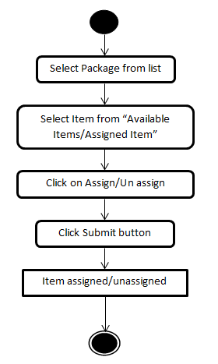

Figure : Package & Pricing Item assignment/ unassignment

### Sequence Diagram

#### Package Assignment and Unassignment ODP Item



Figure : Package Assignment and Unassignment ODP Item

### Business Logic

#### Package & Pricing Item Assignment Objects

None

#### Package & Pricing Item Assignment Presentation Layer classes

None

#### Package & Pricing Item Assignment Servlet

None

#### Package & Pricing Item Assignment Application Layer classes

* **com.myrio.tm.products.packages.al.CPackageSessionBean**

|  |  |  |
| --- | --- | --- |
| ***Existing Method*** | ***Change Description*** | ***Exception*** |
| public HashMap getUnassignedItems(int packageId, String itemType) | Gets the unassigned Items for the package and itemType requested. | CException |
| public void assignItems(int packageId, HashMap hmToBeAssigned) | Assigns items in the HashMap in the packageId provided in the PackageBean | CException |

#### Objects to lock

None.

#### Exceptions

None.

#### Error messages None

#### Package & Pricing Item Assignment Database Layer

* **com.myrio.tm.products.packages.dba.CPackageAssignmentDAO**

|  |  |  |
| --- | --- | --- |
| ***Creating Method*** | ***Change Description*** | ***Exception*** |
| public static HashMap getUnassignedODPItemsForPackage(int packageId) | Gets the unassigned ODP Items for the package Id requested. | Exception |
| public static HashMap getUnassignedODPPackages(int itemid) | Gets the unassigned ODP Packages. | Exception |

|  |  |  |
| --- | --- | --- |
| ***Existing Method*** | ***Change Description*** | ***Exception*** |
| private static HashMap getUnassignedItemsForPackage(int packageId, String tablename) | Gets the unassigned Items for the package and itemType requested. | Exception |
| public static HashMap getAssignedToPackage(int packageId) | public static HashMap getAssignedToPackage(int packageId) | Exception |

## Reports Configuration

### Flow Diagram

#### Reports

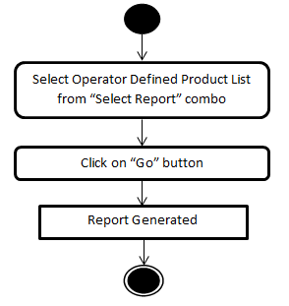

Figure : Reports Flow Diagram

### Sequence Diagram

None

### Business Logic

#### Reports Objects

None

#### Reports Presentation Layer classes

None

#### Reports Servlet

None

#### Reports Application Layer classes

None

#### Objects to lock

None

#### Exceptions

None

#### Error messages

None

#### Reports Database Layer

None

**4.4.1.12 Database changes**

|  |
| --- |
| ***SQL*** |
| INSERT INTO REPORTS (ID,DISPLAYNAME,QUERY) VALUES (1053,'Operator Defined Product List','SELECT ODPT.name ODPTypeName,ODP.id ODPID,ODP.externalid ODPExternalID,ODP.name ODPName,ODP.description ODPDescription,RSC.description ODPStatus FROM OPERATORDEFINEDPRODUCTS ODP JOIN ODPTYPES ODPT ON ODP.odptypeid = ODPT.id JOIN RECORDSTATUSCODES RSC ON ODP.recordstatuscode = RSC.CODE');  INSERT INTO REPORTCOLUMNFORMAT (REPORTID, SEQUENCE, FORMAT) VALUES (1053, 1, 'ODP Type Name||left');  INSERT INTO REPORTCOLUMNFORMAT (REPORTID, SEQUENCE, FORMAT) VALUES (1053, 2, 'ODP ID||left');  INSERT INTO REPORTCOLUMNFORMAT (REPORTID, SEQUENCE, FORMAT) VALUES (1053, 3, 'ODP External ID||left');  INSERT INTO REPORTCOLUMNFORMAT (REPORTID, SEQUENCE, FORMAT) VALUES (1053, 4, 'ODP Name||left');  INSERT INTO REPORTCOLUMNFORMAT (REPORTID, SEQUENCE, FORMAT) VALUES (1053, 5, 'ODP Description||left');  INSERT INTO REPORTCOLUMNFORMAT (REPORTID, SEQUENCE, FORMAT) VALUES (1053, 6, 'ODP Status||left'); |

## Security Profile Configuration

A new module is added for ‘Operator Defined Product Items’ in the security profiles of ‘Products’.

### Flow Diagram

#### Security Profile

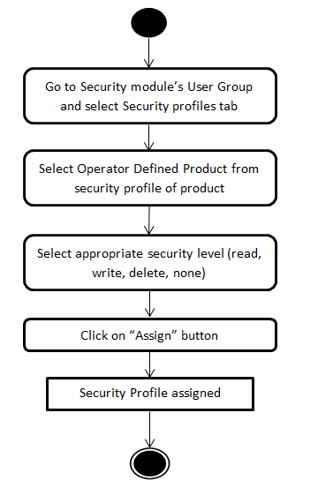

Figure : Security Profile

### Sequence Diagram

None

### Business Logic

#### Security Profile Objects

None

#### Security Profile Presentation Layer classes

New classes need to be implemented Security via TM GUI. This package is included not only for the new panels but also for data manager, who is responsible to connect the TM applet with the servlet and to interpret and treat the applet requests.

* **com.myrio.tm.products.pl.CPLProductsModule.java**

|  |  |  |
| --- | --- | --- |
| ***Creating Attributes*** | ***Attribute Type*** | ***Default Value*** |
| CODPItemModule | Private | null |
| permissionOnODP | private String | IPermissions.FULL_CONTROL |
| odpFeedDataDone | private Boolean | false |

|  |  |  |
| --- | --- | --- |
| ***Existing Method*** | ***Description*** | ***Exception*** |
| public void refreshRegisters() | Refresh Registers of Product Module | None |
| public void showAllTabs() | Shows all Tab in Product Module | None |
| tabPane.addChangeListener() | ChangeListener of Product Module Tabbed Pane | None |
| public void resetOldData() | Resets old Data | None |

* **com.myrio.tm.framework.pl.desktop.CPLDesktopManager.java**

|  |  |  |
| --- | --- | --- |
| ***Existing Method*** | ***Change Description*** | ***Exception*** |
| private void setComponents() | Sets the Components on the panel | None |

* **com.myrio.tm.framework.util.IModuleRegisterID**

|  |  |  |
| --- | --- | --- |
| ***Creating Attributes*** | ***Attribute Type*** | ***Value*** |
| OPERATOR_DEFINED_PRODUCTS_ITEMS_REGISTER | int | 57 |

#### Security Profile Servlet

None

#### Security Profile Application Layer classes

None

#### Objects to lock

None

#### Exceptions

None

#### Error messages

None

#### Security Profile Database Layer

None

#### Database changes

|  |
| --- |
| ***DB SCRIPT*** |
| INSERT INTO SECURITYACCESSPROFILE (id, groupid, moduleid, registerid, privilegecode, lastupdatedatetime, lastupdateuserid, recordstatuscode, timestamp) (SELECT '57', groupid, 2, 57, 'N', '20130901074259621', NULL , 'A', '20130901074259621' FROM usergroup); |

## Operator Defined Server Configuration

Add operation is used for UI section only but Submit operation is used for inserting data into database.

### Flow Diagram

#### Create/Edit Operator Defined Server

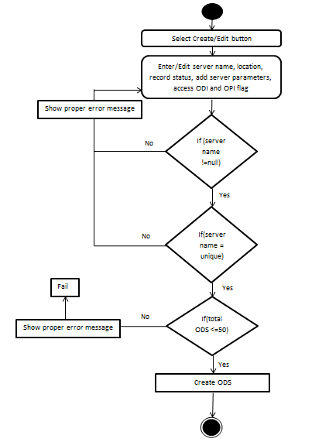

Figure : Create/Edit Operator Defined Server

#### Delete Operator Defined Server

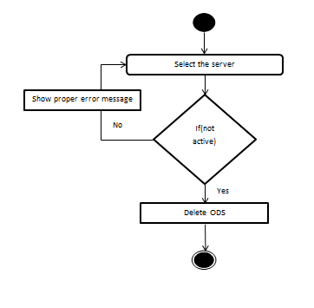

Figure : Delete Operator Defined Server

### Sequence Diagram

#### Add Operator Defined Server



Figure : Add Operator Defined Server

#### Edit Operator Defined Server



Figure : Edit Operator Defined Server

#### Delete Operator Defined Server



Figure : Delete Operator Defined Server

### Business Logic

#### Operator Defined Server Objects

#### Operator Defined Server Presentation Layer classes

* **com.myrio.tm.company.pl.CCompanyPanel**

|  |  |  |
| --- | --- | --- |
| ***Existing Method*** | ***Change Description*** | ***Exception*** |
| public void callStopEditingOfTable() | Tells the editor to stop editing and accept any partially edited value as the value of the editor. | None |

* **com.myrio.tm.company.pl.CCompanyServerDetailsPanel**

|  |  |  |
| --- | --- | --- |
| ***Creating Attributes*** | ***Attribute Type*** | ***Default Value*** |
| odsOCIandOPILabel | private JLabel |  |
| odsServerParametersLabel | private JLabel |  |
| odsOCIandOPIEnabled | private JCheckBox |  |
| panel | JPanel |  |
| obj_CCompanyODSPropertiesPanel | CCompanyODSPropertiesPanel |  |
| createButton | private JButton |  |
| deleteButton | private JButton |  |

|  |  |  |
| --- | --- | --- |
| ***Existing Method*** | ***Change Description*** | ***Exception*** |
| public void initializeComponents() | Initializes the panel components and adds listeners to them | None |
| private void handleServerTypeChange() | Handles Server Type Change event | None |
| public void layoutServers() | Creates the layout for servers types | None |
| public CCompanyServerFeature getServerFeature() | Returns server feature data | CMandatoryFieldNotFoundException, CException,CPLException |
| private void hideAllServer() | Hides all servers | None |
| public void disableServerControls() | Disables Server fields | None |
| public void enableServerControls() | Enables all servers controls | None |
| public void setServerFeature(CCompanyServerFeature serverFeature) | Sets the current selected server data into the panel fields | None |

|  |  |  |
| --- | --- | --- |
| ***Creating Method*** | ***Change Description*** | ***Exception*** |
| private void initODSComponents() | To intialize the ODS Server Specific UI Components | None |
| private void odsButtonPanelLayout() | ODS Server Button Panel Layout | None |
| public void deleteODServerProperties(CCompanyServerFeature serverFtr,Connection conn) | Deletes ODS Server Properties | CException |
| public void showODServer() | Shows ODS server fields | None |
| public void setEnableDeleteButton(boolean b) | Enables Delete button of ODS server | None |
| private void disableODServerControls() | Disables ODS Server fields | None |
| private void enableODServerControls() | Enables ODS server controls | None |
| public void odsdoDelete() | This method is called when the delete button is pressed and calls the method deleteMultipleRowsFromTable from  CCompanyODSPropertiesPanel | None |
| public void odsdoCreate() | This method is called when the create button is pressed and calls the method insertInTable() from  CCompanyODSPropertiesPanel | None |
| public void callStopEditingOfTable() | Calls the CCompanyODSPropertiesPanel.callStopEditingOfTable() method | None |

* **com.myrio.tm.company.pl.CCompanyServerPanel**

|  |  |  |
| --- | --- | --- |
| ***Existing Method*** | ***Change Description*** | ***Exception*** |
| public void doCreate() | Creates a Server | None |
| public void doOk() | Called when Submit Button is Pressed | None |

* **com.myrio.tm.company.pl.resources.Company.properties**

|  |  |
| --- | --- |
| ***Key*** | ***Value*** |
| ods_OCIandOPI | Accessibility in OCI and OPI: |
| ods_ServerParameters | Server Parameters: |
| ods_Parameter_error | Server Parameter cannot be greater than 50 |
| options_Add | Add |
| delete_ODS_parameter_msg | Do you want to delete ODS parameter? |
| delete_ODS_title | Confirm ODS Parameter delete |
| invalid_data_for_ODS_PARAMETERS | Invalid Data For ODS PARAMETERS |

* **com.myrio.tm.company.pl.CCCompanyODServerTable**

|  |  |  |
| --- | --- | --- |
| ***Creating Attributes*** | ***Attribute Type*** | ***Value*** |
| serialVersionUID | private static final long | -7768600288743142678L |

|  |  |  |
| --- | --- | --- |
| ***Constructor*** | ***Change Description*** | ***Exception*** |
| CCCompanyODServerTable() | Creates a new CCCompanyODServerTable object. | None |

* **com.myrio.tm.company.pl.CCCompanyODServerTableModel**

|  |  |  |
| --- | --- | --- |
| ***Creating Attributes*** | ***Attribute Type*** | ***Value*** |
| serialVersionUID | private static final long | 1081481115932396776L |
| data | private ArrayList |  |

|  |  |  |
| --- | --- | --- |
| ***Constructor*** | ***Change Description*** | ***Exception*** |
| CCCompanyODServerTableModel() | Creates a new CCCompanyODServerTableModel object. | None |
| CCCompanyODServerTableModel (HashMap data) | Creates a new CCCompanyODServerTableModel object. | None |
| CCCompanyODServerTableModel(ArrayList data) | Creates a new CCCompanyODServerTableModel object. | None |

|  |  |  |
| --- | --- | --- |
| ***Creating Method*** | ***Change Description*** | ***Exception*** |
| public int getRowCount() | Return a count of the rows in this table model. | None |
| public int getColumnCount() | Return a count of the rows in this table model. | None |
| public String getColumnName(int col) | Return the name of columns in this table model. | None |
| public Class getColumnClass(int col) | Return the java class for objects in the specified column | None |
| public Object getValueAt(int row, int col) | Return the value at the specified row and column indexes. | None |
| public void setValueAt(Object value, int row, int col) | Sets the object value in the given row and column | None |
| public void deleteDataAt(int selectedRow) | This method deletes the data given in the selectedRow position | None |
| public void deleteDataAtRows(int[] selectedRow) | Deletes the selectedRow array of positions from the data array list. changed is called as data of all the rows have changed as rows have moved up when the row being deleted has been deleted | None |
| public void insertNewData() | This method inserts a CCompanyDNSFeature object in data array list. Notifies all listeners that rows in the range [firstRow, lastRow], inclusive, have been inserted | None |
| public boolean isCellEditable(int rowIndex, int columnIndex) | Returns true if the cell at rowIndex and columnIndex is editable | None |
| public ArrayList getData() | Returns the data ArrayList | None |
| public void setData(ArrayList data) | Sets the data ArrayList and then notifies all listeners that all cell values in the table's rows may have changed | None |
| public void setData(HashMap data) | Sets the data ArrayList with values from an HashMap | None |

* **com.myrio.tm.company.pl.CCompanyODSPropertiesPanel**

|  |  |  |
| --- | --- | --- |
| ***Creating Attributes*** | ***Attribute Type*** | ***Default Value*** |
| serialVersionUID | private static final long | -693569046042786155L |
| resource | private CResourceBundle |  |
| obj_CCCompanyODSTable | private CCCompanyODServerTable |  |
| obj_CCCompanyODSTableModel | private CCCompanyODServerTableModel |  |
| odsparameters | ArrayList |  |
| serverpanel | private CCompanyServerDetailsPanel |  |

|  |  |  |
| --- | --- | --- |
| ***Constructor*** | ***Change Description*** | ***Exception*** |
| CCompanyODSPropertiesPanel(CCompanyServerDetailsPanel serverpanel) | CCompanyODSPropertiesPanel(CCompanyServerDetailsPanel serverpanel) | None |

|  |  |  |
| --- | --- | --- |
| ***Creating Method*** | ***Change Description*** | ***Exception*** |
| private void initGUI() | This method creates a JScrollPane that displays the obj_CCCompanyODSTable in a viewport. The JScrollPane is added to this Panel and the configureODFTable() method is called. | None |
| private void configureODFTable() | This method configures the ODS table object CCCompanyODServerTableModel). Setting the table model, creates, resizes and add listeners to insert new data or delete multipleRows from table | None |
| private void deleteFromTable() | This method is not to be called directly.. will be called from deleteMultipleRowsFromTable. This method deletes the selected row. | None |
| void deleteMultipleRowsFromTable() | This method deletes the list of selected rows. If only one row is selected then the deleteFromTable() method is called | None |
| void insertInTable() | This method calls the insertNewData() method from CCompanyODServerTableModel where the CCompanyODSFeature data are inserted in a data array. The rowToBeSelected variable gives the number of the row selected to be set in the ListSelectionModel selection interval | None |
| private void repaintTable() | This method calls the methods that will invalidate, revalidate and repaint CCCompanyODSTable components. | None |
| public boolean callStopEditingOfTable() | This method is called when the Submit button is pressed, it also informs the editor to stop editing and accept any partially edited value as the value of the editor.  The editor returns false if editing was not stopped | None |
| public ArrayList getODSDataFeature() | This method returns an array list of CCompanyODSFeature objects. | None |
| public void setODSData(ArrayList value) | Sets an HashMap of values to the CCCompanyODSTableModel | None |
| public void disableAllControls() | Disables the submit, cancel buttons, and also disables the CCCompanyODSTableModel. | None |
| public void enableAllControls() | Enables the submit, cancel buttons, and also disables the CCCompanyODSTableModel. | None |

* **com.myrio.tm.company.pl.CCompanyODSPropertiesPanel$** **TextUpdateListener**

|  |  |  |
| --- | --- | --- |
| ***Creating Method*** | ***Change Description*** | ***Exception*** |
| public void changedUpdate(DocumentEvent e) | TableCellEditor needs to set the editor used when a cell in the selected column is edited | None |
| public void insertUpdate(DocumentEvent e) | TableCellEditor needs to set the editor when a cell in the selected column has been inserted. | None |
| public void removeUpdate(DocumentEvent e) | TableCellEditor needs to set the editor when a cell in the selected column has been edited | None |

* **com.myrio.tm.company.pl.resources.Company.properties**

|  |  |
| --- | --- |
| ***Key*** | ***Value*** |
| ods_OCIandOPI | Accessibility in OCI and OPI: |
| ods_ServerParameters | Server Parameters: |
| ods_Parameter_error | Server Parameter cannot be greater than 50 |
| options_Add | Add |
| delete_ODS_parameter_msg | Do you want to delete ODS parameter? |
| delete_ODS_title | Confirm ODS Parameter delete |
| invalid_data_for_ODS_PARAMETERS | Invalid Data For ODS PARAMETERS |

#### Operator Defined Server Servlet

#### Operator Defined Server Application Layer classes

* **com.myrio.tm.company.al.CCompanyBean**

|  |  |  |
| --- | --- | --- |
| ***Creating Method*** | ***Change Description*** | ***Exception*** |
| private static void validateODSParameters(ArrayList list) | To validate ODS Parameter | CException |
| private void checkODSServersCount(CCompanyServerFeature server) | Checks for Operator Defined servers are not more than 50. | CException |

|  |  |  |
| --- | --- | --- |
| ***Existing Method*** | ***Change Description*** | ***Exception*** |
| private void validateRequriedServerFields(CCompanyServerFeature server) | Validates all required server fields | CException |
| private void validateAddServerRules(CCompanyServerFeature server) | Validates the added server rules | CException |

* **com.myrio.tm.framework.al.resources.Exceptions.properties**

|  |  |
| --- | --- |
| ***Key*** | ***Value*** |
| COMPANY278 | Name is mandatory. |
| COMPANY285 | Value is mandatory. |
| COMPANY280 | Duplicate  name.\nPlease check for |
| COMPANY281 | Name should not start with space.\nPlease check for |
| COMPANY282 | Value should not start with space.\nPlease check for |
| COMPANY283 | Name should not be more than 20 characters.\nPlease check for |
| COMPANY284 | Value should not be more than 200 characters.\nPlease check for |
| COMPANY286 | Operator Defined Servers must not be greater than 50 |

#### Objects to lock

None

#### Exceptions

None

#### Error messages

|  |  |
| --- | --- |
| ***No.*** | ***Error Message*** |
| 1 | Server Parameter cannot be greater than 50 |
| 2 | Invalid Data For ODS PARAMETERS |
| 3 | Operator Defined Servers must not be greater than 50 |
| 4 | Value should not be more than 200 characters.\nPlease check for |
| 5 | Name should not be more than 20 characters.\nPlease check for |
| 6 | Name is mandatory. |
| 7 | Value is mandatory. |
| 8 | Duplicate name.\nPlease check for |
| 9 | Name should not start with space.\nPlease check for |
| 10 | Value should not start with space.\nPlease check for |
| 11 | Cannot delete a Server that is active. |

#### Operator Defined Product Objects

* **com.myrio.tm.company.util.CCompanyODServerFeature.java**

|  |  |  |
| --- | --- | --- |
| ***Creating Attributes*** | ***Attribute Type*** | ***Value*** |
| SERVER_TYPE | public static String | ODS |
| oPIandOCIEnabled | private CElementBoolean |  |
| companyODSParametersFeaturesList | private ArrayList |  |

|  |  |  |
| --- | --- | --- |
| ***Constructor*** | ***Change Description*** | ***Exception*** |
| public CCompanyODServerFeature() | Creates a new CCompanyODServerFeature object. | None |
| public CCompanyODServerFeature(int companyId, int locationId, int serverId, String serverName,String serverAddress,String lastUpdateDateTime, String lastUpdateUserId,String recordStatusCode,Boolean oPIandOCIEnabled,  ArrayList companyODSParametersFeaturesList ) | Creates a new CCompanyODServerFeature object. | None |

|  |  |  |
| --- | --- | --- |
| ***Creating Method*** | ***Change Description*** | ***Exception*** |
| public CElementBoolean getOPIandOCIEnabled() | Returns OPIandOCIEnabled. | None |
| public void setOPIandOCIEnabled(String text) | Sets OPIandOCIEnabled. | None |
| public void setOPIandOCIEnabled(CElementBoolean value) | Sets OPIandOCIEnabled | None |
| public ArrayList getCompanyODSParametersFeaturesList() | Returns the companyODSParametersFeaturesList | None |
| public void setCompanyODSParametersFeaturesList(  ArrayList companyODSParametersFeaturesList) | Sets companyODSParametersFeaturesList | None |

* **com.myrio.tm.company.util.CCompanyODSParametersFeatures.java**

|  |  |  |
| --- | --- | --- |
| ***Creating Attributes*** | ***Attribute Type*** | ***Value*** |
| name | private CElementText | ODS |
| value | private CElementText |  |
| serverid | private CElementNumber |  |
| newlyInserted | private boolean |  |

|  |  |  |
| --- | --- | --- |
| ***Constructor*** | ***Change Description*** | ***Exception*** |
| public CCompanyODSParametersFeatures() | Creates a new CCompanyODSParametersFeatures object. | None |
| public CCompanyODSParametersFeatures(String name, String value,int serverid) | Creates a new CCompanyODSParametersFeatures object. | None |

|  |  |  |
| --- | --- | --- |
| ***Creating Method*** | ***Change Description*** | ***Exception*** |
| public boolean isNewlyInserted() | Returns boolean isNewlyInserted. | None |
| public void setNewlyInserted(boolean newlyInserted) | Sets isNewlyInserted. | None |
| public CElementText getName() | Returns Name | None |
| public void setName(CElementText name) | Sets Name | None |
| public CElementText getValue() | Returns Value | None |
| public void setValue(CElementText value) | Sets Value | None |
| public CElementNumber getServerid() | Returns Serverid | None |
| public void setServerid(CElementNumber serverid) | Sets Serverid | None |

#### Operator Defined Server Database Layer

* **com.myrio.tm.company.dba.CServerDAO**

|  |  |  |
| --- | --- | --- |
| ***Creating Attributes*** | ***Attribute Type*** | ***Value*** |
| instance | private static CServerDAO |  |

|  |  |  |
| --- | --- | --- |
| ***Creating Method*** | ***Change Description*** | ***Exception*** |
| public static CServerDAO getInstance() | Return the singleton instance for this VM | None |
| private void checkODSServersCount(CCompanyServerFeature server) | Checks for Operator Defined servers are not more than 50. | CException |
| public void deleteODServerProperties(CCompanyServerFeature serverFtr,Connection conn) | Deletes ODS Server Properties | CException |
| public void addAndDeleteODSParameters(CCompanyServerFeature brserver) | Add and Delete ODS Parameters | CException |
| private void getChangesInODSParameters(ArrayList changedList, ArrayList deletions, ArrayList additions,int serverid) | Returns the changes of ODS Parameters | CException |
| private ArrayList getChangesForODS(ArrayList list1, ArrayList list2) | This method is to verify ODS changes | None |
| private boolean isInListForODS(Object obj, ArrayList list) | To verify ODS Parameter | None |
| public ArrayList getODSParametersFromServerid(int serverid) | To get ODS Parameters | CException |
| private ArrayList getODSParametersList(ResultSet rs) | To get ODS Parameters list | CException |
| private CCompanyODSParametersFeatures getCompanyODSParametersFeature(ResultSet rs) | To get ODS Parameters feature Object | CException |
| public int getODServerCount() | Get Count of Operator Defined Servers for the given type | CException |

|  |  |  |
| --- | --- | --- |
| ***Existing Method*** | ***Change Description*** | ***Exception*** |
| public static void addServerProperties(CCompanyServerFeature brserver) | Add Server Properties | CException |
| private void validateAddServerRules(CCompanyServerFeature server) | Validates the added server rules | CException |
| public static void deleteServerProperties(CCompanyServerFeature serverFtr) | Delete Server Properties | CException |
| private static CCompanyServerFeature getServerFeatureFrom(ResultSet rs) | Get Server Feature from Result Set | SQLException, CException |
| private static void getServerProperties(CCompanyServerFeature serverFtr) | Get Server Properties | CException |

# Broker Documents

## Open Client Interfaces

### Global Broker Documents

#### GlobalInstall

The following changes apply to GLOBALINTALL.xml:

* Added Operator Defined Product items.
* Added Operator Defined Server.

#### Class Diagram



Figure : Global Install Class Diagram

#### Flow Diagram

Not applicable

#### Sequence Diagram



Figure : GlobalInstall Sequence Diagram

#### Business Logic

##### Presentation Layer classes

Not applicable

##### Servlet

Not applicable

##### Application Layer classes

* **common_src.mclient.msgr.MessageTypes**

|  |  |  |  |
| --- | --- | --- | --- |
| ***Document*** | ***Tag Name*** | ***Tag Value*** | ***Tag Type*** |
| GlobalInstall | TAG_SERVER_ATTRIBUTE_NAME | Name | String |
| TAG_SERVER_ATTRIBUTE_VALUE | Value | String |
| TAG_SERVER_ATTRIBUTE | Attribute | String |
| TAG_ODPS | ODPs | String |
| TAG_ODPS_ODP | ODP | String |
| TAG_ODP_PROPERTIES | Properties | String |
| TAG_ODP_PROPERTIES_ID | ID | String |
| TAG_ODP_PROPERTIES_EXTERNALID | ExternalID | String |
| TAG_ODP_PROPERTIES_ODPTYPENAME | ODPTypeName | String |
| TAG_ODP_PROPERTIES_NAME | Name | String |
| TAG_ODP_PROPERTIES_DESCRIPTION | Description | String |
| TAG_ODP_ASSIGNEDPACKAGES | AssignedPackages | String |
| TAG_ODP_ASSIGNEDPACKAGES_PACKAGEID | PackageID | String |
| TAG_ODP_PARAMETER | Parameter | String |
| TAG_ODP_PARAMETER_NAME | Name | String |
| TAG_ODP_PARAMETER_VALUE | Value | String |
|  |  |  |

* **com.myrio.broker.globalInstallation.GlobalInstallGeneratorBean**

|  |  |  |
| --- | --- | --- |
| ***Existing Method*** | ***Change Description*** | ***Exception*** |
| public String generateDocument(String languageCode) | Check for new server type as “Operator Defined Server”,“Operator Defined Products” | DocumentGenerationException |
| private void generateServerElement(StringBuilder buf, CCompanyServerFeature server,CGlobalInstallationDataFeature globalInstallation) | Generate the Global Install Document. | None |

|  |  |  |
| --- | --- | --- |
| ***Creating Method*** | ***Change Description*** | ***Exception*** |
| private void generateODServerAttr(StringBuilder buf,CCompanyODServerFeature odServer) | Generates ODS Elements. | None |
| private void generateODPs(StringBuilder buf) | Generates ODP Elements. | None |

* **com.myrio.tm.stbapi.util.CGlobalInstallationDataFeature**

|  |  |  |
| --- | --- | --- |
| ***Existing Method*** | ***Change Description*** | ***Exception*** |
| public CGlobalInstallationDataFeature() | Creates a new CGlobalInstallationDataFeature object. | None |
| public ArrayList getOdpList() | Get the ODPDetails | None |
| public void setOdpList(ArrayList odpList) | Set ODPList | None |

* **com.myrio.tm.stbapi.al.CSTBApiBean**

|  |  |  |
| --- | --- | --- |
| ***Existing Method*** | ***Change Description*** | ***Exception*** |
| private void getODPs(CGlobalInstallationDataFeature globalInstallationDataFeature) | Fetch “ODPs” details from database | CException |
| public CGlobalInstallationDataFeature getGlobalInstallationData() | Fetch GlobalInstallation  Data | CException |

* **com.myrio.tm.product.operatordefinedproducts.util.CODPItemFeature**

|  |  |  |
| --- | --- | --- |
| ***Creating Attributes*** | ***Attribute Type*** | ***Value*** |
| odpTypeId | private String | ODP type id |
| odpId | private String | ODP Id |
| externalId | private String | External Id |
| odpTypeName | private String | ODP Type Name |
| odpItemName | private String | ODP Name |
| description | private String | Description |
| assignedPackageIds | private ArrayList | Package assigned to ODP |
| parametersMap | private HashMap<String, String> | ODP Type Parameter Map |

|  |  |  |
| --- | --- | --- |
| ***Creating Method*** | ***Description*** | ***Exception*** |
| public getXXX() | Method to get the attribute values. Should be defined a method for each class attribute. e.g.: getName() | None |
| public setXXX(…) | Method to set the attribute values. Should be defined a method for each class attribute. e.g.: setName(String name) | None |

* **com.myrio.tm.products.operatordefinedproducts.dba.CODPItemDAO**

|  |  |  |
| --- | --- | --- |
| ***Creating Method*** | ***Description*** | ***Exception*** |
| public ArrayList<CODPItemFeature> getODPItemsDetails() | Returns list with ODP details | CException |
| private HashMap<String, String> getParameterMap(String odpId) | Returns parameter map | CException |
| private ArrayList getAssignedPackages(String odpId) | Returns assigned packages | CException |

##### Objects to lock

Not applicable

##### Exceptions

Not applicable

##### GlobalInstall.xml

<DocumentUpdate version="1328189281876">

<GLOBAL_INSTALL>

…

…

<ServerList>

…

<Server Name="ODS" Address="" Type="ODS" LocationID="1">

<Attribute Name="MinSyncTime" Value="20" />

<Attribute Name="URL" Value="www.google.com" />

</Server>

<Server Name="ODS final" Address="" Type="ODS" LocationID="1">

<Attribute Name="Max Sync Time" Value="24" />

<Attribute Name="URL" Value="www.yahoo.com" />

</Server>

…

</ServerList>

…

…

<ODPs>

<ODP>

<Properties>

<ID>1470150</ID>

<ExternalID>cPVR_028</ExternalID>

<ODPTypeName>cPVR_Premium</ODPTypeName>

<Name>cPVR Gold</Name>

<Description>cPVR Gold for premium subscribers</Description>

</Properties>

<AssignedPackages>

<PackageID>311</PackageID>

<PackageID>1010</PackageID>

</AssignedPackages>

<Parameter>

<Name>HD Allowed</Name>

<Value>false</Value>

</Parameter>

<Parameter>

<Name>Subscription Expiry Date</Name>

<Value>31.08.2011</Value>

</Parameter>

</ODP>

<ODP>

<Properties>

<ID>29298476</ID>

<ExternalID>HMS_541</ExternalID>

<ODPTypeName>HMS_Premium</ODPTypeName>

<Name>HMS Gold</Name>

<Description>HMS Gold for premium subscribers</Description>

</Properties>

<AssignedPackages>

<PackageID>311</PackageID>

</AssignedPackages>

</ODP>

</ODPs>

</GLOBAL_INSTALL>

</DocumentUpdate>

## OPI: Open Portal Integration

### GlobalInfo SOAP interface

#### Class Diagram



Figure : GlobalInfo

#### Flow Diagram

Not applicable

#### Sequence Diagram

Not applicable

#### Business Logic

##### Presentation Layer classes

Not applicable

##### Servlet

Not applicable

##### Application Layer classes

* **com.nsn.he.opa.topserver.util.TOPConstants**

|  |  |  |
| --- | --- | --- |
| ***Creating Attributes*** | ***Attribute Type*** | ***Value*** |
| Version_4_0 | String | 4.0.0 |

* **com.nsn.he.opa.topserver.he40ws.HE40TopServicesImpl**

|  |  |  |
| --- | --- | --- |
| ***Existing Method*** | ***Change Description*** | ***Exception*** |
| public GlobalInfo getGlobalInfo(String version) | Add new server type as “Operator Defined Server” and “Operator Defined Products” | TopException |

* **com.nsn.he.opa.topserver.he40ws.HE40TopServicesImpl**

|  |  |  |
| --- | --- | --- |
| ***Existing Method*** | ***Change Description*** | ***Exception*** |
| private GlobalInfo getGlobalInfo(String clientDetails) | Add new server type as “Operator Defined Server” and “Operator Defined Products” | TopException |

##### Objects to lock

Not applicable

##### Exceptions

Not applicable

##### Opa/ops/config/war/WEB-INF/xslt/getGlobalInfo.xsll

<xsl:template match="DocumentUpdate">

<xsl:for-each select="GLOBAL_INSTALL">

<n:GlobalInstallData>

<n:GlobalInfo>

<!-- For Operator Defined Services -->

<xsl:for-each select="ODPs">

<n:ODPs>

<xsl:for-each select="ODP">

<n:ODP>

<!-- For Operator Defined Services Properties -->

<xsl:for-each select="Properties">

<n:Properties>

<xsl:variable name="ID_long" select="string(./ID)"/>

<n:ID>

<xsl:value-of select="$ID_long" />

</n:ID>

<xsl:variable name="ExternalID_string"

select="string(./ExternalID)"/>

<n:ExternalID>

<xsl:value-of select="$ExternalID_string" />

</n:ExternalID>

<xsl:variable name="ODPTypeName_string"

select="string(./ODPTypeName)"/>

<n:ODPTypeName>

<xsl:value-of select="$ODPTypeName_string" />

</n:ODPTypeName>

<xsl:variable name="Name_string"

select="string(./Name)"/>

<n:Name>

<xsl:value-of select="$Name_string" />

</n:Name>

<xsl:variable name="Description_string"

select="string(./Description)"/>

<n:Description>

<xsl:value-of select="$Description_string" />

</n:Description>

</n:Properties>

</xsl:for-each>

<!-- End Properties -->

<!-- For Operator Defined Services AssignedPackages -->

<xsl:for-each select="AssignedPackages">

<n:AssignedPackages>

<xsl:for-each select="PackageID">

<xsl:variable name="PackageID_string"

select="string(./@PackageID)"/>

<n:PackageID>

<xsl:value-of select="$PackageID_string" />

</n:PackageID>

</xsl:for-each>

</n:AssignedPackages>

</xsl:for-each>

<!-- End AssignedPackages -->

<!-- For Operator Defined Services Parameter -->

<xsl:for-each select="Parameter">

<n:Parameter>

<xsl:variable name="Name_string" select="string(./@Name)"/>

<n:Name>

<xsl:value-of select="$Name_string" />

</n:Name>

<xsl:variable name="Value_string" select="string(./@Value)"/>

<n:Value>

<xsl:value-of select="$Value_string" />

</n:Value>

</n:Parameter>

</xsl:for-each>

<!-- End Parameter --> </n:ODP>

<!-- End ODP -->

</xsl:for-each>

</n:ODPs>

<!-- End ODPs -->

</xsl:for-each>

<!-- End ODS -->

</n:GlobalInfo>

# Exported Interfaces

## ODP Type Definition TM GUI

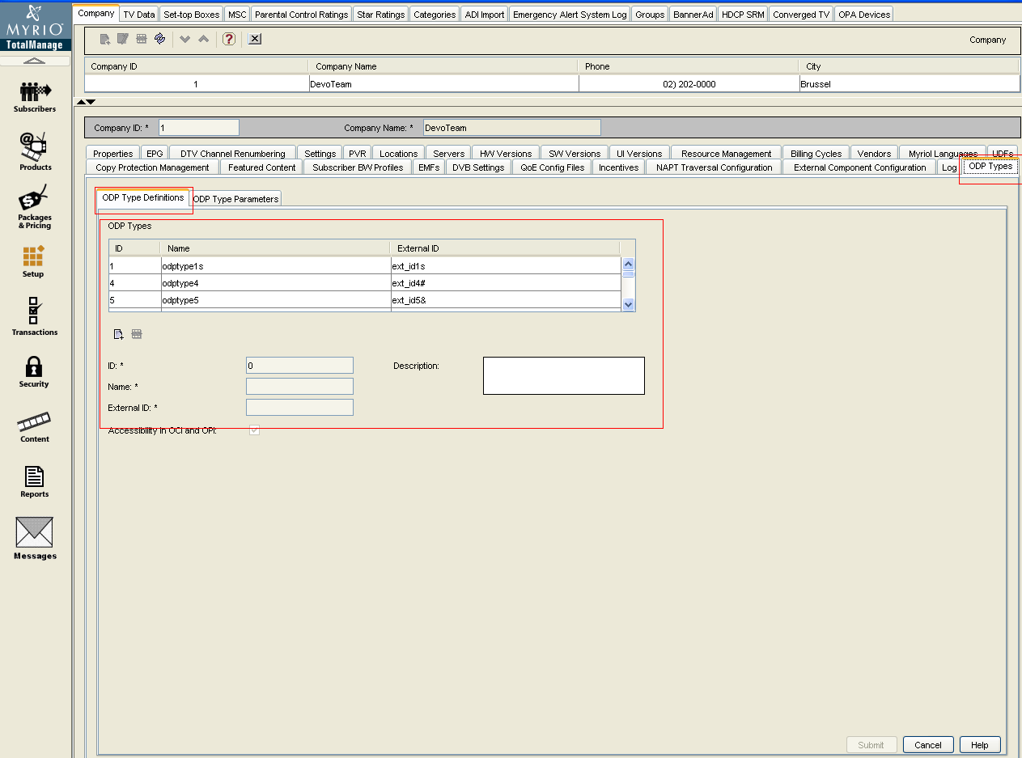

Figure : ODP type Definition TM GUI

## ODP Type Parameters TM GUI

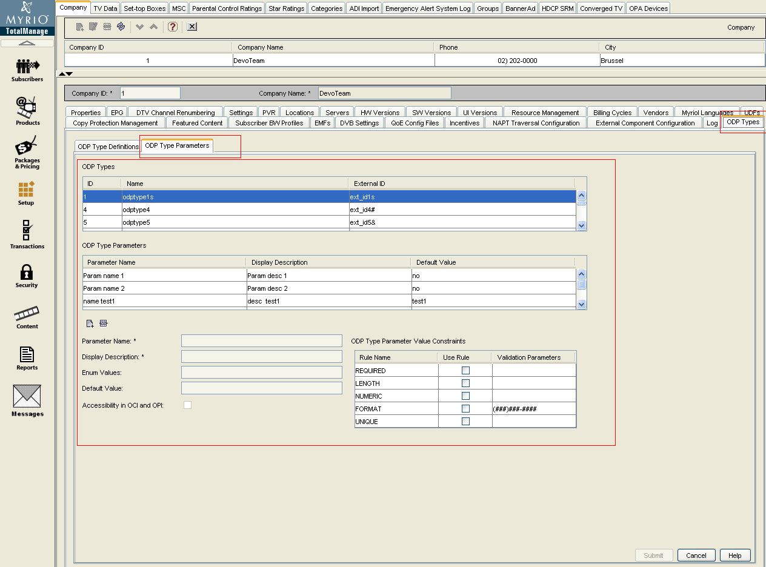

Figure : ODP Type Parameters TM GUI

## Operator Defined Products, Tab Properties TM GUI

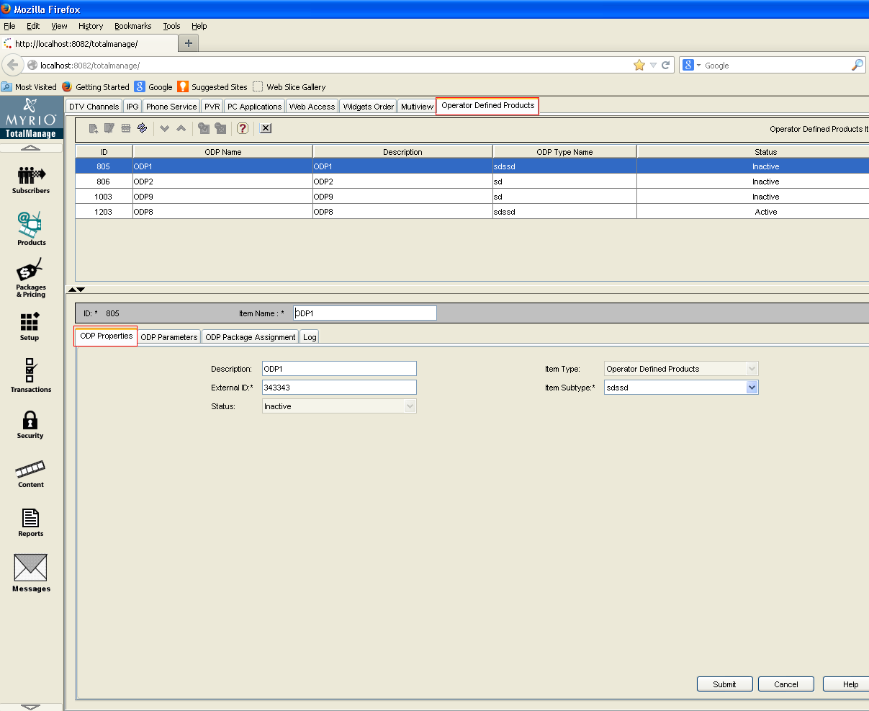

Figure : Operator Defined Products, Tab Properties TM GUI

## Operator Defined Products, TAB Package Assignment TM GUI

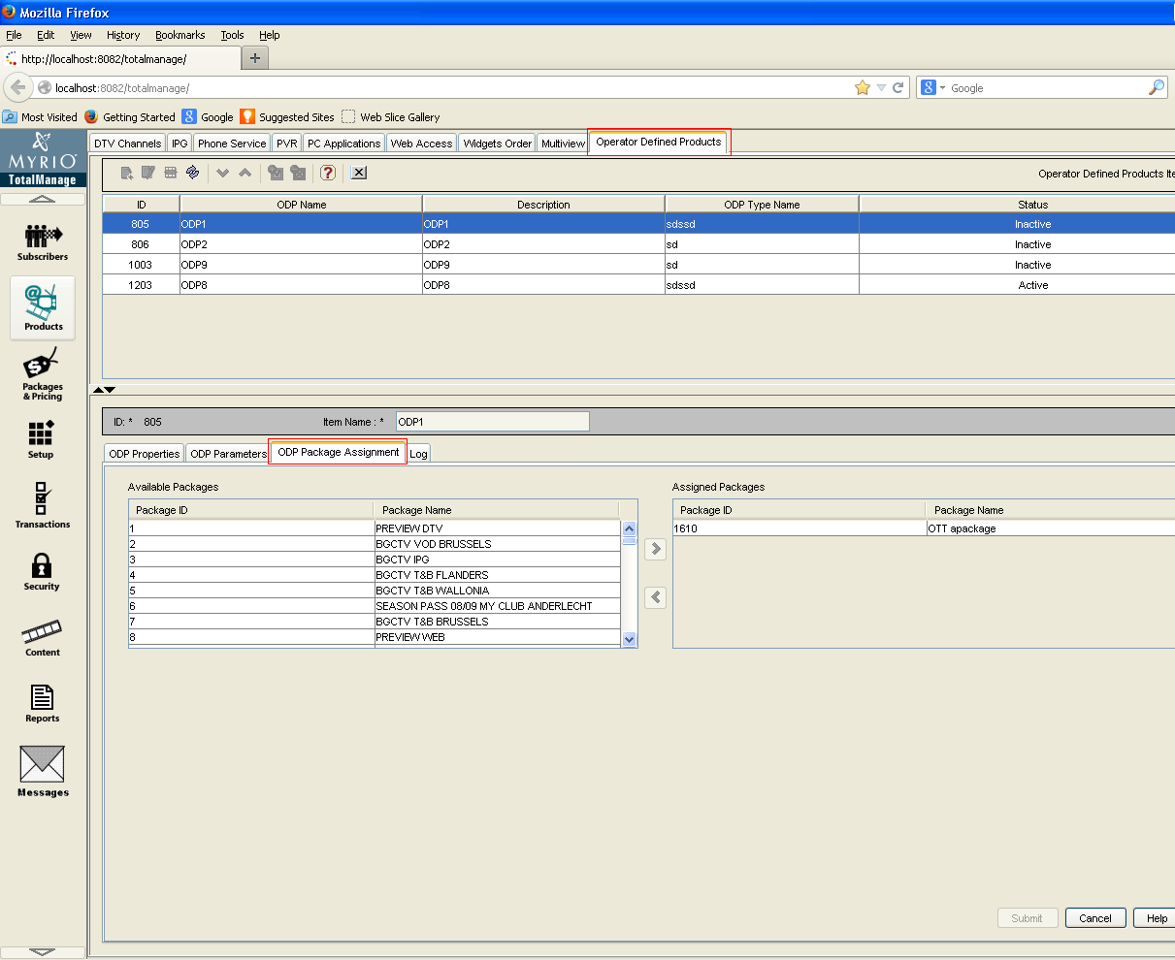

Figure : Operator Defined Products, TAB Package Assignment TM GUI

## Operator Defined Products, TAB Log TM GUI

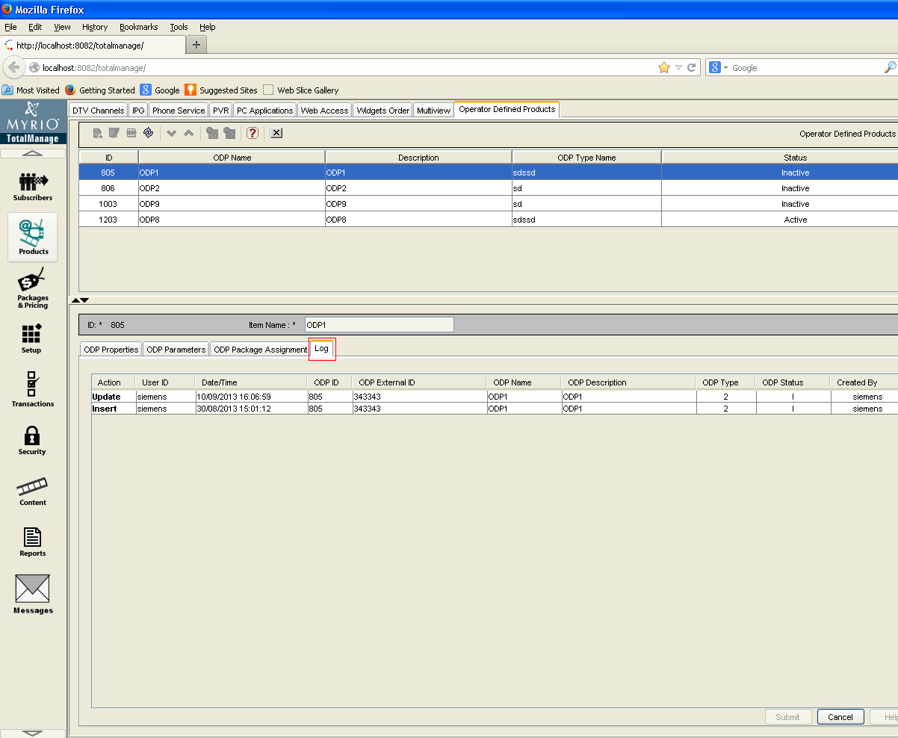

Figure : Operator Defined Products, TAB Log TM GUI

## Packages, TAB Item Assignment TM GUI

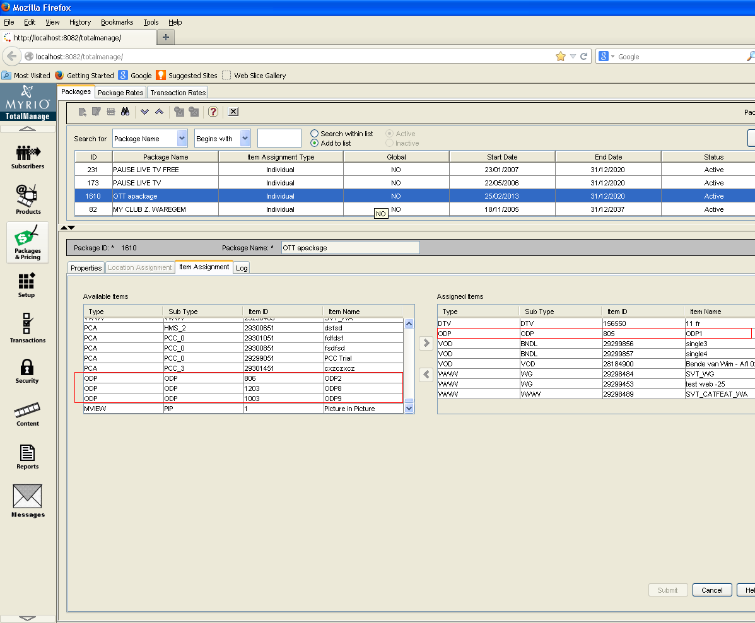

Figure : Packages, TAB Item Assignment TM GUI

## Reports

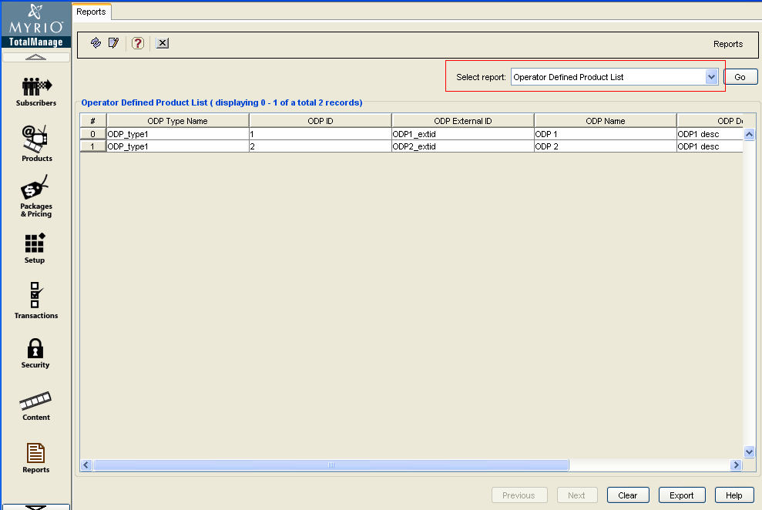

Figure : Reports

## Security 🡪 User Groups, TAB Security Profiles (UPDATE)

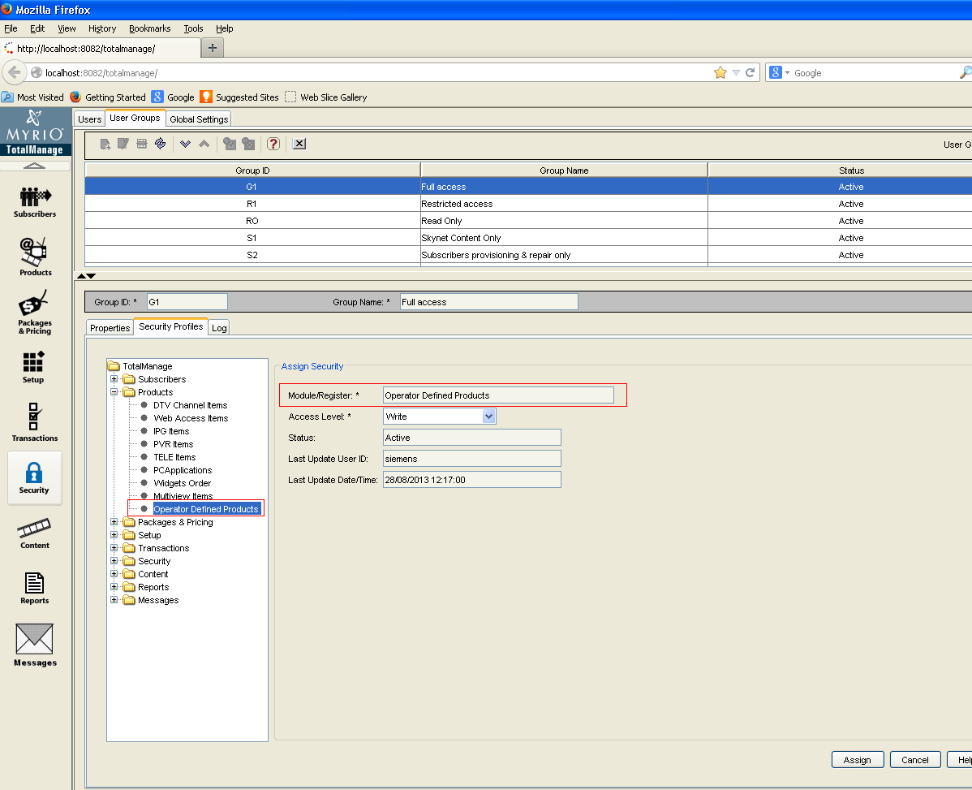

Figure : Security : User Groups, TAB Security Profiles (UPDATE)

## Setup 🡪 Company, TAB Servers TM GUI

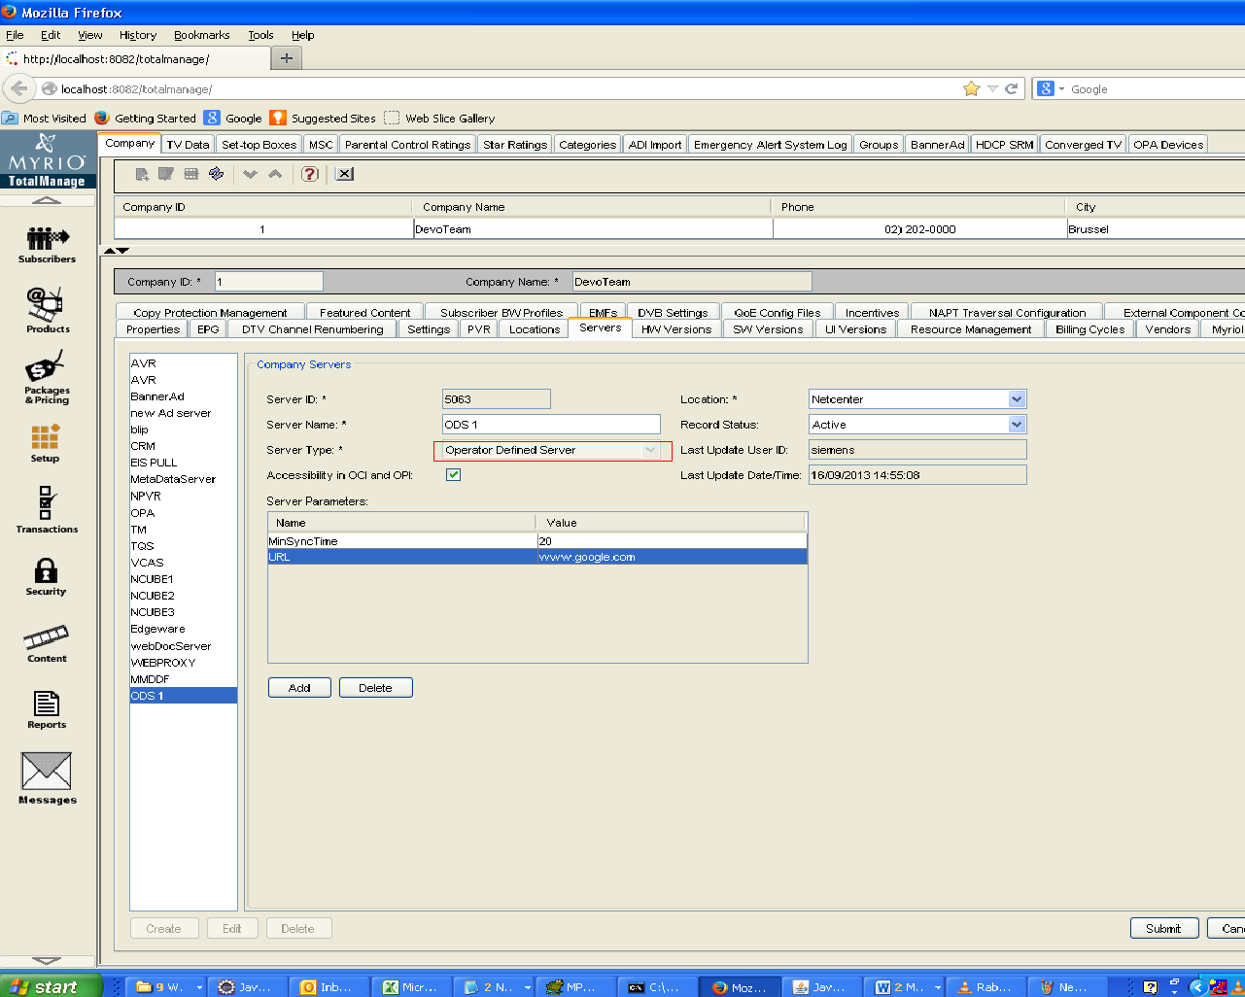

Figure : Setup : Company, TAB Servers TM GUI

# Configuration

Not Applicable

# Imported Interfaces

Not Applicable

# Database Migration/Upgrade

## Database Patch

Added one database patches “TMDB_HE4.0.01-oracle.sql” for Operator Defined Services:



## ODP

Below tables will be used for ODP types and parameters.

### ODP Types

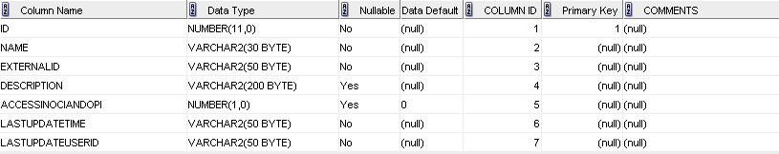

Figure : ODPTYPES Schema

### ODPTYPEPARAMETERS

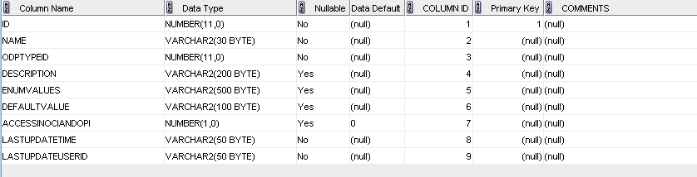

Figure : ODPTYPEPARAMETERS Schema

### ODPTYPEPARAMETERRULESMAPPING

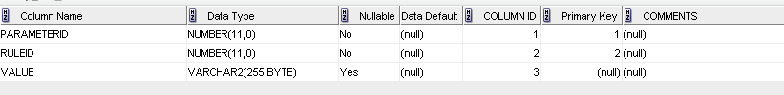

Figure : ODPTYPEPARAMETERRULESMAPPING Schema

### ODPPARAMETERRULES

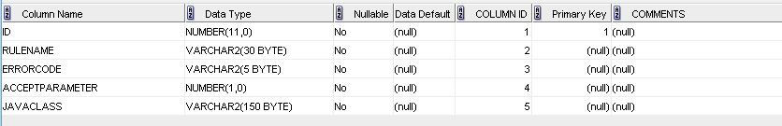

Figure : ODPPARAMETERRULES Schema

### OPERATORDEFINEDPRODUCTS

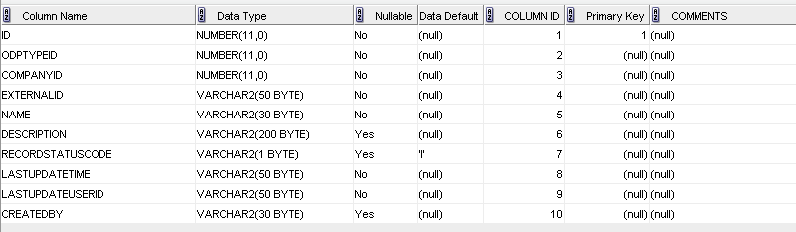

Figure : OPERATORDEFINEDPRODUCTS Schema

### ODPPARAMETERVALUE

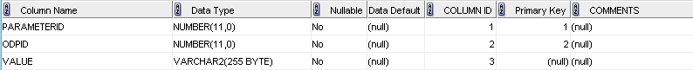

Figure : ODPPARAMETERVALUE Schema

### ITEMTYPES inserts

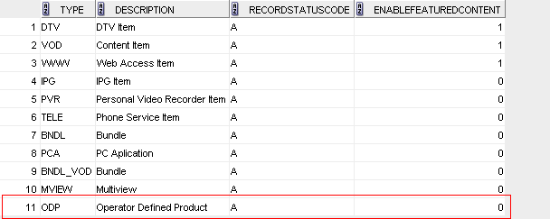

Figure : ITEMTYPES inserts

### COMPANYSERVERTYPES inserts

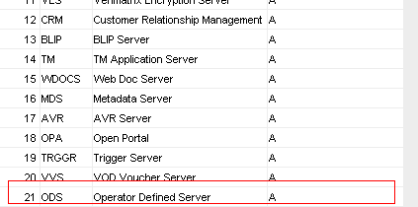

Figure : COMPANYSERVERTYPES inserts

### REGISTERS inserts

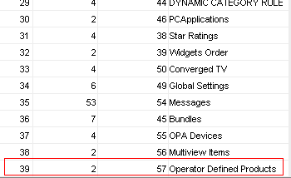

Figure : REGISTERS inserts

### ODPPARAMETERRULES inserts

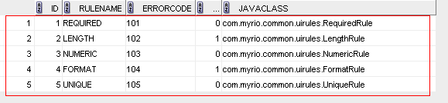

Figure : ODPPARAMETERRULES inserts

### REPORTS inserts

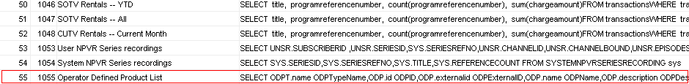

Figure : REPORTS inserts

### REPORTCOLUMNFORMAT inserts

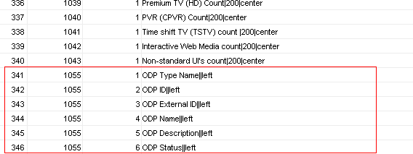

Figure : REPORTCOLUMNFORMAT inserts

# Design Specification Reviewers List & Template

*********** This chapter is Mandatory ***********************

The scope of the next file is to identify specific Design Specifications mandatory and optional reviewers.



Next document refers to Review Report Template.



Review Comments:

