STUDENT MANAGEMENT SYSTEM
Agile Scrum Implementation – Week 12 (Day 2) Hands-On
Prepared By: Vinay Palabandla

1. Introduction
Training institutes often use Excel sheets, WhatsApp, and Emails to manage student data. This creates confusion and delays. To solve this issue, a Student Management System is developed using Agile Scrum methodology.

2. Project Objectives
- Student registration and course enrollment
- Trainer course management
- Admin progress tracking
- Better communication and management
- Incremental software delivery using Scrum

3. Scrum Team Roles
Role | Responsibility | Assigned To
Product Owner | Defines requirements and priorities | Vinay
Scrum Master | Conducts Scrum meetings and Scrum process meetings | Vinay
Development Team | Develops project features and testing | Team Members

4. Product Backlog
ID | User Story | Priority
PB-1 | Student Registration | High
PB-2 | View Courses | High
PB-3 | Enroll in Course | High
PB-4 | Add Course Content | Medium
PB-5 | Track Student Progress | Medium
PB-6 | Manage Student Records | Medium

5. Sprint Planning
Sprint Goal: Enable student registration and course viewing.
Task ID | Task | Estimated Hours
T1 | Design Registration UI | 3 Hours
T2 | Create Registration API | 4 Hours
T3 | Create Course Listing Page | 3 Hours
T4 | Testing | 2 Hours

6. Scrum Task Board
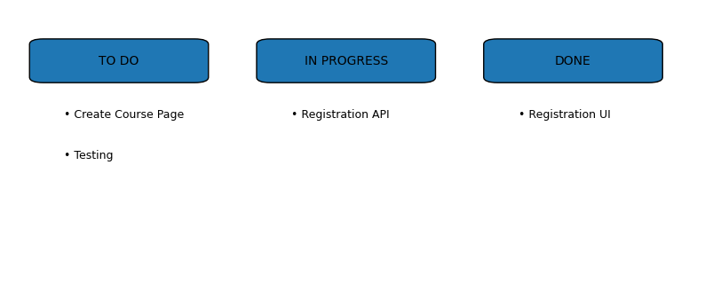

7. Daily Scrum
Yesterday: Completed registration UI.
Today: Working on registration API.
Blockers: Frontend and backend integration issue.

8. Sprint Review
The team successfully completed registration UI and course viewing functionality.

9. Sprint Retrospective
- What went well?
- Good team collaboration
- Tasks completed on time
- What can be improved?
- Improve testing process
- Better API integration

10. Agile vs Traditional
Agile | Traditional
Flexible requirements | Fixed requirements
Continuous feedback | Less customer feedback
Incremental delivery | Final delivery
Team collaboration | Sequential process

11. Scrum Workflow
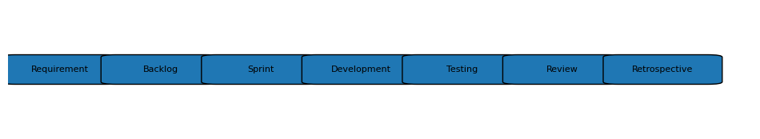

12. Learning Outcomes
- Understanding Scrum workflow
- Writing user stories
- Sprint planning experience
- Team collaboration skills
- Understanding Agile methodology

13. Conclusion
Agile Scrum helps software teams deliver projects step-by-step with continuous feedback and teamwork. It improves collaboration and project management.

