Agile Scrum Implementation for Student Management System
Week-12 (DAY-2) Hands-On Report

1. Introduction
Many training institutes face difficulties in managing student enrollments, course tracking, and communication because they use manual methods such as Excel sheets, WhatsApp messages, and Emails. This causes confusion, delays, and poor management.
To solve this problem, a web-based Student Management System will be developed using Agile Scrum methodology. The application allows students to enroll in courses, trainers to manage course content, and admins to track student progress and placements.

2. Scrum Team Roles
Role | Responsibility | Assigned To
Product Owner | Defines requirements and priorities | Vinay
Scrum Master | Facilitates Scrum process and meetings | Vinay
Development Team | Develops features and testing | Team Members

3. Product Backlog
ID | User Story | Priority
PB-1 | As a student, I want to register so that I can enroll in courses | High
PB-2 | As a student, I want to view available courses | High
PB-3 | As a student, I want to enroll in a course | High
PB-4 | As a trainer, I want to add course content | Medium
PB-5 | As an admin, I want to track student progress | Medium
PB-6 | As an admin, I want to manage student records | Medium

4. Sprint Planning
Sprint Goal: Enable student registration and course viewing.
Task ID | Task Description | Estimated Hours
T1 | Design UI for Registration | 3 Hours
T2 | Create Registration API | 4 Hours
T3 | Create Course Listing Page | 3 Hours
T4 | Testing | 2 Hours

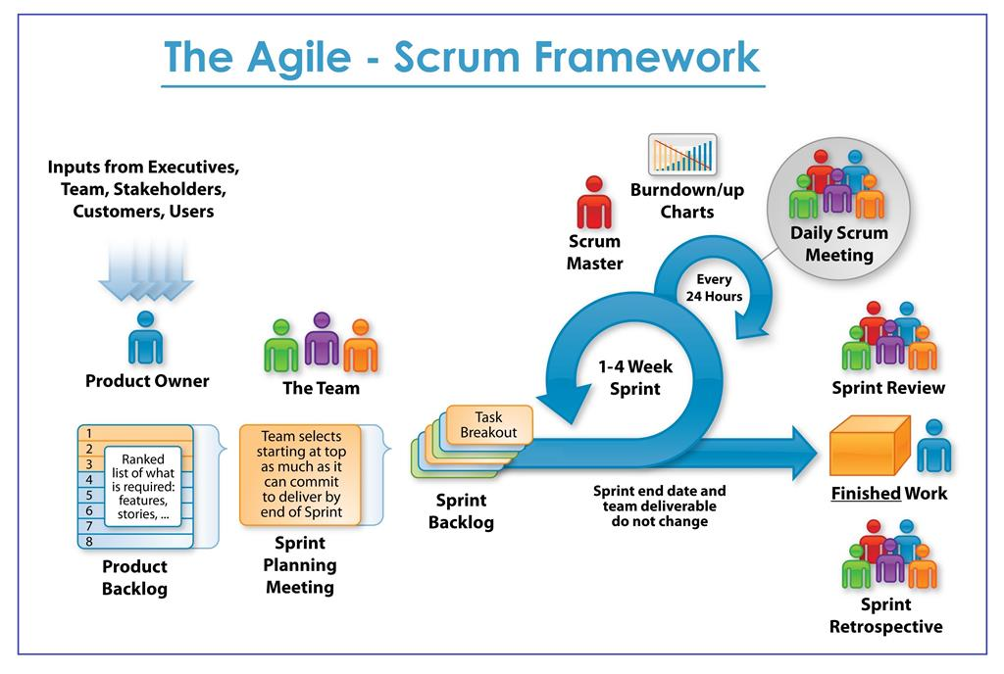
5. Scrum Workflow
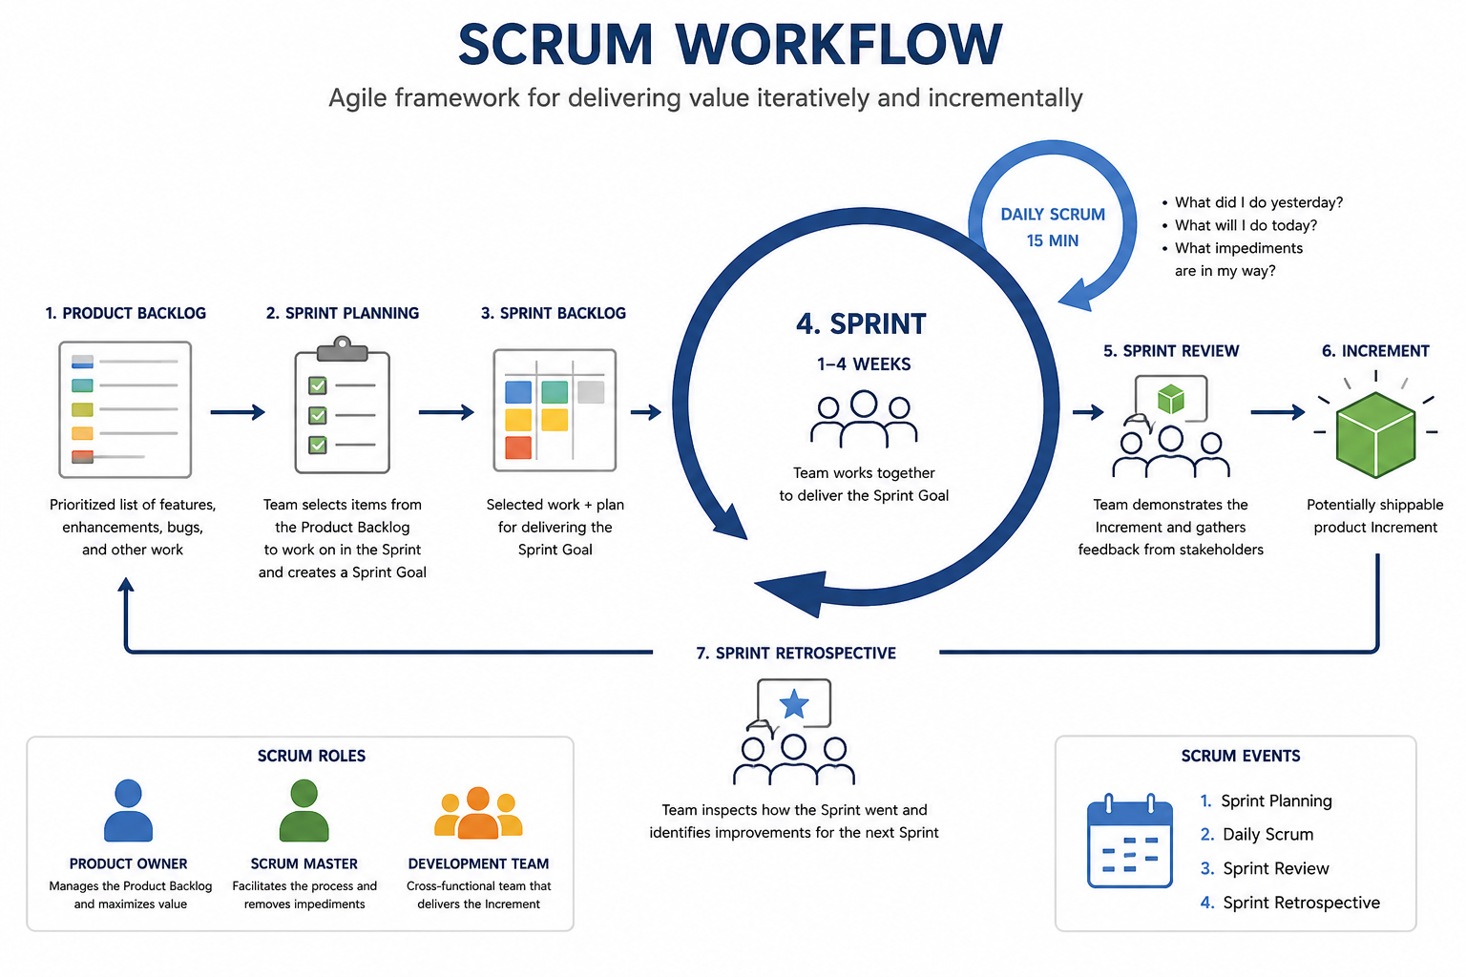

6. Daily Scrum
Yesterday: Completed registration UI design.
Today: Develop registration API and course listing page.
Blockers: Need support for frontend-backend integration.

7. Sprint Review
The team successfully completed Student Registration UI, Registration API, and Course Viewing Page.

8. Sprint Retrospective
What went well?
- Good team collaboration
- Clear communication
- Proper task division
What can be improved?
- Better time estimation
- Faster testing process
- Improved API integration

9. Agile vs Traditional
Agile Methodology | Traditional Methodology
Incremental delivery | Full delivery at end
Flexible requirements | Fixed requirements
Continuous customer feedback | Limited customer interaction
Faster adaptation to changes | Difficult to change

10. Learning Outcomes
- Understanding Agile vs Traditional methodologies
- Knowledge of Scrum roles and responsibilities
- Sprint planning and execution experience
- Real-world collaboration and communication skills

11. Conclusion
The Agile Scrum approach helps the development team deliver the Student Management System incrementally while continuously improving based on client feedback.

