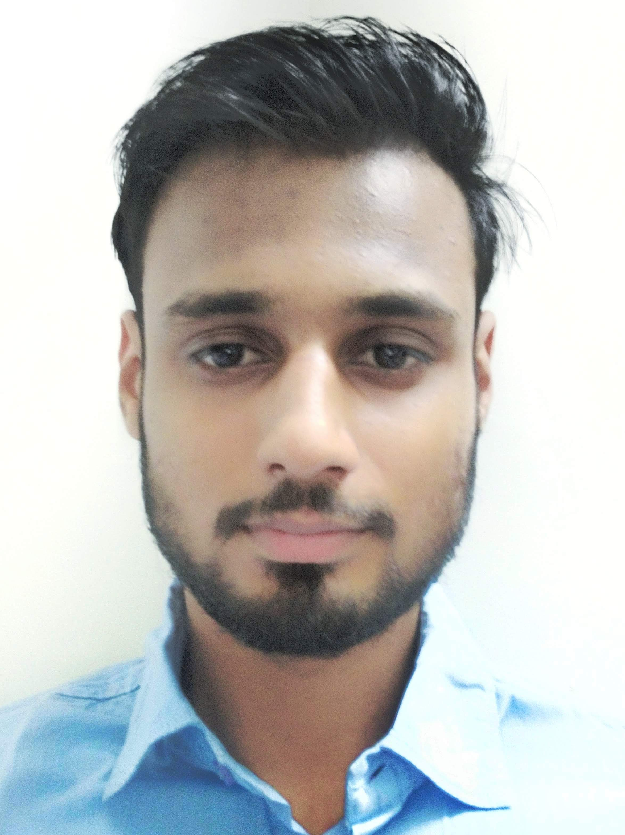

**Vinay Pokra**

The ICFAI University Hostel, Agra Road, Jamdoli, Jaipur

vvinayppokra@gmail.com

+91-7426885024 D.O.B: 24th May 2000

**Education**

|  |  |  |  |  |
| --- | --- | --- | --- | --- |
| **Program** | **Discipline** | **Board/University** | **%/CGPA** | **Year of Completion** |
| B.Tech | Computer science | The ICFAI University | 7.9 | 2021 |
| 12th | Maths & Science | RBSE | 67.50% | 2017 |
| 10th |  | RBSE | 74.00% | 2015 |

**Additional Qualifications**

* Got silver badge in python language on hackerrank
* Passed the C training exam conducted remotely from IIT bombay
* Completed successfully full stack JavaScript course on udemy
* Android ,ios development using cordova

**Computer Proficiency**

* C /C++/ C#/.Net/Python/Java
* Mysql :- database management
* php/JavaScript /Node.js/React.js
* HTML/CSS
* Advanced data structure & Algorithm
* Android development
* Cordova

**Projects & Internship**

Project Title: Event Registration Website

Learning Outcomes: Gained knowledge about live project.

Project Title: College’s student management system (Student portel)

Learning Outcomes: Gained knowledge about dynamic webdevelopment and about databases.

Project Title: Ecommerce website

Learning Outcomes: Gained knowledge about php ,javascrpit and responsive web designing.

**Workshops/Conferences/Seminars**

* Attended Workshop on cyber security.
* Attended Workshop on big data Hadoop.
* Attended Workshop on Android development.
* Attended Workshop on web development.
* Attended Workshop on java.
* Attended workshop on Startups in India.

**Co-Scholastic Engagements**

* Got silver medal in kabaddi.
* Participated in football and cricket.

**Interests**

* Playing cricket and badminton.
* Photography and editing.
* Watching series and sci fi movies.
* Online games.

**Personal Details**

Father’s Name: Mr. Rajendra pokra

Permanent Address: Pratap nagar ,Ramganjmandi,kota(326519)

Languages Known: English, Hindi

Nationality: Indian