Wireframe Document

Heart Disease Diagnostic Analysis



# Revision Number – 0.1

**Last Date of Revision - 13/12/2022**

# Vinay Pritwani

**Document Control**

|  |  |  |  |
| --- | --- | --- | --- |
| **Date** | **Version** | **Description** | **Author** |
| 13/12/2022 | 1.0 | First Version of complete Wireframe | Vinay Pritwani |
|  |  |  |  |
|  |  |  |  |
|  |  |  |  |

# We Performed Exploratory Data Analysis on Jupyter Notebook and then created a Power BI Desktop Dashboard.

## What Kind of Population do we have?

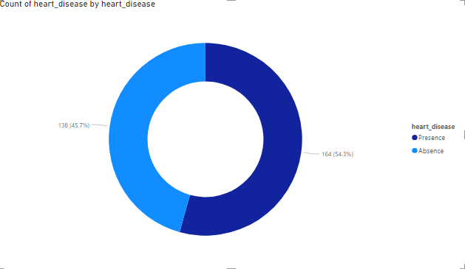

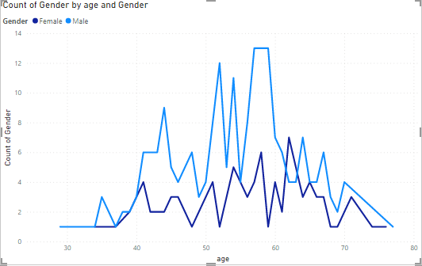

* 54.3% People suffering from heart disease.
* Men who are elderly in age ranging from 50 to 60 Years and Females who are ranging between 55 to 65 Years of age Category are more prone and are suffering from CVD’s or heart Disease.

## Who Suffer from Heart Disease?

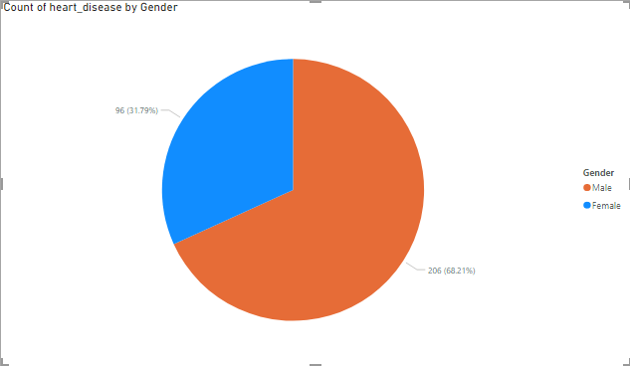

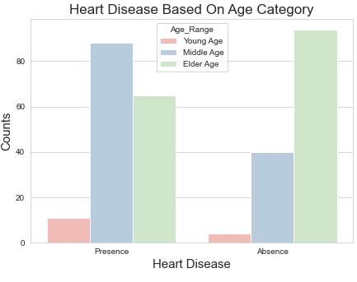

* It can be observed that males are more prone to suffer from heart disease or CVD’s.
* It can be observed that elderly aged people are more prone to heart disease.

## What symptoms people experience in heart disease

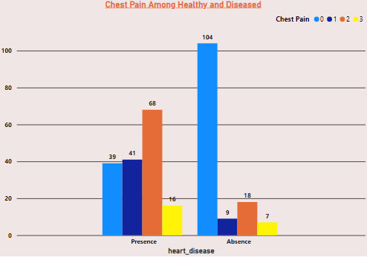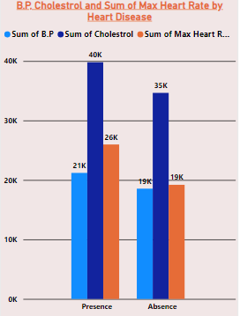

* It can be observed that those having asymptomatic chest pain are prone to heart disease
* Asymptomatic Chest pain refers to it neither shows nor causes symptoms of Heart disease
* It seems high number of cholesterol level in people having heart disease.

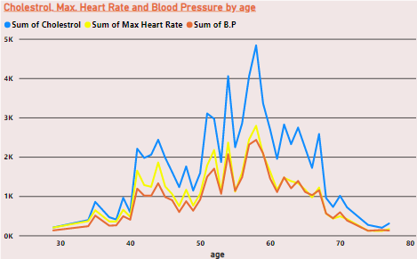

* Here we can observe that Blood Pressure increases between age of 50 to 60 and somehow continue the pattern till 70.
* Similarly, Cholesterol and maximum heart rate Increasing in the age group of 50-60.

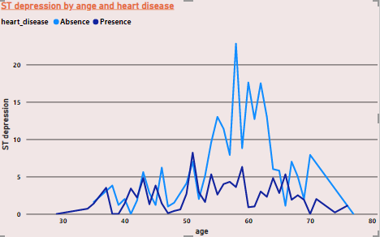

* We can observe from here that ST depression mostly increases between the age group of 30-40.
* ST depression refers to a finding on an electrocardiogram, wherein the trace in the ST segment is abnormally low below the baseline.