Architecture Design

Heart Disease Diagnostic Analysis



**Revision Number – 0.1**

**Last Date of Revision - 13/12/2022**

**Vinay Pritwani**

**Document Control**

|  |  |  |  |
| --- | --- | --- | --- |
| **Date** | **Version** | **Description** | **Author** |
| 13/12/2022 | 1.0 | Introduction, Architecture, Deployment | Vinay Pritwani |
|  |  |  |  |
|  |  |  |  |
|  |  |  |  |

**Contents**

Document Version Control 2

1. Introduction 4
   1. What is Architecture Design Document? 4
   2. Scope… 4
2. Architecture… 5
   1. Power BI Architecture… 5
   2. Components of Power BI Architecture 6
3. Deployment 7
   1. Power BI Deployment 7
   2. Publish datasets and reports from Power BI Desktop 7

# Introduction

## What is Architecture Design Document?

Any software needs the architectural design to represent the design of the software. IEEE defines architectural design as “the process of defining a collection of hardware and software components and their interfaces to establish the framework for the development of a computer system.” The software that is built for computer-based systems can exhibit one of these many architectures.

Each style will describe a system category that consists of:

* + - A set of components (eg: a database, computational modules) that will perform a function required by the system.
    - The set of connectors will help in coordination, communication, and cooperation between the components.
    - Conditions that how components can be integrated to form the system.
    - Semantic models help the designer to understand the overall properties of the system.
  1. **What is Scope?**

### Architecture Design Document (ADD) is an architectural design process that follows a step-by-step refinement process. The process can be used for designing data structures, required software architecture, source code and ultimately, performance algorithms.

### Overall, the design principles may be defined during requirement analysis and then refined during architectural design work.

# Architecture

* 1. **Power BI Architecture**

Power BI is a business suite that includes several technologies that work together. To deliver outstanding business intelligence solutions.

Microsoft Power BI technology consists of a group of components such as:

* + 1. Power Query (for data mash-up and transformation)
    2. Power BI Desktop (a companion development tool)
    3. Power BI Mobile (for Android, iOS, Windows phones)
    4. Power Pivot (for in-memory tabular data modelling)
    5. Power View (for viewing data visualizations)
    6. Power Map (for visualizing 3D geo-spatial data)
    7. Power Q&A (for natural language Q&A)

In simple terms, a Power BI user takes data from various data sources such as files, Azure source, online services and Direct Query or gateway sources.

Then, they work with that data on a client development tool such as Power BI Desktop. Here, the imported data is cleaned and transformed according to the user’s needs.

Once the data is transformed and formatted, it is ready to use in making visualizations in a report. A report is a collection of visualizations like graphs, charts, tables, filters, and slicers.

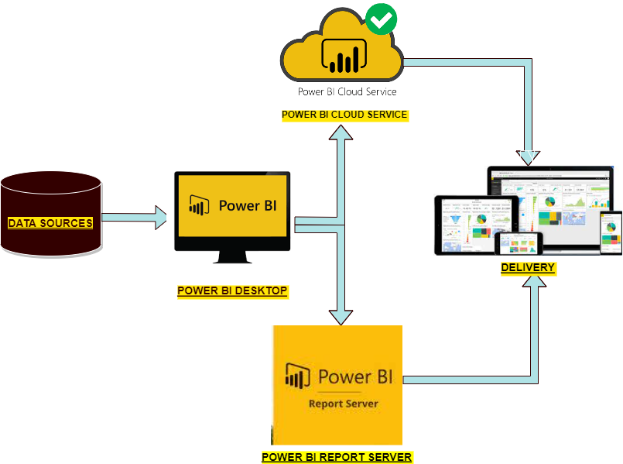

**2.2 Components of Power BI Architecture**

#### Data Sources

An important feature of Power BI is its huge range of data sources. We can import the data from files in our system, from cloud based servers or connect directly to live connections. Some of the data sources used in Power BI are:

* 1. Excel
  2. Text/CSV
  3. XML
  4. JSON
  5. Oracle Database
  6. IBM DB2 Database
  7. MySQL Database
  8. PostgreSQL Database
  9. Sybase Database
  10. Teradata Database
  11. SAP HANA Database
  12. SAP Business Warehouse server
  13. Amazon Redshift
  14. Impala
  15. Google Big Query (Beta)
  16. Azure SQL Database
  17. Salesforce Reports
  18. Google Analytics
  19. Facebook
  20. GitHub

#### Power BI Desktop

Power BI is a open source software that helps us to connect, transform and visualize the data on our desktop. We can connect with data sources through Power BI Desktop and combine the data into a data model. This allows us to create a collection of visuals and graphics that make us portray the information within the organization. Most number of people uses power BI to make and demonstrate their reports of the project they had been working on.

#### Power BI Service

Power BI Service is a web-based platform where we can share the reports we have made on Power BI Desktop, collaborate with other users. It is available in three versions:

* Free version
* Pro version
* Premium version

#### Power BI Report Server

The Power BI Report Server is identical to the Power BI Service but the main difference between the two is that Power BI Report Server is an on-premise platform in which you display and manage reports and KPIs. Along with it come the tools to create Power BI reports, paginated reports, mobile reports, and KPIs. Your users can access those reports in different ways: viewing them in a web browser or mobile device, or as an email in their in-box. It is used by organizations who do not wish to publish the reports for security purpose.

# Deployment

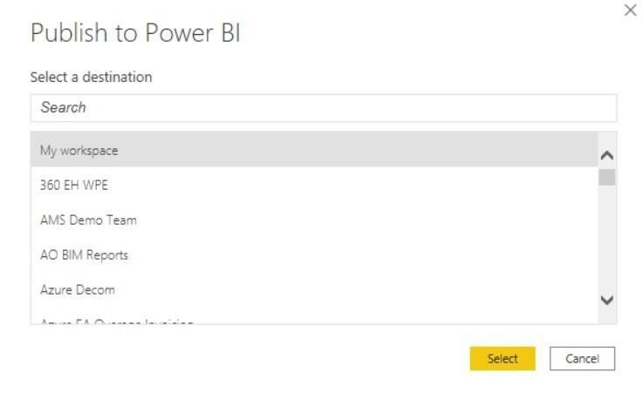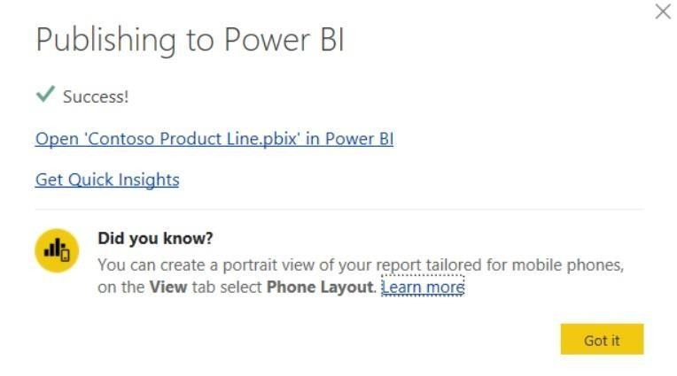

* 1. **Power BI Deployment**

In the deployment process we clone the content from one stage in the pipeline to another, typically from development to test, and from test to production.

While deploying, Power BI takes the content from the current stage, into the target one. The connections between the copied items are kept during the copy process. Power BI also applies the configured deployment rules to the updated content in the target stage. Deploying content may take a while, depending on the number of items being deployed. During this time, you can navigate to other pages in the Power BI portal, but you cannot use the content in the target stage.

* 1. **Publish datasets and reports from Power BI Desktop**

When you publish a Power BI Desktop file to the Power BI service, you publish the data in the model to your Power BI workspace. The same is true for any reports you created in Report view. You’ll see a new dataset with the same name, and any reports in your Workspace navigator.

Publishing from Power BI Desktop has the same effect as using Get Data in Power BI to connect to and upload a Power BI Desktop file.

