Title: Telangana Information Commission Enables Online Filing for Second Appeals and Complaints After Representation

In a welcome move towards digital transparency, the Telangana State Information Commission (TGIC) has now activated the facility for online filing of Second Appeals and Complaints on its official website — https://tgic.telangana.gov.in.
This step follows a representation I submitted to the Hon’ble Chief Information Commissioner on 12 November 2025, highlighting that the TGIC Handbook (October 2025 Edition) mentioned the availability of such a facility, though it was not yet operational on the portal.
After review, the Commission promptly acted on the representation.
Background:
For quite some time, applicants in Telangana had been facing difficulty filing Second Appeals and Complaints before the Telangana State Information Commission (TGIC) because the online filing feature, though mentioned in the Commission’s own handbook, was not actually available on the official website.
After noticing this discrepancy, I decided to formally bring it to the notice of the Hon’ble Chief Information Commissioner. What happened next was a quick and positive administrative action — and the online filing system is now fully functional.
This article documents the entire journey, including the handbook extract, my representation, the emails exchanged, proof of postal delivery, the Commission’s official response, and the updated screenshots of the TGIC portal.
I hope this experience helps other RTI users and encourages more citizens to raise systemic issues constructively.

1. Extract from the TGIC Handbook (October 2025 Edition)
While reading the Handbook on the Right to Information Act, 2005 published by the Commission, I came across the following clear statement on Page 77:
“A second appeal or a complaint can be filed electronically on https://tgic.telangana.gov.in along with the requisite documents. The documents must be duly signed / self-attested / verified before scanning and attaching with the appeal or complaint being filed.”

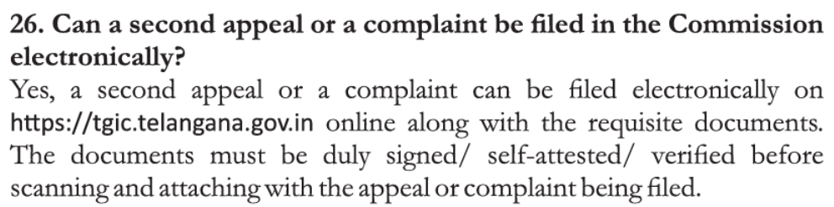
Screenshot of Page 77

However, when I checked the TGIC portal, no such option was available.
This contradiction is what triggered my formal representation.

2. My Representation Letter Dated 12-11-2025
On 12 November 2025, I submitted a detailed representation addressed to
Dr. G. Chandrashekar Reddy Garu, Hon’ble State Chief Information Commissioner.
The complete text of my representation is reproduced below:

Date: 12th November, 2025

To
Dr. G. Chandrashekar Reddy Garu
The State Chief Information Commissioner
Telangana State Information Commission
Samachara Hakku Bhavan,
M.J. Road, Nampally,
Hyderabad – 500001

Subject: Representation regarding non-availability of electronic filing facility for Second Appeals and Complaints on the TGIC portal, and related issues concerning online RTI implementation in Telangana.

Respected Sir,
I write this representation in the larger public interest to seek clarification and improvement in the online Right to Information (RTI) systems operated under the jurisdiction of the Telangana State Information Commission.
As per the “Handbook on the Right to Information Act, 2005” published by the Telangana State Information Commission (October 2025 Edition), it has been clearly mentioned on Page 77 that:
“A second appeal or a complaint can be filed electronically on https://tgic.telangana.gov.in along with the requisite documents. The documents must be duly signed / self-attested / verified before scanning and attaching with the appeal or complaint being filed.”
Extract from Page 77 of the TGIC Handbook on the Right to Information Act, 2005

However, upon visiting the said portal (https://tgic.telangana.gov.in), there appears to be no option or mechanism to file a second appeal or complaint electronically as stated in the official handbook. This discrepancy has created confusion among RTI applicants who rely on the Commission’s own publications for procedural guidance.

Furthermore, it has come to notice that the Commission presently does not accept RTI applications sent through email, and insists on physical hard copies being submitted. This requirement significantly restricts access to the RTI mechanism, especially for citizens residing in remote districts, senior citizens, and those unable to physically deliver or courier documents.

In this regard, I respectfully draw your attention to the judgment of the Hon’ble Supreme Court of India in Pravasi Legal Cell v. Union of India & Ors., W.P. (C) No. 1040 of 2019 (Order dated March 20, 2023). The Hon’ble Supreme Court, in the said order, directed all States, Union Territories, and High Courts to establish and operationalize functional online RTI portals within a stipulated timeframe, to give full effect to Section 6(1) of the Right to Information Act, 2005, which expressly allows applications to be made through electronic means.

In light of the above, it is respectfully submitted that:
- The absence of an online filing facility for second appeals and complaints on the TGIC portal appears inconsistent with both the Commission’s handbook and the Supreme Court’s directions.
- The non-acceptance of RTI applications through email, and the limited utilization of the Telangana RTI portal (https://rti.telangana.gov.in) by public authorities for disposing of applications, undermines the accessibility and transparency envisaged by the Act.

I therefore humbly request the Commission to kindly:
- Clarify whether any online facility currently exists for filing second appeals or complaints electronically, as mentioned in the Commission’s handbook.
- Consider enabling or operationalizing such an online facility on the TGIC portal in line with the Supreme Court’s order and the objectives of the RTI Act.
- Direct all public authorities to utilize the rti.telangana.gov.in portal fully for receiving and disposing of RTI applications online.
- Consider accepting RTI applications, complaints, and appeals through email, to enhance accessibility and compliance with Section 6(1).
I believe such measures would strengthen transparency, citizen access, and accountability in governance—core objectives of the Right to Information Act, 2005.
Yours faithfully,
(B. Vinay Reddy)
3. Email Submission to TGIC (12-11-2025, 11:30 AM)
On the same day, I emailed a signed copy of the representation to:
📩 cic-tgic@telangana.gov.in
📩 recp-tgic@telangana.gov.in
Below is the email screenshot I sent:
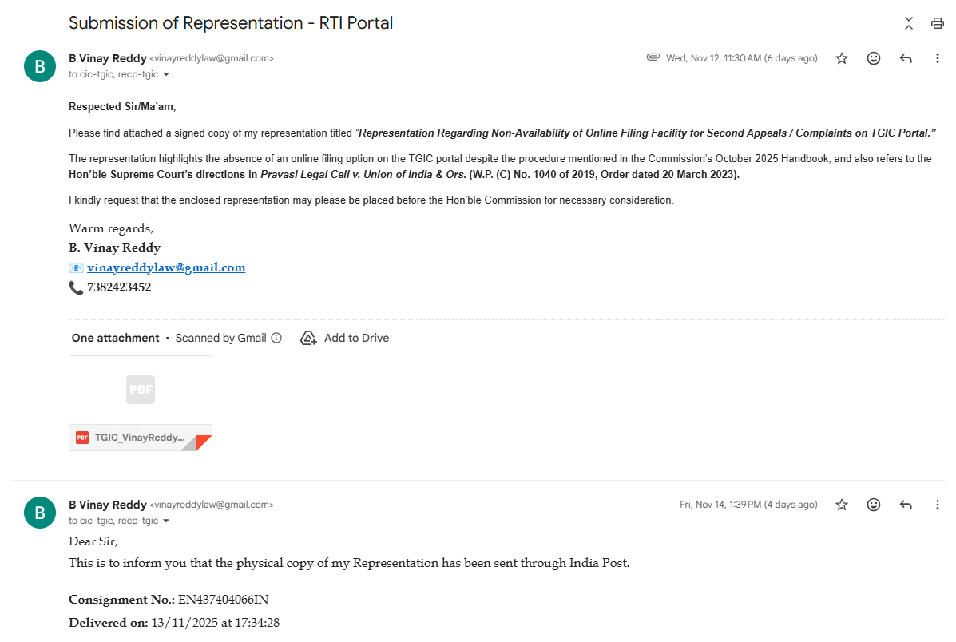

4. Physical Copy Sent via India Post — Delivered on 13-11-2025
To ensure official receipt, I also sent the representation by Speed Post.
Consignment No: EN437404066IN
Delivered on: 13/11/2025 at 17:34:28

5.Official Reply From TGIC (18-11-2025, 12:21 PM)
The response from TGIC was prompt and encouraging. This indicated that the Commission had acted upon the representation and enabled the online system.

Screenshot of TGIC Reply:
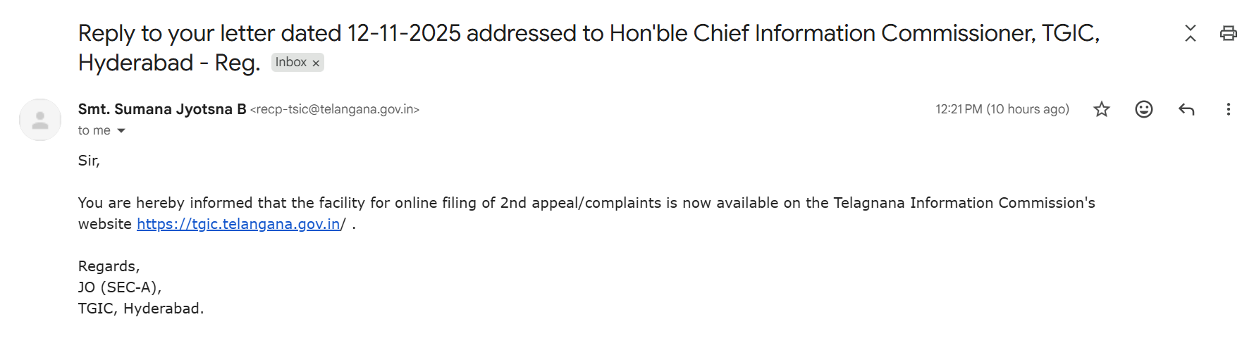

- TGIC Portal Updated – Online Filing Option Now Active
Now, the TGIC portal displayed a new “Online Filing” section with two active links:
- Second Appeal – https://tgic.telangana.gov.in/second-appeal-online.do
- Complaint – https://tgic.telangana.gov.in/complaint-online.do
A screenshot of the updated TGIC portal clearly shows the new “Online Filing” menu.
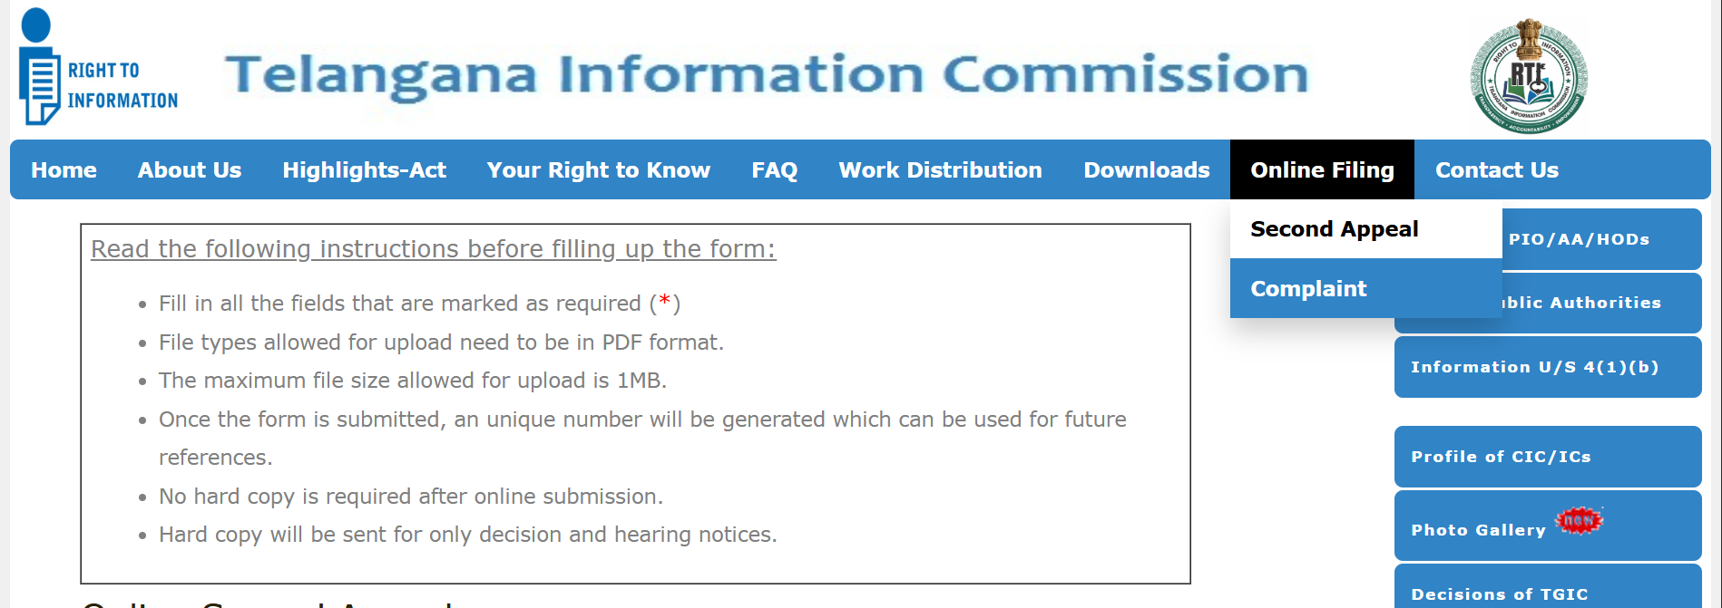
Additionally, the instructions page states:
“No hard copy is required after online submission. Hard copy will be sent only for decision and hearing notices.”
This is a major convenience boost for RTI users across Telangana.

Thank-You & Further Suggestions to TGIC
In appreciation, I sent a formal acknowledgment email thanking TGIC for promptly operationalising the online filing facility.
In the same message, I also suggested one final improvement:
- All RTI Applications and First Appeals should be fully handled through https://rti.telangana.gov.in/
- All Complaints and Second Appeals should be handled through https://tgic.telangana.gov.in
This two-portal system ensures a complete end-to-end digital RTI ecosystem in Telangana.

A Positive Outcome for Transparency
This experience demonstrates how a well-researched, well-written representation—even from an individual citizen—can lead to meaningful administrative action.
- A feature that was mentioned in the handbook but missing on the website is now live.
- Telangana citizens can now file Second Appeals and Complaints electronically, without visiting offices or sending hard copies.
- TGIC has taken a concrete step toward a digitally accessible RTI system, aligned with the Hon’ble Supreme Court’s direction in Pravasi Legal Cell v. Union of India (2023) mandating online RTI systems across all States.
This change will especially benefit applicants from rural districts, working professionals, senior citizens, and anyone unable to travel to Hyderabad for filing appeals or complaints.

Conclusion
Digital access is not merely convenience—it is an integral part of transparency, accountability, and citizens’ fundamental right to information.
I appreciate the Telangana Information Commission for:
- considering the representation promptly,
- enabling online filing,
- and taking a step toward a modern, citizen-centric RTI ecosystem.
With the remaining improvements to the RTI portal, Telangana can become a model State for RTI digital governance in India.

