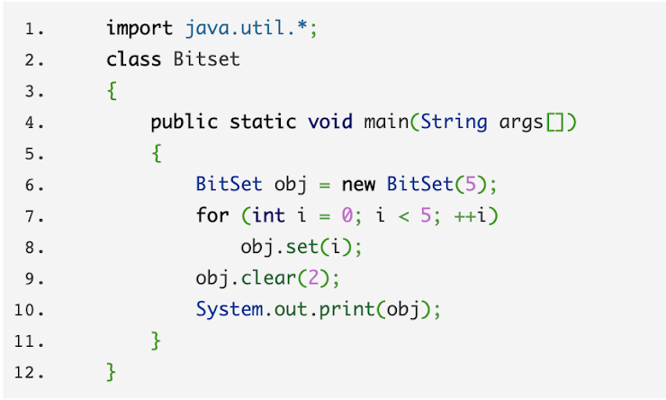

Q1. What will be the output of the following Java program?

1. {0, 1, 1, 3, 4}
2. {0, 1, 2, 3, 4}
3. {0, 1, 3, 4}
4. {0, 0, 0, 3, 4}

Q2. What will be the output of the following Java program? \*

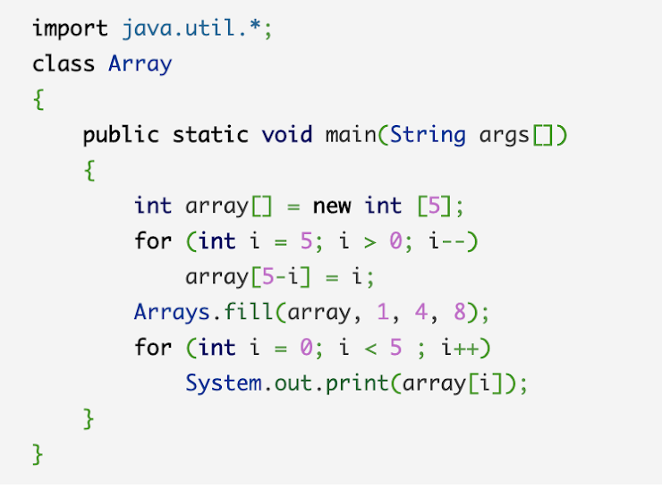

A.12845

B.12885

C.54881

D.58881

Array[0]=5

Array[1]=4🡪8

Array[2]=3🡪8

Array[3]=2🡪8

Array[4]=1

Q3. ​​Which of these classes is not part of Java’s collection framework? \*

A.Array

B.Map

C.LinkedHashset

D.Queue

Q4. Which interface restricts duplicate elements? \*

1. Stack
2. Heap
3. Set
4. List

Q5.In Java Deque and Queue are derived from \*

1. List
2. Collection
3. Abstract List
4. Abstract Collection

Q6. Which of these methods of FileReader class is used to read characters from a file? \*

1. scanf
2. cin
3. read
4. scan

Q7.The add and remove methods of TreeSet have a time complexity of. (n being number of elements, k being number of operations) \*

1. O(k)\*O(log(n))
2. O(log(n))
3. O(1)
4. O(n)

Q8. After resizing, size of ArrayList is increased by \*

1. 10%
2. 100%
3. 50%
4. 200%

Q9. Which provides better performance for the insertion and removal from the middle of the list? \*

A.Linkedlist

B.ArrayList

C.Set

D.Vector

Q10.What will be output of given code \*

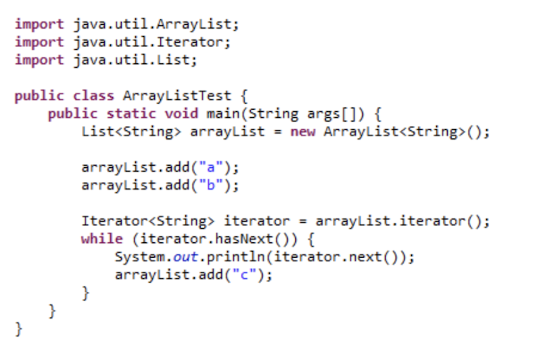

1. abc
2. ac
3. ab
4. followed by ConcurrentModificationException

Q11. What will be output of given code \*

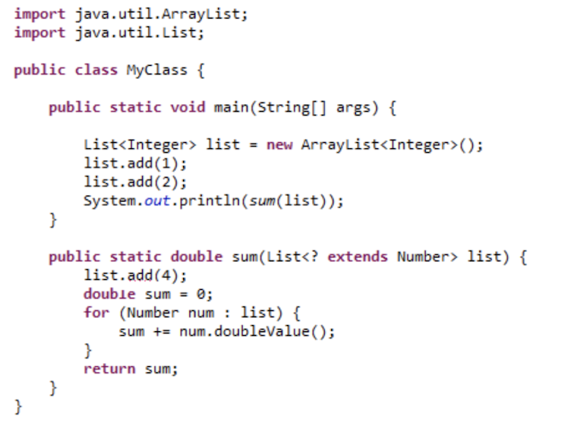

1. Compile time exception
2. 4
3. 7.0
4. Runtime Exception

\

Q12. What will be output of given code \*

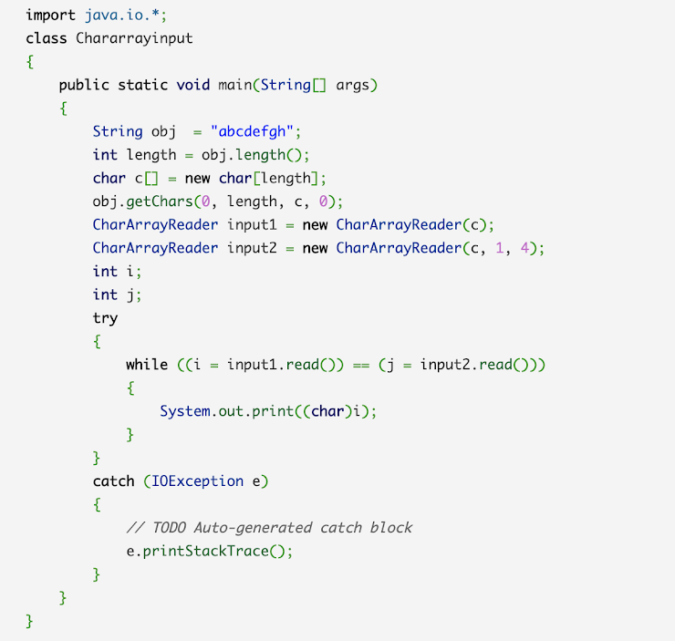

1. NOTA
2. abcd
3. abc
4. abcde

