CONTENTS

TOPIC NAME | PAGE NO.
Feasibility Study | 1
Software Development Life Cycle | 4
Introduction | 6
System used:  - Hardware  - Software | 7
Source Code | 8
Bibliography | 43

Feasibility study

The feasibility study is the important step in any software development process. This is because it makes analysis of different aspects like - cost required for developing and executing the system, the time required for each phase of the system and so on. If these important factors are not analyzed then definitely it would have impact on the organization & the development and the system would be a total failure.
The purpose of feasibility study is not to solve the problem, but to determine whether the problem is worth solving. By making analysis this way it would be possible to make a report of identified area of problem. By making a detailed analysis in this area a detailed document or report is prepared in this phase which has details like project plan or schedule of the project, the cost estimated for developing and executing the system, target dates for each phase of delivery of system developed and so on. This phase is the base of software development process since further steps taken in software development life cycle would be based on the analysis made on this phase and so careful analysis has to be made in this phase.
The feasibility study concentrates on the following area (TELOS):
- Technology and system feasibility
- Economic feasibility
- Legal feasibility
- Operational feasibility
- Schedule feasibility

Technology and system feasibility
The assessment is based on an outline design of system requirements, to determine whether the company has the technical expertise to handle completion of the project.

Economic feasibility (Cost/Benefit Analysis)
The economic feasibility study evaluates the cost of the software development against the ultimate income or benefits expected from the developed system. It includes identifying cost and benefit factors like – Development costs and operating costs. There must be scopes for profit after the successful completion of the project.

Legal feasibility
It determines whether the proposed system conflicts with legal requirements, e.g. a data processing system must comply with the local Data Protection Acts.

Operational feasibility
Operational feasibility is a measure of how well a proposed system solves the problems, and takes advantage of the opportunities identified during scope definition and how it satisfies the requirements identified in the requirements analysis phase of system development.

Schedule feasibility
A project will fail if it takes too long to be completed before it is useful. Typically this means estimating how long the system will take to develop, and if it can be completed in a given time period using some methods like payback period. Schedule feasibility is a measure of how reasonable the project timetable is. Given our technical expertise, are the project deadlines reasonable?

Advantages of making Feasibility study:

- As the initial step of software development life cycle, feasibility study has all the analysis part in it, which helps in analyzing the system requirements completely.

- Helps in identifying the risk factors involved in developing and deploying the system.

- The feasibility study helps in planning for risk analysis

- Feasibility study helps in making cost/benefit analysis which helps the organization and system to run efficiently.

- Feasibility study helps in making plans for training developers for implementing the system.

- So a feasibility study is a report which could be used by the senior or top persons in the organization. This is because based on the report, the organization decides about cost estimation, funding and other important decisions which is very essential for an organization to run profitably and for the system to run stable.

Thus before developing a product or software it is an essential step that one does feasibility study in some or all the areas mentioned which would help in developing and maintaining the software efficiently and effectively within budgeted costs

Software Development Life Cycle

The Systems Development Life Cycle (SDLC) is a conceptual model used in project management that describes the stages involved in an information system development project from an initial feasibility study through maintenance of the completed application.
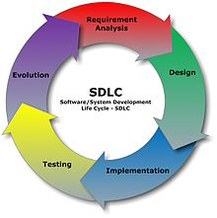
The following are the activities of the SDLC
- Software requirement analysis
- Systems analysis and design
- Design/Code generation
- Testing
- Development and Maintenance
A Systems Development Life Cycle (SDLC) adheres to important phases that are essential for developers, such as planning, analysis, design, and implementation. A number of system development life cycle (SDLC) models have been created such as waterfall, fountain, spiral etc.

Requirement Analysis/Investigation
The 1st stage of SDLC is the investigation phase. During this stage, business opportunities and problems are identified, and information technology solutions are discussed. Multiple alternative projects may be suggested and their feasibility analyzed. The results of the feasibility study can then be compiled into a report, along with preliminary specifications. When the investigation stage ends, a decision whether or not to move forward with the project should be made.

System Analysis
The goal of system analysis is to determine where the problem is, in an attempt to fix the system. It analyzes the requirement for the proposed system. To understand the nature of the program to build, the system engineer must understand the information domain for the software, as well as required functions, performance and the interfacing. This step involves breaking down the system in different pieces to analyze the situation, analyzing project goals, breaking down what needs to be created. From the available information the system engineer develops a list of system level requirement for the project.

Design
Systems design describes screen layouts, business rules, process diagrams, a complete entity-relationship diagram with a full data dictionary and other documentation. It defines specifically how the software is to be written including an object model, the client/server technology, a detailed database design etc. These design elements are intended to describe the software in sufficient detail that skilled programmers may develop the software with minimal additional input design. Analysis and design are very important in the whole development cycle. Any glitch in the design could be very expensive to solve in the later stage of the software development. The design must be translated into a machine readable form.

Testing
In this stage, all the pieces of software are brought together into a special testing environment and then are checked for errors, bugs and interoperability. Unit, system and user acceptance testing is often performed.

Deployment and Maintenance
Deployment is the final stage of initial development. It involves installation, initial training and may involve hardware and network upgrades. Software will definitely undergo change once it is delivered to the customer. There may be many reasons for the change. Change could be due to some unexpected input values into the system. The software should be developed to accommodate changes that could take place during the post implementation period. Maintaining the system is also an important aspect of SDLC. What happens during the rest of the software's life: changes, correction, additions, change to a different computing platform and more. Maintenance is often the longest of all the stages.

INTRODUCTION

The purpose of this project is to provide a system for flight management for the “SVY Travels”. The front end uses Java Swing and the backend uses MySQL.

In this software, we list out all our information about various flights and destinations that are being offered. The software contains two main forms which work with different table’s pDet and fDet which deal with the details of the customer and flights respectively. Each flight has a unique ID called Flight_ID (fid), which can be used in relations.

This software can be operated by the agents only with three main forms of flight details, reservations and cancellation. This project uses Database connectivity to store information in a MySQL Database.

SYSTEM USED

- The software programs used to make the project are as follows:


- Windows 7


- Netbeans IDE 7.2.1

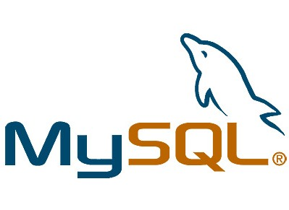

- MySQL 5.5 Command line client

- The hardware used to make the project are:
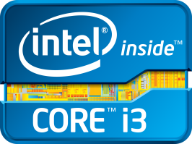

- Intel processor: core i3

- 4GB RAM

- 1TB Hard disc

- Compaq Laptop

SOURCE CODE

MySQL table structures:

- fDet Table (flight details)

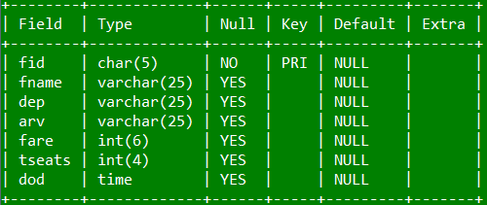

Creation Command:-

Create table fDet(fid char(5) primary key, fname varchar(25), dep varchar(25), arv varchar(25), fare int(6), tseats int(4), dod time);

- pDet Table (Passenger details)

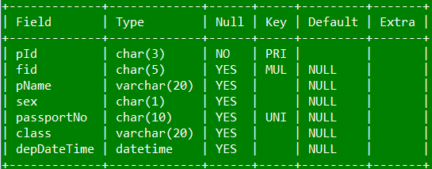

Creation Command:-

Create table pdet(pId char(3) primary key, fid char(5), pName varchar(20), sex char(1), passportNo char(10) unique, class varchar(20), depDateTime datetime, foreign key(fid) references fdet(fid));

The Program Screens:-

- Log-IN Screen :-

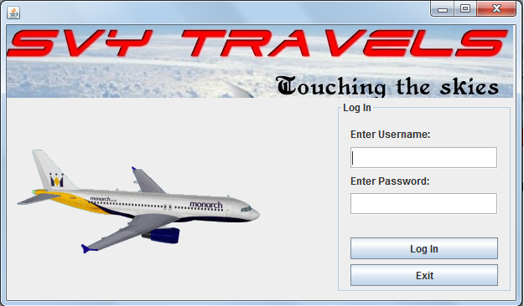

CONTROL | CONTROL NAME
Enter Username (JTextField) | uId
Enter Password (JPasswordField) | pass
Log In (JButton) | logIn
exit (JButton) | exit

private void logInActionPerformed(java.awt.event.ActionEvent evt) {
//Code for logging into the program and open home page
String u=uId.getText();
String p=new String(pass.getPassword());
String p1="";
for(int i=(u.length()-1);i>=0;i--){
p1=p1+u.charAt(i);
}

if(p1.equalsIgnoreCase(p)){
Home j=new Home();
j.setVisible(true);
this.dispose();
}
else {
JOptionPane.showMessageDialog(rootPane,"Please enter the correct password..... TRY AGAIN!!!!");
}
}
private void exitActionPerformed(java.awt.event.ActionEvent evt) {
//This button exits you from the log In screen
System.exit(0);
}

- The Home Screen :-

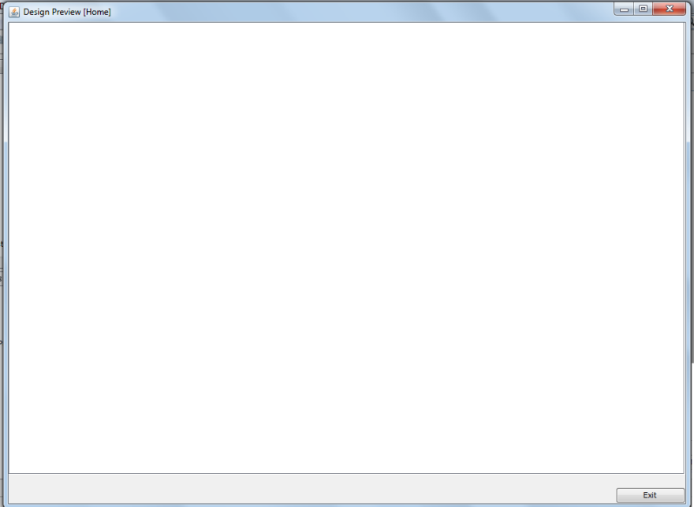

Control | Control Name
JTabbedPane | Home
Exit(JButton) | exit

//Loads the internal frames into the JTabbedPane

private void formWindowOpened(java.awt.event.WindowEvent evt) {

fDetails Det=new fDetails();
pDetails Details = new pDetails();
report rep=new report();
home.addTab("Flight Details",Det);
home.addTab("Passenger Details",Details);
home.addTab("Report",rep);
}

// This Button exits you from the home screen
private void exitActionPerformed(java.awt.event.ActionEvent evt) {
System.exit(0);
}
- Flight Details :-
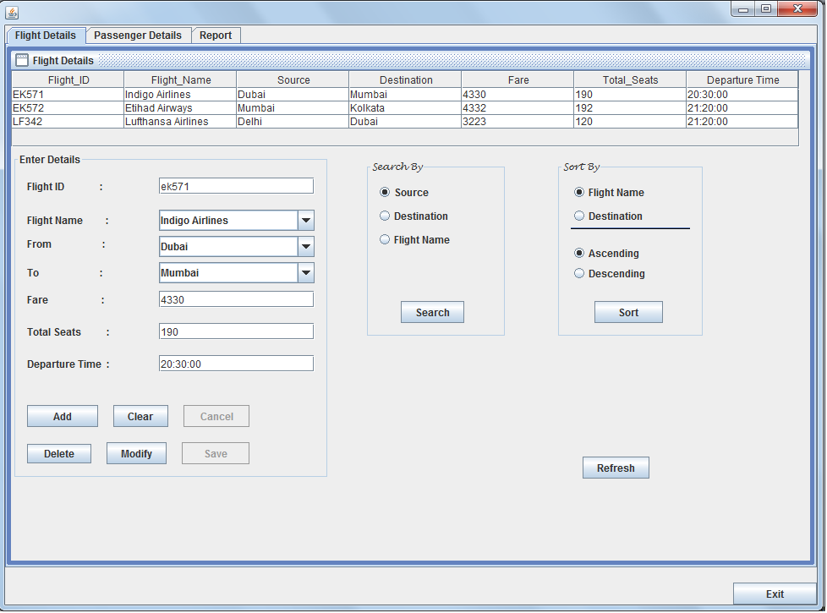

Control | Control Name
JTable | fDet
Flight ID(JTextField) | f_id
Flight Name(JComboBox) | f_name
From(JComboBox) | from
To(JComboBox) | to
Fare(JTextField) | fare
Total Seats(JTextField) | t_seats
Departure Time(JTextField) | dt
Add(JButton) | add
Clear(JButton) | clear
Delete(JButton) | delete
Modify(JButton) | modify
Cancel(JButton) | cancel
Save(JButton) | save
Refresh(JButton) | refresh
Source(JRadioButton) | fr
Destination (Search By) (JRadioButton) | de
Flight Name (Search By) (JRadioButton) | air
Flight Name (Sort By) (JRadioButton) | flight
Destination (Sort By) (JRadioButton) | dest
Ascending (JRadioButton) | asc
Descending (JRadioButton) | desc

// This disables the save & cancel buttons and inserts data into the table
private void formInternalFrameOpened(javax.swing.event. InternalFrameEvent evt) {

save.setEnabled(false);
cancel.setEnabled(false);
refresh.doClick();
f_name.setEditable(true);
from.setEditable(true);
to.setEditable(true);
}

//This button adds the rows into the table
private void addActionPerformed(java.awt.event.ActionEvent evt) {
// TODO add your handling code here:
try{
String fId = f_id.getText();
String fName = (String)f_name.getSelectedItem();
String from1 = (String)from.getSelectedItem();
String to1 = (String)to.getSelectedItem();
String fare1 = fare.getText();
String ts1 = t_seats.getText();
String dod1=dt.getText();
Class.forName("java.sql.DriverManager");
Connection con=(Connection)DriverManager.getConnection("jdbc:mysql://localhost/flight","root","pass");
Statement stmt=(Statement)con.createStatement();
String str="Insert into fDet values('"+fId+"','" +fName+"','"+from1+"','"+ to1+"',"+fare1+","+ts1+",'"+dod1+"')" ;
stmt.executeUpdate(str);
refresh.doClick();
stmt.close();
con.close();
}
catch(Exception e){
JOptionPane.showMessageDialog(this,e.getMessage());
}
clear.doClick();
}

//This button clears the textfields and resets the radio buttons
private void clearActionPerformed(java.awt.event.ActionEvent evt) {

f_id.setText("");
f_name.setSelectedIndex(0);
from.setSelectedIndex(0);
to.setSelectedIndex(0);
fare.setText("");
t_seats.setText("");
dt.setText("");
refresh.doClick();
}

//This button deletes a given record from the table
private void deleteActionPerformed(java.awt.event.ActionEvent evt) {
try{
String fId1=JOptionPane.showInputDialog("Enter Flight ID to be deleted:");
Class.forName("java.sql.DriverManager");
Connection con=(Connection) DriverManager.getConnection("jdbc:mysql://localhost/flight","root","pass");
Statement stmt=(Statement)con.createStatement();
String str="Delete from fDet where fid='"+fId1+"'";
stmt.executeUpdate(str);
refresh.doClick();
stmt.close();
con.close();
}
catch(Exception e){
JOptionPane.showMessageDialog(this,e.getMessage());
}
}

// This button inserts data of a given record into the controls on the internal frame
private void modifyActionPerformed(java.awt.event.ActionEvent evt) {
add.setEnabled(false);
delete.setEnabled(false);
modify.setEnabled(false);
search.setEnabled(false);
sort.setEnabled(false);
save.setEnabled(true);
cancel.setEnabled(true);
clear.setEnabled(false);
try{
String n=JOptionPane.showInputDialog("Enter Flight ID to be Modified:");
Class.forName("java.sql.DriverManager");
Connection con=(Connection)DriverManager.getConnection("jdbc:mysql://localhost/flight","root","pass");
Statement stmt=(Statement)con.createStatement();
String str="Select * from fdet where fid='"+n+"'";
ResultSet rs=stmt.executeQuery(str);
String fid1,fname1,from1,to1,fare1,tseats1,dod1;
rs.next();
fid1=rs.getString(1);
fname1=rs.getString(2);
from1=rs.getString(3);
to1=rs.getString(4);
fare1=rs.getString(5);
tseats1=rs.getString(6);
dod1=rs.getString(7);
f_id.setText(fid1);
f_name.setSelectedItem(fname1);
from.setSelectedItem(from1);
to.setSelectedItem(to1);
fare.setText(fare1);
t_seats.setText(tseats1);
dt.setText(dod1);
f_id.setEditable(false);
}
catch(Exception e){
JOptionPane.showMessageDialog(this,e.getMessage());
}
}

//This button saves the changes made in the record after clicking modify
private void saveActionPerformed(java.awt.event.ActionEvent evt) {
try{
String fno1=f_id.getText();
String name1=(String)f_name.getSelectedItem();
String ffrm=(String)from.getSelectedItem();
String fto1=(String)to.getSelectedItem();
String fare1 = fare.getText();
String ts1 = t_seats.getText();
String dod1=dt.getText();
Class.forName("java.sql.DriverManager");
Connection con=(Connection)DriverManager.getConnection("jdbc:mysql://localhost/flight","root","pass");
Statement Stmt=(Statement)con.createStatement();
String str="Update fdet set fname='"+name1+"',dep='"+ffrm+"',arv='"+fto1+"',fare="+fare1+",tseats="+ts1+",dod='"+dod1+"' where fid='"+fno1+"'";
Stmt.executeUpdate(str);
refresh.doClick();
Stmt.close();
con.close();
} catch(Exception e){
JOptionPane.showMessageDialog(this,e.getMessage());
}
}

// This button Cancels the modify mode and resets the fields
private void cancelActionPerformed(java.awt.event.ActionEvent evt) {

f_id.setEditable(true);
save.setEnabled(false);
cancel.setEnabled(false);
add.setEnabled(true);
clear.setEnabled(true);
delete.setEnabled(true);
modify.setEnabled(true);
search.setEnabled(true);
sort.setEnabled(true);
clear.doClick();
}

//This button takes data from the database and inserts it into the table on screen

private void refreshActionPerformed(java.awt.event.ActionEvent evt) {
try{
Class.forName("java.sql.DriverManager");
Connection con=(Connection)DriverManager.getConnection("jdbc:mysql://localhost/flight","root","pass");
Statement stmt=(Statement)con.createStatement();
String str="Select * from fDet";
ResultSet rs=stmt.executeQuery(str);
DefaultTableModel dtm=(DefaultTableModel)fDet.getModel();
while(dtm.getRowCount()>0) {
dtm.removeRow(0);
}
String fid1,fname1,from1,to1,fare1,tseats1,dod1;
while(rs.next()){
fid1=rs.getString(1);
fname1=rs.getString(2);
from1=rs.getString(3);
to1=rs.getString(4);
fare1=rs.getString(5);
tseats1=rs.getString(6);
dod1=rs.getString(7);
Object nr[]={fid1,fname1,from1,to1,fare1,tseats1,dod1};
dtm.addRow(nr);
}
rs.close();
stmt.close();
con.close();
} catch(Exception e){
JOptionPane.showMessageDialog(this,e.getMessage());
} }
// This button searches for a specific record in the database

private void searchActionPerformed(java.awt.event.ActionEvent evt) {

String str="";
String n="";
if(fr.isSelected()){
str="dep";
n=JOptionPane.showInputDialog("Enter source to be Searched:");
} else if(de.isSelected()){
str="arv";
n=JOptionPane.showInputDialog("Enter destination to be Searched:");
} else if(air.isSelected()){
str="fname";
n=JOptionPane.showInputDialog("Enter airline's name to be Searched:");
}
try{

Class.forName("java.sql.DriverManager");
Connection con=(Connection)DriverManager.getConnection("jdbc:mysql://localhost/flight","root","pass");
Statement stmt=(Statement)con.createStatement();
String str1="Select * from fdet where "+str+" ='"+n+"'";
ResultSet rs=stmt.executeQuery(str1);
DefaultTableModel dtm=(DefaultTableModel)fDet.getModel();
while(dtm.getRowCount()>0) {
dtm.removeRow(0); }
String fid1,fname1,from1,to1,fare1,tseats1,dod1;
while(rs.next()){
fid1=rs.getString(1);
fname1=rs.getString(2);
from1=rs.getString(3);
to1=rs.getString(4);
fare1=rs.getString(5);
tseats1=rs.getString(6);
dod1=rs.getString(7);
Object nr[]={fid1,fname1,from1,to1,fare1,tseats1,dod1};
dtm.addRow(nr);
}
stmt.close();
con.close();
}
catch(Exception e){
JOptionPane.showMessageDialog(this,e.getMessage());
}
}

// This button arranges the records in a specific order
private void sortActionPerformed(java.awt.event.ActionEvent evt) {
try{
String sort1="",order ="";
if(flight.isSelected()) {
sort1="fname";
}
else if(dest.isSelected()) {
sort1="arv";
}
if(asc.isSelected()) {
order="asc";
}
else if(desc.isSelected()) {
order="desc";
}
Class.forName("java.sql.DriverManager");
Connection con=(Connection)DriverManager.getConnection("jdbc:mysql://localhost/flight","root","pass");
Statement stmt=(Statement)con.createStatement();
String str="Select * from fDet order by "+sort1+" "+order;
ResultSet rs=stmt.executeQuery(str);
DefaultTableModel dtm=(DefaultTableModel)fDet.getModel();
while(dtm.getRowCount()>0) {
dtm.removeRow(0);
}
String fid1,fname1,from1,to1,fare1,tseats1,dod1;
while(rs.next()){
fid1=rs.getString(1);
fname1=rs.getString(2);
from1=rs.getString(3);
to1=rs.getString(4);
fare1=rs.getString(5);
tseats1=rs.getString(6);
dod1=rs.getString(7);
Object nr[]={fid1,fname1,from1,to1,fare1,tseats1,dod1};
dtm.addRow(nr);
}

stmt.close();
con.close();
}
catch(Exception e){
JOptionPane.showMessageDialog(this,e.getMessage());
}
}

- Passenger Details
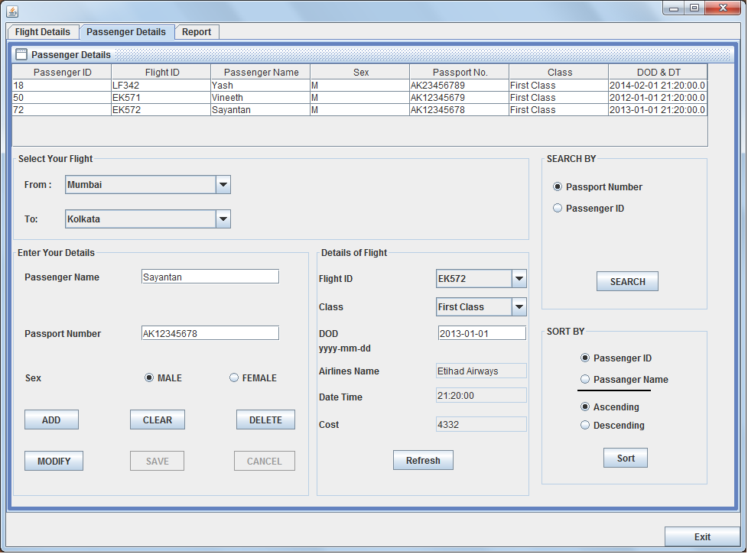

Control | Control Name
Passenger Name (JTextField) | pname
Passport Number (JTextField) | pno
DOD (JTextField) | dod
Airlines Name (JTextField) | airName
Date Time (JTextField) | tod
Cost (JTextField) | cost
Passenger ID (JTextField) | pID
Male (JRadioButton) | male
Female (JRadioButton) | female
Passport Number (JRadioButton) | pnoS
Passenger ID (Search By) (JRadioButton) | PassIDS
Passenger ID (Sort By) (JRadioButton) | srtPid
Passenger Name (JRadioButton) | srtPname
Ascending (JRadioButton) | asc
Descending (JRadioButton) | desc
From (JComboBox) | from
To (JComboBox) | to
Flight ID (JComboBox) | flightID
Class (JComboBox) | class1
ADD (JButton) | add
CLEAR (JButton) | clear
DELETE (JButton) | delete
MODIFY (JButton) | modify
SAVE (JButton) | save
CANCEL (JButton) | cancel
REFRESH (JButton) | refresh
SEARCH (JButton) | search
Sort (JButton) | sort

//Declaration of public variable
String searchAns=null;
//Method modOn() declaration
void modOn(){
add.setEnabled(false);
del.setEnabled(false);
modify.setEnabled(false);
search.setEnabled(false);
sort.setEnabled(false);
save.setEnabled(true);
cancel.setEnabled(true);
clear.setEnabled(false);
}
//Method modOff() declaration
void modOff(){
save.setEnabled(false);
cancel.setEnabled(false);
add.setEnabled(true);
del.setEnabled(true);
modify.setEnabled(true);
search.setEnabled(true);
sort.setEnabled(true);
clear.setEnabled(true);
}
//These actions are performed when the internal frame is opened
private void formInternalFrameOpened(javax.swing.event.InternalFrameEvent evt) {

modOff();
try{
Class.forName("java.sql.DriverManager");
Connection con=(Connection)DriverManager.getConnection("jdbc:mysql://localhost/flight","root","pass");
Statement stmt=(Statement)con.createStatement();
String str1="Select distinct dep from fdet";
ResultSet rs=stmt.executeQuery(str1);
String fid1;
while(rs.next()){
fid1=rs.getString(1);
from.addItem(fid1);
}
rs.close();
stmt.close();
con.close();
}
catch(Exception e){
JOptionPane.showMessageDialog(this,e.getMessage());
}
jLabel10.setVisible(false);
pID.setVisible(false);
refresh.doClick();
}

//This action is performed on fromActionPerformed
private void fromActionPerformed(java.awt.event.ActionEvent evt) {

try{
Class.forName("java.sql.DriverManager");
Connection con=(Connection)DriverManager.getConnection("jdbc:mysql://localhost/flight","root","pass");
Statement stmt=(Statement)con.createStatement();
String dep = (String)from.getSelectedItem();
String str1="Select distinct arv from fdet where dep='"+dep+"' ";
ResultSet rs=stmt.executeQuery(str1);
String fid1;
to.removeAllItems();
while(rs.next()){
fid1=rs.getString(1);
to.addItem(fid1);
}
rs.close();
stmt.close();
con.close();
}

catch(Exception e){
JOptionPane.showMessageDialog(this,e.getMessage());
}
}

// This action is performed on toActionPerformed
private void toActionPerformed(java.awt.event.ActionEvent evt) {
String dep=(String)from.getSelectedItem();
String arv=(String)to.getSelectedItem();
try{
Class.forName("java.sql.DriverManager");
Connection con=(Connection)DriverManager.getConnection("jdbc:mysql://localhost/flight","root","pass");
Statement stmt=(Statement)con.createStatement();
String str1="Select * from fdet where dep='"+dep+"' and arv='"+arv+"' ";
ResultSet rs=stmt.executeQuery(str1);
String fid1;
flightID.removeAllItems();
while(rs.next()){
fid1=rs.getString(1);
flightID.addItem(fid1);
}
rs.close();
stmt.close();
con.close();
}

catch(Exception e){
JOptionPane.showMessageDialog(this,e.getMessage());
}
}
// This action is performed on flightIDActionPerformed
private void flightIDActionPerformed(java.awt.event.ActionEvent evt) {
String fid1=(String) flightID.getSelectedItem();
try{
Class.forName("java.sql.DriverManager");
Connection con=(Connection)DriverManager.getConnection("jdbc:mysql://localhost/flight","root","pass");
Statement stmt=(Statement)con.createStatement();
String str1="Select * from fDet where fid='"+fid1+"' ";
ResultSet rs=stmt.executeQuery(str1);
String fare1,airName1,tod1;
if(rs.next()){
fare1=rs.getString(5);
airName1=rs.getString(2);
tod1=rs.getString(7);
cost.setText(fare1);
airName.setText(airName1);
tod.setText(tod1);
}
rs.close();
stmt.close();
con.close();
}
catch(Exception e){
JOptionPane.showMessageDialog(this,e.getMessage());
}
}
//This button adds records to the table pDet
private void addActionPerformed(java.awt.event.ActionEvent evt) {
try{
String pname1=pname.getText();
String pno1=pno.getText();
String fid1=(String)flightID.getSelectedItem();
String class2=(String)class1.getSelectedItem();
String dot=tod.getText();
String dod1=dod.getText()+" "+dot;
int paNo=((int)(Math.random()*101));

String s;
if(male.isSelected()) {
s="M";
}
else {
s="F";
}
Class.forName("java.sql.DriverManager");
Connection con=(Connection)DriverManager.getConnection("jdbc:mysql://localhost/flight","root","pass");
Statement stmt=(Statement)con.createStatement();
String str="Insert into pDet values('"+paNo+"','"+fid1+"','"+pname1+"','"+s+"','"+pno1+"','"+class2+"','"+dod1+"')";
stmt.executeUpdate(str);
stmt.close();
con.close();
refresh.doClick();
clear.doClick();
}
catch(Exception e){
JOptionPane.showMessageDialog(this,e.getMessage());
}
}
//This button clears all the textfields and resets combo boxes and radio buttons
private void clearActionPerformed(java.awt.event.ActionEvent evt) {
dod.setText("");
cost.setText("");
pname.setText("");
pno.setText("");
male.setSelected(true);
class1.setSelectedIndex(0);
airName.setText("");
tod.setText("");
flightID.removeAllItems();
}

//This button deletes a particular record form the database
private void delActionPerformed(java.awt.event.ActionEvent evt) {
try{
String pId1=JOptionPane.showInputDialog("Enter Passenger ID to be deleted:");
Class.forName("java.sql.DriverManager");
Connection con=(Connection) DriverManager.getConnection("jdbc:mysql://localhost/flight","root","pass");
Statement stmt=(Statement)con.createStatement();
String str="Delete from pDet where pId='"+pId1+"'";
stmt.executeUpdate(str);
stmt.close();
con.close();
refresh.doClick();
clear.doClick();
}
catch(Exception e){
JOptionPane.showMessageDialog(this,e.getMessage());
}
}

// This button inserts data of a given record into the controls on the internal frame
private void modifyActionPerformed(java.awt.event.ActionEvent evt) {
modOn();
try{
String n=JOptionPane.showInputDialog("Enter Passenger ID to be Modified:");
Class.forName("java.sql.DriverManager");
Connection con=(Connection)DriverManager.getConnection("jdbc:mysql://localhost/flight","root","pass");
Statement stmt=(Statement)con.createStatement();
String str="Select * from pdet where pId='"+n+"' ";
ResultSet rs=stmt.executeQuery(str);
String pid1,fid1,pname1,sex1,pno1,class2,dot1;
rs.next();
pid1=rs.getString(1);
fid1=rs.getString(2);
pname1=rs.getString(3);
sex1=rs.getString(4);
pno1=rs.getString(5);
class2=rs.getString(6);
dot1=rs.getString(7);
String dod1=dot1;
String str1="Select dep,arv from fdet where fid='"+fid1+"'";
ResultSet rs1=stmt.executeQuery(str1);
String to1,from1;
rs1.next();
to1=rs1.getString(2);
from1=rs1.getString(1);
from.setSelectedItem(from1);
to.setSelectedItem(to1);
dod.setText(dod1.substring(0,10));
flightID.setSelectedItem(fid1);
pname.setText(pname1);
pno.setText(pno1);
pID.setText(pid1);
if(sex1.equalsIgnoreCase("M")) {
male.setSelected(true);
}
else {
female.setSelected(true);
}
class1.setSelectedItem(class2);
tod.setText(dot1.substring(10,19));
refresh.doClick();
rs.close();
stmt.close();
con.close();

}
catch(Exception e){
JOptionPane.showMessageDialog(this,e.getMessage());
}
}
//This button saves the modified data into the database
private void saveActionPerformed(java.awt.event.ActionEvent evt) {
try{
Class.forName("java.sql.DriverManager");
Connection con=(Connection)DriverManager.getConnection("jdbc:mysql://localhost/flight","root","pass");
Statement Stmt=(Statement)con.createStatement();
String pid1=pID.getText();
String pname1=pname.getText();
String pno1=pno.getText();
String fid1=(String)flightID.getSelectedItem();
String s1="F";
if(male.isSelected()) {
s1="M";
}
String class2=(String)class1.getSelectedItem();
String tod1=dod.getText()+" "+tod.getText();
String str="Update pDet set fid='"+fid1+"',pName='"+pname1 +"',sex='" +s1+"',passportNo='"+pno1+"',class='"+class2+"',depdatetime='"+tod1+
"' where pId="+pid1;
Stmt.executeUpdate(str);
Stmt.close();
con.close();
refresh.doClick();
cancel.doClick();
}
catch(Exception e){
JOptionPane.showMessageDialog(this,e.getMessage());
}
}
// This button Cancels the modify mode and resets the fields
private void cancelActionPerformed(java.awt.event.ActionEvent evt) {
modOff();
clear.doClick();
}

//This button takes data from the database and inserts it into the table on screen
private void refreshActionPerformed(java.awt.event.ActionEvent evt) {
try{
Class.forName("java.sql.DriverManager");
Connection con=(Connection)DriverManager.getConnection("jdbc:mysql://localhost/flight","root","pass");
Statement stmt=(Statement)con.createStatement();
String str="Select * from pdet ";
if(searchAns!=null){
if(pnoS.isSelected()) {
str+= " where passportno='"+searchAns+"'";
}
else if(PassIDS.isSelected()) {
str+=" where pid='"+searchAns+"'";
}
}

String sort1="",order ="";
if(srtPid.isSelected()) {
sort1="Pid";
}
else if(srtPname.isSelected()) {
sort1="pname";
}
if(asc.isSelected()) {
order=" asc";
}
else if(desc.isSelected()) {
order=" desc";
}

str+= " order by "+sort1+order;

ResultSet rs=stmt.executeQuery(str);

DefaultTableModel dtm=(DefaultTableModel)passTable.getModel();
while(dtm.getRowCount()>0) {
dtm.removeRow(0);
}
String pid1,fid1,pname1,dep1,arv1,sex1,pno1,class2,dot1;
while(rs.next()){
pid1=rs.getString(1);
fid1=rs.getString(2);
pname1=rs.getString(3);
sex1=rs.getString(4);
pno1=rs.getString(5);
class2=rs.getString(6);
dot1=rs.getString(7);
Object nr[]={pid1,fid1,pname1,sex1,pno1,class2,dot1};
dtm.addRow(nr);
}
rs.close();
stmt.close();
con.close();
}
catch(Exception e){
JOptionPane.showMessageDialog(this,e.getMessage());
}
searchAns=null;
}
// This button searches for a specific record in the database
private void searchActionPerformed(java.awt.event.ActionEvent evt) {
if(pnoS.isSelected()) {
searchAns=JOptionPane.showInputDialog("Enter Passport Number");
}
else if(PassIDS.isSelected()) {
searchAns=JOptionPane.showInputDialog("Enter passenger ID");
}
refresh.doClick();
}
// This button arranges the records in a specific order
private void sortActionPerformed(java.awt.event.ActionEvent evt) {
refresh.doClick();
}

- Report :-

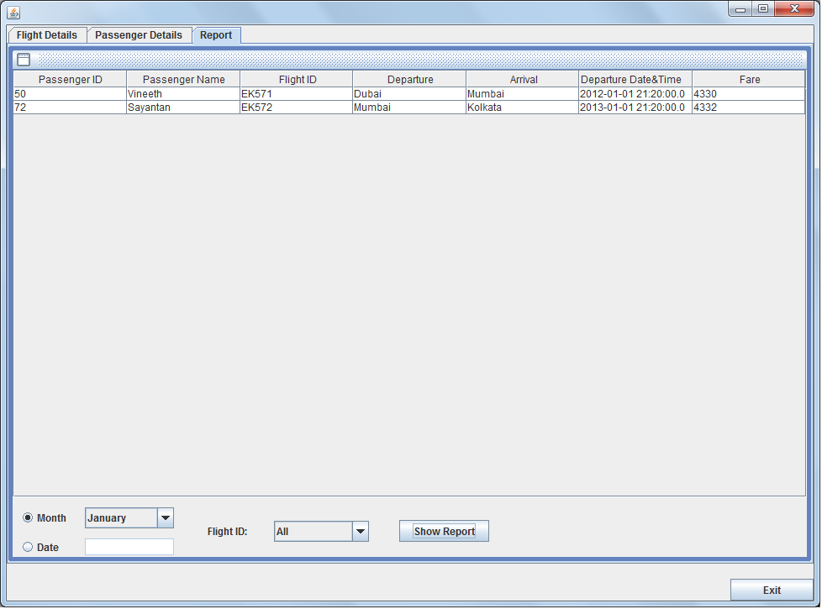

Control | Control Name
JTable | repTable
Month (JRadioButton) | month
Date (JRadioButton) | date
JComboBox | Smonth
JTextField | Sdate
Flight ID (JComboBox) | Sfid
Show Report (JButton) | rep

//This action is performed on opening the internal frame

private void formInternalFrameOpened(javax.swing.event.InternalFrameEvent evt) {

Sdate.setEnabled(false);
try{
Class.forName("java.sql.DriverManager");
Connection con=(Connection)DriverManager.getConnection("jdbc:mysql:// localhost/flight","root","pass");
Statement stmt=(Statement)con.createStatement();
String str1="Select fid from fdet";
ResultSet rs=stmt.executeQuery(str1);
String fid1;
Sfid.addItem("All");
while(rs.next()){
fid1=rs.getString(1);
Sfid.addItem(fid1);
}
rs.close();
stmt.close();
con.close();
}
catch(Exception e){
JOptionPane.showMessageDialog(this,e.getMessage());
}
}

//This action is performed on monthActionPerformed

private void monthActionPerformed(java.awt.event.ActionEvent evt) {

Sdate.setText("");
if(month.isSelected()){
Smonth.setEnabled(true);
Sdate.setEnabled(false);
}
}

//This action is performed on dateActionPerformed

private void dateActionPerformed(java.awt.event.ActionEvent evt) {

Smonth.setSelectedIndex(0);
if(date.isSelected()){
Smonth.setEnabled(false);
Sdate.setEnabled(true);
}
}

//This button shows the report based on the specified criteria

private void repActionPerformed(java.awt.event.ActionEvent evt) {

try{
Class.forName("java.sql.DriverManager");
Connection con= (Connection)DriverManager.getConnection("jdbc:mysql:// localhost/flight","root","pass");
Statement stmt=(Statement)con.createStatement();
String vfid=(String)Sfid.getSelectedItem();
String str="Select * from fDet natural join pdet";
if(month.isSelected()){
str+=" where month(depDateTime)='" +(Smonth.getSelectedIndex()+1)+"'";
}
else{
str+=" where date(depDateTime)='"+(Sdate.getText())+"'";
}
if(Sfid.getSelectedIndex()!=0){
str+=" and fid='"+Sfid.getSelectedItem()+"'";
}
ResultSet rs=stmt.executeQuery(str);

DefaultTableModel dtm=(DefaultTableModel)repTable.getModel();
while(dtm.getRowCount()>0) {
dtm.removeRow(0);
}

String pid1,pname1,fid1,dep1,arv1,dod1,cost1;
while(rs.next()){
pid1=rs.getString(8);
fid1=rs.getString(1);
pname1=rs.getString(9);
dep1=rs.getString(3);
arv1=rs.getString(4);
dod1=rs.getString(13);
cost1=rs.getString(5);
Object nr[]={pid1,pname1,fid1,dep1,arv1,dod1,cost1};
dtm.addRow(nr);
}
rs.close();
stmt.close();
con.close();
}
catch(Exception e){
JOptionPane.showMessageDialog(this,e.getMessage());
}
}

BIBLIOGRAPHY

- Google.com



- Stackoverflow.com


- Netbeans.org


