Customer Shopping Behaviour Analysis
Business Problem Statement:
A leading retail company wants to better understand its customers’ shopping behaviour in order to improve sales, customer satisfaction, and long-term loyalty. The management team has noticed changes in purchasing patterns across demographics, product categories, and sales channels (online vs. offline). They are particularly interested in uncovering which factors, such as discounts, reviews, seasons, or payment preferences, drive consumer decisions and repeat purchases. You are tasked with analyzing the company’s consumer behaviour dataset to answer the following overarching business question: “How can the company leverage consumer shopping data to identify trends, improve customer engagement, and optimize marketing and product strategies?
Project Overview:
This project analyzes customer shopping behavior using transactional data from 3,900 purchases across various product categories. The goal is to uncover insights into spending patterns, customer segments, product preferences, and subscription behaviour to guide strategic business decisions.
DataSet :
Row:3,900
Columns:18
We can find Customer Shopping Behaviour in (Discount Applied, Promo Code Used, Previous Purchases, Frequency of Purchases, Review Rating, Shipping Type)
Puchase Details in(item Purchased, Category, Purchase Amount, Season, Size, Color)
Customer Details in((Age, Gender, Location, Subscription Status).
Exploratory Data Analysis using Python:
We start with Loading Data By using Pandas
Initial Exploration: Used df.info() to check structure and .describe() for summary statistics.set
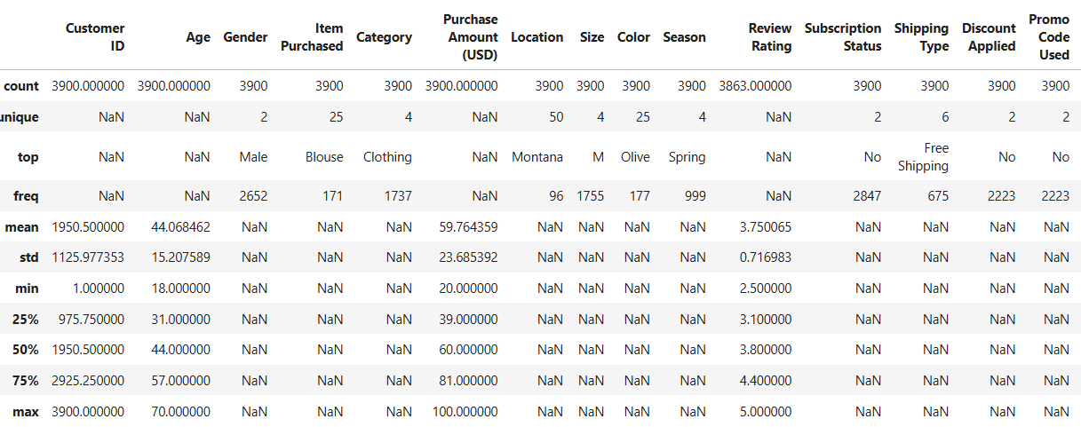
Finding Missing Values: Checked for null values and imputed missing values in the Review Rating column using the median rating of each product category.
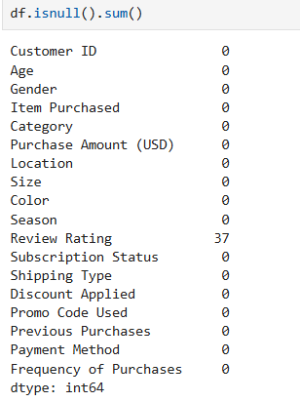
Replaced values :
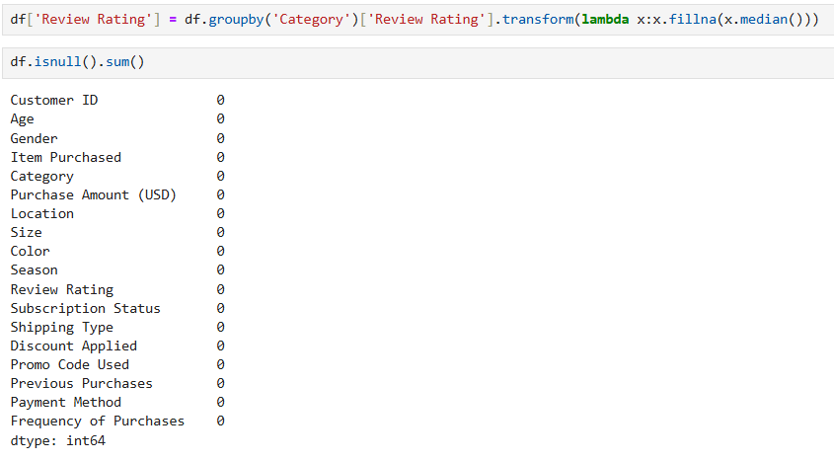
Column Standardization: Renamed columns to snake case for better readability and documentation.
Data Consistency checking and mapping the data accordinglyVerified if discount_applied and promo_code_used were redundant; dropped promo_code_used.
Database Integration: Connected Python script to MySQL WorkBench and loaded the cleaned DataFrame into the database for SQL analysis.
1.Total Revenue Generated By Each Gender: Compared with total revenue and Gender.
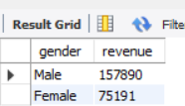
2.Highest Discount :Identify discount and customer how spend above the Average Purchase amount.
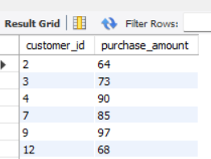
3.Top 5 Products Having Average Review: Found the product with Average RiewRatings
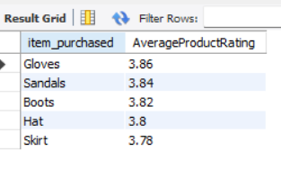
4.Shipping Type :Comapared AVG purchase amount Between shiioping mode
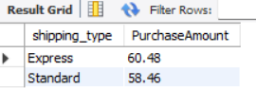
5. Subscribers vs. Non-Subscribers: compared avg spend and total revenue for subscription status.
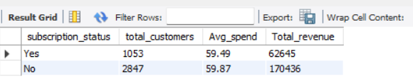
6.Dicsounts dependent on purhcases:
Identified the products with highest percentage of discount
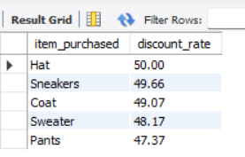
7.Customer Classified Based on Types :
Classified based on there Returning,Loyal,or New.
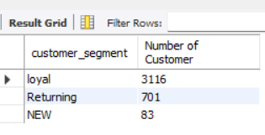
8.Top Products per Category:
Listed of most purchased products
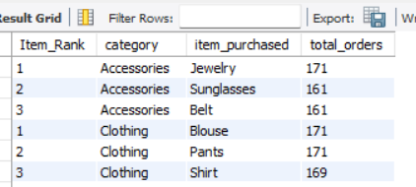
9
Revenue by Age Group – Calculated total revenue contribution of each age group.
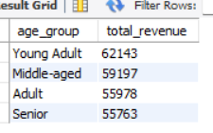
PowerBI Dashboard
