Cloud Service Composition using RedFox Algorithm

Now-a-days many cloud service providers are providing heavy computation resources at cheaper cost and due to this advantages many organizations are migrating their application towards cloud deployment and this huge demand and migration raises quality of services (QOS) issues which need to be solved for both cloud services providers and customers.

If QOS like Delay, response time, throughput and many other QOS metrics are not good then it consume more resources for the cloud service providers and customer will also face Response Delay problem.

To overcome from above issue many optimized algorithms are introduced such PSO, Genetic Algorithm, whale algorithm and many more. This optimized algorithms will take customer requirements or current QOS values as input and then will select best or optimized services based on current QOS or customer requirements.

In propose work we are implementing RedFox hunting behaviour optimization algorithm for cloud service composition. All RedFox will go out in search of food as population and then they will calculate fitness based on nearest food and whatever fox closer to food will inform others.

For cloud service composition also we will take customer requirement or QOS values as population and then will start iteration and for each iteration we will calculate fitness and if selected QOS values are closer to customer requirement then fitness value will be high and this will continue till no more optimizations left and finally high fitness service will be selected as best or optimized services.

To implement this project we are taking below dataset

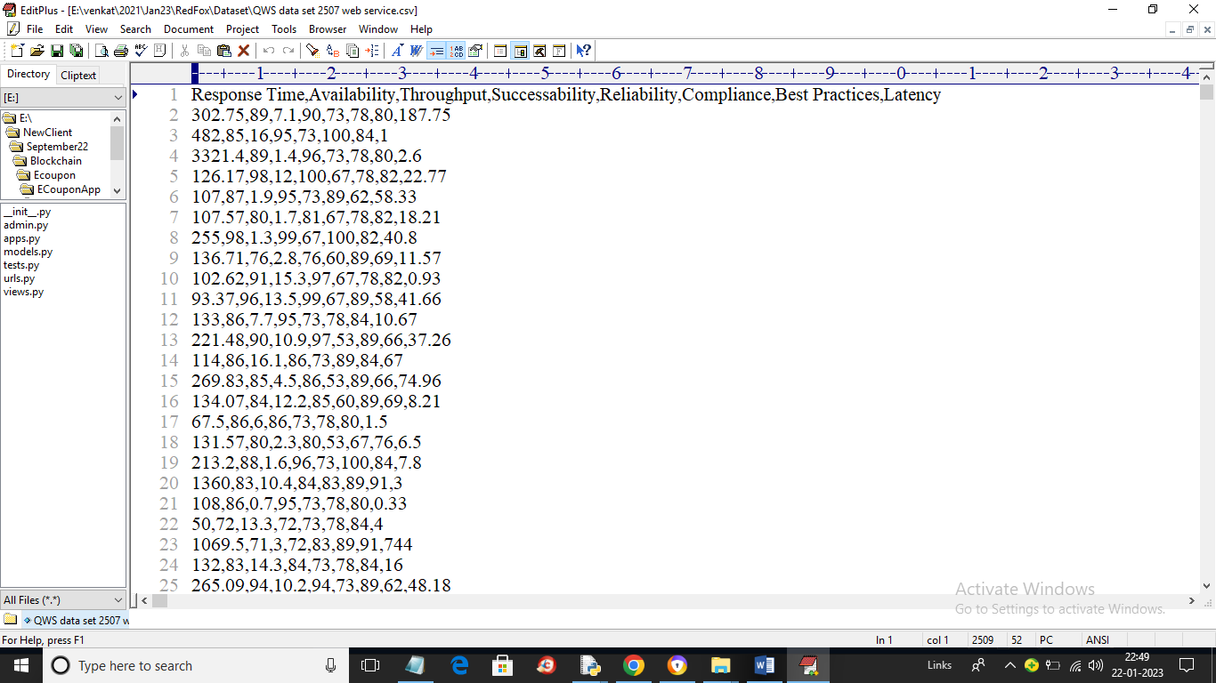

In above dataset screen first row contains dataset column names and remaining rows contains dataset values and those values are the service composition like Response Time, throughput etc. We will input above dataset and then RedFox algorithm will give best service and fitness values as output

To run project double click on ‘run.bat’ file to get below screen

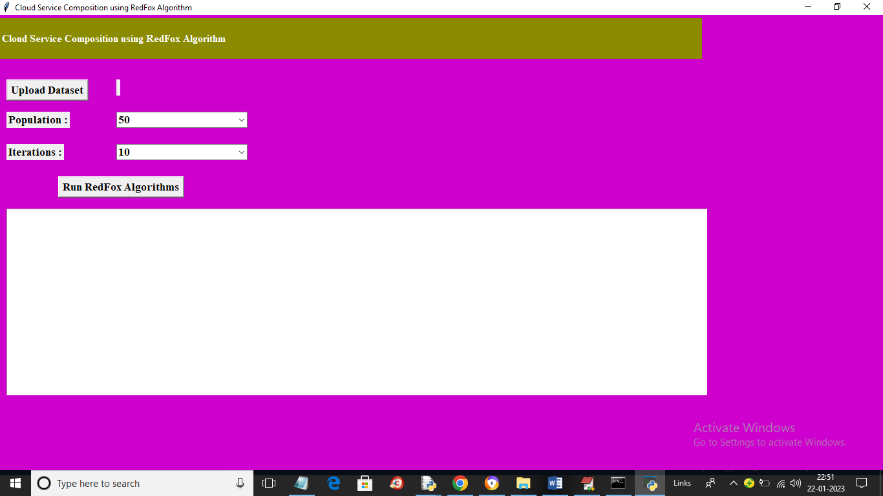

In above screen click on ‘Upload Dataset’ button to upload dataset and get below output

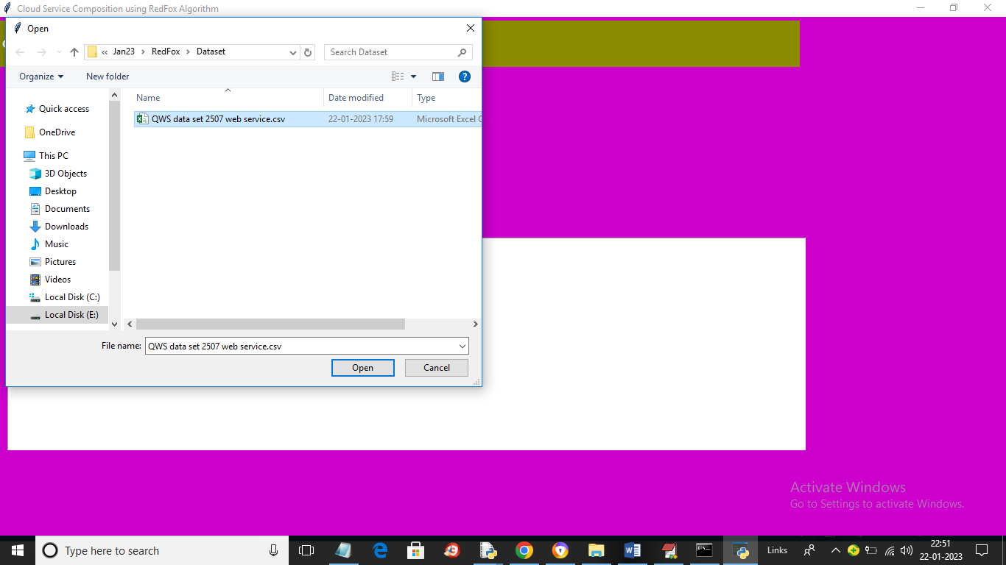

In above screen selecting and uploading dataset file and then click on ‘Open’ button to load dataset and get below output

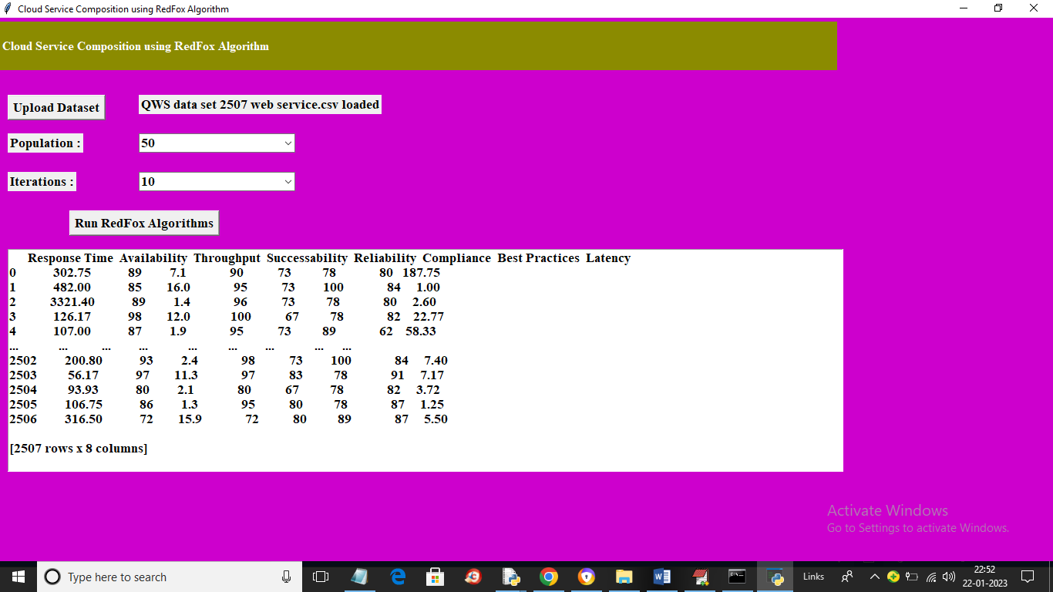

In above screen dataset loaded and now from drop down boxes you can select Population and Iterations and then click on ‘Run RedFox Algorithm’ button to get below service values

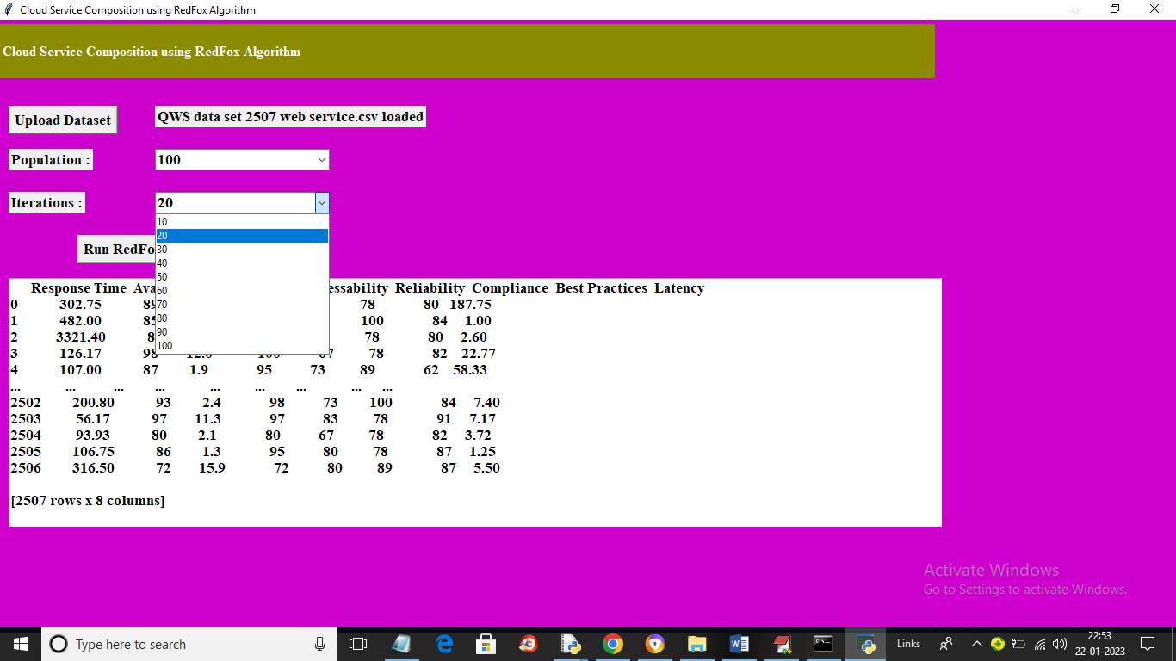

In above screen I selected number of population as 100 and then selecting iterations as 20 and then press button to get below output

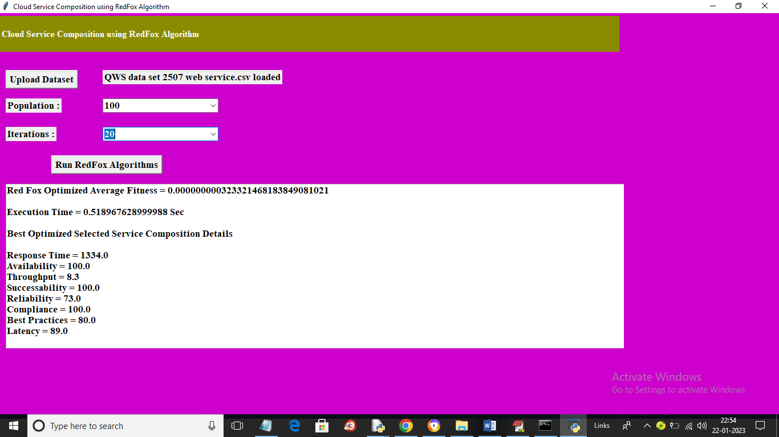

In above screen in text area we can see fitness value and execution time as output and then can see optimized service values such as Response Time, throughput etc. Similarly you can select any number of population and iterations and get best service values as the output

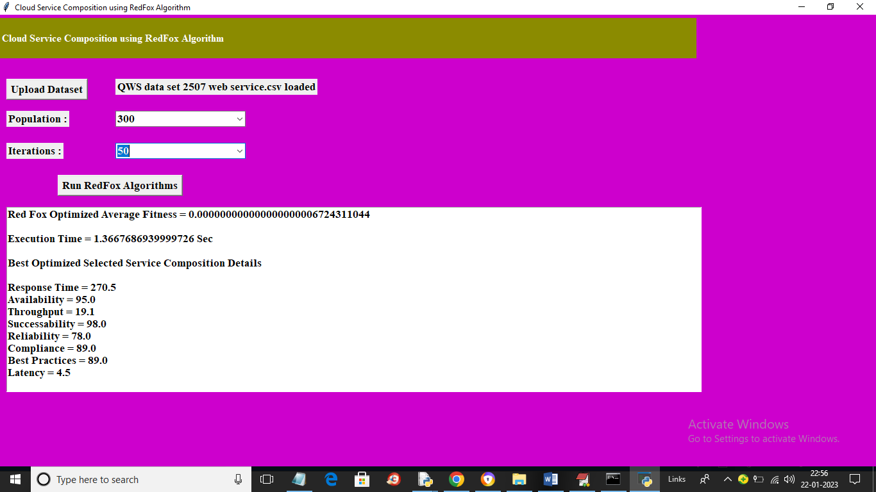

In above screen for selected population and iteration we got above output.

In below screen we are showing code for RedFox

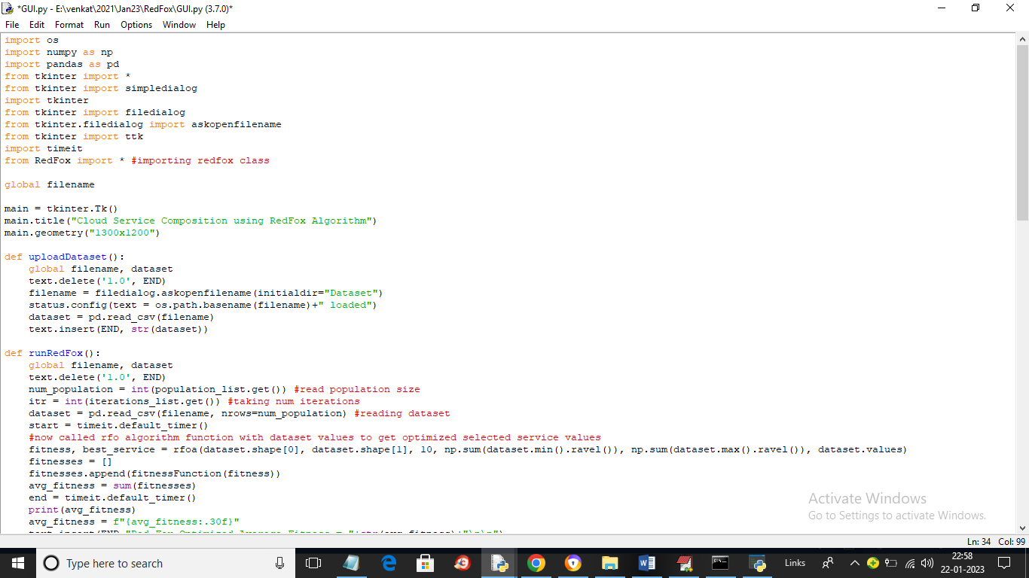

In above screen read red colour comments to know about Red Fox algorithm