Intelligent Agent based Job Search System

In this project we are providing flexibility to job seekers to search job based on their home and company area distance, weekly working days, shift type, preferred salary etc.

This project consists of two users

Employer: Employer can signup and login to application and then post jobs or activate or deactivate job

Applicant: Applicant can signup and login to application and then search job based on preferred distance, shift and working days and this search technique will use fuzzy search mechanism.

SCREEN SHOTS

To run project first create database in MYSQL by copying content from DB.txt file and then paste in MYSQL console

Now double click on ‘runServer.bat’ file to start python DJANGO server and get below screen

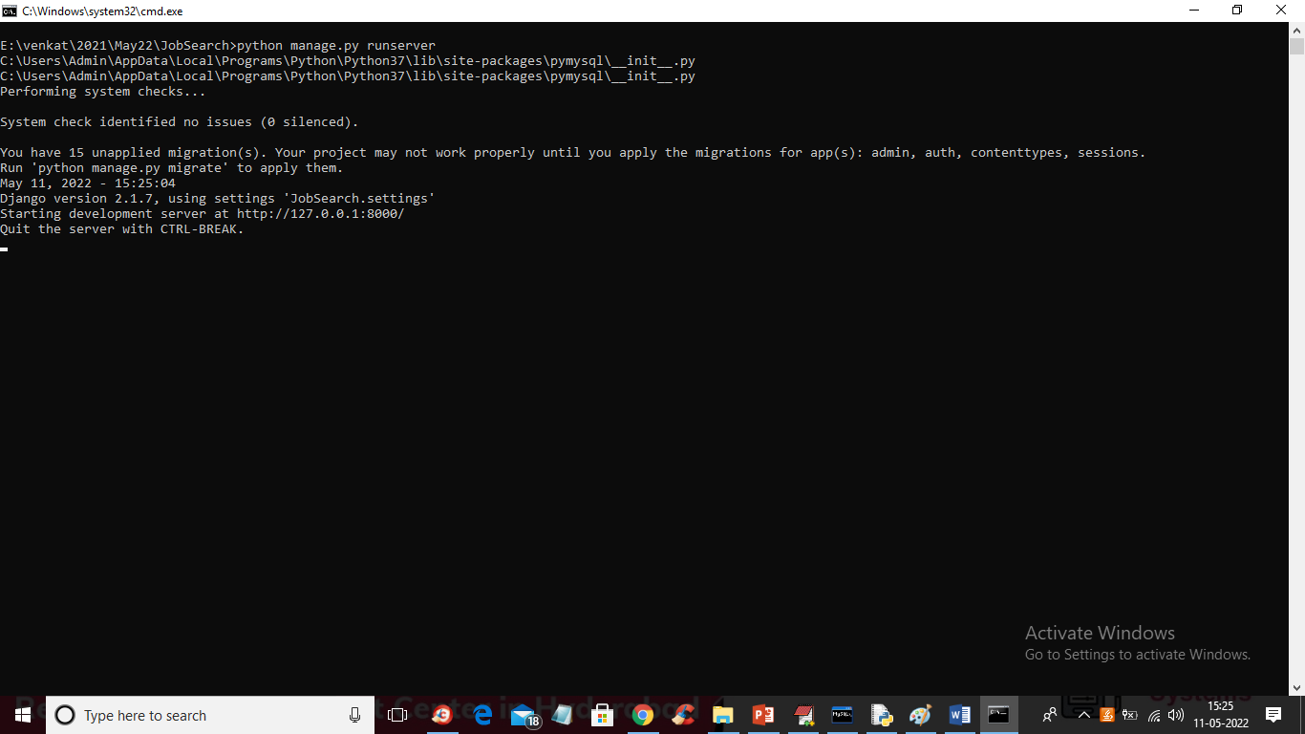

In above screen DJANGO server started and now open browser and enter URL as <http://127.0.0.1:8000/index.html> and press enter key to get below page

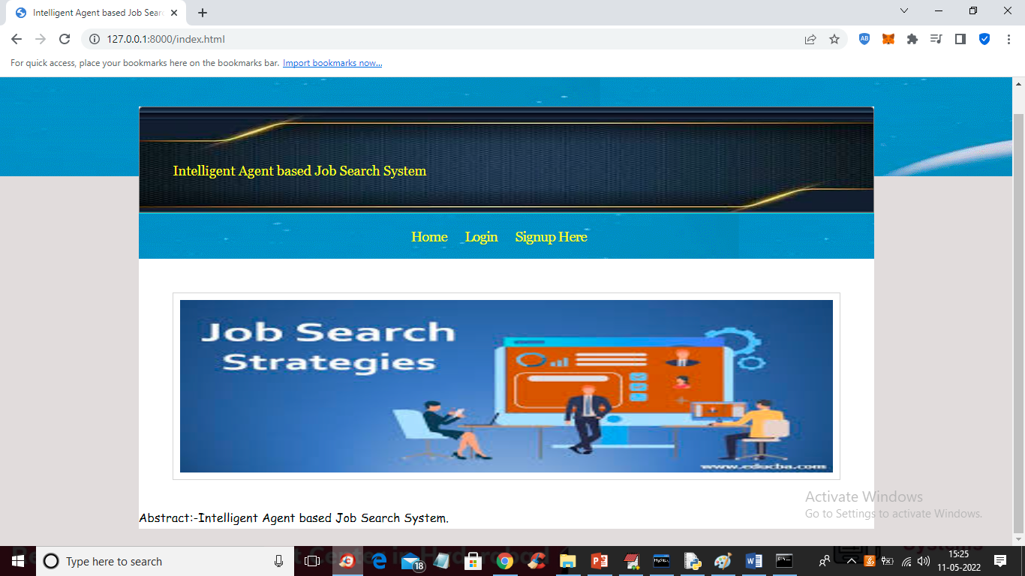

In above screen click on ‘Signup Here’ link to get below signup screen

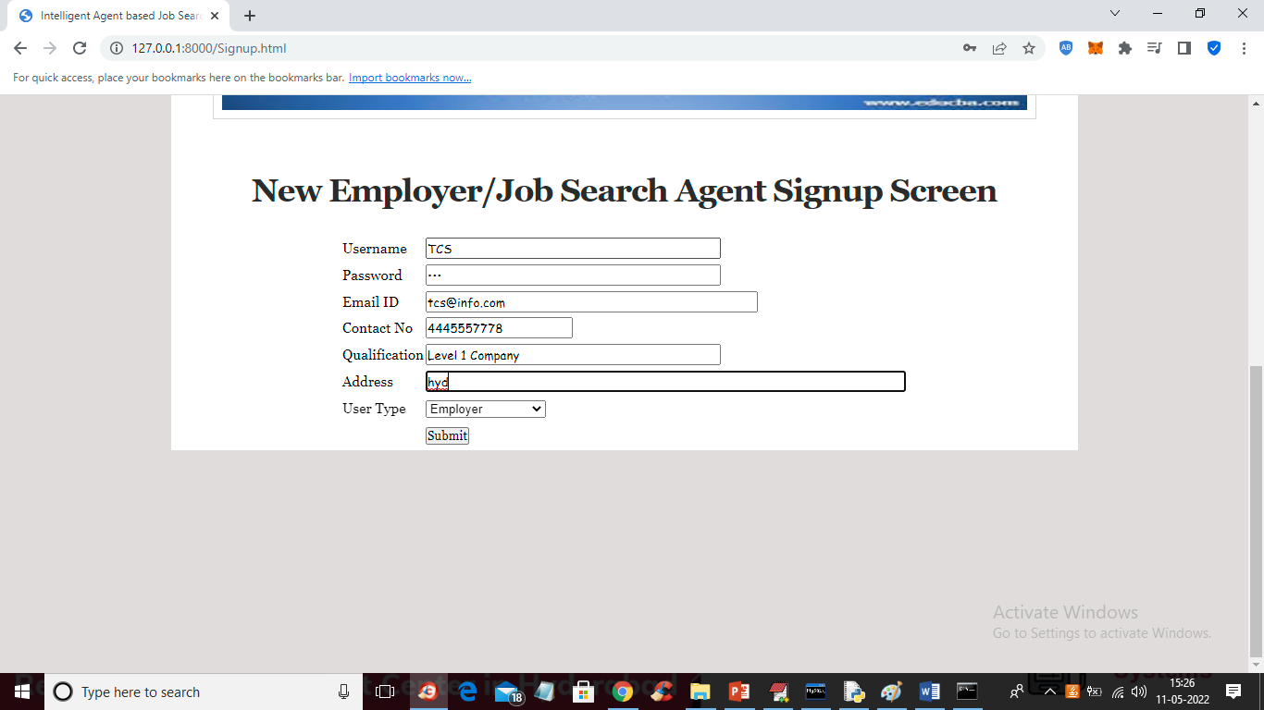

In above screen company is entering signup details and press button to get below screen

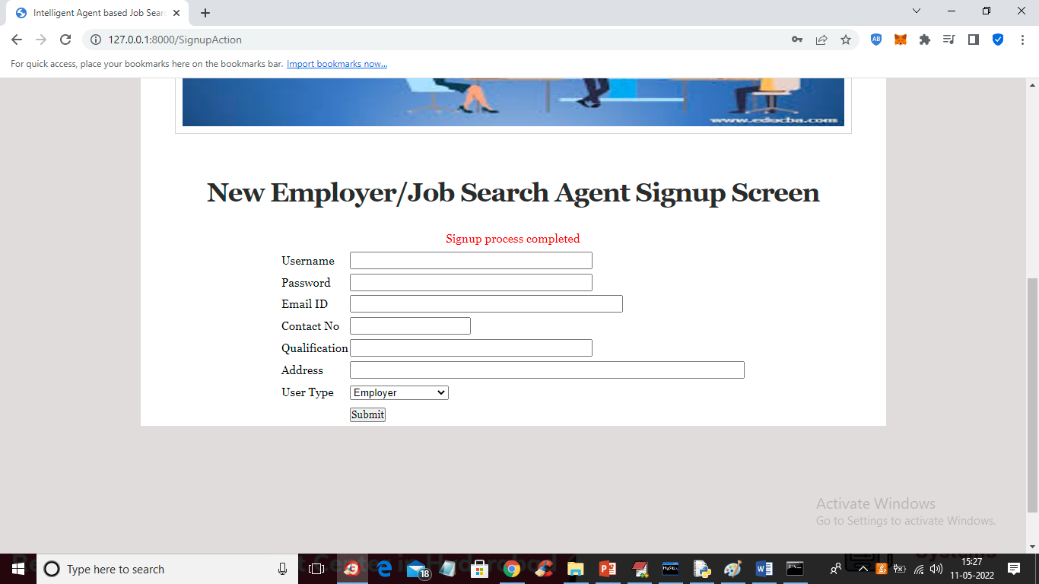

In above Screen Company signup process completed and now signup one application like below screen

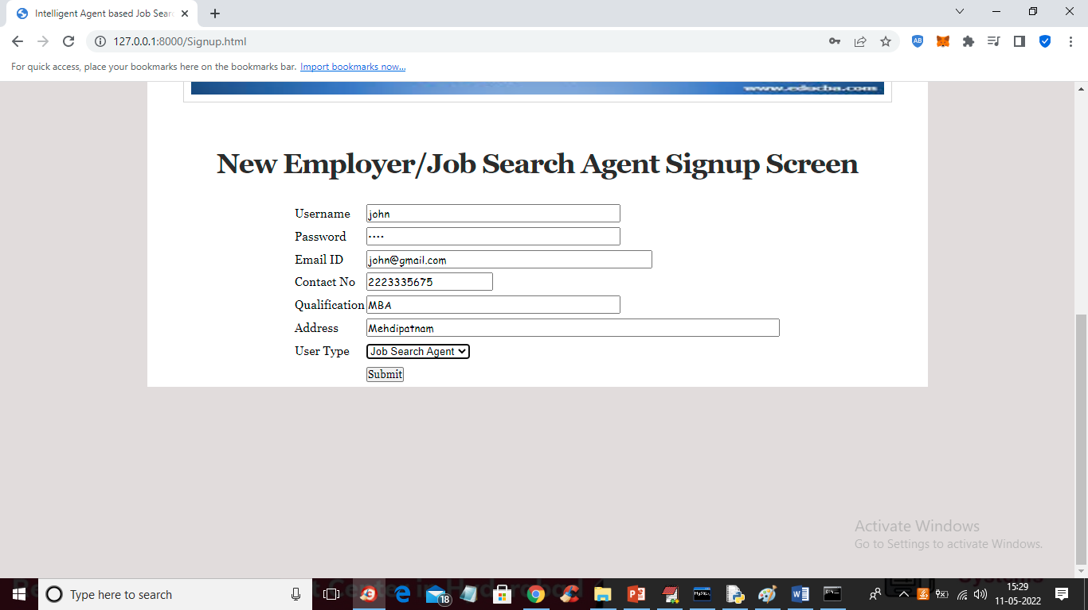

In above screen job applicant is signing up and then click on ‘Submit’ button to get below output

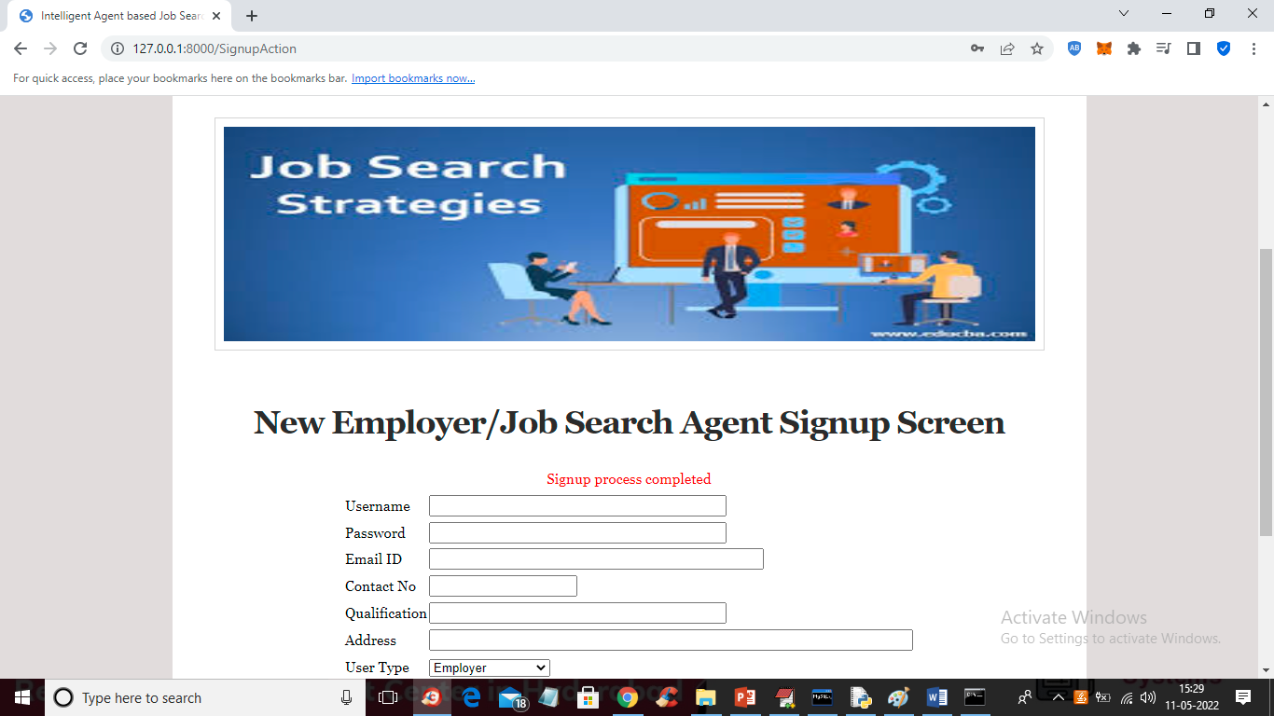

In above screen applicant signup completed and now click on ‘Login Here’ link to login as company

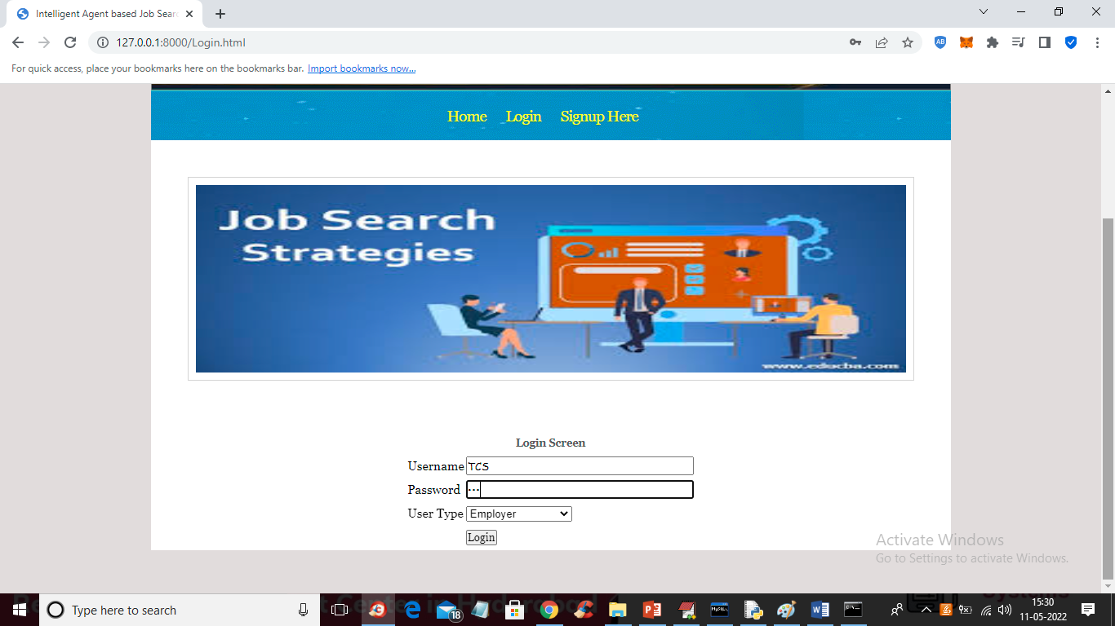

In above screen company is login and after login will get below screen

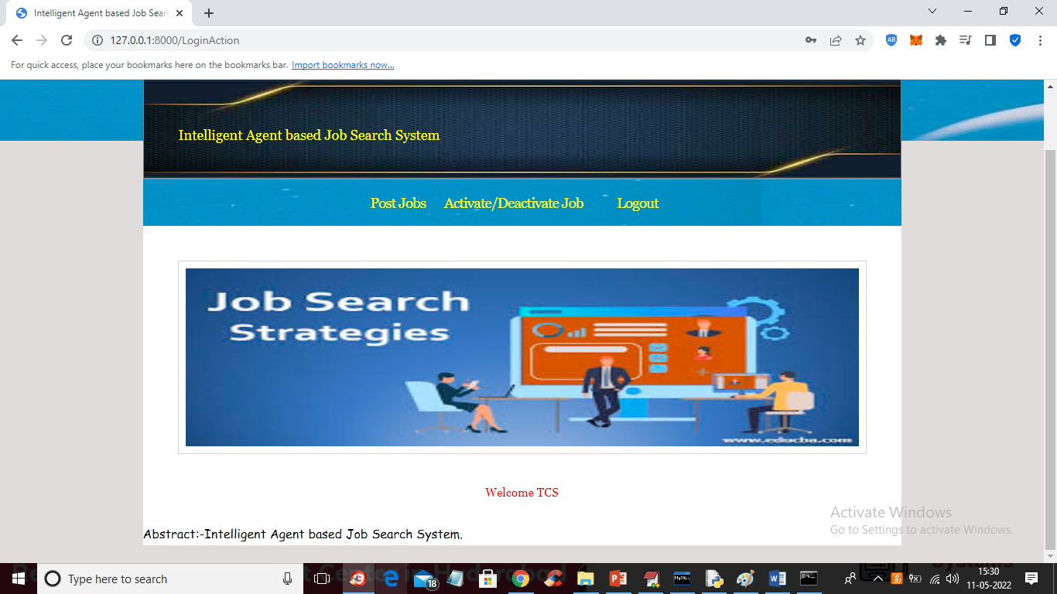

In above screen company can click on ‘Post Jobs’ link to post the new JOB

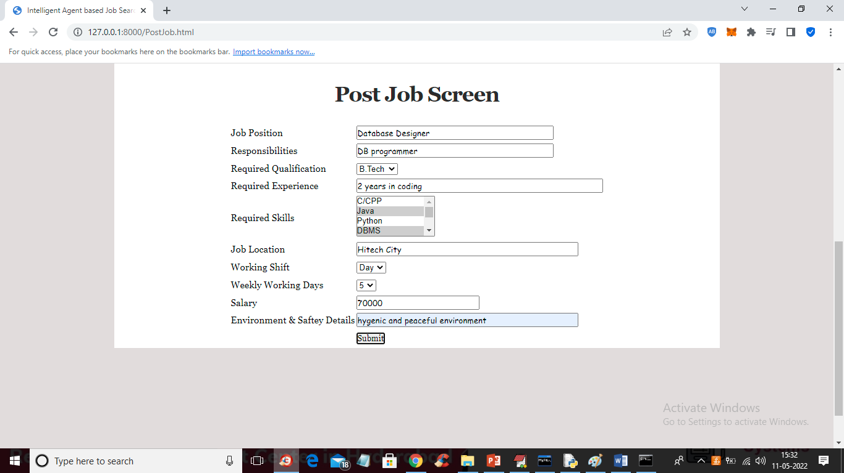

In above screen company is posting the job and now press button to get below output

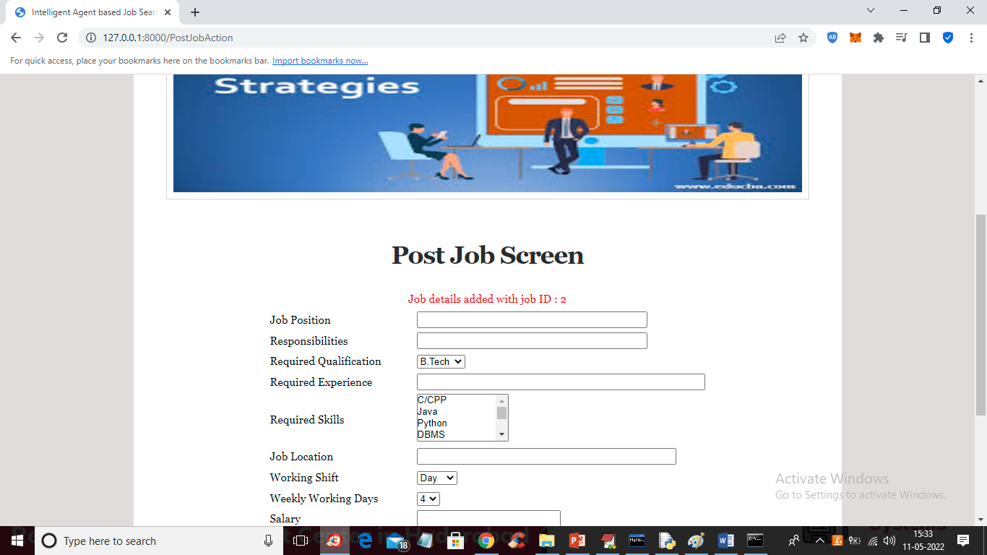

In above screen job details added and now click on ‘Activate/Deactivate Job’ link to get list of jobs posted by company and then activate or deactivate

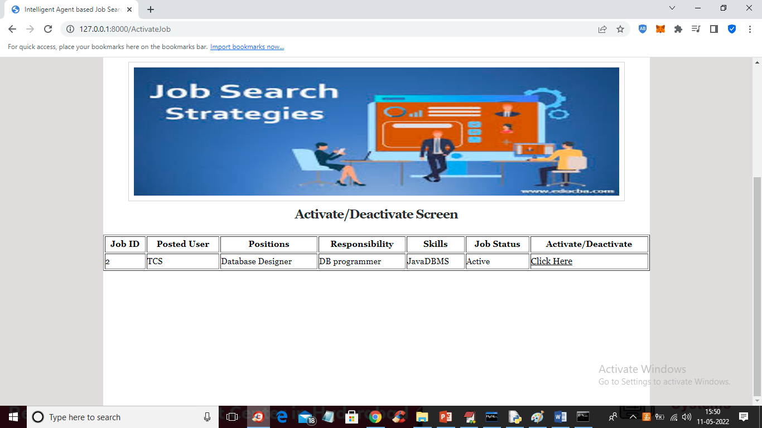

In above screen company can click on ‘Click Here’ link to either activate or deactivate JOB. Now logout and login as ‘job applicant’

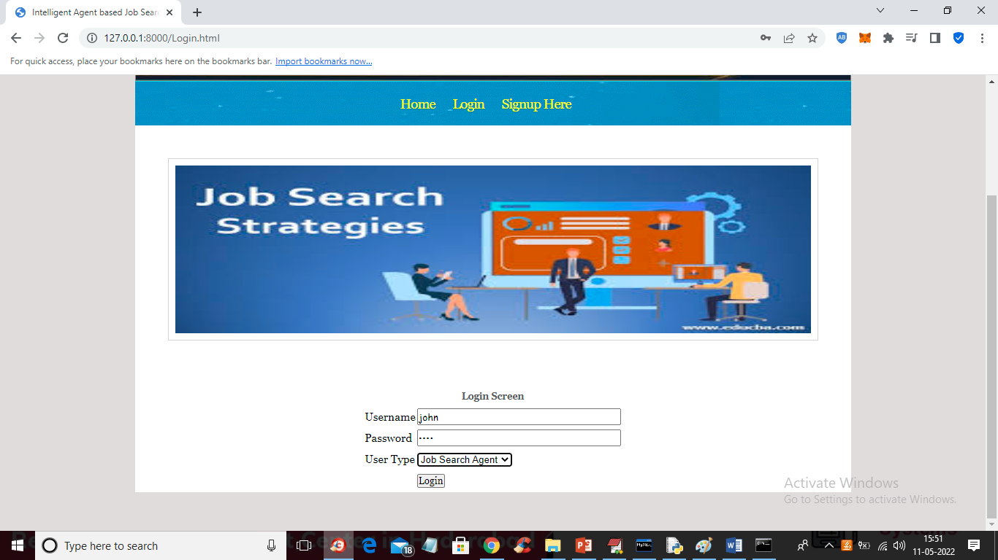

In above screen job applicant is login and after login will get below screen

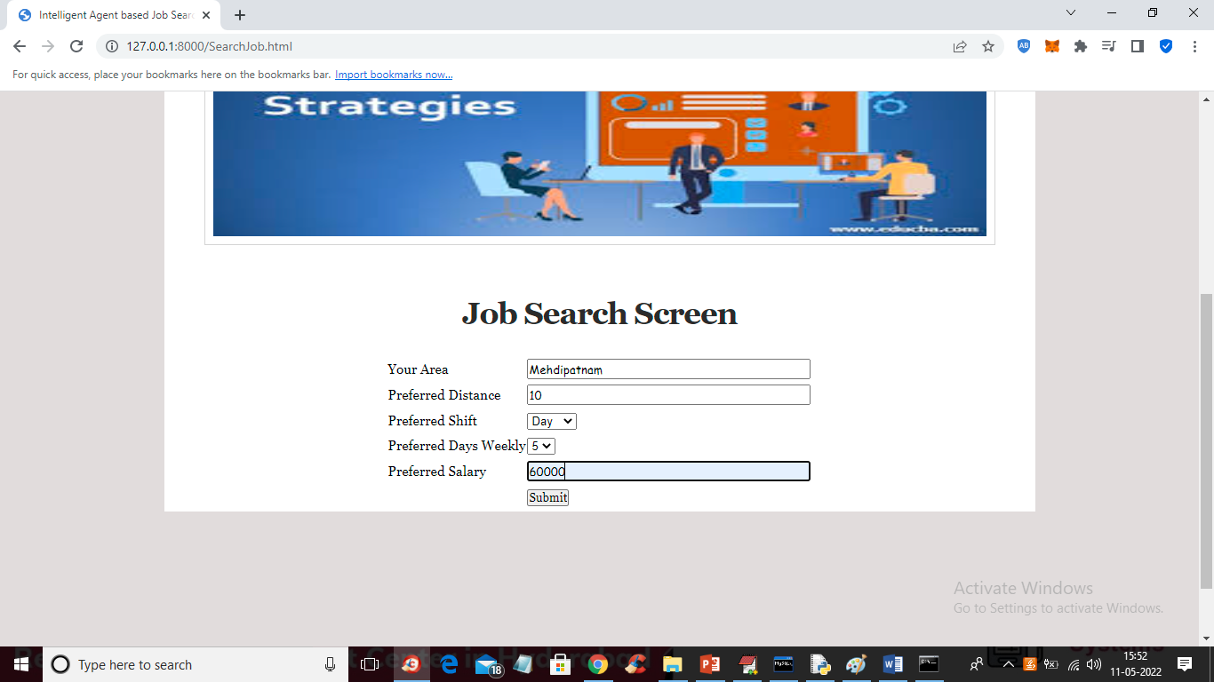

For above search we got below fuzzy search result

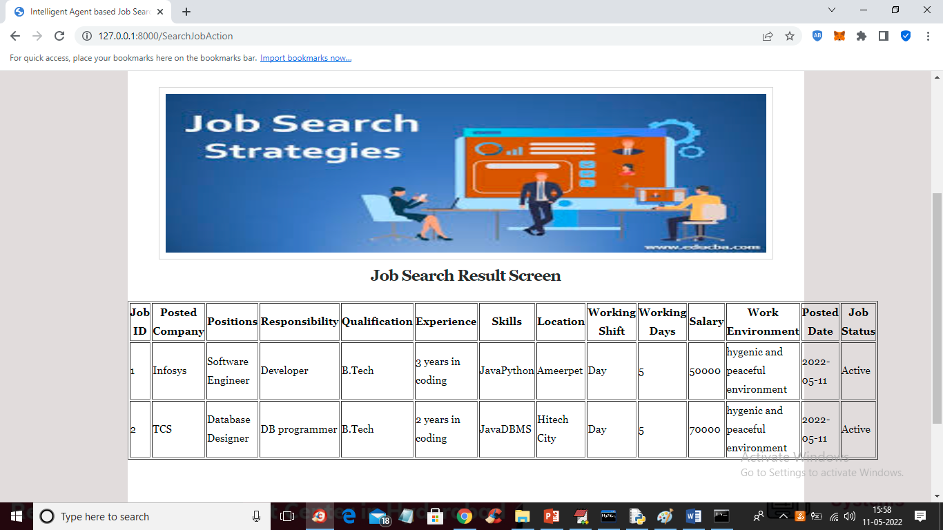

Similarly company will post JOBS and job seekers will search jobs