Bank of Z — Final Results
Everything done by Devin AI on this project, in one document with visualizations. All figures measured — no estimates.

1. Analysis → Requirements (what Devin read and produced)
Devin scanned all 132 files / 33,624 lines in src/base and produced the requirements pack: BRD, FRD, 29 user stories with acceptance criteria, functional test cases and a program→rule→FR→story→test traceability matrix — every business rule cites its source file (doc/reverse-engineering.docx).

2. Legacy simulation (what Devin built to prove the "before")
Parsed all 10 BMS mapsets → field model → runnable 3270-style simulator (deliverables/02_legacy_simulation/). Menu, display-customer and transfer verified end-to-end. All screens labeled simulation — reconstructed from source, not invented.

3. Conversion to Java/Spring Boot (what Devin converted)
Files converted | **99 / 132** (99 of 110 eligible = **90%**)
Lines converted | **20,670 / 33,624 (61.5%)** — **95.1% of eligible**
Replaced by web UI | 22 screen files / 11,885 lines
Not converted | 11 files — IMS Java + MQ (open)
Generated | 53 Java / 2,434 lines + 5 SQL / 140 + 6 test / 512
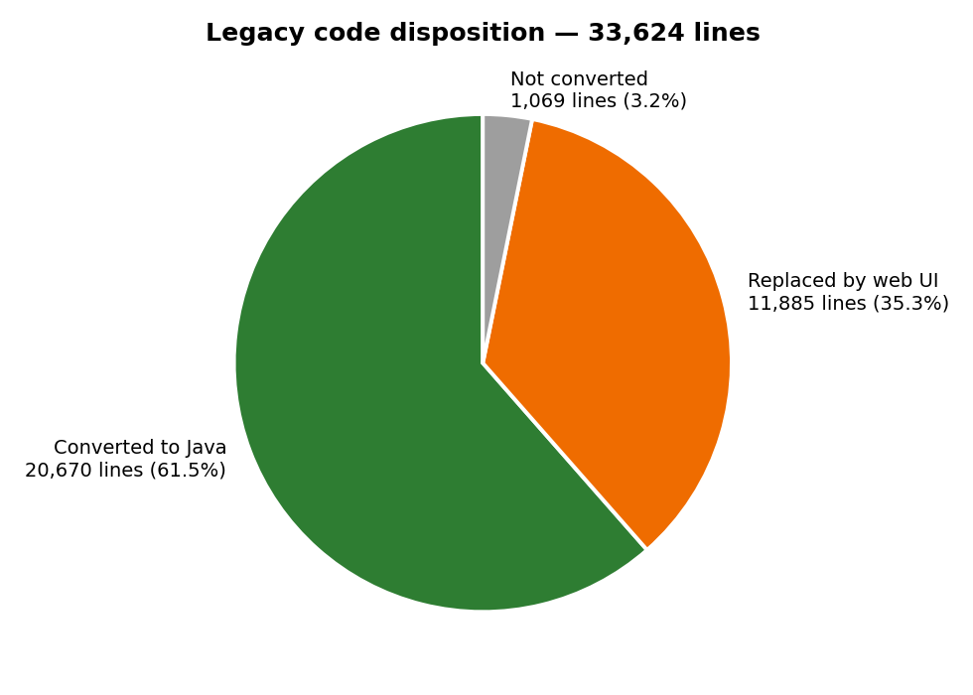
Overall disposition
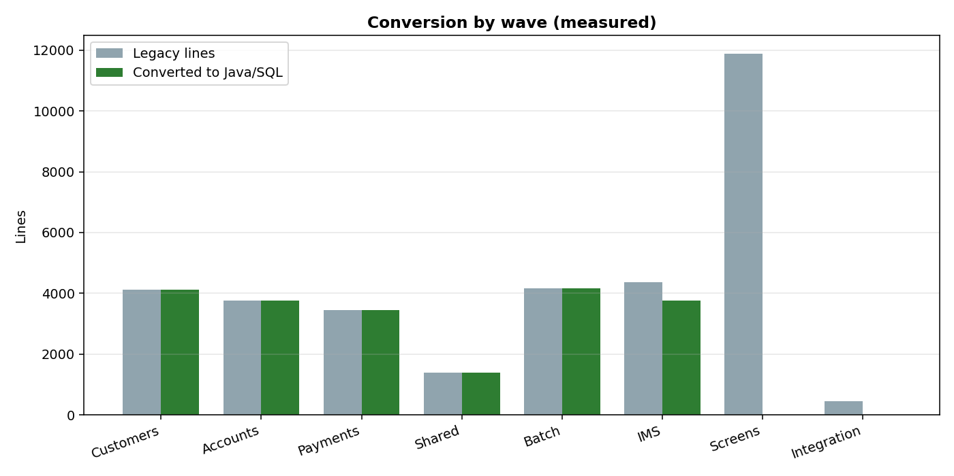
By wave
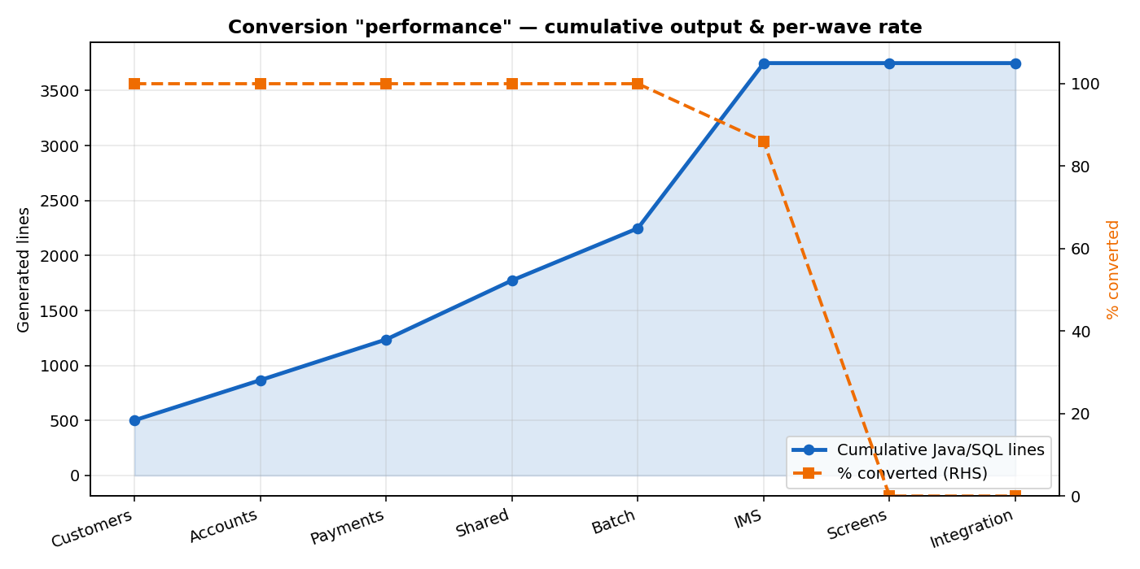
Cumulative progress

4. Validation & comparison (what Devin tested)
- 36/36 tests pass (0 failures) · 88.5% line / 68.7% branch coverage
- All 9 endpoints HTTP 200 · median 4.6 ms, worst p95 72 ms
- Identical scenarios vs the simulator: customer display, transfer, error handling match
- Honest defect found: transfer overdraft check not enforced (G-1) — documented, not hidden
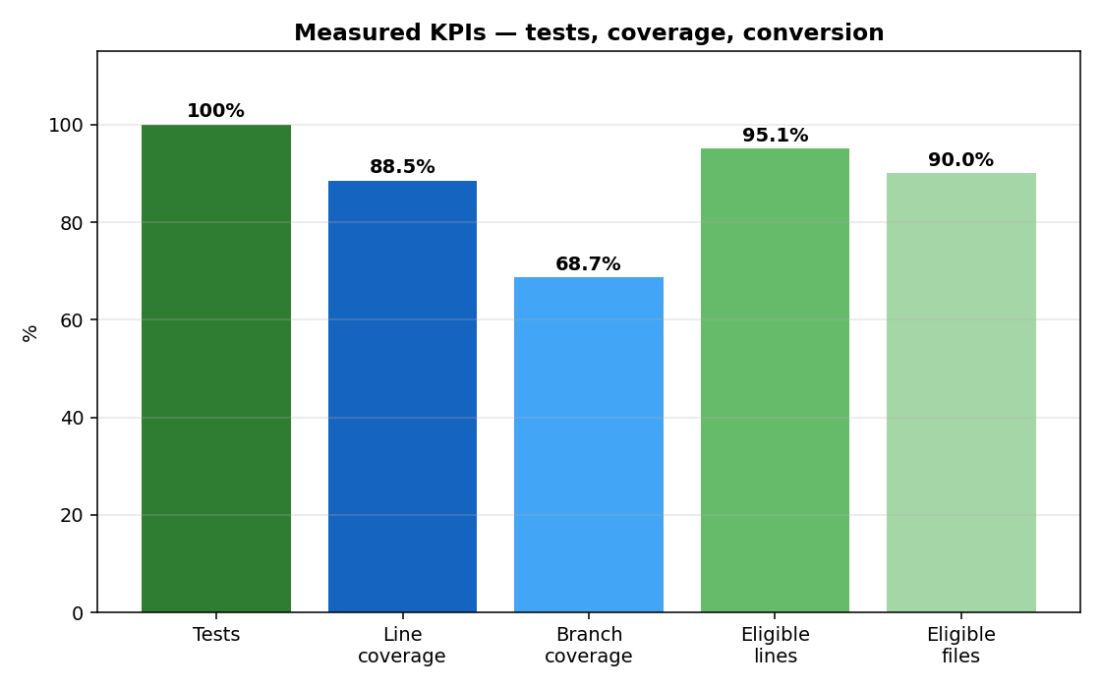
KPIs

5. Where to see it
- Dashboard http://localhost:3001/migration-dashboard.html: journey table (all steps), Mainframe source→Java table, per-file map, charts, test/coverage/perf sections
- Docs doc/*.docx: reverse-engineering, legacy-simulation, modernized-application, comparison-validation, demo-video-structure, devin-work, modernization-results
- Showcase folder showcase/ — everything in one place
- Code src/modern/bankz-app + conversion/input|output

