

Functional Safety Concept Lane Assistance

**Document Version: 1.0**

**Released on 201-05-22**



# Document history

|  |  |  |  |
| --- | --- | --- | --- |
| Date | Version | Editor | Description |
| 2018-05-22 | 1.0 |  | Functional safety concept document |
|  |  |  |  |
|  |  |  |  |
|  |  |  |  |
|  |  |  |  |

# Table of Contents

Document history

Table of Contents

Purpose of the Functional Safety Concept

Inputs to the Functional Safety Analysis

Safety goals from the Hazard Analysis and Risk Assessment

Preliminary Architecture

Description of architecture elements

Functional Safety Concept

Functional Safety Analysis

Functional Safety Requirements

Refinement of the System Architecture

Allocation of Functional Safety Requirements to Architecture Elements

Warning and Degradation Concept

# 

# Purpose of the Functional Safety Concept

Purpose of functional safety concept document is to identify functional safety requirement and assign those requirements to item’s subsystems and elements without getting into technical details.

# Inputs to the Functional Safety Concept

## Safety goals from the Hazard Analysis and Risk Assessment

|  |  |
| --- | --- |
| **ID** | **Safety Goal** |
| Safety_Goal_01 | 1. The lane departure warning system shall ensure that the lane departure oscillating torque amplitude is below Max_Torque_Amplitude. |
| Safety_Goal_02 | 1. The departure warning system shall ensure that the lane departure oscillating torque frequency is below Max_Torque_Frequency. |
| Safety_Goal_03 | 1. The lane keeping assistance system shall be time limited. |

## Preliminary Architecture

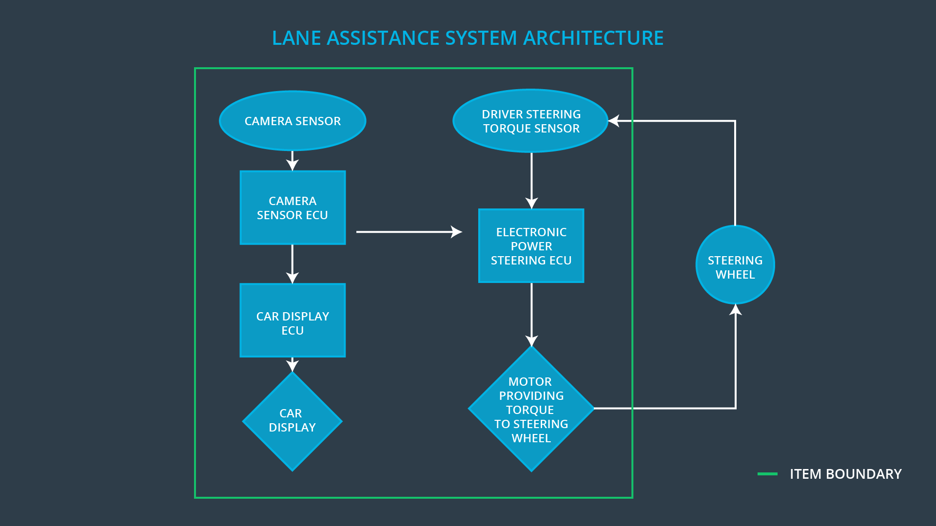

### Description of architecture elements

|  |  |
| --- | --- |
| **Element** | **Description** |
| Camera Sensor | Sends camera images to camera sensor ECU |
| Camera Sensor ECU | Identifies lanes and sends torque request to electronic power steering ECU and warning request to car display ECU |
| Car Display | Shows warning |
| Car Display ECU | Sends warning signals to car display |
| Driver Steering Torque Sensor | Monitors steering torque provided by driver and sends it to electronic power steering ECU |
| Electronic Power Steering ECU | Processes torque request from camera sensor ECU and calculate amount of torque to apply based on input from Driver steering torque sensor and sends it to Motor |
| Motor | Applies amount of torque received from electronic power steering ECU to steering wheel |

# Functional Safety Concept

The functional safety concept consists of:

* Functional safety analysis
* Functional safety requirements
* Functional safety architecture
* Warning and degradation concept

## Functional Safety Analysis

|  |  |  |  |
| --- | --- | --- | --- |
| **Malfunction ID** | **Main Function of the Item Related to Safety Goal Violations** | **Guidewords (NO, WRONG, EARLY, LATE, MORE, LESS)** | **Resulting Malfunction** |
| Malfunction_01 | Lane Departure Warning system shall apply an oscillating steering torque to provide the driver a haptic feedback | MORE | The lane departure warning function applies MORE oscillation torque amplitude then specified limit. |
| Malfunction_02 | Lane Departure Warning system shall apply an oscillating steering torque to provide the driver a haptic feedback | MORE | The lane departure warning function applies MORE oscillation torque frequency then specified limit. |
| Malfunction_03 | Lane Keeping Assistance system shall apply the steering torque when active in order to stay in ego lane | NO | The Lane Keeping Assistance system has NO time limit which results in misuse as autonomous vehicle. |

## 

## Functional Safety Requirements

Lane Departure Warning (LDW) Requirements:

|  |  |  |  |  |
| --- | --- | --- | --- | --- |
| **ID** | **Functional Safety Requirement** | **ASIL** | **Fault Tolerant Time Interval** | **Safe State** |
| Functional  Safety  Requirement  01-01 | The Lane departure warning system shall ensure that oscillation torque amplitude applied to steering wheel is limited. | C | 50 ms | Torque amplitude set to 0 |
| Functional  Safety  Requirement  01-02 | The Lane departure warning system shall ensure that oscillation torque frequency applied to steering wheel is limited. | C | 50 ms | Torque frequency set to 0 |

Lane Departure Warning (LDW) Verification and Validation Acceptance Criteria:

|  |  |  |
| --- | --- | --- |
| **ID** | **Validation Acceptance**  **Criteria and Method** | **Verification Acceptance**  **Criteria and Method** |
| Functional  Safety  Requirement  01-01 | Perform tests on driver’s reaction when different torque amplitude is applied and prove that appropriate max value is chosen. | Verify that system sets torque amplitude to 0 when torque amplitude greater than max torque amplitude is requested. |
| Functional  Safety  Requirement  01-02 | Perform tests on driver’s reaction when different torque frequency is applied and prove that appropriate max value is chosen. | Verify that system sets torque frequency to 0 when torque frequency greater than max torque frequency is requested. |

Lane Keeping Assistance (LKA) Requirements:

|  |  |  |  |  |
| --- | --- | --- | --- | --- |
| **ID** | **Functional Safety Requirement** | **ASIL** | **Fault Tolerant Time Interval** | **Safe State** |
| Functional  Safety  Requirement  02-01 | Lane Keeping Assistance system shall apply the steering torque when active in order to stay in ego lane | B | 500 ms | Steering torque set to 0 |

Lane Keeping Assistance (LKA) Verification and Validation Acceptance Criteria:

|  |  |  |
| --- | --- | --- |
| **ID** | **Validation Acceptance**  **Criteria and Method** | **Verification Acceptance**  **Criteria and Method** |
| Functional  Safety  Requirement  02-01 | Perform tests on time duration chosen to discourage taking off hands from steering wheel and prove that appropriate time duration is chosen. | Verify that system sets steering torque to 0 after time duration. |

## Refinement of the System Architecture

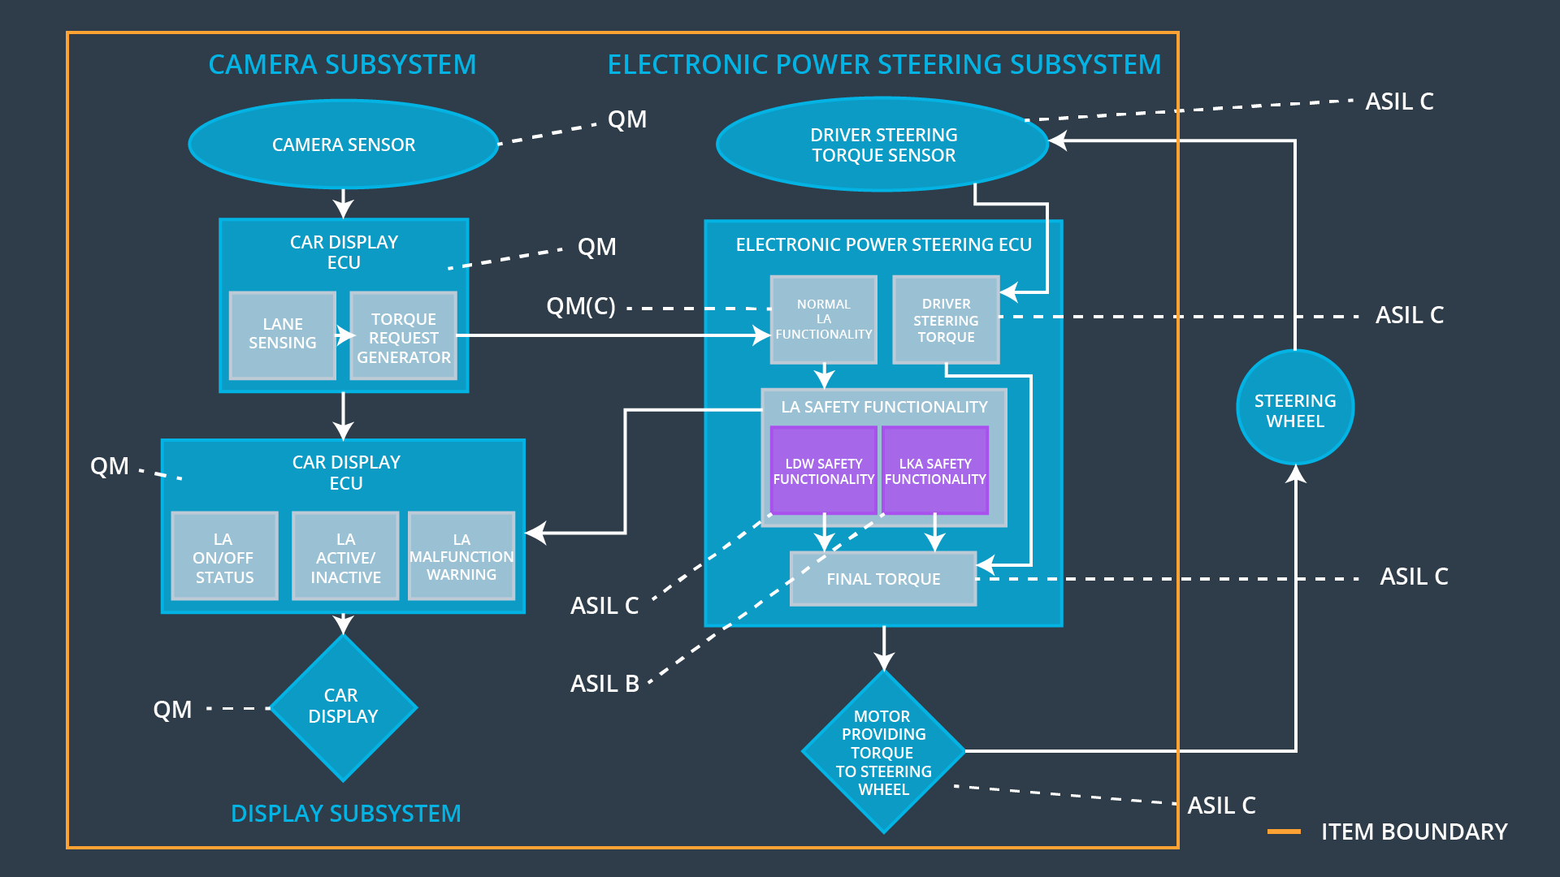

## Allocation of Functional Safety Requirements to Architecture Elements

|  |  |  |  |  |
| --- | --- | --- | --- | --- |
| **ID** | **Functional Safety Requirement** | **Electronic Power Steering ECU** | **Camera ECU** | **Car Display ECU** |
| Functional  Safety  Requirement  01-01 | 1. The lane departure warning system shall ensure that the lane departure oscillating torque amplitude is below Max_Torque_Amplitude. | **x** |  |  |
| Functional  Safety  Requirement  01-02 | The departure warning system shall ensure that the lane departure oscillating torque frequency is below Max_Torque_Frequency. | **x** |  |  |
| Functional  Safety  Requirement  02-01 | The lane keeping assistance system shall be time limited. | **x** |  |  |

## Warning and Degradation Concept

|  |  |  |  |  |
| --- | --- | --- | --- | --- |
| **ID** | **Degradation Mode** | **Trigger for Degradation Mode** | **Safe State invoked?** | **Driver Warning** |
| WDC-01 | Turn off lane assistance system | Malfunction_01 | YES | Warning on Car display |
| WDC-02 | Turn off lane assistance system | Malfunction_02 | YES | Warning on Car display |
| WDC-03 | Turn off lane assistance system | Malfunction_03 | YES | Warning on Car display |