Divorce Prediction Using Neural Networks

Collaborating within a team of freshmen, I built an artificial neural network to predict the occurrence of divorce based on survey responses from married couples. The ANN was built using Python libraries such as Keras, Pandas, and NumPy.

Developing a Graphical User Interface

To facilitate use of a suite of climate modeling scripts coded by Professor Sylvia Dee, I built a Graphical User Interface in Python. Climate researchers may upload their own data to the GUI, specify several model parameters, and run climate modeling simulations to reconstruct climate conditions of the past.

Linear Regression Analysis of Lead Levels in Philadelphia, PA

Taking inspiration from the landmark study “The Racial Ecology of Lead Poisoning” authored by sociologists Robert Sampson and Alix Winter, I constructed 9 linear regression models to understand the various socioeconomic factors associated with higher lead levels among children living in Philadelphia, PA. The model with the greatest explanatory power identified four statistically significant covariates: the % of residents with a bachelor’s degree, % of black residents, % of owner-occupied housing, and the % of housing built prior to 1950.

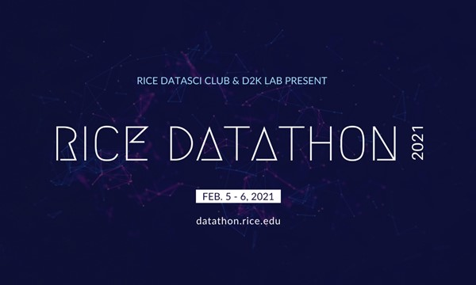

Recommendation System for Washington DC Government Contracts

Using a dataset of millions of transactions completed between Washington DC’s overnment and contractors, I built a collaborative filtering algorithm which recommends certain contractors to particular agencies of the local DC government.

Clustering Analysis of Yeast Gene Expression Patterns

As part of a self-guided foray into bioinformatics, I implemented three clustering algorithms – the Lloyd Algorithm, Soft K-Means Algorithm, and Hierarchical Clustering Algorithm - *from scratch.* I then applied these algorithms to yeast gene expression data for the purposes of identifying groups of genes with potentially similar functions.

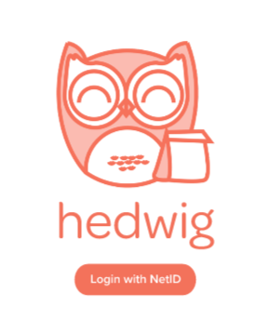

*Hedwig*: Online Ordering from Rice University Restaurants

Through RiceApps, I helped develop *Hedwig* – a web application which facilitates online ordering for Rice University vendors such as Cohen House and East West Tea. Developing Hedwig gave me the chance to view the app development process over the course of months, and this process was the first time I had been exposed to UI/UX challenges. Additionally, I was able to navigate front-end and back-end development tasks through becoming proficient in React and GraphQL.