**EXPERIMENT – 4**

BER Performance over Rayleigh Fading

Student Name: Roll No:

Date of Practical Performed: Date of Submission:

Faculty Signature: Grade:   
_________________________________________________________________________

**AIM:** Simulate BER performance over Rayleigh fading wireless channel with BPSK transmission for SNR 0 to 60 db.

**SOFTWARE/HARDWARE REQUIRED:**

→ Window 7/10/11

→ Matlab

**THEORY:**

In wireless communication systems, the signal may experience various type of disturbances during its propagation. One of the most common phenomena is Rayleigh fading, which caused by random variation in the amplitude and phase of the signal due to multipath reflection and diffractions. To evaluate the performance of communication system over a Rayleigh fading channel, we can use the bit error rate as a metric. In BPSK modulation, the binary information is represented by two phase states of the carrier wave. A logical '1' is represented by a phase shift of 180 degrees and a logical ‘0’ is represented as phase shift of zero degrees. At the receiver a decision is made based on received phase.

The BER of a BPSK system can be expressed as a function of the SNR and the channel condition. For a Rayleigh fading channel, the BER can be derived as,

BER = 0.5 * erfc(SNR)1/2

**PROCEDURE: -**

1. Open matlab.
2. Write function to generate BPSK signal in the experiment script.
3. Write a function to simulate addition of noise and Rayleigh fading.
4. Implement the evaluation parameters in the script
5. Note observation and results.

**CODE:**

clear

N = 10^6 % number of bits or symbols rand('state', 100): % initializing the rand() function randn('state', 200); % initializing randn() function

%Transmitter

ip = rand(1.0)>0.51; % generating 0.1 with equal probability s = 2*ip-1; % BPSK modulation 0 -> -1; 1->1

n = 1/sqrt(2)*[randn(1,N] + j*randn(1, N)]: % white gaussian noise. OdB variance Eb NO_dB = [-3:10]; % multiple Eb/N0 values

for ii = 1:length (Eb_NO_dB)

%Noise addition.

y = s + 10^(-Eb_NO_dB(ii)/20)*n: % additive white gaussian noise

%receiver hard decision decoding ipilat = real(y)>0;

%counting the errors

nErr(ii) = size(find([ip ipHat)).2); end

simBer = nErr/N: % simulated ber

theoryBer = 0.5*erfc(sqrt(10.^(Eb_NO_dB/10))): Jheoretical ber

% plot close all figure

semilogy(Eb_NO_dB. theoryBer, 'b.-'); hold on

semilogy(Eb_NO_dB.sinBer.'mx'): axis([-3 10 10^-5 0.51)

grid on

legend('theory', 'simulation'): xlabel('Eb/No, dB'); ylabel('Bit Error Rate');

title('Bit error probability curve for BPSK modulation');

**OUTPUT:**

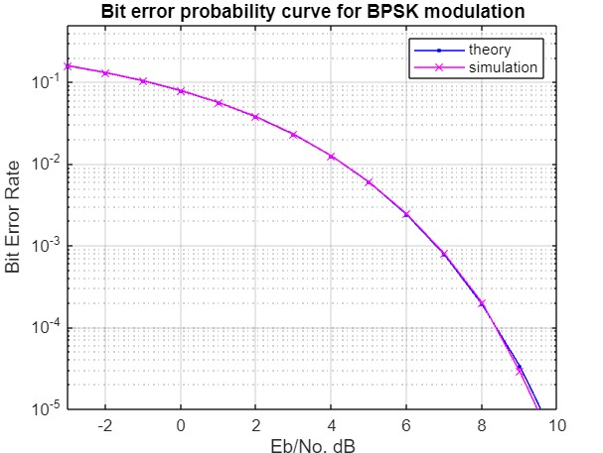

**CONCLUSION:**

Simulating the BER performance of BPSK system over a Rayleigh fading channel is in practical way to evaluate the performance of wireless communication system.