**EXPERIMENT – 5**

Configuring a Cisco router as a DHCP server.

Student Name: Roll No:

Date of Practical Performed: Date of Submission:

Faculty Signature: Grade:

**______________________________________________________________________________**

**AIM**: To configure a cisco router as a DHCP server.

**SOFTWARE/HARDWARE REQUIRED:**

1. Laptop / PC
2. Windows 7/10/11
3. Cisco Packet Tracer Software

**THEORY:** DHCP (Dynamic host configuration protocol) is a network protocol that allows devices to automatically obtain network configuration settings such as IP address, subnet masks default gateways and DNS servers.

It simplifies the process of network configuration by eliminating the need for manual configuration on each device.

To setup a DHCP server we follow the given steps:

1. Install DHCP software.
2. Specify range of IP address.
3. Define parameter like subnet mask, default gateway DNS server lease duration etc.
4. On the client device set the network adapter to obtain an IP address automatically, usually called DHCP client mode.

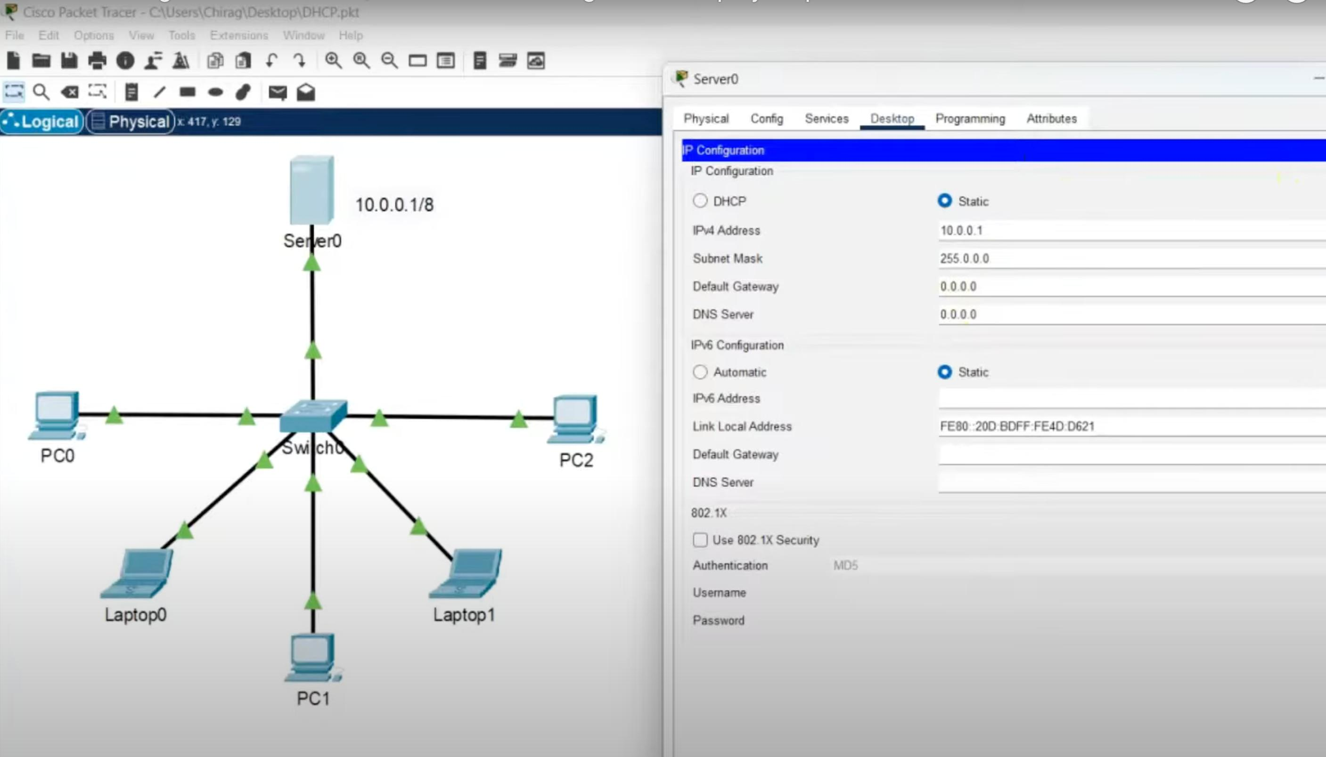

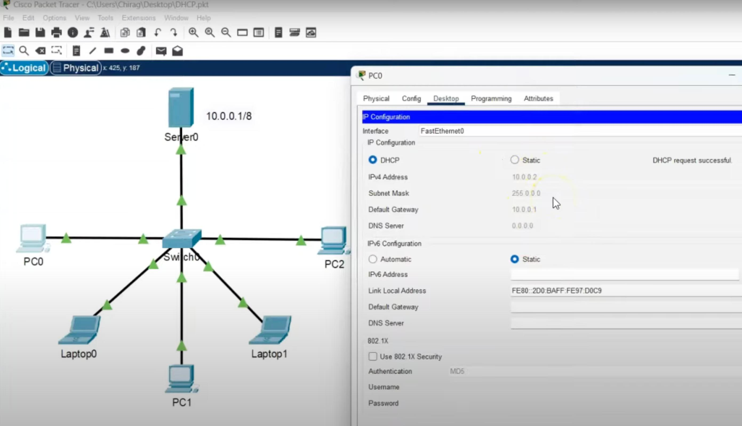

**PROCEDURE**

1. Open the Cisco packet tracer app.
2. Select a server and a switch from devices library and make connections.
3. Select and connect end devices.
4. Open the server configuration and setup the basic IP address, set the other parameter as well.
5. Click on any end devices and in IP configuration select DHCP, now how IP values are assigned automatically.
6. Run simulation and observe.

**CONCLUSION**

A DHCP server allows automatic IP assignment on various devices connected to a network.