Locating the PubSub from the Navigation Menu : -

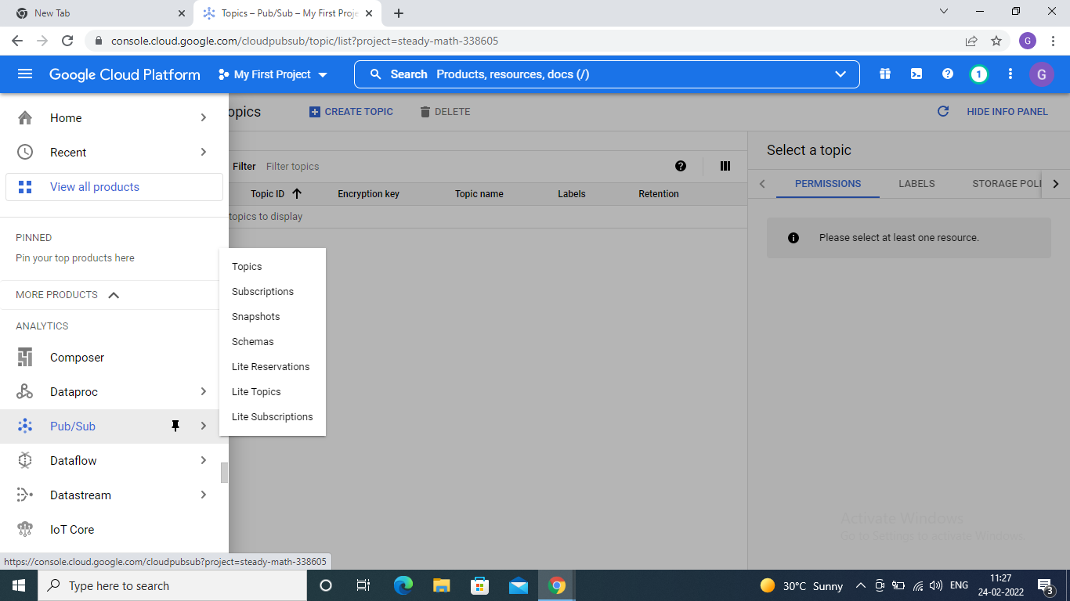

Specify a Name for a Topic and Click on Create

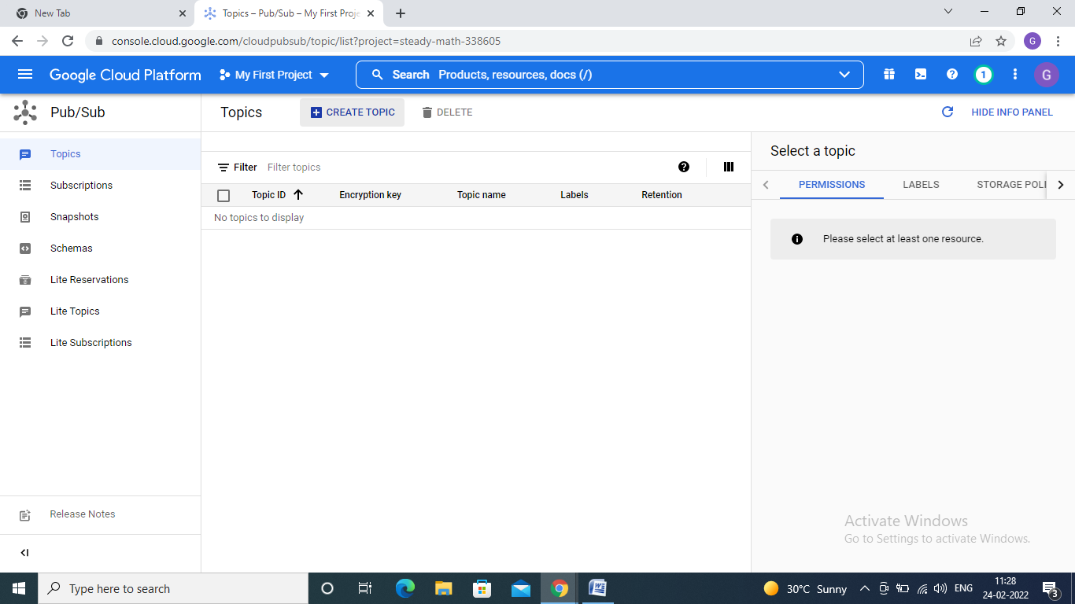

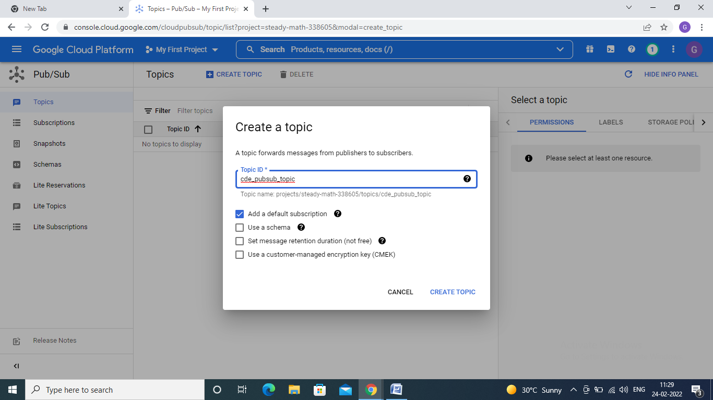

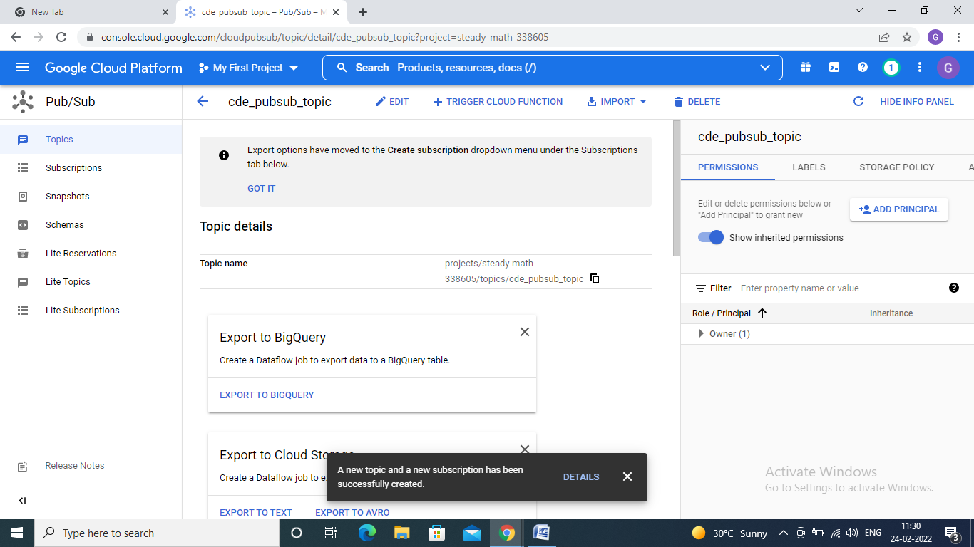

projects/steady-math-338605/topics/cde_pubsub_topic

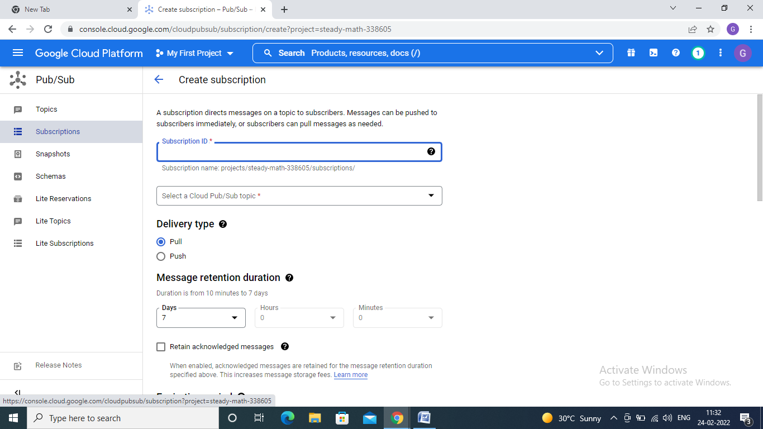

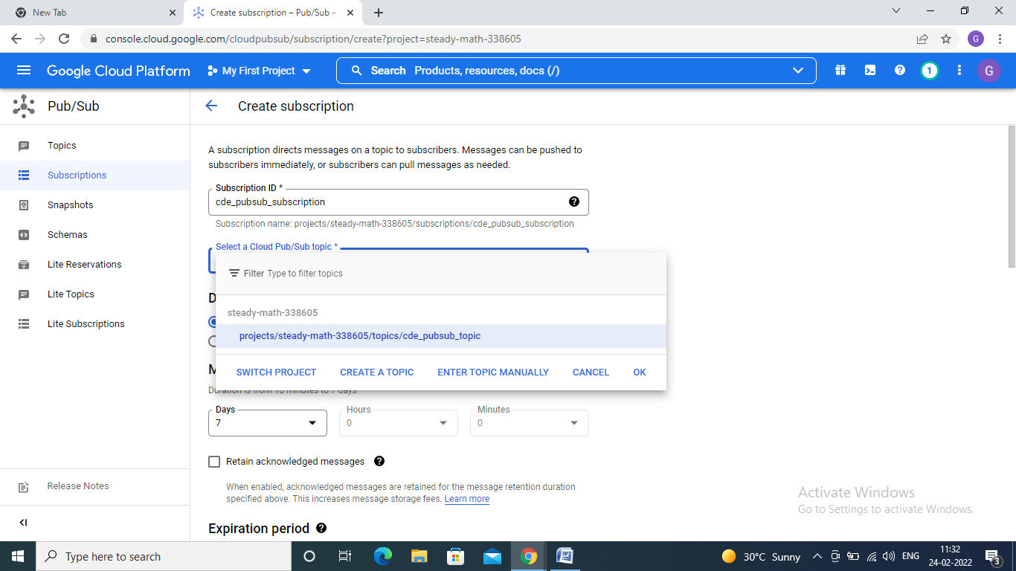

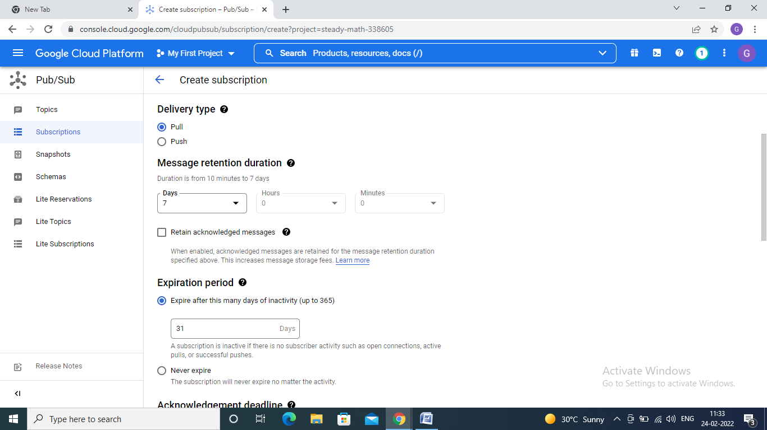

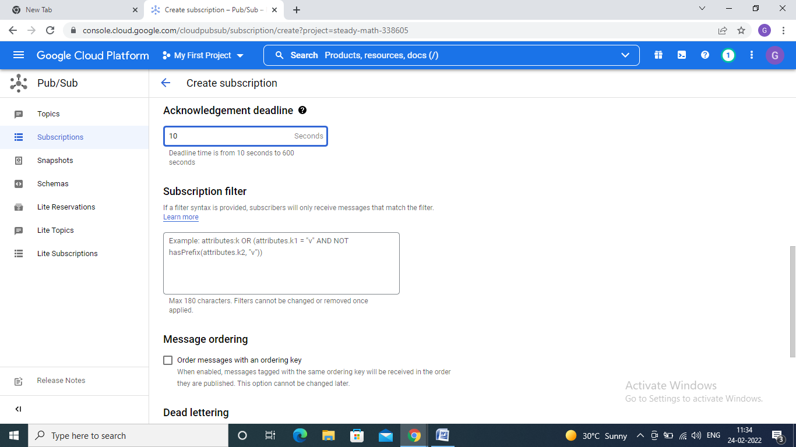

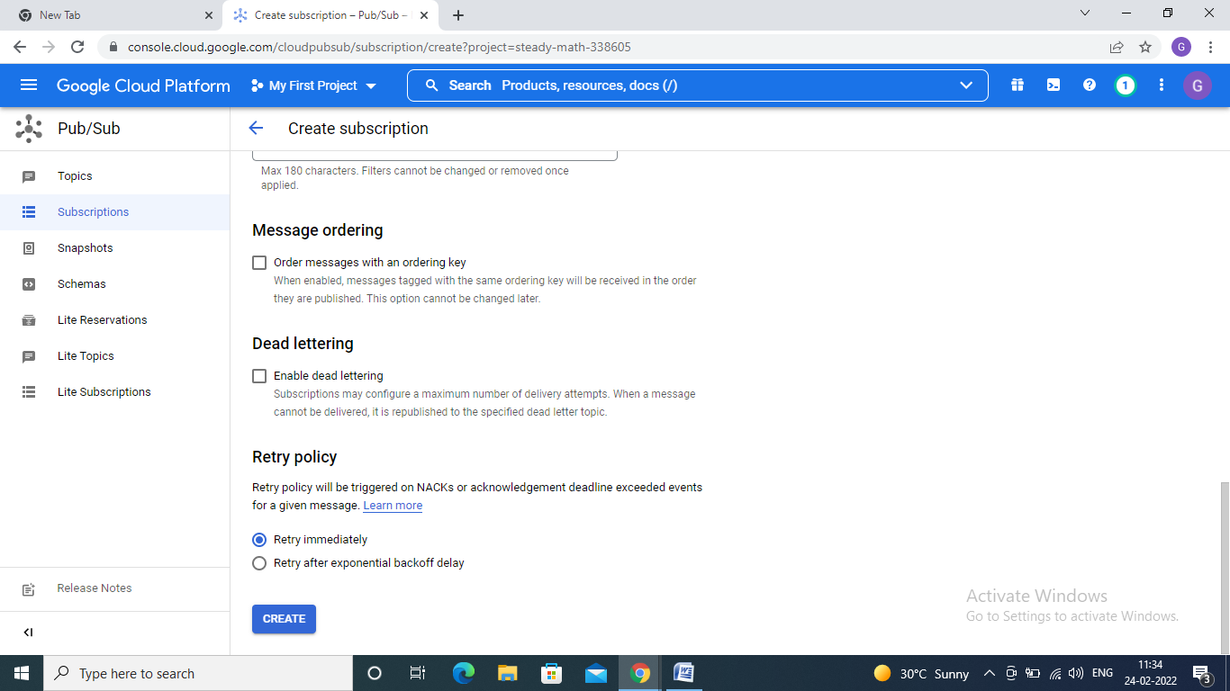

Click on Create Then it will create Subscription for selected topic

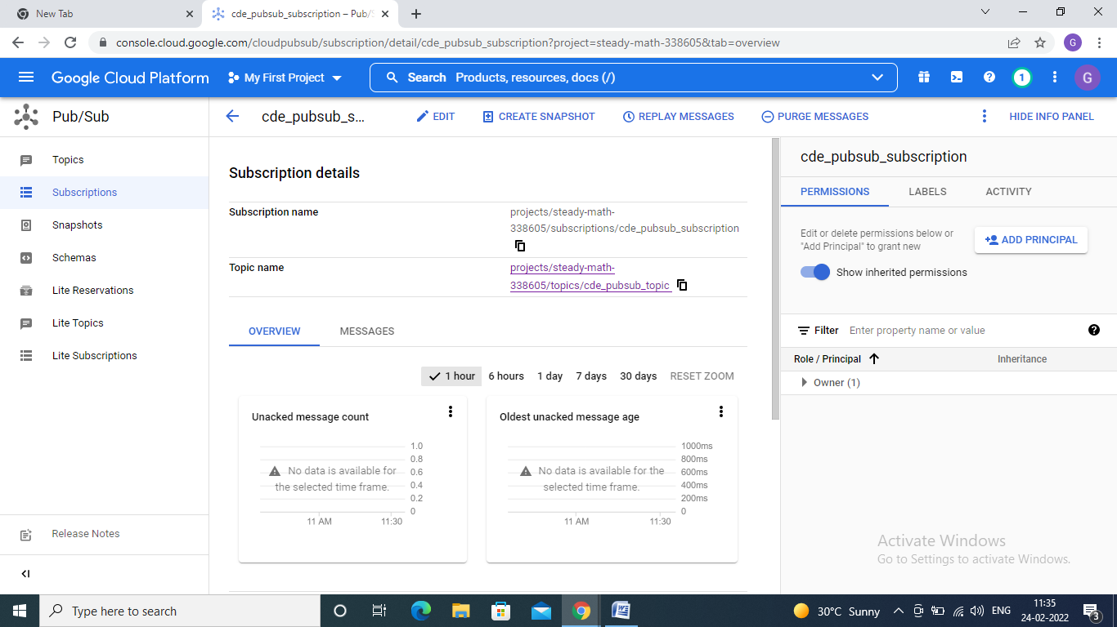

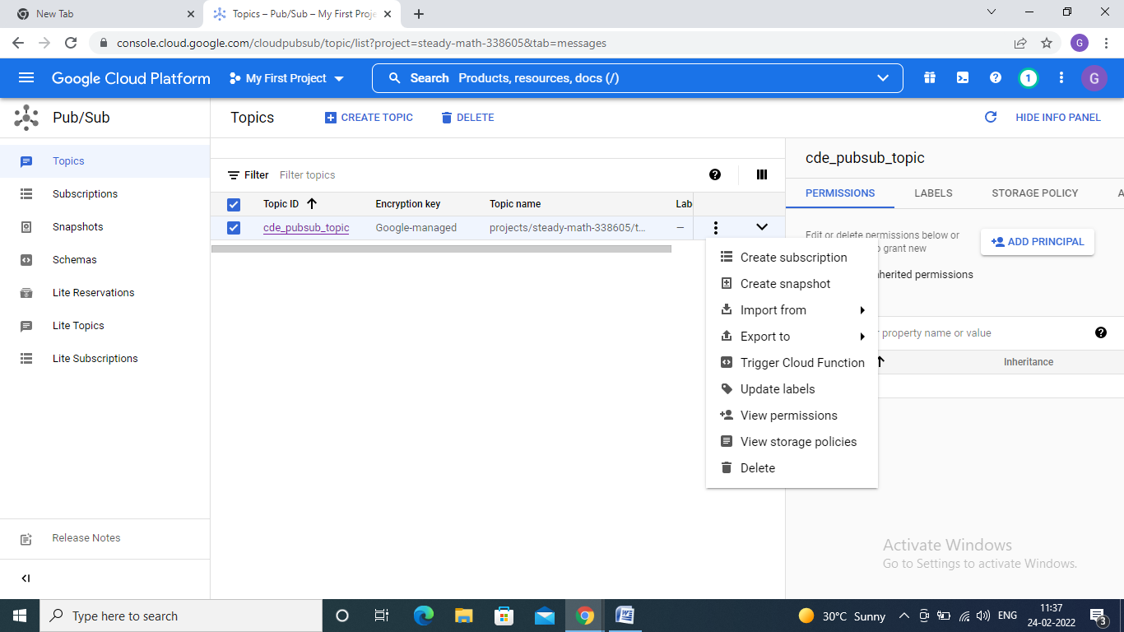

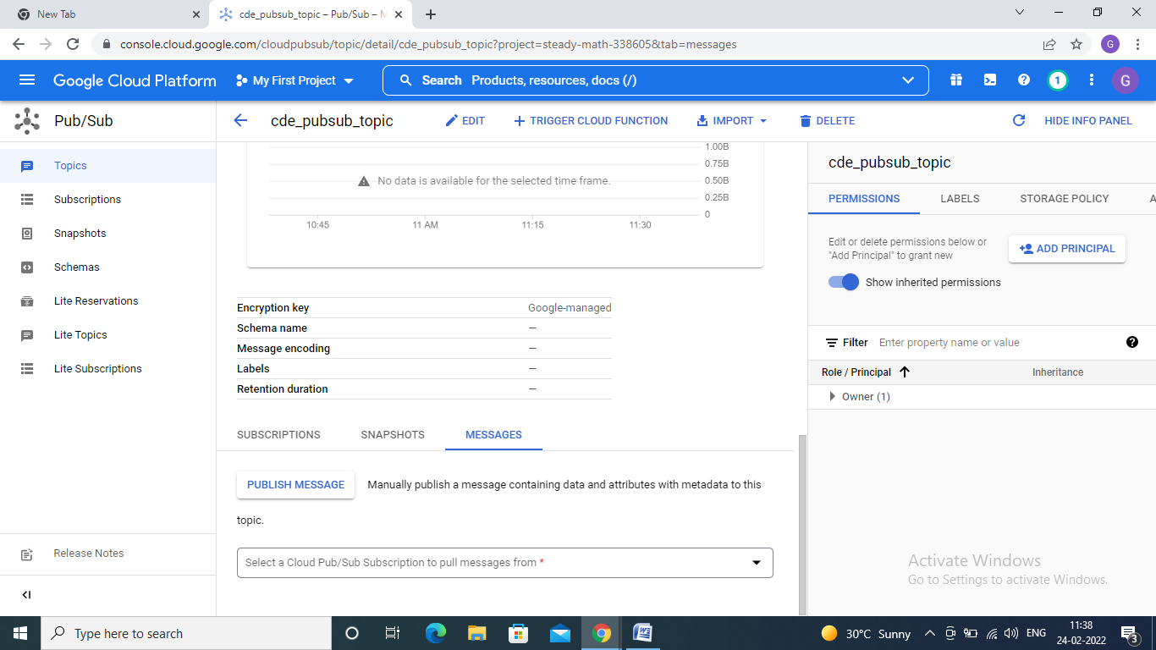

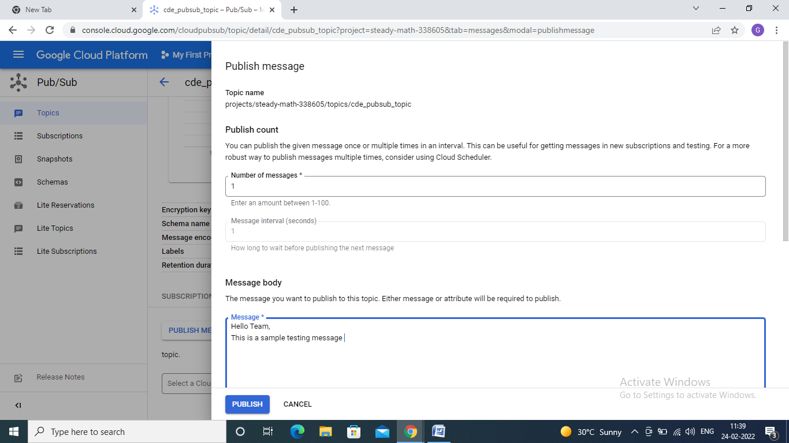

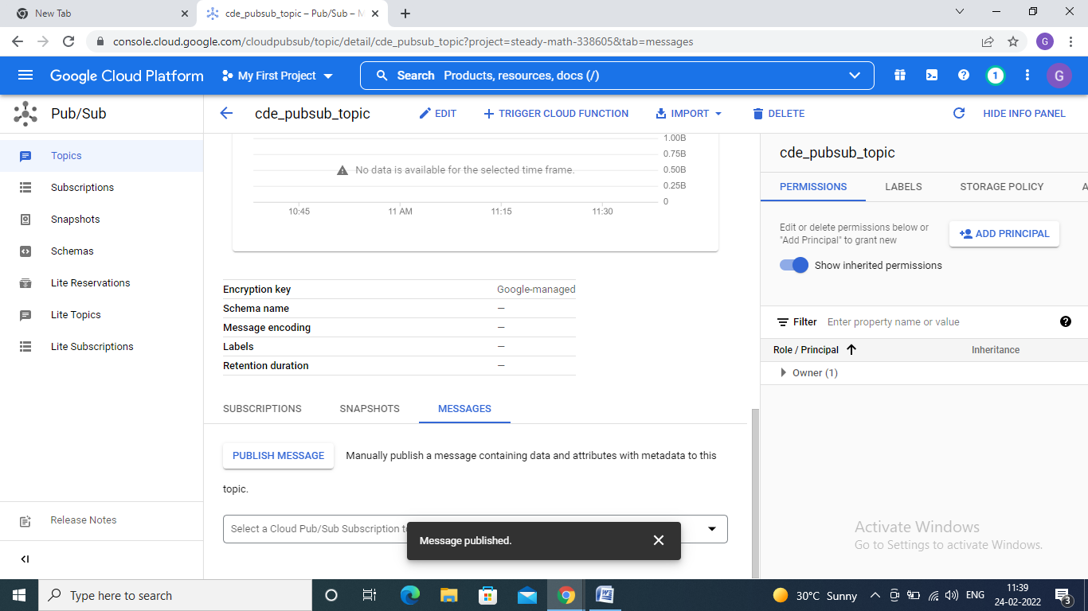

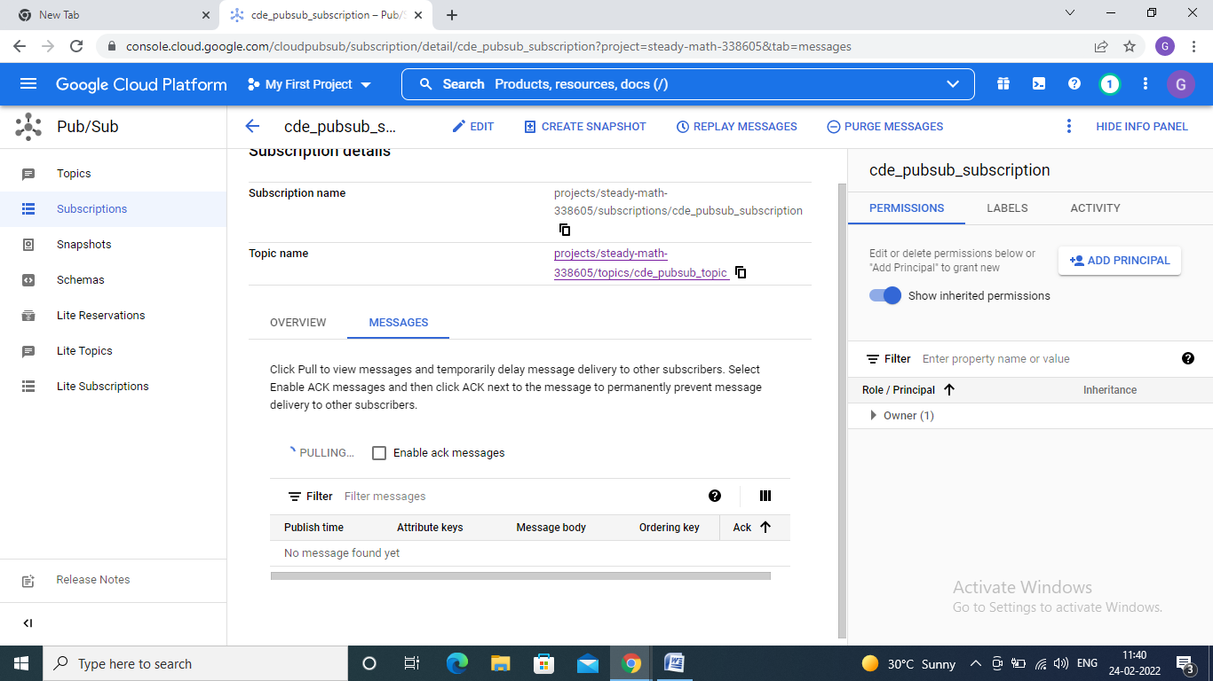



Lets try PubSub using Cloud Shell –

Run the following commands in a serial order : (Please don’t forget to analyze this)

> gcloud pubsub topics create myTopic

Gcloud pubsub subscriptions create --topic myTopicmySubscription

Gcloud pubsub topics publish myTopic --message "hello"

gcloud pubsub subscriptions pull --auto-ack mySubscriptio

gcloud pubsub subscriptions pull --auto-ack [cdetopic-sub](https://console.cloud.google.com/cloudpubsub/subscription/detail/cdetopic-sub?authuser=3&project=cde-b3-007-dev)