Running Compose file in AWS ECS

Generally what i do is create docker images in my CICD pipelines like **Azure devops** or **github actions workflows** and then push all the images into Elastic container registry or docker hub for storing my images then I scan all the docker images with image scanning tools like **snyk** to discover CVEs and fix those CVEs.

First we need to install aws cli and aws copilot cli

References below:

<https://docs.aws.amazon.com/AmazonECS/latest/developerguide/copilot-deploy.html>

<https://docs.aws.amazon.com/cli/latest/userguide/getting-started-install.html>

I am using here AWS Elastic container service which is fully managed service

We can create a cluster and namespace using AWS cli or portal. Present day automation world most of us use tools like terraform for Infrastructure as a code tool to create an infrastructure which helps in creating 100's of VMs in a few seconds. But for now to make it simple I use AWS portal to create a cluster in AWS ECS

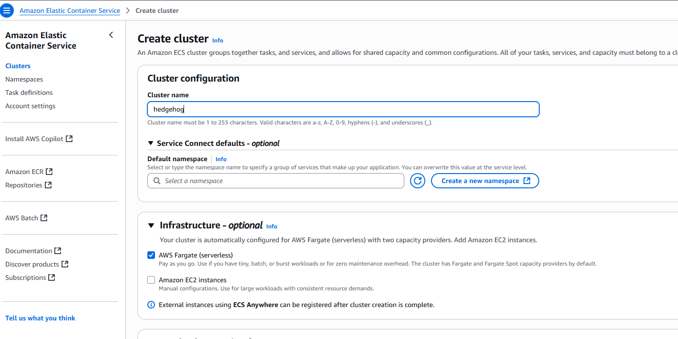

We create a namespace which is like an environment in a cluster.

In the infrastructure I choose AWS Fargate which is serverless totally managed by aws so we don’t need to manage VM security updates, configurations.

If we want to customize infrastructure we can choose EC2 instances where we can set instance type, ASG, volumes, VPC, security groups and instance roles.

Once we configure all the above step then we can create a cluster in ECS then next step will be creating a task definition

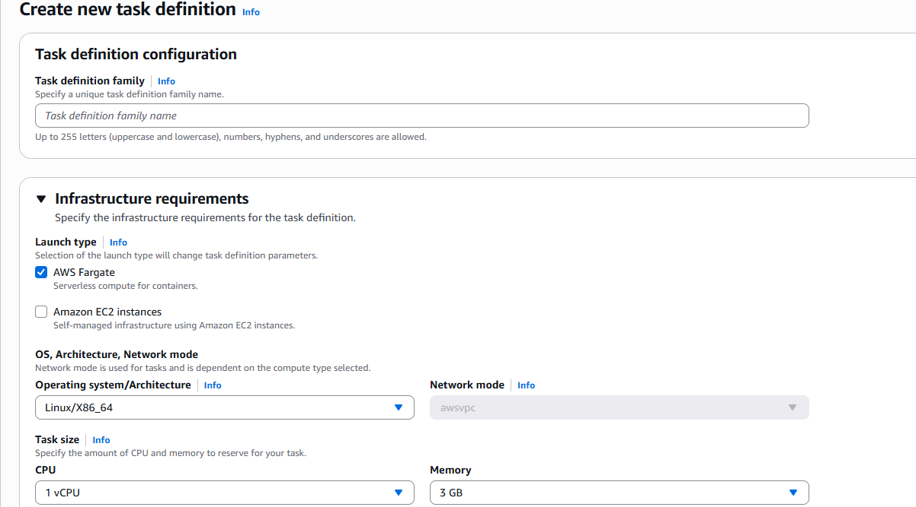

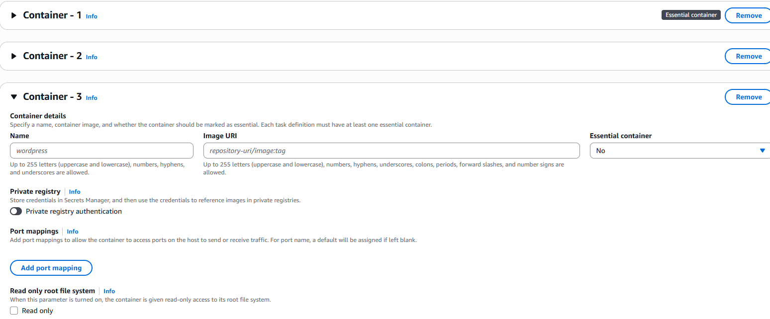

In the task definition we have to give container name and **elastic container registry** or dockerhub URL and also CPU, Memory, VPC and storage configurations

With these steps task definition can be created. Then we have to run the task in the cluster.