

AI GPU Summer Internship Program

CSS7000 INTERNSHIP REPORT

Submitted by

Vinay B T – 20241CSD0166

Under the guidance of,
Dr. Dhannya J

BACHELOR OF TECHNOLOGY

IN

COMPUTER SCIENCE AND ENGINEERING (Data Science)


PRESIDENCY UNIVERSITY
BENGALURU
AUGUST 2026

PRESIDENCY SCHOOL OF
ARTIFICIAL INTELLIGENCE & ADVANCED COMPUTING
BONAFIDE CERTIFICATE

Certified that this report “Face Recognition Attendance System” is a bonafide work of Vinay B T (20241CSD0166), who has successfully carried out the internship work and submitted the report for partial fulfilment of the requirements for the award of the degree of BACHELOR OF TECHNOLOGY in PRESIDENCY SCHOOL OF ARTIFICIAL INTELLIGENCE & ADVANCED COMPUTING, DATA SCIENCE during 2026-2027.

Dr. Dhannya J  Assistant Professor  Internship Guide  PSAIAC  Presidency University | Dr. Radha Kanagaraj  Assistant Professor  Program Internship Coordinator  PSAIAC  Presidency University | Dr. Geetha Arjunan  Associate Professor  School Internship Coordinator  PSAIAC  Presidency University

Dr. S Pravinthraja  Professor & Head of the Department  PSAIAC  Presidency University | Dr. Shakkeera L  Dean  PSAIAC  Presidency University

Sl.No | Name of the Examiner | Signature
1 | Dr. Chandrashekar B

PRESIDENCY UNIVERSITY

PRESIDENCY SCHOOL OF
ARTIFICIAL INTELLIGENCE & ADVANCED COMPUTING
DECLARATION

I am a student of final year B.Tech in COMPUTER SCIENCE AND ENGINEERING (Data Science), at Presidency University, Bengaluru, named VINAY B T, hereby declare that the internship work titled “Face Recognition Attendance System” has been independently carried out by me and submitted in partial fulfillment for the award of the degree of B.Tech in COMPUTER SCIENCE AND ENGINEERING during the academic year of 2026-2027. Further, the matter embodied in the internship has not been submitted previously by anybody for the award of any Degree or Diploma to any other institution.

VINAY B T USN: 20241CSD0166 Signature

PLACE: BENGALURU
DATE: August 2026
ACKNOWLEDGEMENT

For completing this internship work, I have received the support and the guidance from many people whom I would like to mention with deep sense of gratitude and indebtedness. I extend my gratitude to our beloved Chancellor, Pro-Vice Chancellor, and Registrar for their support and encouragement in completion of the internship.
I would like to sincerely thank my internal guide Dr. Dhannya J, Assistant Professor Presidency School Of Artificial Intelligence & Advanced Computing Presidency University, for her moral support, motivation, timely guidance and encouragement provided to me during the period of internship work.

I am also thankful to Dr. S Pravinthraja, Professor, Head of the Department, Presidency School Of Artificial Intelligence & Advanced Computing, Presidency University, for his mentorship and encouragement.
I express my cordial thanks to Dr. Shakkeera L, Dean, Presidency School Of Artificial Intelligence & Advanced Computing, Presidency University for providing the required facilities and intellectually stimulating environment that aided in the completion of my internship work.
We are grateful to Dr. Geetha Arjunan, Associate Professor, School Internship Coordinator, Dr Radha Kanagaraj, Assistant Professor, Program Internship Coordinator, Presidency School Of Artificial Intelligence & Advanced Computing, Presidency University for facilitating problem statements, coordinating reviews, monitoring progress, and providing their valuable support and guidance.

I am also grateful to Teaching and Non-Teaching staff of Presidency School Of Artificial Intelligence & Advanced Computing and also staff from other departments who have extended their valuable help and cooperation.
Vinay B T

TABLE OF CONTENTS

SL. NO | TITLE | PAGE NO
 | BONAFIDE CERTIFICATE | ii
 | DECLARATION | iii
 | ACKNOWLEDGEMENT | iv
 | LIST OF CONTENTS | v
 | LIST OF FIGURES | vi
 | LIST OF TABLES | vi
 | ABSTRACT | vii, viii
1. | Introduction  1.1 Background  1.2 Problem Statement  1.3 Objectives of the work  1.4 Scope and Limitations | 6-10
2. | About Company or Organization  2.1 NVIDIA Corporation | 11-14
3. | Technologies and Concepts Explored  3.1 GPU Computing  3.2 Deep Learning Frameworks | 15-17
4. | About the Project Team and Reporting Manager  4.1 Project Team Structure  4.2 Role and Responsibilities  4.3 Reporting Manager  4.4 Individual Project Development  4.5 Summary | 18-20
5. | Challenges Faced in Internship | 21-23
6. | Internship Project  6.1 Project Overview  6.2 System Architecture  6.3 Direction of Data Flow | 23-28
7. | Objectives of the work  7.1 Development and Implementation | 29-30
8. | Result | 31-32
9. | GitHub Link  Conclusion | 33
10. | References | 34

LIST OF FIGURES

Figure No. | Title | Page No.
Figure 6.1 | Enhanced System Architecture | 26
Figure 6.2 | Database ER Model Diagram | 26
Figure 8.1 | Dashboard | 31
Figure 8.2 | Enrollment | 31
Figure 8.3 | Attendance | 32
Figure 8.3 | Attendance Record | 32

LIST OF TABLES

Table No. | Title | Page No.
Table 2.1 | Key Specification of NVIDIA H200 Tensor Core GPU | 13
Table 3.1 | CPU vs GPU Comparison | 16
Table 6.1 | Components of the Face Recognition Attendance System | 27
Table 6.2 | Technology Stack Overview | 28
Table 7.1 | Project Review Phases | 30

ABSTRACT
The FaceAttend – AI Face Recognition Attendance System is an artificial intelligence-based attendance management system designed to provide a convenient, organized, and efficient method for recording and monitoring student attendance. The system uses face recognition as the primary method for identifying students and recording their attendance. Instead of depending entirely on traditional manual attendance procedures, the system maintains digital attendance records that can be reviewed through individual student reports. The generated report contains important student information, attendance summaries, monthly and weekly attendance breakdowns, and a complete attendance log. This makes it possible to monitor attendance performance in a structured manner and provides a clear record of when attendance was recorded.
The system maintains individual student information along with their attendance history. In the provided report, the student information includes the student name, student ID, department, year, section, email address, and enrollment date. The student considered in the report is a third-year Computer Science student from Section A, enrolled in the system on 19 August 2026. By associating attendance records with individual student information, the system provides a dedicated attendance report for each student. This approach helps organize attendance data and makes the information easier to review. The system also generates a report for the available attendance period, allowing the stored records to be examined without manually checking individual attendance entries.
One of the important features of FaceAttend is its attendance summary. The report provides the number of days a student was present, the number of days absent, the total number of tracked days, and the calculated attendance percentage. In the provided report, three days were tracked and all three were included as present in the attendance summary, producing an overall attendance percentage of 100%. This summary gives a quick view of the student's attendance status and can help users understand their attendance performance without examining the complete attendance log. The system therefore combines individual attendance records into a summarized format that is easier to interpret.
The system also provides a monthly attendance breakdown to show attendance performance over a longer period. The report contains monthly information for the previous twelve months, including the number of present days, working days, attendance percentage, and status. According to the available report, there were no recorded present days from September 2025 through July 2026. For August 2026, three present days were recorded out of 26 working days, resulting in a monthly attendance percentage of 11.5%, which was classified as poor by the system. This monthly analysis provides a broader view of attendance and can help identify periods in which attendance records are low. It also demonstrates how the system can organize attendance information according to different time periods.

In addition to monthly information, FaceAttend provides a weekly attendance breakdown. The report covers the last twelve weeks and displays the number of present days, absent days, total days, and attendance percentage for each week. The available records show zero present days for the weeks beginning from 1 June 2026 through 10 August 2026. For the week beginning 17 August 2026, three present days and three absent days were recorded, giving a weekly attendance percentage of 50%. The weekly breakdown provides a more detailed view of recent attendance activity and complements the monthly and overall attendance summaries.
Another important component of the system is the complete attendance log. The attendance log records details such as the date, day, time, location status, distance, and final attendance status. In the provided report, an attendance record on 19 August 2026 at 22:46:44 was marked as present, with the location identified as within range and a recorded distance of 13.4 metres. Another entry on 20 August 2026 at 23:37:34 was marked as present, although the location information was unavailable. The record dated 21 August 2026 at 07:28:27 was marked as absent, with the location information listed as not available. These records demonstrate how the system maintains detailed information associated with attendance events rather than storing only a simple present or absent value.
The inclusion of location and distance information provides additional context to the attendance records when such information is available. For example, the 19 August entry indicates that the recorded location was within the permitted range and that the measured distance was 13.4 metres. Other records may contain unavailable or not-applicable location information, as shown in the provided report. Therefore, the attendance log provides both attendance status and supporting information about each recorded event. This creates a more detailed digital attendance history that can be examined when reviewing individual records.
Overall, FaceAttend demonstrates an AI-based approach to student attendance management in which face recognition is used for identifying students and attendance information is maintained digitally. The system organizes the resulting information into student profiles, attendance summaries, monthly breakdowns, weekly breakdowns, and detailed attendance logs. The report generated by the system provides a structured representation of the available attendance data and makes it easier to monitor attendance over different periods. By maintaining digital records containing date and time information along with location-related information when available, the system provides a centralized method for reviewing attendance activity.
Keywords: Artificial Intelligence, Face Recognition, Attendance Management System, Facial Recognition, Computer Vision, Student Attendance, Automated Attendance, Attendance Tracking, Digital Attendance, Location Verification, Attendance Report, OpenCV.

1. Introduction
The Face Recognition Attendance System is an AI-based application developed to automate the process of recording and managing attendance using computer vision. The system uses a standard webcam to detect and recognize individuals in real time and automatically records their attendance in a database. It is designed to reduce the time and effort involved in traditional attendance methods while providing a more efficient, contactless, and reliable approach to attendance management. The application is developed as a Python-based web application using the Flask framework, with OpenCV and the face_recognition library used for face detection and recognition.
1.1 Background
Attendance tracking is an important and routine activity in educational institutions and workplaces. Traditional methods such as manual roll calls, paper attendance registers, sign-in sheets, and card or RFID-based systems can be time-consuming and may be vulnerable to proxy attendance. These methods can also require additional hardware and manual effort for maintaining and managing attendance records. With the development of Artificial Intelligence and Computer Vision, face recognition provides an opportunity to automate this process using a standard webcam.
The Face Recognition Attendance System was developed to apply these technologies to a practical attendance-management problem. In the system, a person's face acts as a unique identifier. The camera captures the person's face, the system detects the face from the live video feed, and the face-recognition model generates a numerical representation of the facial features. This representation is compared with previously stored face encodings to identify the individual. Once a registered person is successfully recognized, the system records the attendance along with the date and time in the database.
The project combines computer vision, machine learning, and full-stack web development to provide a complete attendance-management solution. The application includes face registration, live camera-based recognition, automated attendance marking, duplicate-attendance prevention, administrator login, dashboard-based monitoring, and attendance report generation. The system is designed to operate as a locally hosted Flask web application and provides administrators with access to attendance information and historical records.
The project also provided practical experience in applying concepts learned during the internship, particularly Artificial Intelligence, Machine Learning, Neural Networks, Convolutional Neural Networks, Computer Vision, Flask, SQLAlchemy, and database management. The knowledge of face detection, feature extraction, and similarity-based matching was directly applied to develop the face-recognition component, while full-stack development concepts were used to connect the camera interface, backend, recognition engine, and database into a single working application.

1.2 Problem Statement
Attendance management is an important responsibility in educational institutions and organizations, as accurate attendance records are required for monitoring student or employee presence and maintaining proper records. However, traditional attendance methods such as manual roll calls, paper registers, sign-in sheets, and card or RFID-based systems have several limitations. Manual roll calls require the teacher or administrator to spend time calling and recording the names of individuals, which can reduce the time available for teaching or other productive activities. Paper-based attendance registers also require continuous manual maintenance and may result in errors while entering, updating, or calculating attendance records.
Another major problem with conventional attendance systems is the possibility of proxy attendance. In a manual or card-based system, one individual may mark attendance on behalf of another person. RFID cards or identification cards can also be shared between individuals, making it difficult to ensure that the person recorded as present is actually the person who attended. This reduces the reliability and security of the attendance records. The existing methods may also require dedicated hardware, which increases the cost of installation, maintenance, and management.
There is also a limitation in the way attendance information is monitored and managed. Traditional systems may require administrators to manually collect attendance records, calculate attendance percentages, and prepare reports. This makes it difficult to obtain real-time information about attendance and attendance trends. A modern attendance system should therefore be capable of automatically recording attendance, storing the information in a persistent database, and providing administrators with an easy way to view and manage the records.
The main problem addressed by this project is the need for a reliable, efficient, automated, and tamper-resistant attendance system that can identify individuals without requiring manual intervention or specialized biometric hardware. To solve this problem, the proposed Face Recognition Attendance System uses a standard webcam to capture a live video feed and applies computer-vision and face-recognition techniques to identify registered individuals. The detected face is converted into a numerical face encoding and compared with previously stored encodings. When a suitable match is found, the system identifies the person and records their attendance with the corresponding date and time in the database.
The system is also designed to address duplicate attendance entries. Once an individual's attendance has been recorded, the application uses attendance and session-related logic to prevent the same person from being unnecessarily marked multiple times. This improves the reliability of the stored attendance records. The system also handles unknown faces by rejecting unregistered individuals instead of recording them as valid attendees. System testing confirmed successful operation of user registration, face detection, face recognition, unknown-face handling, attendance marking, duplicate prevention, dashboard loading, and report generation.
Another important requirement is providing administrators with a simple interface for monitoring attendance. The proposed system includes an administrator dashboard through which attendance information, recognition status, daily statistics, and historical trends can be viewed. Attendance information can also be exported in CSV or Excel format, making it easier to maintain records and generate reports when required.
Therefore, the problem can be summarized as the development of an AI-based attendance management system that automatically detects and recognizes individuals from a live camera feed, records verified attendance in a database, prevents duplicate attendance, handles unknown individuals, and provides administrators with an accessible dashboard and exportable reports. The system aims to overcome the major limitations of manual and card-based attendance methods while demonstrating the practical application of Artificial Intelligence, Computer Vision, and full-stack web development in a real-world problem.

1.3 Objectives of the Work
The main objective of the internship work was to understand and apply the concepts of Artificial Intelligence, Machine Learning, Deep Learning, and Computer Vision to develop a practical Face Recognition Attendance System. The project was designed to provide an automated method of recording attendance by identifying individuals through their facial features. Through this work, the aim was to connect the theoretical knowledge gained during the internship with a practical and deployable application.
One of the primary objectives was to understand the fundamentals of Artificial Intelligence, Machine Learning, and Deep Learning, with particular emphasis on Neural Networks and Convolutional Neural Networks. These concepts are important for image-based applications because CNNs can learn and extract useful features from images. In the developed system, these concepts were applied to understand how facial features can be detected, encoded, and compared for recognizing registered individuals.
Another important objective was to gain practical knowledge of Computer Vision and implement a real-time face detection and face recognition pipeline. The system uses OpenCV for video capture and frame processing, while the face_recognition library based on dlib is used for face detection and generation of 128-dimensional face encodings. These encodings are compared with stored face encodings to identify the individual in the live camera feed.
The project also aimed to automate the attendance-marking process and reduce the dependence on manual attendance methods. Once a registered individual is successfully recognized, the system records the person's attendance along with the date and time. The system was also designed to prevent duplicate attendance entries for the same person, thereby improving the accuracy and reliability of attendance records.
Another objective was to develop a complete web-based application using full-stack development technologies. The project uses Flask for the backend and routing, Jinja2 for rendering web pages, HTML, CSS, and JavaScript for the user interface, and SQLAlchemy for database management. The application integrates the frontend camera interface, Flask backend, face-recognition engine, and database so that the complete attendance process can be performed through a single application.
The work also aimed to develop a face-registration module through which new students or employees could be registered using multiple facial samples. The system stores the generated face encodings so that they can later be compared with faces captured from the live camera. This registration process forms the foundation of the recognition system because only registered individuals can be identified and marked as present.
Another objective was to provide an administrator dashboard for monitoring and managing attendance information. The dashboard is intended to display attendance statistics, recognition status, and historical trends, allowing administrators to monitor attendance more conveniently. The system also provides the ability to export attendance information in CSV or Excel format, which supports record-keeping and report preparation.
The internship also aimed to provide practical knowledge of GPU-enabled computing and optimization techniques. The training included understanding GPU resource allocation, GPU-enabled JupyterLab environments, mixed-precision training, memory optimization, FlashAttention, and tensor parallelism. Although the final attendance application can operate on a CPU for a single-camera setup, this knowledge provides a foundation for improving performance and scaling the system to larger workloads or multiple camera streams.
1.4 Scope and Limitations
Scope
The scope of the Face Recognition Attendance System is to develop an automated, AI-based attendance management application that uses computer vision and facial recognition to identify registered students or employees and record their attendance. The system is designed to work with a standard webcam and does not require specialized biometric hardware. It provides a contactless method of attendance management in which the individual's face is used as a unique identifier.
The system includes real-time face detection and recognition from a live camera feed. New students or employees can be registered by capturing multiple face samples, which are processed to generate facial encodings. These stored encodings are later used to compare against faces captured through the live camera. The recognition process uses a 128-dimensional numerical representation of facial features and a distance-based matching approach to determine whether the detected face belongs to a registered individual.
Another major part of the scope is automated attendance marking. When a registered individual is successfully recognized, the system records the attendance along with the date and time in the database. The system also includes logic to prevent duplicate attendance entries for the same person. This helps maintain accurate attendance records and reduces the possibility of repeated entries.
The project also covers the development of an administrator dashboard for managing and monitoring attendance information. The dashboard provides access to daily attendance information, recognition status, attendance statistics, and historical trends. The system also supports the generation and export of attendance reports in CSV or Excel format, allowing attendance information to be maintained for future reference and record-keeping.
The application includes secure administrator login and is implemented as a locally hosted Flask web application. The frontend provides interfaces for registration, live camera preview, and dashboard views, while the Flask backend manages routing, authentication, communication with the recognition engine, and database operations. SQLAlchemy is used as the database-access layer, with SQLite/MySQL identified as the supported persistent storage options in the project architecture.
The project scope also includes testing the complete workflow, beginning with user registration and continuing through face detection, face recognition, attendance marking, duplicate prevention, dashboard monitoring, and report generation. The testing results documented in the report indicate that these major functions operated successfully under the tested conditions.
Limitations
Although the system provides an automated approach to attendance management, its recognition accuracy can be affected by environmental and image-related conditions. Poor lighting, face occlusion such as masks or glasses, extreme camera angles, and differences in image quality may reduce the consistency of face detection and recognition. The system therefore performs best under normal lighting and suitable camera conditions.
A significant limitation of the current implementation is the absence of liveness detection. The system primarily verifies whether the facial features captured by the camera match a stored face encoding. Because an additional anti-spoofing or liveness-check mechanism is not currently implemented, the system may be vulnerable to attempts to use a photograph of a registered individual. Additional liveness-detection techniques would be required to provide stronger protection against such spoofing attempts.
The current system is designed for a single-camera and single-machine deployment. It is intended to demonstrate the complete attendance workflow in a controlled environment rather than provide a large-scale distributed attendance infrastructure. Multi-camera support and cloud-based deployment are outside the scope of the present implementation.
Another limitation relates to the number of registered individuals. When the number of stored face encodings becomes very large, comparing a newly detected face against every stored encoding using a linear matching process can increase processing time. Large-scale deployment involving thousands of registered faces would therefore require further optimization of the encoding storage and matching process to maintain real-time recognition performance.
The current system is also not integrated with institutional ERP, HR, or other existing organizational management systems. Such integration would require additional development to connect the attendance database with external systems and their authentication, data, and reporting requirements. Therefore, ERP and HR integration remains outside the scope of the current project.
Overall, the scope of the project focuses on demonstrating a functional, contactless, and automated face-recognition-based attendance solution using a webcam, while the limitations define the areas that would require additional development for large-scale, highly secure, multi-camera, or enterprise-level deployment.

About the Organization

NVIDIA Corporation

Company Overview
NVIDIA Corporation is an American multinational technology company headquartered in Santa Clara, California. Founded in 1993 by Jensen Huang, Chris Malachowsky, and Curtis Priem, the company has grown into a major technology organization in the fields of accelerated computing, artificial intelligence, graphics processing, and high-performance computing. NVIDIA initially gained recognition through the development of Graphics Processing Units (GPUs) for gaming and professional visualization. Over time, its technology evolved beyond graphics applications and became an important part of scientific computing, data analytics, deep learning, artificial intelligence, and other computationally intensive fields.
A significant stage in NVIDIA's technological development was the introduction of CUDA, or Compute Unified Device Architecture, in 2006. CUDA made it possible for developers to use the parallel processing capabilities of GPUs for general-purpose computing. This expanded the role of GPUs beyond graphics rendering and enabled their application in areas such as scientific research, data analysis, machine learning, and high-performance computing. The ability of GPUs to perform a large number of operations simultaneously made them particularly suitable for computational tasks involving large datasets and complex mathematical calculations.
Today, NVIDIA technology is used across a broad range of industries and application areas. Its GPUs and accelerated computing platforms support gaming and entertainment applications, cloud computing and data centers, professional visualization, automotive systems, healthcare technologies, financial analysis, scientific research, and artificial intelligence. In AI and machine learning environments, GPU-based computing has become particularly important because the training and execution of advanced models often require significant computational power. NVIDIA's hardware and software ecosystem provides infrastructure for these workloads and supports the development of increasingly complex AI systems.
The company places significant emphasis on innovation and research in areas related to accelerated computing and artificial intelligence. Its research and development activities cover technologies such as computer graphics, computer vision, natural language processing, deep learning, robotics, and GPU-accelerated computing. NVIDIA has also contributed to educational and academic development through training programs, academic partnerships, and AI Centre of Excellence collaborations. These initiatives provide students, researchers, and practitioners with opportunities to gain exposure to modern AI technologies, computational resources, and accelerated computing environments.
The relevance of NVIDIA to this internship is particularly significant because the AI GPU Summer Internship Program provided exposure to GPU-enabled computing and modern AI technologies. The program was associated with the NVIDIA Accelerated AI Centre of Excellence and introduced concepts related to artificial intelligence, machine learning, deep learning, large language models, generative AI, and GPU optimization.

Core Technology Focus
NVIDIA's technology ecosystem is centered around accelerated computing, in which specialized hardware and software are used to improve the performance of computationally intensive workloads. One of the most important components of this approach is GPU computing. Unlike traditional Central Processing Units (CPUs), which are primarily designed to efficiently handle sequential and general-purpose operations, GPUs are designed to perform many calculations simultaneously. This parallel processing capability makes GPUs suitable for workloads involving large-scale numerical computations, matrix operations, image processing, scientific simulations, and machine learning.
The parallel computing capabilities of GPUs are particularly useful in artificial intelligence and machine learning because many AI algorithms require repeated mathematical operations on large volumes of data. NVIDIA's GPU technologies provide high computational capacity, substantial memory bandwidth, and specialized processing capabilities for such workloads. Modern GPU architectures also include specialized components, such as Tensor Cores, which are designed to accelerate operations commonly used in deep learning and AI models. Multiple GPUs can also be connected and used together to increase the available computational resources for larger workloads.
Artificial intelligence and machine learning represent major areas of NVIDIA's technology focus. The company provides both hardware and software infrastructure for AI model development, training, inference, and deployment. GPU hardware provides the computational resources, while software technologies and programming platforms support the development and optimization of AI applications. CUDA provides a programming environment for GPU computing, while optimized frameworks and software tools help developers use GPU resources efficiently. The NVIDIA software ecosystem also includes platforms and resources that support the deployment and execution of AI workloads.
Deep learning is another important area supported by NVIDIA technologies. Deep learning models often contain multiple neural network layers and require substantial computational resources during training. NVIDIA GPUs are designed to accelerate these operations and can support different neural network architectures used in modern AI applications. These include Convolutional Neural Networks used extensively in computer vision, Recurrent Neural Networks used for sequential data, Transformer-based architectures used in natural language processing and generative AI, and Graph Neural Networks used for graph-structured data. The availability of accelerated computing resources has contributed significantly to the practical development and use of these advanced AI models.
Generative AI has also become an important area of modern AI research and development. Generative models are capable of creating new content, including text, images, audio, and video, based on patterns learned from training data. Large Language Models and other Transformer-based systems require substantial computational resources because of their large number of parameters and complex operations. Similarly, image-generation technologies such as diffusion models require significant processing capabilities during training and inference. NVIDIA's GPU infrastructure plays an important role in supporting these computational requirements and enabling the efficient development and execution of generative AI applications.

NVIDIA's broader accelerated computing approach combines hardware, software, and computing infrastructure to support a variety of demanding applications. These include scientific computing, data analytics, high-performance computing, climate research, genomics, molecular simulations, and business intelligence. By providing specialized computational resources for parallel processing, NVIDIA technologies enable researchers and organizations to process complex workloads more efficiently. This focus on accelerated computing is particularly relevant to the growing field of artificial intelligence, where increasing dataset sizes and model complexity continue to create greater computational requirements.

NVIDIA H200 GPU Architecture
The NVIDIA H200 Tensor Core GPU is designed for demanding artificial intelligence, high-performance computing, and large-scale data-processing workloads. It is based on NVIDIA's Hopper architecture and incorporates increased memory capacity and memory bandwidth to support computationally intensive applications. Such GPU architectures are particularly relevant to modern AI because the training and execution of large models can require significant amounts of memory and high-speed data transfer between processing components.
The H200 provides 141 GB of HBM3e memory and a memory bandwidth of 4.8 TB/s, according to the technical specifications provided for this report. The combination of high memory capacity and bandwidth is intended to support workloads involving large datasets and complex AI models. The architecture also includes CUDA Cores, Tensor Cores, and specialized technologies intended to improve the efficiency of advanced computational workloads. The following table summarizes the major specifications of the NVIDIA H200 Tensor Core GPU.
Specification | Detail
Architecture | Hopper (GH100)
Memory | 141 GB HBM3e
Memory Bandwidth | 4.8 TB/s
FP8 Tensor Performance | 3,958 FP8 Tensor TFLOPS
CUDA Cores | 16,896
Tensor Cores | 528
Specialized Feature | Transformer Engine
Table 2.1: Key Specifications of NVIDIA H200 Tensor Core GPU
The Hopper architecture is designed to support accelerated computing and modern AI workloads. An important feature of this architecture is the use of advanced Tensor Core technology, which supports numerical operations commonly used in machine learning and deep learning. The architecture also incorporates technologies intended to improve the execution of Transformer-based models, which have become important in natural language processing, large language models, and generative AI applications. The availability of specialized hardware features allows computational resources to be better aligned with the requirements of modern AI workloads.

The H200 architecture includes a Transformer Engine designed to support Transformer-based neural network models. Transformer models involve large-scale mathematical operations and can require substantial memory and computational capacity during training and inference. The Transformer Engine supports efficient precision handling and mixed-precision computation, helping to balance computational performance with memory requirements. The use of lower-precision numerical formats, where appropriate, can reduce computational and memory demands while maintaining the effectiveness required for AI workloads.
Another important feature of the H200 is its HBM3e memory. High-bandwidth memory is particularly valuable for AI and data-intensive workloads because processing systems frequently need to transfer large amounts of data between memory and computational units. Increased memory capacity can also support larger models and larger batches of data, while high memory bandwidth can reduce bottlenecks associated with data transfer. These characteristics are useful in applications involving large language models, deep neural networks, scientific simulations, and other computationally intensive systems.
The architecture also supports high-speed interconnection technologies for multi-GPU environments. NVLink enables communication between GPUs and supports the scaling of computational workloads across multiple processing units. This is particularly useful when a single GPU does not provide sufficient computational capacity or memory for a specific application. By distributing workloads across multiple GPUs, larger AI models and more demanding computational tasks can be processed more effectively.
The performance characteristics of advanced GPUs such as the H200 are relevant to several AI applications. Large language models can benefit from increased memory capacity and computational performance, while generative AI applications can use GPU acceleration to reduce processing time during inference and model development. Multi-GPU configurations can further support distributed training and large-scale computational workloads. The use of accelerated computing can also improve performance per unit of energy for workloads that require extensive numerical processing.
Although the “Face Recognition Attendence System” developed during the internship does not itself require the full computational capacity of a high-end GPU architecture such as the H200 for every dataset analysis operation, understanding GPU computing and advanced AI infrastructure formed an important part of the internship learning experience. The exposure to GPU-enabled environments, AI workloads, machine learning concepts, and computational optimization provided broader knowledge about the infrastructure that supports modern AI systems. This understanding complements the development of the project, which focuses on improving the quality and readiness of data before it is used in later stages of the machine learning pipeline.

3. Technologies and Concepts

3.1 GPU Computing

CPU vs GPU Architecture
Understanding the architectural differences between Central Processing Units (CPUs) and Graphics Processing Units (GPUs) is important for understanding the concept of GPU-accelerated computing. Both CPUs and GPUs are processing units, but they are designed with different objectives and are therefore suitable for different types of computational workloads. A CPU is primarily designed for general-purpose computing and efficient execution of sequential and complex operations, whereas a GPU is designed to perform a large number of similar operations simultaneously. This fundamental difference makes GPUs particularly useful for data-intensive and highly parallel workloads such as artificial intelligence, machine learning, deep learning, scientific computing, and large-scale data processing.
The CPU generally contains a relatively smaller number of powerful and complex processing cores. These cores are supported by a large cache hierarchy and are designed to execute complex instructions with low latency. CPUs typically operate at higher clock speeds and are capable of efficiently handling sequential programs, conditional branching, unpredictable memory access, and tasks that require frequent decision-making. Their architecture is optimized to minimize the time required to complete individual operations, making them suitable for operating systems, application logic, database queries, and other general-purpose computing tasks.
In contrast, a GPU contains a significantly larger number of simpler processing cores. Instead of focusing primarily on minimizing the latency of a single task, the GPU architecture is designed to maximize the total amount of computational work completed within a given period. A large number of operations can therefore be executed concurrently across many processing cores. GPUs generally have lower clock speeds than CPUs but compensate for this through massive parallelism and high memory bandwidth. Their architecture is particularly effective when the same or similar operations must be performed repeatedly on large volumes of data.
The CPU architecture includes several features that support efficient general-purpose processing. Its smaller number of complex cores can handle sophisticated instructions and different types of program logic efficiently. Large caches help reduce delays caused by accessing main memory, while higher clock speeds allow instructions to be executed rapidly. CPUs also use advanced mechanisms to manage conditional branches and unpredictable program execution. These characteristics make the CPU suitable for workloads in which tasks depend heavily on the results of previous operations or involve complex control flow.

The major architectural differences between CPUs and GPUs are summarized in the following table.
Aspect | CPU | GPU
Core Count | Few tens of cores, typically 4–64 | Thousands of cores, up to 16,896 in advanced GPUs
Core Design | Complex cores with large caches | Simpler cores with smaller caches
Clock Speed | Higher, typically 3–5 GHz | Lower, typically 1–2 GHz
Memory | DDR RAM with relatively lower bandwidth | GDDR or HBM memory with higher bandwidth
Latency | Optimized for low latency | Focused more on throughput than individual-task latency
Threading | Handles a relatively smaller number of threads simultaneously | Supports thousands of concurrent threads
Design Goal | Minimize latency and efficiently execute complex operations | Maximize throughput through parallel processing
Best Suited For | Sequential and complex tasks | Parallel and data-intensive tasks
Table 3.1: CPU vs GPU Comparison

GPU architecture follows a different approach by allocating more hardware resources to parallel computation. A large number of simpler cores work simultaneously on multiple threads, making it possible to process large quantities of data in parallel. This approach is particularly effective when the same computational operation needs to be repeated across many data elements. The GPU uses a Single Instruction, Multiple Threads (SIMT) execution model, in which multiple threads can execute similar instructions concurrently. Combined with high-bandwidth memory, this architecture enables efficient processing of computationally intensive workloads.
The choice between CPU and GPU depends on the nature of the problem being solved. CPUs are generally more suitable for sequential programs, complex branching operations, unpredictable memory access patterns, and tasks requiring low latency. GPUs are more suitable for highly parallel programs, bulk data processing, predictable memory access patterns, and workloads involving repeated mathematical operations. In modern AI systems, both processing units often work together, with the CPU managing general application operations and the GPU accelerating computationally intensive tasks.
The study of GPU computing during the internship provided an understanding of why GPUs have become important in modern artificial intelligence and machine learning. Although the “ML Data-Readiness Risk Analyzer” primarily focuses on dataset assessment and quality analysis rather than large-scale neural network training, the knowledge of GPU architecture and accelerated computing provides important background regarding the computational infrastructure used in advanced machine learning workflows.

3.2 Deep Learning Frameworks
Deep Learning played an important role in the Face Recognition Attendance System, particularly in understanding how facial features can be extracted and represented for recognition. During the internship, the concepts of Neural Networks and Convolutional Neural Networks (CNNs) were studied as part of the Artificial Intelligence and Computer Vision domain. Neural Networks consist of interconnected neurons arranged into input, hidden, and output layers, where weights, biases, and activation functions are used to process information. CNNs are especially suitable for image-based applications because they can automatically learn and extract important spatial features from images.
In the developed attendance system, the deep-learning-based face-recognition functionality was implemented using the face_recognition library, which is based on dlib. The system uses a pretrained model to generate a 128-dimensional numerical encoding for a detected face. This encoding represents the distinguishing facial characteristics of an individual and provides a compact numerical representation that can be stored and compared during the recognition process.
The face-recognition process begins when a face is detected from the live camera feed. The detected face is processed by the recognition model to generate its 128-dimensional encoding. During registration, these encodings are stored for the corresponding individual. When a person appears in front of the camera later, the newly generated encoding is compared with the previously stored encodings using a distance-based matching approach. If the distance between the live encoding and a stored encoding falls below the defined threshold, the system considers the faces to be a match and uses the corresponding identity for attendance marking.
OpenCV is used alongside the face-recognition framework for computer-vision operations such as video capture and frame preprocessing. The combination of OpenCV and face_recognition allows the application to receive frames from the webcam, detect faces, generate facial encodings, and perform recognition in real time. This integration forms the main computer-vision component of the attendance system.
The internship also provided exposure to GPU-enabled computing and deep-learning optimization techniques. The training covered GPU resource allocation, GPU-enabled JupyterLab environments, mixed-precision training, memory optimization, FlashAttention, and tensor parallelism. These concepts were useful for understanding how deep-learning workloads can be accelerated and optimized. However, the deployed attendance system itself is designed to run comfortably on a CPU for its single-camera configuration, while GPU optimization concepts provide a foundation for future scaling and performance improvements.
Therefore, the deep learning component of the project primarily focuses on CNN-based facial feature representation through the face_recognition/dlib framework. It demonstrates how deep-learning concepts can be integrated with OpenCV, Flask, and database technologies to create a practical real-time face recognition and attendance management application.

4. About the Project Team and Reporting Manager
4.1 Project Team Structure
The Face Recognition Attendance System was developed as an individual project during the internship. The complete development lifecycle of the project was carried out independently, including problem identification, requirement analysis, project planning, system design, implementation, integration, testing, debugging, documentation, and final presentation. Since the project was developed individually, there was no separate development team with different members assigned to specific modules. The major responsibilities related to the design, development, testing, and documentation of the application were handled by the student under the guidance and supervision of the assigned internship guide.
Working as an individual developer required involvement in different technical areas of the project. These included designing the face-registration process, implementing the live camera interface, developing the face-detection and face-recognition pipeline, connecting the recognition system with the database, implementing attendance-marking logic, developing the administrator dashboard, and preparing attendance reports. Managing these different components provided practical exposure to the complete development of an AI-based web application rather than focusing on only one specialized module.
4.2 Role and Responsibilities
As the sole developer of the Face Recognition Attendance System, the major responsibility was to manage the different stages involved in designing and developing the application. The work began with understanding the problem of traditional attendance management and identifying the requirements for an automated face-recognition-based solution. Based on these requirements, the overall application structure, workflow, database requirements, and face-recognition process were planned.
One of the main responsibilities was designing and implementing the face-registration workflow. The registration process captures multiple facial samples of a student or employee and uses them to generate face encodings. These encodings are stored so that the system can later compare them with faces captured through the live camera. This registration process forms the foundation of the face-recognition functionality.
Another major responsibility was implementing the real-time face-detection and face-recognition pipeline using OpenCV and the face_recognition library. OpenCV was used for webcam access, video capture, and frame processing, while the face_recognition library was used to detect faces and generate 128-dimensional face encodings. The generated encoding from a live camera frame was compared with stored encodings to identify registered individuals.
The project also involved developing the Flask-based backend and integrating the application with the database using SQLAlchemy. The backend was responsible for handling application routes, authentication, recognition-related operations, attendance logging, and communication between the frontend, recognition engine, and database. Student information, face encodings, and attendance records were maintained through the database layer.
Another important responsibility was implementing the attendance-marking functionality. Once a registered person was successfully recognized, the system recorded the person's attendance along with the date and time. Logic was also implemented to prevent duplicate attendance entries, ensuring that the same person was not unnecessarily marked multiple times. The system was additionally tested to ensure that unknown or unregistered faces were not incorrectly recorded as valid attendees.
The development of the administrator dashboard was also part of the responsibilities. The dashboard was designed to provide access to attendance information, recognition status, daily attendance statistics, and historical trends. The system also included functionality for generating and exporting attendance reports in CSV or Excel format, making it easier to maintain and review attendance records.
Testing and debugging were important responsibilities throughout the project. Individual features such as user registration, administrator login, face detection, face recognition, unknown-face handling, attendance marking, duplicate prevention, dashboard loading, and report generation were tested. Implementation errors, recognition-accuracy issues, and integration problems were identified and resolved through continuous testing and debugging.
In addition to technical development, responsibility was undertaken for maintaining project documentation, recording development progress, organizing the application components, and preparing the completed project for evaluation and presentation. Working individually provided practical experience across different stages of the software development lifecycle and strengthened skills in problem-solving, debugging, technical decision-making, time management, and independent implementation.
4.3 Reporting Manager & Internship Guide
The internship project was carried out under the guidance of Ms. Dhannya J, Assistant Professor, Presidency School of Artificial Intelligence & Advanced Computing, Presidency University. She served as the internship and project guide for the Face Recognition Attendance System.
The internship guide provided academic and technical guidance throughout the development of the project. Her guidance helped in understanding the project requirements, reviewing development progress, identifying areas requiring improvement, and providing feedback during the implementation and evaluation stages. Guidance was particularly useful while addressing technical aspects such as face-recognition accuracy, application development, testing, and overall project progress.
The supervision received during the internship helped maintain a structured development process and provided direction when technical challenges were encountered. Regular feedback and review contributed to improving the implementation and ensuring that the project remained aligned with the objectives of the internship.

4.4 Individual Project Development
Since the Face Recognition Attendance System was developed as an individual project, the development process required independent decision-making and continuous learning throughout the project lifecycle. The work involved multiple areas, including requirement analysis, application design, frontend development, face-recognition implementation, backend development, database management, attendance processing, testing, debugging, documentation, and presentation.
The project began with identifying the limitations of traditional attendance methods and defining the requirements for an automated face-recognition solution. The next stages involved designing the application architecture and developing the registration, recognition, attendance, and dashboard components. The different components were then integrated so that the camera feed could communicate with the face-recognition engine, the recognized identity could be processed by the Flask backend, and the attendance information could be stored in the database.
The individual development approach provided practical exposure to the complete software development lifecycle. It required continuous problem-solving while working with computer vision, face recognition, web development, databases, and application integration. Challenges related to recognition accuracy, lighting conditions, camera angles, duplicate attendance, matching efficiency, and communication between the frontend, backend, recognition engine, and database were addressed through experimentation, testing, and debugging.
Developing the project individually also strengthened practical skills such as independent learning, technical decision-making, debugging, time management, system integration, documentation, and presentation. Taking responsibility for the complete project provided a better understanding of how an AI-based application progresses from a problem statement and requirements to a functional and tested software solution.
4.5 Summary
The Face Recognition Attendance System was developed as an individual internship project by Vinay B T under the guidance of Ms. Dhannya J, Assistant Professor, Presidency School of Artificial Intelligence & Advanced Computing. Since the project did not involve a larger development team, responsibility for the major stages of development was handled independently, beginning with problem identification and requirement analysis and continuing through system design, implementation, testing, debugging, documentation, and final presentation.
The individual development process provided practical experience in building a complete AI-based attendance application. The project required the integration of face registration, real-time face detection, face recognition, attendance logging, duplicate prevention, database management, administrator dashboard functionality, and report generation. It also provided practical experience in combining computer vision, deep learning concepts, Flask-based web development, and database technologies into a single working system. Overall, the project helped strengthen technical knowledge, problem-solving abilities, independent development skills, and understanding of the complete software development lifecycle.
5. Challenges Faced in Internship
5.1 Understanding Face Recognition and Computer Vision
One of the initial challenges faced during the internship was understanding the concepts involved in computer vision and face recognition. Unlike traditional software applications, a face recognition system needs to process visual information obtained from a camera and identify meaningful facial features from images. Understanding how face detection, facial feature extraction, face encoding, and face matching work together required both theoretical learning and practical experimentation. The challenge was gradually addressed by studying computer vision concepts and applying them using OpenCV and the face_recognition library.
5.2 Implementing Real-Time Face Detection
Another challenge was implementing reliable face detection from a live webcam feed. The system needed to continuously capture video frames and detect faces in real time without causing unnecessary delays. Processing every frame at full resolution could increase computational requirements and affect application performance. This challenge was addressed by using OpenCV for webcam access and frame processing and integrating it with the face-recognition pipeline. The implementation demonstrated how real-time camera input can be processed for an attendance application.
5.3 Improving Face Recognition Accuracy
Achieving reliable face recognition was one of the important technical challenges of the project. Recognition accuracy can be affected by factors such as lighting conditions, camera quality, facial expressions, face angles, and differences between registration images and live camera images. The project therefore required experimentation with face encodings and matching thresholds to obtain reliable recognition results. The challenge was addressed by using multiple face samples during registration and applying a distance-based comparison between the live face encoding and the stored face encodings.
5.4 Handling Different Lighting and Camera Conditions
The system also faced challenges caused by variations in environmental conditions. Poor lighting, shadows, face occlusion, extreme camera angles, and changes in image quality can affect the ability of the system to detect and recognize a face correctly. Since the project uses a standard webcam, the quality of the captured image depends on the surrounding environment and camera position. Testing under different conditions helped identify these limitations and provided a better understanding of the practical challenges involved in deploying computer-vision applications.
5.5 Preventing Duplicate Attendance
Another important challenge was preventing the same individual from being marked as present multiple times during the same attendance session. Since the recognition system continuously processes the camera feed, a recognized person may appear in several consecutive frames. Without appropriate attendance logic, the application could create repeated attendance records. This challenge was addressed by implementing duplicate-prevention logic that checks existing attendance records before creating a new entry.
5.6 Handling Unknown and Unregistered Faces
The system also needed to distinguish between registered and unregistered individuals. A face detected by the camera should not automatically result in an attendance entry. The detected face must first be compared against the stored face encodings, and only a sufficiently close match should be accepted. Handling unknown faces was therefore an important part of the recognition workflow. The system was tested to ensure that unregistered individuals were not incorrectly recorded as valid attendees.
5.7 Integrating Multiple Technologies
Integrating different technologies into a single working application was another significant challenge. The project combines Flask for the web application, OpenCV for camera and image processing, the face_recognition library for facial recognition, SQLAlchemy for database operations, HTML/CSS/JavaScript for the frontend, and a relational database for storing application information. Ensuring that these different components communicated correctly required careful application design and continuous testing.
5.8 Database and Attendance Management
Managing the relationship between user information, face encodings, and attendance records presented another challenge. The system needed to store registered user information and associated face encodings while also maintaining accurate attendance records with dates and timestamps. The database structure had to support these relationships and allow the application to retrieve the appropriate information during recognition. SQLAlchemy was used as the database-access layer to simplify communication between the Flask application and the database.
5.9 Developing the Administrator Dashboard
Developing an administrator dashboard that presents attendance information in a clear and useful manner was another challenge. The dashboard needed to provide information such as attendance records, recognition status, daily statistics, and historical trends. The application also needed to support attendance report generation and export in CSV or Excel format. Designing these features required coordination between the frontend, backend, and database components.
5.10 Debugging and Testing the Complete Application
Testing and debugging were continuous parts of the project development process. Since the system contains several interconnected components, an error in one component could affect the complete attendance workflow. Testing therefore covered registration, administrator login, face detection, face recognition, unknown-face handling, attendance marking, duplicate prevention, dashboard loading, and report generation. Continuous testing and debugging helped identify implementation and integration problems and improve the reliability of the final application.
5.11 Understanding Deep Learning and GPU Concepts
The internship also involved learning Artificial Intelligence, Machine Learning, Neural Networks, Convolutional Neural Networks, and GPU computing concepts. Understanding how deep-learning-based models represent facial features and how GPU acceleration can be used for computationally intensive AI workloads required additional learning. Although the final attendance application was designed to operate on a CPU for a single-camera setup, the knowledge gained about GPU computing, mixed-precision processing, memory optimization, and other optimization techniques provided a broader understanding of AI system development.
5.12 Summary of Challenges
The internship and development of the Face Recognition Attendance System involved several conceptual and technical challenges. These included understanding computer vision and face recognition, implementing real-time face detection, improving recognition accuracy, handling different lighting and camera conditions, preventing duplicate attendance, identifying unknown faces, integrating multiple technologies, managing databases, developing the administrator dashboard, and testing and debugging the complete application.
Overcoming these challenges provided valuable practical experience in developing an AI-based software application. The development process improved skills in computer vision, face recognition, Flask-based web development, database management, debugging, system integration, and independent problem-solving. The challenges also provided a practical understanding of the limitations of face-recognition systems and the importance of testing under realistic conditions. Overall, the experience helped transform the theoretical concepts learned during the internship into a functional Face Recognition Attendance System.

6. INTERNSHIP PROJECT: FACE RECOGNITION ATTENDANCE SYSTEM
6.1 Project Overview
The Face Recognition Attendance System was developed as the major internship project to address the limitations of traditional attendance-management methods. Conventional methods such as manual roll calls, paper registers, and card-based attendance systems can require significant manual effort and may be affected by human errors, duplicate entries, and proxy attendance. The objective of the project was therefore to develop an automated and contactless attendance system that could identify registered individuals using their facial features and record their attendance automatically.
The system uses a standard webcam to capture the user's face and perform real-time face detection and recognition. During registration, multiple facial samples are captured and processed to generate face encodings. These encodings are stored and later used as references when a person appears in front of the camera. The face_recognition library, which is based on dlib, generates a 128-dimensional numerical representation of the detected face. The newly generated encoding is compared with the stored encodings to determine the identity of the individual.
The primary goal of the project is to automate the complete attendance-marking process. Once a registered individual is successfully recognized, the system records the person's attendance along with the corresponding date and time. The system also contains logic to prevent duplicate attendance entries and does not record unknown or unregistered individuals as valid attendees. This helps improve the reliability and accuracy of attendance records.
The project combines computer vision, face recognition, web development, and database technologies into a single application. OpenCV is used for webcam access, video capture, and frame processing, while the face_recognition library is used for facial feature encoding and matching. Flask provides the web-application backend, and SQLAlchemy is used as the database-access layer. HTML, CSS, JavaScript, and Jinja2 are used to provide the user interface and application pages.
Another important feature of the project is the administrator dashboard. The dashboard allows attendance information to be monitored and provides access to attendance statistics, recognition status, and historical information. The system also supports attendance-report generation and export in CSV or Excel format, making it easier to maintain and review attendance records.
The project was designed as a locally hosted Flask application and was developed as an individual internship project. The complete development process, including requirement analysis, system design, implementation, testing, debugging, documentation, and presentation, was handled independently under the guidance of the internship guide.
Overall, the Face Recognition Attendance System provides an automated approach to attendance management by combining real-time face recognition with database-based attendance recording.
6.2 System Architecture
Overall System Architecture
The Face Recognition Attendance System follows a web-based architecture in which the user interacts with the application through a browser, the Flask backend manages application requests and processing, the face-recognition component processes the camera input, and the database stores user and attendance information. The major components are integrated to provide a complete workflow from user registration to face recognition and attendance recording.
The architecture can be divided into several major components. The frontend layer provides the user interface for administrator login, user registration, live camera preview, attendance monitoring, and dashboard access. The Flask backend manages routing, authentication, application logic, communication with the recognition engine, and database operations. The face-recognition layer uses OpenCV and the face_recognition library to capture and process faces from the webcam. The database layer stores registered user information, face encodings, and attendance records.
The overall flow begins when a new student or employee is registered through the application. Multiple facial samples are captured using the webcam and processed to generate facial encodings. These encodings are associated with the registered individual's information and stored for future recognition. During attendance marking, the webcam continuously captures frames, and OpenCV processes the camera input to detect faces.
After a face is detected, the face_recognition component generates a 128-dimensional face encoding. This encoding is compared with the previously stored encodings using a distance-based matching approach. If the distance between the live encoding and a stored encoding is within the defined threshold, the system identifies the individual as a registered person. If no suitable match is found, the face is treated as unknown and attendance is not recorded.
Once a registered individual has been successfully recognized, the Flask backend processes the recognition result and checks the attendance information. If the person has not already been marked as present for the relevant attendance session, a new attendance record containing the individual's identity, date, and time is stored in the database. Duplicate-prevention logic ensures that repeated recognition of the same person does not unnecessarily create multiple attendance records.
The stored attendance information can then be accessed through the administrator dashboard. The dashboard provides attendance statistics, recognition information, and historical attendance trends. The system also provides report-generation functionality, allowing attendance information to be exported in CSV or Excel format for record keeping and further analysis.
The overall architecture can therefore be represented through the following sequence:
User Registration → Webcam Capture → Face Detection → Face Encoding → Store Face Encoding → Live Camera Capture → Face Recognition → Identity Matching → Duplicate Check → Attendance Recording → Database → Administrator Dashboard → Attendance Report
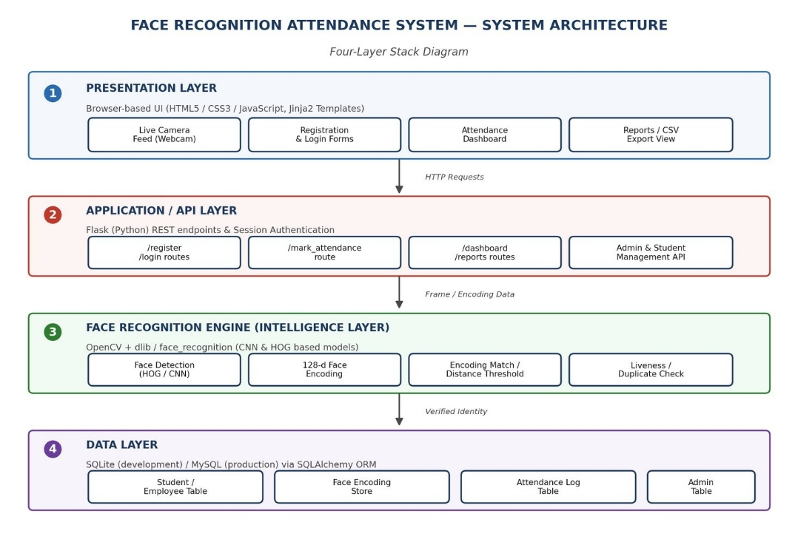

Figure 6.1: Enhanced System Architecture

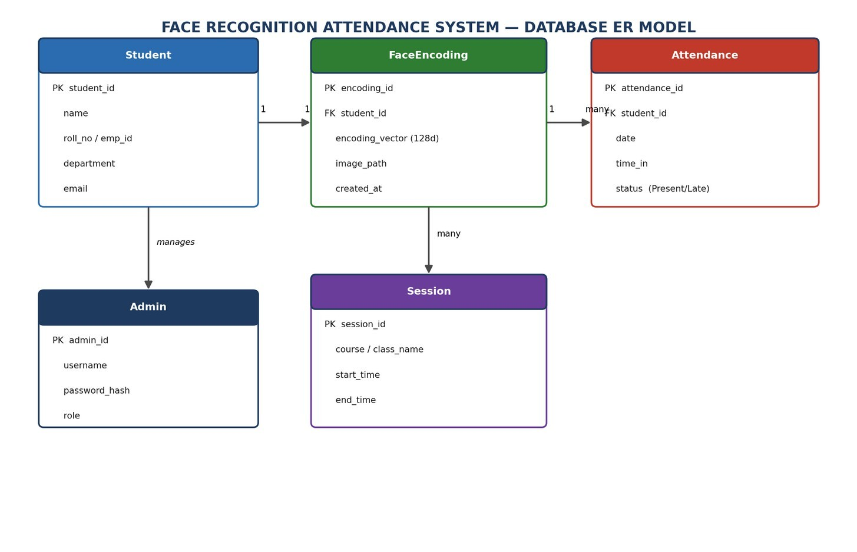

Figure 6.2: Database ER Model Diagram

Layer / Component | Technology / Module | Input | Output
User Interface | HTML, CSS, JavaScript, Jinja2 | User actions | Web pages and results
User Registration | Flask + OpenCV | User details and face images | Registered user and face data
Camera Capture | OpenCV | Webcam feed | Video frames
Face Detection | OpenCV | Video frames | Detected faces
Face Recognition | face_recognition / dlib | Detected faces and stored encodings | Recognized or unknown person
Attendance Management | Flask + Database | Recognized user, date, and time | Attendance record
Database | SQLAlchemy + SQLite/MySQL | User, face, and attendance data | Stored records
Admin Dashboard | Flask + Jinja2 | Attendance records | Attendance statistics and history
Report Generation | CSV/Excel | Attendance records | Attendance report

Table 6.1: Components of the Face Recognition Attendance System

6.3 Direction of Data Flow

The Face Recognition Attendance System follows a sequential data flow starting from user registration or live camera capture. The user interacts with the system through the web interface, where registration details can be entered and the webcam can be accessed. The captured camera frames are processed using OpenCV, and detected faces are passed to the face_recognition module for face encoding and recognition.

During registration, facial samples are captured and converted into face encodings, which are stored in the database along with the user's information. During attendance marking, the live camera captures a face and generates a new encoding. This encoding is compared with the stored face encodings to identify the person. If a registered person is recognized, the system checks for duplicate attendance and records the person's attendance with the date and time.

The attendance information is then stored in the database and made available through the administrator dashboard. The administrator can view attendance records, statistics, and historical information and can generate attendance reports. Therefore, the main data flow can be represented as:

User → Web Interface → Webcam → OpenCV → Face Recognition → Attendance Processing → Database → Dashboard/Report → User
Category | Technology / Tool | Purpose in the Project
Web Framework | Flask | Used to develop the web application and manage backend operations
Frontend | HTML, CSS, JavaScript, Jinja2 | Used to create the user interface and application pages
Computer Vision | OpenCV | Used for webcam access, video capture, and image processing
Face Recognition | face_recognition / dlib | Used to detect faces, generate face encodings, and recognize registered individuals
Database Access | SQLAlchemy | Used to communicate between the application and database
Database | SQLite / MySQL | Used to store user information, face encodings, and attendance records
Report Generation | CSV / Excel | Used to export attendance records for reporting

Table 6.2: Technology Stack Overview

Objectives of the Work

The primary objective of the ML Data-Readiness Risk Analyzer project is to develop an intelligent web-based system that helps users evaluate the quality and readiness of datasets before they are used for machine learning model development. The specific objectives of the project are:

To develop a web-based system for analyzing datasets before they are used for machine learning model development.

To enable users to upload and process commonly used dataset formats such as CSV and Excel files.

To perform automated data profiling and systematically examine important characteristics of the uploaded dataset.

To identify data-quality issues such as missing values, duplicate records, inconsistent data formats, incorrect data types, outliers, and other potential concerns.

To detect and categorize potential risks that may negatively affect machine learning workflows and model performance.

To assess the overall readiness of a dataset for use in machine learning applications.

To generate an understandable ML Data-Readiness Score based on the identified dataset characteristics and quality-related risks.

To provide detailed insights into the specific issues that contribute to the overall readiness assessment.

To provide AI-assisted interpretation and recommendations for improving the quality and usability of the dataset.

To present dataset findings, risk information, and readiness results through an interactive and user-friendly interface.

To visualize important data-quality metrics and analysis results using charts and graphical representations.

To help users identify areas that may require data cleaning, preprocessing, transformation, or further investigation.

7.1 Development and Implementation

Development Methodology
The Face Recognition Attendance System was developed using a phased and incremental approach. The development process was divided into four review phases to ensure that the project progressed systematically from initial problem identification to implementation, integration, testing, and refinement. Each phase focused on a specific group of project requirements, while the results of earlier stages provided the foundation for the following stages.
The first phase focused on establishing the project foundation, including understanding the problem, defining the requirements, designing the system architecture, selecting appropriate technologies, and preparing the development environment. The second phase concentrated on implementing the core dataset-processing functionality and developing the mechanisms required for automated data analysis and risk identification. The third phase focused on integrating AI-assisted functionality and implementing the ML data-readiness assessment and scoring mechanism. The final phase concentrated on testing the complete application, identifying errors, refining the interface and workflows, and improving the overall usability of the system.
Review | Focus | Timeline
Review 1 | Project Foundation and System Design | Days 1–4
Review 2 | Dataset Processing, Data Analysis and Risk Detection | Days 5–6
Review 3 | AI Integration and Face Recognition Attendance System | Days 7–8
Review 4 | Testing, Debugging and Application Refinement | Days 9–10
Table 7.1: Project Review Phases

Development Principles
The development of the project followed an incremental approach in which the core functionality was established before additional features were integrated. The dataset upload and processing workflow formed the initial functional foundation, after which data-quality analysis, risk identification, readiness assessment, AI-assisted interpretation, visualization, and reporting capabilities were progressively incorporated.
Continuous testing was performed throughout the development process to identify implementation and integration issues at an early stage. Individual modules were examined during development, followed by testing of the complete workflow from dataset upload to the generation and presentation of final results.
The application was designed with a user-centered approach so that complex dataset-quality information could be presented in an understandable and accessible manner. Documentation and version control were also maintained throughout development to organize the project structure and track changes.

Result

Website Output and Results

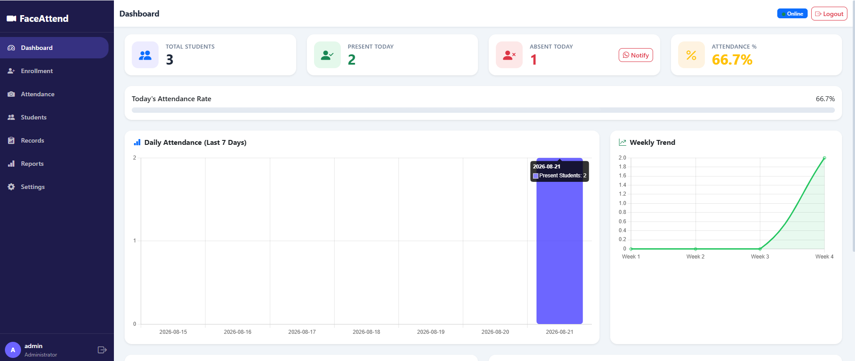

Figure 8.1: Dashboard

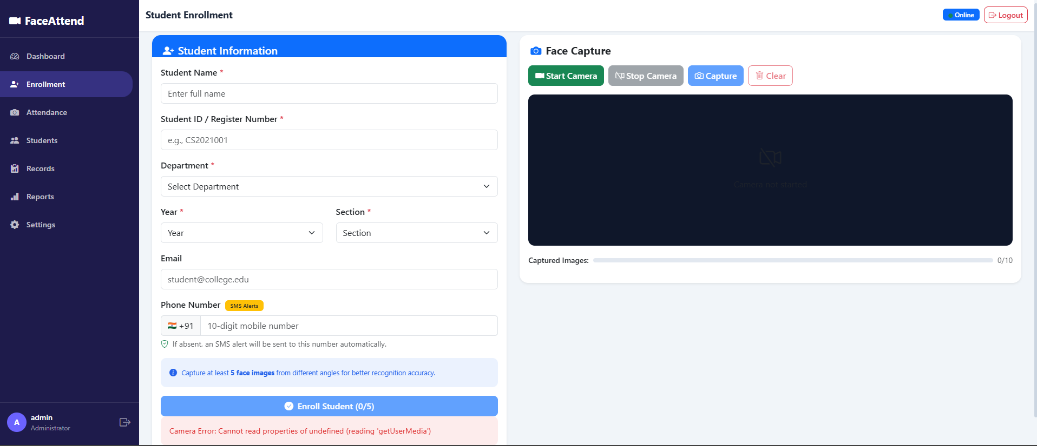

Figure 8.2: Enrollment

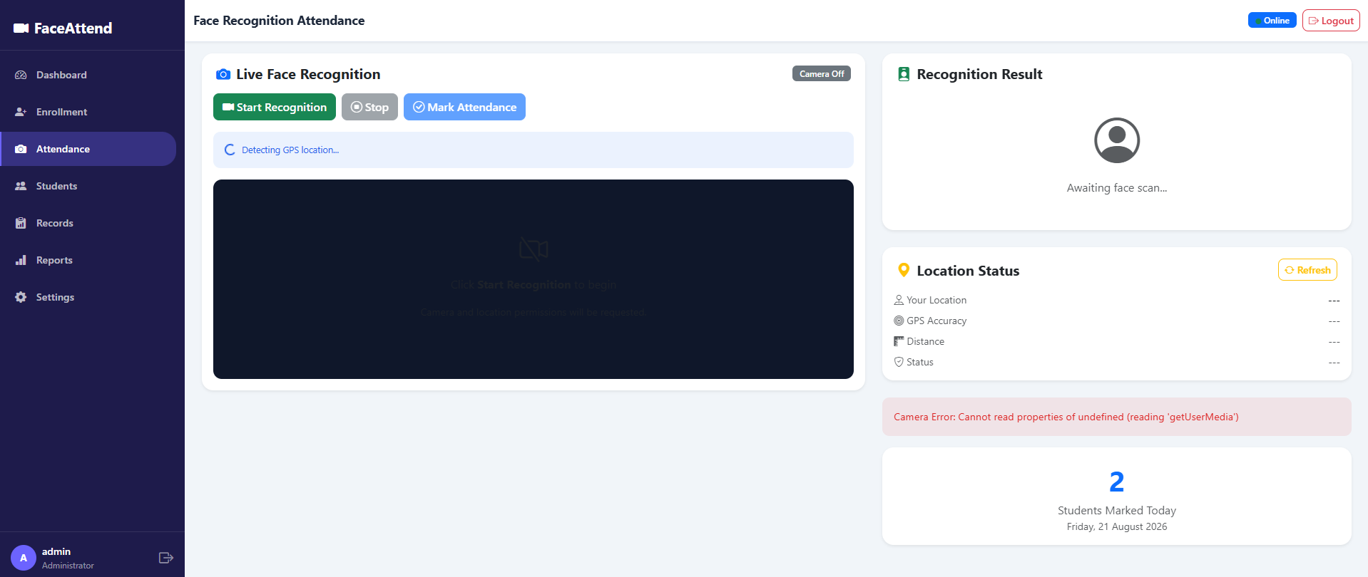

Figure 8.3: Attendance

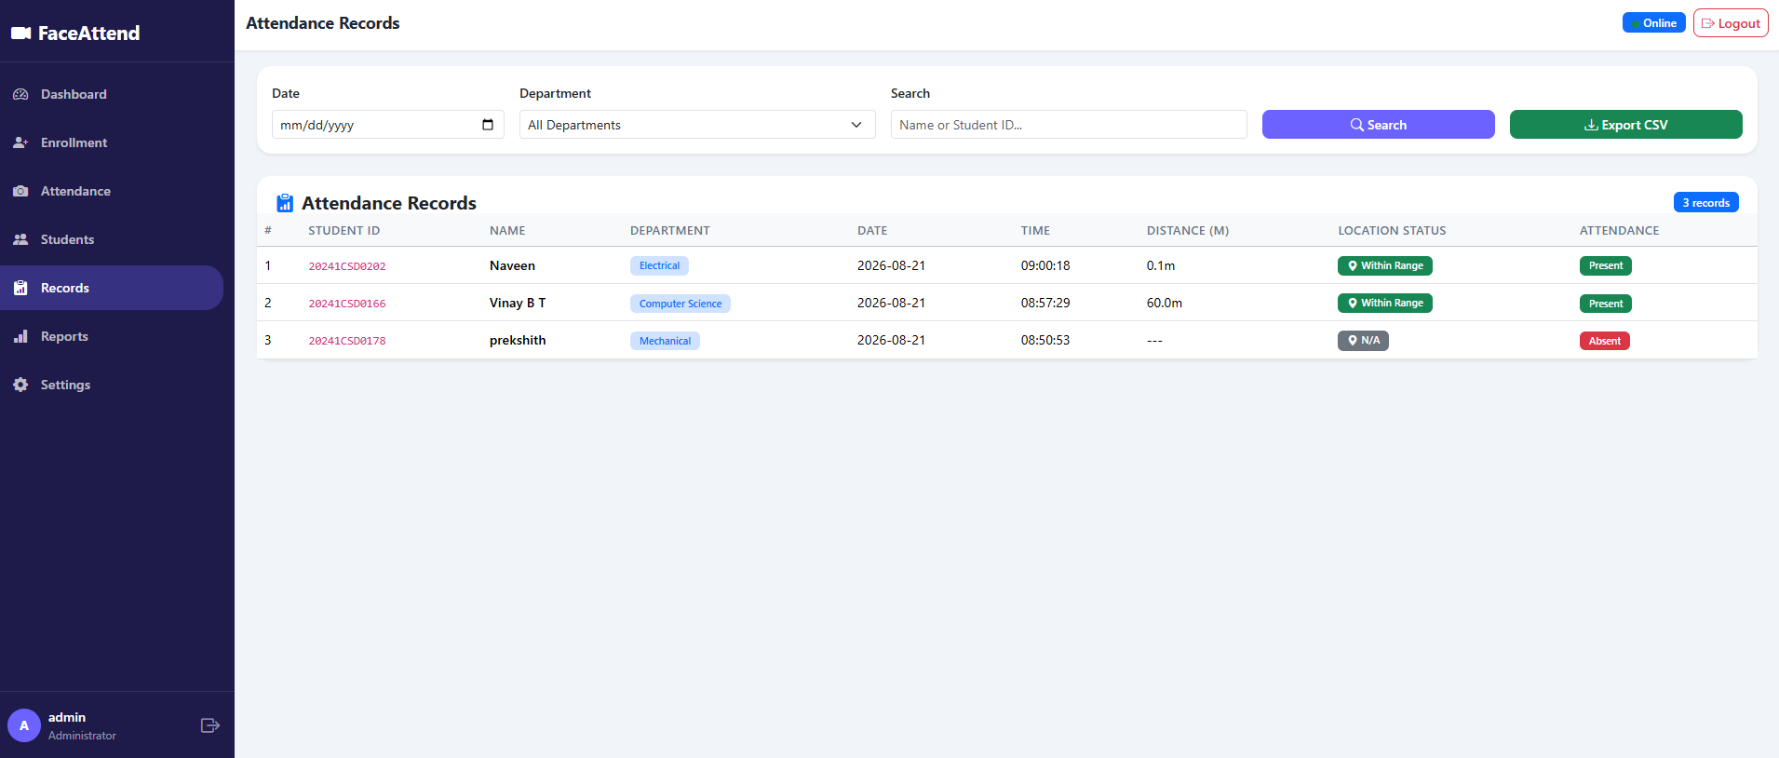

Figure 8.4: Attendance Record

Github Repository
Project: Face Recognition Attendance System
Repository:

Conclusion
The Face Recognition Attendance System was successfully developed as an AI-based, computer-vision-driven application for automating the process of attendance management. The project demonstrated the practical integration of computer vision, face recognition, database management, and full-stack web development to provide an efficient and contactless alternative to conventional attendance methods.
The system enables registered individuals to be detected and recognized through a live camera feed and automatically records their attendance with the corresponding date and time. The implemented workflow includes face registration, face detection, face encoding, face matching, identity verification, attendance logging, duplicate prevention, dashboard monitoring, and report generation.
The completed application was tested across its major functionalities, including user registration, administrator login, face detection, face recognition, handling of unknown faces, attendance marking, duplicate prevention, dashboard loading, and report export. The testing results confirmed that these features functioned as expected under the implemented conditions.
The project also provided practical experience in applying Artificial Intelligence and Computer Vision concepts to a real-world problem while developing a complete web-based application. By combining OpenCV, face-recognition technology, Flask, SQLAlchemy, database systems, and a browser-based dashboard, the project demonstrated how multiple technologies can be integrated into a single functional system.
Overall, the Face Recognition Attendance System provides a practical, automated, and efficient approach to attendance management. The project establishes a foundation for future enhancements such as liveness detection, improved recognition under challenging conditions, multi-camera support, large-scale deployment, and integration with institutional or organizational management systems.
.

10. References
- Presidency University, PSAIAC AI GPU Summer Internship Program (NVIDIA Accelerated), Internship Training Materials and Daily Activity Records, 2026.
- NVIDIA, NVIDIA Developer Documentation, GPU Computing, CUDA, and Accelerated Computing Resources.
- OpenCV, OpenCV Documentation, Documentation for Computer Vision and Image Processing Functions.
- face_recognition / dlib, Library Documentation, Documentation for Face Detection, Face Recognition, and Face Encoding Generation.
- Flask, Flask Documentation, Documentation for Python-Based Web Application Development.
- SQLAlchemy, SQLAlchemy Documentation, Documentation for ORM-Based Database Access and Management.
- Hugging Face, Transformers Documentation, Documentation Related to Transformer Architectures and Large Language Models.
- King, D. E., “Dlib-ml: A Machine Learning Toolkit,” Journal of Machine Learning Research, 2009.
- Schroff, F., Kalenichenko, D., and Philbin, J., “FaceNet: A Unified Embedding for Face Recognition and Clustering,” Proceedings of the IEEE Conference on Computer Vision and Pattern Recognition (CVPR), 2015.
- Vaswani, A., et al., “Attention Is All You Need,” Advances in Neural Information Processing Systems (NeurIPS), 2017.
- Face Recognition Attendance System Project Repository, GitHub, Source Code and Project Implementation.

