Back End Engineering-I

Project Report Semester-V (Batch 2023)
Event Management System

Group - G27



Supervised By: Submitted By:
Dr. Shivani Vinay (2310992560)
Mr. Nitesh Kumar Vivek (2310992562)
Vrinda(2310992563)
Vansh (2310992554)

Department of Computer Science and Engineering Chitkara University Institute of Engineering & Technology,
Chitkara University, Punjab

ABSTRACT
Event management systems play a crucial role in coordinating activities, registrations, schedules, and communication for events of varying scales. As user expectations shift toward instant updates and seamless interaction, traditional systems that rely on periodic refreshes or heavy database queries often fail to meet performance and scalability requirements. This project presents a real-time Event Management System designed to overcome these limitations by integrating efficient backend technologies that support fast communication, high responsiveness, and smooth data handling.
The system utilizes WebSocket to maintain a persistent, two-way connection between the server and clients, ensuring that updates such as announcements, schedule changes, and notifications are delivered instantly without repeated requests. Redis forms the performance backbone of the system by providing high-speed caching to reduce database load, pub/sub messaging for broadcasting live updates, and message queueing for managing background tasks during peak activity. MongoDB serves as the primary data storage solution, offering flexible document-based storage and indexing capabilities to ensure quick data retrieval and efficient organization of event-related information.
By combining these technologies, the system delivers a scalable architecture capable of handling high user traffic, real-time communication demands, and large volumes of event data. The result is a robust and responsive platform that enhances user experience, supports efficient event management, and demonstrates an effective approach to building modern, event-driven backend systems.

TABLE OF CONTENTS

S. No. | Contents | Page No.
1 | Introduction | 4-6
2 | Problem Statement & Requirements | 7-8
3 | Proposed Methodology/Design | 9-11
4 | Results | 12-14
5 | References | 15

- Introduction
Managing events can be difficult because it involves handling registrations, schedules, notifications, and communication between many users at the same time. As event platforms grow in scale, the need for quick responses and real-time updates becomes essential.
This Event Management System is designed to meet these needs by using WebSocket communication for continuous, live interaction between users and the server. Redis is integrated to improve system speed through caching, message queueing, and pub/sub messaging so that frequent data can be accessed instantly and updates can be delivered efficiently.
MongoDB is used as the main database, supported by indexing to ensure fast retrieval of event information. By combining these technologies, the system aims to provide smooth real-time functionality and a reliable backend that can handle high activity during events.
1.1 Background
Event management systems need to handle registrations, updates, and user communication quickly, which becomes challenging as the number of participants increases. Traditional systems often face delays and heavy database load, resulting in slow updates and reduced user experience.
To address these issues, modern platforms use WebSocket for real-time communication and Redis for fast caching, message queues, and pub/sub messaging. MongoDB provides flexible data storage supported by indexing for quicker data access.
Together, these technologies create a strong and efficient foundation for delivering responsive, real-time event management features that can scale smoothly during high-activity periods. This project builds upon that gap, aiming to provide a unified solution that simplifies event management, reduces dependency on manual processes, and ensures smooth coordination between organizers, participants, and administrators.
1.2 Objectives
The main objectives of this Event Management System are to provide real-time communication, faster
data access, and a smooth user experience through efficient backend technologies.
- To build a backend system that supports real-time communication using WebSocket.
- To reduce response time and improve data retrieval speed through Redis caching.
- To enable efficient message handling using Redis-based message queues and pub/sub.
- To store event-related information in MongoDB with indexing for faster queries.
- To ensure smooth and scalable event operations even during high user activity.
- To provide instant updates, notifications, and status changes to all connected users.
- To create a reliable and responsive event management platform that enhances user experience.
1.3 Significance
The Event Management System holds significant value as it addresses the growing need for fast, reliable, and real-time communication in modern event platforms. By incorporating WebSocket, the system ensures that users receive instant updates without delays. Redis enhances overall performance through high-speed caching, efficient message handling, and seamless pub/sub communication, which helps reduce server load and improves responsiveness. MongoDB with indexing supports quick data access, making the system capable of managing large amounts of event-related information.
Overall, the project demonstrates an effective backend approach for creating scalable, real-time event applications that can handle high user engagement and provide a smooth experience throughout the event.

1.4 Key Features
- Real-time communication using WebSocket for instant updates and notifications.
- Fast data access through Redis caching to reduce server load and improve performance.
- Redis-based pub/sub system for efficient broadcasting of event messages.
- Message queueing in Redis to handle background tasks and manage high traffic smoothly.
- MongoDB database with indexing for quick retrieval of event and user information.
- Scalable backend architecture capable of supporting large numbers of participants.
- Smooth event operations with live status tracking, updates, and user interactions.
- Reliable and responsive system designed to enhance the overall event experience.
1.5 Impact
The Event Management System creates a strong impact by improving the speed, reliability, and responsiveness of event operations. Real-time communication through WebSocket enables users to receive updates instantly, reducing delays and improving coordination. Redis significantly enhances system performance by managing caching, message queues, and pub/sub messaging, which helps the backend handle high traffic without slowing down. MongoDB with indexing ensures quick access to event-related data, contributing to an efficient workflow.
Overall, the system improves user engagement, enhances event management efficiency, and provides a seamless experience for both organizers and participants. Additionally, its scalability makes it adaptable for future requirements such as online registrations, automated reminders, and feedback mechanisms, ensuring long-term relevance and usefulness.

1.6 Future Vision
The future vision for this project is to evolve the web-based Event Management System into a comprehensive college event ecosystem. This will be achieved by developing a complete frontend using React to provide a seamless, user-friendly interface for all users. The system will also be enhanced with new features such as the automated generation of digital certificates for participants and robust feedback collection mechanisms. Additionally, to maximize accessibility and convenience, a dedicated mobile application will be introduced, allowing students and organizers to stay informed and engaged on the go. Finally, the integration of analytics and reporting features will enable organizers to make data-driven decisions, transforming the platform into a powerful tool that not only promotes events but also fosters a more digitally empowered academic environment.

- PROBLEM STATEMENT & REQUIREMENTS
  - Problem Statement
The manual and often disorganized methods of event management within educational institutions, such as relying on classroom announcements, physical notices, and paper-based registrations, are inefficient and create significant challenges.
- Event platforms struggle to provide real-time updates to users during high activity.
- Traditional systems rely on repeated database queries, causing delays and slow response times.
- Heavy traffic can overload the system, leading to missed notifications and inconsistent information.
- Frequent page refreshes reduce user experience and make communication inefficient.
- Managing large volumes of event data becomes difficult without optimized storage and fast retrieval.
- There is a need for a system that supports instant communication, efficient data flow, and high scalability.
  - Functional Requirements
- The system must allow real-time communication using WebSocket for instant updates.
- Users should be able to register, view event details, and receive notifications.
- The system must handle message broadcasting through Redis pub/sub.
- Event data should be stored and managed in MongoDB.
- The system should support fast data retrieval using Redis caching.
- Admins should be able to manage events, schedules, and announcements.
- The system must process background tasks using Redis message queues.
- Users should receive live status changes and updates without page refresh.
2.3 Non-Functional Requirements
- Security: The system must protect sensitive user data by using secure authentication.
- Scalability: The architecture must be designed to handle a growing number of users and events without a significant decrease in performance.
- Reliability: The system must be consistently available and stable, with minimal downtime.
- Usability: The user interface should be intuitive and easy to navigate for all user roles.
- Maintainability: The codebase must be modular, well-documented, and easy to update and debug.
- Performance: The system must provide quick response times for all API requests and data retrieval operations.
2.4 Software Requirements
- Operating System: Windows, macOS, or Linux.
- Backend: Node.js, Express.js.
- Database: MongoDB.
- Caching & Messaging: Redis
- Programming Languages: JavaScript (for Node.js) and HTML/CSS/JavaScript (for the frontend, if developed).
- WebSocket Library: ws
- Package Manager: npm (Node Package Manager).
- Text Editor/IDE: Visual Studio Code, Sublime Text, or Atom.
- API Testing Tool: Postman or Insomnia (for testing the backend endpoints).
- Version Control: Git.
2.5 Hardware Requirements
- Processor: A multi-core processor (e.g., Intel Core i5 or equivalent) is recommended for development.
- RAM: At least 4 GB of RAM (8 GB or more is recommended for a smoother development experience).
- Storage: 20 GB of free disk space for the operating system, development tools, and project files.
- Internet Connection: A stable internet connection is required for downloading dependencies and accessing online resources.

3. PROPOSED DESIGN/METHODOLOGY
3.1 Overview

The Event Management System is designed to provide real-time communication, fast data access, and smooth coordination between users and event organizers. The system uses WebSocket for live updates, Redis for caching, pub/sub, and message queueing, and MongoDB for structured data storage with indexing support. Together, these components ensure that users receive instant notifications, event details load quickly, and the backend can efficiently handle high levels of activity during events.

System Architecture

3.1.1. Presentation Layer (Client Side)

Users interact with the system through a web or mobile interface.

A WebSocket connection is established to receive real-time updates.

Displays event details, notifications, schedules, and live changes instantly.

3.1.2. Communication Layer (WebSocket Layer)

Maintains a persistent connection between client and server.

Sends and receives real-time messages without repeated HTTP requests.

Handles updates like new registrations, announcements, and status changes instantly.

3.1.3. Application Layer (Backend Server)

Processes all business logic related to events, users, and notifications.

Manages WebSocket events, handles incoming messages, and routes updates.

Coordinates between Redis and MongoDB for efficient data flow.

3.1.4. Data Storage Layer (MongoDB Layer)

Stores all event information, user data, registration details, and schedules.

MongoDB indexing ensures fast search operations for large datasets.

Serves as the primary and consistent data source for the entire system.

3.3 Conceptual Overview
- Users interact with the system through a WebSocket connection, allowing immediate delivery of updates and notifications.
- Event data such as registrations, schedules, and announcements is stored in MongoDB.
- Redis caching ensures frequently accessed data is delivered faster without repeated database queries.
- Redis pub/sub routes real-time messages to all connected clients or specific groups when updates occur.
- Background tasks and heavy processes are offloaded to Redis message queues for smooth system performance.
- The system operates as an event-driven architecture where actions trigger immediate responses and broadcasts.
3.4 Methodology
- Define core event-related functionalities such as registration, updates, and notifications.
- Implement WebSocket communication to support real-time interaction and live data transmission.
- Integrate Redis caching to speed up data access and reduce the load on MongoDB.
- Utilize Redis pub/sub to broadcast event updates instantly to all subscribed users.
- Use Redis message queues to handle background operations and manage high-volume tasks efficiently.
- Store event and user data in MongoDB with appropriate indexing for fast query performance.
- Test the system for performance, reliability, and scalability under different user loads.
3.5 File Structure
EventManagementSystem/
│
└── api/
│
├── controllers/
│ ├── authController.js
│ ├── eventController.js
│ ├── participantController.js
│ └── userController.js
│
├── middleware/
│ └── middleware.js
│
├── models/
│ ├── Event.js
│ ├── Participant.js
│ └── User.js
│
├── routes/
│ ├── authRoutes.js
│ ├── eventRoutes.js
│ ├── messageRoutes.js
│ ├── participantRoutes.js
│ └── userRoutes.js
│
├── utils/
│ ├── cache.js
│ └── redisClient.js
│
├── queue/
│ ├── messageQueue.js
│ └── workers
├── package.json
├── server.js

4.Results
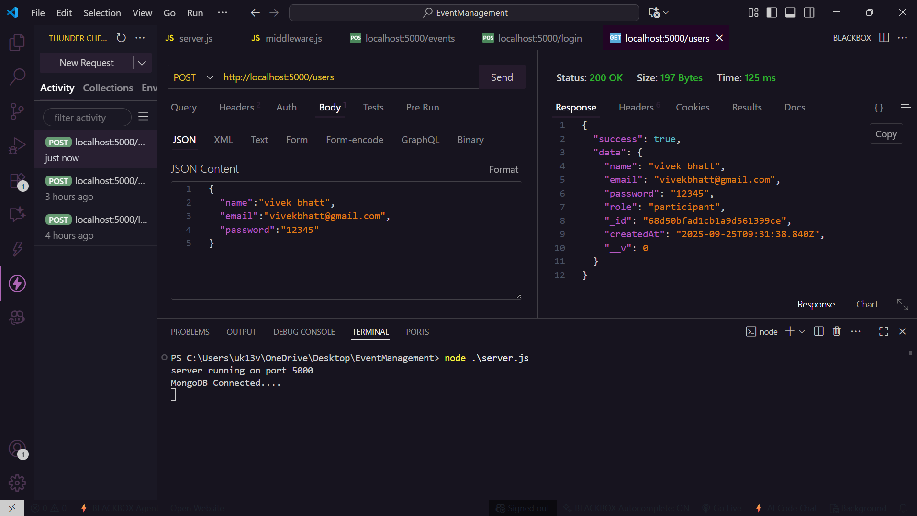Fig 4.1-Registration of user
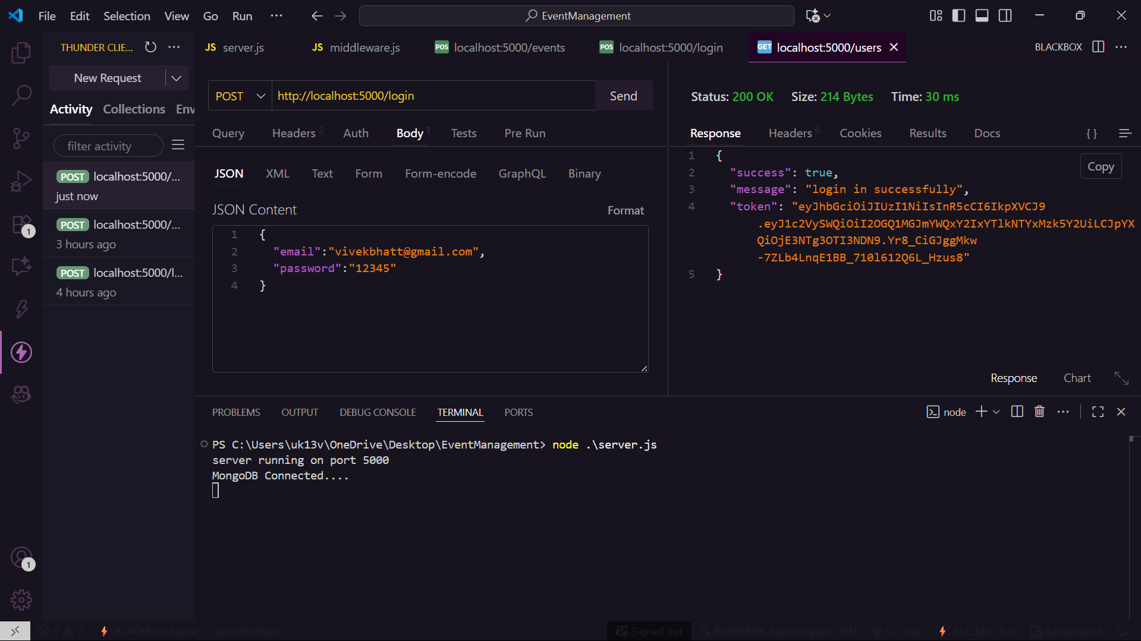Fig 4.2-Login of user

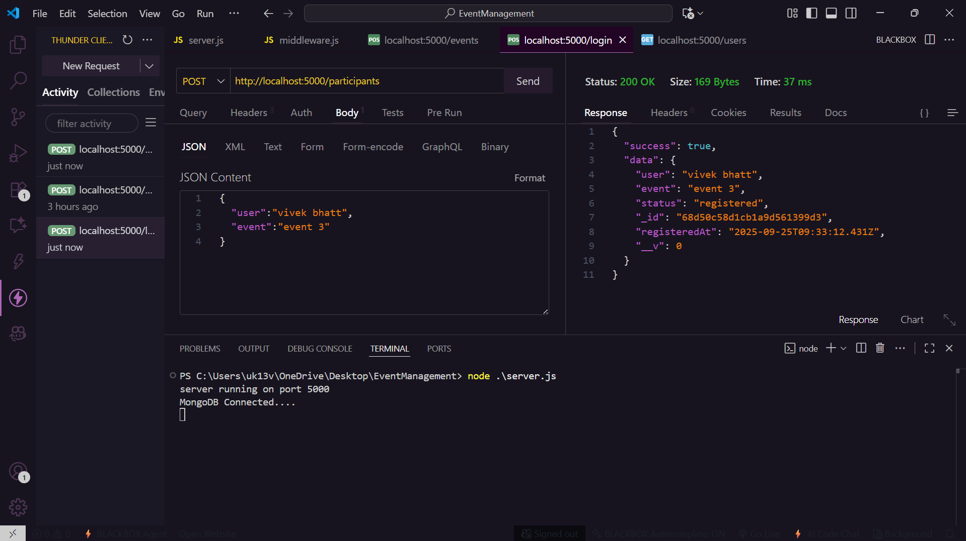
Fig 4.3- Registering of an event by using post request
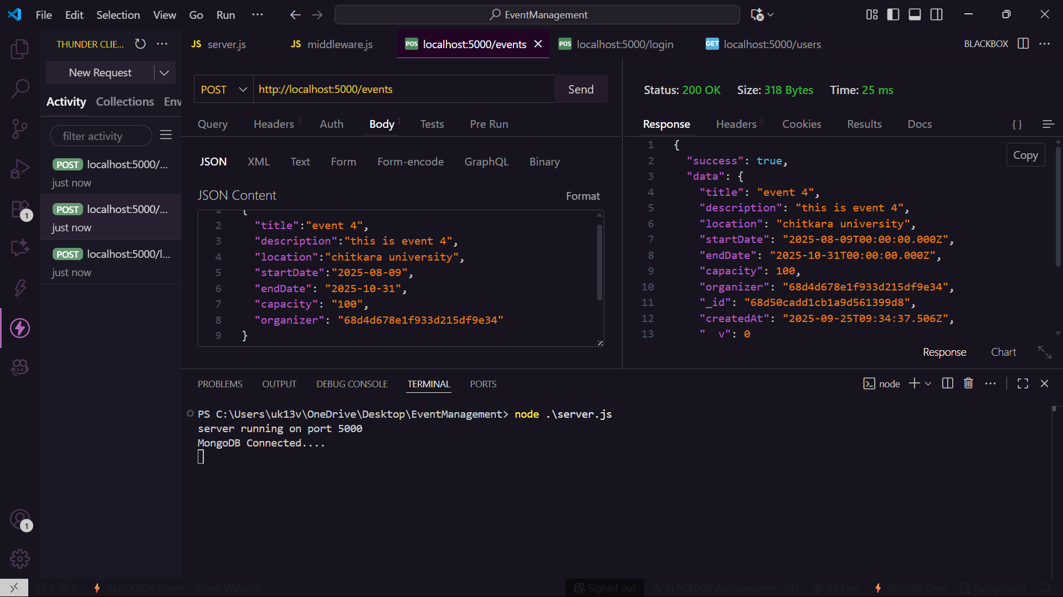
Fig4.4 -Adding of a new event which is done by organiser
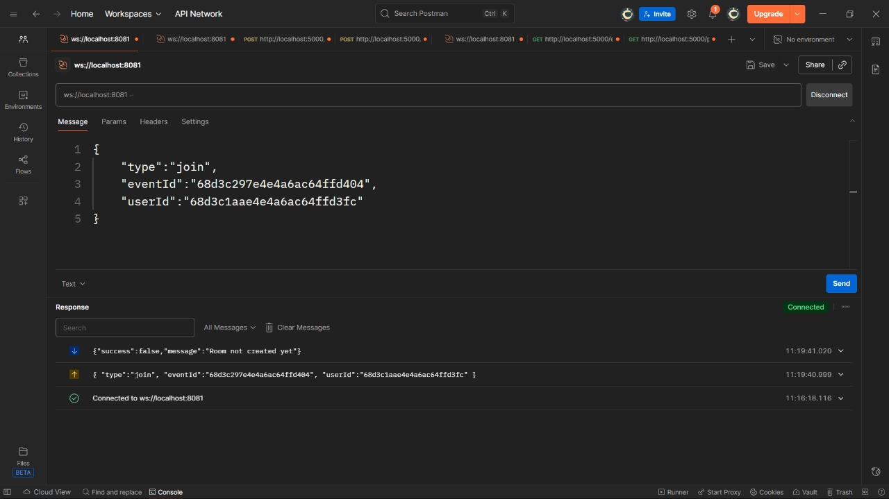
Fig4.5 -joining a room without creating it
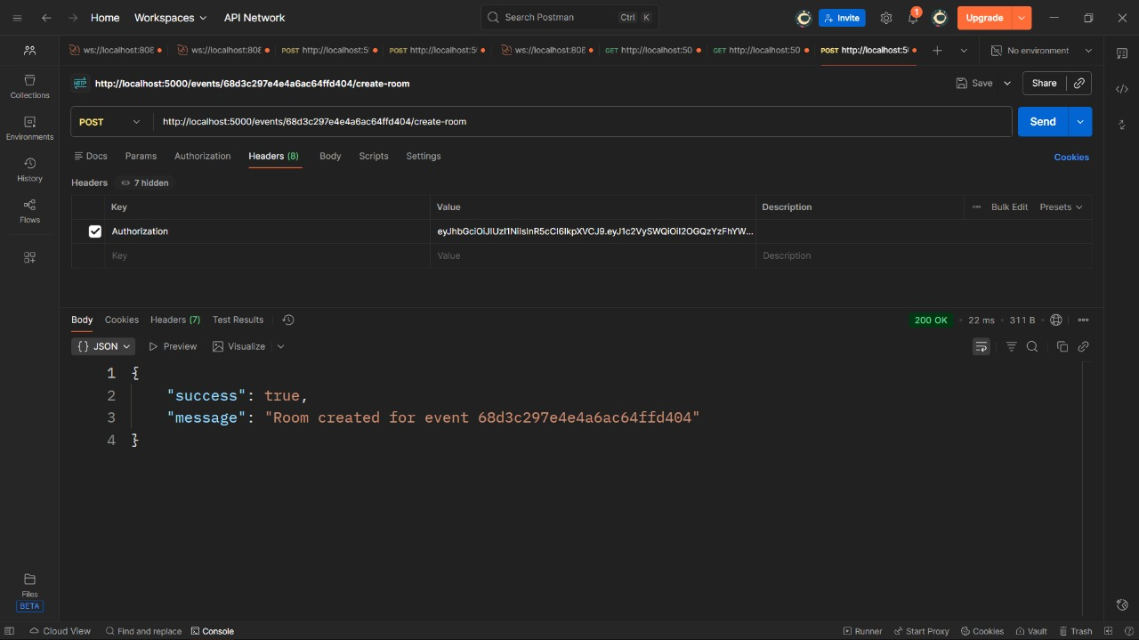 Fig4.6 -creating a room by eventId
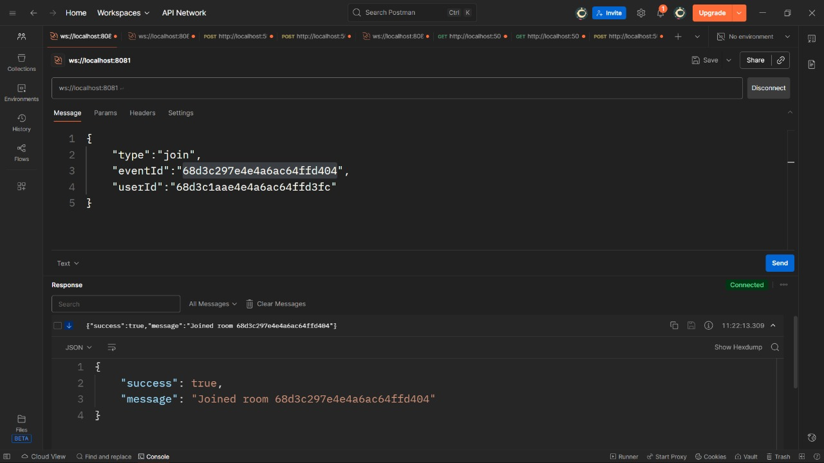
Fig4.7 -joining a room after creation
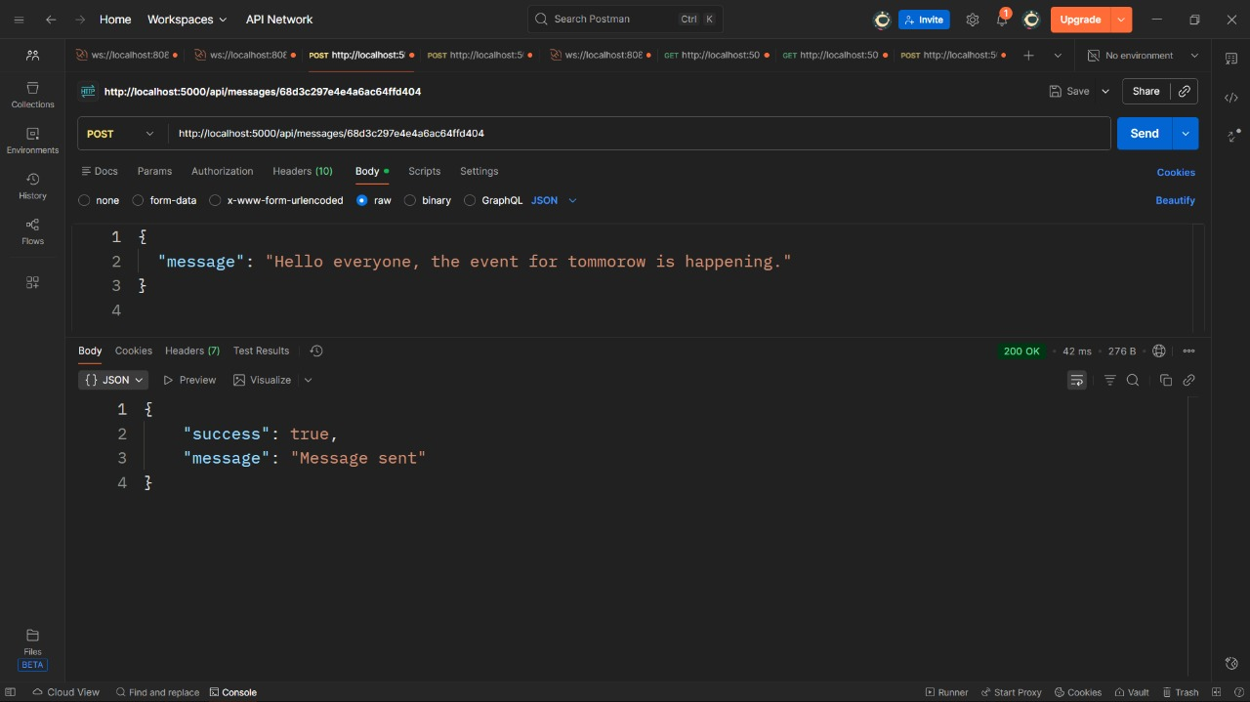
Fig4.8 -sending a message to a room
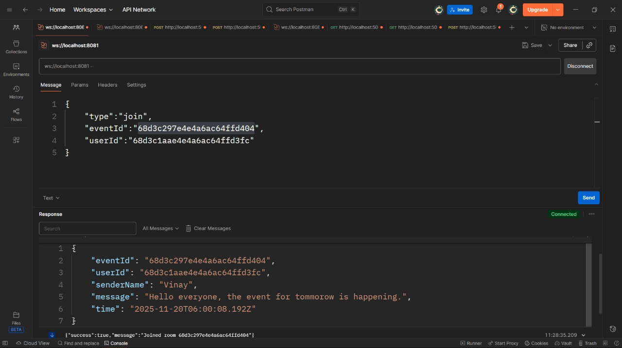
Fig4.9 -receiving messages in a room

5. REFERENCES/LINKS USED

- https://nodejs.org/en/docs/
- https://expressjs.com/
- https://www.mongodb.com/docs/
- https://redis.io/docs/data-types/streams/
- https://mongoosejs.com/docs/
- https://handlebarsjs.com/
- https://www.w3schools.com/
- https://www.freepik.com/
- https://unsplash.com/
- https://web.dev/responsive-web-design-basics/

