**SQL ASSIGNMENT 1**

Q-1. Write an SQL query to fetch “FIRST_NAME” from Worker table using the alias name as <WORKER_NAME>.

Step 1 – Go to New query 🡪 Create Database 🡪 Create Table workers

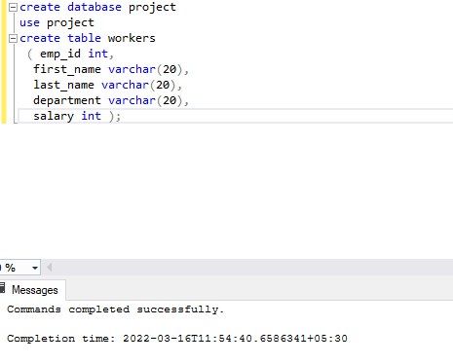

Step 2 - Add value to the column with INSERT INTO and VALUES

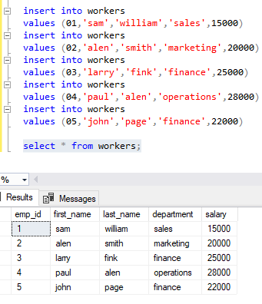

Q1. Write an SQL query to fetch “FIRST_NAME” from Worker table using the alias name as <WORKER_NAME>

**Solution:**

Step-3. Writing an SQL query to fetch “FIRST_NAME” from Worker table using the alias name as <WORKER_NAME>

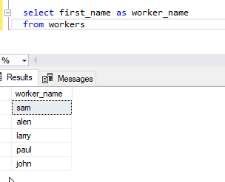

Q-2. Write an SQL query to fetch unique value of DEPARTMENT from Worker table.

**Solution:**

Step -4. Writing an SQL query to fetch unique value of DEPARTMENT from Worker table.

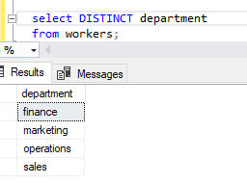

#### Q3. Write and SQL query to show the last 5 record from a table.

#### Solution:

Step-5. Writing SQL query to show the last 5 record from worker table.

