**SQL ASSIGNMENT 4**

Q1. Write an SQL query to print the FIRST NAME from worker table after replacing ‘a’ with ‘A’.

**Solution:**

Step-1. Use REPLACE function to replace ‘a’ with ‘A’ in FIRST NAME from worker table

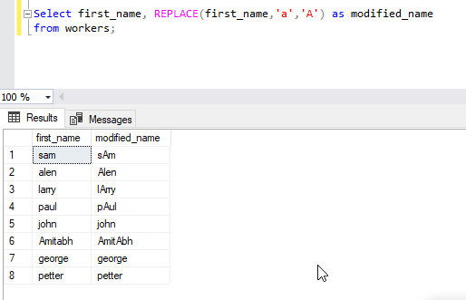

Q2. Write an SQL query to print all worker details from the worker table order by FIRST_NAME Ascending and DEPARTMENT Descending.

**Solution:**

Step-2. Using ORDER BY clause in FIRST_NAME and DEPARTMENT from worker table.

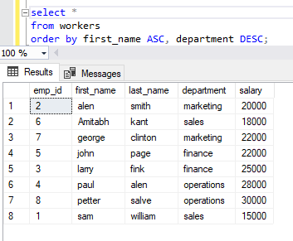

Q3. Write an SQL query to fetch the name of workers who earn the highest salary.

**Solution:**

Step-3. Query to fetch the name of workers who earn the highest salary.

