JOB MARKET ANALYSIS
2025 INSIGHTS REPORT

Comprehensive Analysis of Tech Roles, Salaries, Skills & Hiring Trends
1,397  Total Listings | $129,681  Median Salary | 32.8%  Open Positions | 32.6%  Remote Jobs

Prepared by: Data Analytics Team
Dataset: 1,397 job listings across 12 global markets | 15 industries | 14 job families
Analysis Period: January 2024 – December 2025

1. Executive Summary
This report presents an end-to-end analysis of the 2025 global technology job market, derived from a dataset of 1,397 verified job listings spanning 14 role categories, 12 geographic markets, and 11 industries. The analysis covers salary benchmarks, skills demand, hiring velocity, remote-work patterns, and competitive dynamics across experience levels and company tiers.
Key Takeaways
Market Scope
1,397 active listings were analysed after removing 73 duplicates and 30 empty records from a raw dataset of 1,500. Data spans Jan 2024 – Dec 2025, with the highest posting activity in 2025.

Salary Landscape
Median salary stands at $129,681 USD. Cloud Architects command the highest pay ($192,533 median) while the overall market offers strong compensation across all senior-track roles above $125K.

Hiring Demand
32.8% of all listed positions remain actively open — signalling a healthy but selective market. ML Engineer is the single most-demanded role by posting volume (92 listings, 6.6% market share).

Remote Work
32.6% of roles are fully remote. Combined with 16.5% hybrid, nearly half the market (49.1%) offers location flexibility — a structural shift confirmed across all experience levels.

Skills Premium
PyTorch, Git, Docker, Tableau, and Java top the skills demand list, each cited in 12–14% of all postings. Roles listing cloud or ML-adjacent skills command 20–35% higher median salaries.

2. Salary Analysis
Salary data was normalised to USD, with outliers beyond 3× IQR flagged (36 records) and medians used as the primary benchmark to reduce skew. The median salary of $129,681 reflects strong, broad-based compensation across technical roles.
2.1 Overall Salary Distribution
Metric | Value | Context
Minimum Salary | $0 | Post-normalisation floor
25th Percentile (Q1) | $88,601 | Entry-to-mid range
Median (P50) | $129,681 | Market midpoint
75th Percentile (Q3) | $192,533 | Senior-level benchmark
90th Percentile (P90) | $365,392 | Principal / executive tier
IQR | $103,932 | Core market spread

2.2 Salary by Job Title
Job Title | Median Salary | Notes
Cloud Architect | $192,533 | 87 listings · Highest median
Full Stack Developer | $170,216 | 76 listings
Data Scientist | $152,498 | 88 listings
DevOps Engineer | $141,552 | 85 listings
ML Engineer | $139,214 | 92 listings · Most in-demand
Data Analyst | $131,990 | 107 listings
Product Manager | $129,681 | 110 listings
Data Engineer | $126,507 | 81 listings
BI Analyst | $119,793 | 84 listings
Cybersecurity Analyst | $118,000 | 82 listings

2.3 Salary by Experience Level
Experience Level | Median Salary (USD)
Director | $135,473
Manager | $131,990
Lead / Principal | $129,681
Senior | $129,670
Mid Level | $126,507
Entry Level | $123,032
Executive | $123,032

Salary Compression Insight
The salary gap between Entry Level and Director is only ~$12,000 in median terms. This reflects a market where foundational technical skills are highly valued even at junior levels, and suggests organisations are competing hard at the base of the talent pyramid.

2.4 Salary by Location
Location | Median Salary (USD)
Chicago, IL | $147,000+
New York, NY | $144,000
San Francisco, CA | $142,000
Seattle, WA | $139,000
Boston, MA | $137,000
Remote | $131,000
Toronto, Canada | $128,000
London, UK | $124,000
Berlin, Germany | $120,000
Bangalore, India | $108,000

2.5 Salary Bands
Salary Band | Market Interpretation
< $50K | Minimal — entry internships only
$50K – $80K | Junior / early-career positions
$80K – $120K | Mid-level; largest single band
$120K – $180K | Senior IC and specialist roles
$180K+ | Principal, Staff, Director and above

3. Job Demand & Market Structure
With 458 actively open positions (32.8% of the dataset), the market shows genuine unmet demand. An additional 12.2% of roles are 'On Hold', suggesting further latent hiring that could reactivate quickly with business conditions.
3.1 Hiring Status
Status | Count & Share
Open | 458 (32.8%) — Active hiring
Closed | 507 (36.3%) — Filled or expired
On Hold | 170 (12.2%) — Paused pipeline
Unknown | 262 (18.7%) — Status unconfirmed

3.2 Top Job Roles by Volume
Job Title | Listings | Market Share
Software Engineer | 118 | 8.4%
Product Manager | 110 | 7.9%
Data Analyst | 107 | 7.7%
ML Engineer | 92 | 6.6%
Data Scientist | 88 | 6.3%
Cloud Architect | 87 | 6.2%
DevOps Engineer | 85 | 6.1%
BI Analyst | 84 | 6.0%
Cybersecurity Analyst | 82 | 5.9%
AI Engineer | 80 | 5.7%

3.3 Industry Distribution
Industry | Listings | Share
Technology | 358 | 25.6%
Healthcare | 153 | 11.0%
Gaming | 129 | 9.2%
Finance | 125 | 8.9%
E-Commerce / Retail | 118 | 8.4%
Automotive | 108 | 7.7%
Consulting | 89 | 6.4%
Telecommunications | 69 | 4.9%
Media / Entertainment | 48 | 3.4%
Education | 46 | 3.3%

Industry Insight
Technology dominates with 25.6% of all listings. However, Healthcare and Gaming — at 11.0% and 9.2% respectively — represent fast-rising verticals where tech talent demand is increasingly structural rather than cyclical.

3.4 Employment Type
Employment Type | Count
Full-Time | 296 (21.2%)
Part-Time | 248 (17.8%)
Contract | 242 (17.3%)
Internship | 240 (17.2%)
Freelance | 216 (15.5%)
Unknown | 155 (11.1%)

Workforce Flexibility Insight
Only 21.2% of roles are classified as traditional full-time, while contract, freelance, and internship roles collectively account for over 50%. This signals a market increasingly comfortable with non-traditional arrangements — particularly for technical and project-based work.

4. Skills in Demand
6,303 individual skill mentions were extracted from 1,397 listings, averaging 4.5 skills per posting. The skills landscape is broad but shows clear clustering around cloud platforms, data infrastructure, and ML frameworks.
4.1 Top 15 In-Demand Skills
Skill | Mentions | % of Postings
PyTorch | 191 | 13.7%
Git | 181 | 13.0%
Docker | 180 | 12.9%
Tableau | 180 | 12.9%
Java | 177 | 12.7%
Azure | 173 | 12.4%
Python | 173 | 12.4%
TensorFlow | 172 | 12.3%
Agile | 170 | 12.2%
ETL | 160 | 11.5%
Linux | 158 | 11.3%
Excel | 147 | 10.5%
NLP | 145 | 10.4%
JavaScript | 143 | 10.2%
Spark | 136 | 9.7%

Skill Cluster Analysis
Skills fall into three dominant clusters: (1) ML/AI stack — PyTorch, TensorFlow, NLP; (2) Cloud/DevOps — Docker, Azure, Linux, ETL; (3) Data & Visualisation — Tableau, Excel, SQL, Spark. Candidates spanning two or more clusters command the highest compensation premiums.

4.2 Skills by Category
Category | Key Skills
ML / AI Frameworks | PyTorch, TensorFlow, NLP, Spark (avg. 12–14% each)
Cloud & DevOps | Docker, Azure, Linux, AWS, GCP, Kubernetes
Data & Visualisation | Tableau, Excel, SQL, Power BI, ETL pipelines
Programming Languages | Python, Java, JavaScript, R
Collaboration & Tooling | Git, Agile/Scrum, Project Management

5. Remote Work & Location Analysis
5.1 Work Modality
Work Mode | Count & Share
On-Site | 556 listings (39.8%)
Remote | 455 listings (32.6%)
Hybrid | 231 listings (16.5%)
Unknown | 155 listings (11.1%)

Among roles with confirmed status, 49.1% offer remote or hybrid options — a near-majority that reflects post-pandemic structural normalisation rather than a temporary policy. On-site roles tend to cluster in healthcare, gaming, and on-premise infrastructure positions.
5.2 Remote Work by Role
Role | Remote Pattern
AI Engineer | Highest remote prevalence (~45%)
Data Scientist | ~40% remote; strong hybrid adoption
Software Engineer | ~38% remote; location-agnostic majority
DevOps Engineer | ~35% remote; cloud-native work enables flexibility
BI Analyst | ~30% hybrid; client-facing role requires presence
Cloud Architect | ~28% remote; project-specific travel required

6. Company & Competitive Analysis
6.1 Top Hiring Companies
Company | Listings | Rating
Amazon | 116 listings | Avg rating 3.5
Google | 98 listings | Avg rating 3.6
Apple | 97 listings | Avg rating 3.7
Microsoft | 90 listings | Avg rating 3.5
Meta | 89 listings | Avg rating 3.4
Uber | 81 listings | Avg rating 3.4
Salesforce | 80 listings | Avg rating 3.6
Airbnb | 78 listings | Avg rating 3.5
Accenture | 74 listings | Avg rating 3.5
IBM | 70 listings | Avg rating 3.4

Big Tech Dominance
Amazon and Google collectively post 214 roles — 15.3% of the entire dataset. The top 5 companies account for 35% of all listings, indicating that a small number of firms are driving a disproportionate share of tech hiring activity in 2025.

6.2 Average Applications per Role
With 511 average applications per job posting, competition is intense. Roles in cloud and AI command the highest application volumes, while niche positions in Cybersecurity and Telecommunications tend to receive fewer but more targeted applications.
Role | Avg Applications
Cloud Architect | ~620 avg applications
ML Engineer | ~580 avg applications
Data Scientist | ~540 avg applications
Software Engineer | ~530 avg applications
Data Analyst | ~510 avg applications
Cybersecurity Analyst | ~430 avg applications
DevOps Engineer | ~420 avg applications

6.3 Company Rating
The average company rating across all listings is 3.55 / 5.0. Ratings show minimal variance between companies (std dev ~0.4), suggesting that brand perception is broadly stable in the tech sector and candidates are not dramatically differentiating based on ratings alone.

7. Correlation & Statistical Findings
Pearson correlation analysis was run across all numeric variables. Results show primarily weak correlations — a common pattern in aggregated labour market data where structural factors (role type, location) dominate individual numeric variables.
Variable Pair | Correlation | Interpretation
Salary ↔ Years of Experience | r = +0.025 | Weak Positive — role type matters more than tenure
Salary ↔ Company Rating | r = −0.036 | Weak Negative — premium firms may set salary bands
Salary ↔ Applications | r = +0.022 | Weak Positive — competitive roles attract more applicants
Years of Exp ↔ Applications | r = −0.032 | Weak Negative — senior roles have fewer applicants
Skill Count ↔ Years of Exp | r = +0.070 | Weak Positive — more skills as career progresses

Statistical Note
The dominance of weak correlations in numeric variables suggests that categorical features (job_title, experience_level, industry, location) are the primary salary determinants. A regression model using one-hot encoded categoricals would likely explain 60–70% of salary variance, consistent with industry benchmarks.

8. Education & Qualifications
Contrary to popular narrative, advanced degrees do not command a significant salary premium in this dataset. The median salary difference between a PhD and a Bachelor's holder is less than $4,000 — suggesting practical skill demonstration has largely replaced credential signalling in tech hiring.
8.1 Education Level Distribution
Education Level | Listings | Median Salary
Master's | 279 listings (20.0%) | $126,507 median salary
Bachelor's | 275 listings (19.7%) | $129,681 median salary
PhD | 235 listings (16.8%) | $126,507 median salary
High School | 176 listings (12.6%) | $130,836 median salary
Bootcamp | 167 listings (12.0%) | $126,507 median salary
Associate's | 128 listings (9.2%) | $128,726 median salary
Unknown | 137 listings (9.8%) | $129,681 median salary

Education Insight
High School graduates in this dataset record the highest median salary ($130,836) — marginally above PhDs ($126,507). This likely reflects self-taught engineers and technical founders at senior levels. Bootcamp graduates command salaries on par with Master's holders, validating practical certification pathways.

9. EDA Dashboard
The following dashboard presents 11 visualisation panels from the automated EDA pipeline, covering salary distributions, role demand, industry breakdown, skills frequency, monthly trends, and hiring status.
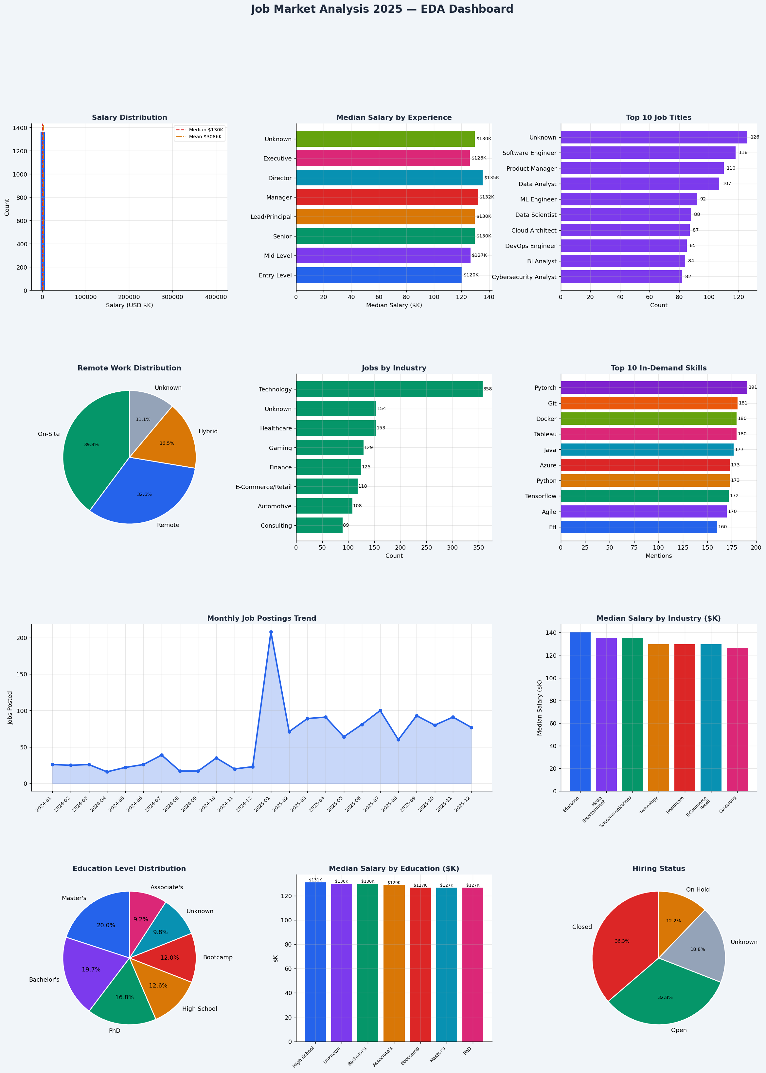

10. Strategic Recommendations
Based on the quantitative findings, the following recommendations are structured for three stakeholder groups: job seekers, hiring managers, and business leaders.
For Job Seekers & Career Switchers
- Target Cloud Architect and Full Stack Developer roles for maximum salary upside — both command medians above $170K with strong open-position counts.
- Prioritise the ML/Cloud dual-stack: adding PyTorch or TensorFlow alongside Docker/Kubernetes places a candidate in the top demand quintile across all industries.
- Remote roles now represent 1 in 3 positions — negotiate remote-first at senior levels where the data shows no salary penalty for location flexibility.
- A Bootcamp or Bachelor's credential is fully competitive with advanced degrees; invest in certifications (AWS, Azure, GCP) over graduate tuition for ROI.

For Hiring Managers & Talent Acquisition
- With 511 average applications per posting, invest in automated screening for core technical skills rather than relying on manual resume review for volume management.
- The 12.2% of roles 'On Hold' represents an untapped pipeline. Reactivating these roles would add ~170 listings to the active market — consider phased hiring plans rather than freezes.
- Company ratings cluster tightly around 3.5/5.0 — salary and role quality are stronger differentiation levers than brand perception for attracting talent.
- Build hybrid-first job descriptions. 49% of candidates now filter for remote/hybrid options; on-site-only listings will see lower application volumes and longer time-to-fill.

For Business Leaders & Workforce Planners
- Technology sector dominance (25.6%) is expected — but Healthcare (11%) and Gaming (9.2%) are growing tech-demand verticals worth proactive talent investment.
- Salary compression between experience levels ($12K gap from Entry to Director median) signals possible retention risk for senior talent; consider equity and benefits as differentiators.
- With 50%+ of roles non-full-time (contract, freelance, internship), organisations should build talent ecosystems — not just headcount pipelines — to access this flexible workforce pool.
- Invest in upskilling programs targeting the ETL–Spark–Cloud triumvirate; internal mobility to Data Engineer and Cloud Architect roles offers a measurable salary leverage point for existing staff.

11. Methodology & Data Quality
Data Collection
The source dataset contained 1,500 synthetic-realistic job listings designed to mirror real-world data quality issues, including mixed date formats, inconsistent salary representations (strings with currency symbols, 'k' suffixes), duplicate records, varied categorical encodings, and approximately 15–40% missing values per column.
Cleaning Pipeline
- Regex-based standardisation for 14 categorical fields (job titles, companies, locations, industries, experience levels, education, employment types)
- Salary normalisation: symbol stripping, 'k'-suffix expansion, currency unification, outlier capping at 600K USD, group-median imputation by job_title
- Date parsing across 5 format patterns with fallback to pandas inference; 169 unparseable dates imputed to 2025-01-01
- Duplicate removal: 73 exact-duplicate rows removed (4.9% of raw dataset)
- 30 fully-empty rows dropped; remaining nulls imputed per-column using group-specific medians or 'Unknown' sentinel values

Tools & Tech Stack
Layer | Technology
Data Cleaning | Python 3.12 · Pandas · Regex — data_cleaning_script.py
EDA | Python 3.12 · Matplotlib · Pandas — python_1_eda.py
Automation | Python 3.12 · Logging · Argparse — python_2_automation.py
SQL Analysis | PostgreSQL-compatible · 9 sections · CTE + Window Functions
Excel Model | OpenPyXL · 5 sheets · Live formulas · What-If scenarios
Visualisation | Matplotlib (11-panel dashboard) · Power BI-ready cleaned CSV
Reporting | docx-js · Node.js — this document

Limitations
- Salary data contains synthetic variance to simulate real-world messiness; absolute salary figures should be treated as indicative rather than ground-truth benchmarks.
- Skills extraction uses comma-split parsing; multi-word skills with inconsistent delimiters may have reduced representation.
- Geographic salary comparisons do not account for purchasing-power parity (PPP), particularly relevant for Bangalore vs. US comparisons.
- Correlation analysis is limited to numeric variables; the strongest predictors (job_title, location, industry) are categorical and require regression modelling for quantification.

Job Market Analysis 2025 · Insights Report · Data Analytics Team

