**1.Establish an end to end ci/cd pipeline in aws to build a docker image of a simple web application, push it to amazon container registry(ecr) and then deploy it to an amazon EKS cluster.**

**Provision aws resources**

Amazon ECR: created a ecr repository

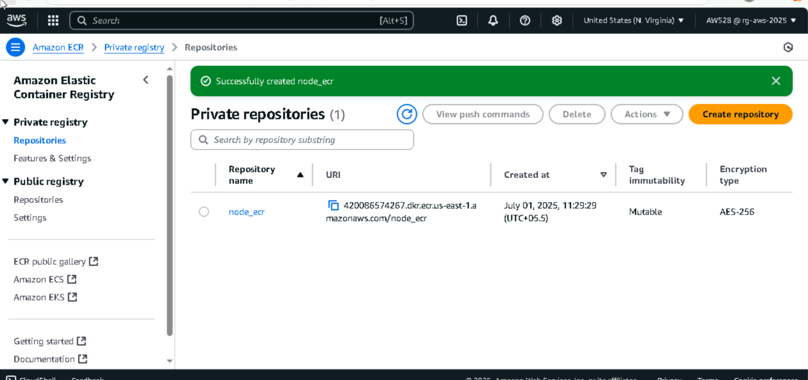

Amazon EKS cluster: created a eks cluster using cli

Command :

**Cluster is created**

**Node group also successfully created**

**ECR-EKS inegration**

For this code build need a permission to ecr that I have give me in IAM code build role for I’ve given permissions

**EKS inegration:** I havegiven a permission to acces code pipeline to eks cluster..that I’ve in eks cluster -> acces. Given acces ..codepipeline service role arn ad into thi eks cluste and I given a eks cluster admin policyA screenshot of a computer

**Set up a aws cicd environment**

Clone repository:

-created a amazon codecomit (we don’t have acces to github)

I have cloned git repository and push into **amzon code commit**

And pushed all files into my code commit repository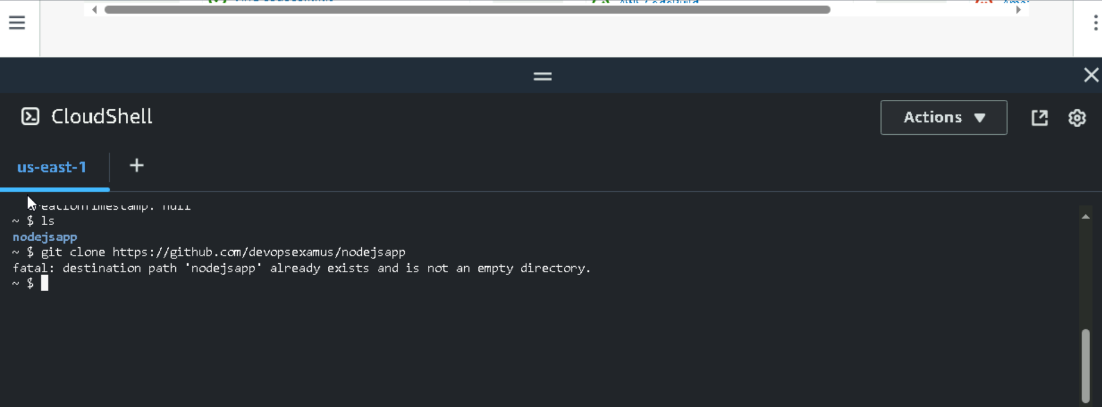

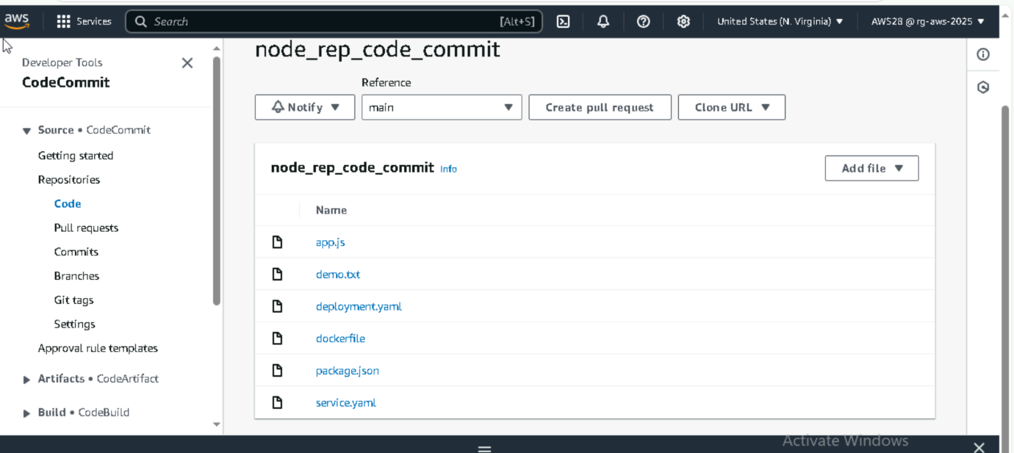

**Service connection:**

Connection establishing for pipeline

I have connect my code build repository to pipeline for source artifacts

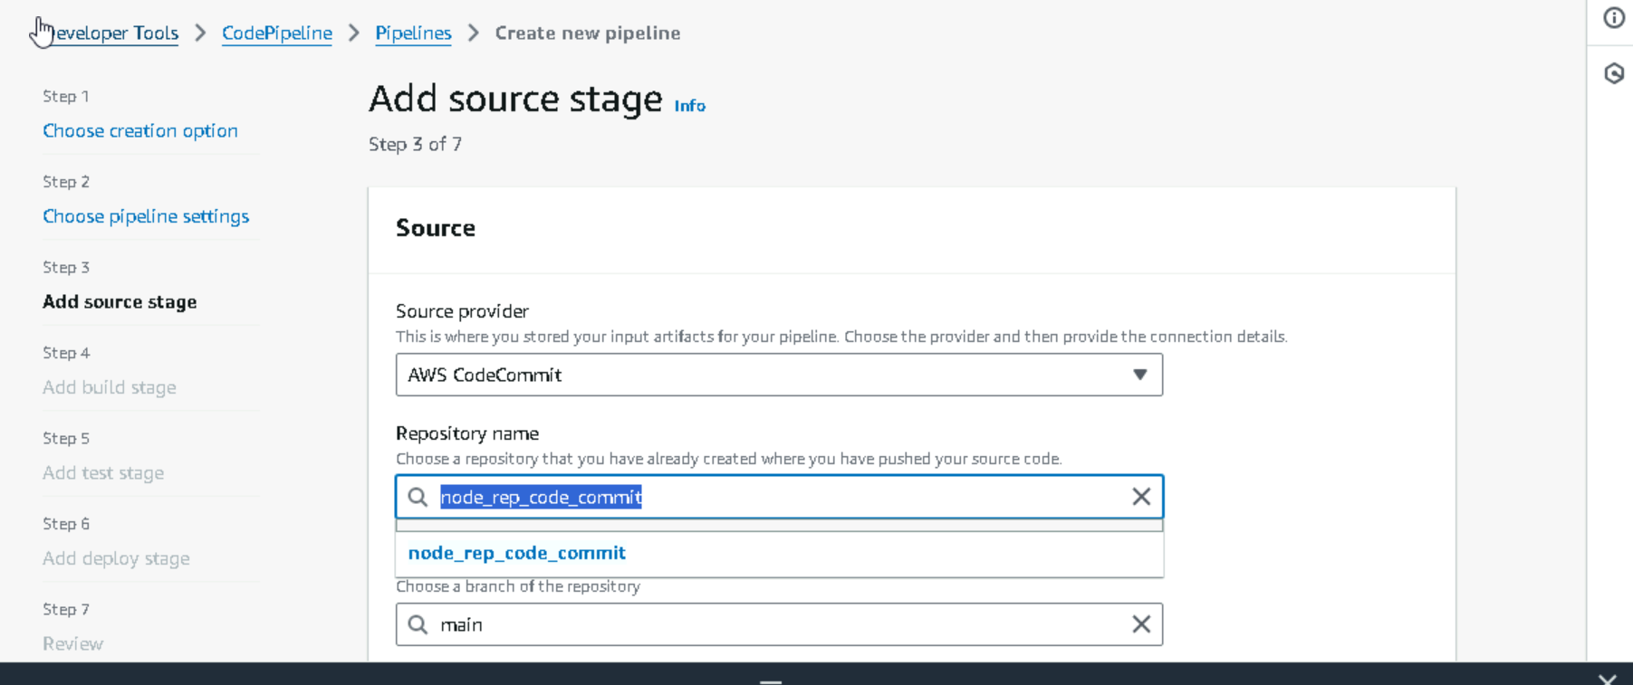

2. I have added a build stage which I created code build before

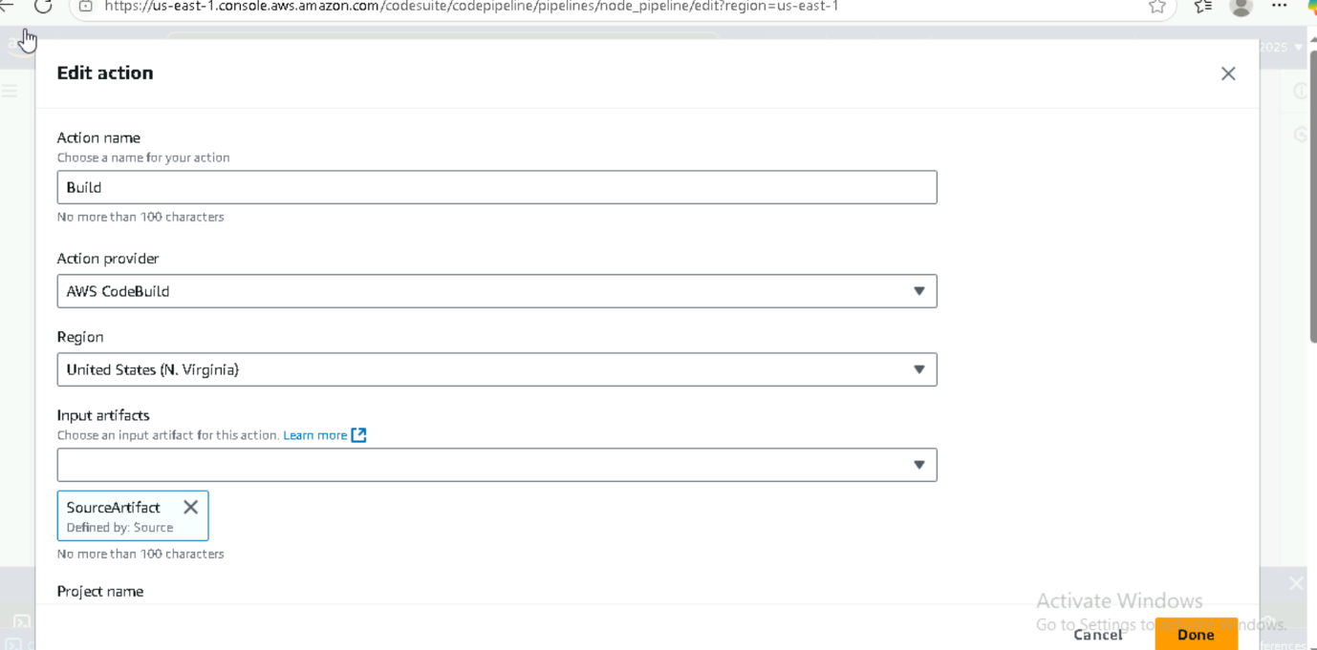

And finally deploy stage ..application deploy into the eks cluster for configured

Now pipeline configuration is done..i have given permissions also

**Configure the ci cd pipeline using aws code pipeline**

1.i have given a connection codebuild for source

1. created a code build

In that I have wrote buildspect yaml file for all steps

Then all phases arre seccesfull login,build.pull all phases

Then in code pipeline I have configure a eks cluster to deploy stage

Now all configuration is done

Stage2. Successfully pushed the image into ecr is done

Deploy an image to eks cluster is done :

And access using load balancer service load balancer balancer :

Application is deployed successfully

**Run and verifify pipeline:**

and evidences is logs: build push and deloy



