**Aws** …. Topics covered

**Vpc**  **iam**  **ami**

Vpc User Launch template

Subnet Groups EC2

internet gateway Roles

NAT gateway

IP(classA,B,C)/16/24

Load balancer

Target Groups

Auto scaling group

S3

Terraform – variables, modules, .tfvars, locals, target, lifecycle, meta handlers,

Workspace, PROJECT 3 tier

Vpc – peering (vpc a-vpc b)

-transit gateway

-vpn(on premises machine – aws machine) connection

**Storage**

BLOCK FILE OBJECT

1,Instance store-ephemirial (efs) (s3)

2, EBS – 1,boot volume

-2, data volume

Attach and detach volumes.. to instances

Route53

-(Dns)..hosted zone- create record—assigning a ip address to a domain name

Load balancer-target groups-add rules to another instance condition based path

S3-web hosting—using cloud front(speed) —web time

SNS & SQS

Again—hosted zon-2 records same domain name

(**Ebs**)Elastic bean stack : just need a code file ..remaining deploy,,resources they backend automatically happen

**SSM**: system manager

-fleet manager .. ssm roles(policies)

-resource group

-run command

**labmda** : lamda fucntion

event bridge—to target sns

cloud trail--all

cloud watch-particuler resources

sns

task:check (sheduled) delete the unatched ebs volume and send a notification using this

**Tasks**

**1**

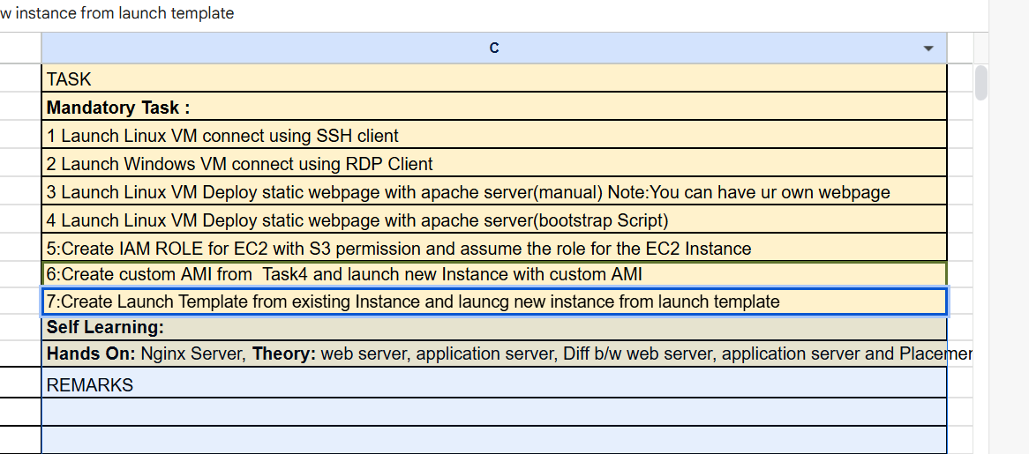

**2**

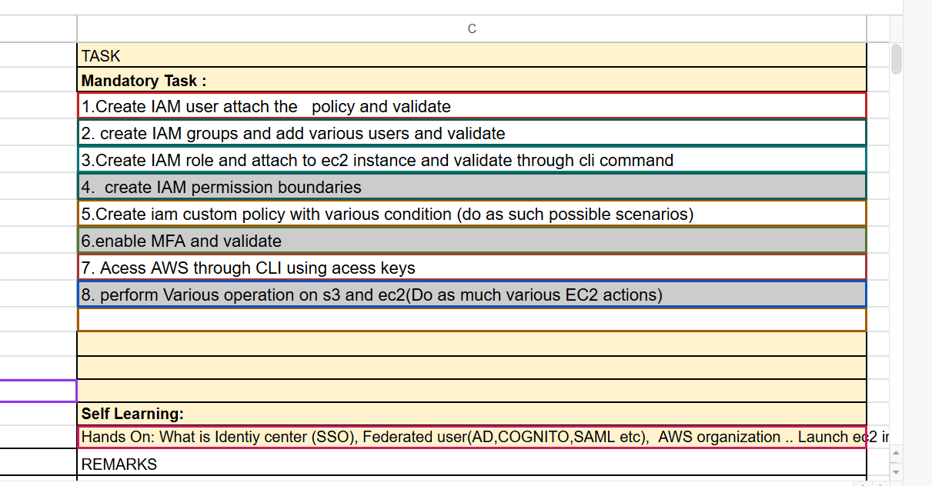

**Connect lnx instance into cloud shell**

**Ssh -i “ust1.pem” ec2-user@pub_ip**

**some cli commands..**cli command in another file

1 ls

2 aws configure

3 aws s3 ls

4 aws ec2 describe-instances

5 aws iam list-users

6 aws ec2 describe-regions

7 aws ec2 run-instances --image-id ami-0e449927258d45bc4 --count 1 --instance- type t2.micro --key-name ust1

7 aws ec2 stop-instances --instance-ids i-073c2763fe1e8c21a

8 aws ec2 start-instances --instance-ids i-073c2763fe1e8c21a

9 aws ec2 create-key-pair --key-name MyNewKeyPair --query 'KeyMaterial' --

output text > MyNewKeyPair.pem

11 aws ec2 create-security-group --group-name MySecurityGroup --description

"Security group for my app"

13 ls

14 aws s3 ls

**Command: create instance with bootstrap script and apache**

aws ec2 run-instances --image-id ami-0e449927258d45bc4 --count 1 --instance-type t2.micro --key-name ust1 --user-data <file://boot_strap.sh>

3 **IAM**

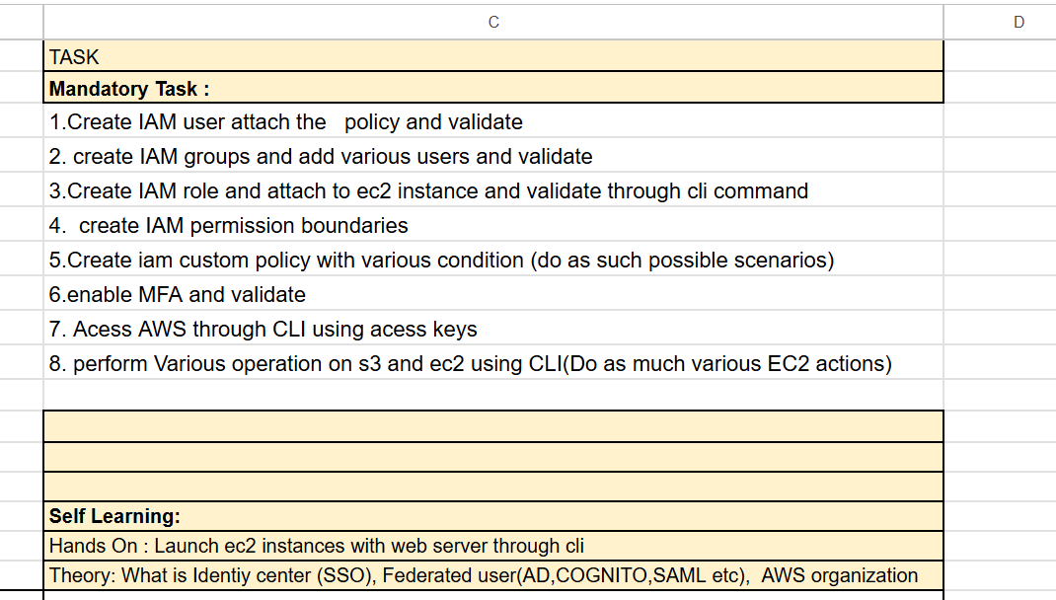

**4**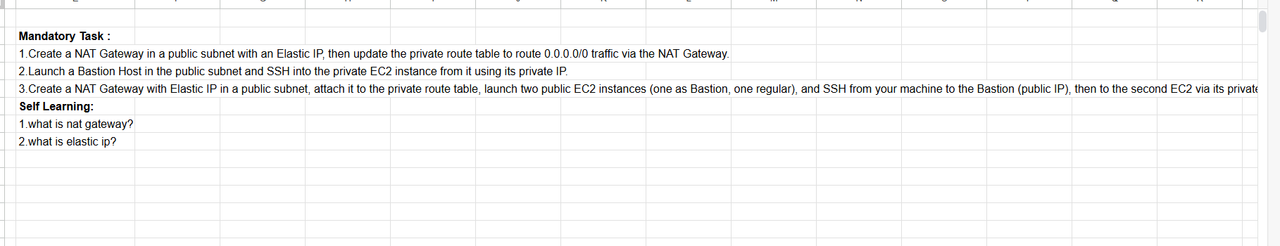

**5**

**vpc:**

1.create vpc

2.create 2 subnets(pri &pub) under vpc

3.create route 2 route tables for each pri @pub.

4.subnet association with route tables

5.create internet gateway and attach vpc-A

6.in pub route table add destination target internet gateway

7.create a security group under vpc add rules

8.launch ec2 under custum vpc(vpc,subnet) assign auto ip

9. do all same in cli also

**Nat gateway**

1.Nat gateway

2.create elastic ip public and and attach nat gateway

3.there is 2 pub &pri sub instance under vpc

4.go inside pub instance via sshand again go inside pri_instance via ssh and try to access internet -problem

5.create a Nat gateway specify public subnet & attach elastic ip

6.go to pri_inst route table and edit route rules and add rule 0.0.0.0/0 and target Nat gateway

7.now access( yum install httpd and curl pri ip) it works -prblm solved

**Day-7**

**Load balancer, Auto scaling groups**

Day8

S3 bucket and given permission(by policy)

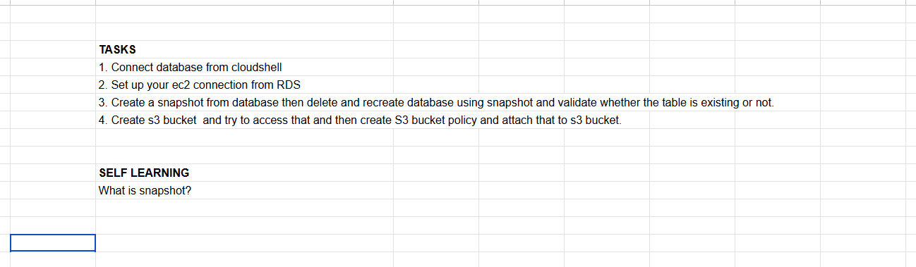

Day-9

**Terraform:**

Terraform init - download provider plugins & setups

Terraform plan - compare current & desired state , CRUD ,display execution

Terraform apply- executes the plan & makes real changes

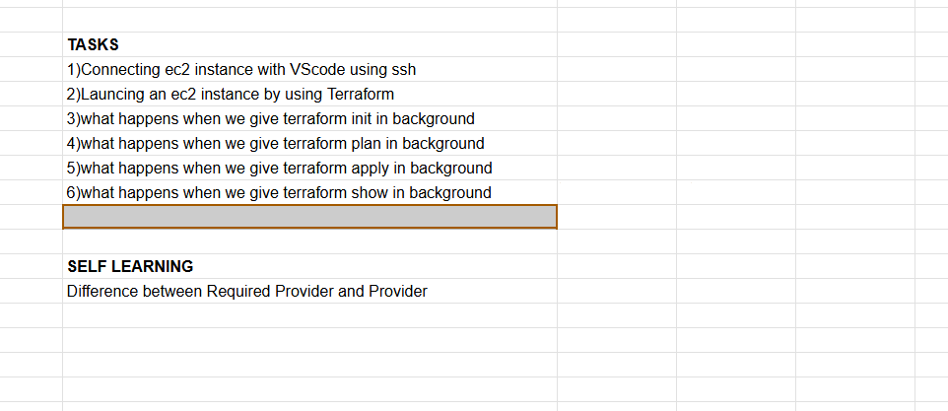

Day11

Day12

Meta arguments:

Dynamic ,count ,data,locals,