**DATABASE FUNDAMENTALS**

# Database Fundamentals

* **Definition**: A database is an organized collection of data that can be easily accessed, managed, and updated. Databases are essential for storing large volumes of data in an efficient and structured manner.
* **Types of Databases**:
  + Relational (RDBMS) o NoSQL (e.g., MongoDB)
  + Hierarchical

o Object-oriented

* **Database Management System (DBMS)**: Software that manages databases.

Examples include MySQL, PostgreSQL, Oracle DB, and MongoDB.

# Database Concepts and Architecture

* **Three-Tier Architecture**:
  + **Physical Layer**: Storage of data on disks.
  + **Logical Layer**: Defines the structure of data (schemas, tables, relationships).
  + **View Layer**: How users interact with data (via queries or UI).
* **Schemas**:
* o **Physical Schema**: Defines physical storage.
* o **Logical Schema**: Defines the structure (tables, views).

**View Schema**: Subset of data accessible to users.

* **Client-Server Architecture**: Databases operate in a client-server model where a server hosts the database, and clients access it.

**Practical Task**: Design a simple schema for a "Library Management System. book store"

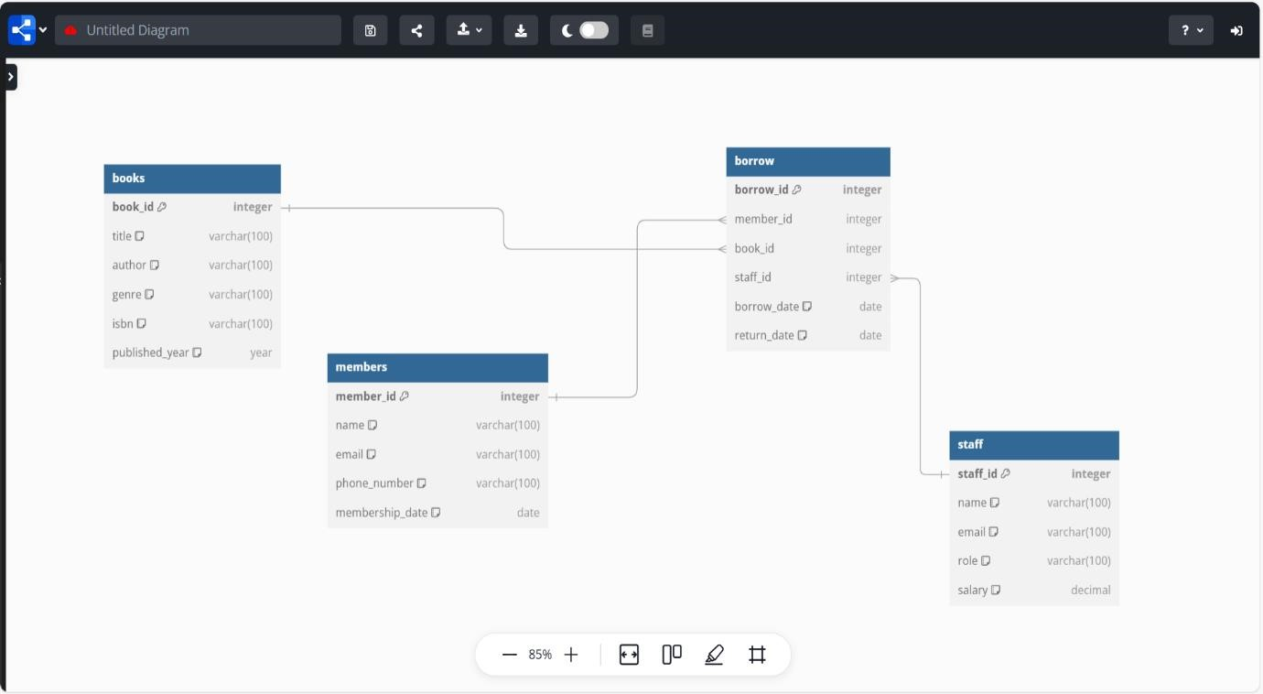

# Relational Database Management Systems (RDBMS)

* **Definition**: A type of database that organizes data into tables (rows and columns) and uses relationships to connect them.
* **Key Features**:

o Structured Data o Data Integrity o Use of SQL for operations

* **Examples**: MySQL, PostgreSQL, Oracle, Microsoft SQL Server.

**Practical Task:**

Create a table called books with columns: id, title, author, published_year, and genre.

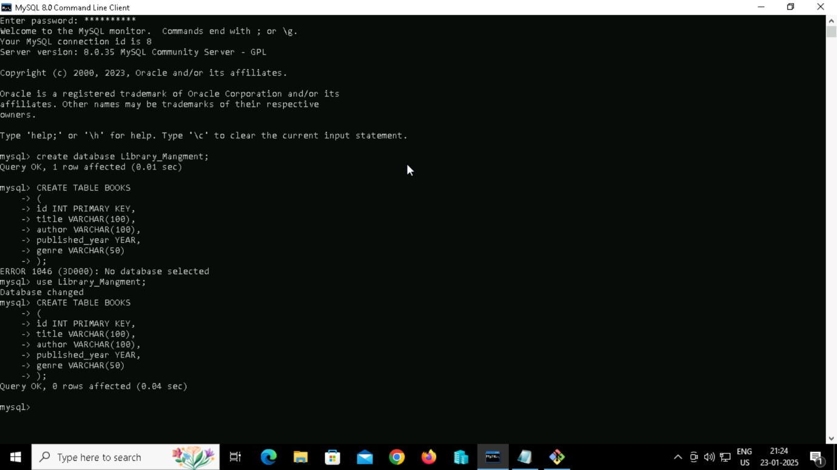

# Tables and Relationships

* **Table**: A collection of rows (records) and columns (fields). Each table represents an entity.
* **Relationships**:
  + **One-to-One**: Each row in Table A maps to one row in Table B.
  + **One-to-Many**: One row in Table A maps to multiple rows in Table B.
  + **Many-to-Many**: Multiple rows in Table A map to multiple rows in Table B via a junction table.

**Practical Task**:

Create two tables: customers and orders. Define a one-to-many relationship between them using foreign keys.

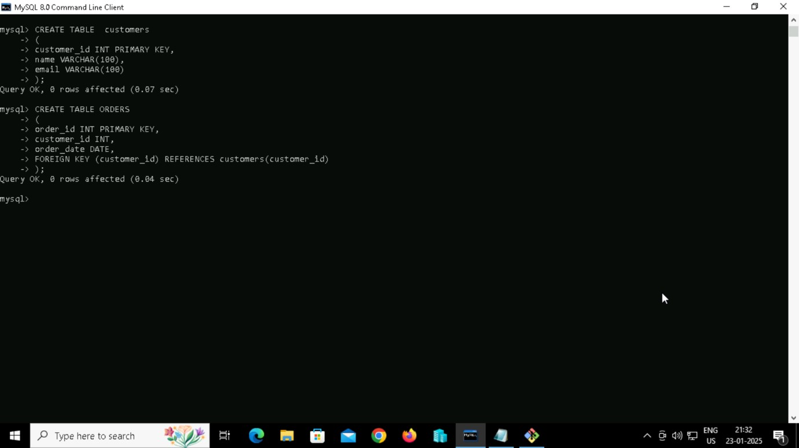

# Primary Keys and Foreign Keys

* **Primary Key**:
  + Uniquely identifies each row in a table. o Cannot contain NULL values.
  + Example: id in a users table.
* **Foreign Key**:
  + Establishes a relationship between two tables.
  + Refers to the primary key in another table. o Example: user_id in an orders table references id in the users table.

**Practical Task**:

Create a table departments with a primary key, and another table employees with a foreign key referencing departments.

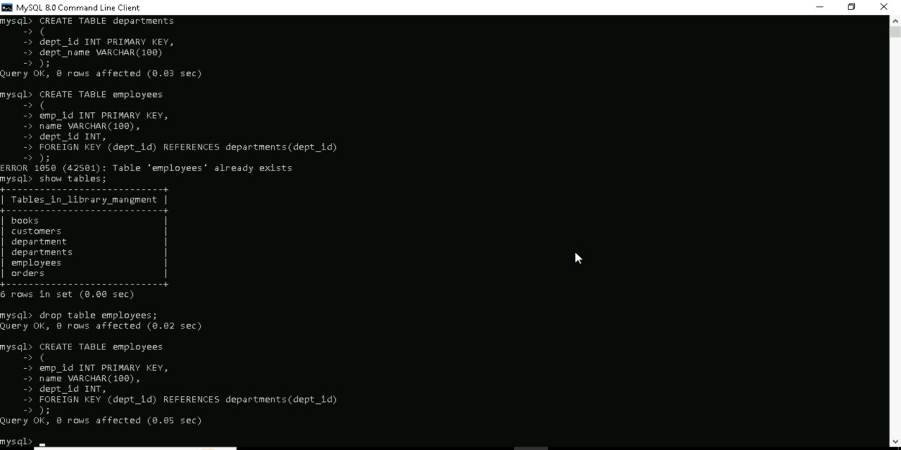

# SQL Basics

* **SELECT**: Retrieve data from a table.
* **INSERT**: Add new data to a table.
* **UPDATE**: Modify existing data.
* **DELETE**: Remove data.

**Practical Task**:

* Perform CRUD operations on the books table

**Inserting** Data into books table

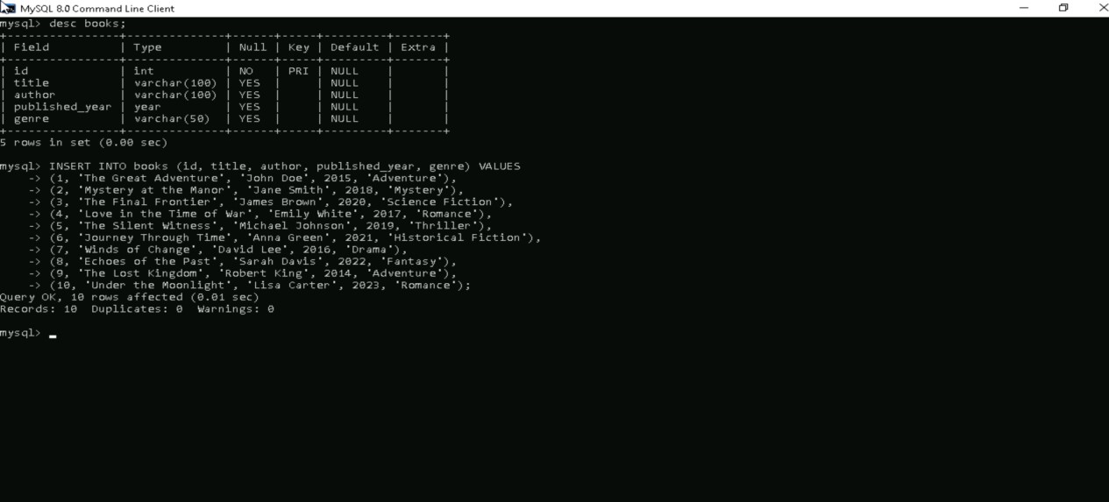

**SELECT** Retrieve data from a table.

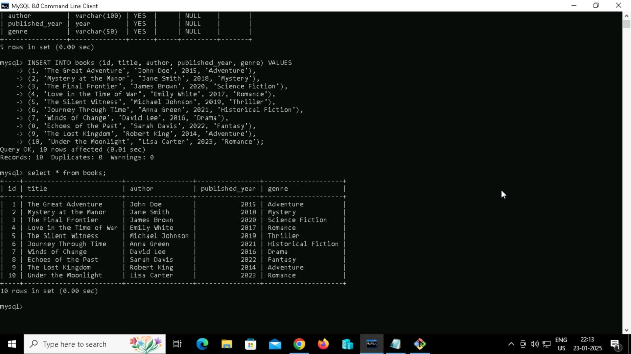

**UPDATE**: Modify existing data.

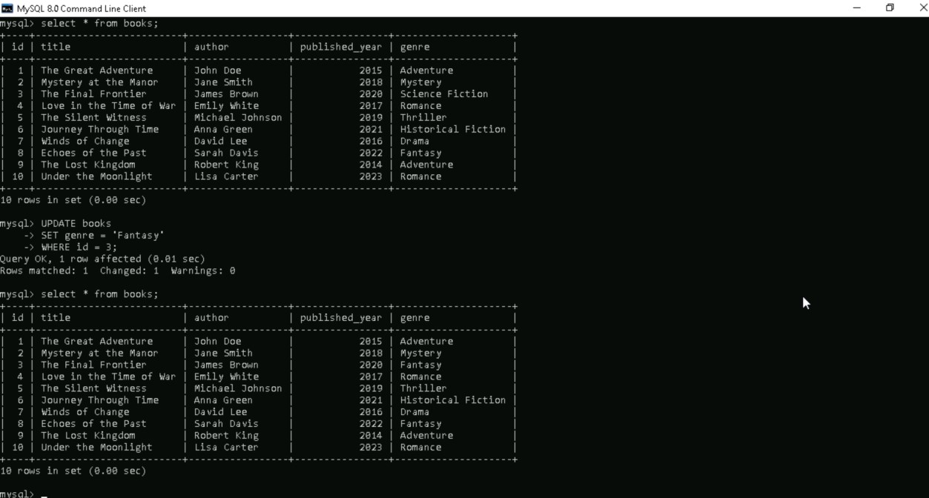

**DELETE**: Remove data.

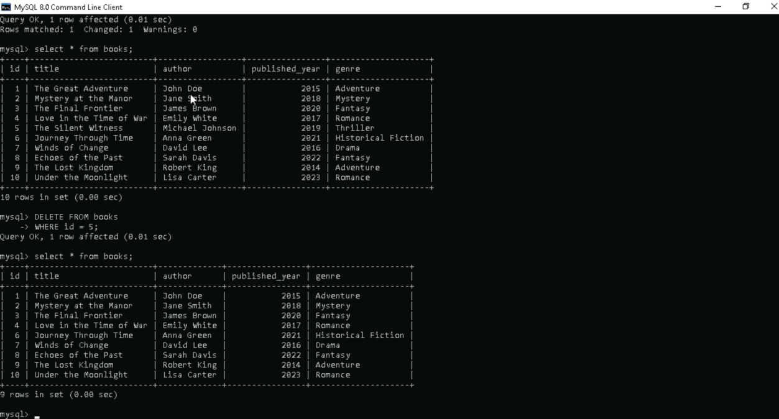

# Normalization

* **Definition**: Process of organizing data to reduce redundancy and improve efficiency.
* **Forms of Normalization**:
  + **1NF (First Normal Form)**: Ensure atomic values and unique rows.
  + **2NF (Second Normal Form)**: Eliminate partial dependencies.
  + **3NF (Third Normal Form)**: Remove transitive dependencies.
  + **BCNF (Boyce-Codd Normal Form)**: Handle more complex dependencies.

**Transactions and ACID Properties**

* **Transaction**: A sequence of database operations treated as a single logical unit.
* **ACID Properties**:
  + **Atomicity**: Transactions are all-or-nothing.
  + **Consistency**: Transactions bring the database from one valid state to another.
  + **Isolation**: Transactions do not interfere with each other.
  + **Durability**: Once committed, data remains saved even in case of a failure.

**Practical Task**:

* Perform a transaction with multiple SQL operations and test rollback.

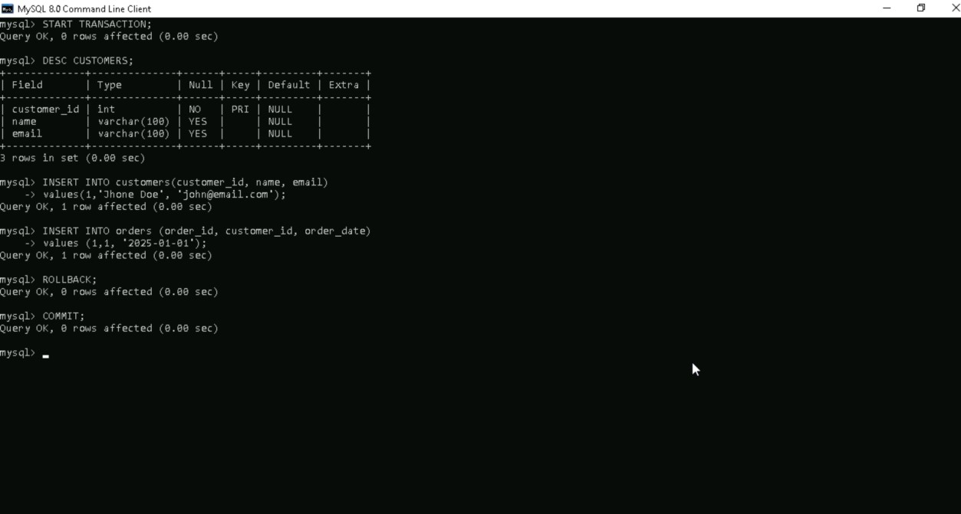

# Indexes

* **Definition**: A database optimization technique to speed up data retrieval.
* **Types**:
  + **Primary Index**: Automatically created for the primary key.
  + **Secondary Index**: Manually created on other columns for faster lookups.
* **Trade-offs**:
  + Improves SELECT queries.
  + Slows down INSERT/UPDATE/DELETE due to index maintenance.

**Practical Task**:

* Create an index on the title column of the books table.

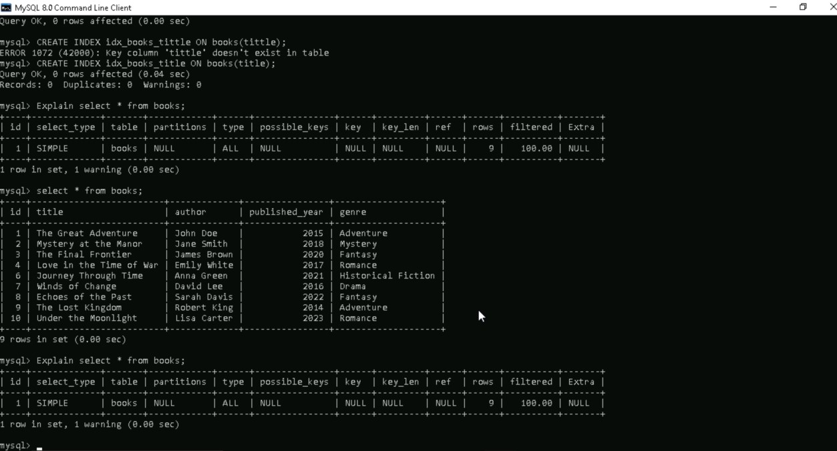

# Database Design

* **Steps**:
  + **Requirement Analysis**: Understand data needs.
  + **Conceptual Design**: Create Entity-Relationship (ER) diagrams. o **Logical Design**: Define tables, relationships, and keys.
  + **Physical Design**: Optimize storage and indexing.
* **Best Practices**:
  + Use normalization. o Avoid redundancy. o Optimize queries for performance.

**Practical Task**:

* Design a database for an "Online Store" using:
  + Entities: Products, Categories, Orders, Customers.
  + Relationships: Define primary keys and foreign keys.

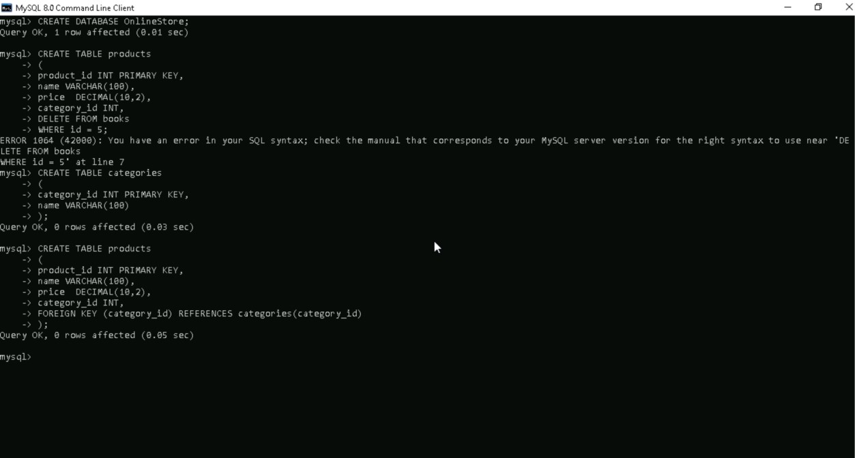

# Backup and Recovery

* **Backup**:
  + Regularly save copies of database data.
  + Types: Full, Incremental, Differential.
* **Recovery**: o Process of restoring data after a failure.
  + **Point-in-Time Recovery**: Restore database to a specific moment.
* **Tools**:
  + MySQL Backup Tools, pg_dump (PostgreSQL), RMAN (Oracle).

**Practical Task**:

* Perform a full backup of your database:

mysqldump -u root -p my_database > my_database_backup.sql

* Simulate a data loss scenario by dropping a table, then restore it:

DROP TABLE books;

|  |  |
| --- | --- |
| -- Restore using the backup |  |
| SOURCE my_database_backup.sql; | |