MODEM

A **modem** (short for **modulator-demodulator**) is a device used in networking to convert digital data from a computer or other digital device into analog signals that can be transmitted over telephone lines, cable systems, or other communication mediums. It also works in reverse, converting incoming analog signals back into digital data for the receiving device.

Here’s how it works:

1. **Modulation**: The modem takes digital data from a device (e.g., a computer) and converts it into analog signals for transmission over a communication medium.
2. **Demodulation**: The modem receives analog signals from the communication medium, then converts those back into digital data that the receiving device can understand.
3. The modems establish a communication protocol during handshaking to make sure that data is transmitted accurately and effectively. They also exchange information about their capabilities

Modems are commonly used in various types of internet connections, such as:

* **Dial-up connections** (using telephone lines)
* **Cable modems** (using cable TV lines)
* **DSL modems** (using telephone lines for high-speed internet)

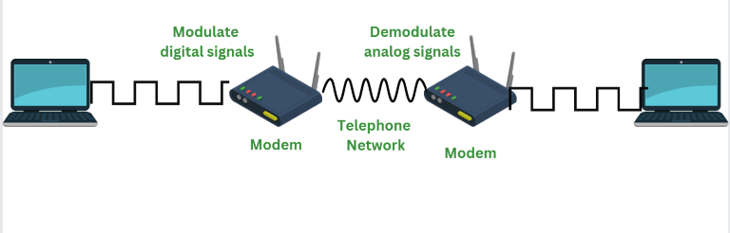

* Modem allows to connect only a specific number of devices to the internet.

## Types of Modem

There are different types of modems available. Each modem has different features and provides with different benefits. Below are the different types of modems:

### 1. Optical Modem

In modem, different type of media is used to transfer the signals. Optical Modem is the type of modem that makes use of optical cables instead of using another metallic type of media. The digital data is converted into the pulse of light that is transmitted on the [optical fiber](https://www.geeksforgeeks.org/types-of-joints-in-optical-fiber/)used in the optical Modem.

### 2. Digital Modem

Digital Modem is defined as a type of modem that is used to convert digital data into digital signals. Digital data is in form of 0s and 1s. For this, it performs the process of modulation. Digital Modem modulates the digital data on digital carrier signals for transmission.

### 3. Cable Modem

Cable modems are defined as a type of modem used to establish a communication between computer systems and the Internet Service Providers. A cable modem helps to access high-speed data through cable TV networks. Such modems are usually connected to desktops or systems and work like external devices.

### 4. Satellite Modem

Satellite Modems are defined as a type of modem that provides with the internet connection through satellite dishes. This type of modem works by sending the input bits into output radio signals and vice versa. The internet network that is provided by such types of modems is more reliable and efficient as compared to other types of modems.

### 5. Dial Modem

A Dial Modem is a type of modem that converts data used in telephone and data used on computers. In short dial modem converts between analog form and digital form. The networking devices connected to the computer are all at one end and the telephone line is at another end. This type of modem transmits the data at a speed of 56000 per/sec.

## Advantages of Modem

* A modem converts digital signals into an analog signal.
* The cost of a modem increases according to the features it has.
* The modem helps to connect the [LAN](https://www.geeksforgeeks.org/lan-full-form/) to the internet.
* Modem performs both modulation and demodulation processes simultaneously

**Disadvantages of Modem**

* When using a modem a limited number of network devices can be connected to the internet.
* Modems have a high rock of security-related attacks.
* The working of the modem slows down when connected to the hub.

Types of modems:

### **Telephone modem**

A computer is connected through telephone lines to access the [**network of other computers**](https://www.tutorialspoint.com/computer_fundamentals/computer_networking.htm). It is cheaper when compared to other modems because it does not have any installation cost and also the monthly fee of a telephone modem is low. It can be used in any house if a telephone network is provided.

Given below is the diagram of telephone modem −

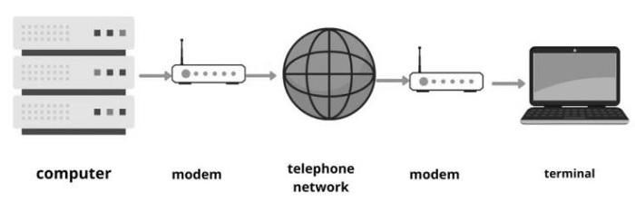

### **Digital subscriber Line**

It provides high speed internet connection through telephone lines. It is expensive when compared to a telephone modem. The DSL is also connected with phone lines similar to telephone modem, but the difference is in DSL voice communication and internet service is used simultaneously whereas in telephone modem it is not provided.

Given below is the diagram of [**digital subscriber line (DSL)**](https://www.tutorialspoint.com/dsl/dsl_overview.htm) −

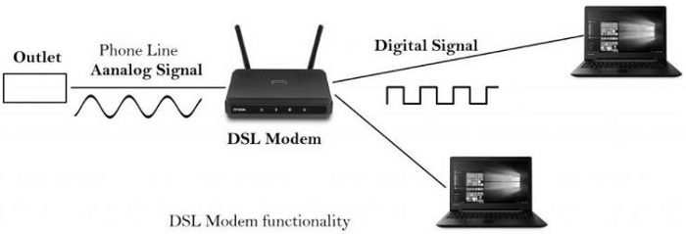

### **Cable modem**

Cable Modem is a device that allows high-speed data access via a cable TV (CATV) network. Most cable modems are currently external devices that connect to the PC through a standard 10 BASE-T Ethernet card and [**twisted-pair wiring**](https://www.tutorialspoint.com/what-is-twisted-pair-cable).

Given below is the diagram of cable modem −

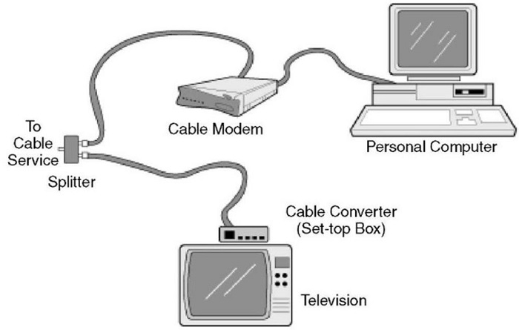

### **Satellite modem**

It is a device that provides internet connection through satellite dishes. It transfers the input bits to output radio signals and then executes vice versa. It is costlier when compared to all other modems but provides better reliability to the internet network.

