1. **Branching Strategy and Execution Rules**

**II.           Webhook Integration**

**a.     Configure a GitHub webhook that triggers Jenkins when:**

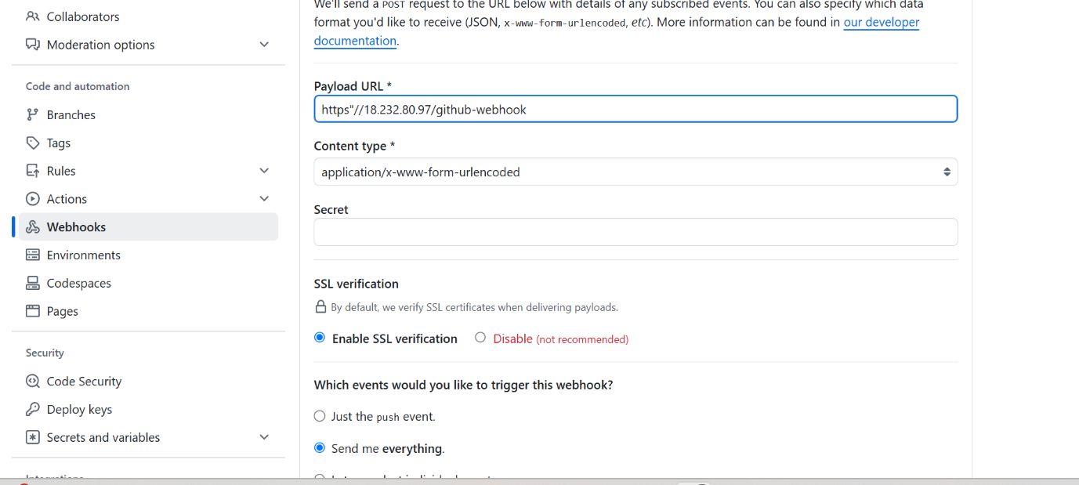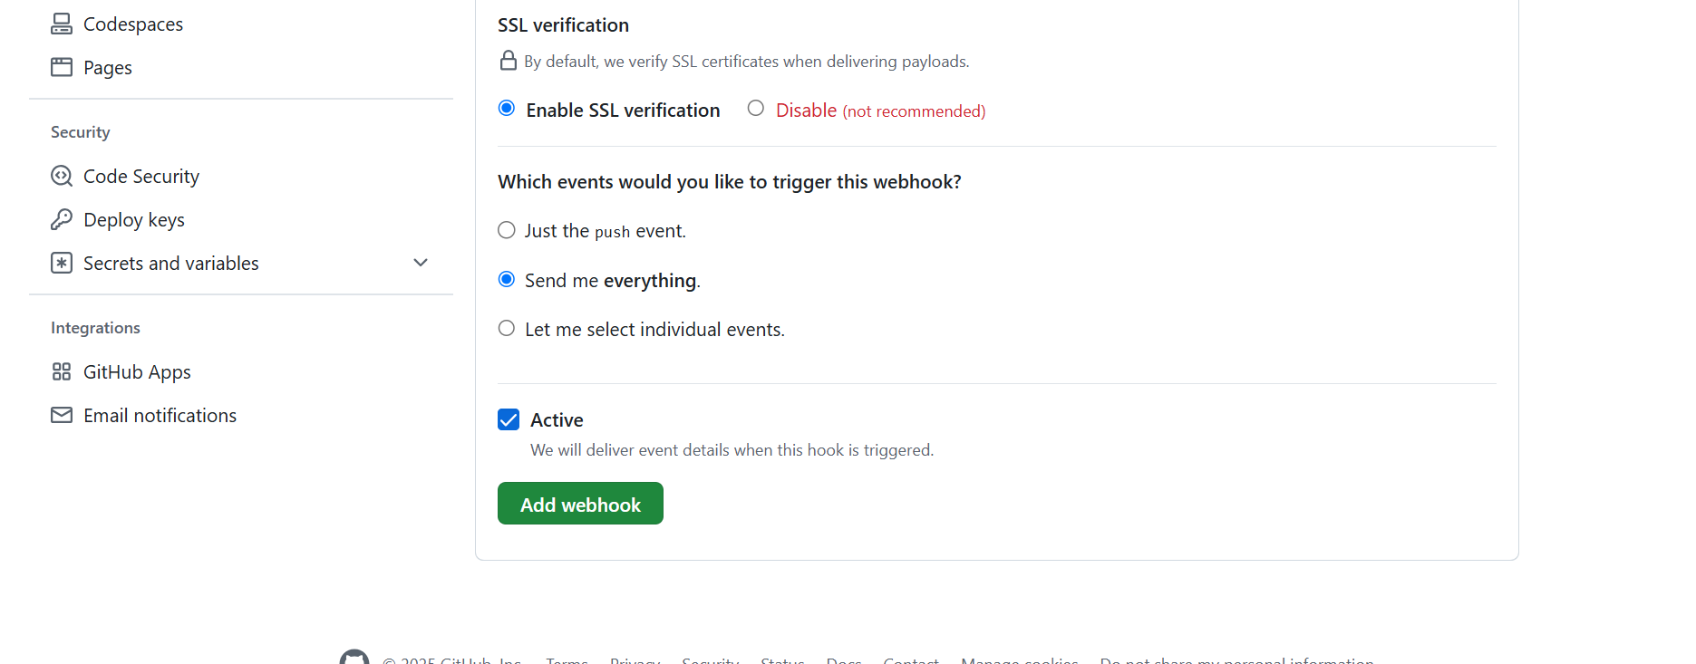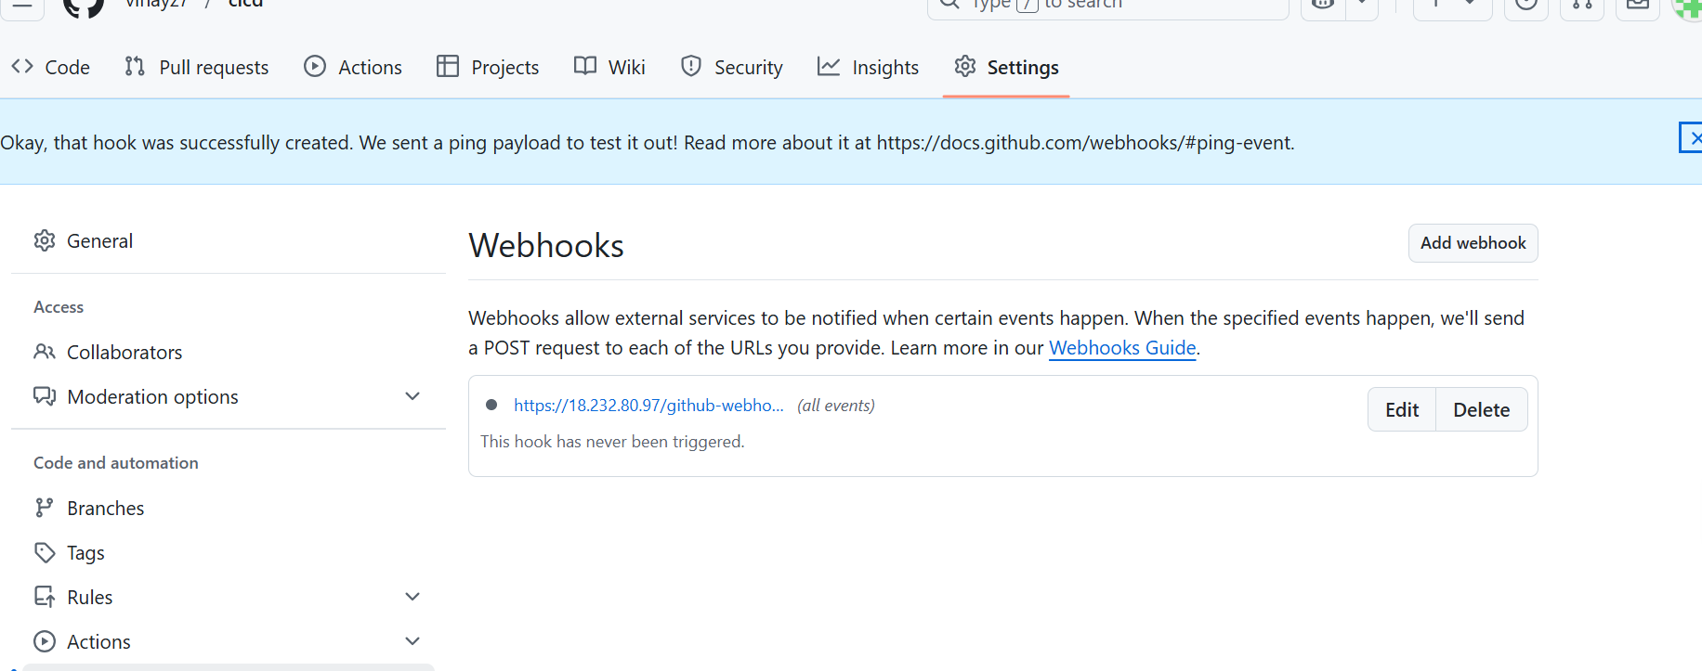

**III.           Building Java Code with Maven**

**a.     Compile the application using Maven.**

**b.     Generate .jar file as the build artifact.**

**a.     Write a Dockerfile with the following specifications:**

**i.     Base Image: openjdk:11-jre-slim**

**ii.     Copies the application JAR from the build output.**

**iii.     Exposes port 8080 (the application port).**

**iv.     Uses ENTRYPOINT [“java”, “-jar”, “/app.jar”].**

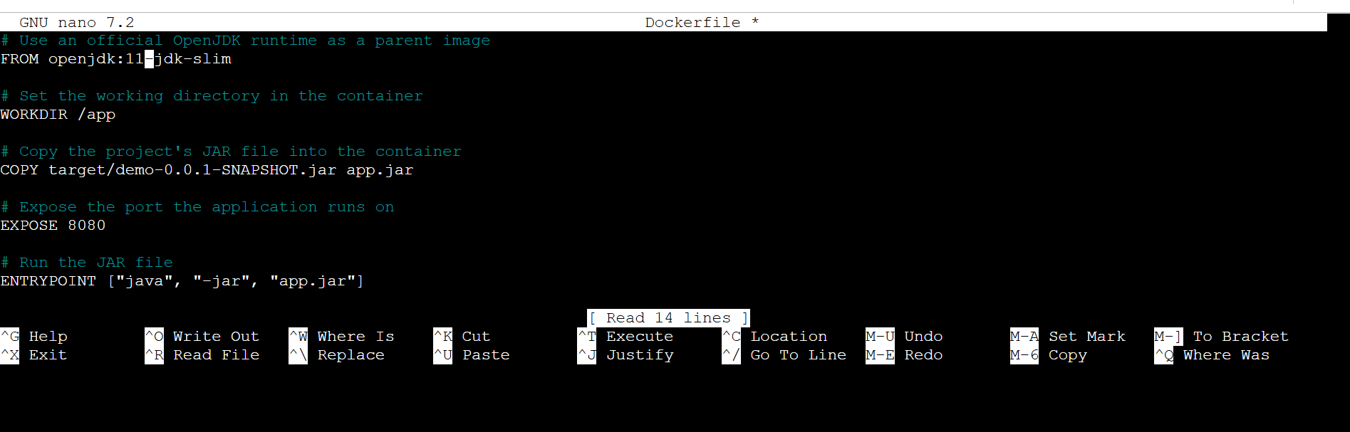

**Command : docker build -t javaimage .**

**Docker push:**

Dochub link: <https://hub.docker.com/repository/docker/vinayz7/javaimage/general>

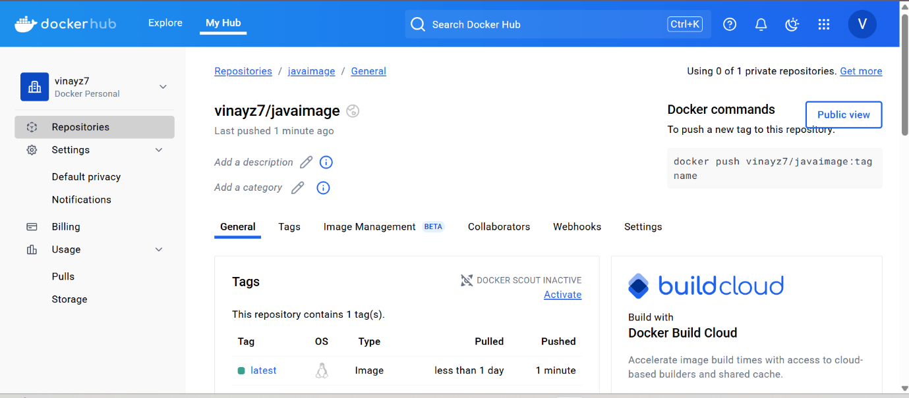

VI.           Kubernetes Deployment

a.     Write Kubernetes manifest files that include:

 i.     deployment.yaml (Defines the app deployment and replicas).

 ii.     service.yaml (Exposes the application internally).

b.     Add Kubernetes apply command to Jenkinsfile to enable deployment.

Kubectl apply -f deploy.yaml



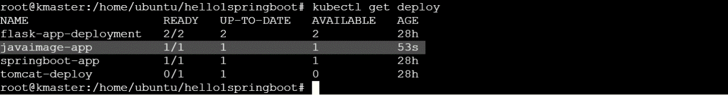

service.yaml (Exposes the application internally).

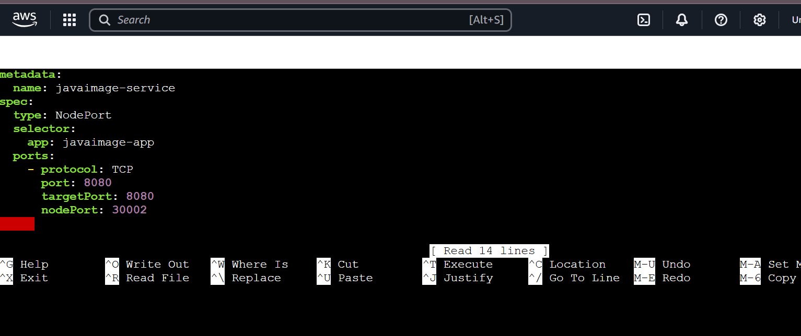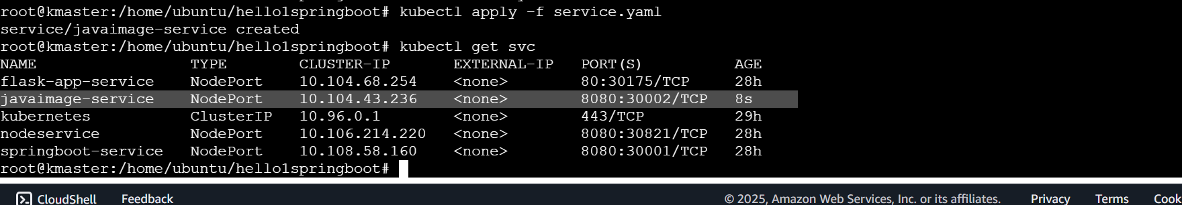

1. **Implement a CI/CD pipeline using Jenkins multi-branch pipelines , Docker for containerization, GitHub webhooks and Kubernetes for deployment.**

Github repo[: https://github.com/vinayz7/hello1springboot](:%20https:/github.com/vinayz7/hello1springboot)

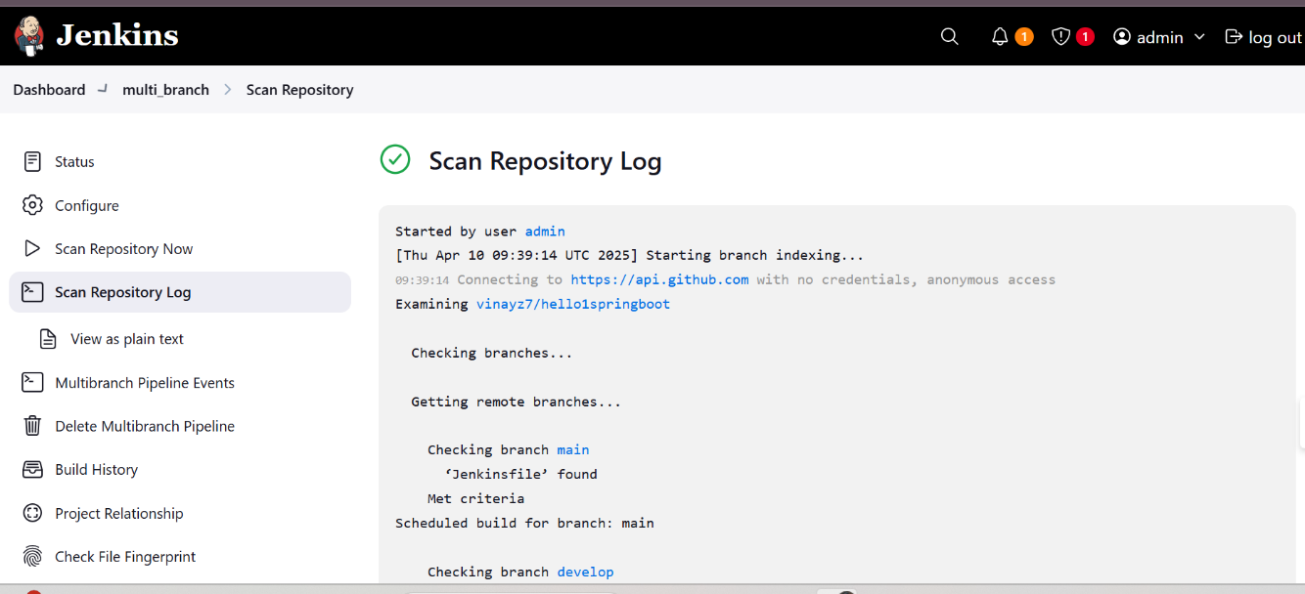

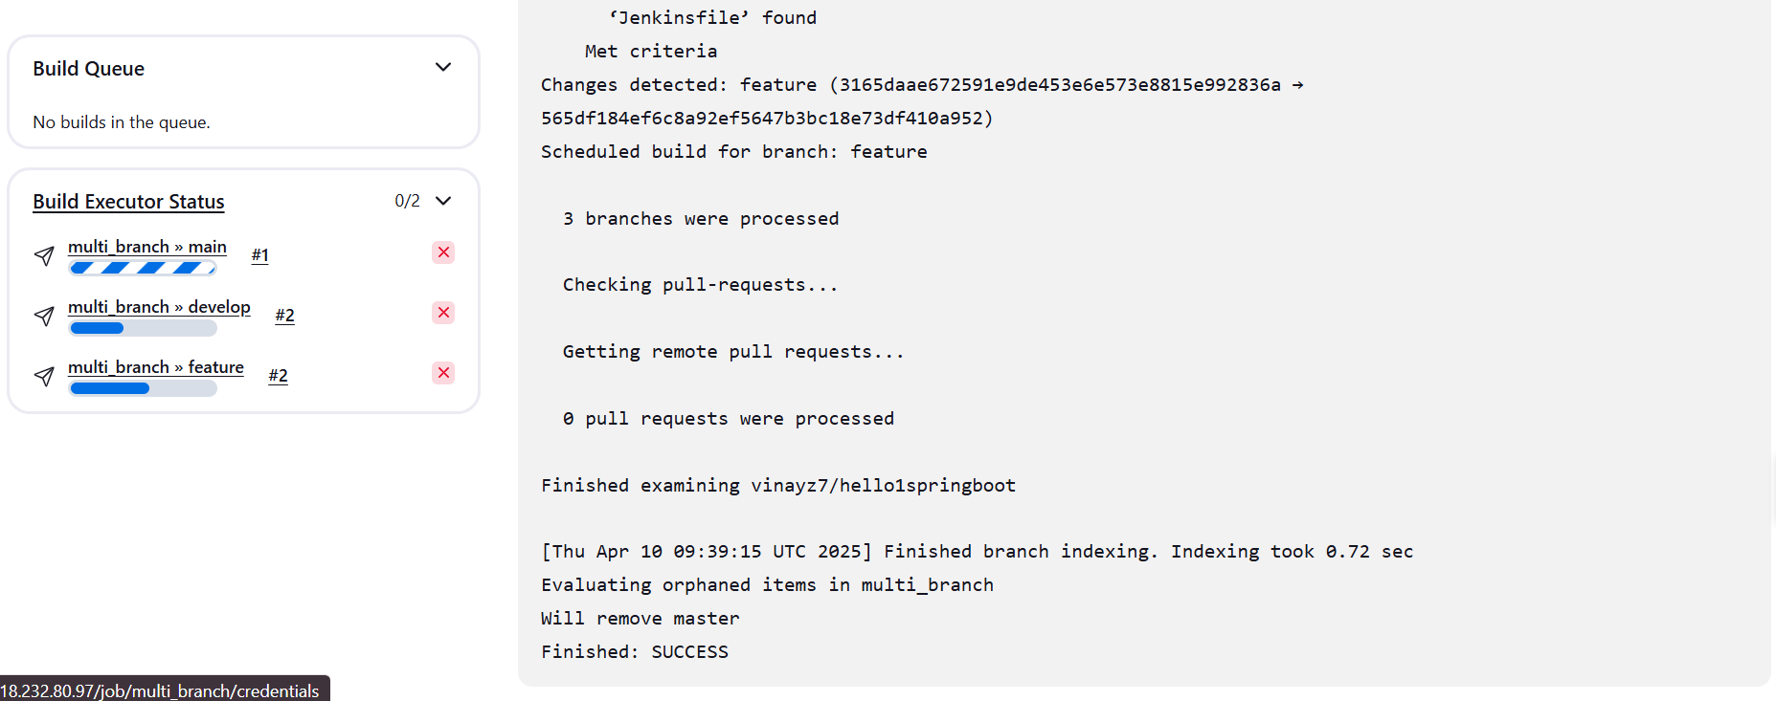

**Jenkins pipe line script :**

pipeline {

agent any

environment {

DOCKER_IMAGE = 'vinayz7/javaimage:latest'

}

stages {

stage('Clone Repository') {

steps {

git url: 'https://github.com/vinayz7/hello1springboot', branch: 'main'

}

}

stage('build mvn for jar') {

steps {

sh 'mvn clean install'

}

}

stage('Build Docker Image') {

steps {

sh 'docker build -t $DOCKER_IMAGE .'

}

}

stage('Push Docker Image') {

steps {

withCredentials([usernamePassword(credentialsId: 'docker-hub-credentials', usernameVariable: 'DOCKER_USER', passwordVariable: 'DOCKER_PASS')]) {

sh """

docker login -u $DOCKER_USER -p $DOCKER_PASS

"""

sh 'docker push $DOCKER_IMAGE'

}

}

}

stage('Deploy to Kubernetes') {

steps {

sh 'kubectl apply -f deploy.yaml'

}

}

stage('Expose Service') {

steps {

sh 'kubectl apply -f service.yaml'

}

}

}

}

