AWS

Cloud Formation is something like Terraform which is cloud native to AWS.

CDK – Cloud Development Kit,

Web Server – A software that provisions us to expose our application to network

**Protocols**

Three type of Instances

1. On demand instance – whatever we are creating usually for casual use
2. Spot Instance - bidding price
3. Reserved – we will keep it for particular fixed period of time.

Private vs public clouds?

Global Infrastructure

1. Region
2. Availability Zone
3. Edge locations

CDN - content delivery network

* Origin of data is somewhere but to get better and faster user experience they are storing or hosting it in the nearby network zone

S3, EBS – difference like hard disk vs google drive

Containerization vs Virtualization

Light weight

Packaging

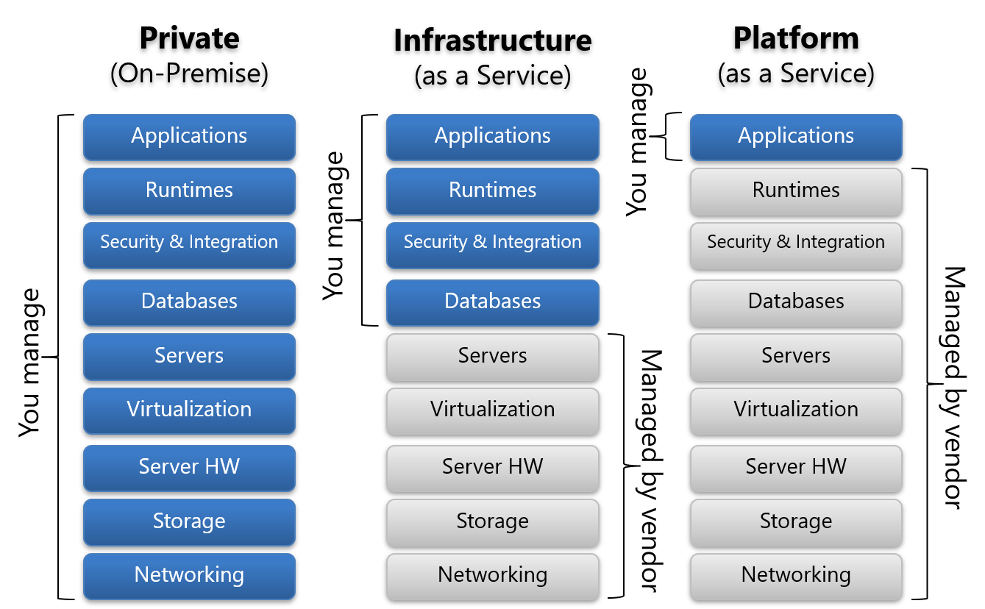

Launch template vs AMI (amazon machine language)

Types of machines

1. General Purpose
2. Compute
3. Storage optimized
4. Memory Optimised
5. Networking capabilities – ENI

Encryption

* Symmetric
* Asymmetric

NACL – Network Access Control List

VPC –

Subnets-

Day – 1

* AWS Console & Installation
* IAM
  + IAM is a global service for authentication and authorization
  + Route 53 is another global service
  + IAM Policy is written in JSON format, here policy refers to the rule written for the authorization.
  + We can create multiple IAM users using IAM system from the root user account
    - We have 2 kinds of policies:-
      * Identity based policy – based on the email or IAM user details the authorizations (policy) is written
      * Resource based policy – attaching or configuring policies to the resources with the list of users who can access it.
* Compute Service
  + EC2
    - **Hardware Place**
    - Dedicated machine , no sharing with other machines
    - Dedicated host
    - **Cost-wise**
    - On-demand
    - Reserve
    - Spot instance
    - **Based on the type of requirement**
    - Storage based
    - Memory based
    - CPU based

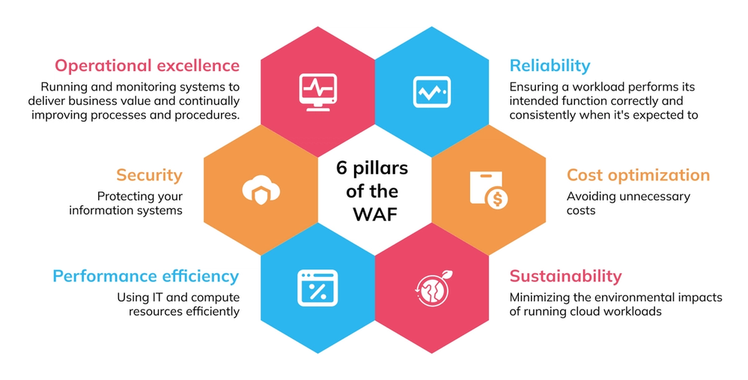

* AWS CLI
  + Console
  + IAC
  + CDK
  + Cloud Formation
* S3
* VPC
  + Create VPC
  + Create subnet
  + Create EC2 inside it

**Three types of Storage**

1. Object storage – Google drive – S3 in AWS
2. File Storage – file level stored, EFS in AWS
3. Block Storage – the thing which we want to store is divided into blocks, like hard disk – EBS volume

Auto Scalability

AWS Config

* We can make configuration to the whole aws cloud account level to access a particular ec2 type like t2.large or not , similar things

**HTTP vs HTTPS**

**TLS**

**In Cloud Practioner**

1. Compute Service
2. IAM
3. Storage
4. Container
5. Service Integrations
6. Serverless service – API gateway, Lambda
7. DB service
8. Monitoring Service
9. Management & Governance service
10. Network Services – VPC, Load Balancer

**In Devops Professional**

1. CloudFormation
2. CodeBuild
3. CodeDeploy
4. CodePipeline
5. CodeCommit
6. CDK

What is SaaS, PaaS, IaaS

Difference between Dedicated hosts vs Dedicated Instance

Purchase Options

Placement group