# Creating a Shared Library in Jenkins to Standardize Build

## Created a new git repo in my git

Repo Url: <https://github.com/royg-9595/jenkins-shared-library>

## Add pipeline logic

Created a folder **vars/** inside the repo and created a file **gitClone.groovy** to standardize the clone functionality in the organization.

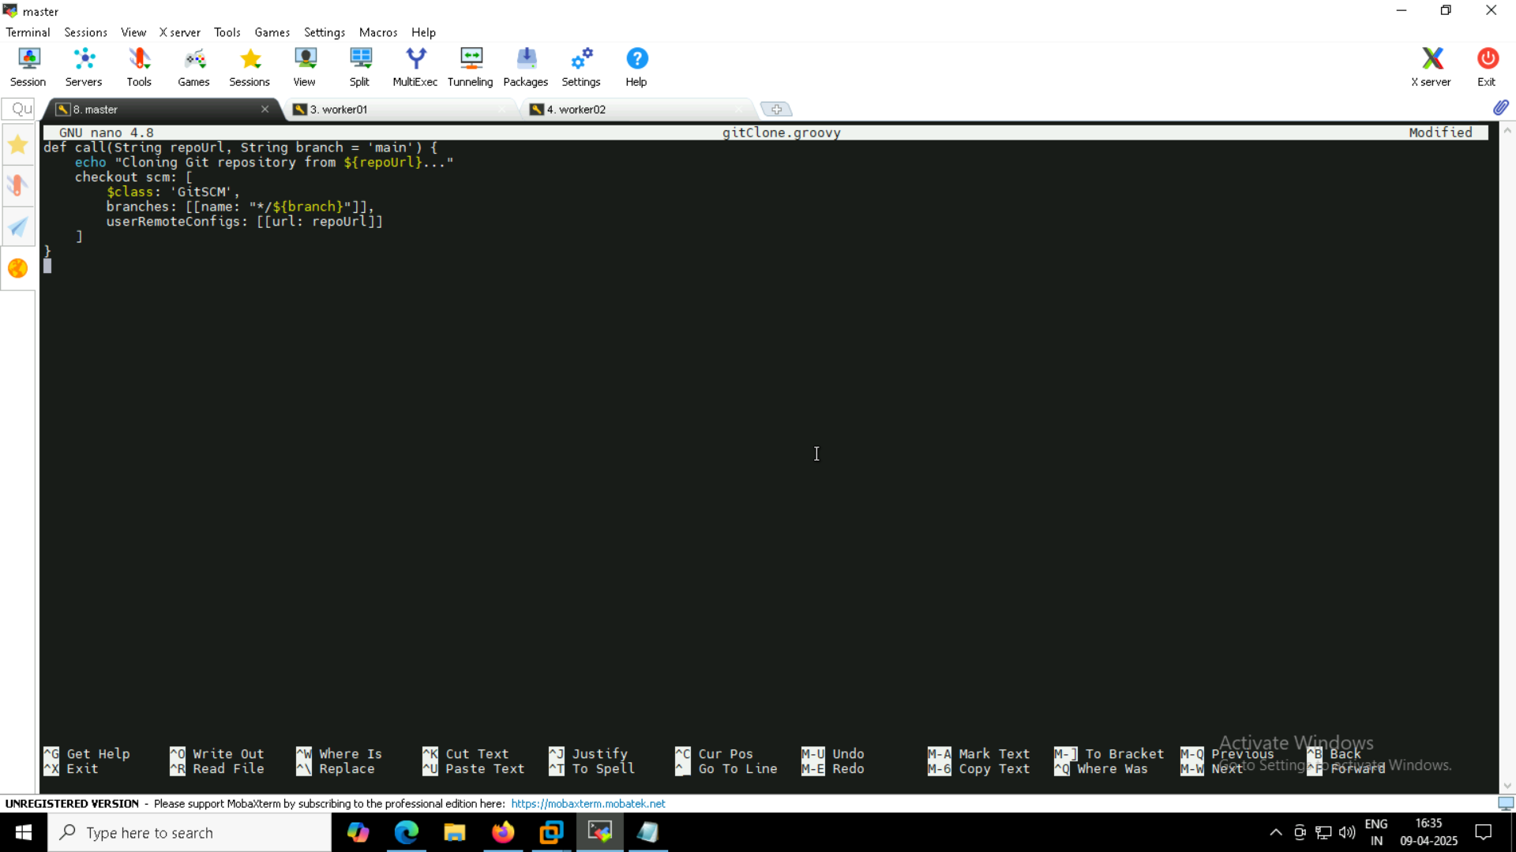

## Register the shared library in Jenkins

Dashboard 🡪 System 🡪 search ‘*global trusted pipelines*’ . Add the library git repo url.

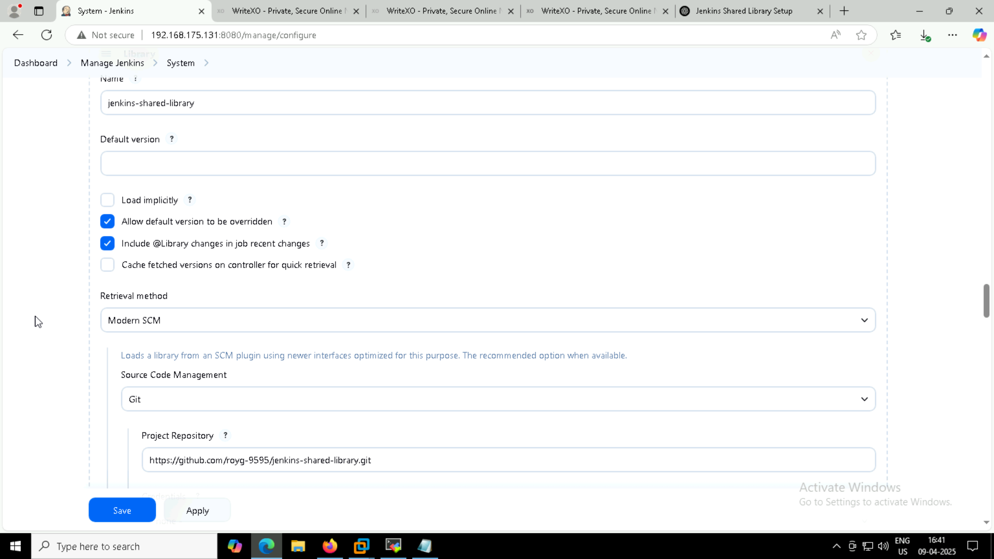

gitClone.groovy file (code ) in the github repo

Created it inside **vars/** folder

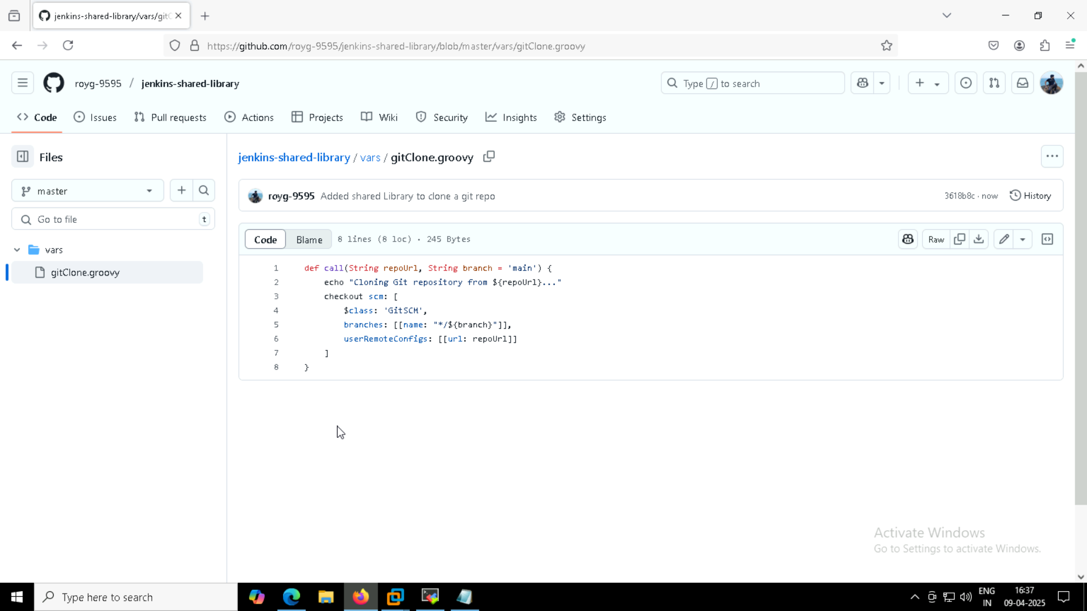

## Using the shared Library in Jenkins pipeline

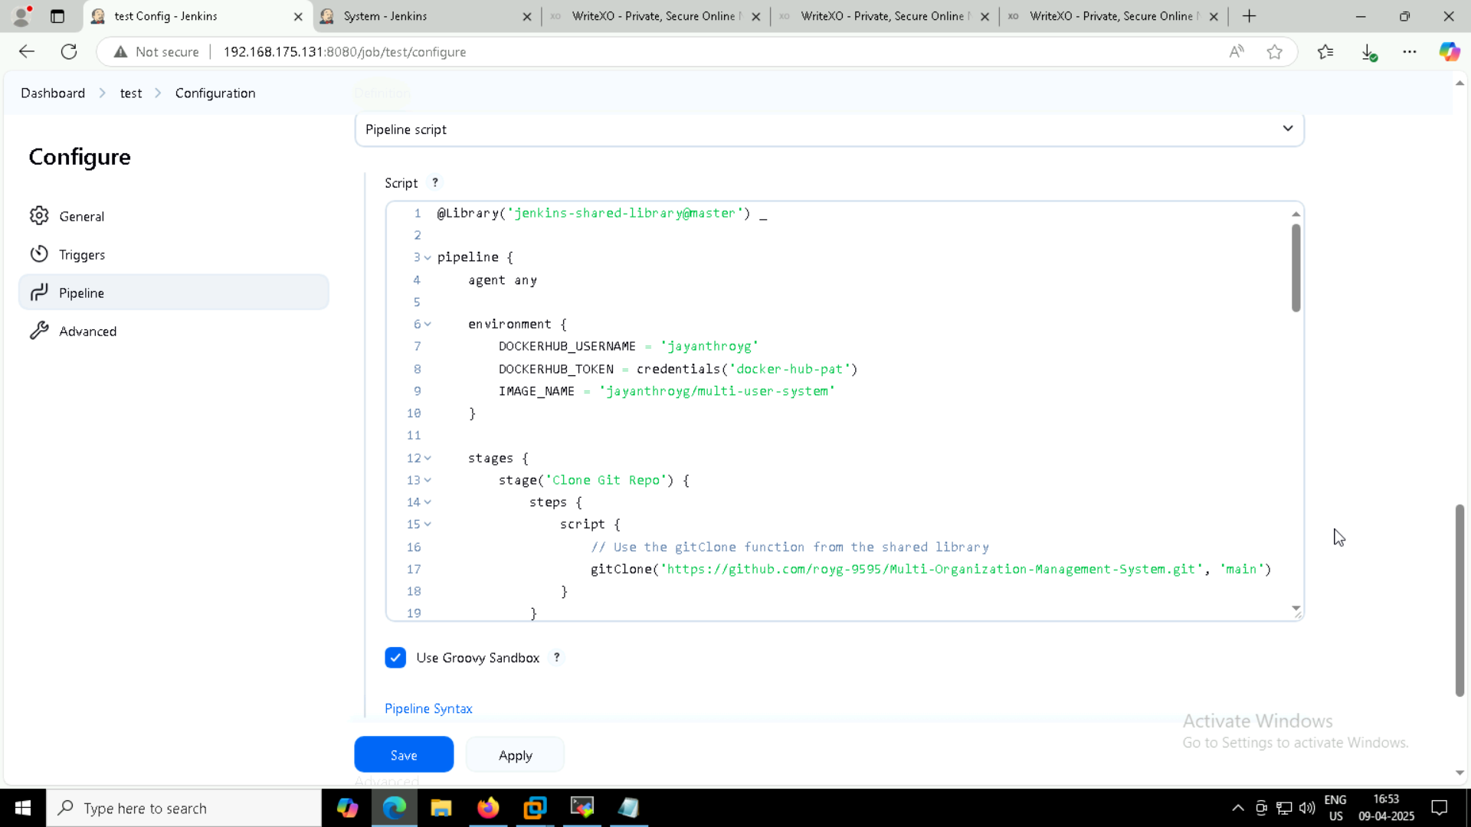

## Build the pipeline and the pipeline executed success

